**BUDAPEST UNIVERSITY OF TECHNOLOGY AND ECHONOMICS**

**Thesis one: Power Consumption and management using machine learning algorithm for LPWAN Networks**

**Report One**

By: - Mussa Ebrahim Bidaru

Msc in computer Science Engineering

Neptune code: Q1DWS7

Collage of Electrical engineering and informatics

Department of Telecommunications and Media Informatics

Supervisor: - Husam Rajab

Submission Date: - October 18, 2019

**Introduction**

IoT is about extending the power of internet beyond computers and smartphones to the whole range of other things (sensors, heartbeat monitor, moisture sensor, etc.) these devices are connected through different IoT connection methods(Wi-Fi, LPWAN, Cellular, Satellite, Bluetooth, etc.) to send and receive data back and forth. The most relevant question this day is that which of this connection method will be suitable for the IoT device which we are going to implement? And the key challenge in these Networks is the battery life, the ability of devices to communicate over a long-range and security. In this report, I will analyze and classify IoT, IoT connection Methods and comparison of these connection methods using different measurements.

**Internet of things (IoT)**

IoT is a system of interrelated computing devices, mechanical and digital machines, objects, animals or people that are provided with unique identifiers and the ability to transfer data over a network without requiring human to human or human to computer interaction. In short, IoT is a network of physical devices that are connected to the internet and are able to talk to each other. The number of IoT devices are growing time to time, by 2020 number of IoT devices are estimated to reach 30billion; which leads us to the question as the number of IoT device grow the harder it gets for companies to manage the devices and less secure people will become or there will be more advantages for the hacker to Britch peoples security.

**Why IoT Matters**

When something is connected to the internet, that means that it can send information or receive information, or both. This ability to send or receive information makes things “smart”. For example, smartphones right now, you can listen to just about any song in the world, but it’s not because your phone has every song in the world stored on it. It’s because every song in the world is stored somewhere else, but your phone can send information (asking for that song) and then receive information (streaming that song on your phone). To be smart, a thing doesn’t need to have super storage or a supercomputer inside of it. All a thing has to do is connect to super storage or a supercomputer. In the Internet of Things, all the things that are being connected to the internet can be put into three categories:

* Things that collect information and send it.
* Things that receive information and then act on it.
* Things that do both.

**Collect and Send information**

A device that allows us to automatically collect information from the environment and let us take more intelligent decisions (temperature sensor, moisture sensor, air quality sensor, light sensor, etc.)

On a farm, automatically getting information about the soil moisture can tell farmers exactly when their crops need to be watered. Instead of watering too much (which can be an expensive over-use of irrigation systems) or watering too little (which can be an expensive loss of crops), the farmer can ensure that crops get exactly the right amount of water. This enables farmers to increase their crop yield while decreasing their associated expenses.

**Receive and act on Information**

a device that receives information/command and acts on it is more familiar e.g. a Car receives signal from a car key and the door opens, the printer receives the document and prints it, etc.

**Doing Both (Goal of IoT System)**

The real power of IoT arises when things can do both of the above things collect information and send it, but also receive information and act on it. E.g. Sensors can collect information about the soil moisture to tell the farmer how much to water the crops, but you don’t need the farmer. Instead, the irrigation system can automatically turn on as needed based on how much moisture is in the soil.

**IoT Connectivity**

The sensors/devices can be connected to the cloud through a variety of methods including cellular, satellite, Wi-Fi, Bluetooth, low-power wide-area networks (LPWAN), connecting via a gateway/router or connecting directly to the internet via ethernet. Each option has tradeoffs between power consumption, range, and bandwidth. Choosing which connectivity option is best comes down to the specific IoT application. And within each of these options there can be different providers (e. g. for cellular there’s T-Mobile, Verizon, AT&T, Sprint, etc.). Connectivity is a huge facet of IoT, so it’s important to understand the options that run smoothly at the lowest expense.

IoT devices can be connected to the internet using different wireless technologies:

* Short Range wireless communication
* Cellular communication
* Long Range Wide Area Network (LPWAN) communication

**Cellular**

5G

4G

3G

2G

**Data Rate**

**Short range wireless communication**

Wi-Fi

Bluetooth

BLE

NFC/RFID

wZigbee

**LPWAN**

NB-IoT

LoRA

SigFox

**Range**

Fig1. IoT device connection types

**Cellular Connectivity**

Cellular connectivity has High power consumption, high Range and high bandwidth. To wirelessly send a lot of data over a great distance, it takes a lot of power. E.g. smartphone can receive and transmit large amounts of data (video) over great distances, but you need to charge it every 1–2 days. Connectivity options in this group include cellular and satellite. Cellular is used when the sensor/device is within coverage of cell towers. For sensors/devices that are, say, in the middle of the ocean, satellite becomes necessary. Cellular connectivity has been focused on range and bandwidth at the expense of power consumption, meaning that it can send lots of data over long distance but drains battery rather quickly.

**Short Range Wireless Connectivity**

Short-range wireless connectivity has low power consumption, low range, and high bandwidth. To decrease power consumption and still send a lot of data, you have to decrease the range. Connectivity options in this group include Wi-Fi, Bluetooth, Ethernet, etc. Ethernet is a hard-wired connection, so the range is short because it’s only as far as the wire length. Wi-Fi and Bluetooth are both wireless connections with high bandwidth, limited range and lower power consumption than cellular and satellite.

**Low Power Wide Area Network (LPWAN)**

LPWAN allows low power consumption over wide-area (long-range). To increase range while maintaining low power consumption, we have to decrease the amount of data we are sending. The perfect connectivity option would consume extremely little power, have huge range, and would be able to transmit large amounts of data (high bandwidth). LPWAN sends small amount of data which allows it to operate at very low power with the range of miles. E.g. vehicle track location sensor, battery-powered locks, waste container full/empty sensor, etc. Thus, LPWAN technology plays a great role in enabling internet of things. It makes it possible to have many thousands of sensors/devices collecting and sending data at lower cost, over longer range, with better battery life than other connectivity’s.

The most competing LPWAN technologies are classified regarding the frequency spectrum they use:

**Frequency spectrum**

**Licensed Frequencies**

**Unlicensed Frequencies**

**NB-IOT**

**LoRa**

**LTE-M**

**SigFox**

**Long Range (LoRa)**

LoRa is Unlicensed LPWAN wireless technology where low powered sender transmit small data package (0.33kbps to 5.5kbps) to receiver over long range distance. LoRa is a new modulation technique that offers long range communication which is called Frequency Modulated (FM) chirp or chirp spread spectrum, this modulation system has been used in by military and space communication because of its significant and robustness against interferences.

Lora operates in unlicensed ISM(industrial, scientific and medical) radio band that are available worldwide. E.g. In Hungary LoRaWAN operates in 863-870MHz frequency band.

LoRa represents a good radio network for IoT solutions and has better link budgets than other comparable radio technologies. if you want to connect to LoRaWAN networks or use LoRa at all you need to deploy your own network gateway. Which is an advantage setting up your own gateway creates a completely separate and secure network.

LoRa devices work well when they are in motion, which makes them useful for tracking assets on the move, such as shipments.

LoRaWAN is is developed by the LoRa Alliance, which is an open, non-profit organization. LoRa is a link layer protocol and does not specify the network architecture. LoRaWAN, on the other hand, is a Media Access Control (MAC) layer protocol which specifies the network architecture.

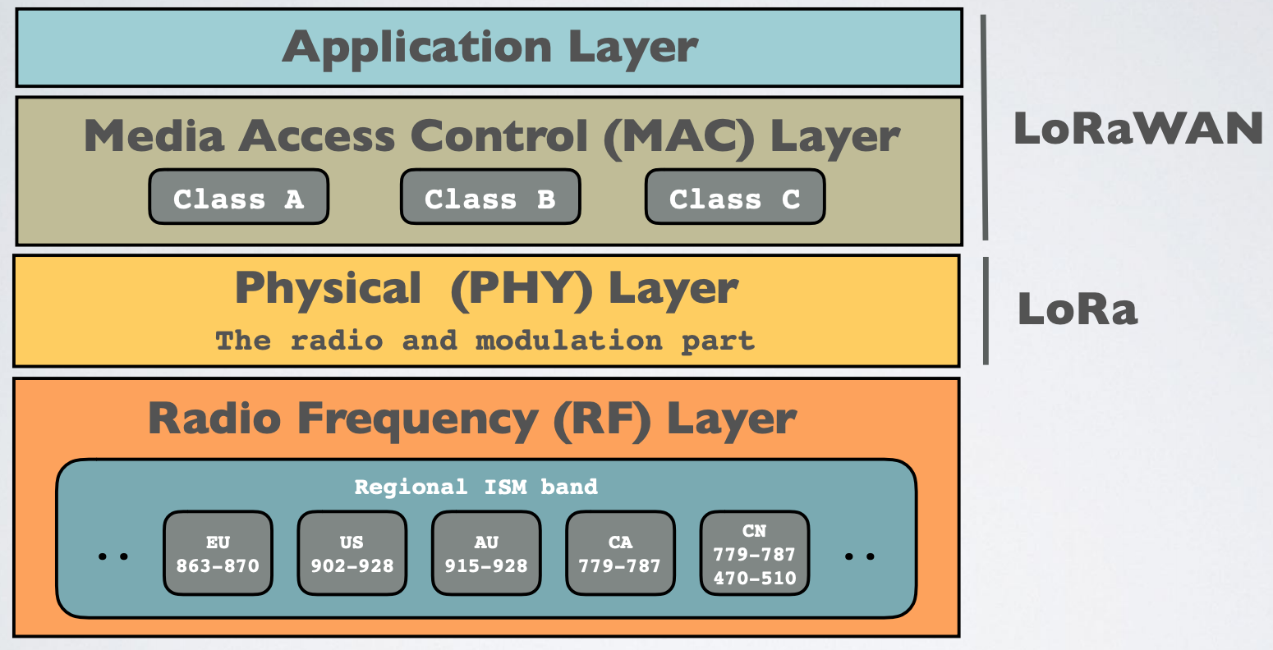

Fig2. LoRa and LoRaWAN protocol stack

LoRaWAN network architecture is deployed in a star topology, the communication between the end node and gateway is bidirectional which means the end node can send data to the gateway, but it can also receive data from the gateway.

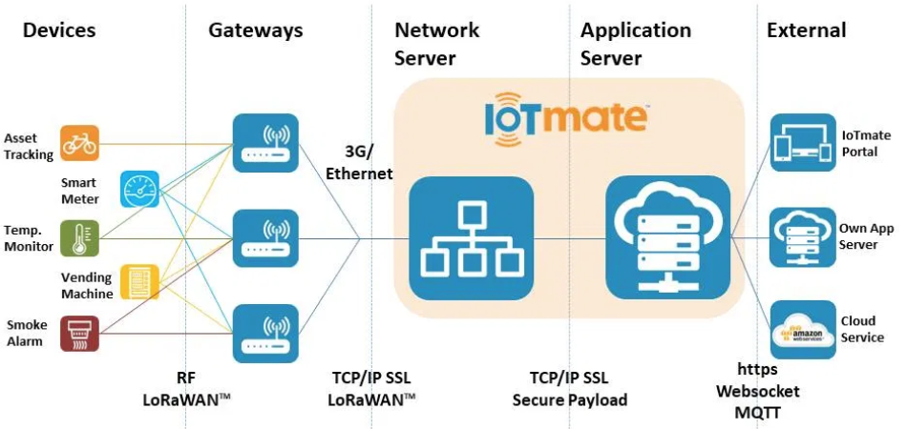

Fig3. LoRaWAN network topology

**SigFox**

SigFox is founded in 2009 it is a french company based it uses proprietary technology, an example of using a slow modulation rate to achieve a more extended range. Due to this design choice, SigFox is an excellent option for applications where the system only needs to send small, infrequent bursts of data without frequent communication,

Like LoRa Sigfox utilises Licence free ISM network which means others can use this network for free which affects the performance of this technology by slowing down the data transfer rate, Data usage is limited to 12 bytes per hour.

Sigfox is uplink only. Though limited downlink is possible, it has a different link budget and is very restricted. And it uses ultra-narrow band (UNB) and binary phase-shift keying (BPSK) to achieve the extended range of an LPWAN. In UNB communication, it always operates above the noise floor. The drawback is interference if noise peaks exist in the communication band. The UNB is 192 KHz wide between 868 and 868.2 MHz in Europe, and between 902 and 928 MHz in the rest of the world. Each message on the air occupies 100 Hz. Transmission between an end device and the network is unsynchronized, the device transmits data on a random frequency and then sends two additional copies of the same message at another point in time on another frequency. This feature is known as "random access" On the other end, base stations scan the whole 192 kHz searching for UNB signals for demodulation.

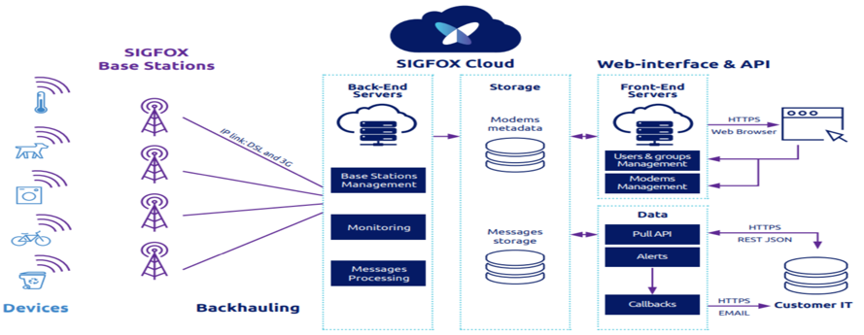

Fig 4. SigFox network arctecture

Figure 4 shows the standard network architecture of the Sigfox network. The end devices send data to base stations over the air using the UNB and BPSK modulation technique. The base stations communicate with the backend via DSL and 3G. The backend handles all the message processing, redundant messages are discarded, and only the relevant messages are stored in the database. The web interface allows customers to access their messages by using the browser or a REST API.

**Narow Band IoT (NB-IoT)**

Narrowband IoT (NB-IoT) is a 3GPP, it uses the same principle and building blocks as the LTE physical layer, this allows for rapid standardization and product development. It has been designed inherently to have more coverage and consume less power as compared to conventional GSM networks.

NB-IoT is a cellular-grade wireless technology that uses OFDM modulation, the chips are more complex, but the link budgets are better. That means users get the high-performance level associated with cellular connections, but at the cost of more complexity and greater power consumption.

It is message-based, similar to Sigfox and LoRa, but with a much faster modulation rate that can handle a lot more data than those technologies. But NB-IoT is *not* an IP-based communication protocol like LTE-M (another LPWA cellular technology associated with IoT applications)

Its advantage is that coverage is very good. NB-IoT devices rely on 4G coverage, so they would work well indoors and in dense urban areas, It has faster response times than LoRa and can guarantee a better quality of service and No limitation to output, highest download and upload rates(up to ten times higher than LoRa and sigfox besides There are several LTE network providers like vodafone, AT&T while LoRa and sigfox have only one providers. But unlike other networks it have little drawbacks Some of the design specifications for NB-IoT make it such that sending larger amounts of data down to a device is hard, Network and tower handoffs will be a problem, so NB-IoT is best suited for primarily static assets, like meters and sensors in a fixed location, rather than roaming assets

**LTE-CAT-M1**

LTE-M stands for Long Term Evolution for Machine-Type Communications is successor of Cat-1 and Cat-0. In 3GPP It is mainly developed to fulfill cellular IoT device objectives such as reduce complexity as compared to GSM/GPRS mobile devices, low device cost, deep coverage, longer battery life, higher cell capacity and so on, the extended battery life is achieved by use of power saving mode (PSM) and extended idle-mode Discontinuous Reception (eDRX).

LTE-M, also known as LTE Cat M1, is a variant of the existing 4G networks and it is comparable to NB-IoT. Compared to the other LTE networks, LTE-M is available for a wider bandwidth, although it offers reduced coverage. LTE-M is designed to frequently transmit data at a lower speed than what is common for 4G networks.

Its advantage is that LTE-M is comparable to NB-IOT. It offers a larger bandwidth so you can transmit more data, at the cost of slightly limited coverage. LTE-M cellular technologies can transfer larger amounts of data than NB-IoT, Sigfox and LoRaWAN technologies and have fastest speed of transmission, As it uses TCP/IP, the network can be connected to any server and offers fastest Data rate, It supports capacity to accommodate large number of devices per cell, It is easy to deploy and it is interoperable with LTE networks.

**Comparison of LPWAN networks**

In order for selection of LPWAN technology selection criteria has to be evaluated depending on the need of the user:

* Modulation Technique
* Data throughput
* Operation frequency, and
* range
* power consumption

The modulation technique determines the key characteristic of a communication system. Techniques that provide inherent interference protection are preferred. For instance, spread spectrum techniques are designed to be detected even below the noise level and are preferred over the others. Data throughput should be enough to transmit 100-500 bytes per 5 minutes. Operating frequency of the technology should be in the unlicensed spectrum. Node power consumption should be as minimum as possible with a range of a few kilometers. And low node power consumption which is an inherent property of an LPWAN technology.

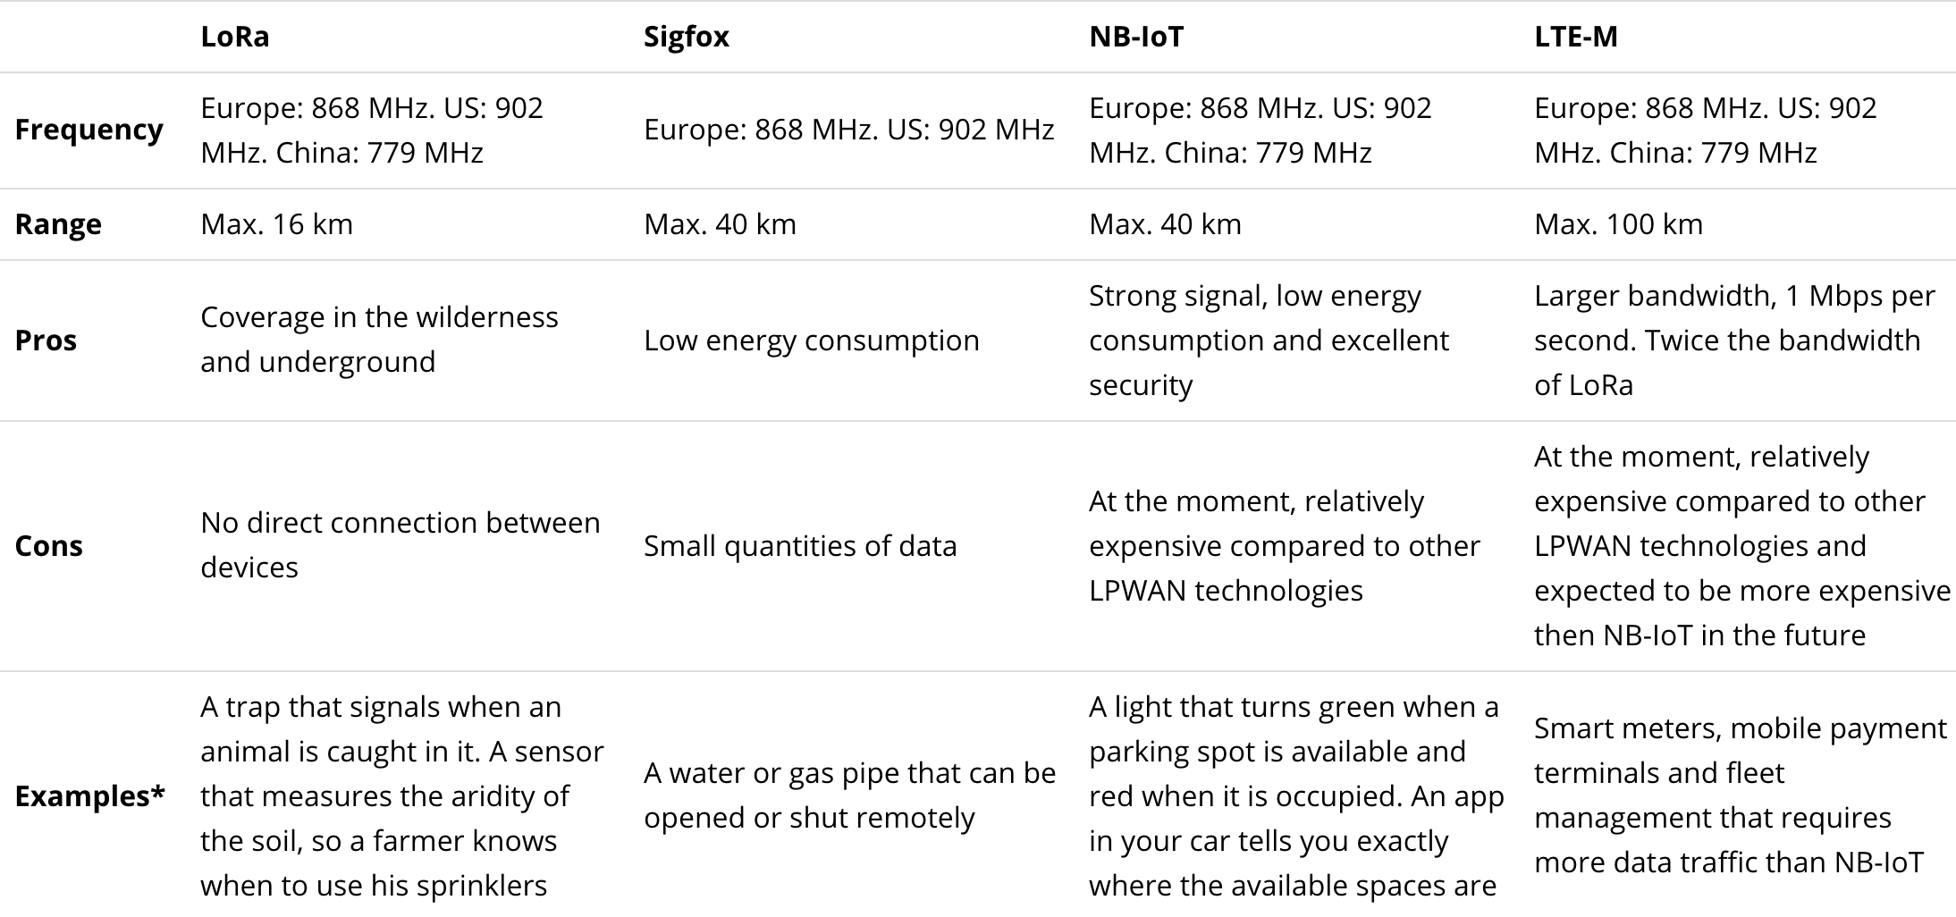

Fig 5. Comparison based on frequency and range

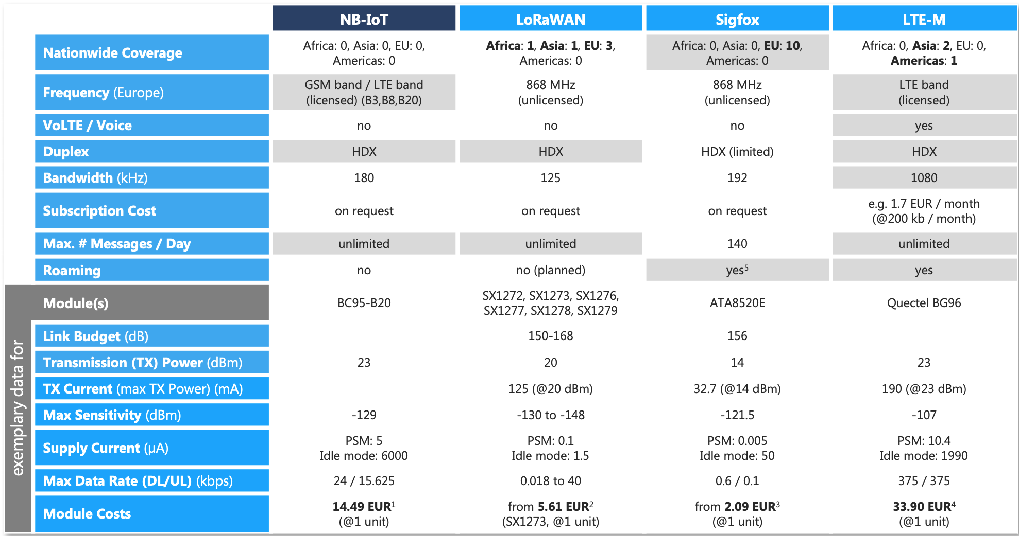

Fig 6. Comparison based of selection criteria

**Conclusion**

After considering all this in my opinion among these LPWAN networks one can be more preferable than the other depending on the use case which means depending on what you need them for (requirements).

Technologies like LoRa will most likely be best used for “discrete” applications like smart buildings or campuses, where mobile network connectivity is not needed. LoRa devices work well when they are in motion, which makes them useful for tracking assets on the move, such as shipments

LTE-M have higher data rates, which is important for data-rich use-cases. For instance, patient monitoring devices would likely require real-time communication leaving LTE-M as the clear winner. However, an application like pipeline monitoring would likely work with sending batch communication and therefore either NB-IoT or LTE-M could be used.

Another example where either technology could be used would be a smart city application, like waste management, where sensors report on how full a city dumpster is. You don’t need up to the second alerts on this type of information you can receive updates periodically. Plus, there’s very little data to report at any given time. For these types of applications, you have the flexibility to choose based on regional availability or pricing.

For larger areas like farms, campuses or cities, where small- volume data transmissions are needed self-contained LPWANs are the perfect answer (LoRaWAN and SigFox). when talking about covering regional areas and across boundaries, a cellular protocol like NB-IOT or Cat-M may look increasingly practical.