Application – on Internet

Information for hosting administrator

Mussa Justin Muhindo
Table of contents
1 Hosting account registration 3
2 Hosting server administrator data 5
3 Application installation 5
4 Running the application on Internet 8
4.1 Internet address 8
4.2 Application manual 8
4.2.1 Permissions 8
4.2.2 User manual 8

Hosting account registration
- Prerequisites:
- A computer with an operating system installed (Windows, macOS, or Linux).
- An internet connection.
- A web browser (such as Chrome, Firefox, or Edge).

- Navigate to Netlify:
- In the address bar, type https://www.netlify.com/ and press Enter.
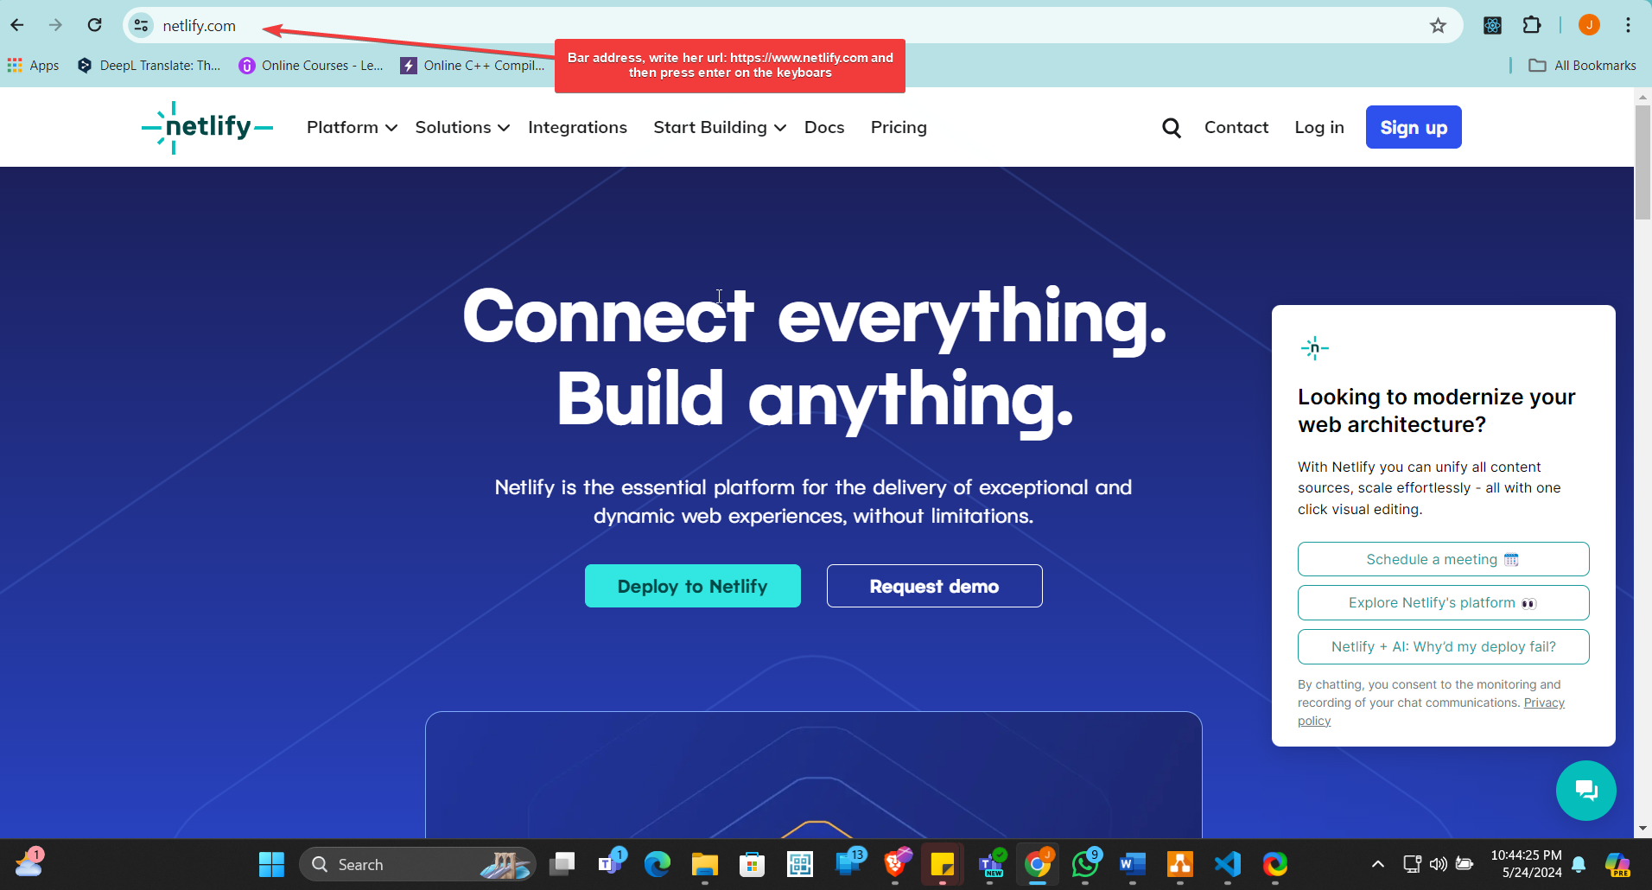
- Go to the Sign-Up Page: On the Netlify homepage, click on the "Sign up" button in the top-right corner.
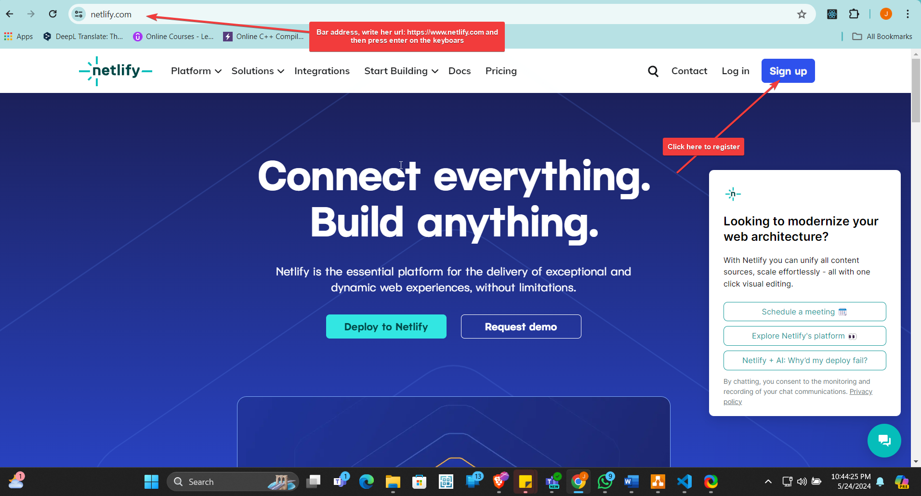
- Choose a Sign-Up Method: You can sign up using your GitHub, GitLab, or Bitbucket account if you have one. Alternatively, you can sign up using your email address. Click on "Sign up with GitHub" to proceed.
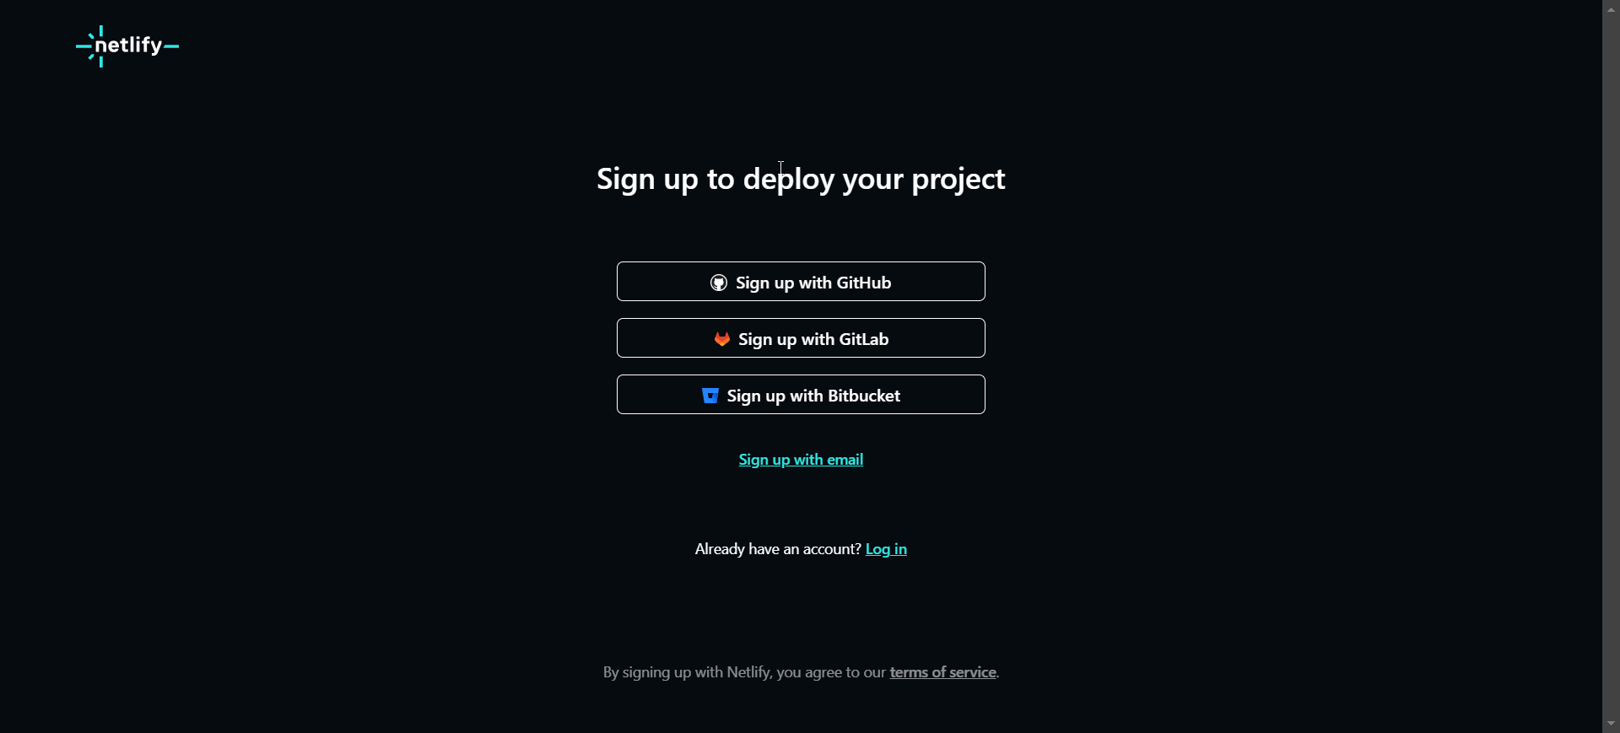

- Choose GitHub for Sign-Up: On the sign-up page, click on "Sign up with GitHub" Authorize Netlify on GitHub:
- You will be redirected to the GitHub login page if you are not already logged in.
- Enter GitHub credentials (username: mussajustin and password: Poland@2024_05) and click "Sign in".
- GitHub will ask for authorization to allow Netlify to access your GitHub account. Click "Authorize netlify" to proceed.

- Log In to Netlify: After authorizing, you will be redirected back to the Netlify dashboard. If not automatically logged in, click on "Log in" in the top-right corner and select "Log in with GitHub".

Hosting server administrator data
Hosting service url address: | https://github.com/mussajustin
Admin id: | mussajustin
Admin password: | Poland@2024_05

Application installation
- Before deploying to Netlify, I build my project locally: Access the directory “hello-world” as it is frontend built using react js, run the command on the terminal “cd hello-world.”
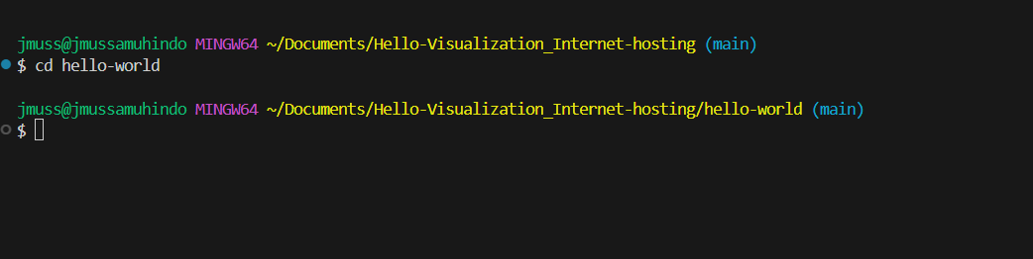
Once you are inside of the directory run the command “npm run build” then click enter
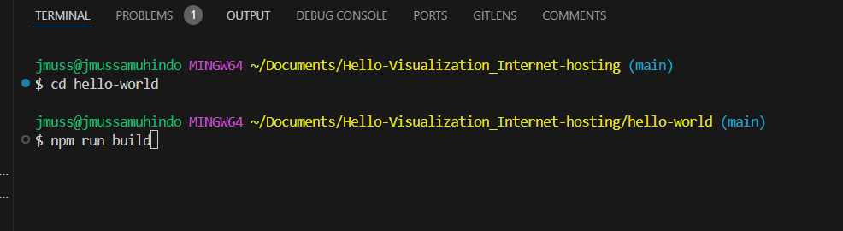
After running the command, the file build will be created on the project.
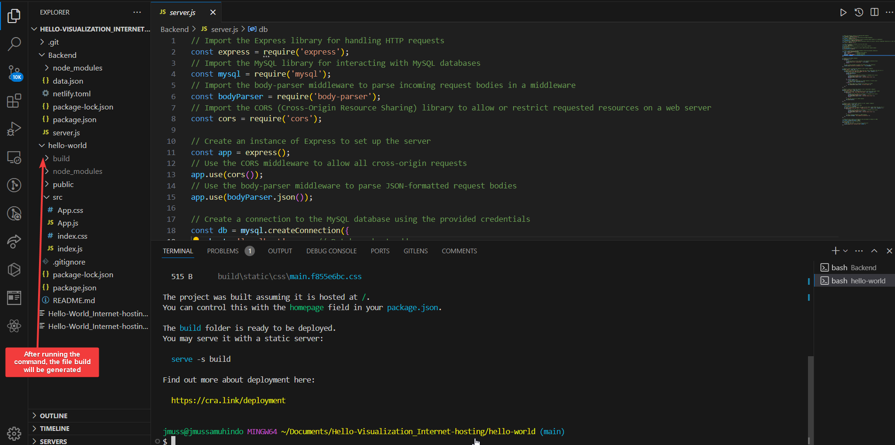
- Create a New Site: On the Netlify dashboard, click on the "New site from Git" button to start setting up your site, in my case I used manually:
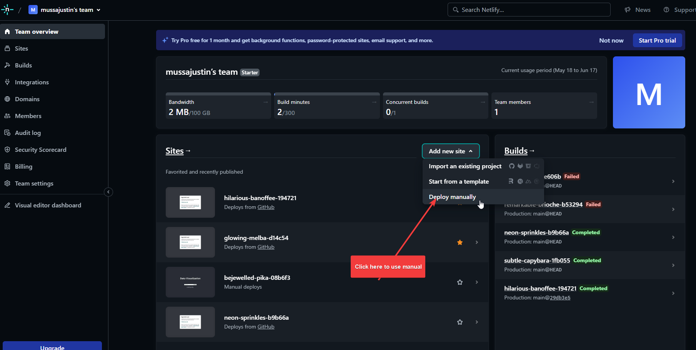
- Deploy via Drag and Drop: Scroll down to the "Manual Deploys" section then I drag and drop my build folder “build” into the provided area.

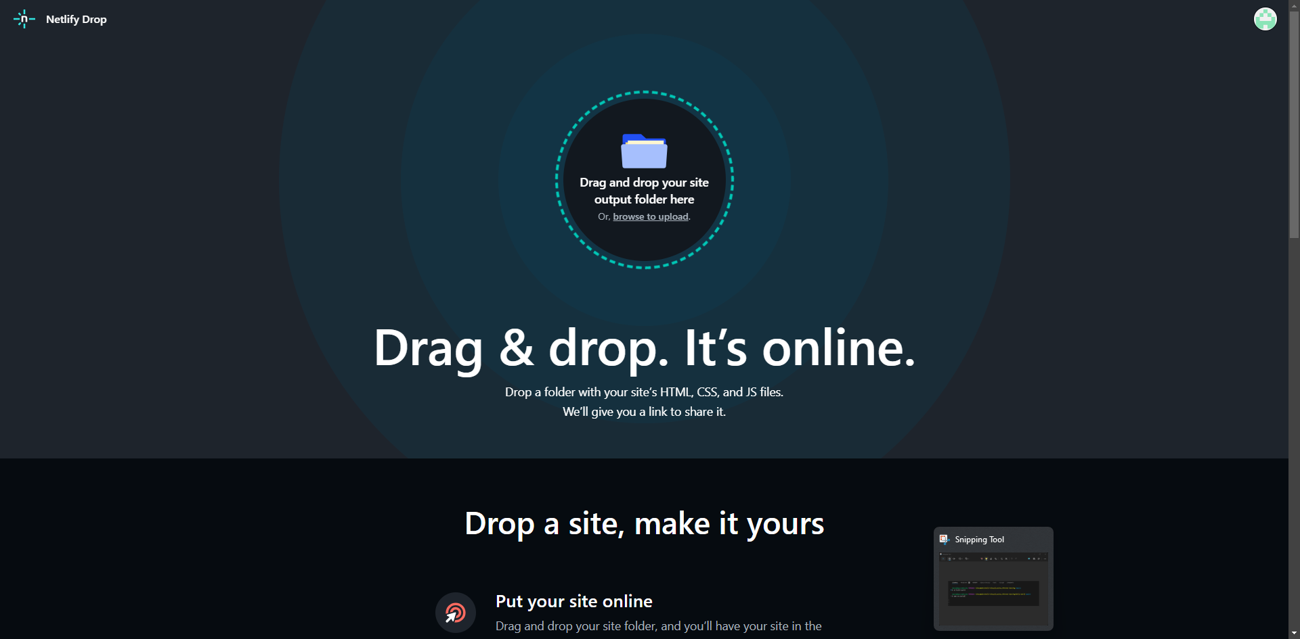
- Verify Deployment: I waited for the deployment process to be completed. Netlify will show a progress bar and logs. Once the deployment is complete, i will see a confirmation message.
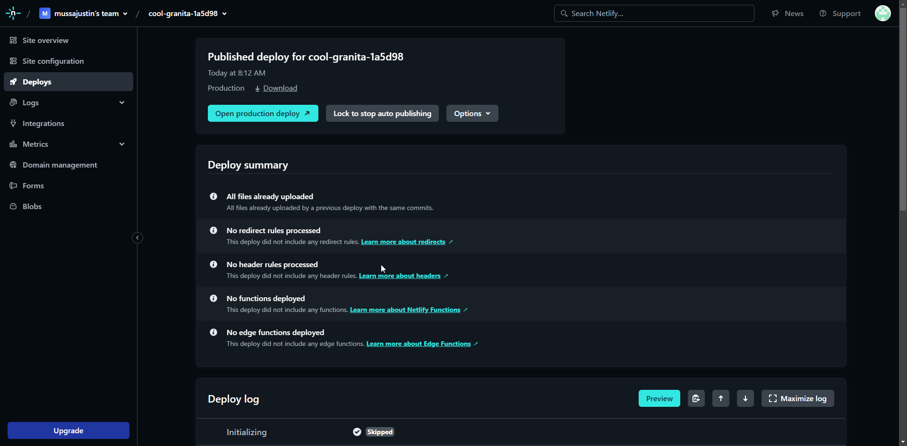
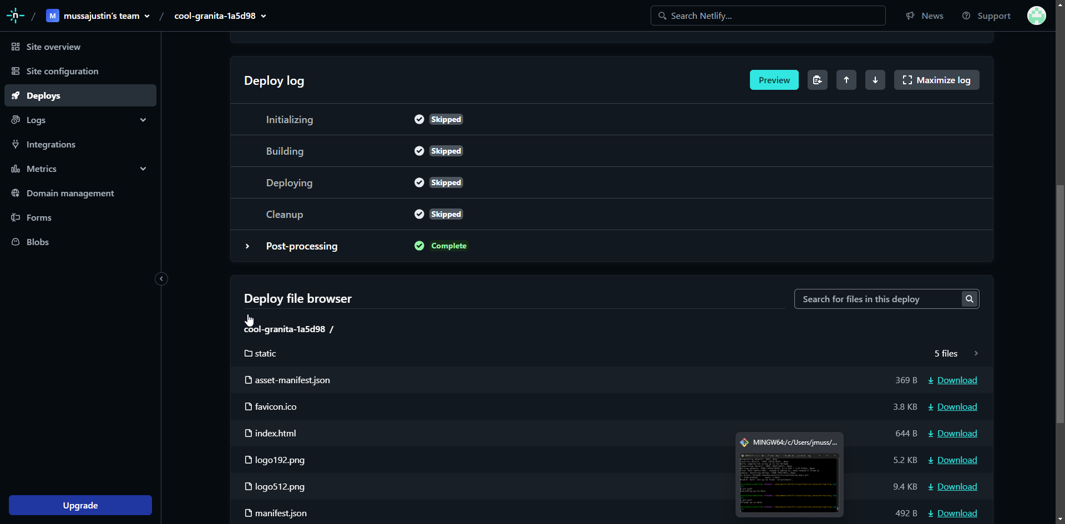

- Access My Site: My site will be accessible at the provided Netlify subdomain (https://665181679c181ff5b18e1b9b--cool-granita-1a5d98.netlify.app/). I clicked on the URL to visit my live site.

Running the application on Internet

Internet address
Internet address of the application: | https://665181679c181ff5b18e1b9b--cool-granita-1a5d98.netlify.app/

Application manual

Permissions
No Permissions

User manual
Click just only to following URL: https://665181679c181ff5b18e1b9b--cool-granita-1a5d98.netlify.app/

