Application – on Internet

Information for hosting administrator

Development of the Legal Connect System with React JS and Node.js

Mussa Justin Muhindo
Table of Contents
1 Hosting account registration 3
2 Hosting server administrator data 3
3 Application installation 3
4 Running the application on Internet 10
4.1 Internet address 10
4.2 Application manual 10
4.2.1 Permissions 10
4.2.2 User manual 10
4.2.2.1 Sign up 11
4.2.2.1.1 Sign up Process for Lawyer 11
4.2.2.1.1.1 Fill in the form for Identification. 13
4.2.2.2 Sign up Process for Client 17
4.2.2.2.1 Fill in the form for Identification. 18
4.2.2.3 Administrator Dashboard 20

Hosting account registration
To host a web application on DigitalOcean using a GitHub account, first create a GitHub repository to manage project's source code, and then set up a DigitalOcean account to deploy application. Here’s a step-by-step guide:

Step1: Create a GitHub Account
- Visit GitHub's website (https://github.com/).
- Sign up by entering a username, email address, and password.
- Verify the email address when prompted to activate the account.
- Log in to the new GitHub account.

Step2: Create a DigitalOcean Account
      - Visit DigitalOcean’s website (https://cloud.digitalocean.com).
      - Sign up by entering the full name, email address and password.
      - Verify the email address when prompted to activate the account.
      - Log in to the new DigitalOcean account.
      - Verify your email for the 6-digit code to sign in page to confirm your identity.

Hosting server administrator data
Hosting service url address: | https://cloud.digitalocean.com/login
Admin id: | jmussamuhindo@gmail.com
Admin password: | Poland@2024

Application installation
  - GitHub installation
      - Create a New Repository:
- After logging in, navigate to the top-right corner, click the "+" icon, then select "New repository".
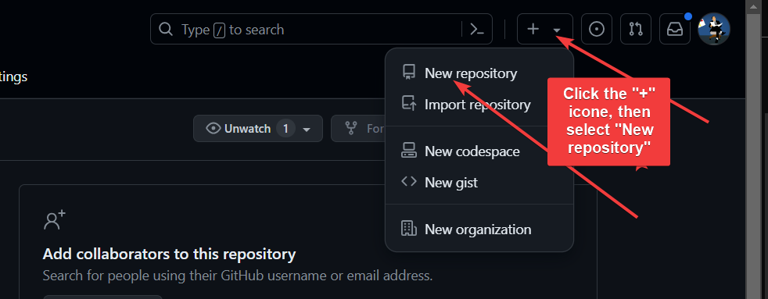
      - Name the repository "legal-connect-system".
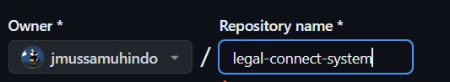
      - Set the repository to "Public" (so anyone can see it) or "Private" (so only approved collaborators can access it). In my case, since my project is not yet finished, I have set it as private so that I can provide a link to collaborator for access.
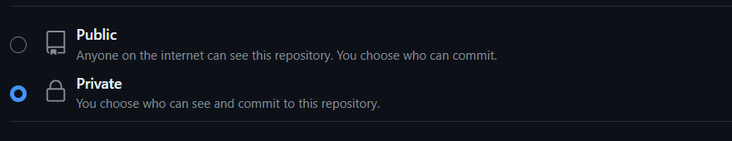
      - Initialize the repository with a README file (this acts as the landing page for the project).
      - Click "Create repository".

Step3: Push the Project to GitHub
To connect the local project to GitHub, Git is required. If Git is not installed, download, and install it from https://git-scm.com/.
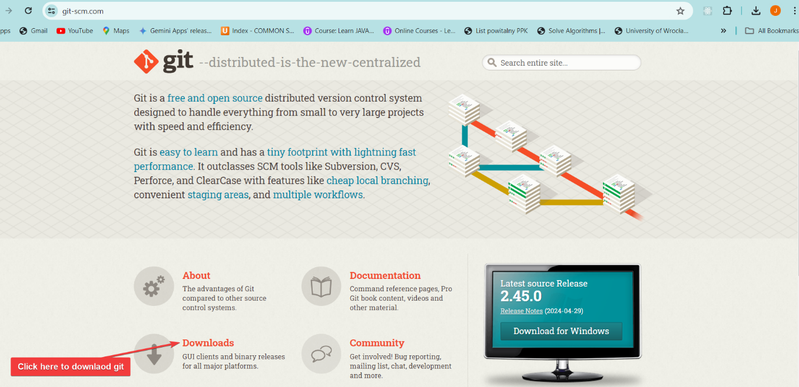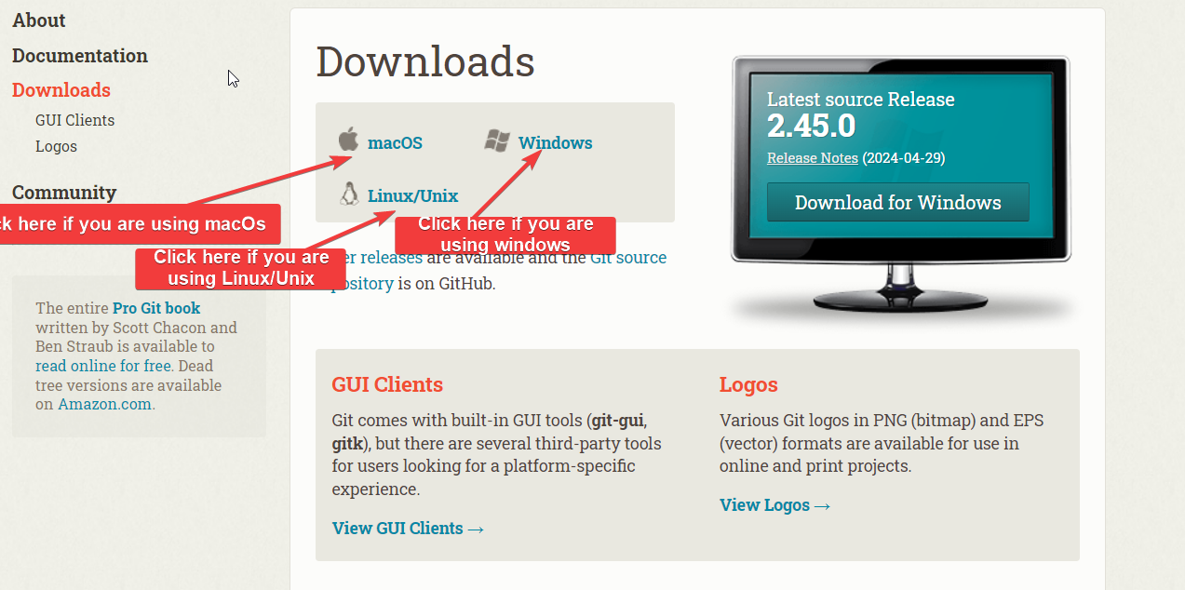
        - Open the terminal/command prompt on the computer.
        - Navigate to the project directory (legal-connect-system).
        - Initialize directory with Git using:
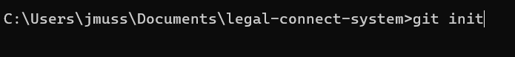
        - Add all project files to Git:
        - Commit the files to the local repository:
        - Return to the GitHub repository and copy the remoty repository URL provided.
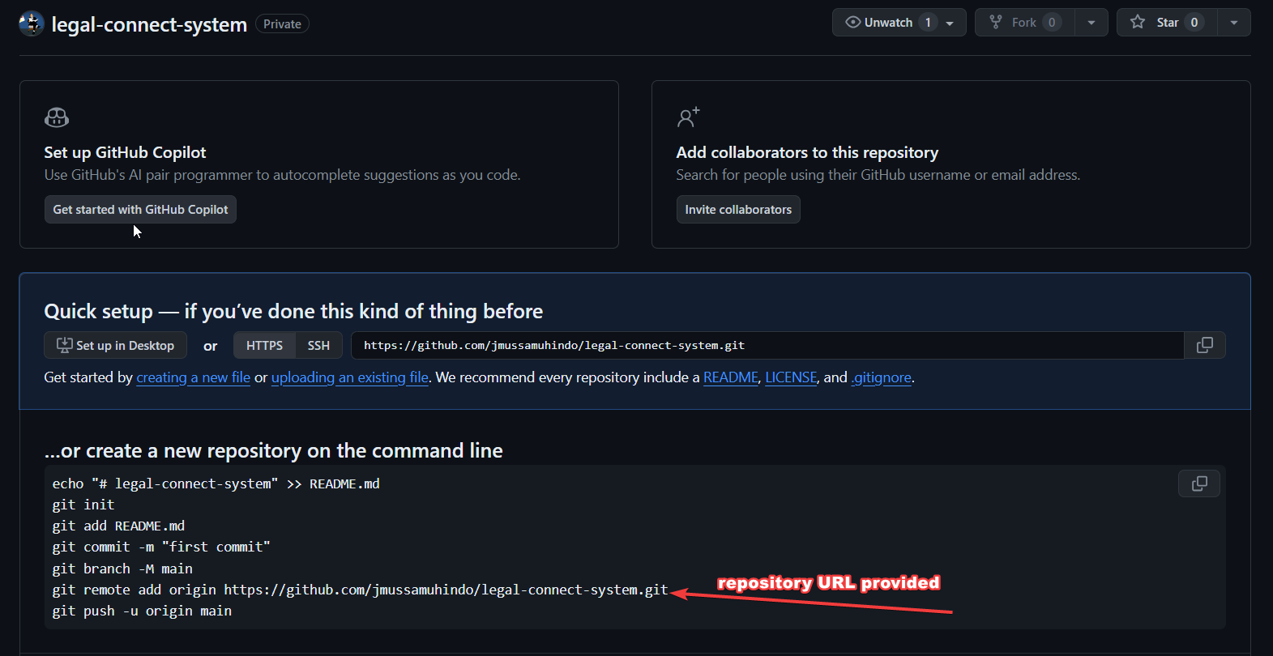
        - Link the local repository with the remote repository
        - Push the commits to GitHub

  - Deploy the project to DigitalOcean
      - Create a Droplet (this is virtual server):
- Choose an image (for Nod.js, select an Ubuntu server)
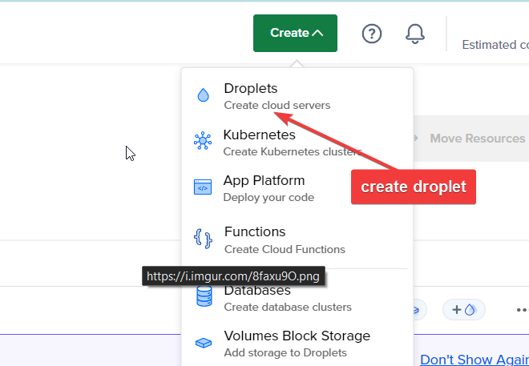
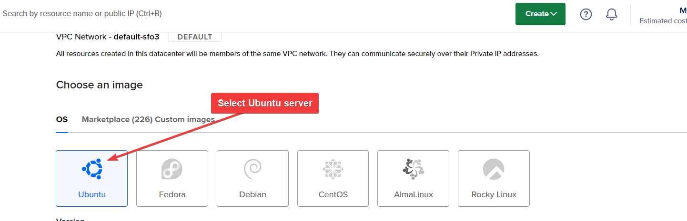

- Select a plan (the basic plan is usually sufficient for development and small projects).

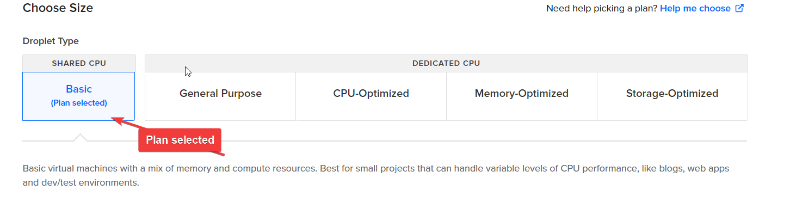

- Choose a datacenter region (select one closest to the user base)

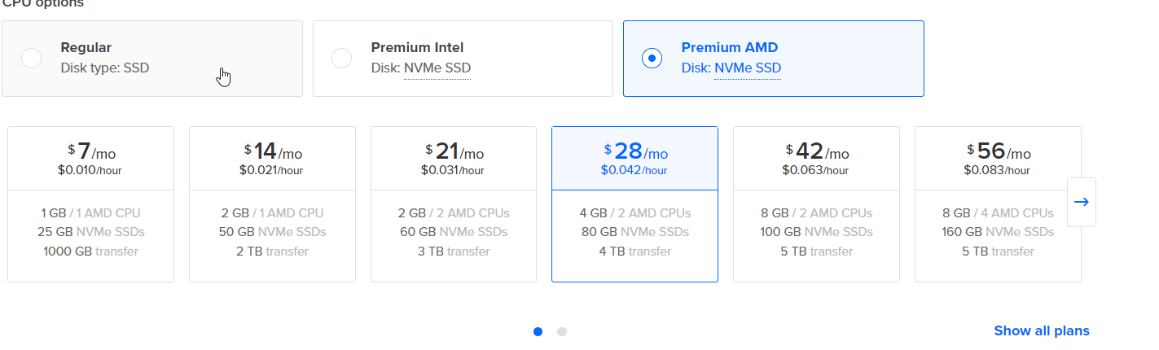

- Choose additional options like backups if desired.
- Add SSH keys for secure access (guides available online on how to set up SSH keys with DigitalOcean) here is the link https://docs.digitalocean.com/products/droplets/how-to/.
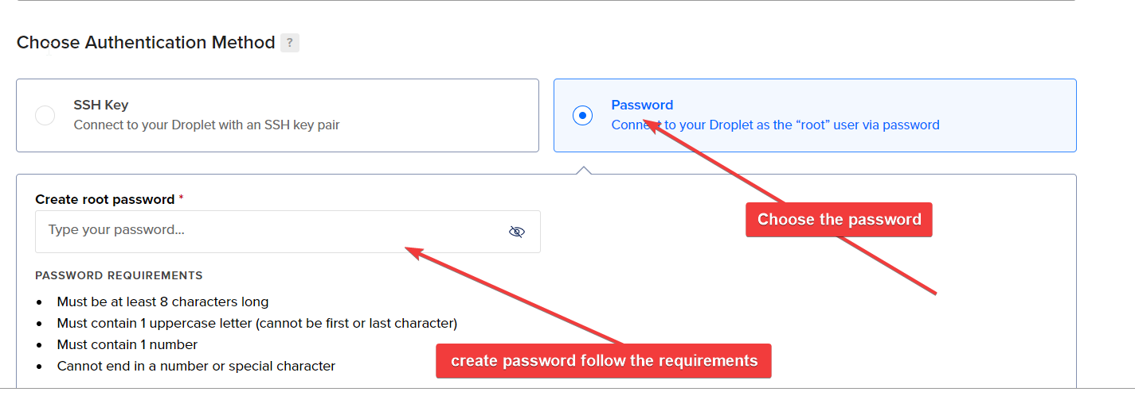

- Finalize and create the Droplet.

      - Deploy the Project to DigitalOcean
- SSH into the droplet
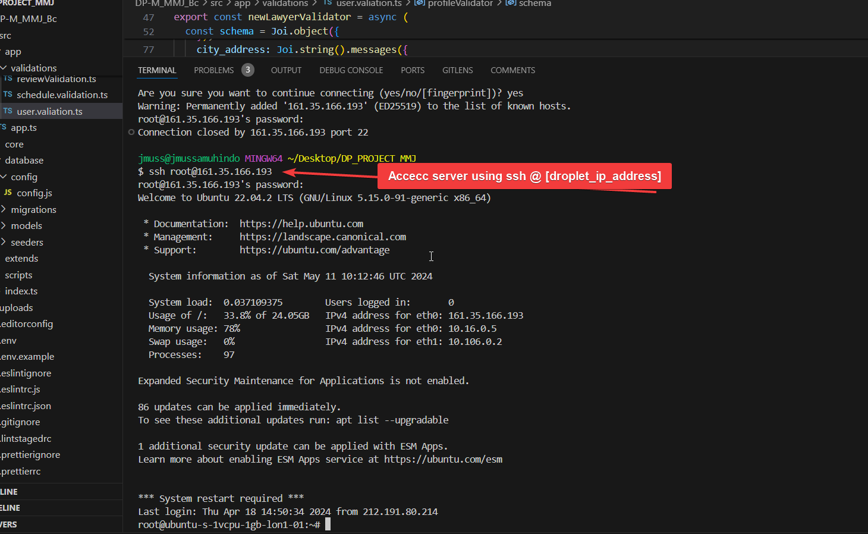

- Install Node.js, npm, and MySQL on the Droplet:
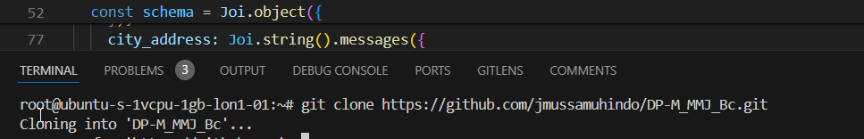

- Install Node.js, npm, and MySQL on the Droplet:

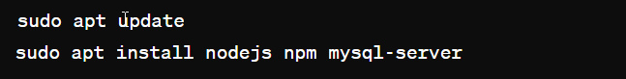

- Clone the project from GitHub.

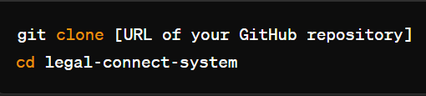

- Install project dependencies:

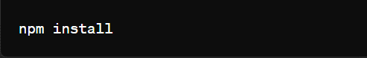

- Set up the MySQL database.

- Login into mySQL:



- Create a database:



- Run the Node.js application:



Running the application on Internet

Internet address
Internet address of the application: | https://legalc.net/

Application manual

Permissions
      - Administrator
Id: superadmin@me.com Password: test@123

      - Lawyers
- Id: jmussamuhindo@gmail.com Password: Kigali@2023
- Id: lawyer.one@gmail.com Password: Lodz@2024
- Id: lawyer.two@yahoo.fr Password: Poznan@2024
      - Clients
- Id: muhissakings@gmail.com Password: Kigali@2023
- Id: client.one@hotmail.com Password: Lodz@2024
- Id: client.two@gmail.com Password: Poznan@2024
- Id: client03@gmail.com Password: Opole@2024

User manual
- Initial step, with providing the URL https://legalc.net
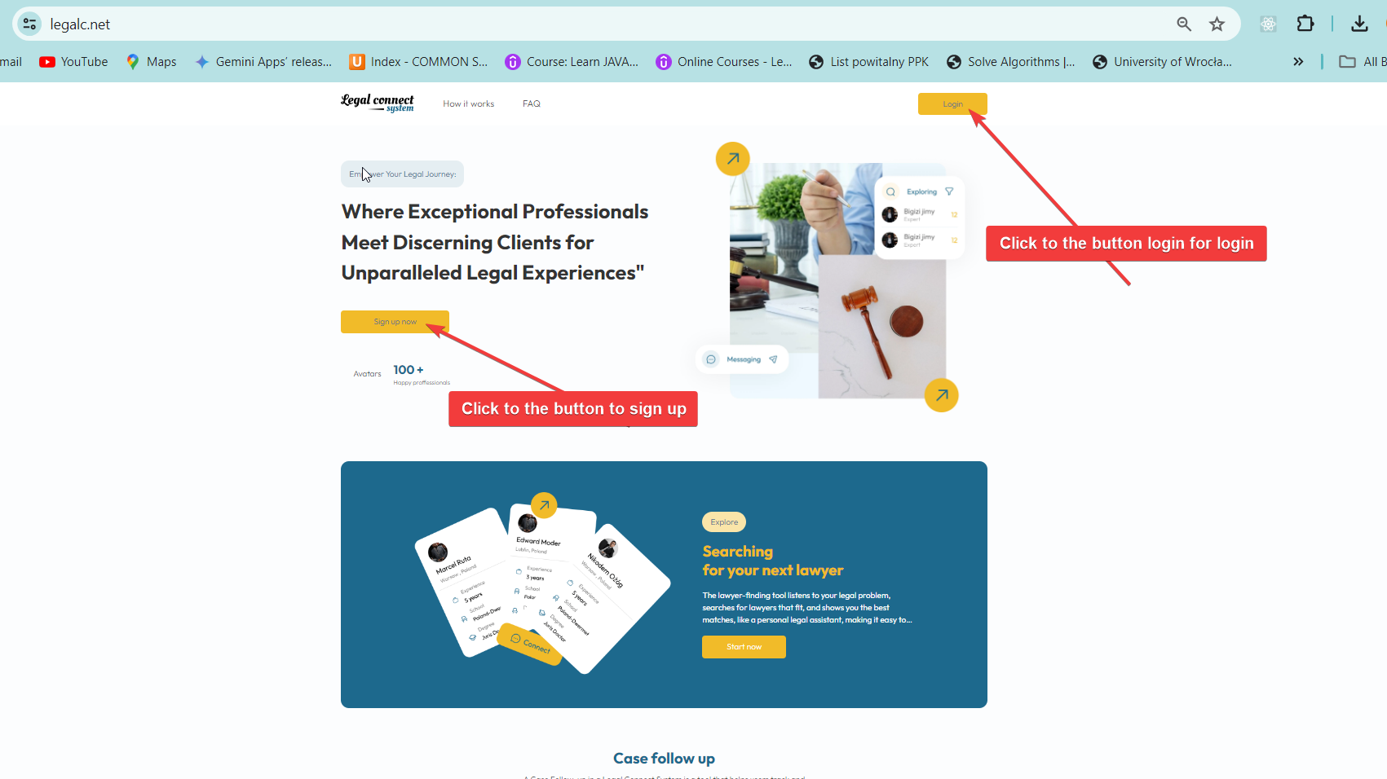
The above screenshot is from a user manual demonstrating the initial step required for accessing the Legal Connect System, an online platform that connects legal professionals with potential clients. Section 4.2 of the manual, labeled "Logging In," instructs users to navigate to the website https://legalc.net to begin their login process. The manual includes a visual guide showing the website's homepage, emphasizing the importance of this step in accessing the platform's services. This section is crucial for ensuring that users can securely access their accounts and utilize the platform's features effectively.

Sign up

The screenshot from the "Legal Connect System" website portrays a well-designed homepage that serves as a portal for legal professionals and clients to interact and engage in legal services.
- Call-to-Action Buttons: The yellow button labeled "Sign up now" encourages immediate user engagement by directing them to the registration process. The duplication of the signup button, with arrows pointing to one of them, highlights its importance and the site's intention to guide new visitors towards becoming active users.
This homepage exemplifies how digital platforms can facilitate the connection between service providers and users in niche professional fields such as law. The design elements not only aid in user navigation but also strategically position the platform as a specialist tool for legal connections, enhancing both usability and service perception through a focused user interface and experience.

Sign up Process for Lawyer

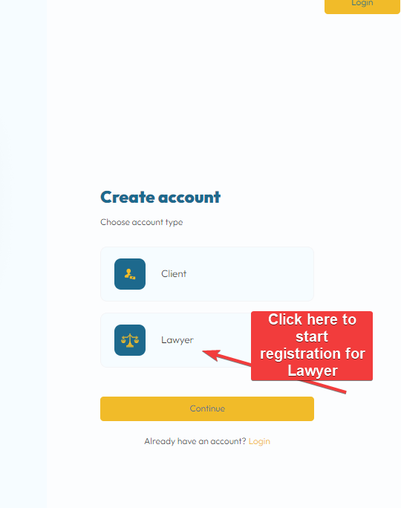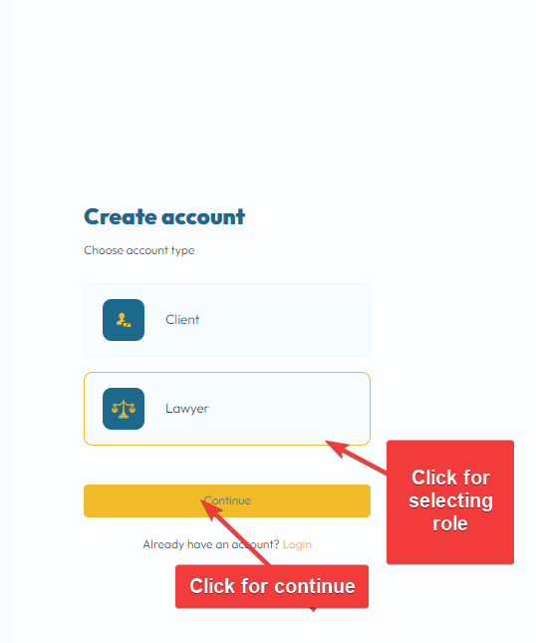

The screenshot illustrates the initial step of the account creation process on a legal platform, offering two distinct user roles: Client and Lawyer. Users can choose their intended role by clicking on the respective buttons, with the visual cue of the arrows pointing to the "Lawyer" button and continue, indicating the start of registration for legal professionals. This design ensures a tailored registration process that aligns with the specific needs and functionalities relevant to each user type, enhancing user experience and system efficiency.

Fill in the form for Identification.
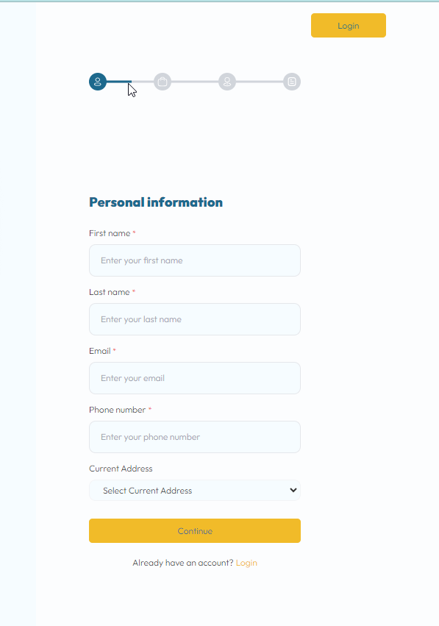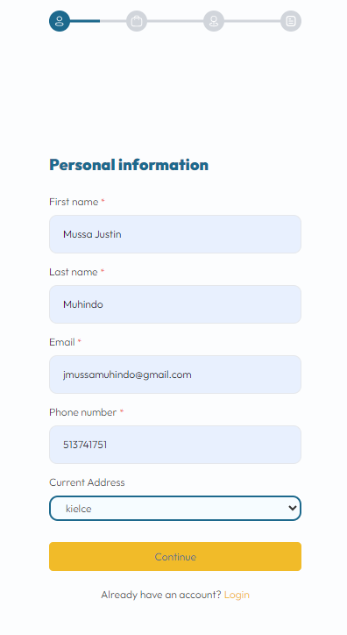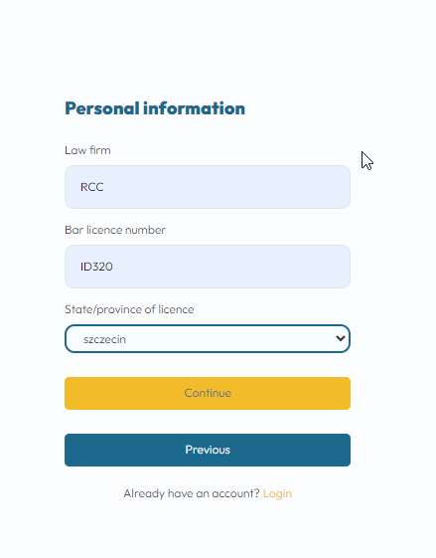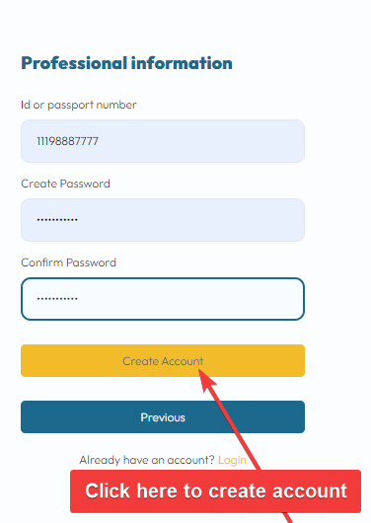
The images above illustrates the registration process for creating a new account on a legal platform, where users must provide personal and professional information. For legal professionals, this includes sensitive details like bar registration numbers. After submitting the necessary information and creating an account, lawyers will initially have limited access; they can log in but only to upload documents for verification, such as a passport picture and other documents required for lawyers. A notification is sent to the provided email address, informing them that full access to all platform features will be granted once an administrator has verified the submitted documents and activated the account. This layered access control ensures secure and authenticated use of the platform.

        - Use assigned username and password to log in.

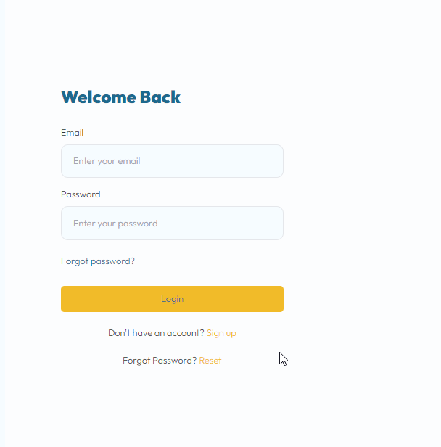
This login page above is a universal interface designed for multiple types of users, including clients, lawyers, and administrators, to access their respective accounts within a legal services platform. The screenshot shows a login interface for a digital platform clearly demonstrating the user authentication process. It features a simple form where users are prompted to enter their email address and password, both of which are essential for verifying their identity and granting access to their account.

          - Lawyer’s login

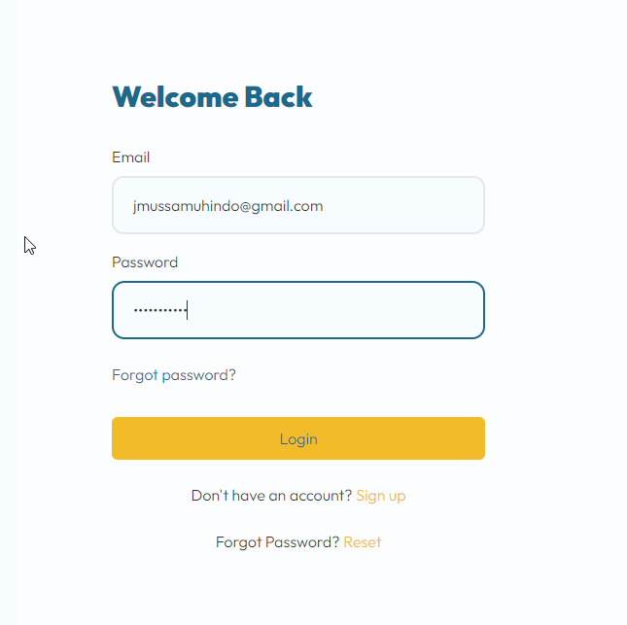

          - Lawyer’s Dashboard
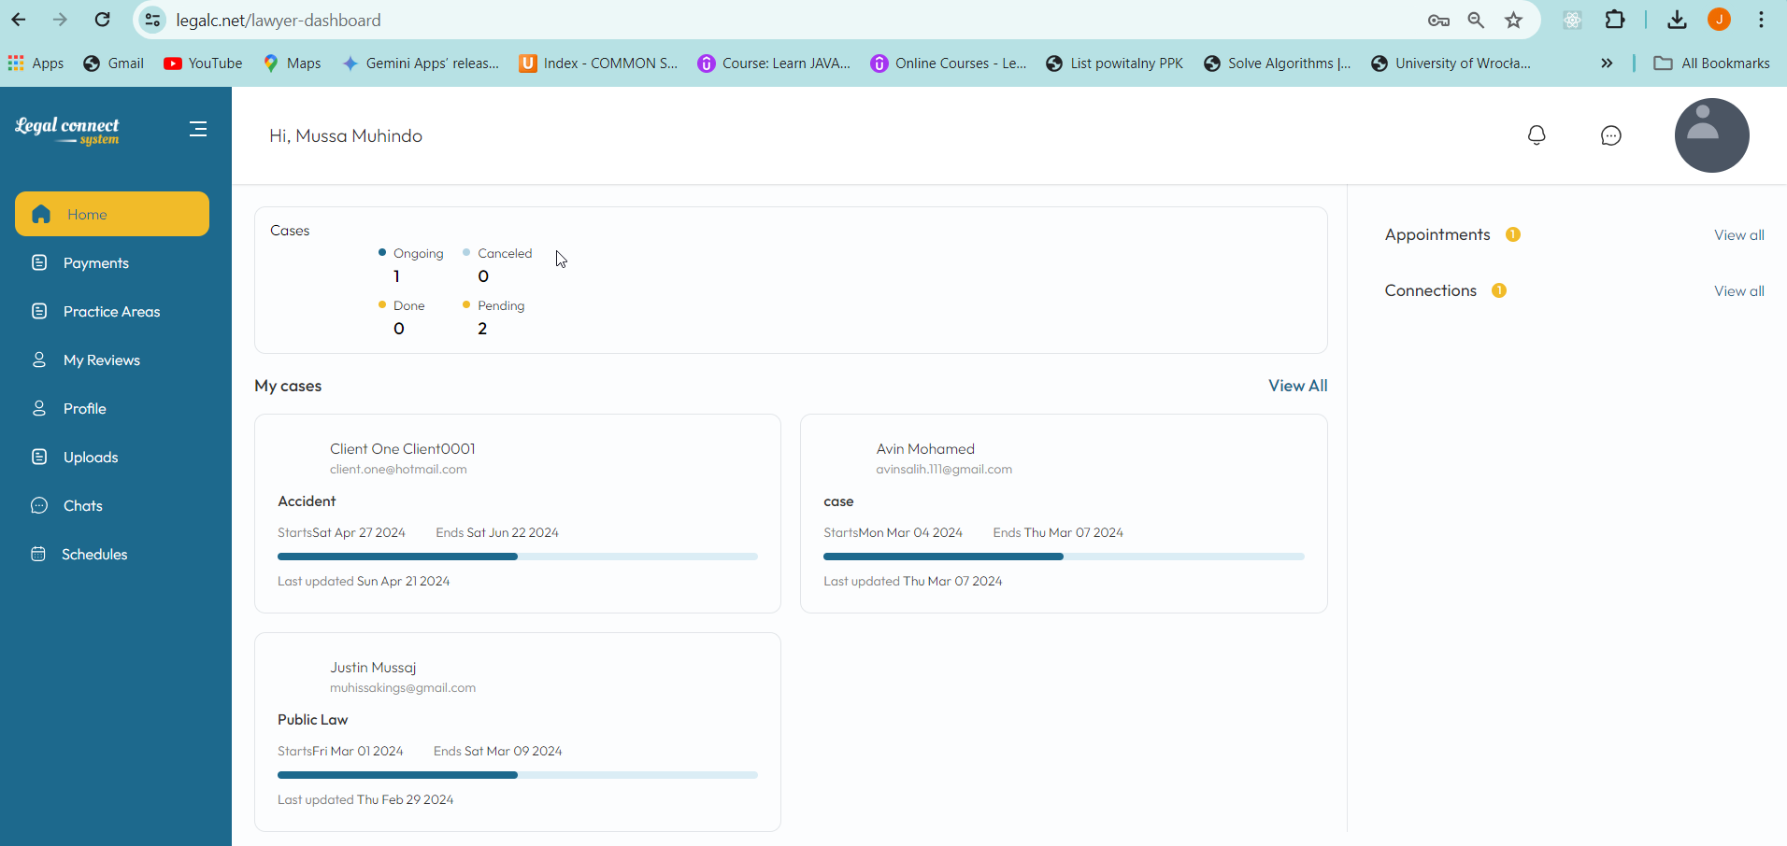

The screenshot shows a user dashboard from the Legal Connect System, specifically tailored for a lawyer named Musa Muhindo. This dashboard is a central hub for managing legal cases and client interactions. Key features include:

  - Navigation Menu: On the left, a vertical navigation menu provides quick access to various sections such as Home, Payments, Practice Areas, Reviews, Profile, Uploads, Chats, and Schedules.
  - Case Overview: The central panel displays a summary of cases with categories like Ongoing, Canceled, Done, and Pending, offering a quick snapshot of the lawyer's current workload.
  - Detailed Case List: Below the summary, detailed entries for individual cases show client names, case types, and status with timestamps, enabling the lawyer to track progress and update efficiently.
  - Sidebar Widgets: On the right, widgets display upcoming appointments and recent connections, streamlining the organization of the lawyer’s schedule and professional networking.
  - Personalized Greeting: The dashboard greets the user by name, enhancing the personalized user experience.

This dashboard is designed to optimize the user’s workflow by providing a comprehensive overview of professional activities and necessary tools for effective case management within the platform.
          - Lawyer Log Out
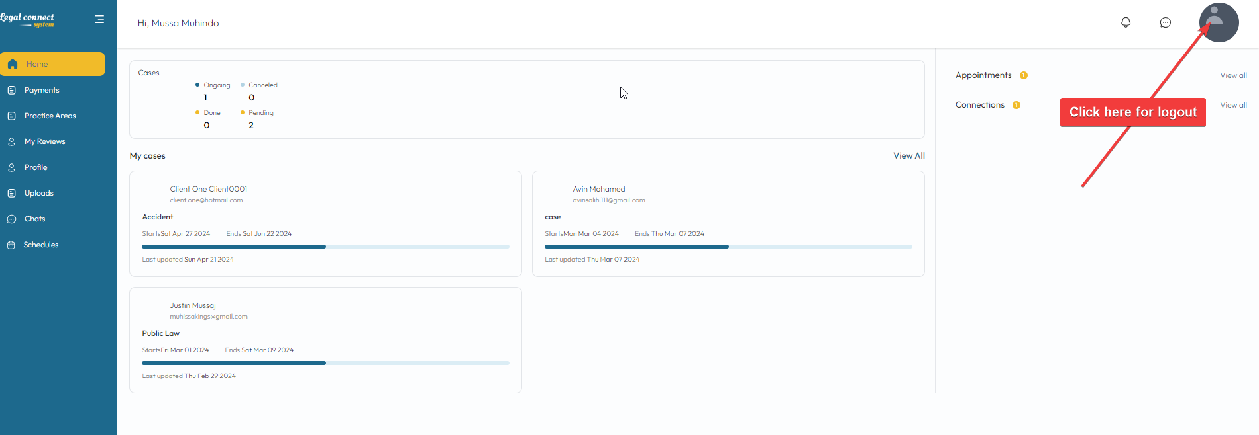

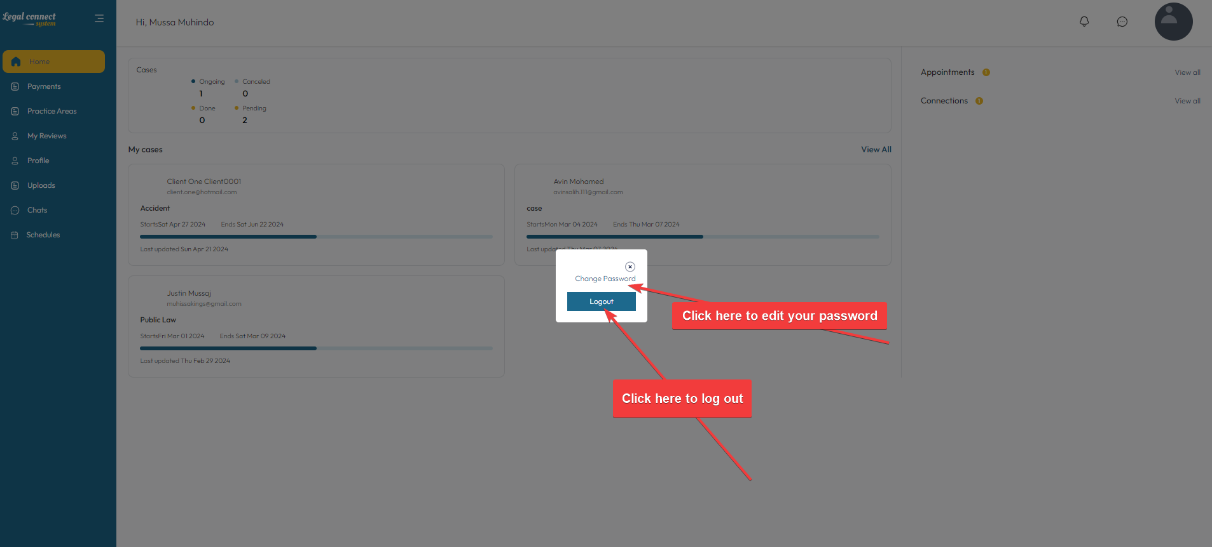
The screenshots above display user profile dashboard on the "Legal Connect System," where a logged-in user can manage their legal cases and view ongoing, pending, and completed interactions. The profile icon in the top right corner offers additional functionalities such as editing the password or logging out, indicated by a red arrow pointing to the logout option. After clicking the profile picture user will be able to see a dropdown menu from the profile icon for a logged-in user, this menu offers options to either "Change Password" or "Logout," enhancing user account security and accessibility. The interface design prioritizes user convenience and account management, allowing quick modifications to personal security settings or an easy logout process. This user interface facilitates easy access to personal account management and legal case oversight, streamlining the user experience on the platform.

Sign up Process for Client

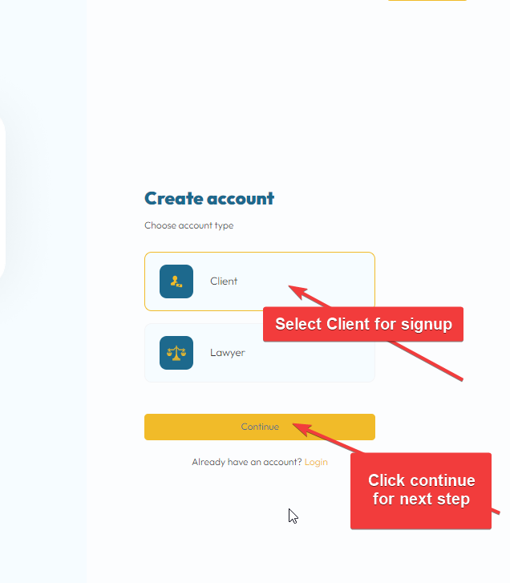
The screenshot shows the initial step of the account creation process on a legal platform, where users select between 'Client' and 'Lawyer' account types, with visual guides prompting the user to choose the 'Client' option and proceed by clicking 'Continue'.

Fill in the form for Identification.
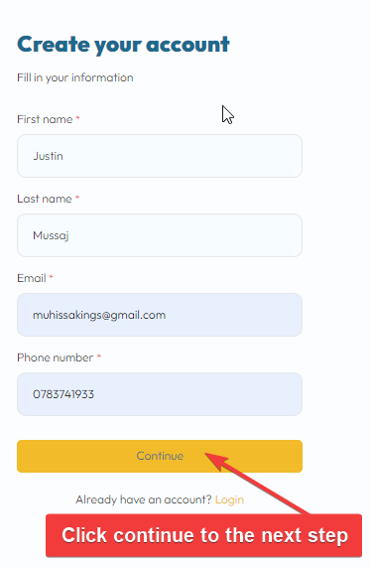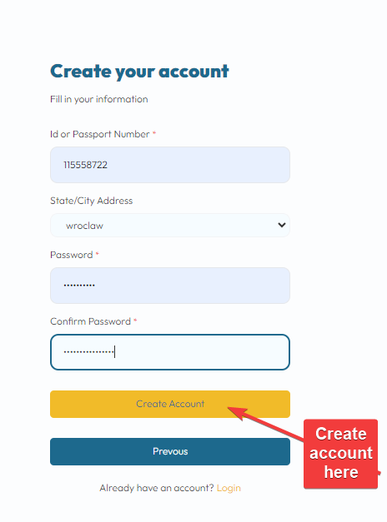
The screenshots above show two stages of an online account creation process for a legal platform, where users input essential information such as name, email, phone number, and ID or passport number. Users progress through the form by clicking either "Continue" or "Create Account," depending on the stage, with visual cues provided to guide them towards the next steps. These interfaces are designed to be user-friendly, ensuring that all necessary details are collected efficiently before the account is created.

        - Client’s Dashboard
The screenshot below shows the client interface of the "Legal Connect System" where clients can manage their legal cases. The page is personalized for a user named "Justin Mussaj," providing a welcoming and user-centric experience. Key features of this dashboard include:
    - Case Cards: Each case the client is involved with is displayed as an individual card. These cards include the status of the case (pending, active), a brief description, the date, and the lawyer handling the case. This allows easy tracking and management of each legal issue.
    - Navigation Menu: The top menu offers easy access to other sections of the site such as Home, Payments, Reviews, Appointments, and Cases, enabling users to navigate the platform seamlessly.
    - Action Buttons: Each case card features buttons like "Check Status" and "Visit Lawyer Profile," which facilitate immediate action and interaction, enhancing the client's engagement with their legal processes.
    - New Case Button: A prominent "New Case" button allows users to initiate new legal inquiries quickly, showing the platform's emphasis on user convenience and efficiency.

This interface is strategically designed to streamline the management of legal cases for clients, making it easier to track case progress, review lawyer profiles, and initiate new legal actions. Such a system improves client satisfaction and operational efficiency, key aspects to discuss in a thesis exploring legal tech innovations.

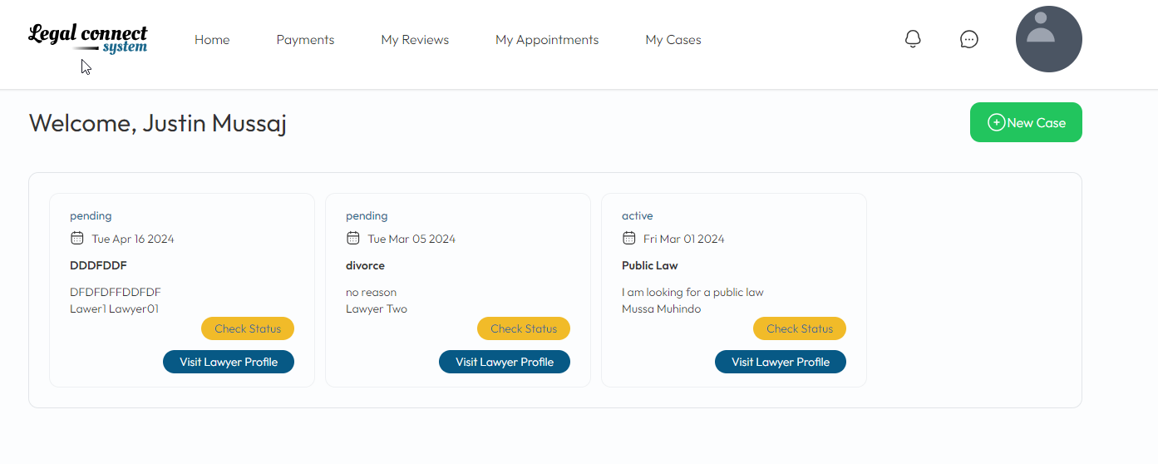
      - Logout and Edit profile.
A user menu provides quick access for editing personal profiles and logging out, enhancing the usability and accessibility of the platform. This streamlined interface is designed to facilitate easy navigation and effective management of legal services for clients.
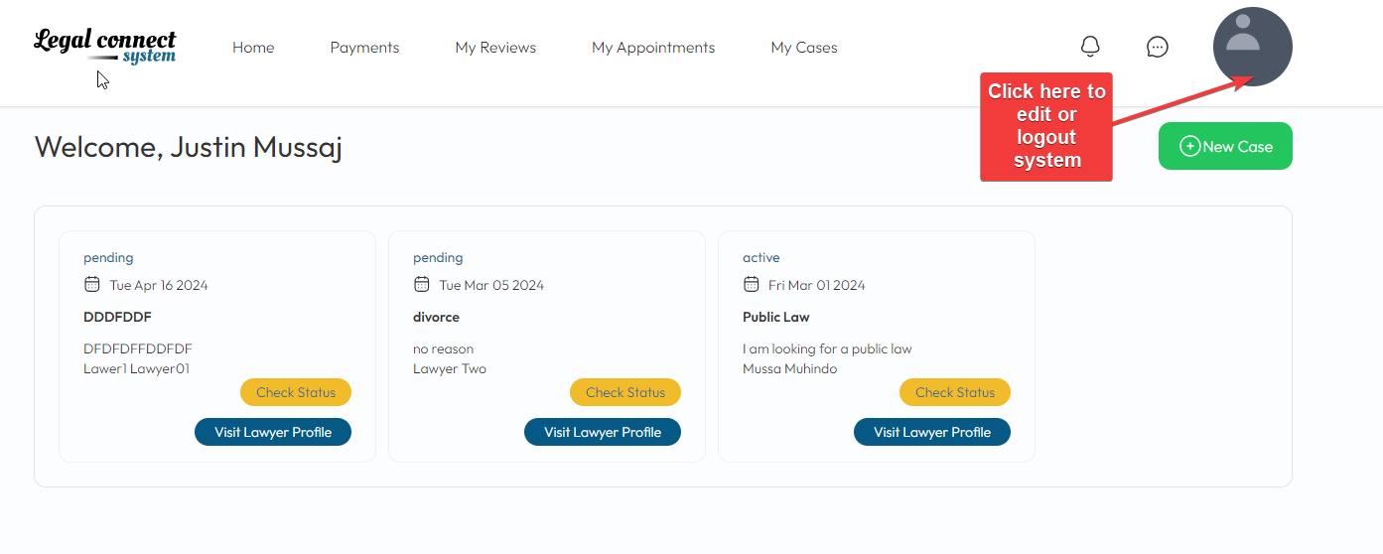

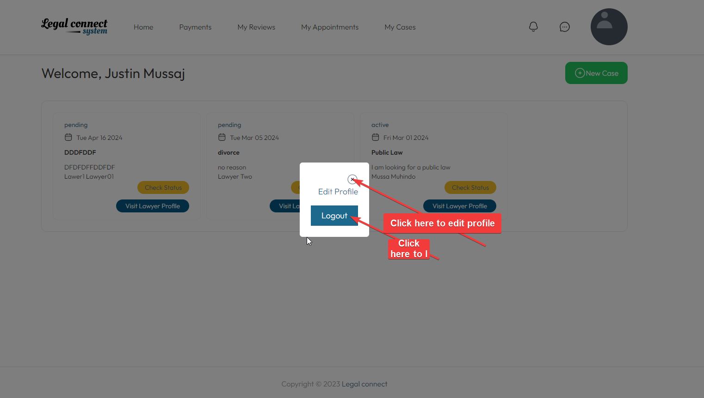

Administrator Dashboard
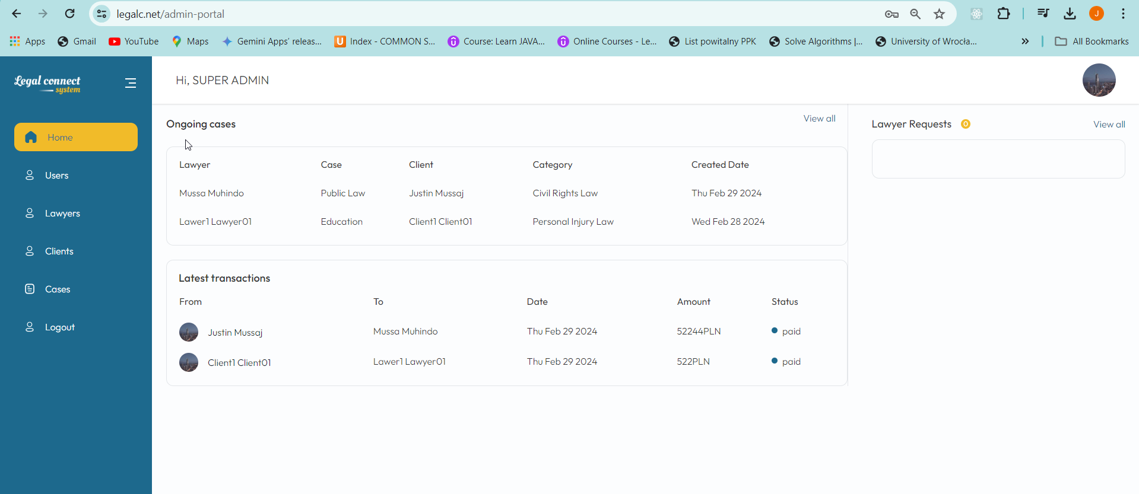
The screenshot displays the administrator dashboard of the "Legal Connect System," designed for a super admin user. This interface provides a comprehensive overview of ongoing legal cases and financial transactions within the platform. Here's a brief breakdown:

      - Ongoing Cases Section: Lists current cases managed by the system, detailing the lawyer assigned, the client involved, the category of law, and the creation date of each case.
      - Latest Transactions Section: Shows recent financial transactions between clients and lawyers, including details such as transaction participants, date, amount, and payment status.
      - Navigation Menu: A vertical menu on the left provides quick access to various administrative functions like managing users, lawyers, clients, and cases, as well as logging out of the system.
      - User-Friendly Interface: The design is clean and organized, aimed at ensuring ease of access to vital information, which aids in efficient management and oversight of platform operations.

This admin portal is crucial for monitoring and managing the platform's operations, ensuring that all activities, from case management to financial transactions, are conducted smoothly and transparently.

