Information for a user

Project Hello Visualization

Mussa Justin Muhindo

Table of Contents
1 Integrating Data Visualization in a React Application with MySQL Backend 3
1.1 Setting Up the MySQL Database 4
1.1.1 Create the Database 4
1.1.1.1 Use the Database 5
1.1.1.1.1 Create the “hello” Table 5
1.1.1.1.2 Create the “chart_data” Table 5
1.2 Setting Up the Backend Server 5
1.2.1 Create “server.js” 6
1.2.1.1 Install necessary packages. 8
1.2.1.2 Start the server. 8
1.3 Setting Up the React Frontend 8
1.4 Create the React Application 8
1.5 Install “recharts” 8
1.6 Update “src/App.js” 8
1.7 Start the React application. 11
2 Access your application at http://localhost:3000. 11

Integrating Data Visualization in a React Application with MySQL Backend

First, set up a MySQL database to store the data for the application.

- Procedure for Creating a MySQL Database
Creating a database in MySQL involves several steps, from installing the MySQL server to creating and managing databases. Below is a detailed explanation of the process.

  - Installation of MySQL Server
Before creating a database, you need to have MySQL installed on your machine.
Follow these steps:
- Download MySQL: Visit the official MySQL website “https://dev.mysql.com/downloads/mysql/” and download the MySQL installer for your operating system.
- Install MySQL: Run the installer and follow the on-screen instructions. During the installation process, you will set up a root password. Ensure you remember this password as it is crucial for accessing the MySQL server.

    - Accessing the MySQL Command Line
- Once MySQL is installed, you can access the MySQL command-line interface (CLI) to interact with the server:
- Open MySQL CLI: Open a terminal (on Linux or macOS) or Command Prompt (on Windows).
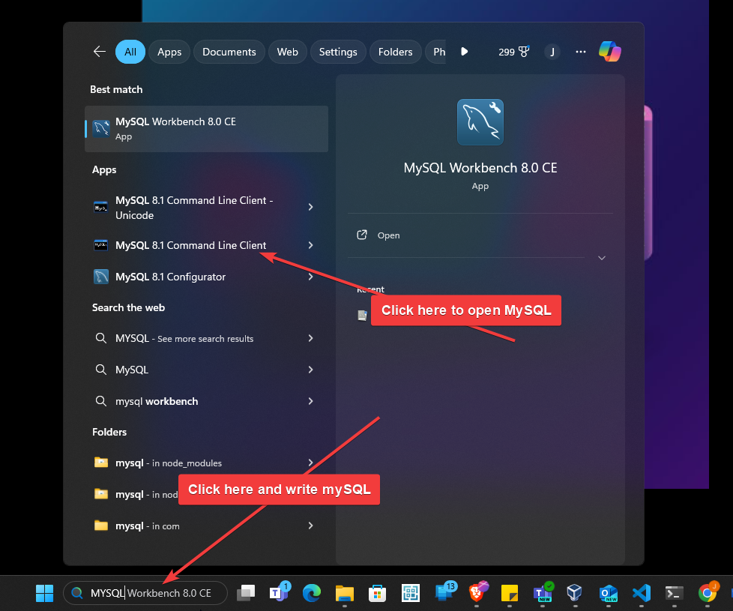
- Login to MySQL: Type the following command and press Enter: 
- You will be prompted to enter the root password that you set during installation.
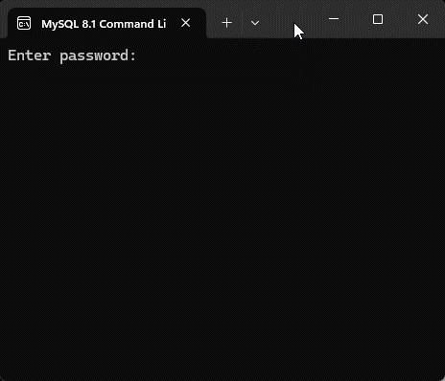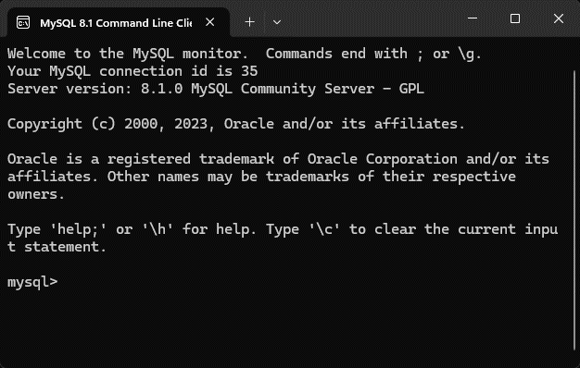

Setting Up the MySQL Database
First, we need to set up a MySQL database to store the data for our application.

Create the Database


Use the Database
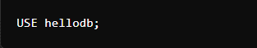

Create the “hello” Table
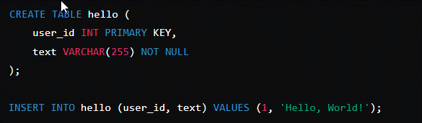

Create the “chart_data” Table
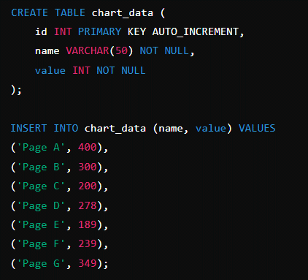

Setting Up the Backend Server
Next, we will create an Express server to interact with the MySQL database. The server will fetch data for visualization and handle updates.

Create “server.js”
// Import the Express library for handling HTTP requests
const express = require('express');
// Import the MySQL library for interacting with MySQL databases
const mysql = require('mysql');
// Import the body-parser middleware to parse incoming request bodies in a middleware
const bodyParser = require('body-parser');
// Import the CORS (Cross-Origin Resource Sharing) library to allow or restrict requested resources on a web server
const cors = require('cors');

// Create an instance of Express to set up the server
const app = express();
// Use the CORS middleware to allow all cross-origin requests
app.use(cors());
// Use the body-parser middleware to parse JSON-formatted request bodies
app.use(bodyParser.json());

// Create a connection to the MySQL database using the provided credentials
const db = mysql.createConnection({
host: 'localhost', // Database host address
user: 'root', // Database username
password: 'Kigali@2023',// Database password
database: 'hellodb' // Database name
});

// Connect to the MySQL database
db.connect(err => {
if (err) {
// Log and return an error message if the database connection fails
console.error('Error connecting: ' + err.stack);
return;
}
// Log a success message including the thread ID of the connection
console.log('Connected to database as ID ' + db.threadId);
});

// Define a route to handle GET requests to the '/hello' endpoint
app.get('/hello', (req, res) => {
// Perform a SQL query to select text from the 'hello' table where the user_id is 1
db.query('SELECT text FROM hello WHERE user_id=1', (err, results) => {
// Log the results of the query
console.log(results);
if (err) {
// Log and send a 500 error response if a database error occurs
console.error('Database error:', err);
res.status(500).json({ error: 'Internal Server Error' });
return;
}
if (results.length > 0) {
// Send the retrieved text as a JSON response if results exist
res.json({ text: results[0].text });
} else {
// Send a 404 error response if no results are found
res.status(404).json({ error: 'No text found' });
}
});
});

// Define a route to handle GET requests to the '/chart-data' endpoint
app.get('/chart-data', (req, res) => {
// Perform a SQL query to select name and value from the 'chart_data' table
db.query('SELECT name, value FROM chart_data', (err, results) => {
if (err) {
// Log and send a 500 error response if a database error occurs
console.error('Database error:', err);
res.status(500).json({ error: 'Internal Server Error' });
return;
}
// Send the results as a JSON response
res.json(results);
});
});

// Define a route to handle POST requests to the '/update' endpoint
app.post('/update', (req, res) => {
// Extract text from the request body
const { text } = req.body;
// Perform a SQL query to update the text in the 'hello' table where the user_id is 1
db.query('UPDATE hello SET text = ? WHERE user_id = 1', [text], (err, results) => {
if (err) {
// Log and send a 500 error response if a database error occurs
console.error('Database error:', err);
res.status(500).json({ error: 'Internal Server Error' });
return;
}
// Send a success message as a JSON response
res.json({ message: 'Text updated successfully' });
});
});

// Define the port number as provided by the environment or default to 3001
const PORT = process.env.PORT || 3001;
// Start the server on the defined port
app.listen(PORT, () => {
// Log that the server is running and on which port
console.log(`Server running on port ${PORT}`);
});

Install necessary packages.
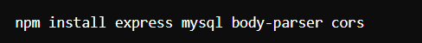

Start the server.
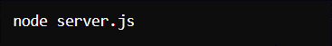

Setting Up the React Frontend
Now, we will create a React application that fetches data from the backend and displays it using “recharts”.

Create the React Application
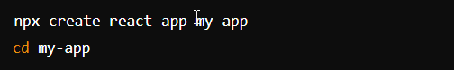

Install “recharts”
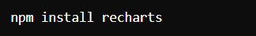

Update “src/App.js”
// Importing necessary React hooks and components from React and recharts library
import React, { useEffect, useState } from 'react';
import { LineChart, Line, BarChart, Bar, PieChart, Pie, Cell, CartesianGrid, XAxis, YAxis, Tooltip, Legend } from 'recharts';
// Importing CSS for styling the application
import './App.css';

// Main function component for the application
function App() {
// State variables for storing chart data, current text, and new text input by the user
const [chartData, setChartData] = useState([]);
const [text, setText] = useState('');
const [newText, setNewText] = useState('');

// useEffect hook to fetch data from APIs on component mount
useEffect(() => {
// Fetching a text greeting from the server
fetch('http://localhost:3001/hello')
.then(response => {
// Checking for successful response
if (!response.ok) {
throw new Error('Network response was not ok');
}
return response.json();
})
.then(data => setText(data.text))
.catch(err => console.error('Error fetching data:', err));

// Fetching chart data from the server
fetch('http://localhost:3001/chart-data')
.then(response => response.json())
.then(data => setChartData(data))
.catch(err => console.error('Error fetching data:', err));
}, []); // Empty dependency array to run only once on mount

// Function to handle form submission for updating text
const handleUpdate = (e) => {
e.preventDefault();
fetch('http://localhost:3001/update', {
method: 'POST',
headers: {
'Content-Type': 'application/json'
},
body: JSON.stringify({ text: newText })
})
.then(response => {
// Checking for successful response
if (!response.ok) {
throw new Error('Network response was not ok');
}
return response.json();
})
.then(data => {
console.log(data.message);
setText(newText); // Updating displayed text with new text
setNewText(''); // Clearing the input field
})
.catch(err => console.error('Error updating text:', err));
};

// Array of colors for chart elements
const COLORS = ['#0088FE', '#00C49F', '#FFBB28', '#FF8042', '#8884D8', '#82ca9d', '#a4de6c'];

// Rendering the application UI
return (
<div className="App">
<header className="App-header">
<h1>Data Visualization</h1>
<p>{text}</p>
<form onSubmit={handleUpdate}>
<input
type="text"
value={newText}
onChange={(e) => setNewText(e.target.value)}
placeholder="Update text"
/>
<button type="submit">Update</button>
</form>
<div style={{ display: 'flex', justifyContent: 'space-around', width: '100%' }}>
{chartData.length > 0 ? (
<>
<LineChart width={400} height={300} data={chartData}>
<Line type="monotone" dataKey="value" stroke="#8884d8" />
<CartesianGrid stroke="#ccc" />
<XAxis dataKey="name" />
<YAxis />
<Tooltip />
<Legend />
</LineChart>
<BarChart width={400} height={300} data={chartData}>
<Bar dataKey="value" fill="#8884d8" />
<CartesianGrid stroke="#ccc" />
<XAxis dataKey="name" />
<YAxis />
<Tooltip />
<Legend />
</BarChart>
<PieChart width={400} height={300}>
<Pie
data={chartData}
dataKey="value"
nameKey="name"
cx="60%"
cy="60%"
outerRadius={100}
fill="#8884d8"
label
>
{chartData.map((entry, index) => (
<Cell key={`cell-${index}`} fill={COLORS[index % COLORS.length]} />
))}
</Pie>
<Tooltip />
<Legend />
</PieChart>
</>
) : (
<p>Loading data...</p>
)}
</div>
</header>
</div>
);
}

// Exporting the App component for use in other parts of the application
export default App;

Start the React application.
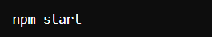

Access your application at http://localhost:3000.

Explanation of the React Component
- State Management:
- “chartData”: Stores the data for the charts.
- “text”: Stores the text fetched from the database.
- “newText”: Stores the new text input by the user for updating the database.
- Data Fetching:
- “useEffect”: Fetches the initial data for the text and chart data when the component mounts.
- “fetch('http://localhost:3001/hello')”: Fetches the text from the backend.
- “fetch('http://localhost:3001/chart-data')”: Fetches the chart data from the backend.

- Data Updating:
- “handleUpdate”: Handles the form submission to update the text in the database.

- Rendering Charts:
- “LineChart”, “BarChart”, “PieChart”: Components from recharts used to render the respective charts.
- “COLORS”: An array of colors used to style the Pie Chart.

Conclusion

The above documentation demonstrated how to integrate data visualization in a React application with a MySQL backend. We set up the database, created an Express server to fetch and update data, and built a React frontend to display the data using various charts. This process provides a comprehensive approach to building interactive data-driven web applications.

