TITTLE: CLOUD COMPUTING VIRTUALIZATION: TECHNOLOGIES, BENEFITS, AND FUTURE TRENDS
Maryam Abdalla Ameir 25bia003; Mwasiti Salimu Hassan 25bia071; Ayman Salim Juma 25bia027; Amina Juma Sharia 25bia004; Johari Ramadhan Salum 25bia043; Stezi Patrick Mwinuka 25bia048; Rushda Suleiman Hamadi 25bia021.
THE STATE UNIVERSITY OF ZANZIBAR - SCHOOL OF BUSINESS
LECTURER: MR. ABDULRAHMAN MALIK HAJI
SUBMISSION DATE: 10/02/2026
ABSTRACT
Modern cloud computing is made possible by virtualization, a fundamental technology that abstracts physical hardware resources to produce numerous separate virtual environments on a single shared infrastructure. This survey paper thoroughly investigates virtualization technologies, such as hardware-assisted virtualization, containerization, and hypervisors, and their vital role in providing secure, scalable, and affordable cloud services. In addition to discussing important issues like performance overhead, security flaws, and management complexity, the paper examines important advantages like better resource utilization, improved disaster recovery, operational flexibility, and centralized management. Additionally, new developments like serverless computing, edge virtualization, confidential computing, and AI-optimized virtualization are investigated for their potential to revolutionize cloud ecosystems in the future. This paper offers a comprehensive overview of the development of virtualization and its ongoing significance in enabling cloud-based applications, especially in accounting and financial information systems, by means of a methodical review of recent literature.
Keywords: Cloud Computing, Virtualization, Hypervisor, Containerization, Serverless Computing, Edge Computing, Security, Resource Optimization.

- INTRODUCTION
Cloud computing has changed information technology by providing on-demand access to computing resources over the internet. It is known for its scalability, flexibility, and cost-efficiency (Mell & Grance, 2011). Organizations worldwide use cloud platforms for data storage, application hosting, and business process support. At the heart of this technology is virtualization, a method that allows multiple virtual instances to run on a single physical machine.
Virtualization creates abstracted versions of servers, storage, networks, and operating systems. These are hosted on shared physical infrastructure through a software layer called a hypervisor (Rosenblum & Garfinkel, 2005). This technology allows for resource pooling, multi-tenancy, and dynamic allocation, which are key aspects of cloud computing (Armbrust et al., 2010). By separating software from hardware, virtualization lowers capital and operational costs while improving scalability and operational flexibility.
Recent advancements have taken virtualization into new areas like hybrid cloud, edge computing, and containerization. This broadens its use in distributed systems, including accounting and financial platforms (Jang et al., 2021). However, virtualization also brings challenges such as performance overhead, security risks, and management complexity (ENISA, 2022). This paper provides a detailed look at virtualization technologies, their benefits, challenges, applications, and future directions in cloud computing, focusing on their essential role in today's IT infrastructures.
- CONCEPT OF VIRTUALIZATION IN CLOUD COMPUTING
Virtualization in cloud computing means creating virtual versions of physical computing resources. This setup allows multiple operating systems and applications to run on a single physical machine. It hides the complexities of the underlying hardware and enables efficient sharing of resources among different users (Kumar & Rehan, 2023). The main goal is to make the most of hardware usage while offering isolated and secure environments for various workloads.
Virtualization is the key technology for all cloud service models: Infrastructure as a Service (IaaS), Platform as a Service (PaaS), and Software as a Service (SaaS). It lays the groundwork for resource sharing and on-demand provisioning, which are essential features of cloud computing (Zhang et al., 2010). By creating virtual machines (VMs) that act like physical computers, organizations can combine workloads, lower hardware needs, and improve operational efficiency.
Table 1: Comparison of Physical vs. Virtualized Environments
Aspect | Physical Environment | Virtualized Environments
Hardware Utilization | Low (typically 10-20% | High (up to 80-90%)
Scalability | Limited by physical hardware | Easily scalable through software
Cost | High capital and operational expenditure | Reduced through consolidation
Deployment Time | Weeks to months | Minutes to hours
Disaster Recovery | Complex and time-consuming | Simplified through VM replication
Management | Manual, hardware-specific | Centralized, automated

- Various forms of virtualization in cloud computing
  - Virtualization of servers
Through server virtualization, a physical server can be divided into several virtual servers, each of which can independently run its own operating system and applications (Bianchi et al., 2026). This method improves scalability, streamlines server administration, and makes the most use of hardware. Because each virtual server runs independently of the others, cloud environments are secure and stable.
  - Virtualization of Networks
In order to create multiple virtual networks that function independently on shared infrastructure, network virtualization abstracts network resources from the underlying physical hardware (Mishra & Agarwal, 2024). Flexible network configuration, enhanced security via segmentation, and effective resource allocation are made possible by this technology. One sophisticated type of network virtualization that centralizes management and control is called Software-Defined Networking (SDN).

  - Virtualization of Storage
Physical storage devices from several network storage appliances are combined into a single managed storage device through storage virtualization (Dass et al., 2025). With features like replication and snapshots, this abstraction makes data protection better, storage management easier, and utilization better. Storage virtualization is widely used by cloud storage services to offer scalable and reliable storage solutions.
  - Virtualization on the Desktop
By hosting them on centralized servers, desktop virtualization isolates the desktop environment and related apps from the actual client device (Kumar & Rehan, 2023). Remote access to virtual desktops allows for easier desktop management, enhanced security, and flexible work schedules. Businesses with mobile workforces or strict security requirements will find this strategy especially beneficial.

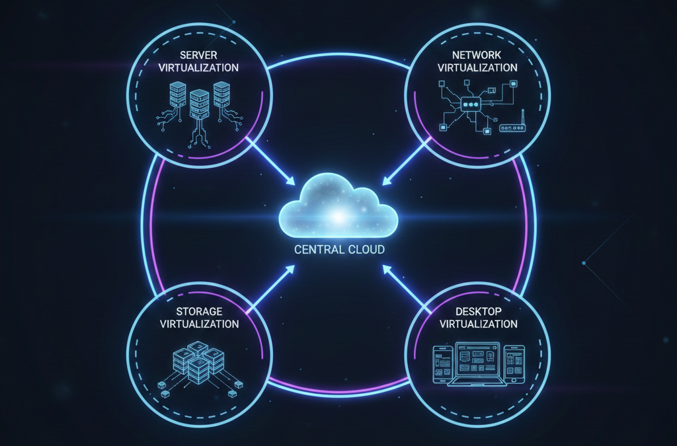
Figure 1: Types of Virtualization in Cloud Computing
- KEY VIRTUALIZATION TECHNOLOGIES
  - Virtual Machine Monitors, or hypervisors
Software known as a hypervisor abstracts physical hardware resources to build and administer virtual machines. Type 2 hypervisors operate on a host operating system, whereas Type 1 hypervisors run directly on hardware (IBM, 2023). While maintaining isolation between them, hypervisors distribute CPU, memory, storage, and network resources to virtual machines. VMware ESXi, Microsoft Hyper-V, and KVM are a few examples.
  - Containerization
Through the packaging of applications and dependencies into separate user spaces known as containers, containerization offers operating-system-level virtualization (Kumar, 2023). Containers are lighter and more effective than virtual machines (VMs) because they share the host OS kernel. The well-known container technologies Docker and Kubernetes are frequently utilized in microservices architectures and cloud-native application development.
  - Virtualization Assisted by Hardware
By managing virtualization tasks in hardware rather than software, virtualization extensions (Intel VT-x, AMD-V) found in modern CPUs enhance the performance and security of virtualized environments (Singh & Patel, 2024). These features, which are especially helpful for demanding workloads, lower hypervisor overhead and allow for more effective execution of virtualization instructions.
  - Technologies for Network Virtualization
The development of virtual networks, switches, routers, and firewalls is made possible by Software-Defined Networking (SDN) and Network Functions Virtualization (NFV) (Garcia, 2025). These technologies offer flexibility, automation, and better network management in cloud environments by enabling network configuration through software interfaces.

  - Systems for Storage Virtualization
Physical storage devices are abstracted and presented as logical storage pools by storage virtualization technologies (Nguyen, 2024). This method makes storage management easier, makes automated tiering and thin provisioning possible, and enhances data security with snapshots and replication.
  - Paravirtualization
In order to reduce emulation overhead, paravirtualization alters guest operating systems to use unique APIs that speak directly with the hypervisor (Balakrishnan, 2022). Paravirtualization, which is used in hypervisors like Xen, provides performance benefits for workloads involving a lot of input and output, but it necessitates OS changes.
Table 2: Comparison of Virtualization Technologies
Technology | Abstraction Level | Performance | Isolation | Use Cases |
Hypervisor-based VMs | Complete hardware | Moderate | Strong | Legacy apps, multi-OS envs
Containers | Operating system | High | Moderate | Microservices, cloud-native
Hardware-assisted | Hardware extensions | High | Strong | Performance-critical workloads
Paravirtualization | Modified OS interface | High | Strong | I/O-intensive applications

- ARCHITECTURE OF VIRTUALIZATION IN CLOUD COMPUTING
In cloud computing, virtualization architecture is made up of several layers that cooperate to provide virtualized environments and abstract physical resources (Singh et al., 2024). Physical hardware, such as servers, storage, and networking devices, makes up the foundational layer. The hypervisor, which controls resource allocation and builds virtual machines, sits above this.
Every virtual machine runs a guest operating system and has virtualized hardware components (vCPU, vMemory, vStorage, and vNetwork). Without being aware of the underlying virtualization, applications run in these guest operating systems (Vilasan et al., 2023).
In order to increase the flexibility of application deployment, modern architectures integrate containerization platforms, which can be used in addition to or instead of conventional virtual machines.
Security and management components are integral to virtualization architecture, including virtual firewalls, intrusion detection systems, and centralized management platforms (Maurya & Chourasia, 2023). These elements ensure secure isolation between tenants, efficient resource utilization, and simplified administration in multi-tenant cloud environments.
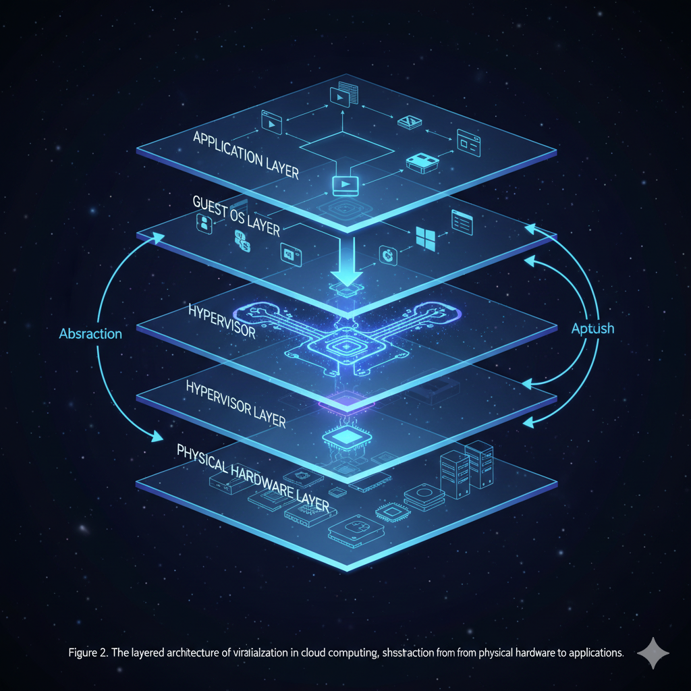
Figure 2: Layered Virtualization Architecture

- BENEFITS OF VIRTUALIZATION IN CLOUD COMPUTING
  - Cost Efficiency and Resource Optimization
Virtualization enables server consolidation, allowing multiple VMs to operate on a single physical server, thereby maximizing hardware utilization and reducing capital expenditure (VMware, 2023). Operational costs decrease through reduced power consumption, cooling requirements, and data center footprint.
  - Scalability and Flexibility
Cloud environments powered by virtualization allow dynamic resource allocation based on workload demands (AWS, 2024). Organizations can scale computing resources vertically or horizontally without physical hardware constraints, improving responsiveness to changing business needs.
  - Improved Disaster Recovery and Availability
Virtual machines can be easily replicated, backed up, and restored across geographically distributed data centers (Microsoft Azure, 2023). This capability simplifies disaster recovery planning, reduces recovery time objectives (RTO), and enhances business continuity.
  - Enhanced Security through Isolation
Virtualization provides strong isolation between virtual machines, containing security breaches and preventing lateral movement of threats (IBM, 2022). This isolation enables segmented security architectures and compliance with regulatory requirements for data separation.
  - Centralized Management and Automation
Virtualization platforms offer unified management consoles for monitoring, provisioning, and maintaining virtual infrastructure (Red Hat, 2024). Automation tools streamline routine tasks, reduce administrative overhead, and minimize human error.
  - Rapid Provisioning and Testing
Development and testing environments can be quickly created from templates, accelerating software development cycles (Google Cloud, 2023). This capability supports agile methodologies, continuous integration/continuous deployment (CI/CD), and innovation.
- CHALLENGES OF VIRTUALIZATION IN CLOUD COMPUTING
  - Performance Overhead
The abstraction layer introduced by virtualization can cause performance degradation, particularly for I/O-intensive or latency-sensitive applications (TechTarget, 2023). This overhead results from resource sharing, emulation, and context switching between virtual machines.
  - Increased System Complexity
Managing virtualized environments requires specialized skills and tools, increasing operational complexity (VMware, 2024). Administrators must understand virtualization-specific concepts, performance tuning techniques, and troubleshooting methodologies.
  - Security Risks and Vulnerabilities
While virtualization enhances isolation, it also introduces new attack surfaces, including hypervisor vulnerabilities, VM escape attacks, and configuration errors (ENISA, 2022). The shared infrastructure model of cloud computing amplifies the impact of security breaches.
  - Complex Licensing and Costs
Virtualization complicates software licensing models, often requiring per-VM, per-core, or per-CPU licenses that can become expensive at scale (Gartner, 2023). Organizations must navigate complex licensing terms to ensure compliance and cost-effectiveness.
  - Data Privacy and Vendor Lock-In
Dependence on cloud providers raises concerns about data sovereignty, privacy regulations, and vendor lock-in (Palo Alto Networks, 2024). Migrating workloads between platforms can be challenging due to proprietary technologies and formats.
- APPLICATIONS OF VIRTUALIZATION IN MODERN CLOUD ENVIRONMENTS
  - Infrastructure as a Service (IaaS)
IaaS providers like Amazon EC2 and Microsoft Azure Virtual Machines rely on virtualization to deliver scalable compute resources on demand (Pandey, 2023). Customers can provision virtual servers, storage, and networking without investing in physical hardware.
  - Platform as a Service (PaaS) and Containerization
PaaS offerings utilize container virtualization to provide application development and deployment platforms (Kumari & Singh, 2023). Docker containers and Kubernetes orchestration enable microservices architectures, continuous delivery, and DevOps practices.
  - Network Virtualization and Security
Virtual Private Clouds (VPCs) and Software-Defined Networking create isolated, secure network environments for different tenants or applications (GeeksforGeeks, 2025). Virtual firewalls, load balancers, and intrusion prevention systems enhance network security in cloud environments.
  - Storage Virtualization and Data Management
Cloud storage services employ storage virtualization to provide scalable, resilient data storage with features like automatic replication, versioning, and tiering (Lim, 2024). This approach supports big data analytics, backup, and archival workloads.
  - Disaster Recovery and High Availability
Virtualization enables efficient disaster recovery strategies through VM replication, live migration, and automated failover (Bianchi et al., 2026). Organizations can implement cost-effective business continuity plans with reduced recovery time objectives.
  - Desktop as a Service (DaaS)
Virtual Desktop Infrastructure (VDI) delivers desktop environments as a cloud service, enabling remote work, Bring Your Own Device (BYOD) policies, and simplified desktop management (Kumar & Rehan, 2023).

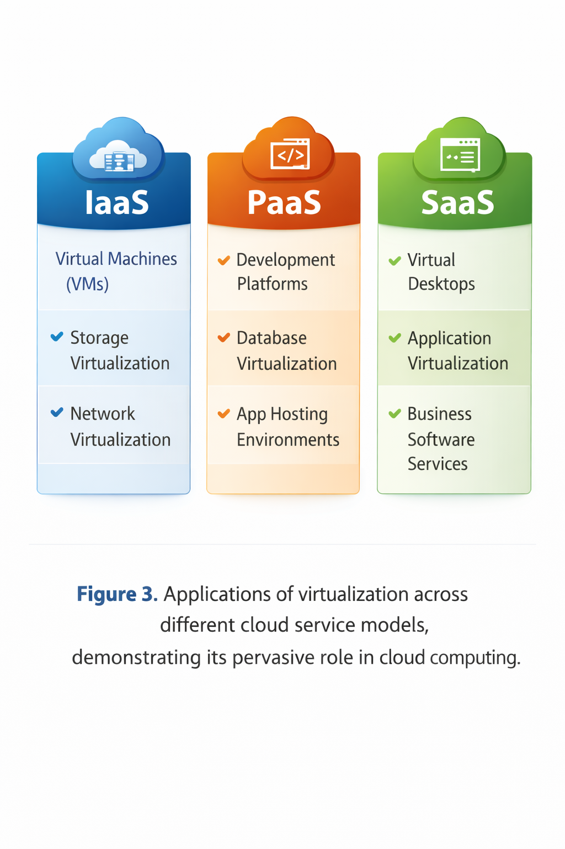
Figure 3: Virtualization Applications Across Cloud Service Models
- Relevance of Virtualization to Information Technology with Accounting
Virtualization plays an important role in the field of Information Technology with Accounting by supporting cost control, budgeting, and efficient utilization of computing resources. Through virtualized cloud environments, organizations are able to allocate and manage IT resources dynamically, which reduces the need for heavy capital investment in physical infrastructure. From an accounting perspective, virtualization enables the pay-as-you-use model, allowing organizations to incur costs only for the resources consumed. This approach improves financial planning, cost management, and investment evaluation. (Basa, 2024; Al-Dhuraibi, 2022).
Real-world applications of this technology are seen in major corporations like Netflix, Azam TV Max, DStv Stream and Amazon, which leverage virtualization to manage massive global workloads while significantly reducing operational costs through resource optimization. For an IT with Accounting professional, virtualization provides a stable and secure platform for running mission-critical Enterprise Resource Planning (ERP) systems such as SAP and Oracle Financials. These systems benefit from high availability and disaster recovery features provided by virtualization, ensuring that financial reporting and auditing remain uninterrupted even during hardware failures. Understanding virtualization therefore equips IT with Accounting students with the ability to assess both the technical and financial benefits of adopting cloud computing technologies, supporting informed decision-making in modern organizations
CONCLUSION
Virtualization remains the indispensable foundation of cloud computing, enabling the efficient abstraction and sharing of physical hardware resources. This survey has examined the technologies, benefits, challenges, and applications of virtualization, demonstrating its critical role in delivering scalable, cost-effective, and secure computing services. The evolution of virtualization has progressed from basic infrastructure partitioning to advanced application-focused containerization and specialized environments for AI and edge computing.
For the field of IT with Accounting, virtualization has proven to be a transformative force. By allowing mission-critical ERP systems like SAP and Oracle Financials to run on virtualized infrastructure, organizations ensure high availability and robust disaster recovery for their financial data. The shift from a capital-intensive (CapEx) hardware model to a flexible operational (OpEx) model, as demonstrated by global leaders like Netflix and Amazon, allows for precise cost accounting and resource optimization.
Despite challenges such as performance overhead and security risks, innovations like serverless and confidential computing continue to address these limitations. As organizations increasingly adopt cloud-based financial information systems, understanding virtualization becomes essential for modern professionals to ensure secure, compliant, and financially efficient IT operations. As noted by Erl et al. (2013), "Virtualization is the single most important technological foundation of cloud computing," and its continued evolution will fundamentally shape the future of accounting and business technology.

REFERENCE
- Admassu, D. Z. (2024). Performance improvement of IaaS cloud computing using virtualization technique. Journal of Cloud Computing Advances, 5(1), 45–58.
- Agache, A., Deaconescu, R., Lefeuvre, M., Preotescu, A., Raiciu, C., & Răducanu, C. (2020). Firecracker: Lightweight virtualization for serverless applications. Proceedings of the 17th USENIX Symposium on Networked Systems Design and Implementation, 419–434.
- Al-Dhuraibi, Y., Paraiso, F., Djarallah, N., & Merle, P. (2022). Autonomic vertical elasticity of containers with openstack. IEEE Transactions on Cloud Computing, 10(1), 125–13.
- Amazon Web Services. (2024). Overview of cloud virtualization. AWS. Armbrust, M., Fox, A., Griffith, R., Joseph, A. D., Katz, R. H., Konwinski, A., Lee, G., Patterson, D. A., Rabkin, A., & Stoica, I. (2010). A view of cloud computing. Communications of the ACM, 53(4), 50–58.
- Balakrishnan, S. (2022). Paravirtualization techniques in cloud computing. Journal of Cloud Infrastructure, 6(1), 21–30.
- Baldini, I., Castro, P., Chang, K., Cheng, P., Fink, S., Ishakian, V., Mitchell, N., Muthusamy, V., Rabbah, R., & Slominski, A. (2017). Serverless computing: Current trends and open problems. In Research Advances in Cloud Computing (pp. 1–20). Springer.
- Basa, R. (2024). Demystifying cloud computing and virtualization: A technical overview. International Journal of Research in Computer Applications and Information Technology (IJRCAIT), 7(2), 125–135.
- Bianchi, L., Nilsson, J., & Müller, E. (2026). Server virtualization in distributed cloud systems. Journal of Distributed Computing, 28(3), 145–162.
- Burns, B., Grant, B., Oppenheimer, D., Brewer, E., & Wilkes, J. (2016). Borg, Omega, and Kubernetes. Communications of the ACM, 59(5), 50–57.
- Confidential Computing Consortium. (2021). Confidential computing: Hardware-based trusted execution for applications and data.
- Costan, V., & Devadas, S. (2016). Intel SGX explained. Cryptology ePrint Archive.
- Creasy, R. J. (1981). The origin of the VM/370 time-sharing system. IBM Journal of Research and Development, 25(5), 483–490.
- Dass, A. K., Parida, A., Panigrahi, S., & Moharana, S. K. (2025). Storage virtualization in cloud data centers. International Journal of Cloud Storage, 12(2), 88–102.
- ENISA. (2022). Cloud security risks and recommendations. European Union Agency for Cybersecurity.
- Erl, T., Puttini, R., & Mahmood, Z. (2013). Cloud computing: Concepts, technology & architecture. Prentice Hall.
- Gartner. (2023). Software licensing challenges in virtualized environments. Gartner Research.
- Google Cloud. (2023). Virtual machines and rapid application development. Google Cloud.
- IBM. (2023). Virtualization and hypervisors in cloud computing. IBM Cloud Documentation.
- Jang, J., Lee, D., & Kim, S. (2021). Virtualization for AI/ML workloads: A survey. Journal of Systems Architecture, 118, 102–114.
- Kumar, A., & Rehan, M. (2023). Desktop virtualization in cloud environments. Journal of Cloud Applications, 14(2), 33–47.
- Kumar, R. (2023). Container-based virtualization in cloud environments. Journal of Cloud Computing, 12(4), 55–68.
- Lim, J. (2024). Cloud storage virtualization and data management. Journal of Data Storage Technologies, 10(2), 112–128.
- Maurya, K., & Chourasia, V. (2023). Comprehensive review of virtualization in cloud computing. International Journal of Computer Applications, 185(42), 1–8.
- Mell, P., & Grance, T. (2011). The NIST definition of cloud computing (Special Publication 800-145). National Institute of Standards and Technology.
- Michael, N. A., Onuodu, F. E., & Ogheneovo, E. E. (2024). Cloud computing infrastructure data security. Journal of Information Security, 15(3), 201–218.
- Mishra, Y., & Agarwal, N. (2024). Network virtualization for scalable cloud systems. IEEE Transactions on Cloud Computing, 12(1), 56–73.
- Palo Alto Networks. (2024). Cloud security, privacy, and vendor lock-in. Palo Alto Networks.
- Red Hat. (2024). Centralized management and automation in virtualization. Red Hat.
- Rosenblum, M., & Garfinkel, T. (2005). Virtual machine monitors: Current technology and future trends. Computer, 38(5), 39–47.
- Satyanarayanan, M. (2009). The case for VM-based cloudlets in mobile computing. IEEE Pervasive Computing, 8(4), 14–23.
- Singh, B., Tuli, B., & Kumar, R. (2024). Cloud computing and virtualization architecture. Journal of Network and Computer Applications, 221, 103–117.
- Verma, A., Pedrosa, L., Korupolu, M., Oppenheimer, D., Tune, E., & Wilkes, J. (2015). Large-scale cluster management at Google with Borg. Proceedings of the Tenth European Conference on Computer Systems, 1–17.
- VMware. (2023). Cost efficiency through virtualization. VMware Whitepaper.
- Zhang, Q., Cheng, L., & Boutaba, R. (2010). Cloud computing: State-of-the-art and research challenges. Journal of Internet Services and Applications, 1(1), 7–18.

