SMART CAMPUS CANTEEN APP
Complete Semester Project Documentation
Step-by-Step Development Guide with Mockups, Schemas & Code
Tech Stack  Frontend: Expo + React Native  Backend: Node.js + Express  Database: MongoDB Atlas  Auth: JWT + bcryptjs | Project Scope  Duration: 6 Weeks  Screens: 14 Screens  API Routes: 18 Endpoints  Collections: 6 MongoDB

1. Project Overview
The Smart Campus Canteen App is a full-stack mobile application that digitizes the university food ordering experience. Students can browse the menu, place orders, and pay using a wallet system — while canteen admins manage inventory and track orders in real time.

Problem Statement: Students waste time queuing at the canteen without knowing what food is available or how long the wait will be. This app solves both problems with a digital ordering and queue management system.

1.1 Why This Project Is Strong for Viva
- Demonstrates MongoDB multi-document ACID transactions (advanced DB topic)
- Full CRUD operations across 6 collections
- JWT-based stateless auth — relevant to security topics
- Mobile + backend + database in one project
- Real-world problem with clean, verifiable features

1.2 Tech Stack
Layer | Technology | Purpose
Frontend | Expo + React Native | Cross-platform mobile app (iOS + Android) | npm install
Navigation | Expo Router | File-based routing inside the app/ folder | npm install
HTTP Client | Axios | Makes API requests from Expo to Node.js backend | npm install
State Mgmt | React Context API | Auth state, cart state across screens | npm install
Backend | Node.js + Express | REST API server handling all business logic | npm install
Database | MongoDB Atlas | Cloud-hosted NoSQL database (free tier) | npm install
ODM | Mongoose | Schema modeling and query interface for MongoDB | npm install
Auth | JWT + bcryptjs | Stateless authentication with hashed passwords | npm install
Hosting | Render / Railway | Free backend hosting for deployed API | npm install
Version Control | GitHub | Source code + README + screenshots | npm install

2. App Screens & Wireframe Mockups
Below are wireframe mockups of all 14 screens. Each mockup shows the layout, key UI elements, and navigation flow. Build these screens one by one in Expo — do not try to style them perfectly at first.

Design Tip: Use React Native Paper or NativeBase for ready-made components. Keep UI minimal in Week 2-3 and polish it in Week 6.

2.1 Welcome Screen
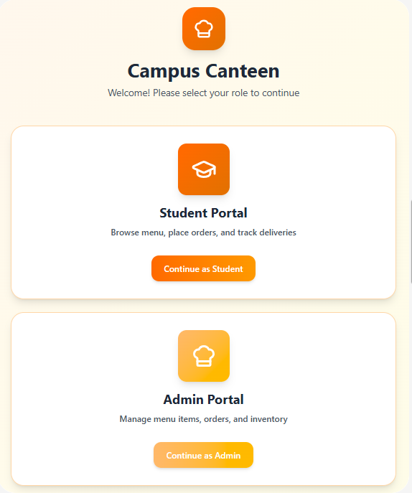

2.2 Student Screens
1. Login Screen

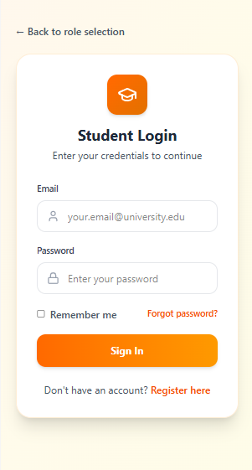
- Home / Menu List Screen
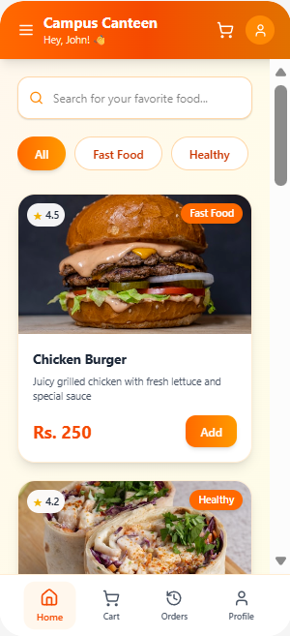
3. Cart Screen
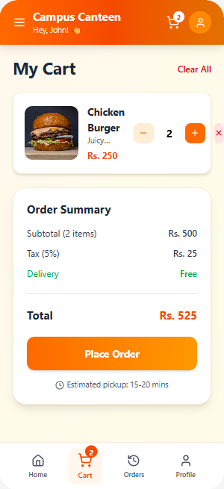
4. My Orders Screen
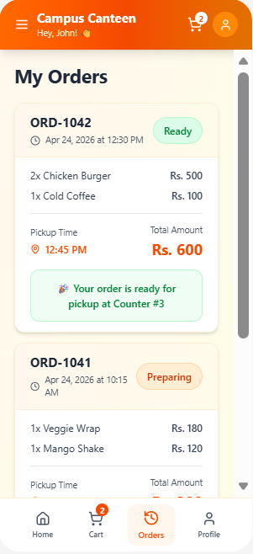
- Profile Screen
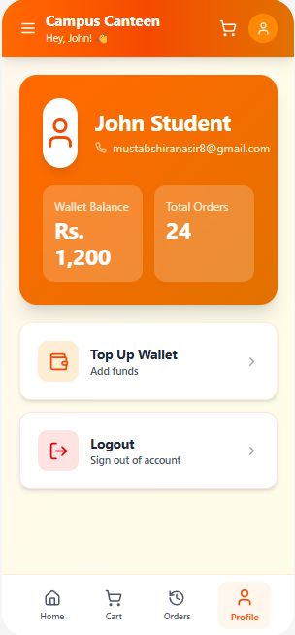

2.3 Admin Screens
1. Admin Login Screen
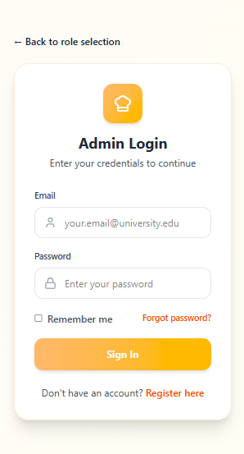
- Admin Dashboard
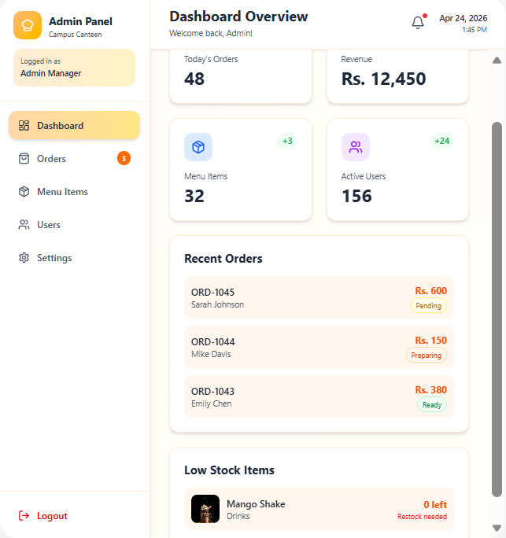
5. Manage Orders Screen
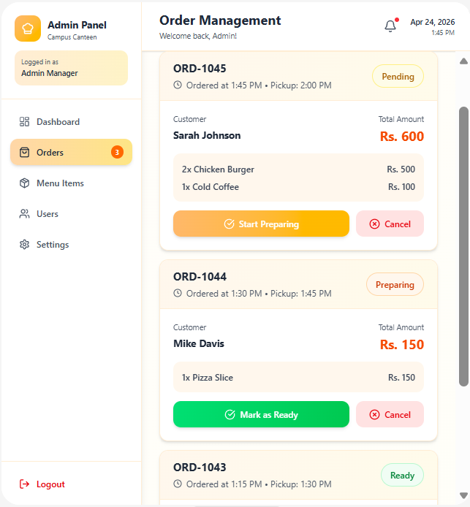
- Manage Menu Screen
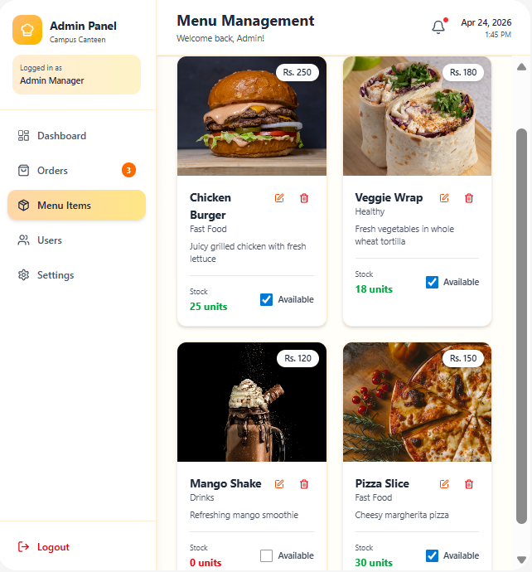

2.2 Complete Screen List
Student Side (9 screens)  - 1. Splash / Welcome Screen  - 2. Login Screen  - 3. Register Screen  - 4. Home / Menu List Screen  - 5. Food Detail Screen  - 6. Cart Screen  - 7. Checkout Screen  - 8. My Orders Screen  - 9. Profile / Wallet Screen | Admin Side (5 screens)  - 1. Admin Login Screen  - 2. Admin Dashboard  - 3. Manage Menu Screen  - 4. Add / Edit Food Screen  - 5. Manage Orders Screen

3. Database Design — MongoDB Collections
Your database has 6 collections. Design them first before writing any backend code. The schemas below use Mongoose notation. Copy these directly into your model files.

Why MongoDB? MongoDB supports multi-document ACID transactions via sessions. This is critical for the checkout flow where an order, payment, stock update, and cart deletion must all succeed or all fail together.

3.1 users collection
Field | Type | Description
_id | ObjectId | Auto-generated unique ID (primary key)
name | String | Full name of student or admin
email | String | Unique email address — used for login
passwordHash | String | bcrypt hashed password — NEVER store plain text
role | String | 'student' or 'admin' — controls access to routes
walletBalance | Number | Wallet balance in Rs. Default: 0
createdAt | Date | Auto set by timestamps: true in Mongoose

3.2 menuItems collection
Field | Type | Description
_id | ObjectId | Auto-generated unique ID
name | String | Display name e.g. 'Chicken Burger'
price | Number | Price in Rs e.g. 250
category | String | 'Fast Food', 'Drinks', 'Snacks', 'Healthy'
description | String | Short description for the food detail screen
stock | Number | Current quantity available (decremented on order)
isAvailable | Boolean | Admin toggle to show/hide item from menu
imageUrl | String | URL to food image (use placeholder initially)

3.3 carts collection
Field | Type | Description
_id | ObjectId | Auto-generated unique ID
userId | ObjectId | Reference to users._id — one cart per user
items | Array | Array of { menuItemId, name, price, qty }
totalAmount | Number | Computed sum of all items x qty
updatedAt | Date | Timestamp of last cart change

3.4 orders collection
Field | Type | Description
_id | ObjectId | Auto-generated unique ID
userId | ObjectId | Reference to the student who placed order
items | Array | Snapshot of ordered items (copy from cart)
totalAmount | Number | Final order total in Rs
paymentMethod | String | 'wallet' or 'cash'
status | String | 'pending' → 'preparing' → 'ready' → 'delivered'
pickupTime | Date | Student-selected pickup time
createdAt | Date | Auto-set by Mongoose timestamps

3.5 payments collection
Field | Type | Description
_id | ObjectId | Auto-generated unique ID
orderId | ObjectId | Reference to orders._id
userId | ObjectId | Reference to users._id
amount | Number | Amount paid in Rs
method | String | 'wallet' or 'cash'
status | String | 'paid' or 'refunded'
createdAt | Date | Timestamp of payment

3.6 walletTransactions collection (optional)
Field | Type | Description
_id | ObjectId | Auto-generated unique ID
userId | ObjectId | Reference to users._id
type | String | 'credit' (top-up) or 'debit' (order payment)
amount | Number | Transaction amount in Rs
reason | String | 'Order Payment', 'Top Up', 'Refund'
orderId | ObjectId | Reference to order (null for top-ups)
createdAt | Date | Timestamp

4. Backend Setup — Step-by-Step

Step 1: Create Project Structure
Run the following commands in your terminal to create the full backend folder structure:

# Create root folder
mkdir smart-canteen-app
cd smart-canteen-app

# Create both sub-projects
mkdir backend mobile

# Initialize backend
cd backend
npm init -y

# Install all dependencies
npm install express mongoose cors dotenv bcryptjs jsonwebtoken
npm install --save-dev nodemon

# Create folder structure
mkdir -p src/config src/controllers src/middleware src/models src/routes

Step 2: Create server.js — Entry Point
This is the first file you write. It starts the Express server and connects MongoDB:

// backend/server.js
require('dotenv').config();
const app = require('./src/app');
const connectDB = require('./src/config/db');

const PORT = process.env.PORT || 5000;

connectDB().then(() => {
app.listen(PORT, () => {
console.log(`Server running on port ${PORT}`);
});
});

Step 3: Create db.js — MongoDB Connection

// backend/src/config/db.js
const mongoose = require('mongoose');

const connectDB = async () => {
try {
await mongoose.connect(process.env.MONGODB_URI);
console.log('MongoDB Connected');
} catch (error) {
console.error('DB connection failed:', error.message);
process.exit(1);
}
};

module.exports = connectDB;

Step 4: .env File — Environment Variables

# backend/.env
PORT=5000
MONGODB_URI=mongodb+srv://<user>:<password>@cluster.mongodb.net/canteen
JWT_SECRET=your_super_secret_key_here

Important: Never commit .env to GitHub. Add it to .gitignore. Create a .env.example with empty values for documentation.

Step 5: Create User Model

// backend/src/models/User.js
const mongoose = require('mongoose');

const userSchema = new mongoose.Schema({
name: { type: String, required: true, trim: true },
email: { type: String, required: true, unique: true, lowercase: true },
passwordHash: { type: String, required: true },
role: { type: String, enum: ['student', 'admin'], default: 'student' },
walletBalance: { type: Number, default: 0 },
}, { timestamps: true });

module.exports = mongoose.model('User', userSchema);

Step 6: Auth Controller — Register & Login

// backend/src/controllers/authController.js
const bcrypt = require('bcryptjs');
const jwt = require('jsonwebtoken');
const User = require('../models/User');

exports.register = async (req, res) => {
try {
const { name, email, password } = req.body;
const exists = await User.findOne({ email });
if (exists) return res.status(400).json({ message: 'Email already registered' });

const passwordHash = await bcrypt.hash(password, 10);
const user = await User.create({ name, email, passwordHash });

res.status(201).json({ message: 'User registered successfully', userId: user._id });
} catch (err) {
res.status(500).json({ message: err.message });
}
};

exports.login = async (req, res) => {
try {
const { email, password } = req.body;
const user = await User.findOne({ email });
if (!user) return res.status(401).json({ message: 'Invalid credentials' });

const match = await bcrypt.compare(password, user.passwordHash);
if (!match) return res.status(401).json({ message: 'Invalid credentials' });

const token = jwt.sign(
{ userId: user._id, role: user.role },
process.env.JWT_SECRET,
{ expiresIn: '7d' }
);

res.json({ token, user: { id: user._id, name: user.name, role: user.role } });
} catch (err) {
res.status(500).json({ message: err.message });
}
};

5. Complete API Endpoint Reference
Build these endpoints in this order. Test each one in Postman or Thunder Client before moving to the next.

5.1 Authentication Endpoints
Method | Endpoint | Auth | Description
POST | /api/auth/register | Public | Register new student account
POST | /api/auth/login | Public | Login and receive JWT token
GET | /api/auth/me | JWT | Get current logged-in user profile

5.2 Menu Endpoints
Method | Endpoint | Auth | Description
GET | /api/menu | Public | Get all available menu items
GET | /api/menu/:id | Public | Get single menu item by ID
POST | /api/menu | Admin | Add new menu item
PUT | /api/menu/:id | Admin | Update menu item details
DELETE | /api/menu/:id | Admin | Delete menu item
PATCH | /api/menu/:id/toggle | Admin | Toggle isAvailable on/off

5.3 Cart Endpoints
Method | Endpoint | Auth | Description
GET | /api/cart | JWT | Get current user's cart
POST | /api/cart/add | JWT | Add item to cart
PUT | /api/cart/update | JWT | Update item quantity in cart
DELETE | /api/cart/item/:id | JWT | Remove item from cart
DELETE | /api/cart/clear | JWT | Clear entire cart

5.4 Order Endpoints
Method | Endpoint | Auth | Description
POST | /api/orders/checkout | JWT | Place order (runs MongoDB transaction)
GET | /api/orders/my | JWT | Get all orders for current user
GET | /api/orders | Admin | Get all orders (admin view)
PATCH | /api/orders/:id/status | Admin | Update order status

5.5 Wallet & Payment Endpoints
Method | Endpoint | Auth | Description
GET | /api/wallet | JWT | Get current wallet balance + transactions
POST | /api/wallet/topup | JWT | Add funds to wallet (mock for now)
GET | /api/payments/my | JWT | Get payment history for user

6. MongoDB Transaction — Checkout Flow
This is the most important backend feature. It demonstrates advanced database usage and is what will impress your examiner the most.

Key Concept: A MongoDB transaction uses a session. All database operations inside the session are atomic — either ALL succeed and get committed, or ONE fails and EVERYTHING is rolled back. No partial data remains.

6.1 Transaction Step-by-Step Flow

1 | Read Cart | Fetch userId cart from carts collection
2 | Verify Stock | Check each menuItem stock >= qty ordered
3 | Create Order | Insert new document into orders collection
4 | Reduce Stock | Decrement stock field on each menuItem
5 | Create Payment | Insert document into payments collection
6 | Deduct Wallet | Subtract amount from user.walletBalance
7 | Clear Cart | Delete cart document for this user
✓ | COMMIT | All changes saved atomically

6.2 Checkout Controller Code

// backend/src/controllers/orderController.js
const mongoose = require('mongoose');
const Order = require('../models/Order');
const Cart = require('../models/Cart');
const MenuItem = require('../models/MenuItem');
const Payment = require('../models/Payment');
const User = require('../models/User');

exports.checkout = async (req, res) => {
const { paymentMethod, pickupTime } = req.body;
const userId = req.user.userId;
const session = await mongoose.startSession();

try {
await session.withTransaction(async () => {

// Step 1: Get user's cart
const cart = await Cart.findOne({ userId }).session(session);
if (!cart || cart.items.length === 0)
throw new Error('Cart is empty');

// Step 2: Verify stock for all items
for (const item of cart.items) {
const menuItem = await MenuItem.findById(item.menuItemId).session(session);
if (!menuItem || menuItem.stock < item.qty)
throw new Error(`${item.name} is out of stock`);
}

// Step 3: Create order
const order = await Order.create([{
userId, items: cart.items,
totalAmount: cart.totalAmount,
paymentMethod, pickupTime, status: 'pending'
}], { session });

// Step 4: Reduce stock
for (const item of cart.items) {
await MenuItem.updateOne(
{ _id: item.menuItemId },
{ $inc: { stock: -item.qty } },
{ session }
);
}

// Step 5: Create payment record
await Payment.create([{
orderId: order[0]._id, userId,
amount: cart.totalAmount,
method: paymentMethod, status: 'paid'
}], { session });

// Step 6: Deduct wallet (only if wallet payment)
if (paymentMethod === 'wallet') {
await User.updateOne(
{ _id: userId },
{ $inc: { walletBalance: -cart.totalAmount } },
{ session }
);
}

// Step 7: Clear cart
await Cart.deleteOne({ userId }, { session });
});

res.status(201).json({ message: 'Order placed successfully' });
} catch (error) {
res.status(400).json({ message: error.message });
} finally {
await session.endSession();
}
};

Viva Tip: Be ready to explain: 'What happens if Step 4 fails?' Answer: 'The session aborts the entire transaction. The order created in Step 3 is rolled back automatically. No partial data exists in the database.'

7. Expo Frontend — Step-by-Step Setup

Step 1: Create Expo App

# From smart-canteen-app/ root
cd mobile
npx create-expo-app@latest .

# Install navigation and HTTP libraries
npx expo install expo-router react-native-safe-area-context
npx expo install react-native-screens
npm install axios @react-native-async-storage/async-storage

Step 2: Create API Service File
This file centralizes all API calls. Import it in your screens instead of writing fetch/axios code everywhere:

// mobile/services/api.js
import axios from 'axios';
import AsyncStorage from '@react-native-async-storage/async-storage';

const BASE_URL = 'http://YOUR_IP:5000/api'; // use your machine IP

const api = axios.create({ baseURL: BASE_URL });

// Auto-attach JWT token to every request
api.interceptors.request.use(async (config) => {
const token = await AsyncStorage.getItem('token');
if (token) config.headers.Authorization = `Bearer ${token}`;
return config;
});

export default api;

Step 3: Auth Context
Wrap your app with AuthContext so any screen can access the current user:

// mobile/context/AuthContext.js
import { createContext, useContext, useState, useEffect } from 'react';
import AsyncStorage from '@react-native-async-storage/async-storage';

const AuthContext = createContext();

export const AuthProvider = ({ children }) => {
const [user, setUser] = useState(null);
const [token, setToken] = useState(null);

useEffect(() => {
AsyncStorage.getItem('token').then(t => {
if (t) setToken(t);
});
}, []);

const login = async (userData, jwtToken) => {
setUser(userData);
setToken(jwtToken);
await AsyncStorage.setItem('token', jwtToken);
};

const logout = async () => {
setUser(null);
setToken(null);
await AsyncStorage.removeItem('token');
};

return (
<AuthContext.Provider value={{ user, token, login, logout }}>
{children}
</AuthContext.Provider>
);
};

export const useAuth = () => useContext(AuthContext);

8. Complete Project Folder Structure
This is the exact folder structure you should have by Week 5. Create folders as you build each feature.

smart-canteen-app/
backend/
src/
config/
db.js ← MongoDB connection
controllers/
authController.js
menuController.js
cartController.js
orderController.js
middleware/
auth.js ← JWT verify middleware
models/
User.js
MenuItem.js
Cart.js
Order.js
Payment.js
routes/
authRoutes.js
menuRoutes.js
cartRoutes.js
orderRoutes.js
app.js ← Express app setup
server.js ← Entry point
.env
.env.example
package.json
mobile/ ← Expo app
app/
(auth)/
login.jsx
register.jsx
(student)/
index.jsx ← Home/Menu
cart.jsx
checkout.jsx
orders.jsx
profile.jsx
(admin)/
dashboard.jsx
menu.jsx
orders.jsx
components/
services/ ← API calls (axios)
context/ ← AuthContext
README.md
.gitignore

9. Week-by-Week Development Roadmap
Follow this roadmap strictly. Do not jump ahead to a later week's tasks. The sequence matters — each week builds on the previous one.

Timeline | Deliverables & Tasks
Week 1  Backend Setup | Node.js project init, MongoDB Atlas connection, .env config, test route GET /api/test working
Week 2  Auth & Models | User model (Mongoose), POST /register, POST /login, JWT generation, bcrypt password hashing
Week 3  Menu APIs + Expo Start | MenuItem model, full CRUD for menu, create Expo app with create-expo-app, Login + Menu screens
Week 4  Cart & Order APIs | Cart model, add/update/remove cart items, Order model, POST /checkout with MongoDB transaction
Week 5  Admin Panel + Frontend Connect | Admin screens: Dashboard, Manage Menu, Manage Orders. Connect all Expo screens to real APIs.
Week 6  Polish & Submit | Testing, fix bugs, write README, add screenshots to GitHub, record demo video, submit

9.1 Day-by-Day Breakdown — Week 1
Day | Task
Day 1 | Create GitHub repo, mkdir smart-canteen-app, mkdir backend mobile, npm init -y
Day 2 | Install dependencies, create server.js + app.js + db.js, connect MongoDB Atlas, test GET /api/test
Day 3 | Create User model, write authController.js (register + login), create authRoutes.js
Day 4 | Test register and login with Postman, create auth middleware (JWT verify), test protected route
Day 5 | Create MenuItem model, write menu CRUD endpoints, test all 5 menu routes in Postman
Day 6 | Create Cart model + controller, test add/update/remove cart, verify totalAmount calculation
Day 7 | Review all code, commit to GitHub, write progress in README

10. GitHub Setup & Submission Checklist

10.1 .gitignore

# backend/.gitignore
node_modules/
.env

# mobile/.gitignore
node_modules/
.expo/
*.jks
*.keystore

10.2 README.md Sections
Your README is the first thing graders and employers see. Include all of these:

README Section | What to Write
Project Title & Badge | Smart Campus Canteen App + tech stack badges
Problem Statement | Why students need this (1-2 sentences)
Features | Bullet list of all working features
Screenshots | Inline images of 4-6 app screens
Tech Stack | Table of frontend/backend/DB technologies
Database Schema | ERD image or table of your 6 collections
API Endpoints | Table of all 18 routes with method and description
Transaction Explanation | 1 paragraph explaining the checkout transaction
How to Run Locally | Step by step: clone, npm install, set .env, npm start
Team Members | Names and student IDs

10.3 Final Submission Checklist

- GitHub repo is public and has correct folder structure (backend/ + mobile/)
- All commits have meaningful messages (not 'fix' or 'update')
- README has screenshots, schema, and API table
- .env.example exists in backend/ with empty values
- MongoDB checkout transaction is working and tested
- Admin can add/edit/delete menu items
- Student can register, login, add to cart, and place order
- Order status updates are working from admin side
- App runs on physical device or emulator without crashes
- Demo video recorded and link added to README

11. Common Mistakes to Avoid
❌ DO NOT DO THIS  - Start with UI design before backend works  - Store plain text passwords (ALWAYS use bcrypt)  - Commit .env file to GitHub  - Try to build wallet/payments/analytics in Week 1  - Use Snack as your main project workflow  - Add real payment gateway (not needed for semester)  - Build admin dashboard before basic student flow works  - Start coding without designing MongoDB schema first | ✅ DO THIS INSTEAD  - Backend works first, then connect Expo  - Always hash with bcrypt before saving to DB  - Add .env to .gitignore immediately  - Complete MVP first, add features only after  - Use local Expo project with create-expo-app  - Use mock wallet top-up — simple number update  - Student flow first: login → menu → cart → order  - Design all 6 collection schemas on paper first

12. Quick Reference — npm Commands
# Backend (from backend/)  npm run dev # Start with nodemon  npm start # Start production  node src/server.js # Direct start | # Frontend (from mobile/)  npx expo start # Start Expo dev  npx expo start --tunnel # Use with backend  npx expo android # Run on Android

Final Advice: A working project with 5 features is far better than a half-broken project with 15. Focus on quality over quantity. Your transaction checkout alone will demonstrate more database knowledge than 10 basic CRUD screens.

