Travel Hub platform



Introduction :

This platform was programmed to make it easier for tourism and travel lovers to communicate with each other through group chat. They can also publish posts and stories, comment and interact, and there are offers presented by the site’s team.

The target group is tourism lovers and those interested in it.

Site features and functions:

I added many features to my site in order to ensure its superiority over many of its counterpart sites, such as the ability to send a voice comment, the ability to post statuses for 24 hours, and the ability to enter group chat rooms with the ability to keep messages for 3 days. Old messages are filtered to receive many other messages.

Installation and operation:

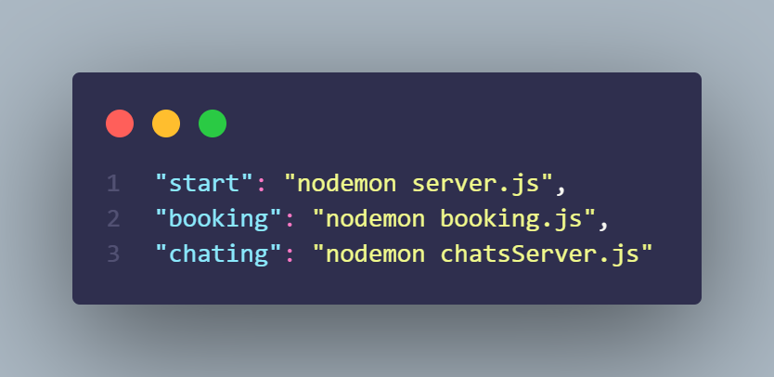

Open terminal then create 3 then enter :

Npm run start ,

Npm run booking ,

Npm run chating ,

Finally choose any html file => first.html

Then => open with live server

My tools: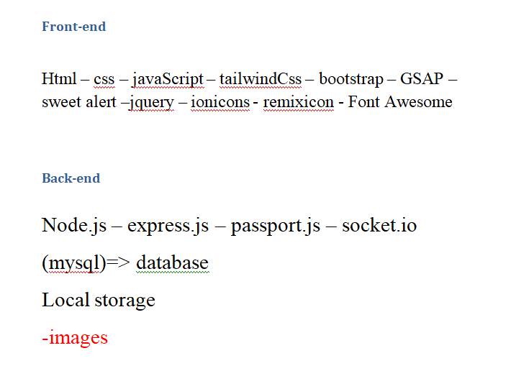

**Platform Overview**

The platform is a comprehensive web application built using a modern tech stack including Passport.js, Express, Node.js, and Socket.io. It offers a range of features designed to enhance user interaction and engagement in a social and tourism-oriented environment.

**Key Features**

1. **User Authentication:**
   * **Passport.js Integration:** The platform uses Passport.js for user authentication, ensuring secure login and registration processes. This allows users to create accounts, log in, and manage their profiles with ease.
2. **Profile Management:**
   * **Profile Setup:** Users can create and customize their profiles, including uploading profile pictures and setting personal information.
   * **Profile Interaction:** Users can interact with posts by liking them, commenting, and adding voice comments.
3. **Content Management:**
   * **Post Creation:** Users can create, edit, and delete posts. This includes adding text, images, and other media.
   * **Commenting System:** Users can add, edit, and delete comments on posts. Additionally, they can leave voice comments for a richer interaction experience.
4. **Chat and Communication:**
   * **Group Chat:** The platform features real-time group chat functionality using Socket.io. Users can join and participate in three distinct chat rooms related to tourism:
     + **Tourism in Egypt**
     + **Traveling Abroad**
     + **travelling**
   * **Live Interaction:** Users can exchange messages and stay connected with others in real-time.
5. **Service Booking:**
   * **Travel Services:** The platform provides a booking system where users can browse and book travel services. This includes searching for and reserving trips and accommodations.
6. **Temporary Content Availability:**
   * **Story Feature:** Users can post stories that are visible for 24 hours, providing a temporary way to share updates and experiences with others.

**Technical Details**

* **Backend Framework:** The application is built on Node.js with Express.js, providing a robust backend for handling requests and managing data.
* **Real-time Communication:** Socket.io enables real-time communication, crucial for the interactive chat features.
* **Authentication:** Passport.js is utilized for managing user authentication and sessions securely.

**User Experience**

The platform is designed to be user-friendly and interactive. Users can easily navigate through the chat rooms, post updates, interact with content, and book travel services. The integration of real-time features and secure authentication ensures a smooth and engaging experience.