**Jenkins -02**

Task: Configure Webhook to Jenkins job

Launch an instance with following configs hostname

'Master-server-Jenkins’ > AMI HVM2 > t2.medium > VPC – default > Subnet us-east-1a > Enable Auto-Assign

IP > SG - default i.e all ports are opened > Storage -30GB >

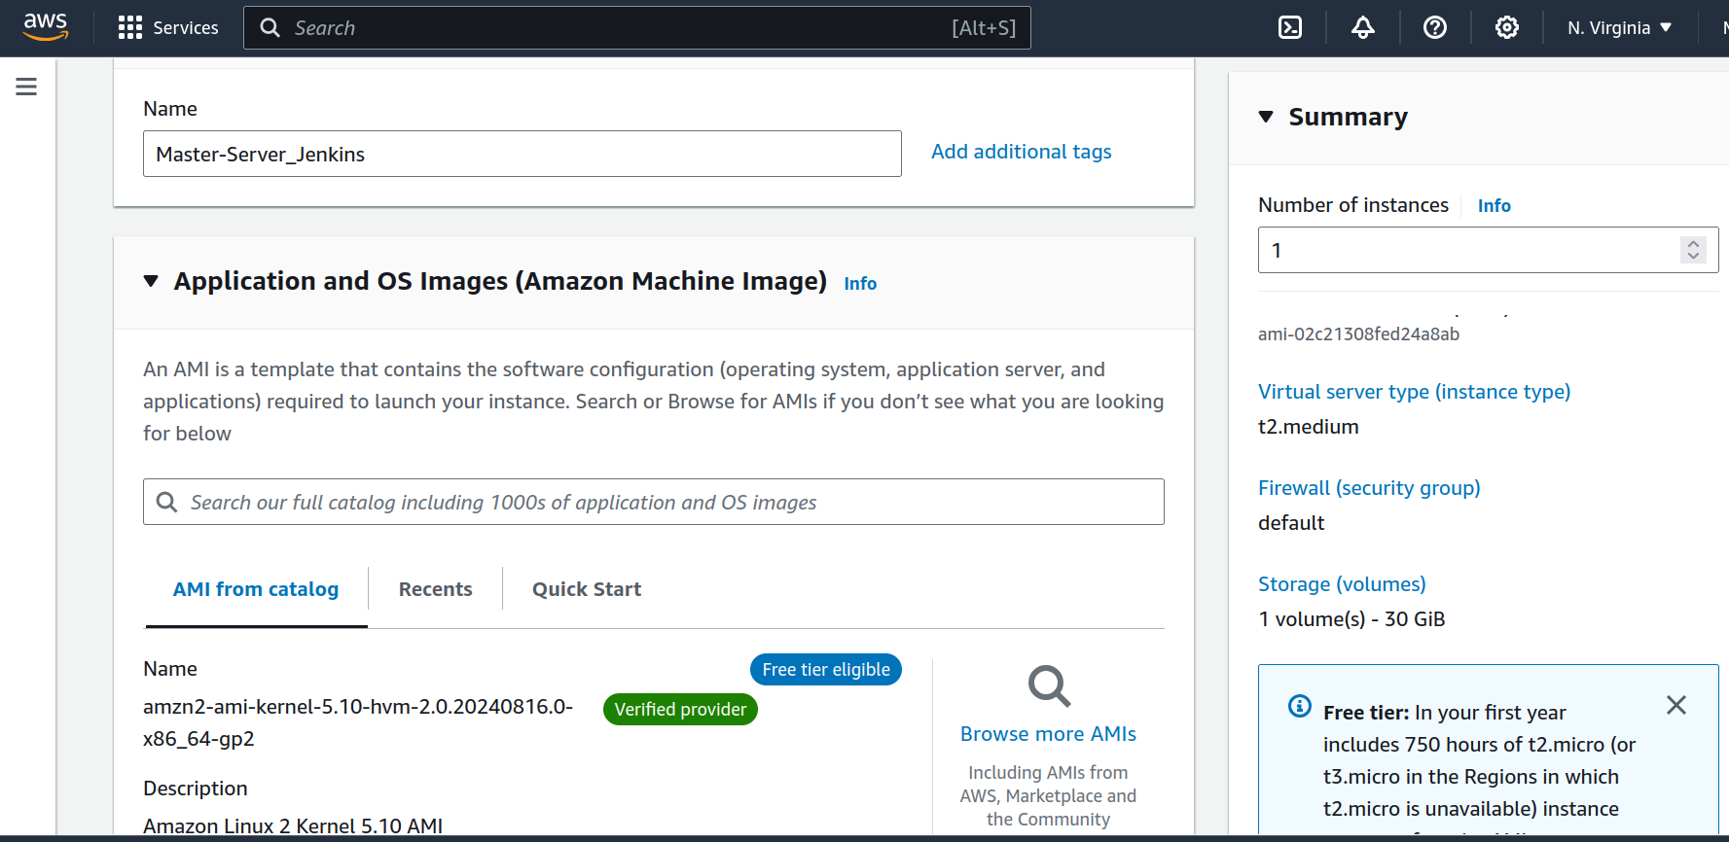

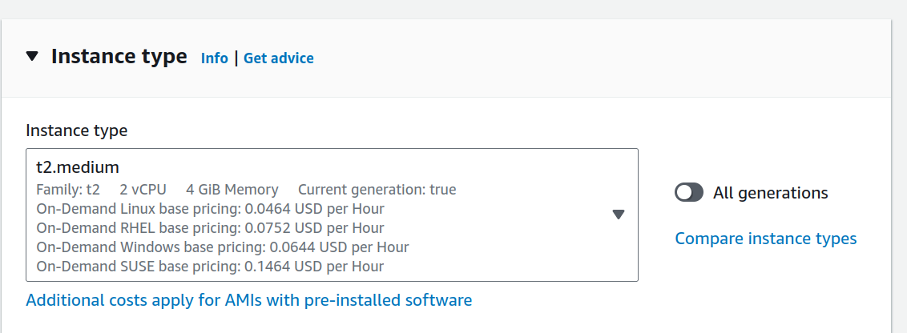

Pre-requisites to install Jenkins:

Download jenkins Repo:

=====================

sudo wget -O /etc/yum.repos.d/jenkins.repo https://pkg.jenkins.io/redhat-stable/jenkins.repo

Import the jenkins key:

======================

sudo rpm --import https://pkg.jenkins.io/redhat-stable/jenkins.io-2023.key

Update ec2:

==========

sudo yum upgrade

Add required dependencies for the jenkins package:

=================================================

sudo amazon-linux-extras install java-openjdk11

Install Jenkins:

===============

sudo yum install jenkins

enable status

Access the jenkins webpage from browser using public IP followed by 8080 port no.

http://44.202.156.210:8080/

Secure the jenkins server by changing password from user > configure >

Create 3 jobs:

DashB > New item >

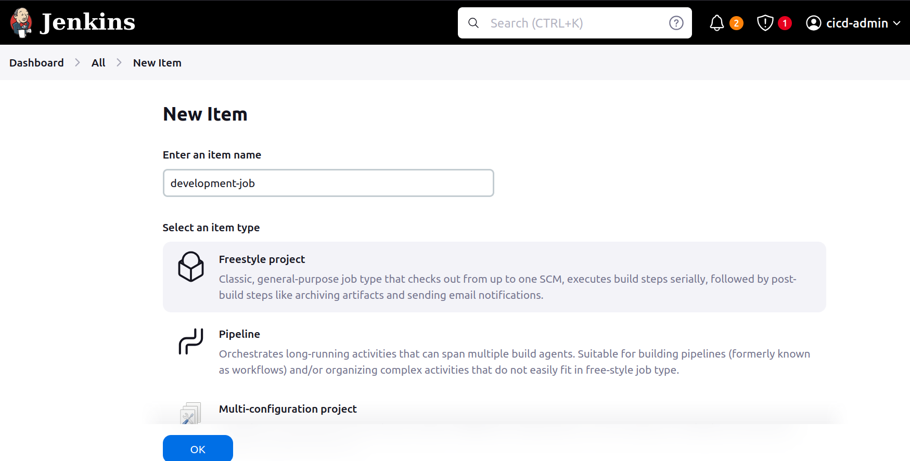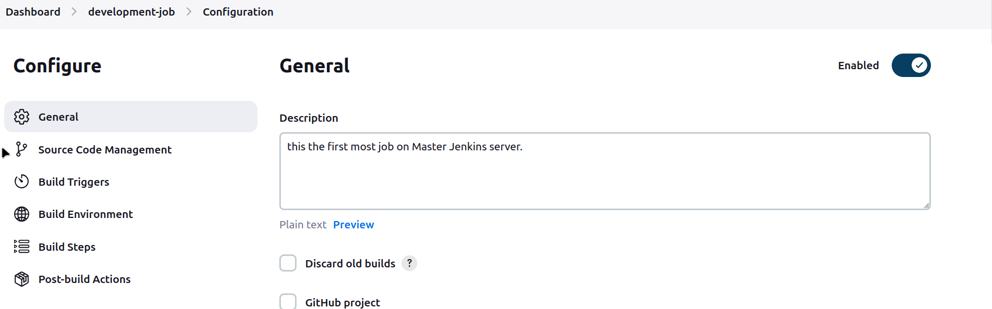

Goto Github repo which is public copy the repo link from Code button

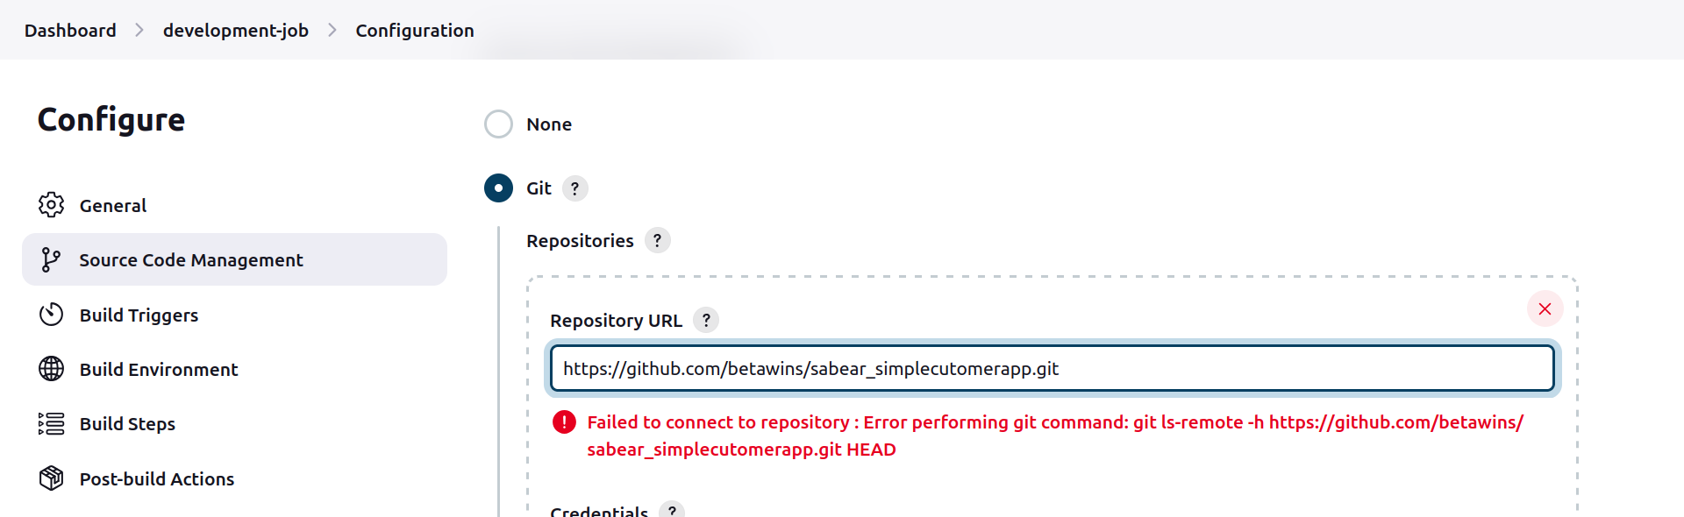  
error due to upcoming build/provided repo have git commands whereas jenkins server doesn’t have any git package installed on it.

Go to Master-server-jenkins via cli and install git

#sudo yum install git

#git –version

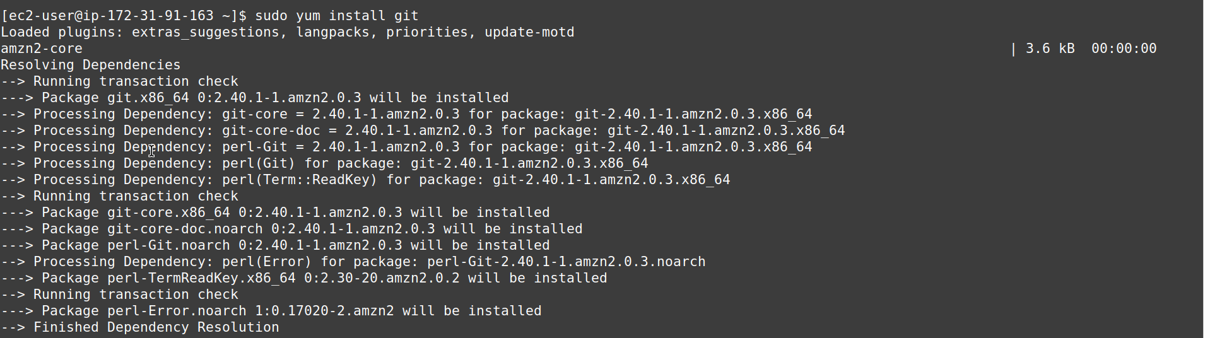

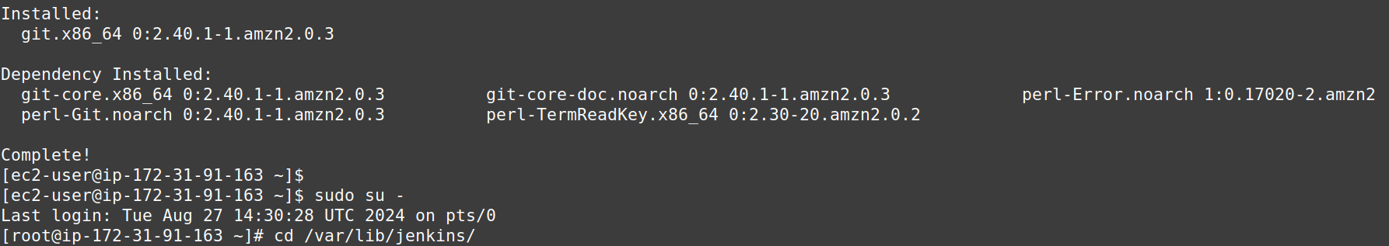

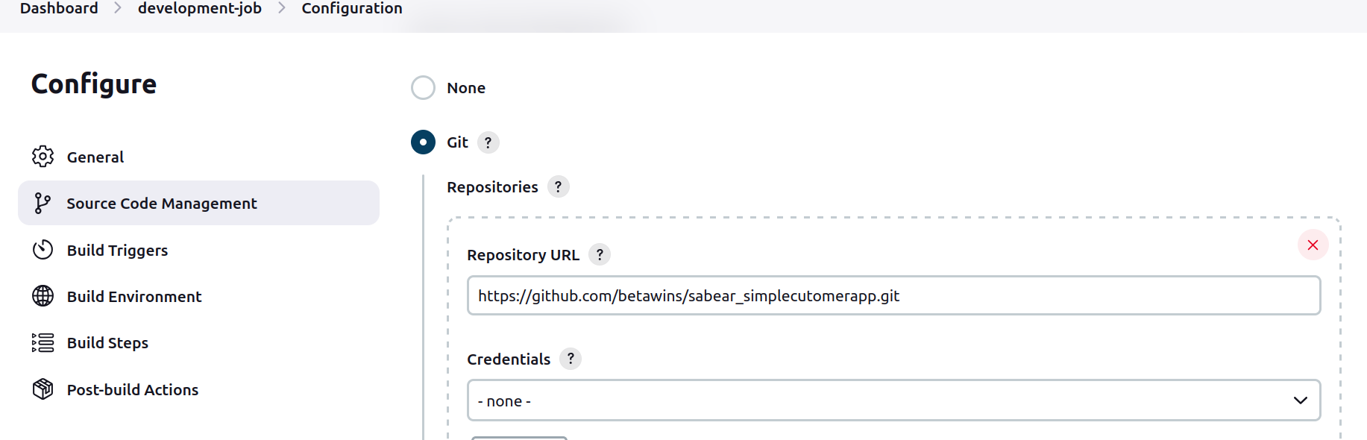

Select following Build trigger

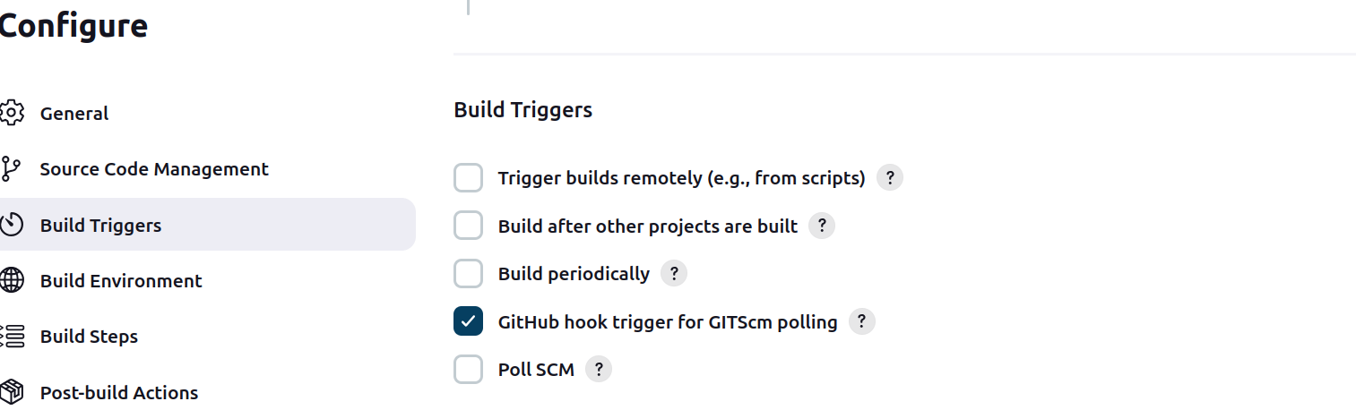  
Goto Github repo > Settings > Webhooks > Add Webhook

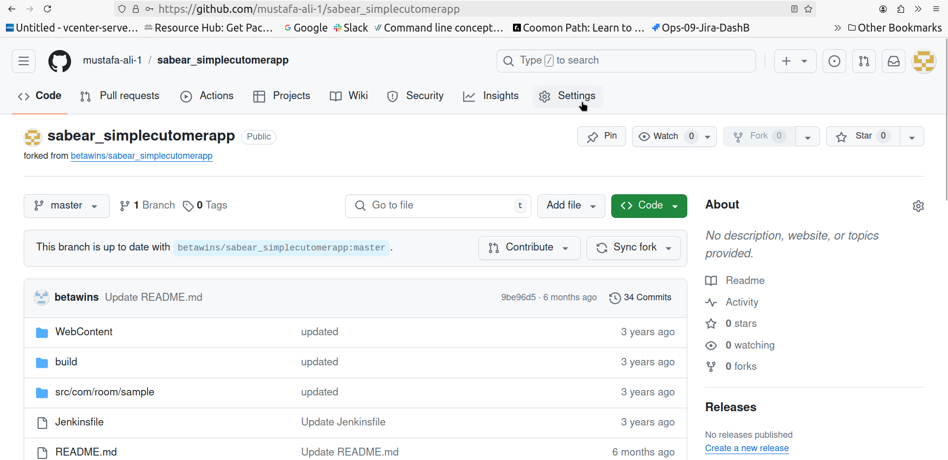  
Under PayLoad URL paste the jenkins Server URL and then append following line

for example:

<http://44.202.156.210:8080/github-webhook/>

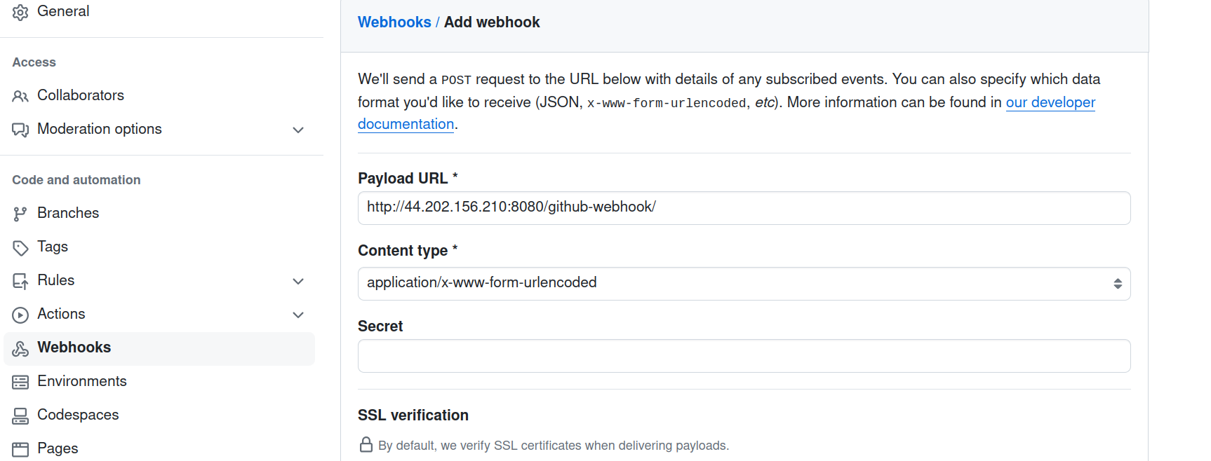

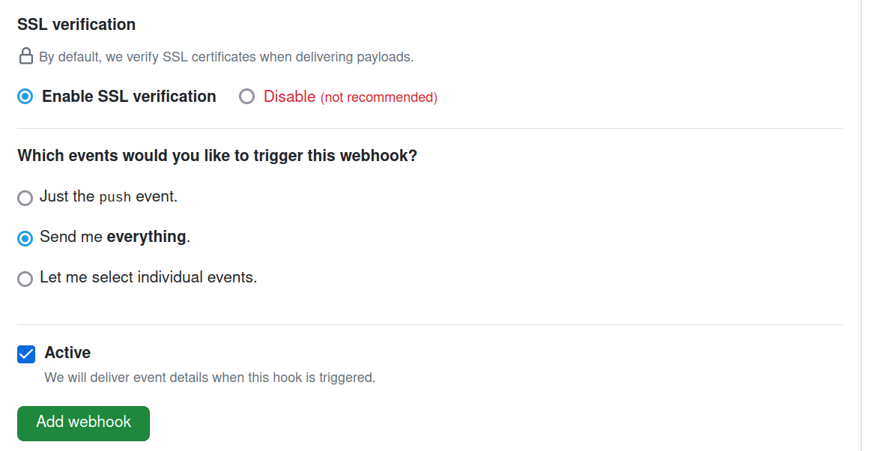  
For Which events would you like to trigger this webhook?

Select ‘Send me everything’

Goto Jenkins webpage for first job (contd.) add Build Step > Execute Shell > add sleep 25 > Save

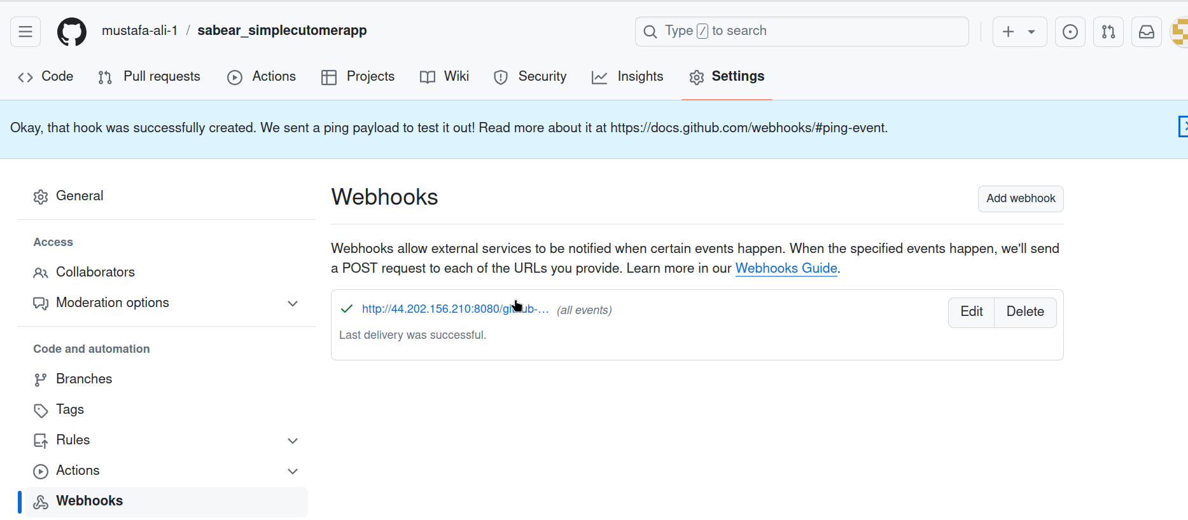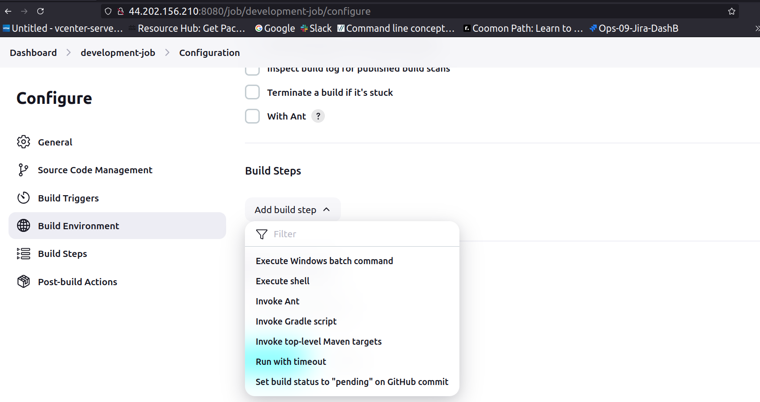

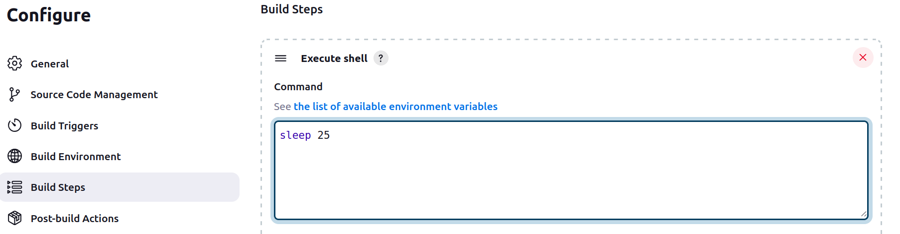  
to check and confirm, modify the READ.me file of github repo, by appending .

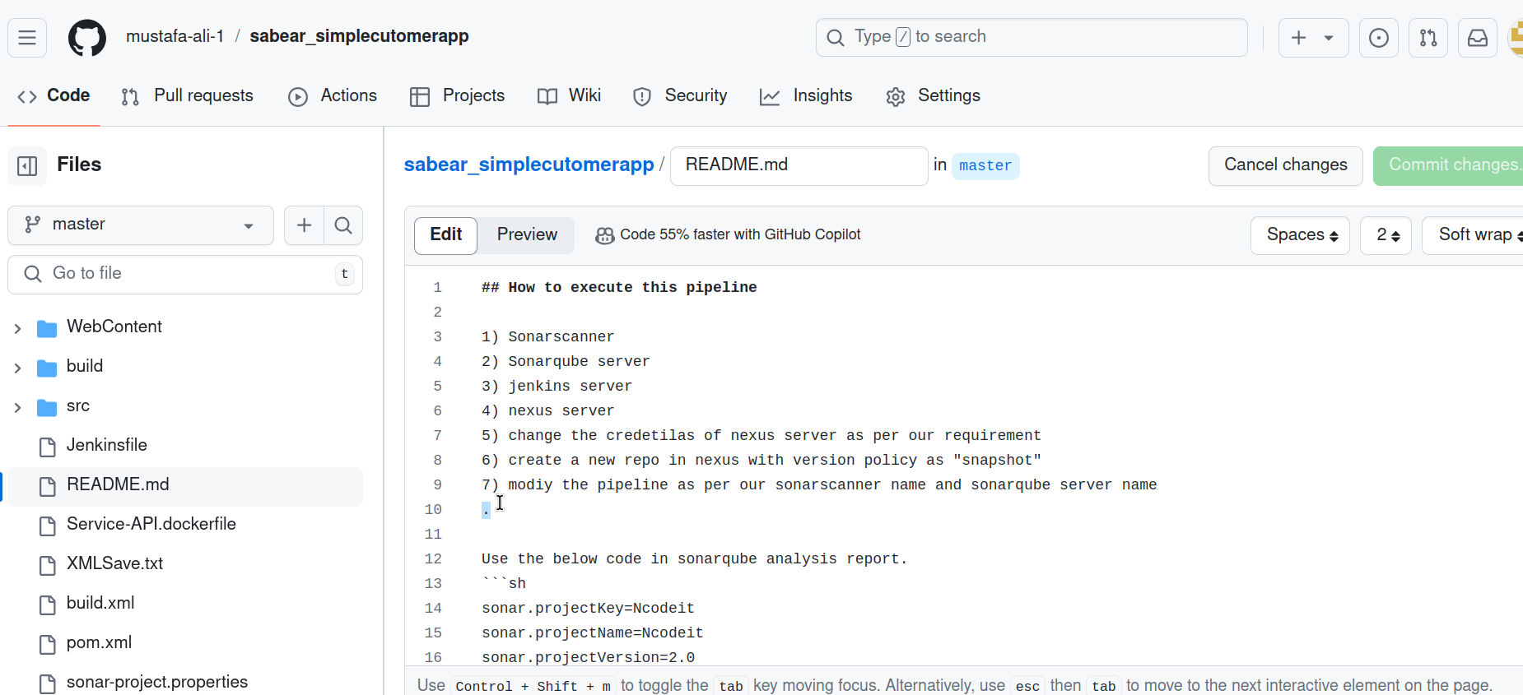  
Save the file and Commit the changes, as soon as you commit the change, the Webhook will send the update to Jenkins through the use of “Git webhook trigger for GitScm polling” option and job will start executing/job will build

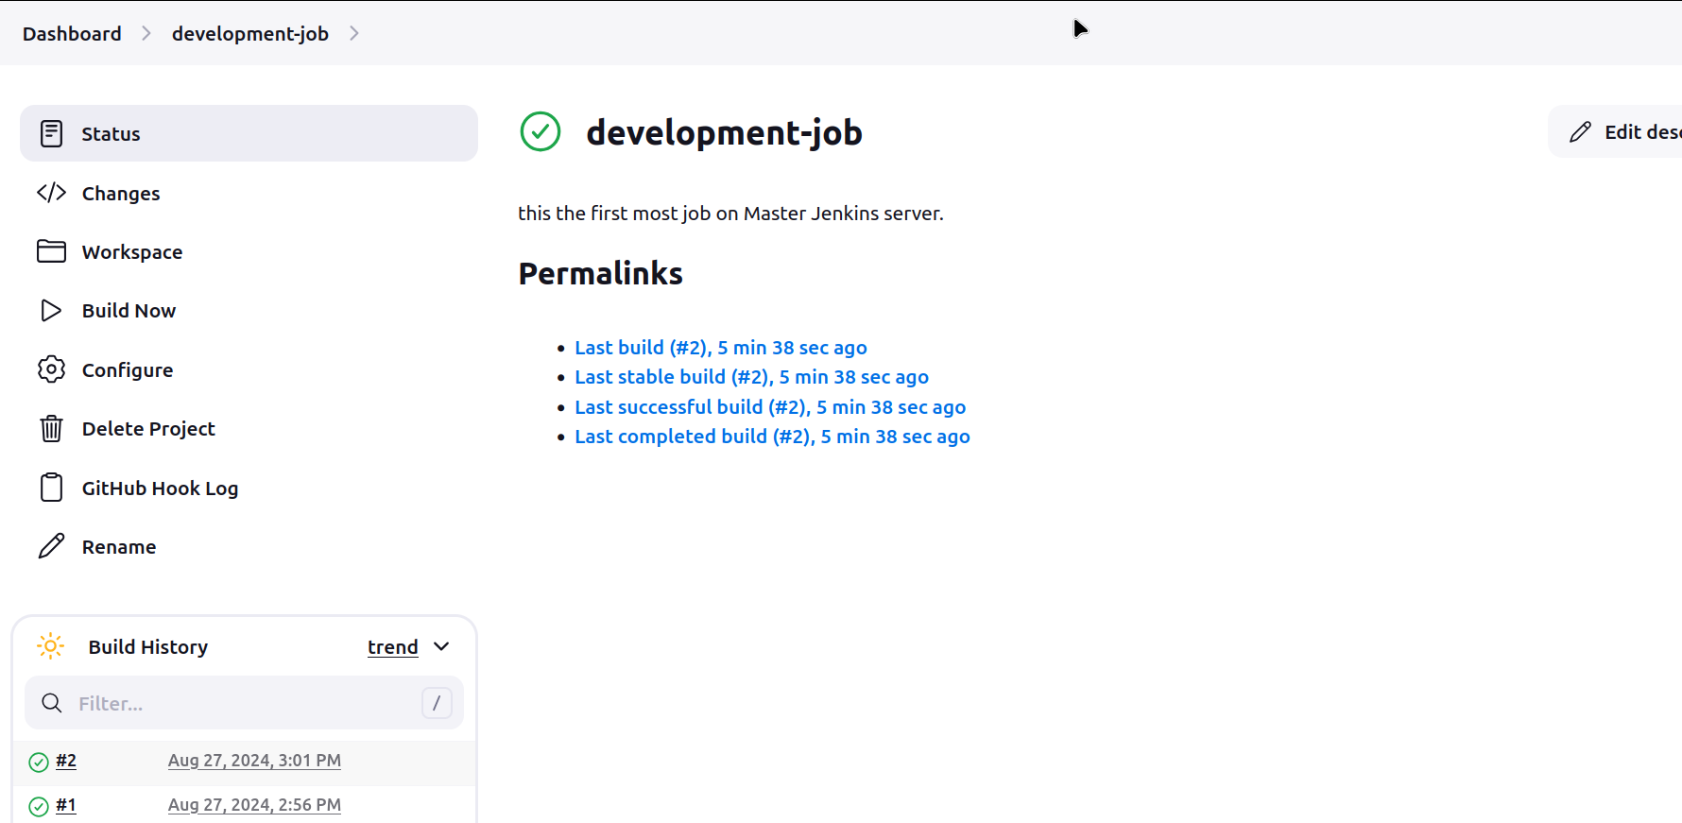

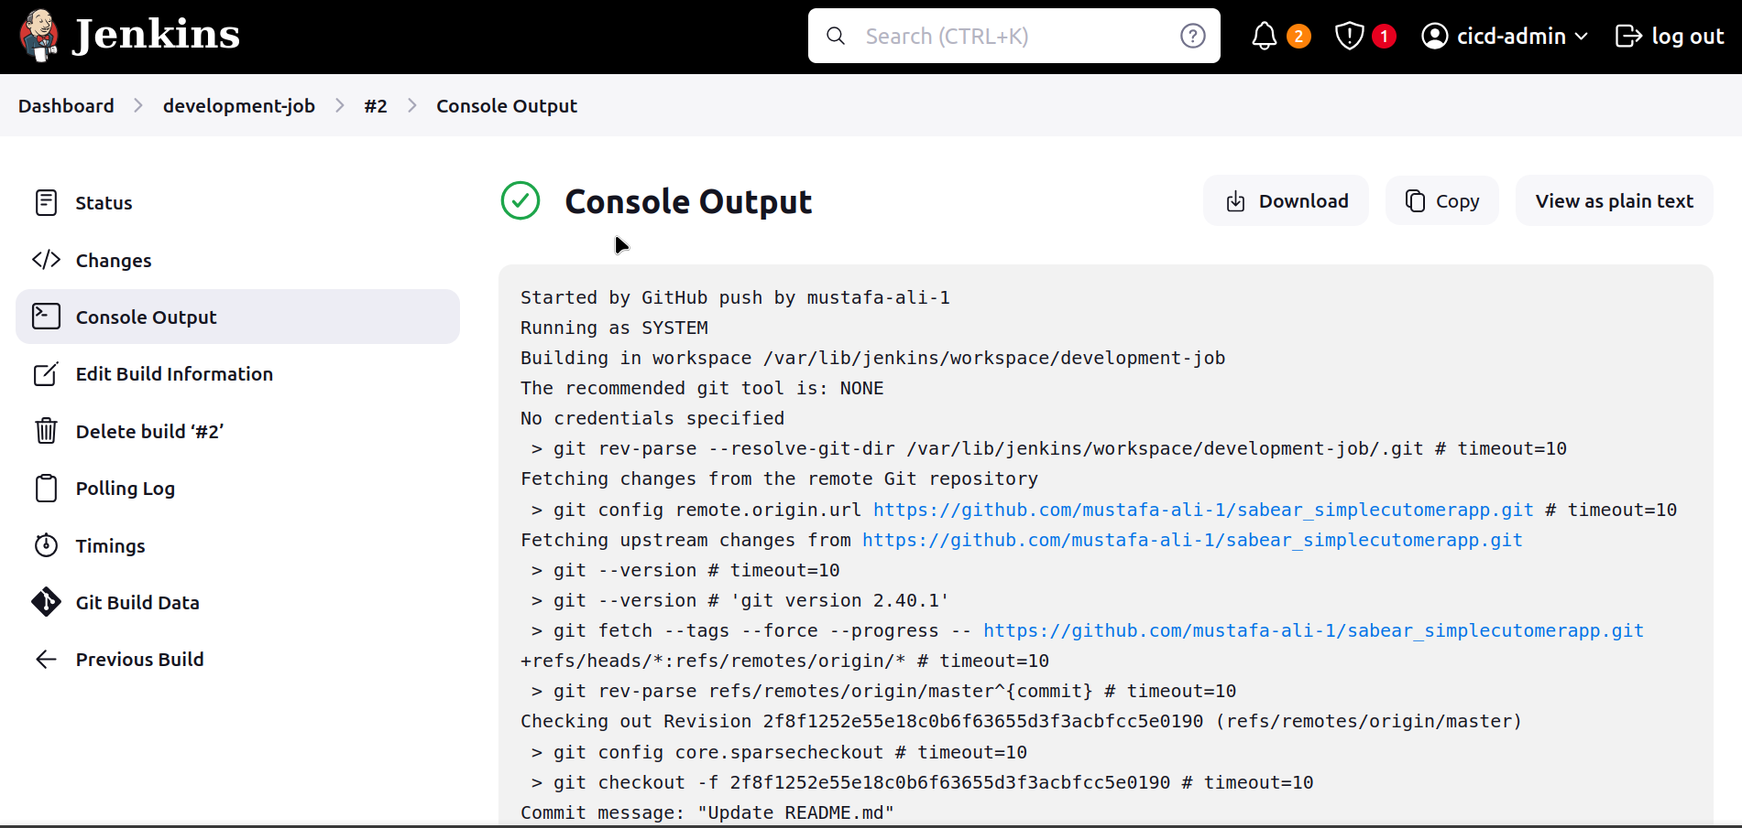  


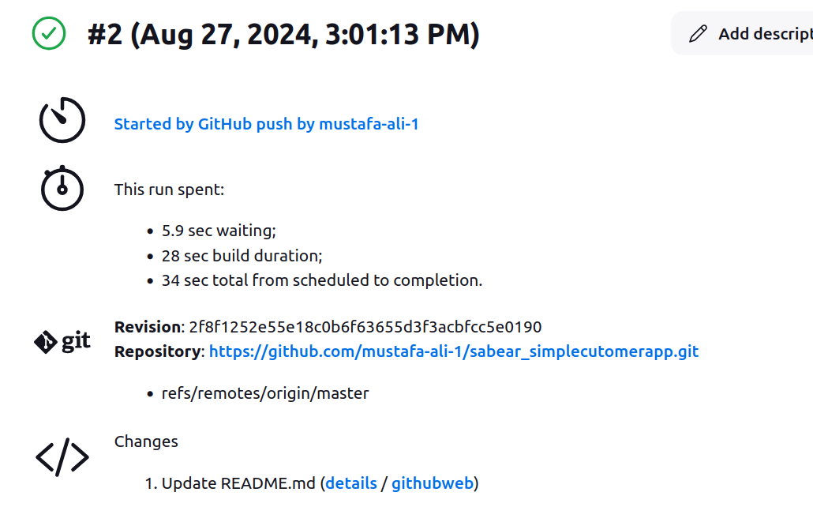  
As soon the job/ is executed/Build is finished the Source Code Will be Downloaded to jenkins Server in a newly created directory called “workspace” and

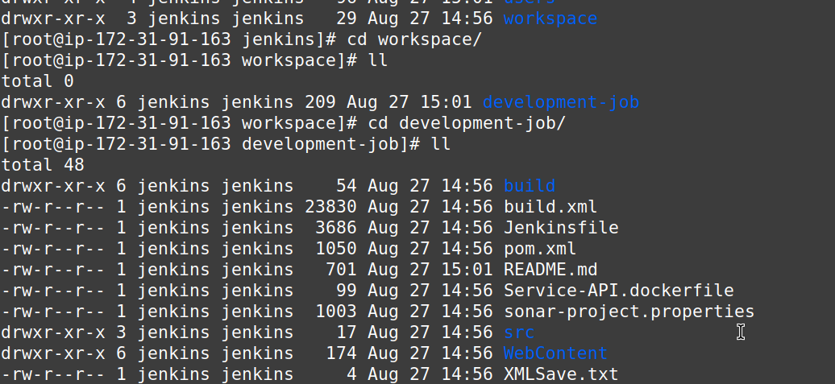  
Same files available on Github repo will be saved inside the workspace directory

And again if you go to Github repo’s READ.me file and undo the changes made it will again execute the job/start running the Build.

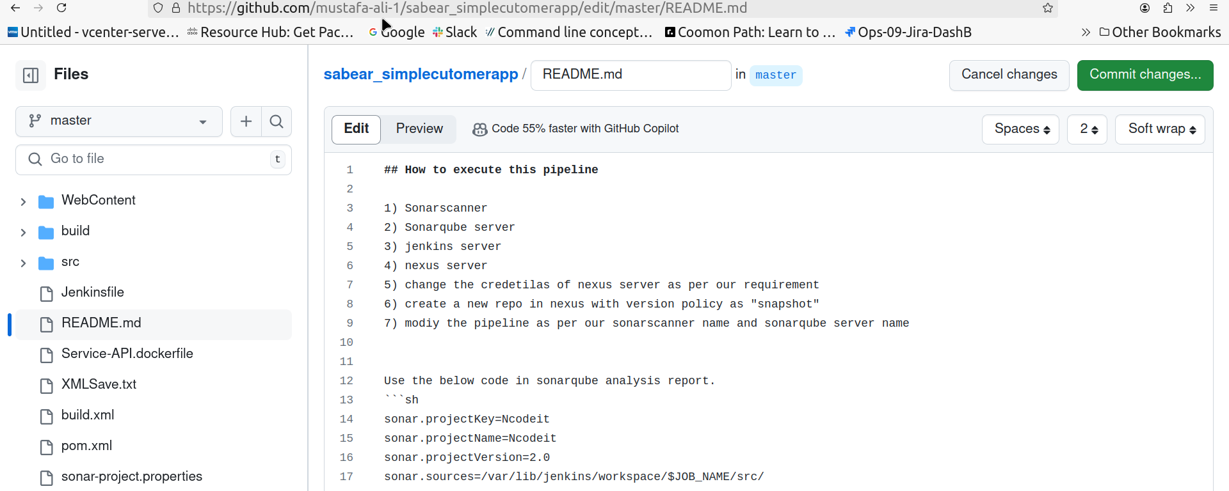

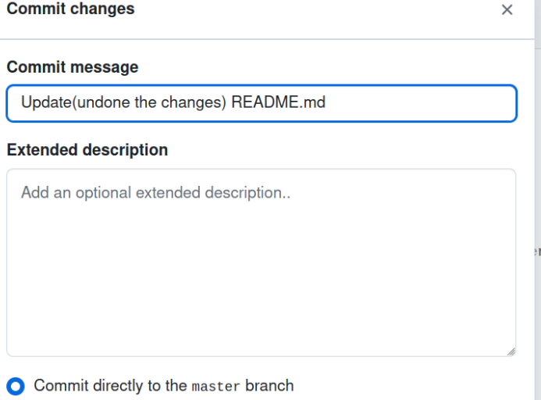

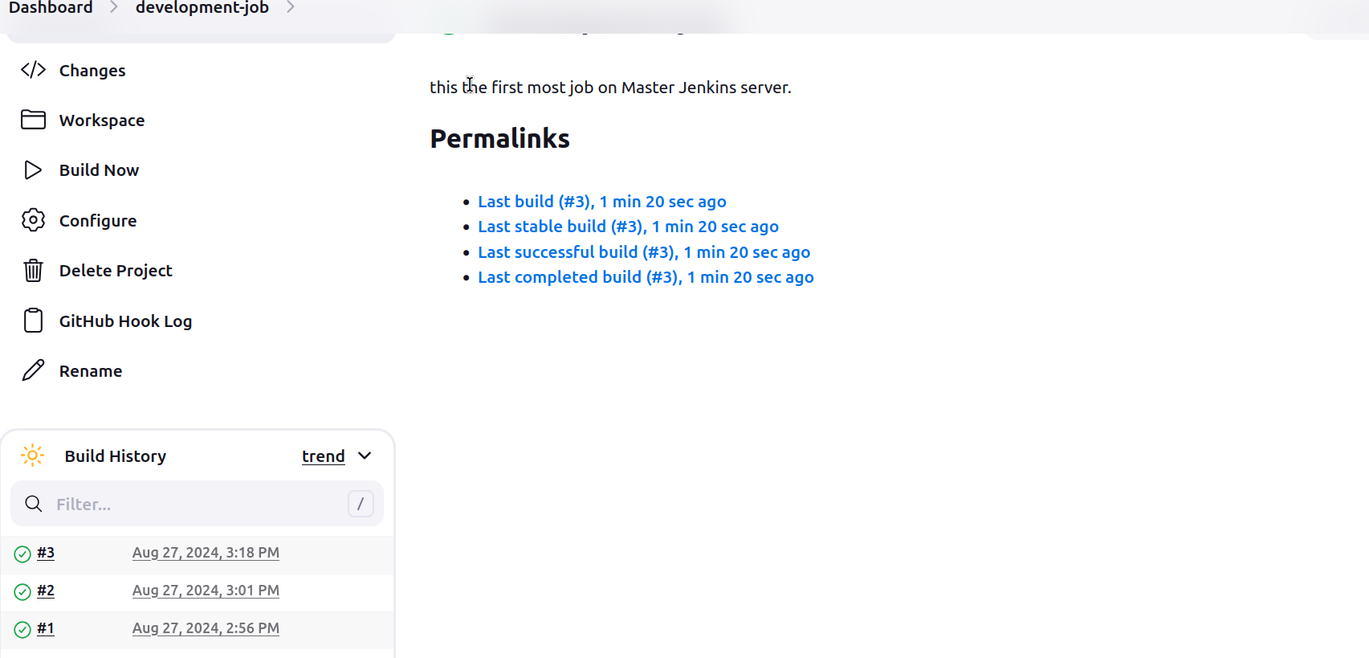  
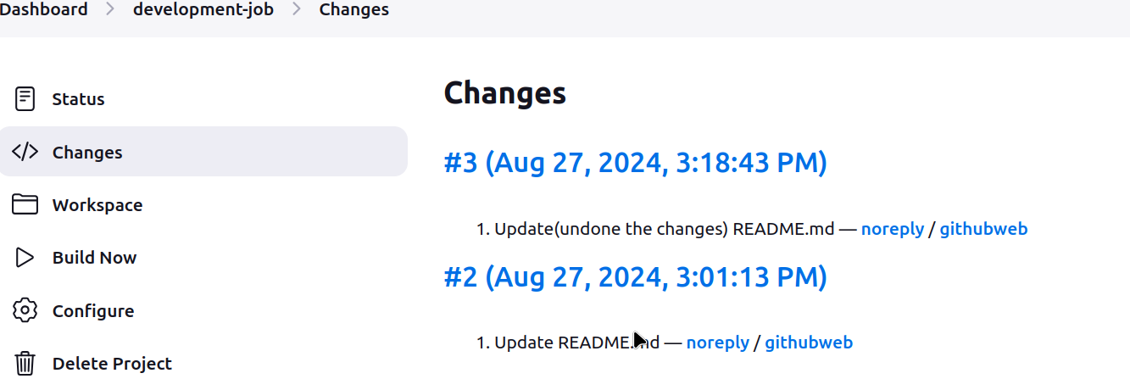

Task: Configure Poll SCM and Build Periodical options in jenkins job

Goto DashB > development_job > Configure > uncheck “GitHub hook trigger for GITScm polling”

option and check the Poll SCM option

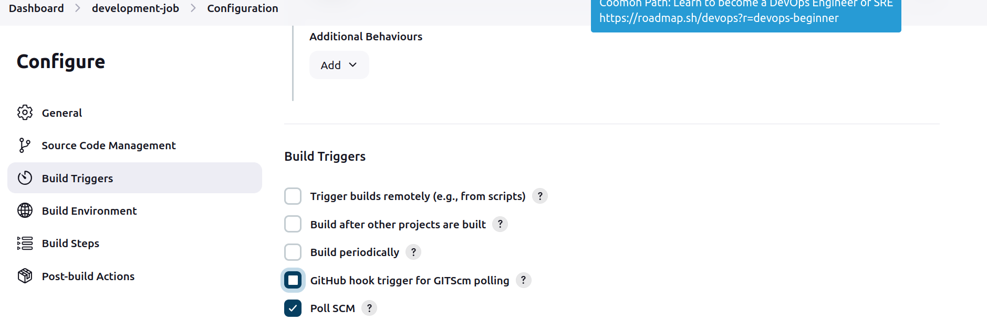

Create a new repo with read.me file and add the webhook for the Poll-SCM job.

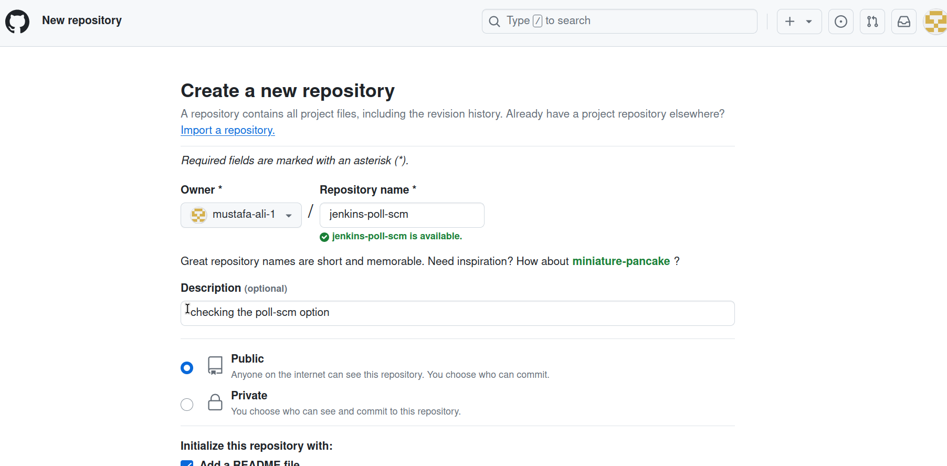  
Paste the github repo inside the configure option of the job

https://github.com/mustafa-ali-1/jenkins-poll-scm.git

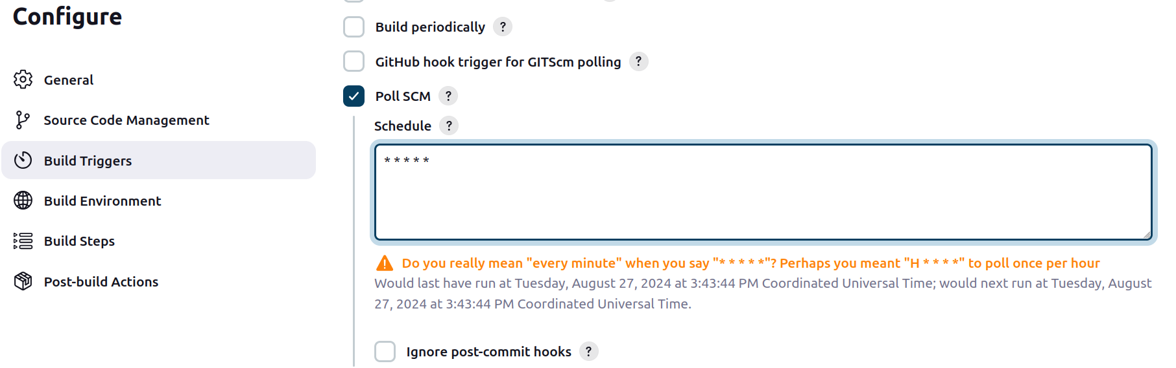  
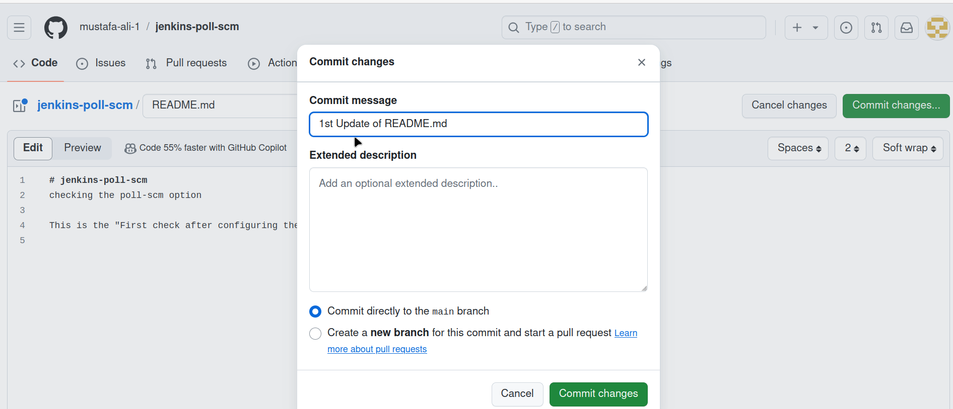  
Make sure to check the confirm the Branch name on Github and in Jenkins Job configurations.

