**Terraform**

Task: Install Terraform on PC

#Steps To Install Terraform on Windows 10 or 8 or 7

1) Download Terraform

https://www.terraform.io/downloads.html

2) Unzip the terraform package

Extract the downloaded zip file, after extracting the zip file you can see terraform.exe file.

Extracted path can be Example "C:\Users\devops\Downloads\terraform_0.12.23_windows_amd64"

3) Configure environment variables for terraform

This PC(MyComputer)—>properties —>advanced system settings–>environment variables—>system variables—>path–edit–>new

paste the path "C:\Users\devops\Downloads\terraform_0.12.23_windows_amd64"

Click on Ok.

4) Verify terraform version

Open gitbash and enter

> terraform version

Terraform v0.12.23

#wget -O- https://apt.releases.hashicorp.com/gpg | sudo gpg --dearmor -o /usr/share/keyrings/hashicorp-archive-keyring.gpg

echo "deb [signed-by=/usr/share/keyrings/hashicorp-archive-keyring.gpg] https://apt.releases.hashicorp.com $(. /etc/os-release && echo "$UBUNTU_CODENAME") main" | sudo tee /etc/apt/sources.list.d/hashicorp.list

sudo apt update && sudo apt install terraform

Ensure that your system is up to date and you have installed the gnupg, software-properties-common, and curl /wget packages installed.

These packages will be used to verify HashiCorp's GPG signature and install HashiCorp's Debian package repository.

$ sudo apt-get update && sudo apt-get install -y gnupg software-properties-common’

‘Downloads’ HashiCorp's GPG signature and ‘Writes;’ wget -O, --output-document=FILE writes documents to FILE

#wget -O- <https://apt.releases.hashicorp.com/gpg>

Encryption/decryption commands · Key management commands

#sudo gpg --dearmor -o /usr/share/keyrings/hashicorp-archive-keyring.gpg

.

.

.

.

.

.

This sequence of commands downloads and installs the GPG key for verifying HashiCorp packages, adds the HashiCorp repository to the system, updates the package list, and then installs Terraform.

Task:

Check Registries of Terraform ==> https://registry.terraform.io

- Providers

- Modules

https://registry.terraform.io/browse/modules

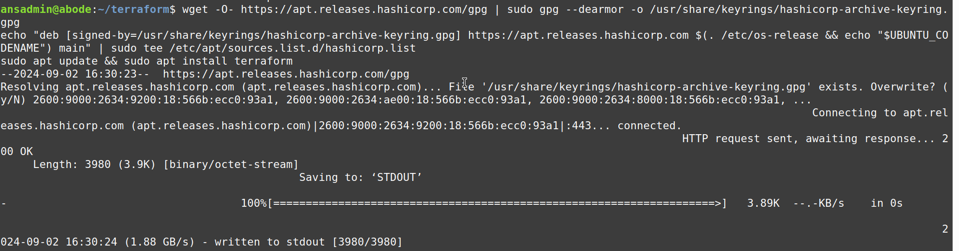  
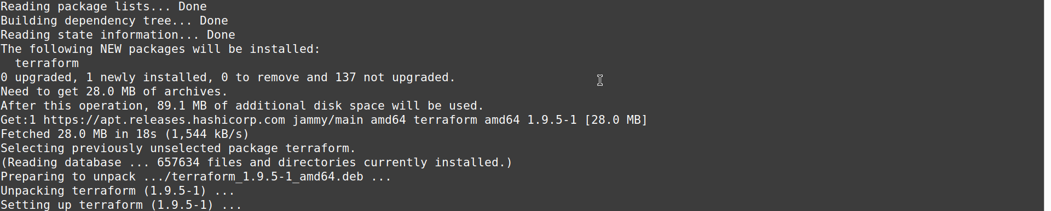  
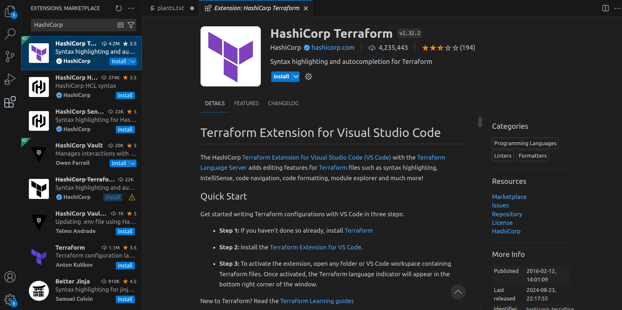

Task: Execute all the templates shown in video

Task: Note down points -Terraform Init, -Terraform Plan, -Terraform Apply, -Terraform Provider.

Example:

=======

<block> <parameters> {

key1= value1

key2 = value2

}

Go to Files > open terraform default-set folder with VS Code

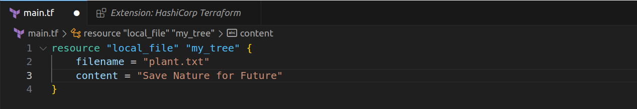  
Open Terminal from top side title bar

Check for the file

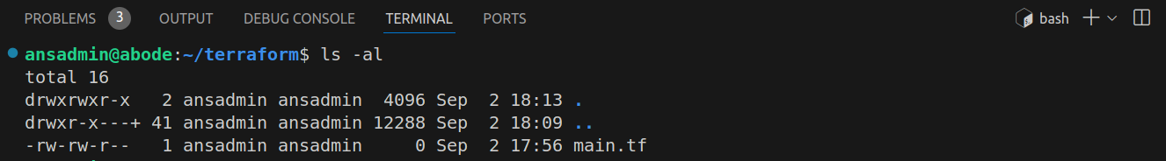  
#Terraform Init  
To initialize the terraform asimilar to git init and download the Provider mentioned in the main.tf file named local, and install dependency/api for calling/Plug-in.

Without the terraform initialization script connot be executed.

#Terraform Plan

Kind of dry run or blue print which helps in understanding the what changes are going to be made (or) how changes will be implemented/executed on the end/target machine by print the expected output

+ indicates an object will be created

- indicates a file/folder ll

~ indicates

#Terraform Provider:

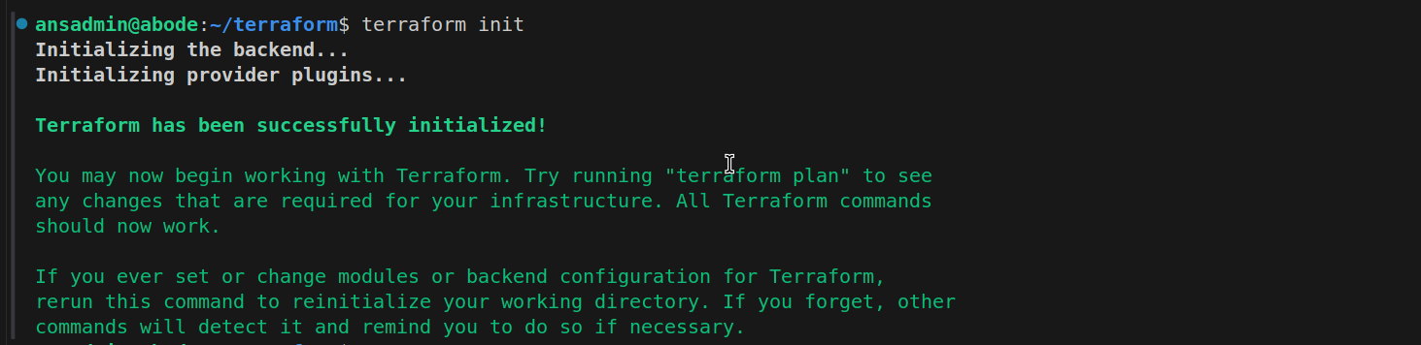  
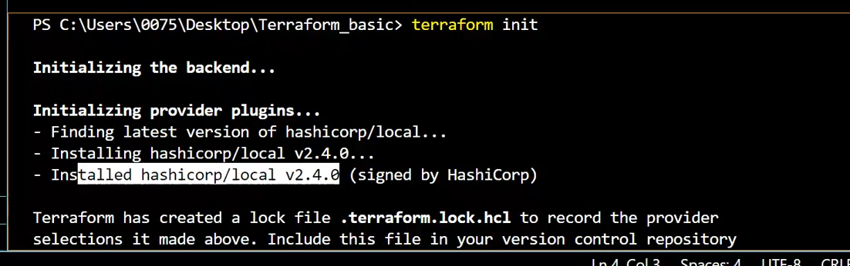Videos Output

Modify content of the file main.tf

And finally run Apply command to execute the changes and run the terraform code/script file