**Jenkins**

Task: Install Jenkins and run jenkins on port number 8081

Launch an ec2 instance with following configs hostname

'testintjenkins001’ > Ubuntu HVM2 > VPC – default > Subnet us-east-1a > Enable Auto-Assign

IP > SG - default i.e all ports are opened > Storage -8GB >

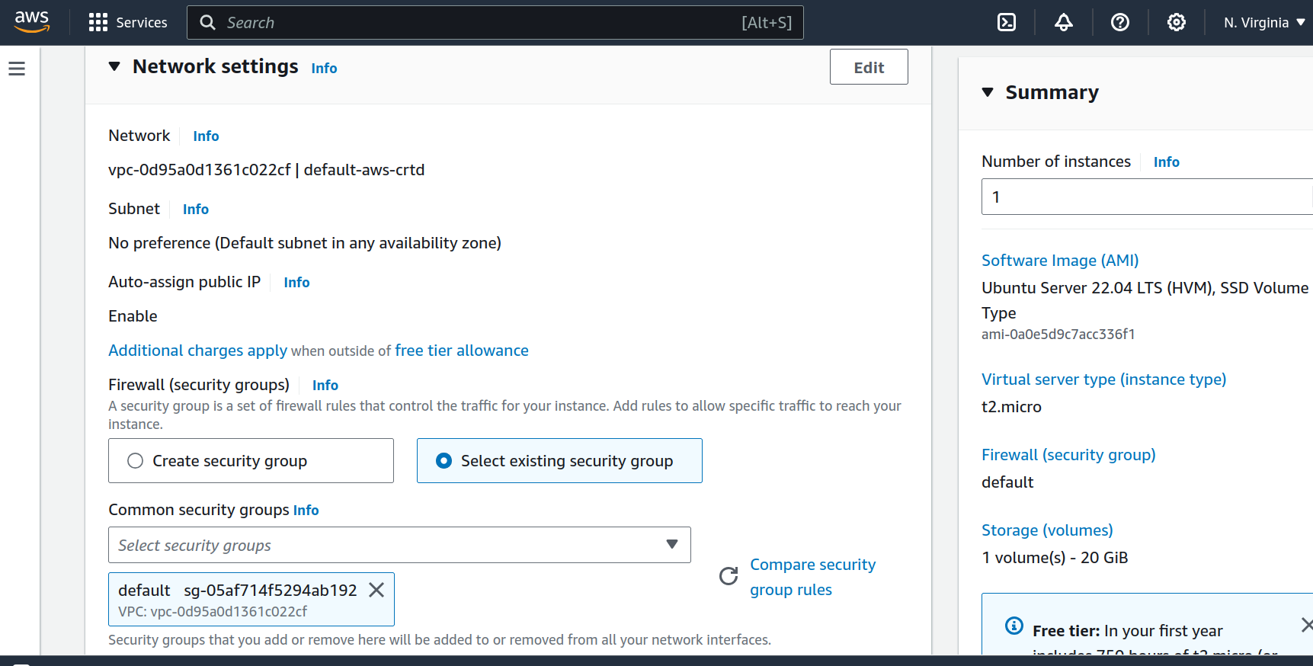

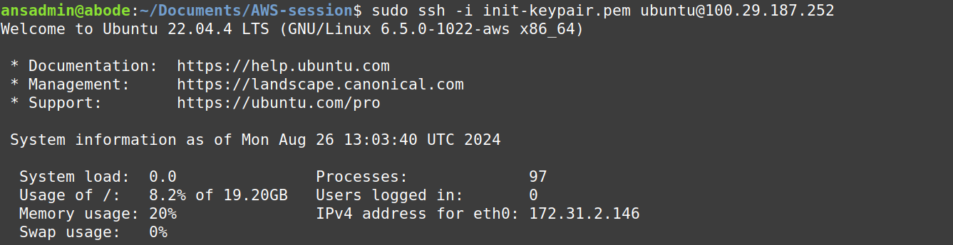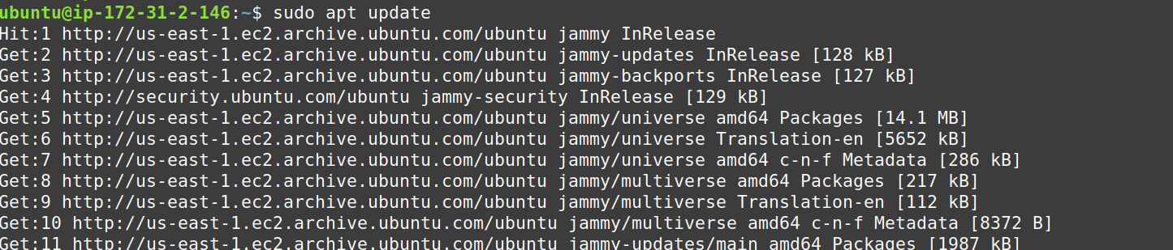

ssh into the instance using username as “ubuntu” and update the instance.

Follow Jenkins Official Documentation, docs > installing linux > debian/ubuntu

At first, run commands under heading “Installation of Java” and then “LongTerm Support Release”.

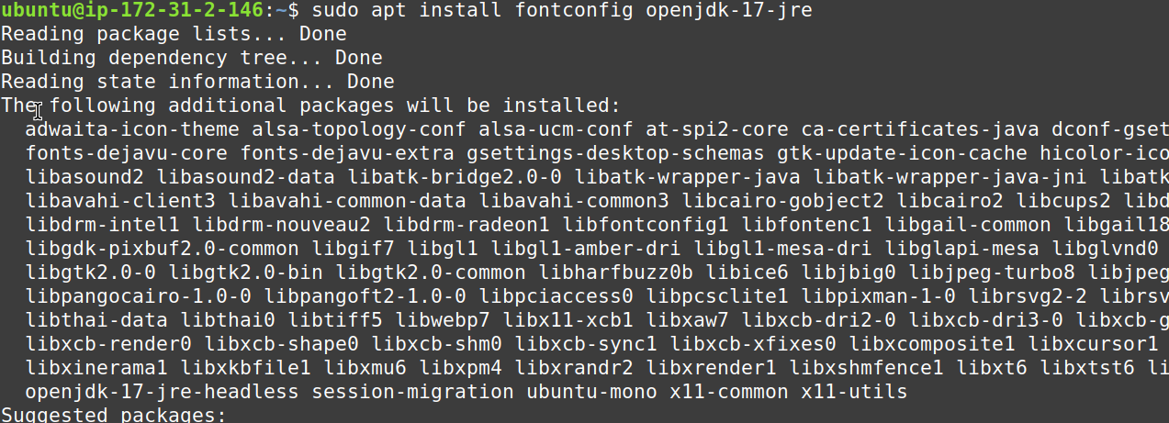

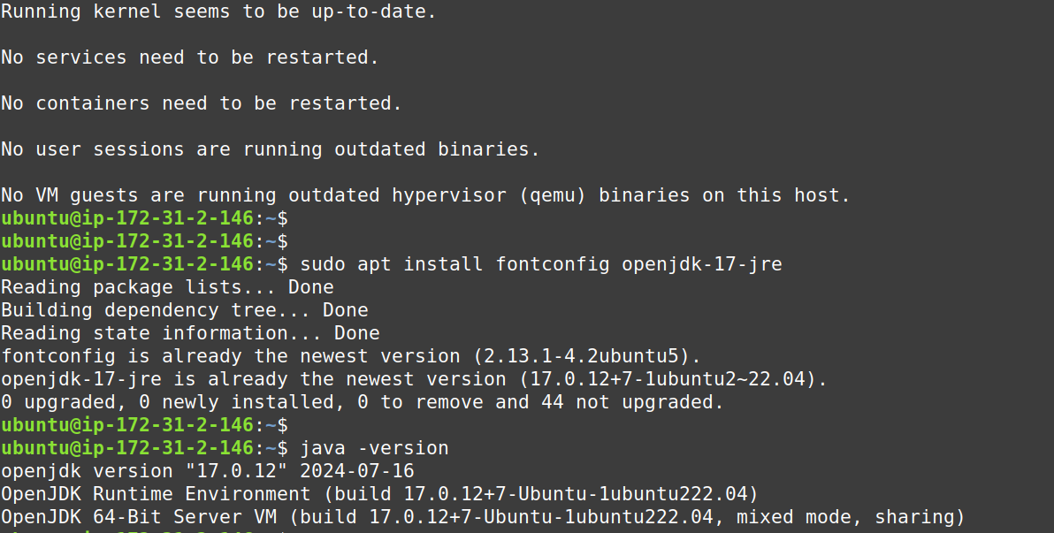  
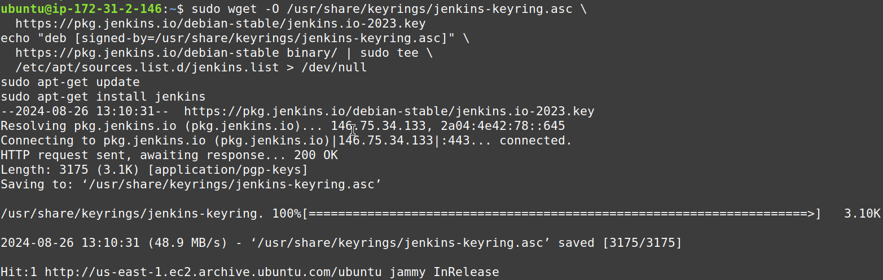

  
if in b/w instance restarted as we know public IP changes, and enkins console can be accessed from

ip, in such case stop and start the jenkins service and wait for few mins and access the webpage.

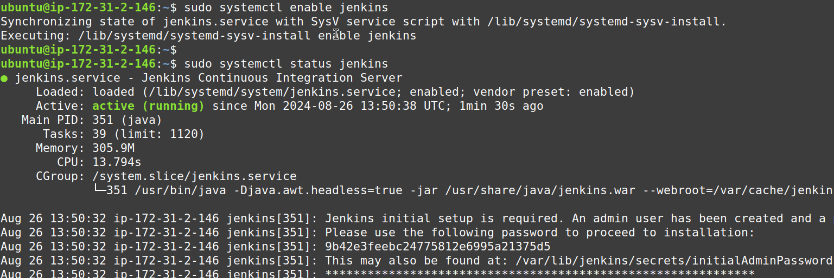  
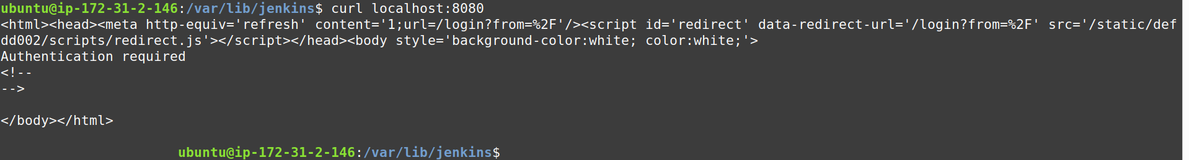  
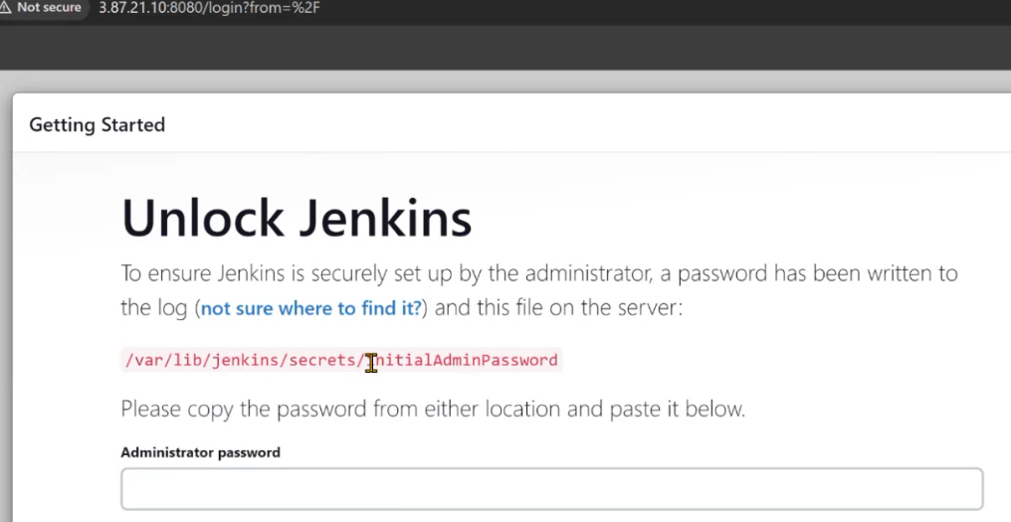

.

.

.

.

.

.

.

.

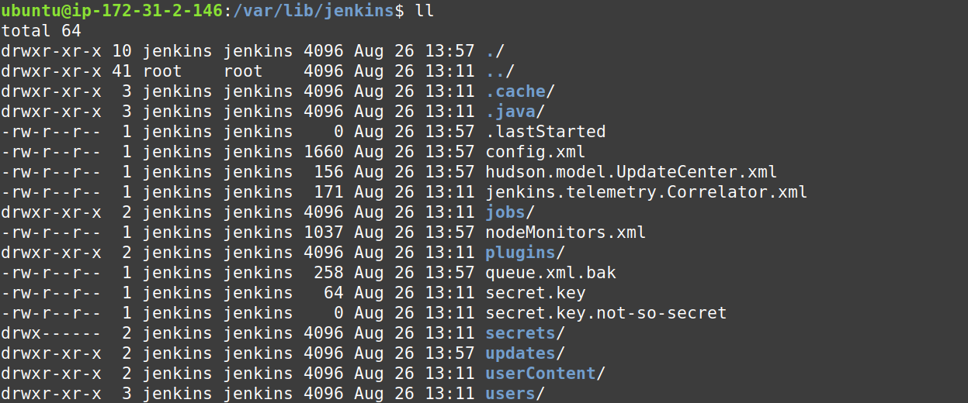  
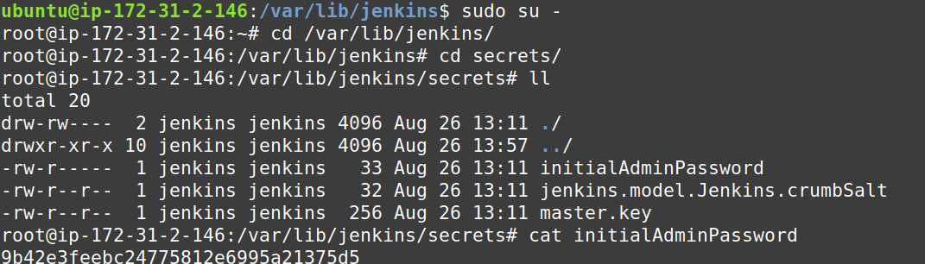  
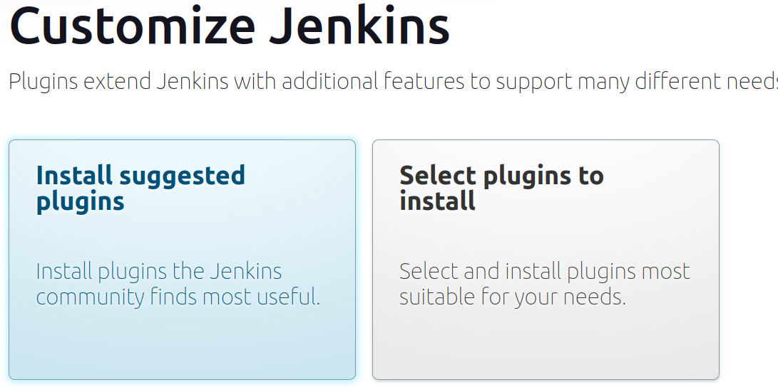

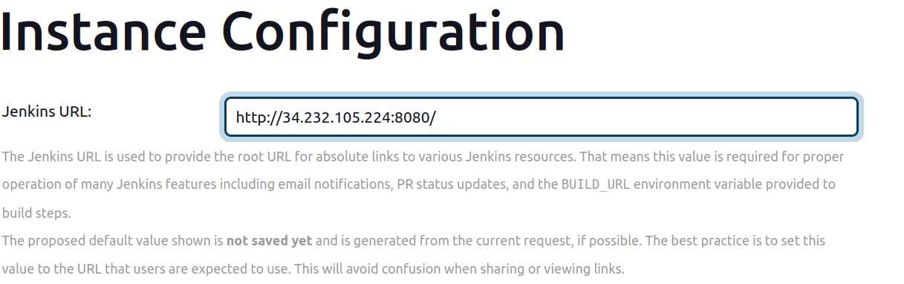

switch to the following path /lib/systemd/system

#vi lib/systemd/system/jenkins.service

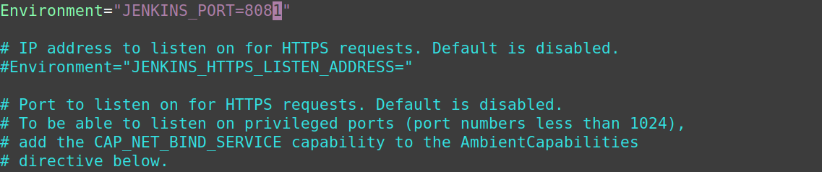  
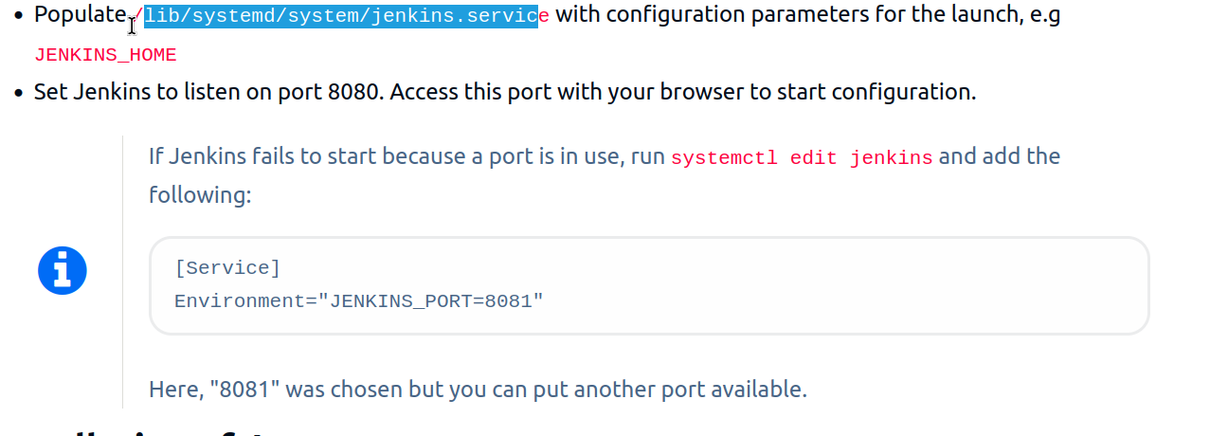

netstat -na 8081

systemctl daemon-reload

curl localhost:8081

curl 18.206.86.9:8081

**http://18.206.86.9:8081/**

Task: Secure Jenkins server

Login > Admin > Configure > change password



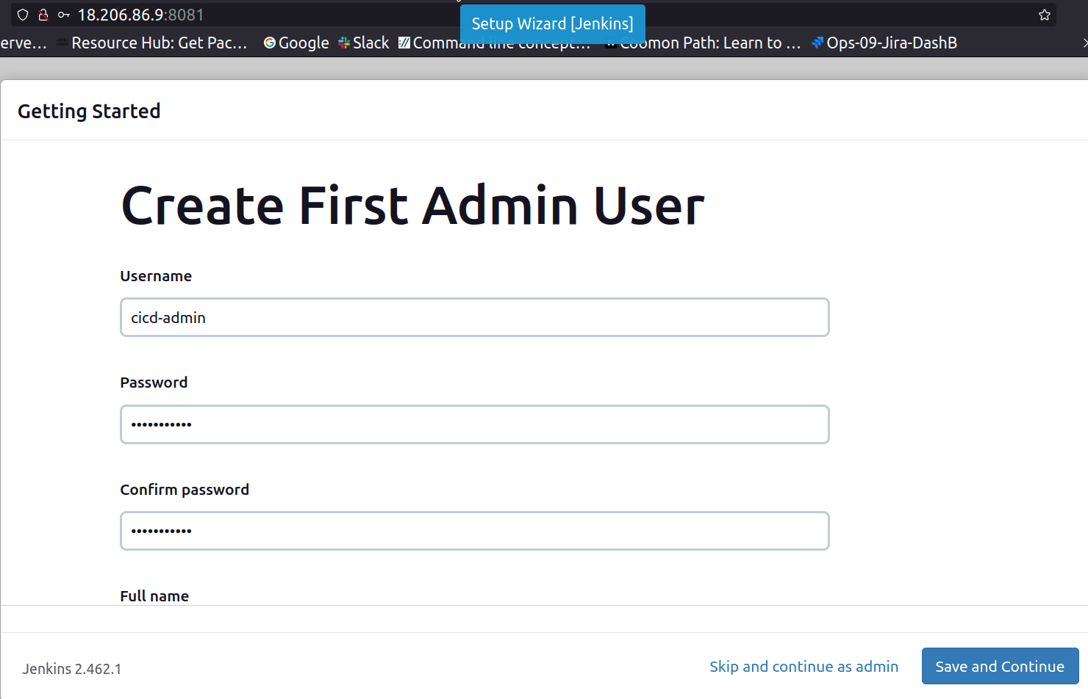

http://18.206.86.9:8081/

netstat -na 8081

systemctl daemon-reload

curl localhost:8081

curl 18.206.86.9:8081

http://18.206.86.9:8081/

Task: Create users called Devops, Testing in Jenkins with Limited access

Dashboard > Manage > Users >

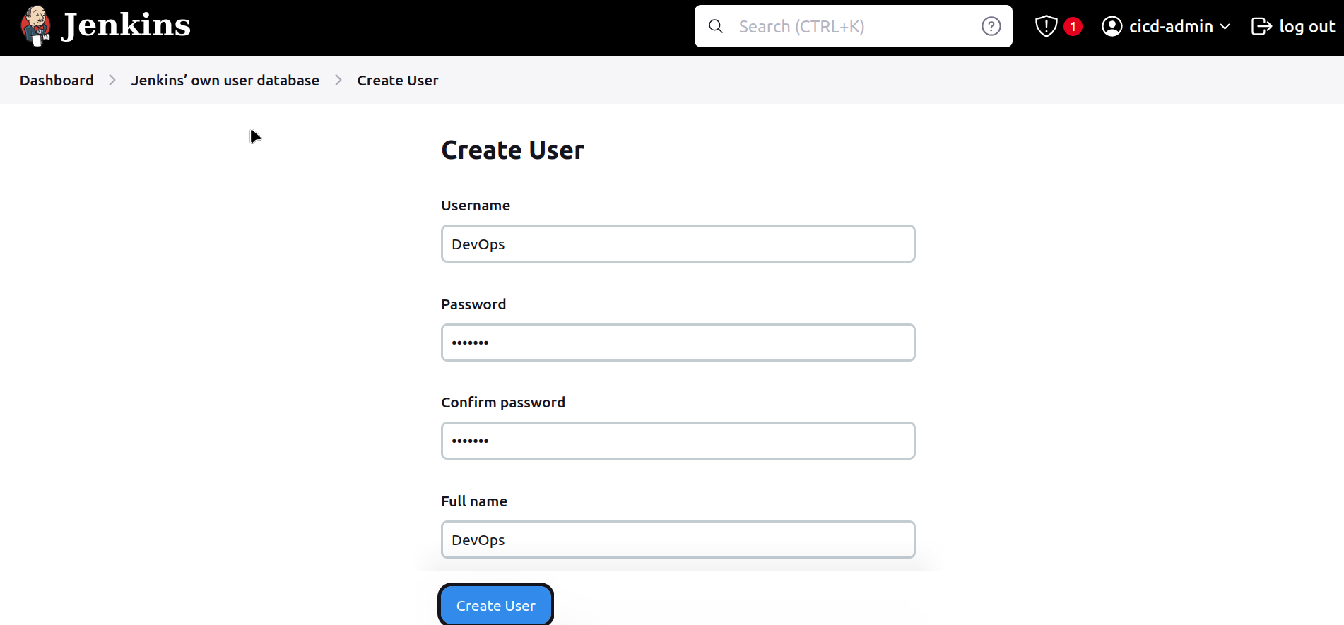

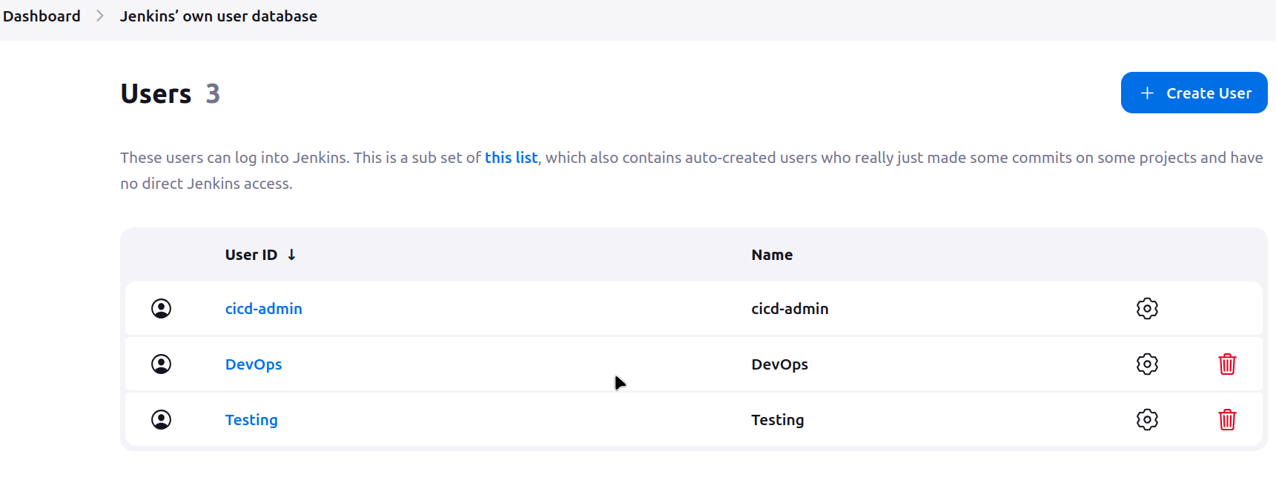  
Dashboard > Manage > Security >

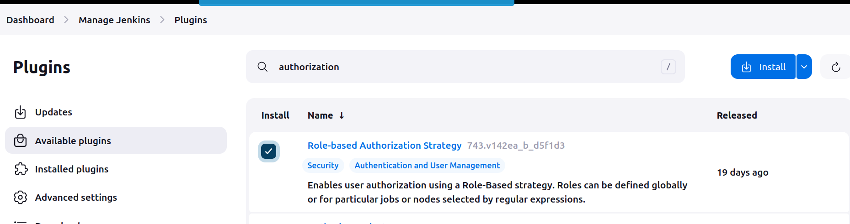

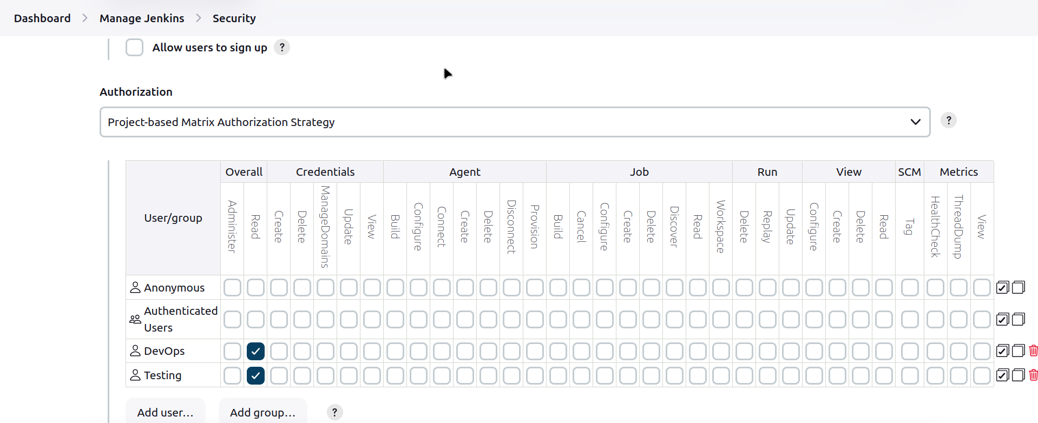

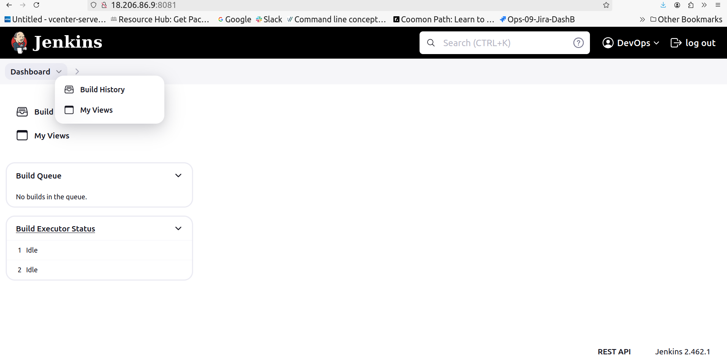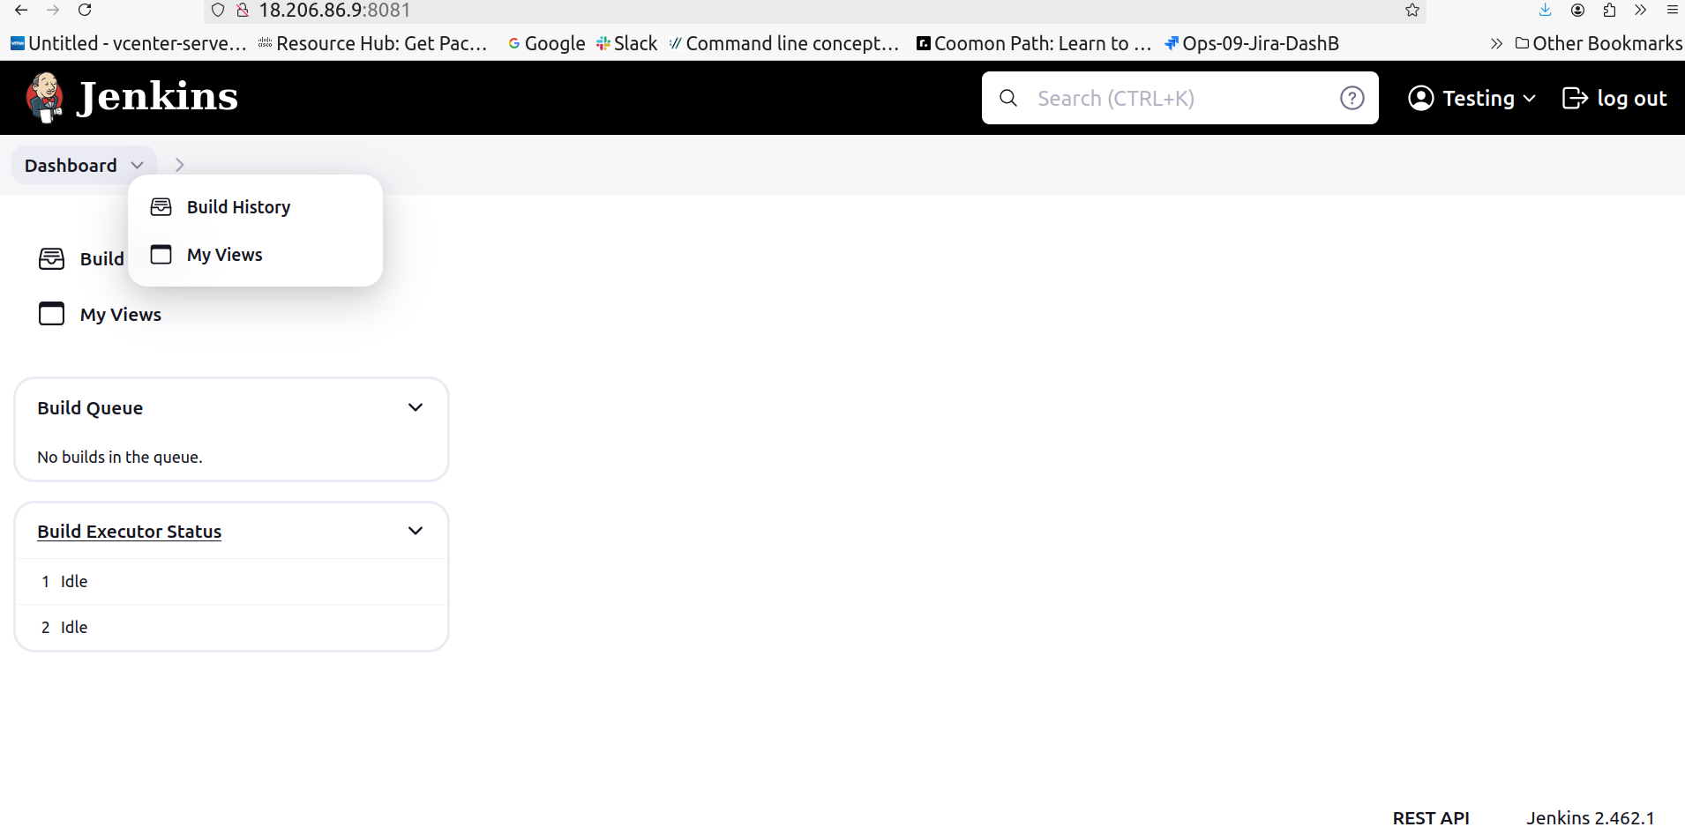

Task: Configure Labels and Restrict the jobs to execute based on label only

Dashboard > New Item > name > Freestyle project

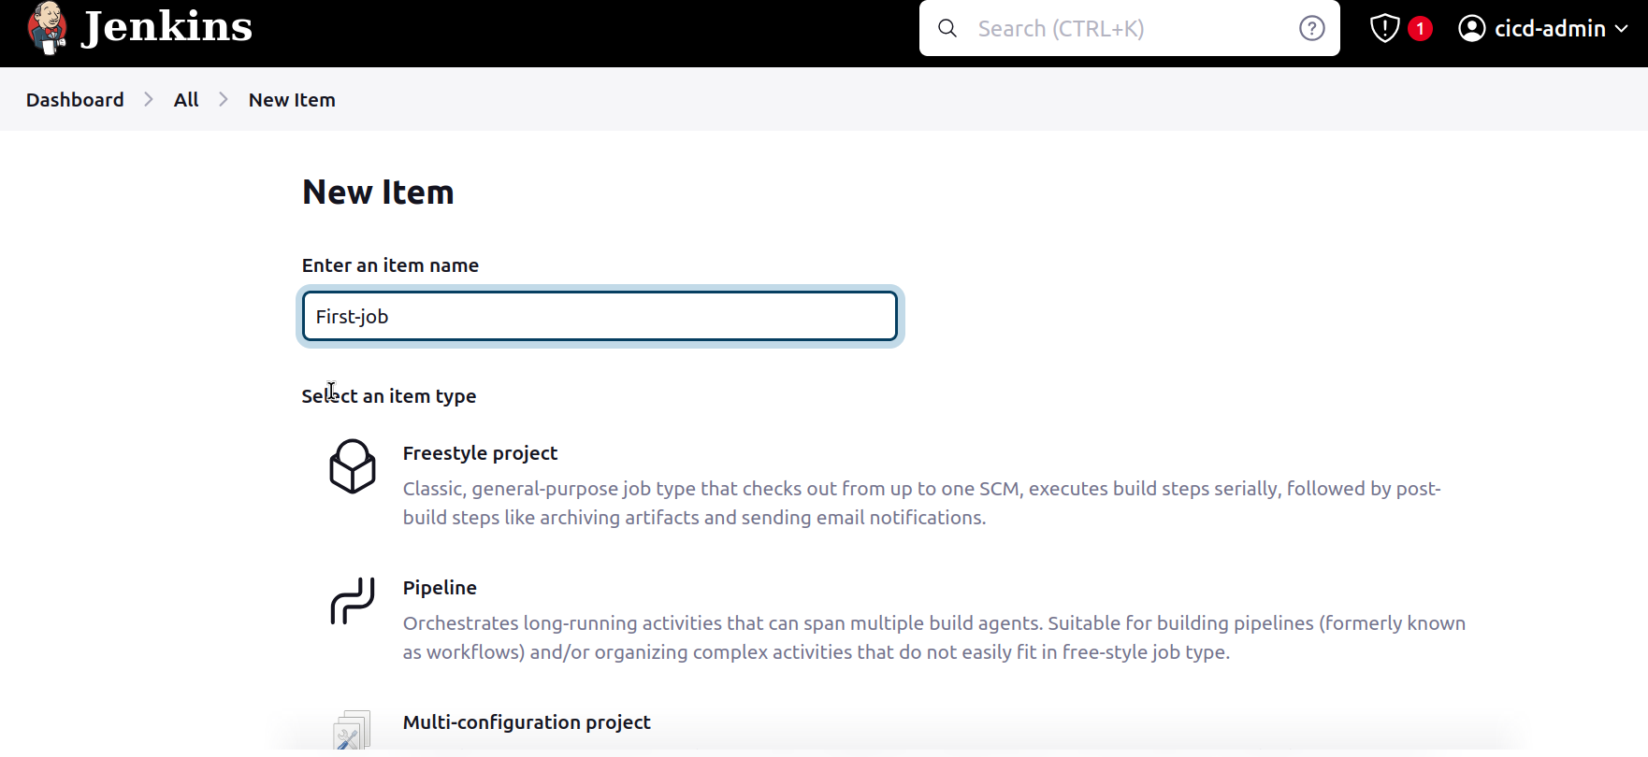

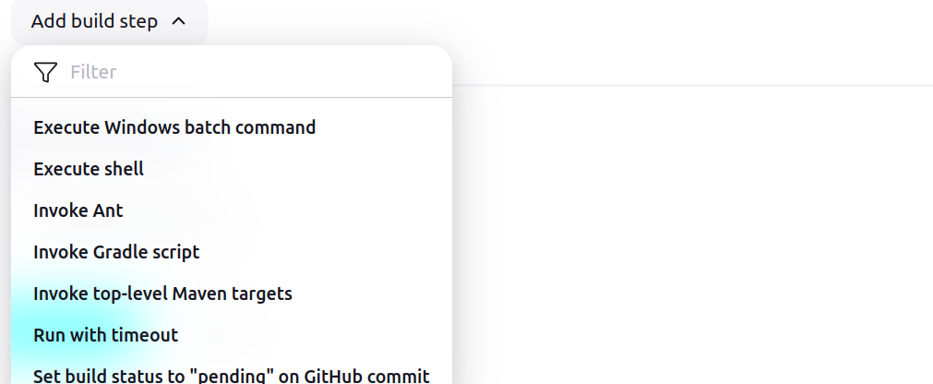

Under Build Steps – select Execute shell since we are using Linux.

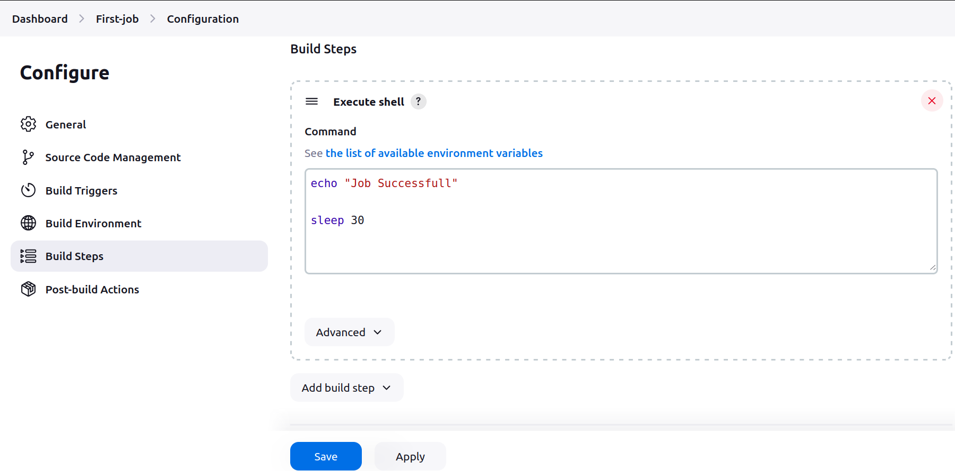  
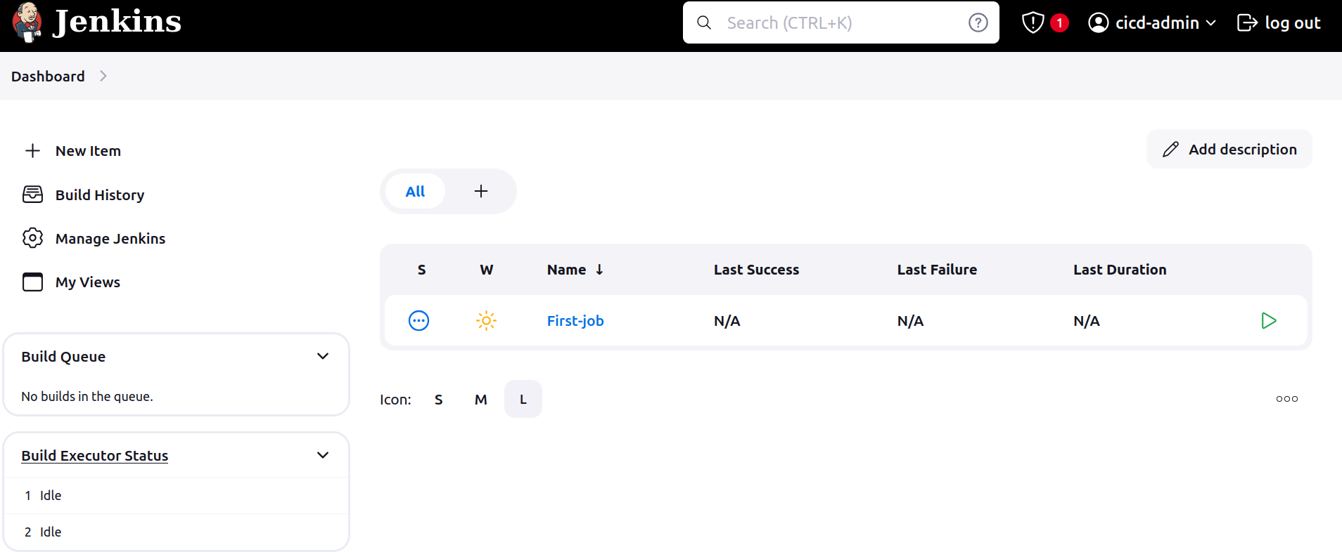  
Job is created but it isn’t executed, once you execute the job workspace will be created on the Jenkins-Server inside the / var / lib / Jenkins /

if you go to job and click on Build Now it will execute the job.

  
Workspace directory is important is lost, we lose the data

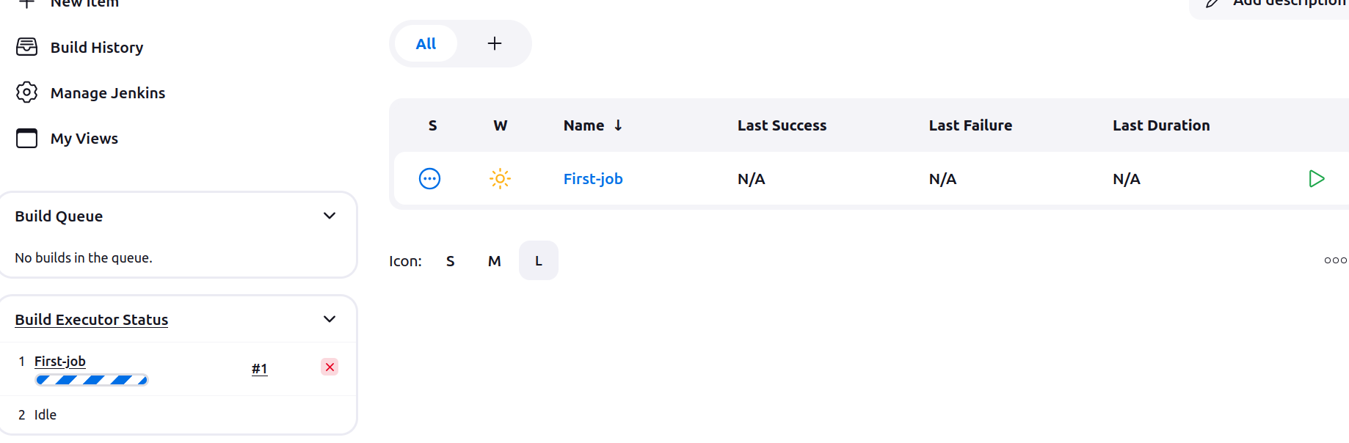

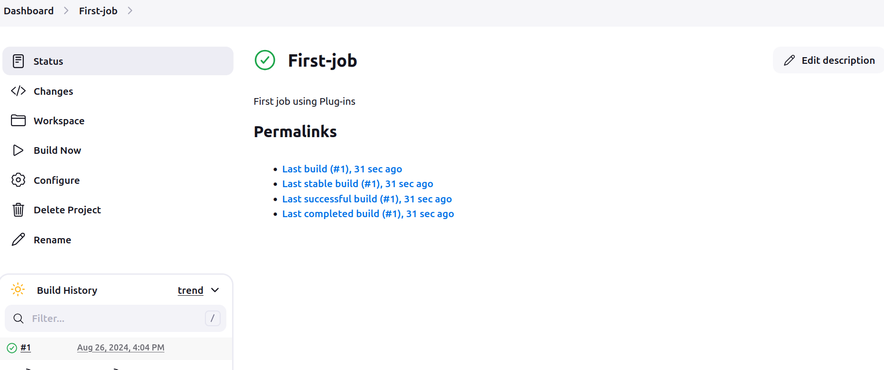

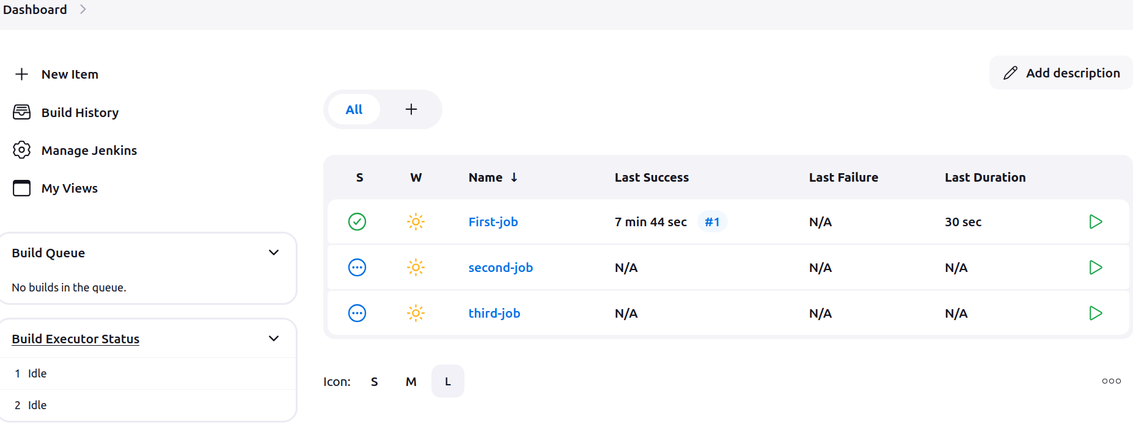

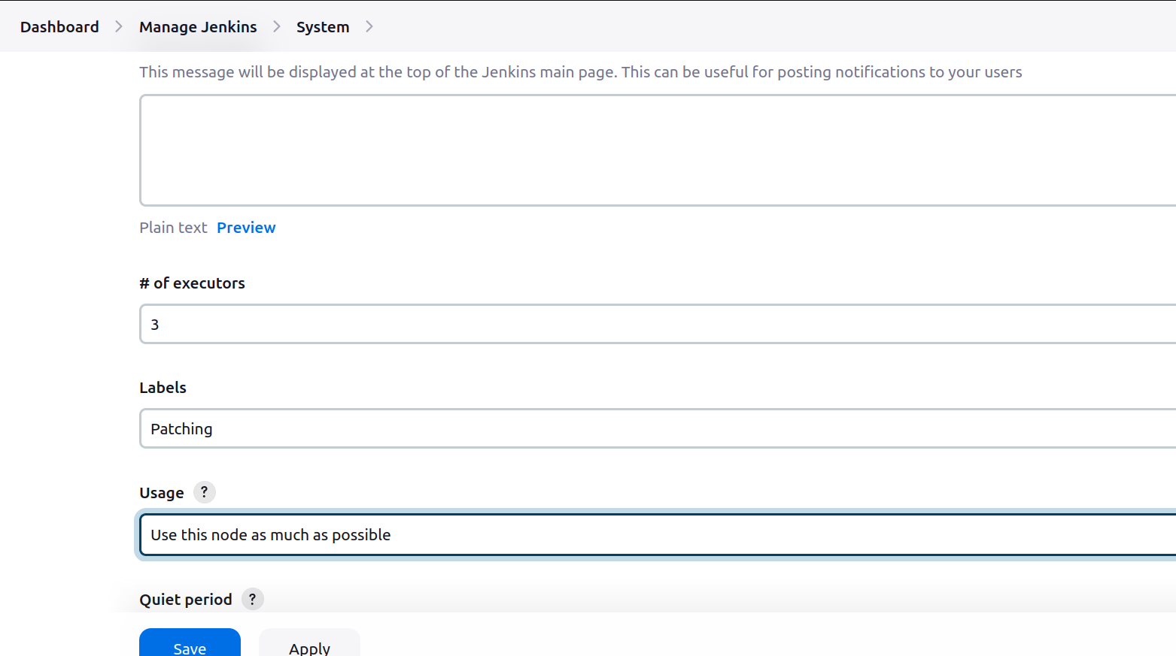  
  
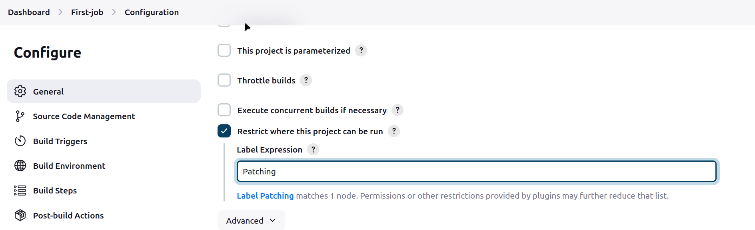

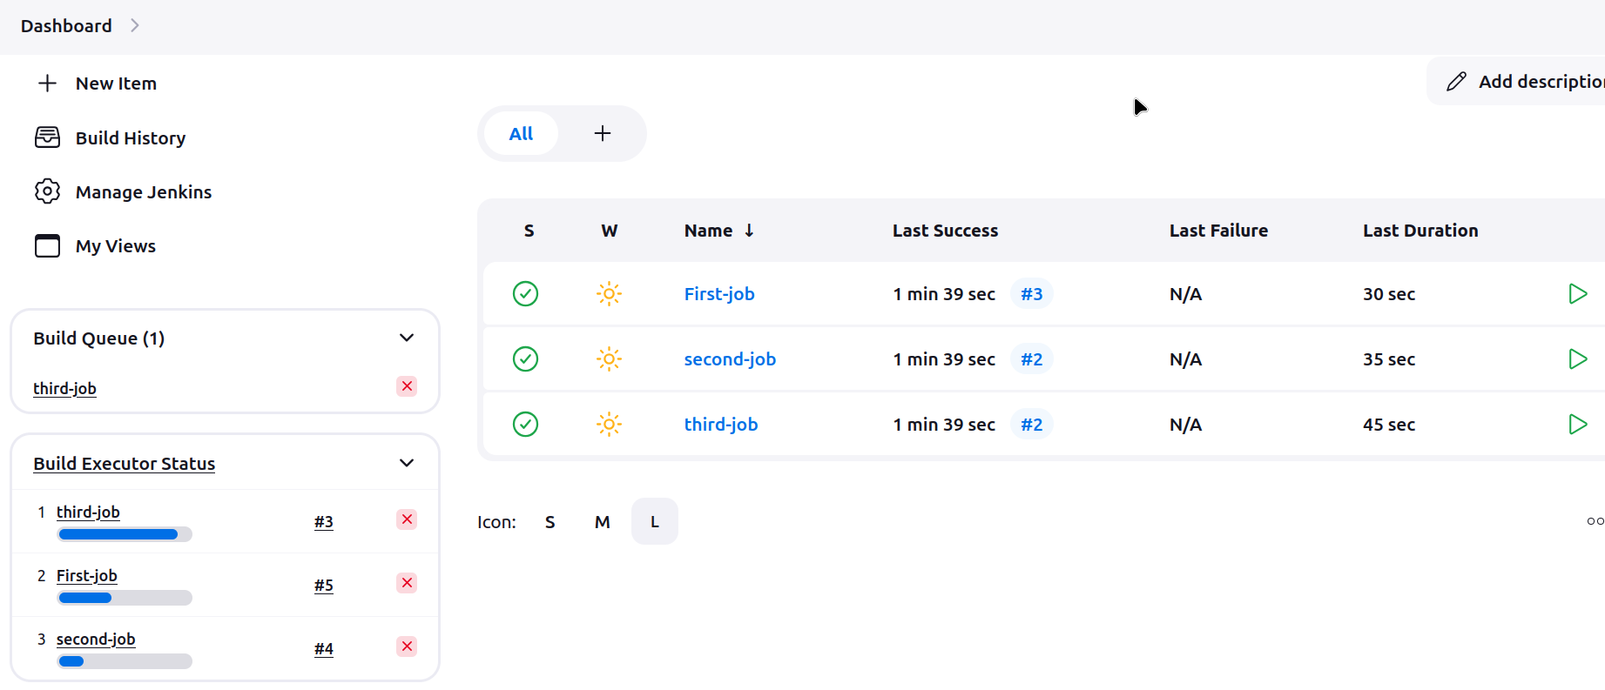

Task: Create Three sample jobs using the below URL

