**Quick check for the distinct value:**

> table(Globepay_Acceptance_Report$state)

ACCEPTED DECLINED

3777 1653

acceptance_rate_over_time <- sqldf("SELECT

+ date_time_as_date,

+ total_attempted_transaction,

+ total_accepted,

+ -- Safe divide logic

+ CASE WHEN (total_attempted_transaction >0 AND

+ total_accepted>0) THEN ROUND(100*1.0*(total_accepted/total_attempted_transaction),2)

+ ELSE 0

+ END AS acceptance_rate

+

+ FROM

+ (

+ SELECT

+ date_time_as_date,

+ COUNT(DISTINCT external_ref) AS total_attempted_transaction,

+ COUNT(DISTINCT CASE WHEN state='ACCEPTED' THEN external_ref ELSE NULL END) AS total_accepted

+ FROM Globepay_Acceptance_Report

+ GROUP BY 1

+ ) AS main "

+ )

> plot_acceptance_rate_over_time <- ggplot(acceptance_rate_over_time, aes(x=(date_time_as_date), y=acceptance_rate)) + geom_line() +

+ ggtitle("Acceptance Rate by Day") +

+ ylab("Percentage Accepted Transaction") +

+ xlab("Day")

> print(plot_acceptance_rate_over_time)

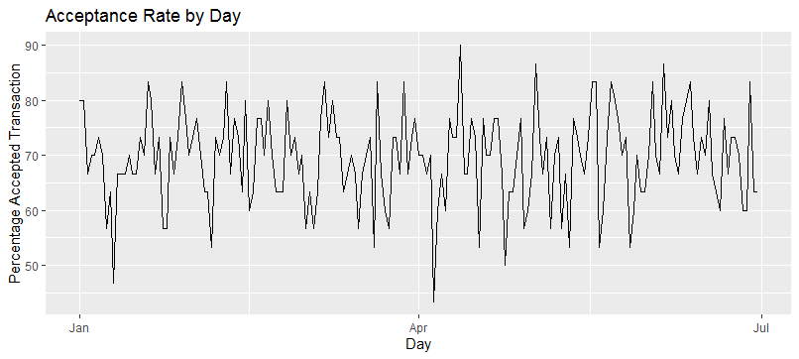

|  |
| --- |
| > declined_amount_by_country <- sqldf("  + SELECT  + country,  + SUM(CASE WHEN state='DECLINED' THEN amount ELSE 0 END) AS total_declined_amount  + FROM Globepay_Acceptance_Report  + GROUP BY 1  + HAVING SUM(CASE WHEN state='DECLINED' THEN amount ELSE 0 END) > 25000000 "  + )  > head(declined_amount_by_country)  country total_declined_amount  1 AE 26335152  2 CA 25583267  3 US 25125670 |
|  |
| |  | | --- | | > | |

|  |  |
| --- | --- |
| country | DECLINED Amount |
| AE | 26,335,152.43 |
| CA | 25,583,266.66 |
| US | 25,125,669.78 |

|  |
| --- |
| dim(Globepay_Chargeback_Report)  [1] 5430 4 |
|  |
| |  | | --- | | >  > table(Globepay_Chargeback_Report$chargeback)  FALSE TRUE  5207 223  Missing Chargeback data:  > missing_charge_backs <- sqldf("  + SELECT  + a.*,  + b.*  + FROM Globepay_Acceptance_Report a  + LEFT JOIN Globepay_Chargeback_Report b ON (a.external_ref = b.external_ref)  + WHERE b.external_ref IS NULL  + "  + )  > dim(missing_charge_backs)  [1] 0 17 | |

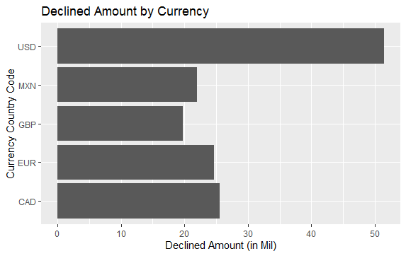

> declinced_volume_amount <- sqldf("

+ SELECT

+ currency,

+ SUM(CASE WHEN state='DECLINED' THEN amount ELSE 0 END) / 1000000 total_declined_amount

+ FROM Globepay_Acceptance_Report

+ GROUP BY 1

+ "

+ )

> plot_declinced_volume_amount <- ggplot(declinced_volume_amount, aes(y=(currency), x=total_declined_amount)) + geom_bar(stat = "identity") +

+ ggtitle("Declined Amount by Currency") +

+ ylab("Declined Amount (in Mil)") +

+ xlab("Currency")

> print(plot_declinced_volume_amount)

> plot_declinced_volume_amount <- ggplot(declinced_volume_amount, aes(y=(currency), x=total_declined_amount)) + geom_bar(stat = "identity") +

+ ggtitle("Declined Amount by Currency") +

+ xlab("Declined Amount (in Mil)") +

+ ylab("Currency Country Code")

> print(plot_declinced_volume_amount)

|  |  |  |
| --- | --- | --- |
| country | DECLINED Amount | % Distribution |
| AE | 26,335,152.43 | 18.37% |
| CA | 25,583,266.66 | 17.85% |
| FR | 24,609,910.18 | 17.17% |
| MX | 21,970,362.99 | 15.33% |
| UK | 19,713,233.74 | 13.75% |
| **US** | **25,125,669.78** | **17.53%** |

|  |  |  |
| --- | --- | --- |
| **currency** | **DECLINED** | **% Distribution** |
| CAD | 25,583,266.66 | 17.85% |
| EUR | 24,609,910.18 | 17.17% |
| GBP | 19,713,233.74 | 13.75% |
| MXN | 21,970,362.99 | 15.33% |
| **USD** | **51,460,822.21** | **35.90%** |

Key Notes:

* Apparently, significantly higher percentage of USD currency getting declined arising from countries other than USA itself (namely AE).
* Another reason to ask when country like AE is paying in USD instead of local currency.
* Is that a normal course of business? Or a slight deviation from the normal course.
* Acceptance rate took a sharp decline from April to June. Besides, that downward trend, the acceptance rate paints a steady picture (averaging around mid to late 50s)