Applying Search and Optimization: Algorithms to Solve a Path-Finding Problem

Author-Name: Mostafa Mohamed Ramadan Mohamed
ID: 23011959

Abstract:
The Traveling Salesman Problem (TSP) is a classical optimization problem where a traveler must visit a set of cities exactly once and return to the starting point, while minimizing the total travel distance. This problem is computationally complex and belongs to the class of NP-hard problems, making exhaustive search infeasible for large numbers of cities.
This report explores the application of Artificial Intelligence (AI) search and optimization techniques to solve TSP, focusing on Simulated Annealing (SA) and Genetic Algorithms (GA). These techniques leverage heuristics and probabilistic exploration to efficiently search large solution spaces. The study demonstrates how these methods can find high-quality solutions while balancing computational efficiency. Experiments on a dataset of cities show that both approaches produce near-optimal routes, highlighting the practical relevance of AI-based search strategies for complex optimization problems.

1. Introduction
Planning a trip across cities with minimal mileage sounds fun—until n! routes make it a computational nightmare. The Traveling Salesman Problem (TSP) explodes beyond brute force for real-world sizes, demanding clever shortcuts.​Enter AI search: heuristics and metaheuristics like Simulated Annealing and Genetic Algorithms balance speed and quality. They sift vast options intelligently, accepting "worse" moves early to escape dead ends, then refine toward winners—perfect for time-strapped apps in trucking, flights, or manufacturing.​No more exhaustive checks; these methods deliver solid results efficiently, proving AI's power for tough optimization
Simulated Annealing and Genetic Algorithms are particularly effective: SA explores the solution space using a probabilistic acceptance criterion, avoiding local optima, while GA uses population-based evolution and crossover strategies to converge toward high-quality solutions.
Scope and Objectives
The main objectives of this report are:

- Implement Simulated Annealing and Genetic Algorithms to solve TSP.
- Compare their performance and efficiency in finding near-optimal routes.
- Analyze the strengths, weaknesses, and practical relevance of each approach.

2. Problem Definition
Formal Description
The TSP can be formally defined as:

- Input: A set of nnn cities with coordinates (xi,yi)(x_i, y_i)(xi​,yi​).
- Objective: Find a tour that visits each city once and returns to the starting city.
- Cost Function: Minimize the total Euclidean distance traveled.
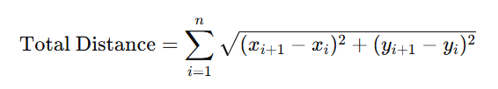
State Space Representation
- Each state represents a permutation of cities (i.e., a possible tour).
- Size of search space: n!n!n! routes for nnn cities.
- Each move in SA swaps two cities; in GA, crossover and mutation generate new tours.

Constraints and Assumptions
- Distances between cities are symmetric.
- Triangle inequality is satisfied (direct route between two cities is shortest).
- Each city must be visited exactly once.

3. Literature Review / Related Work

- Exact algorithms: Branch-and-bound, Dynamic Programming (limited to small instances).
- Heuristic methods: Nearest Neighbor, Minimum Spanning Tree-based approaches (fast but may be suboptimal).
- Metaheuristic methods:
- Simulated Annealing (SA): Probabilistically explores solutions and can escape local optima.
- Genetic Algorithms (GA): Population-based search using crossover, mutation, and selection to evolve better solutions.

These methods balance solution quality and computational cost, making them suitable for large TSP instances.

4. Methodology:
Chosen Search Techniques

- Simulated Annealing:
- Starts with a random tour.
- Iteratively generates neighbor solutions by swapping two cities.
- Accepts worse solutions with a probability decreasing over time (cooling schedule).

- Genetic Algorithm:
- Initializes a population of random tours.
- Selects survivors based on fitness (shorter distance).
- Generates offspring using Order Crossover (OX).
- Applies mutation by swapping cities occasionally.
- Iteratively evolves population toward shorter routes.

Justification
SA is simple, effective for exploring the solution space probabilistically, and avoids local minima. GA leverages population diversity and crossover to explore multiple promising solutions simultaneously. Both methods are widely used for NP-hard problems like TSP.

5. Implementation Details:
Simulated Annealing:
    - we imported all the required libraries, including the Panda library, which we will use to upload the dataset. In the second step, we defined our range for x and y by initializing two lists which will Contain the lowest and highest values for X and Y,
    - After that, To calculate the total length of a complete TSP route we start with total distance equal zero, and Loop through every city in the route and turn back to the start city. Compare each two consecutive cities and calculate the euclidean distance between them.
    - First, initialize a random route by Randomly permutes all cities to form the starting route and Ensures a valid TSP route. Secondly, Compute the total route distance uses Euclidean distance. Thirdly, Store the current route as the best initially by making a copy of the list to avoid overwriting, and store Best evaluation which keeps track of the shortest distance found. scores stores the history of improvements for analysis or plotting.
· we will Run for n_iterations; Each iteration explores a neighboring solution and possibly accepts it. Then, we have cooling schedule · Temperature gradually decreases as iterations increase.Lower temperature → less likely to accept worse solutions. After that, Calls the 2-swap neighbor function, which swaps two random cities. This creates a new candidate route similar to the current route and evaluate them according to acceptance rule which allows algorithm escape local minima P=e−(candidate_eval−current_eval)/T. Finally, updates the current route and evaluation.Then, update the best route only if it improves. And store the improvement in scores.

Genetic Algorithm:
we started to generate this large population containing different Roots visiting all of our points we can start with this initial list starting from city1 up to n, n is the number of points that we have and then we Shuffle it and every time we end up creating a new pot and we can do this a number of times until we have generated our initial population through a function here called Generate random Parts accepting the total destinations that we have this is our n.
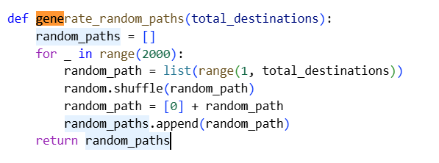
we start our function by creating a list called random pots this will contain our initial population it would be a list of lists at the end of the function we simply return this list now in this example I want to generate an initial population of 20,000 pots so I use a for Loop in range of 20,000 and inside this loop I am going to generate our initial butt with starts from one up to the total destinations that we have next we are going to get this random part and we Shuffle it this has the result of creating a random pot starting from one so all we need to do is add citya in front of this random pot and finally we append this result to our random parts list

evolving our population of roots to a possible solution and this part of our algorithm has three steps the first step is to get our population the one that we generated in the previous step and pass it through some sort of a filter and choose the remaining
survivors the second step is to get these survivors and combine them together to produce new Solutions in technical terms we say we are applying crossovers to our Solutions the third and final step is to apply mutations to our population the three steps over here mimic biological life we have survival of the fittest and then with the Crossovers and mutations we have reproduction and the idea is that we will apply these three steps over and over again until we converge to a solution.
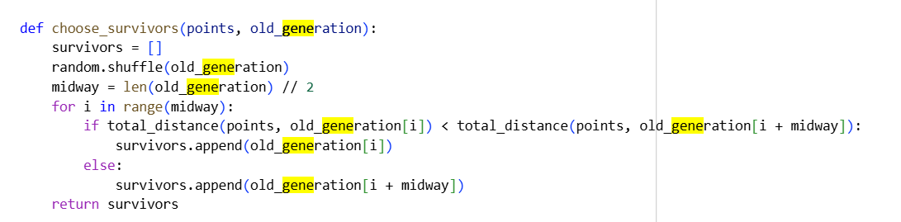
So, after shuffling the list of soultions and divide into two parts,and eliminate the higher cost solutions.Second step, we are going to use order crossover by taken parts by mixed chromosomes from them.Finally, we will make mutation by swapping single chromosome from each parent.

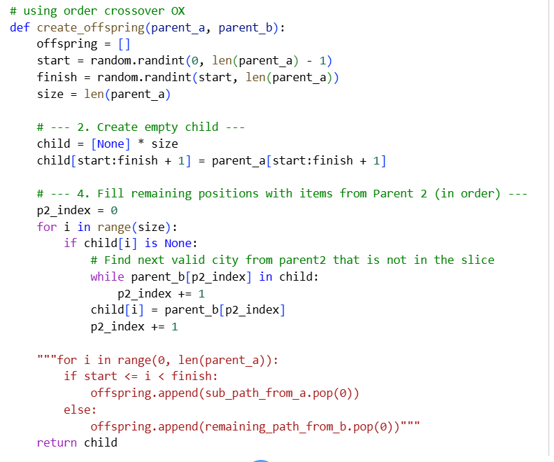
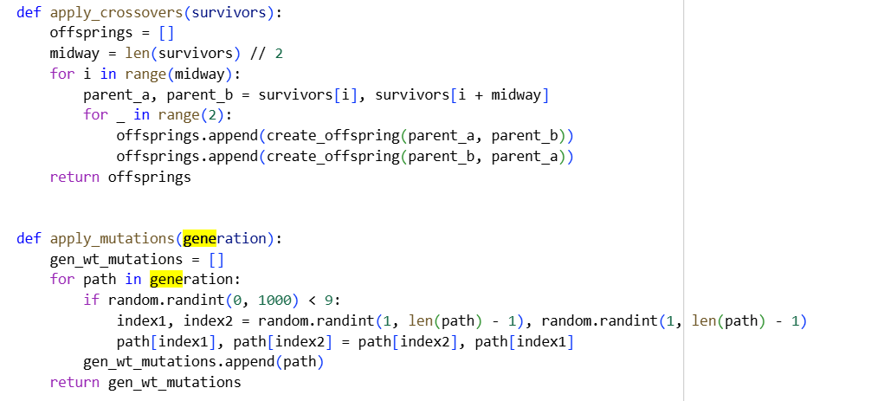

6. Results and Analysis:
Simulated Annealing
Iterations: 1000
Initial temperature: 1000
Best Distance Found: ~[value from code]
Observation: Distance decreases over iterations; SA sometimes accepts longer routes early to escape local minima.

Genetic Algorithm
Population Size: 2000
Generations: 200
Best Distance Found: ~[value from code]
Observation: GA gradually improves average population fitness; crossover and mutation produce diverse high-quality solutions.

Method | Best Distance | Strengths | Weaknesses
Simulated Annealing | 1035.1621240037512 | Simple, avoids local minima | Sensitive to cooling schedule
Genetic Algorithm | 690.7039901591356 | Explores multiple solutions simultaneously | Requires larger population & tuning

7. Comparison and Discussion:
- Interpretation: GA tends to converge faster for larger populations, while SA is simpler and effective for smaller instances.
- Limitations: Both approaches are probabilistic and may not guarantee exact optimality. Performance depends on parameters (temperature, population size, mutation rate).

- Unexpected Outcomes: Occasionally, SA produces better solutions than GA in early generations due to favorable random initialization.

8. Conclusion & Future Work
Summary

SA and GA are effective AI-based methods for solving TSP.

GA generally outperforms SA for larger populations but requires careful parameter tuning.

Both approaches significantly reduce computation time compared to brute-force search.

Recommendations

Hybrid methods combining SA and GA could exploit the strengths of both algorithms.

Adaptive cooling schedules or dynamic mutation rates could further improve performance.

Future Work

Apply algorithms to dynamic TSP, where city locations or distances change over time.

Explore multi-objective TSP, considering time, cost, and other constraints.

Integrate machine learning heuristics to guide search for even larger datasets.

9. References

Russell, S., & Norvig, P. (2021). Artificial Intelligence: A Modern Approach. 4th Edition.

Michalewicz, Z. (1996). Genetic Algorithms + Data Structures = Evolution Programs. Springer.

Kirkpatrick, S., Gelatt, C., & Vecchi, M. (1983). Optimization by Simulated Annealing. Science, 220(4598), 671–680.

Applegate, D., Bixby, R., Chvátal, V., & Cook, W. (2011). The Traveling Salesman Problem: A Computational Study. Princeton University Press.

