Namaz Vakti Desktop Skeleton (Option 1)
Electron + Node + template-first XLSX generation skeleton for:
- Read monthly TSV (paterson_YYYY-MM.tsv)
- Compute grouped iqamah times
- Export XLSX and PNG

Folder Layout
desktop-app/
assets/
templates/
README.md
src/
domain/
types.ts
iqamah-rules.ts
optimizer.ts
grouping.ts
pipeline.ts
main/
index.ts
ipc-handlers.ts
preload/
index.ts
renderer/
index.html
src/
main.ts
global.d.ts
services/
tsv-reader.ts
xlsx-writer.ts
png-renderer.ts
template-map.ts
shared/
ipc.ts
electron.vite.config.ts
package.json
tsconfig.json

IPC Contracts
Defined in src/shared/ipc.ts:
- listMonths(tsvFolder) -> string[]
- previewMonth(options) -> PreviewMonthResponse
- generateOutputs(options) -> { xlsxPath, pngPath, warnings }
- selectTsvFolder() -> string | null
- selectOutputFolder() -> string | null
- selectTemplateFile() -> string | null
GenerationOptions includes:
- month (YYYY-MM)
- tsvFolder, outputFolder, templateFile
- locale (en|tr), timeFormat (ampm|24h)
- baseGroupSize (5|10|15)

Algorithm Interfaces
src/domain/iqamah-rules.ts
- Rule definitions per prayer
- Base group-size validation
src/domain/optimizer.ts
- buildBaseGroups(days, size)
- optimizeIqamahForPrayer(days, rule)
- optimizeGroups(baseGroups, rules)
src/domain/grouping.ts
- collapseAdjacentSameGroups(groups)
- assignColorTokens(baseGroups, theme)
src/domain/pipeline.ts
- buildMonthlyPlan(input) orchestrates full flow: parse minutes -> base groups -> optimize -> collapse -> color sequence.

Implementation Notes
- Optimizer enforces prayer constraints (>= +offset for zhuhr/asr/maghrib/isha, <= -offset from sunrise for fajr) and applies 5-minute quantization except maghrib.
- XLSX writer now uses concrete Odd/Even sheet maps from the provided template and preserves template styles by copying source row styles.
- PNG export is generated from a hidden offscreen BrowserWindow for deterministic capture.

Application Screenshots
The following screenshots show the same application state in English and Turkish. The language switch changes the user interface labels while the generated-output language remains an independent setting in the Advanced section.

Basic window
The basic window provides the location, month, mosque information, announcement, and output controls without expanding the advanced settings.
English | Turkish
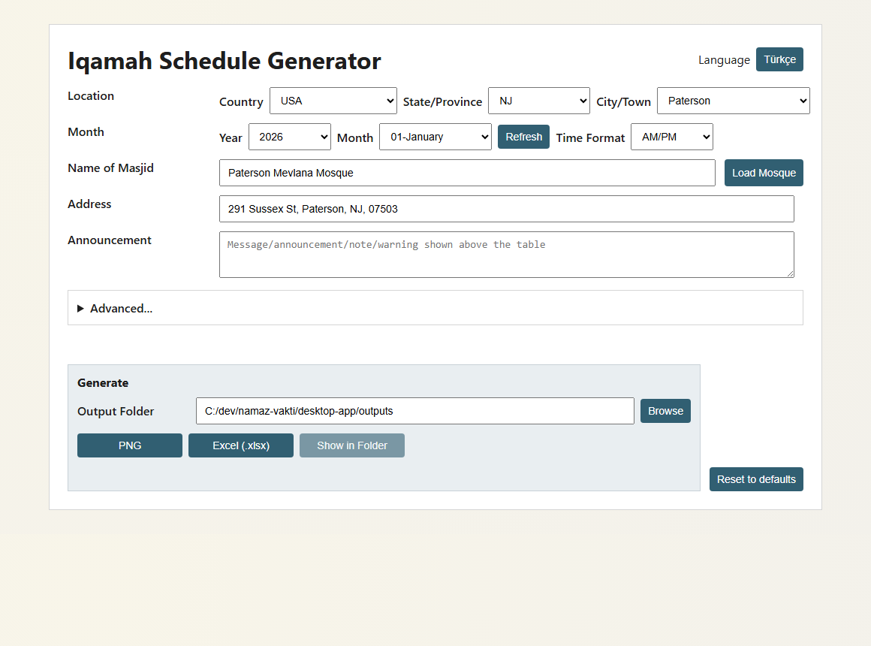 | 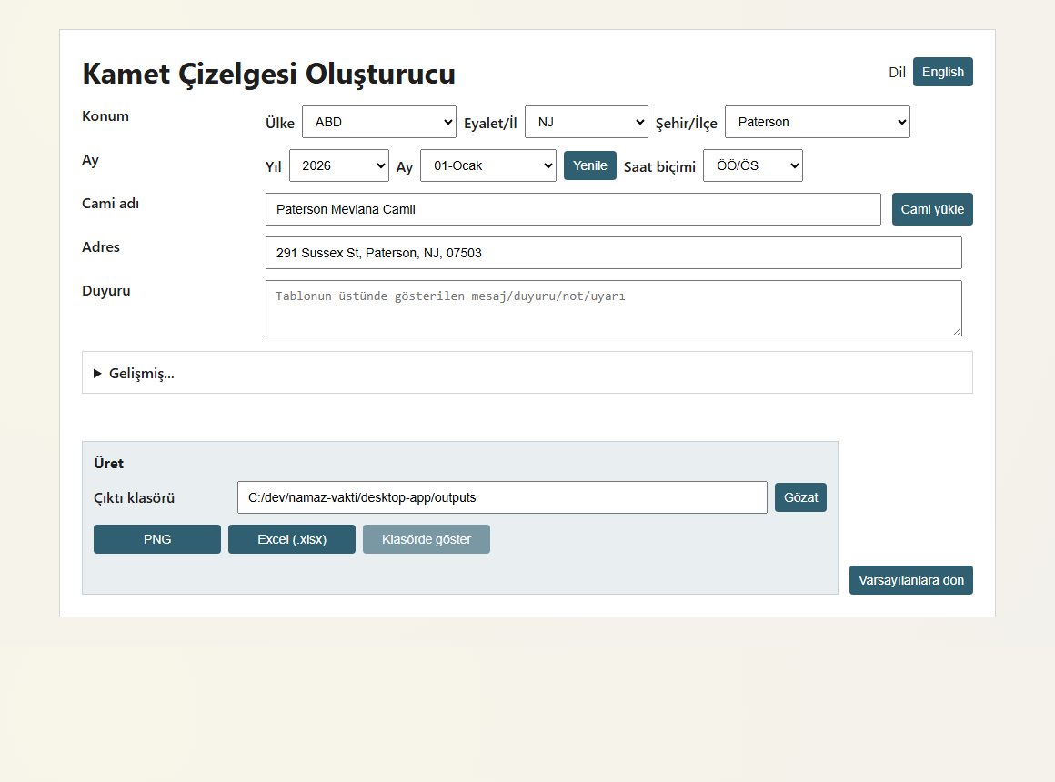

Advanced section opened
The Advanced section exposes the generated-content language, base group size, Ramadan calculation option, and the entry point to prayer-time customization.
English | Turkish
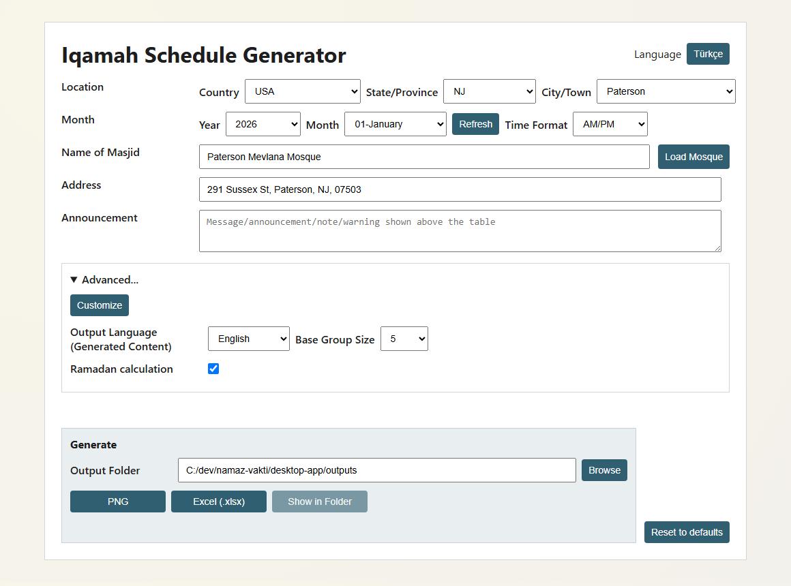 | 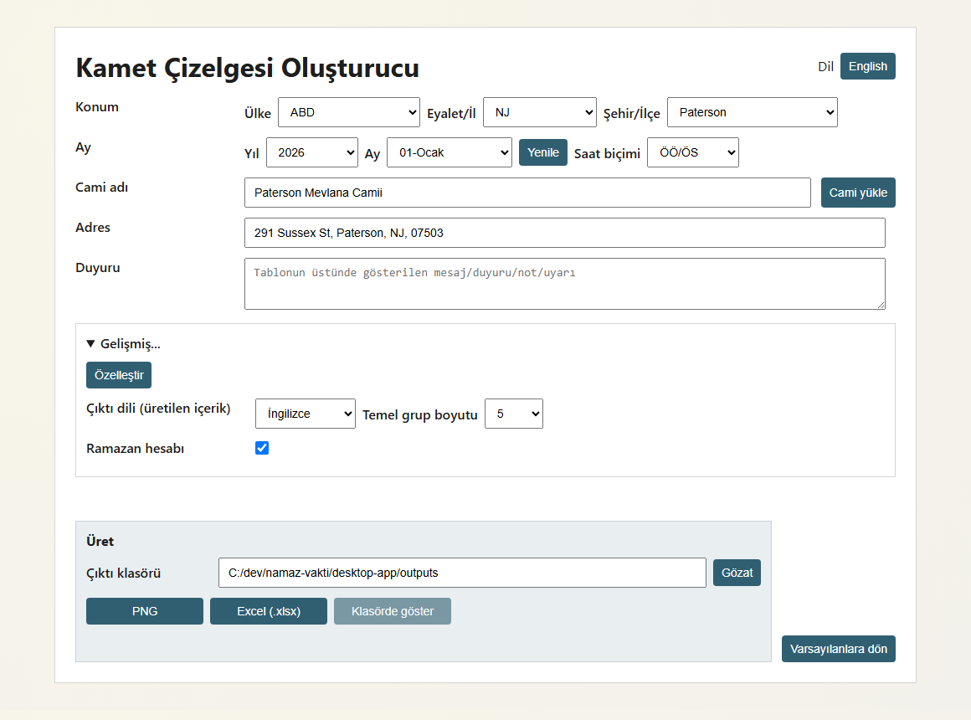

Customize window opened
The Customize dialog lets each prayer be enabled or disabled and adjusts its direction, minute offset, rounding multiple, and optional earliest/latest limits.
English | Turkish
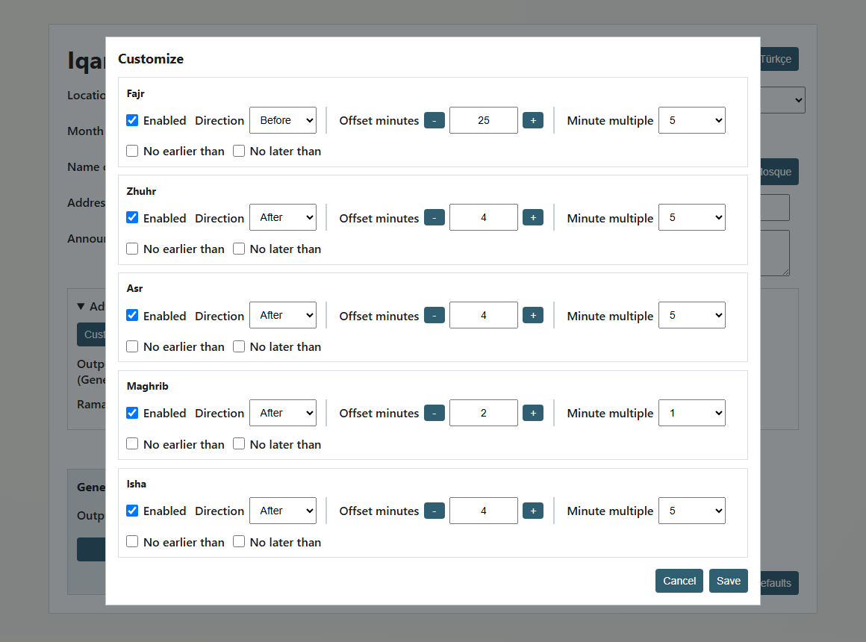 | 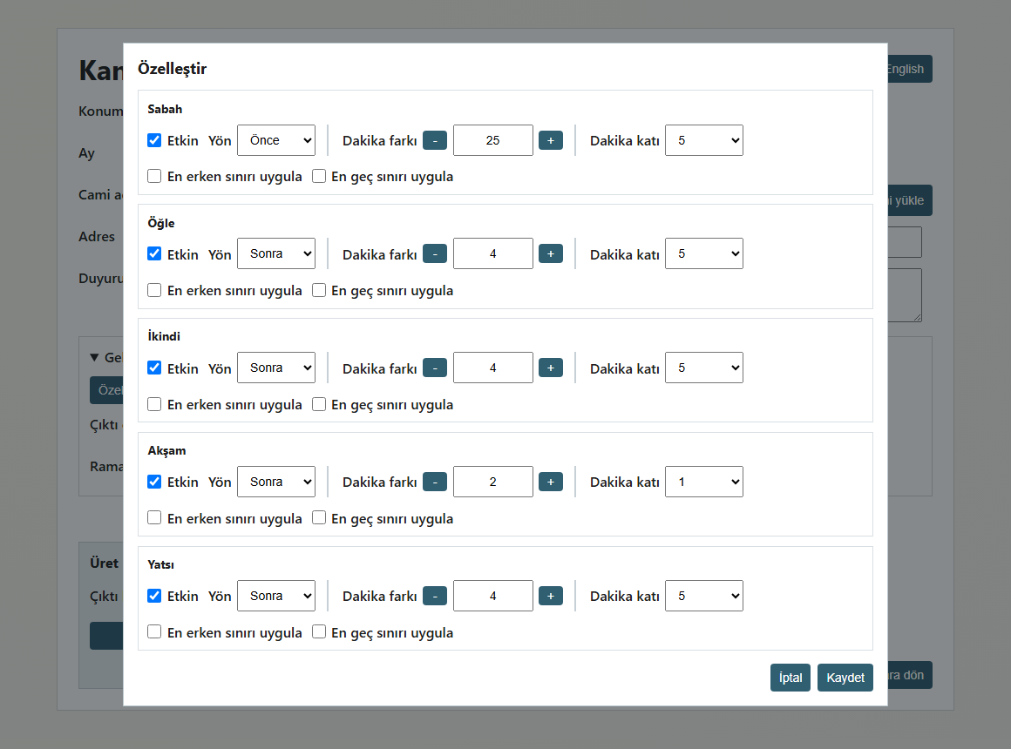

Schedule snapshots
These examples show the exported schedule layout for an odd-numbered month (January 2026) and an even-numbered month (February 2026). The odd-month example displays Turkish schedule headings; the even-month example keeps the English output labels. The alternating colored blocks represent groups of days that share the same calculated iqamah values.
Odd month — Turkish output | Even month — English output
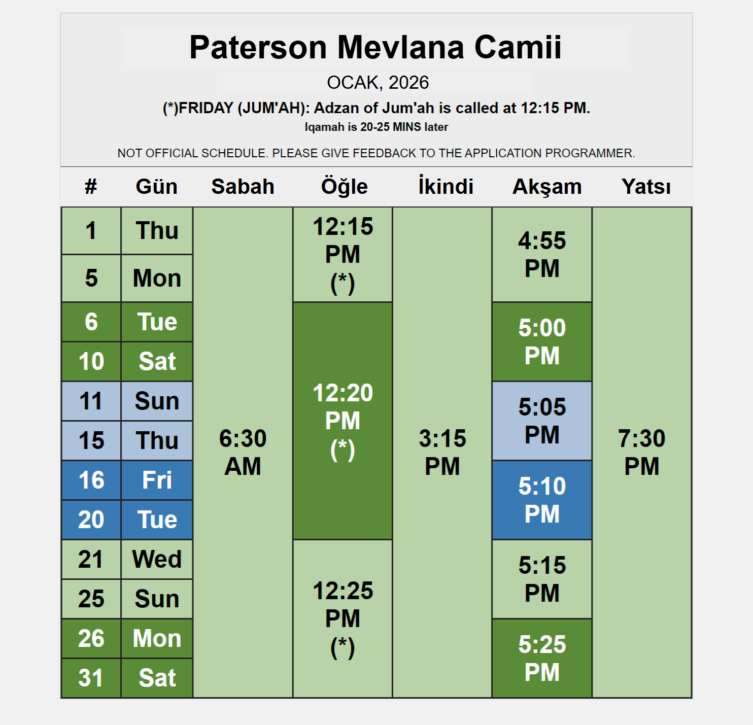 | 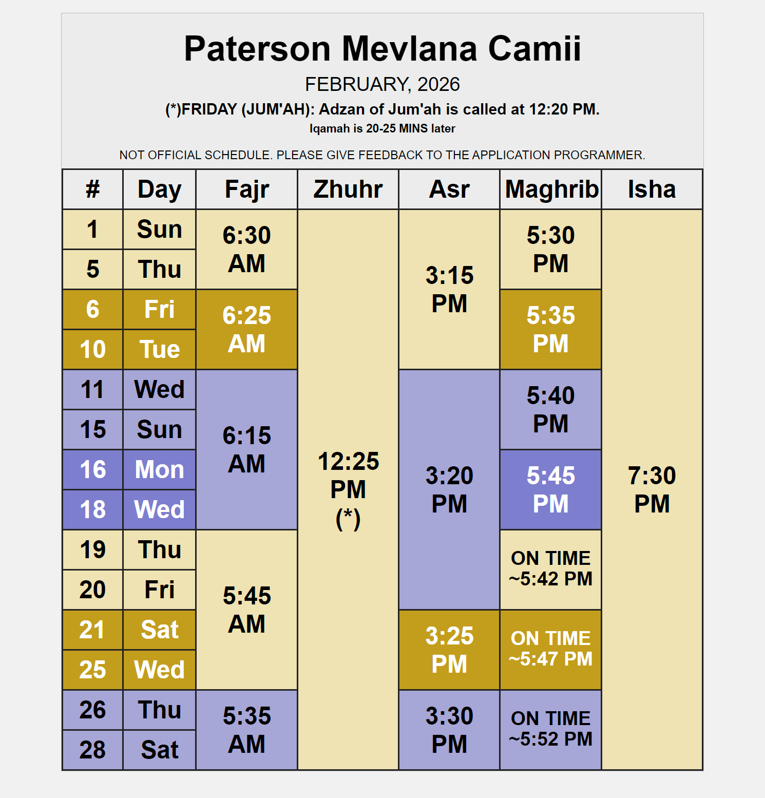

Run
cd desktop-app
npm install
npm run dev

Next Coding Step
- Finalize template mapping (src/services/template-map.ts) using named ranges or stable coordinates.
- Implement full XLSX write logic in src/services/xlsx-writer.ts.
- Render a dedicated print view for PNG export.
- Add unit tests around optimizer.ts and grouping.ts.

