PROJECT

STUDENT FEEDBACK SYSTEM

Group members

Mustafa sp23-bse-067

Ahmad sp23-bse-05

Fahad sp23-bse-063

### ****Overview****

A **modern JavaFX-based desktop application** that allows students to submit feedback about courses and teachers, while faculty and admins can view and analyze feedback reports.

### ****Key Features****

✔ **User Roles** (Student, Teacher, Admin) with different dashboards  
✔ **Secure Login** with password authentication  
✔ **Feedback Submission** with ratings (1-5) and comments  
✔ **Responsive GUI** with a web-like attractive interface  
✔ **Database Integration** (MySQL) for storing users and feedback  
✔ **OOP Principles** (Encapsulation, Inheritance, Polymorphism, Abstraction)

### ****Tech Stack****

**Frontend**: JavaFX (for modern UI components)

**Backend**: Java (JDBC for database connectivity)

**Database**: MySQL (stores user accounts and feedback)

**Security**: Password hashing (basic implementation

Student Feedback System - General Components 1

1. User Roles 1

2. Core Features 1

3. Technical Requirements 1

4. Optional Enhancements 1

Chapter No 1 3

INTRODUCTION 3

Student Feedback System - General Components 3

1. User Roles 3

2. Core Features 3

3. Technical Requirements 4

4. Optional Enhancements 4

Chapter 2 4

Usecase 4

Fahad sp23-bse-063 4

Mustafa Sp23bse-067 5

Ahmad sp23-bse-59 6

Chapter 3 7

Fully addressed 7

Fahad sp23-bse-063 7

Mustafa kamal sp23-bse-067 8

Ahmad sp23-bse-059 10

Chapter 3 11

SSD 11

Fahad sp23-bse-063 11

Mustafa sp23-bse-067 12

Ahmad sp23-bse-059 12

Chapter 4 13

Class diagram 13

Fahad sp23-bse-063 13

MUSTAFA SP23-BSE-067 14

AHMAD SP23-BSE-059 15

Chapter 5 16

Communication diagram 16

FAHAD SP23-BSE063 16

Mustafa sp23-bse-067 17

AHMAD SP23-BSE-059 17

# Chapter No 1

## INTRODUCTION

# ****Student Feedback System - General Components****

### ****1. User Roles****

**Students** – Submit feedback on courses/teachers.

**Teachers/Faculty** – View feedback reports

**Admin** – Manages users & system settings

### ****2. Core Features****

**Authentication** (Login/Signup for students & faculty).

**Feedback Submission Form** (Ratings + Comments).

**Dashboard** (View feedback analytics for teachers/admins).

**Admin Panel** (User management, feedback moderation).

### ****3. Technical Requirements****

**Frontend**: JavaFX (for modern UI components)

**Backend**: Java (JDBC for database connectivity)

**Database**: MySQL (stores user accounts and feedback)

**Security**: Password hashing (basic implementation)

### ****4. Optional Enhancements****

Email notifications (feedback submission/updates).

Charts/Graphs for feedback visualization.

Anonymous feedback option.

This system automates feedback collection and analysis for educational institutions

# Chapter 2

## Usecase

### Fahad sp23-bse-063

Feedback form

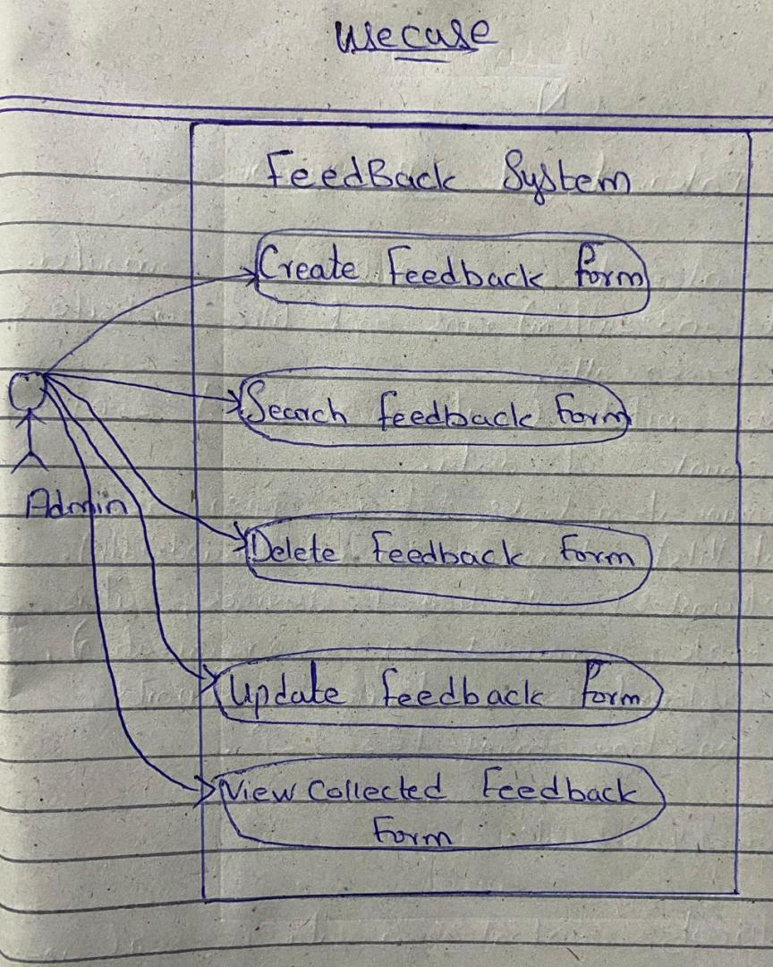

### Mustafa Sp23bse-067

Login

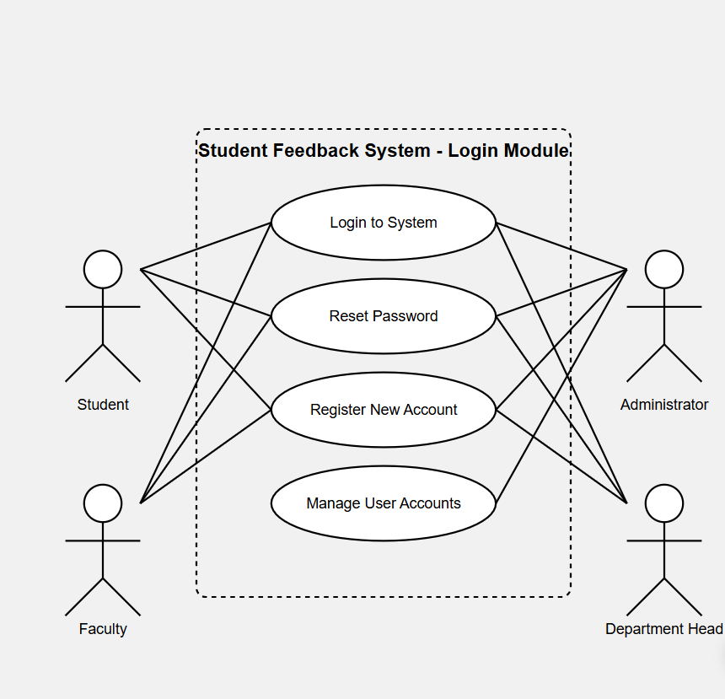

### 

### Ahmad sp23-bse-59

Submit course feedback

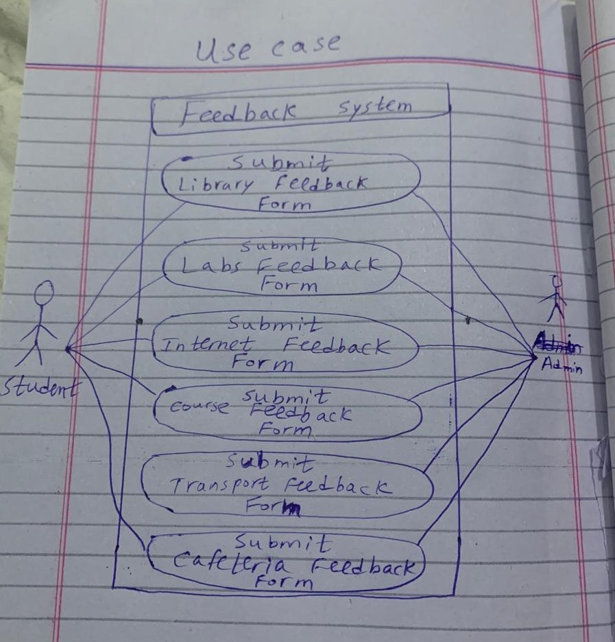

# 

# Chapter 3

## Fully addressed

### Fahad sp23-bse-063

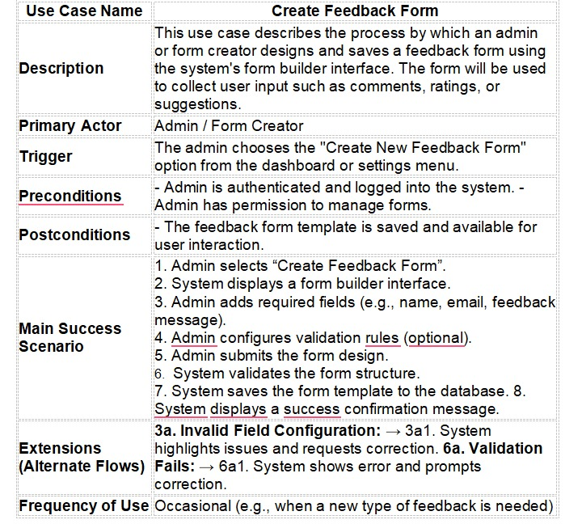

### 

### Mustafa kamal sp23-bse-067

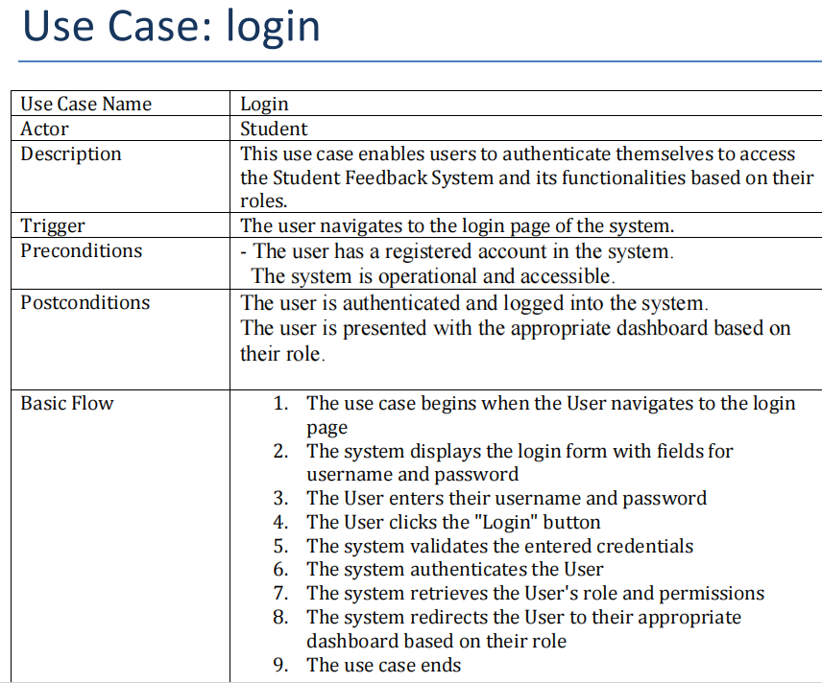

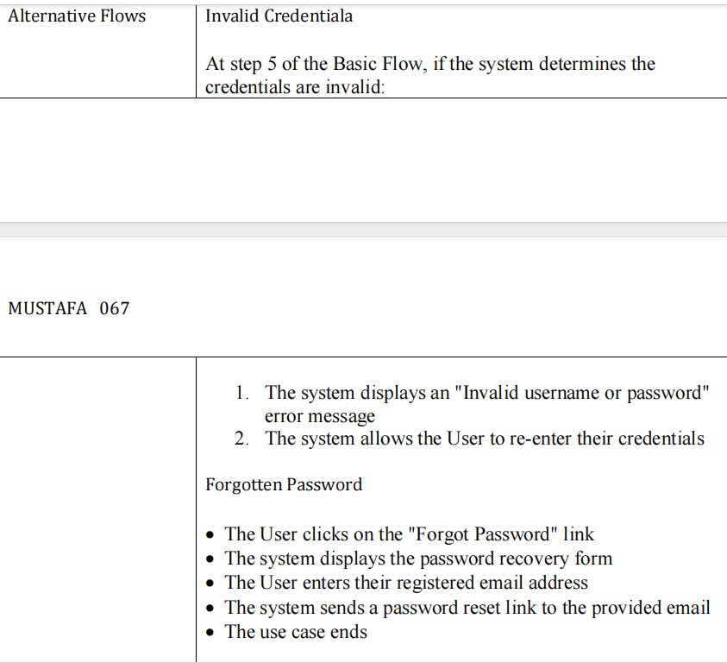

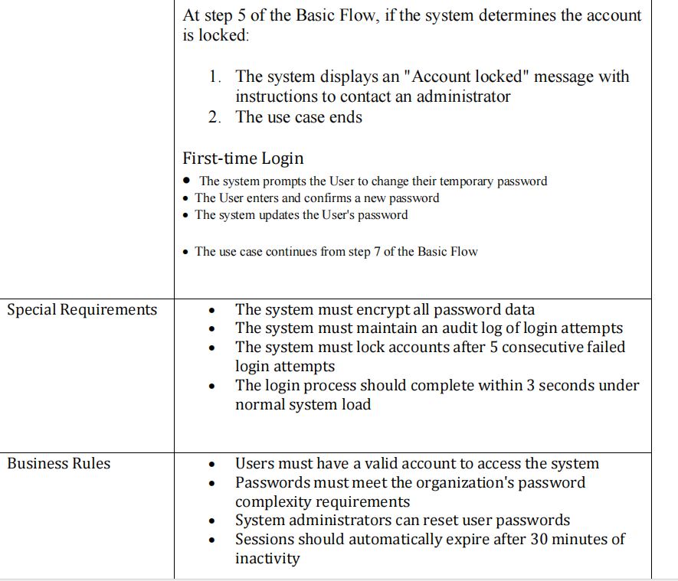

### Ahmad sp23-bse-059

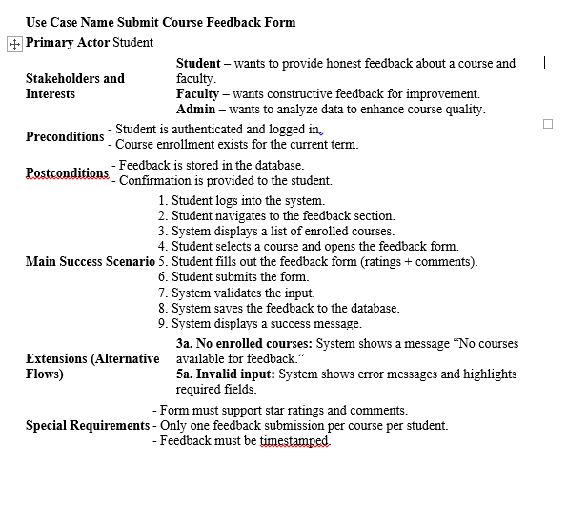

# 

# Chapter 3

## SSD

### Fahad sp23-bse-063

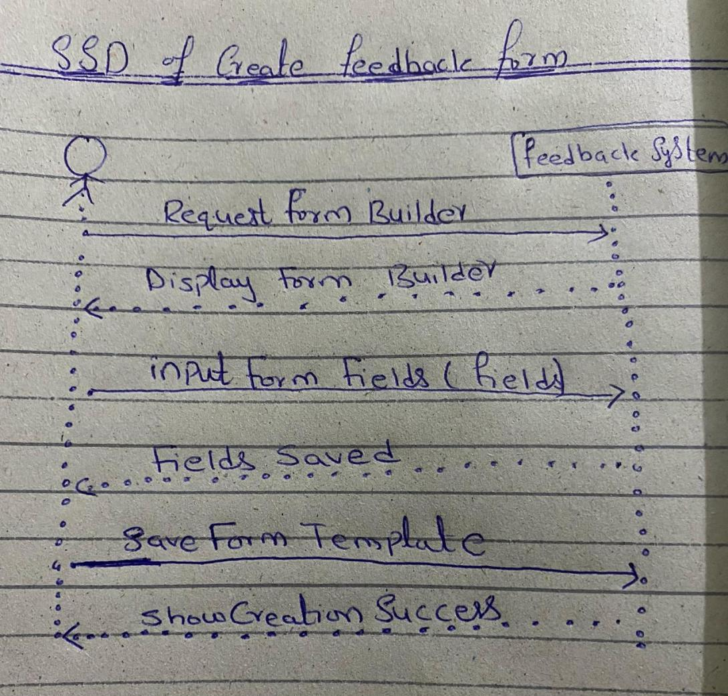

### 

### Mustafa sp23-bse-067

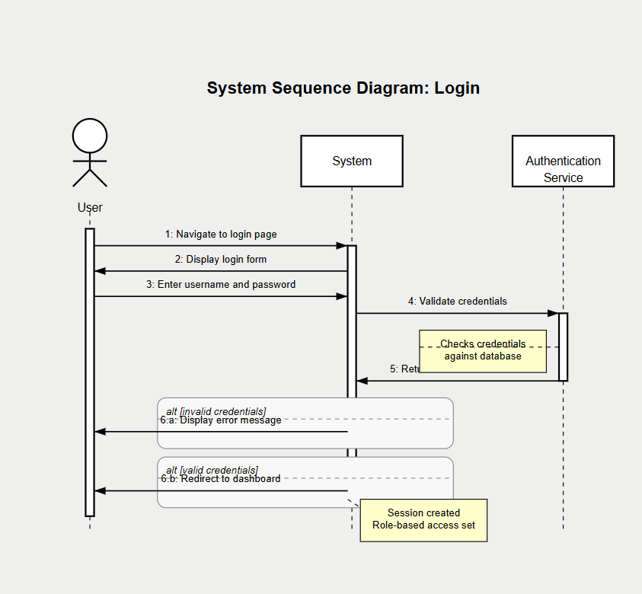

### 

### Ahmad sp23-bse-059

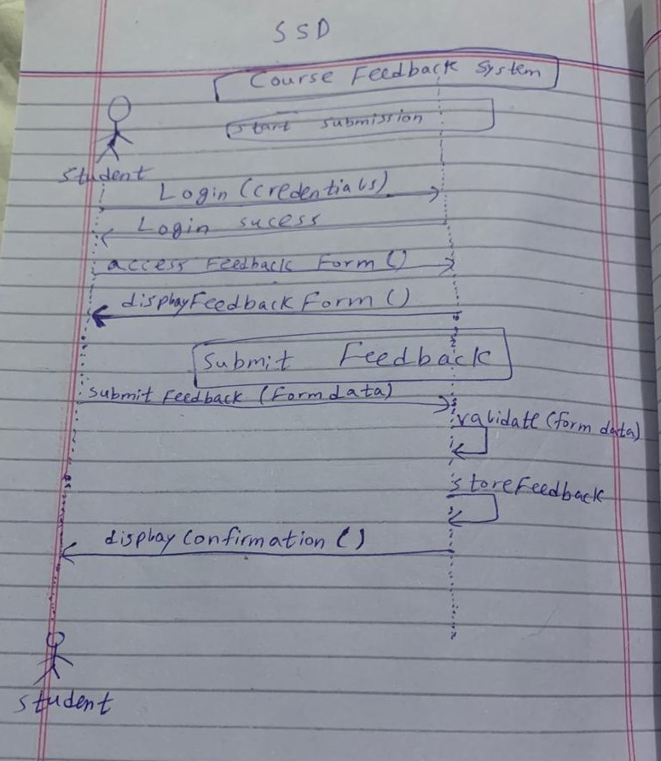

# 

# Chapter 4

## Class diagram

### Fahad sp23-bse-063

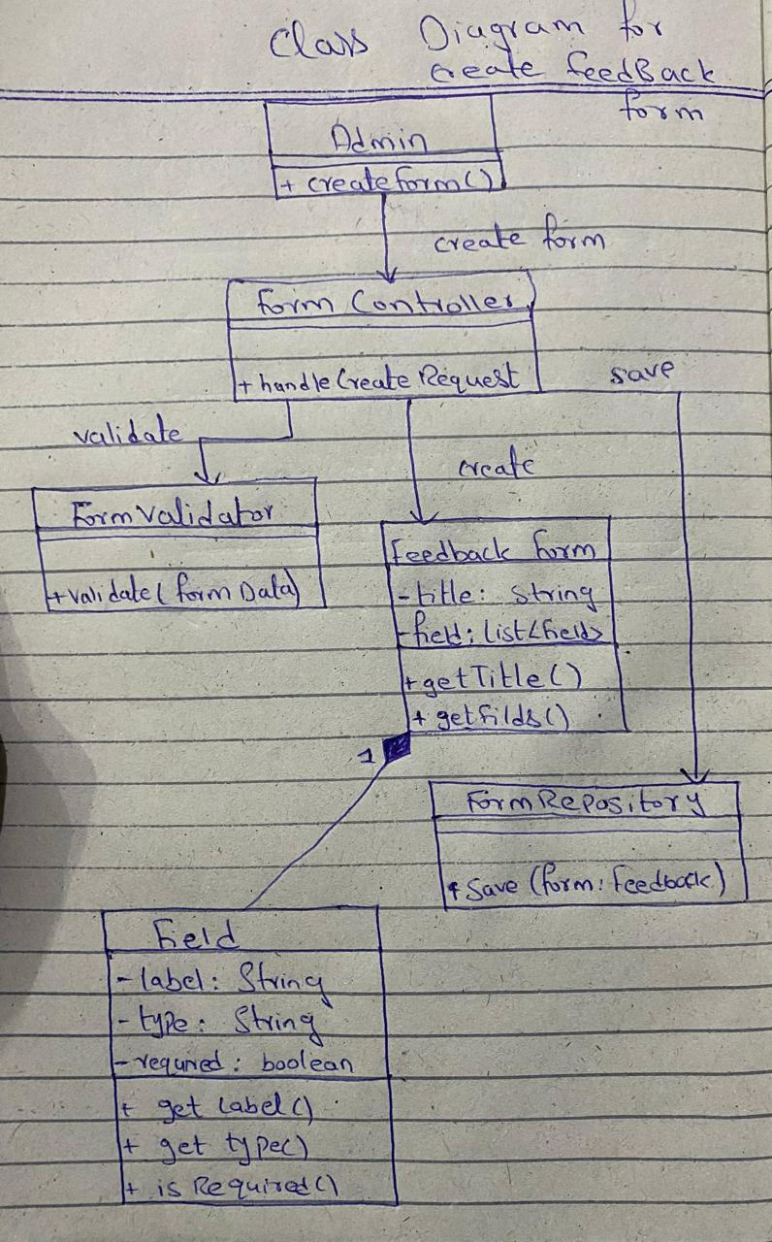

### MUSTAFA SP23-BSE-067

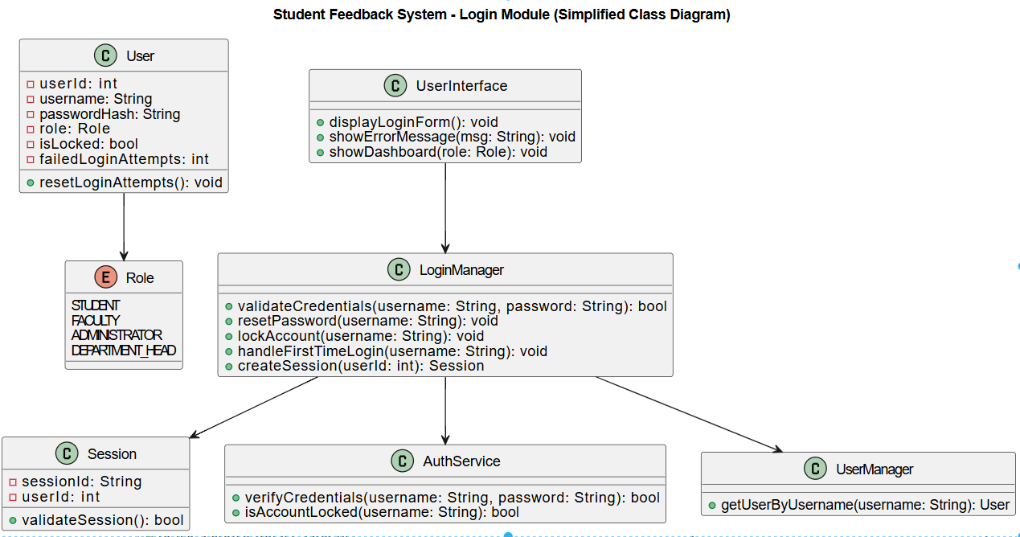

### AHMAD SP23-BSE-059

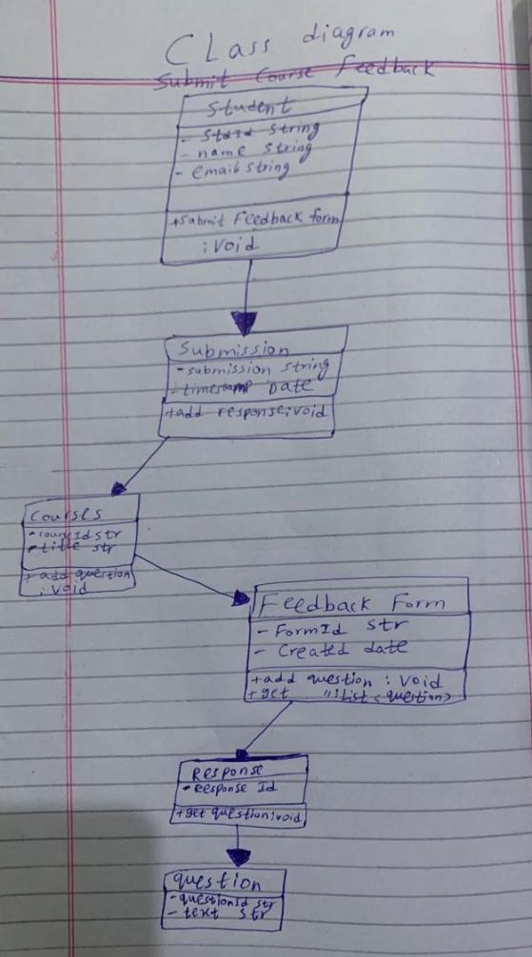

# 

# Chapter 5

## Communication diagram

### FAHAD SP23-BSE063

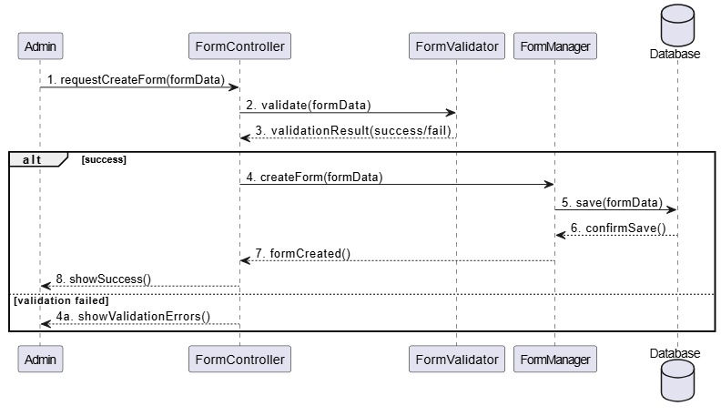

### 

### Mustafa sp23-bse-067

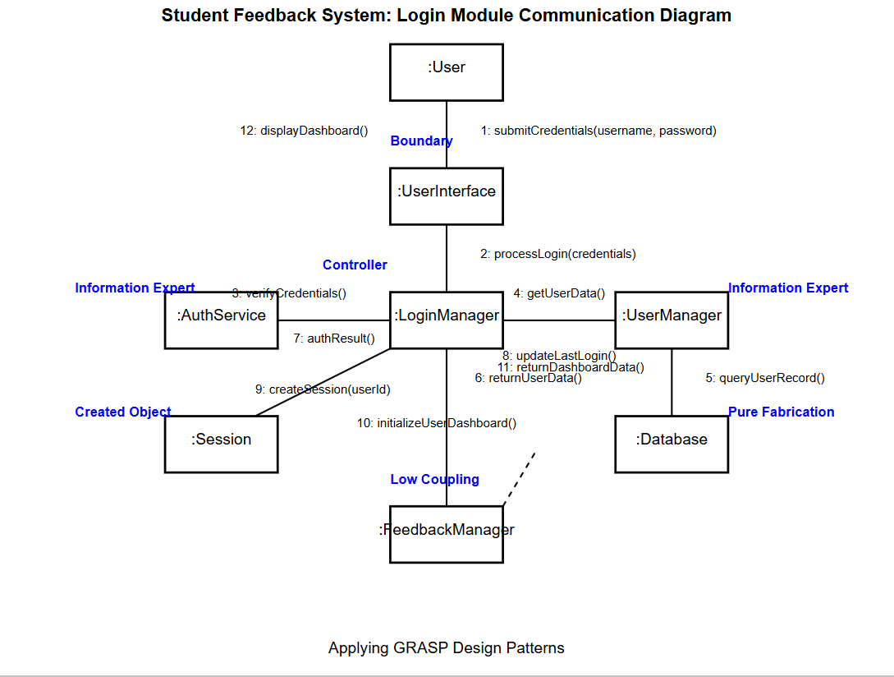

### AHMAD SP23-BSE-059

