**public** String print(){  
 Node<E> i=**head**.getNext();  
 String all=**""**;  
 **while** (i!=**null**){  
 all=all+i.getElement().toString();  
 i=i.getNext();  
 }  
 **return** all;  
}



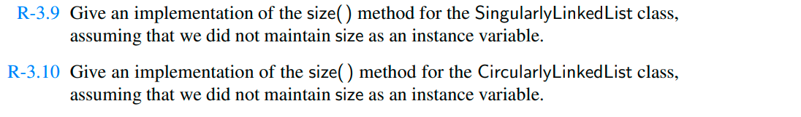

**if**(isEmpty()) {  
 **throws new** Empty();  
 }  
 **int count** = 1;  
 Node **runner** = **head**;  
**while**(**runner**.getNext()!=**null**) {  
 **count**++;  
 **runner** = **runner**.getNext();  
 }



**public void** concat(task4<E> a,task4<E> b,task4<E> c){  
 c.**head**=a.**head**;  
 a.**tail**.setNext(b.**head**);  
 **tail**=c.**tail**;  
}



**public void** concat(task4<E> a,task4<E> b,task4<E> c){  
 c.**head**=a.**head**;  
 a.**tail**.setNext(b.**head**);  
 **tail**=c.**tail**;  
}