Answer two questions

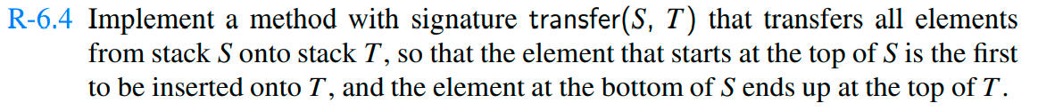

**public void** transfer(LinkedStack s,LinkedStack t){  
 **if** (s.isEmpty()){  
 System.***out***.println(**"is empty"**);  
 **return**;  
 }  
 **int** n=s.size();  
 **for** (**int** i = 0; i < n; i++) {  
 t.push(s.pop());  
 }  
}

**public class** TestLinkedStack {  
  
 **public static double** evaluate(**char** op,String f,String l){  
 **if** (op==**'+'**)  
 {  
 **return** Double.*parseDouble*(f) + Double.*parseDouble*(l);  
 }  
 **if** (op==**'-'**)  
 {  
 **return** Double.*parseDouble*(l)-Double.*parseDouble*(f);  
 }  
 **if** (op==**'*'**)  
 {  
 **return** Double.*parseDouble*(f)*Double.*parseDouble*(l);  
 }  
 **if** (op==**'/'**)  
 {  
 **return** Double.*parseDouble*(l)/Double.*parseDouble*(f);  
 }  
 **return** -1;  
 }  
   
 **public static boolean** op(**char** a)  
 {  
 **if**(a==**'+'** || a==**'-'** || a==**'*'** || a==**'/'**)**return true**;  
 **return false**;  
 }  
 **public static void** main(String[] args) {  
 LinkedStack<String>stack= **new** LinkedStack<>();  
 String a=**"52+83-*4/"**;  
 **double** b=0;  
 **for** (**int** i = 0; i <a.length();i++) {  
 **if** (stack.isEmpty())stack.push(**"("**);  
 **if** (*op*(a.charAt(i)))  
 {  
 b=*evaluate*(a.charAt(i),stack.pop(),stack.pop());  
 stack.push(String.*valueOf*(b));  
 }  
 **else** stack.push(String.*valueOf*(a.charAt(i)));  
 }

System.***out***.println(stack.pop());

}  
}