Write a program that solve josephus problem 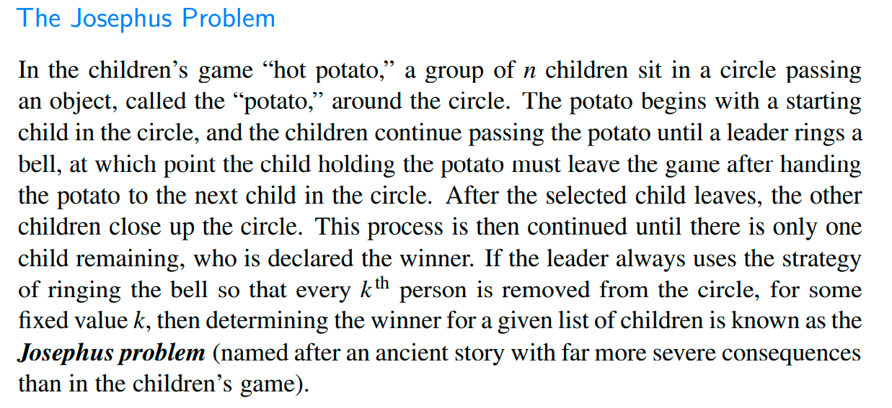

*/**  
 * Created by dcy on 23/07/2010.  
 */***public class** Josiph {  
 CircularQueue<String> **c**=**new** CircularQueue<>();  
  
 **public** String josipho(){  
 **if** (**c**.isEmpty())**return "empty"**;  
 **while** (**c**.size()>1){  
 **c**.rotate();  
 **c**.dequeue();  
 }  
 **return c**.dequeue();  
 }  
  
 **public void** enq(String a[]){  
 **for** (**int** i = 0; i <a.**length** ; i++)  
 {  
 **c**.enqueue(a[i]);  
 }  
 }  
 **public static void** main(String[] args) {  
 String a[]={**"1"**,**"2"**,**"3"**,**"4"**,**"5"**,**"6"**,**"7"**};  
 Josiph j=**new** Josiph();  
 j.enq(a);  
 System.***out***.println(j.josipho());  
  
 }  
}