Data Technician
Week 5 Workbook
Cloud Computing and Azure Data Fundamentals

Name:
Course Date:
Table of contents
Day 1: Task 1 3
Day 1: Task 2 4
Day 1: Task 3 5
Day 1: Task 4 6
Day 2: Task 1 7
Day 2: Task 2 8
Day 2: Task 3 (if finished Day 2 Task 2 early) 12
Day 3: Task 1: Activity: Azure Services 13
Day 3: Task 2: Skillable 15
Day 3: Task 3: Skillable 16
Day 4: Task 1: Skillable 17
Day 4: Task 2: Skillable (Optional) 18
Day 4: Task 3 (Optional) 18
1. Scenario Background 18
2. Data Laws and Regulations 18
3. Azure Service Recommendations 19
4. Data Types and Data Modelling 19
5. Data Storage Formats and Structures in Azure 20
6. Additional Considerations 20
Submission Guidelines: 20
Course Notes 22
Additional Information 22

Day 1: Task 1

Please research and complete the below questions relating to key concepts of cloud.

Be prepared to discuss the below in the group following this task.

What can cloud computing do for us in the real-world? | Cloud computing is the delivery of computing services over the internet such as storage, servers, databases and networks. Examples are thing such as iCloud, google drive, Microsoft 365.
How can it benefit a business? | It is cheaper and there is no need to pay for servers, can access anywhere from any store, data is always backed up and the security is very efficient.
What’s the alternative to cloud computing? | On premise is an alternative where you buy your own physical severs and keep them in your office or data centre. You have tp manage it by your self and it is very expensive and hard to scale.
What cloud providers can we use, what are their features and functions? | AWS- has virtual servers, and databases like my sql  Microsoft azure- virtual machines, sql, java and connects with Microsoft 365  Google cloud platform- big querys, app engine and google drive integration

Day 1: Task 2

Read the information on this page: Explore the pricing calculator - Training | Microsoft Learn

Activity: Explore different scenarios
- Visit this page Pricing Calculator | Microsoft Azure
- Choose Estimate templates

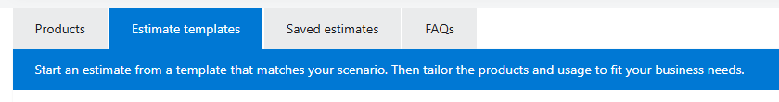
- Start estimate for Design an enterprise BI solution
Implement a pipeline that moves data from an on-premises data warehouse to a cloud and then use a business intelligence (BI) model to serve the data.
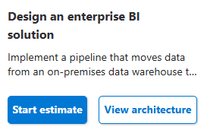

- Explore the services and the cost.

Cost of a Design an enterprise BI solution | 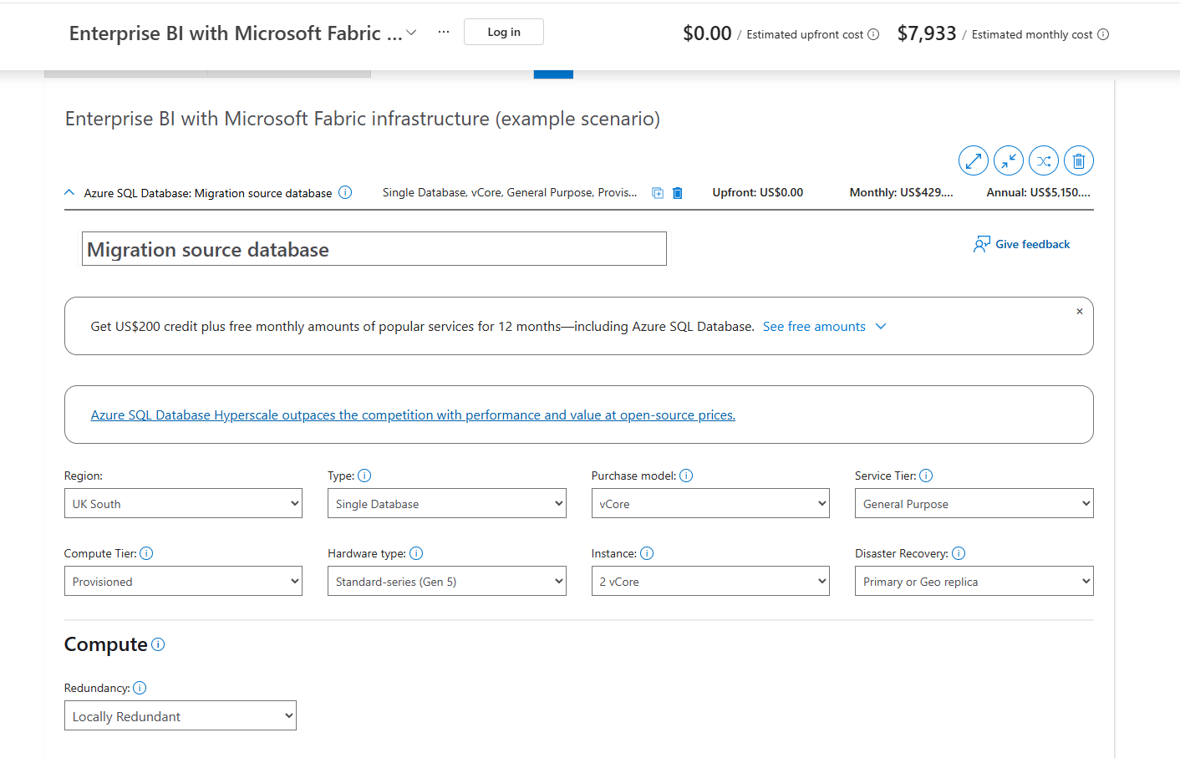  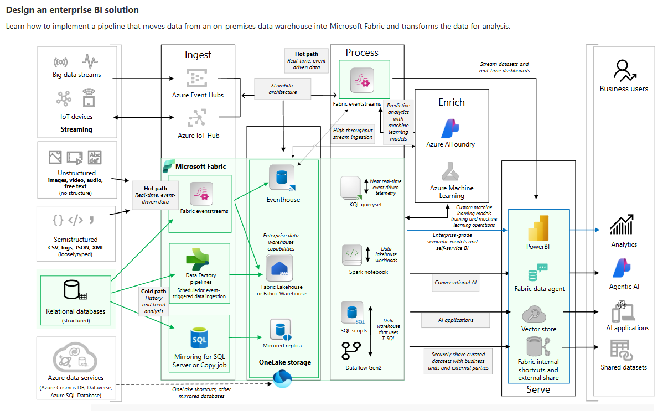

Day 1: Task 3

Please research the below cloud offerings, explain what they are and examples of use cases.

Cloud Offerings | Explain what it is | When / how might you use this service in the real-world?
IaaS (Infrastructure as a service) | Rent servers, storage networking on cloud. You manage OS and apps. Like renting a empty house | Company moves old sql databases to azure instead of buying physical server.
PaaS (Platform as a service) | Platforms to build apps without managing servers. Microsoft manages the hardware you just put in the data or code. | Use azure, SQL, databases or Microsoft fabric. And you can upload data, azure handles updates backups, scaling.
SaaS (Software as a service) | Ready made software on internet, pay monthly. | Power bi, office 365, Gmail, users just login and use reports in enterprise bi solutions

Day 1: Task 4

Please research the below terms and explain what they are, when they would be appropriate and a real-world example of where it could be implemented (i.e. what type of organisation).

Public Cloud | Public cloud is open to anyone over the internet such as Microsoft and AWS, and it is pay as you go. It is cheap and scalable depending on how large your data is and some examples are Azure SQL.
Private Cloud | Private cloud is only for one company and is more secure and has its own networking system. And this is used when data is highly important and needs to have full control. For example, banks and the NHS use it to keep clients or patients' personal data.
Hybrid Cloud | Hybrid cloud is a mix of public and private cloud which is very good as you get both security and scalability. Examples are retail shops keep customers card details private, but sales and dashboards are public.
Community Cloud | Community cloud is shared by a few different organisations with the same needs, so they all have easy access to their data. This type pf cloud is used when the same data or needs need to be met by different companies. Examples where this might be used is universities police forces to share a cloud for researching data.

Day 2: Task 1
You are a Cloud Consultant hired by a client. You will identify the most suitable cloud service model for a client requiring control over infrastructure, estimate potential cloud costs, and explain the benefits of cloud adoption.
🏭 Client – "DataCore Enterprises"
- A large enterprise wants to move its internal database servers to the cloud.
- They already have IT staff.
- They want full control over operating systems and storage configuration.
Questions for you:
- Which service model suits them? (IaaS, PaaS, Saas)
IaaS suits this best as they want full control over OS and storage.
- How can they estimate the cost of using cloud services?
They can use azure pricing calculator

- What are the possible benefits of using cloud services?
Don't need to buy hardware, very scalable, saves data automatically.

- Bonus: What might be potential risks?

Downtime if internet fails, cost overrun if not managed

Day 2: Task 2

Describe, with examples, the three major areas that the Computer Misuse Act deals with.

Area | Description | Example
Unauthorised access to computer material | Accessing a computer system without permission and hacking into someone else’s personal data. | Guessing someone’s email password or logging into the email to read the emails or using a colleague’s laptop without permission to gain information
Unauthorised access with intend to commit further offence | You hack in order to commit a bigger crime like fraud theft, blackmail, identity theft. | hacking into a bank system to steal money or transfer funds or hacking into a university database to change grades
unauthorised acts with attend to impair operations | you damage or delete or corrupt data and stop systems working, You add virusesto the computer. | An example is sending a virus that deletes files or doing a trial attack or fishing someone through an email or a company website to make a crash.

The computer misuse act 1990 is an act where an individual can be criminalised because of computer related offense. Describe three extra powers that the Police and Justice Act 2006 (Computer Misuse) has added.

Description
Making or supplying hacking tools and making tools such as password crackers, or virus creation kits.

DDoS Explicity made illegal

Any new offence that coaches causes serious damage to economy environment or national Security can get you up to 14 years

Look at the below website to answer the questions:
https://www.gov.uk/personal-data-my-employer-can-keep-about-me

Write down three items of data which a company can store about an employee.
Name and address

Date of birth

NIN and bank details

Give three more examples of data that an employer can only store if they first get the employee’s permission.
Health/medical records and data

Biometric data like race or ethnics

Religious belief/sexual orientation/political opinions

Conduct further research to answer the below questions.

Question | Answer
Provide one example of: Copyright infringement | Downloading a movie from a torrent site and uploading it to youtube.
Provide one example of: Plagiarism | Copying text from Wikipedia or ai and classing is as your own work.
What are two consequences of copyright infringement and software piracy? | Person or company can get sued and fined £50,000 or get upto 10 years in prison.
Give three possible consequences for individuals when using pirated software | Fine or prison, security risk like viruses
Listed below are some laws which we have covered today:
1. Computer Misuse Act 1990
2. Police and Justice Act 2006 (Computer Misuse)
3. Copyright, Designs and Patents Act 1988
4. Copyright (Computer Programs) Regulations 1992
5. The Health and Safety (Display Screen Equipment) Regulations 1992
6. Data Protection Act 2018
7. Consumer Rights Act 2015

- Insert a number in the first column of each row to match each of the statements with one of the above Acts.

- One of statements is incorrect and not illegal. For this statement, write ‘Not illegal’.

Act number | Clause
3 | With some exceptions, it is illegal to use unlicensed software
7 | Any product, digital or otherwise, must be fit for the purpose it is supplied for
1 | Unauthorised modification of computer material is illegal
6 | It is illegal to create or use a hacking tool for penetration testing
6 | Personal data may only be used for specified, explicit purposes
5 | Employers must provide their computer users with adequate health and safety training for any workstation they work at
2 | It is illegal to distribute hacking tools for criminal purposes
3 | It is illegal to distribute an illicit recording
6 | Personal data may not be kept longer than necessary
1 | Gaining unauthorised access to a computer system is illegal
5 | Employers must ensure that employees take regular and adequate breaks from looking at their screens
2 | It is illegal to prevent or hinder access (e.g. by a denial-of-service attack) to any program or data held in any computer
6 | Personal data must be accurate and where necessary kept up to date

Day 2: Task 3 (if finished Day 2 Task 2 early)

Please complete this activity to the best of your ability. This is an introduction to Azure Cloud Computing. You can skip Exercises as we will complete day later. Sing in using bootcamp email to save your progress.
Introduction to Cloud Infrastructure: Describe Azure Architecture and Services - Training | Microsoft Learn

Screenshot of XP

Day 3: Task 1: Activity: Azure Services
Research 3 of the following Azure Services and write a brief description of their main points.
Use Azure products website or search online: Directory of Azure Cloud Services | Microsoft Azure
- API Management
- Application Insights
- Azure Active Directory
- Azure Rights Management
- Batch
- BizTalk Services
- Data Factory
- HDInsight
- StorSimple
- Operational Insights

Service 1 -
HDInsight
It is for big data. It runs Hadoop and Spark for you in Azure so you don't need to set up your own servers. Used to process very large data.

Service 2 -
StorSimple
It is storage that is half in office, half in cloud. New data stays in office for fast use, old data goes to Azure cloud automatically to save space and money.

Service 3 -
Operational Insights
It watches your computers and apps. It collects logs and shows if something is broken. You can check problems and get alerts.

Challenge: Explain if any other Azure Cloud service might benefit you or your business.
Service -
Data Factory
It moves data from one place to another. Like copying data from Excel/SQL to Azure. You can make it automatic and run every day.

Azure Simulators
Learn by doing it! Each simulation below links out to an interactive lab that you can complete, just as if you were in a real Azure environment! Access any simulation you wish, as often as you wish.

- CREATE A RESOURCE GROUP
In this simulation, you will be guided, step-by-step, through the process of creating a new resource group in Microsoft Azure, using the Azure Portal.

- DEPLOY A WINDOWS VM
In this simulation, you will be guided, step-by-step, through the process of provisioning a new Windows virtual machine in Microsoft Azure, via the Azure Portal.

- PROVISION A STORAGE ACCOUNT
In this simulation, you will be guided, step-by-step, through the process of provisioning a new General Purpose V2 storage account in Azure, using the Azure Portal.

- DEPLOY AN AZURE FILE SHARE
In this simulation, you will be guided through the process of creating an Azure file share, called myfileshare in an existing storage account.

Day 3: Task 2: Skillable

Please complete the below lab (1) Explore Azure SQL Database and paste evidence of the completed lab in the box provided.

  - Visit https://leeptalent.learnondemand.net/
  - Sign into your account
  - Select activity DP-900T00-A Introduction to Microsoft Azure Data
  - Find and Launch Explore Azure SQL Database
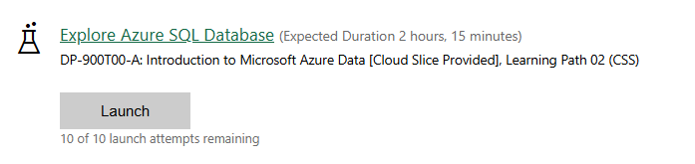

You can watch this video on how to complete the lab.
Lab 1 Explore Azure SQL Database.webm

Completed Lab

Day 3: Task 3: Skillable

Please complete the below lab (2) Explore Azure Storage for non-relational data and paste evidence of the completed lab in the box provided.

  - Visit https://leeptalent.learnondemand.net/
  - Sign into your account
  - Select activity DP-900T00-A Introduction to Microsoft Azure Data
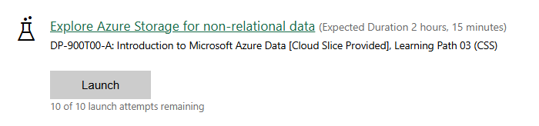
  - Find and Launch Explore Azure Storage for non-relational data.

You can watch this video tutorials on how to complete the labs.
Part 1: Explore Storage Account: Azure Lab 2 Storage Account.mp4
Part 2: Explore Azure Cosmos DB Azure Lab 2 Azure Cosmos DB.webm

Completed Lab

Day 4: Task 1: Skillable
Please complete the below lab (3) Explore fundamentals of large-scale data analytics and paste evidence of the completed lab in the box provided.

  - Visit https://leeptalent.learnondemand.net/
  - Sign into your account
  - Select activity DP-900T00-A Introduction to Microsoft Azure Data
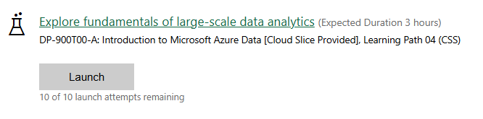
  - Find and Launch Explore Azure Storage for non-relational data Explore fundamentals of large-scale data analytics

You can watch this video on how to complete the lab.
Part 1: Azure Lab 3 Part 1 Explore data analytics in Microsoft Fabric.webm
Part 2: Azure Lab 3 Part 2 Explore real-time analytics in Microsoft Fabric.webm
Part 3: Azure Lab 3 Part 3 Explore fundamentals of data visualization Power BI.webm

Completed lab

Day 4: Task 2: Skillable (Optional)

After completing all the labs, you can complete the Azure DP-900 practice exam and paste your result below – this is open book and please research and discuss your answers as a team.
  - Visit https://leeptalent.learnondemand.net/
  - Sign into your account
  - Select activity DP -900T00-A Introduction to Microsoft Azure Data
  - Find and Launch Practice Assessment: DP-900T00-A Microsoft Azure Data Fundamentals
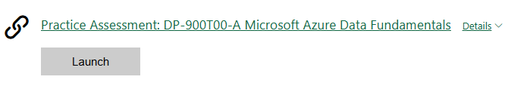

Completed lab

Day 4: Task 3 (Optional)

1. Scenario Background
"Paws & Whiskers" is a growing pet shop that aims to improve its business by analysing sales, customer information, and inventory data. Currently, the data is collected manually or stored in spreadsheets. Management is interested in transitioning to Microsoft Azure to streamline data storage, analysis, and reporting, enabling them to make data-driven decisions.

2. Data Laws and Regulations
Identify and explain the data laws and regulations relevant to handling customer data within the proposal. Ensure you cover the following points:
- GDPR Compliance: Highlight the importance of adhering to the General Data Protection Regulation (GDPR), particularly as it relates to storing and processing customer information.
- Data Protection Act (DPA) 2018: Outline how the DPA 2018 may affect the way "Paws & Whiskers" collects and stores data, ensuring compliance with UK laws on data privacy.
- Other Industry Standards: Research any additional data protection standards or regulations that may apply to pet shop data, particularly if they involve sensitive or payment information.

3. Azure Service Recommendations
Recommend Microsoft Azure services that would suit the company’s data analysis needs and explain why these services are suitable. Your recommendations should include:
- Data Storage: Identify suitable storage options, such as Azure Blob Storage or Azure SQL Database, and discuss the benefits of each for storing large datasets, including inventory, sales transactions, and customer details.
- Data Analysis Tools: Recommend tools such as Azure Machine Learning for customer behaviour analysis or Azure Synapse Analytics for analysing sales trends.
- Data Integration and Automation: Explain how services like Azure Data Factory could automate data collection and integration processes, improving efficiency.

4. Data Types and Data Modelling
Define the types of data "Paws & Whiskers" will need to work with and describe your approach to data modelling:
- Data Categories: Identify key data types, such as customer demographics, transaction history, pet inventory, and product categories.
- Data Modelling Approach: Outline how you would structure this data using a relational model or a data warehouse approach, considering factors like tables, entities, relationships, and primary keys.

5. Data Storage Formats and Structures in Azure
Discuss how you would store data within Azure and the formats you would recommend:
- Data Formats: Specify recommended formats (e.g., CSV for raw data imports, JSON for structured data, Parquet for analytics) and explain why these formats are suitable for specific data types.
- Data Security and Encryption: Include recommendations for securing data using Azure’s built-in encryption features and access controls to ensure compliance with data privacy regulations.

6. Additional Considerations
Provide any other considerations that might enhance data handling and efficiency in Azure, such as:
- Backup and Disaster Recovery: Outline a backup plan using Azure Backup or Azure Site Recovery to safeguard against data loss.
- Data Visualisation: Discuss potential use of Power BI within Azure for creating dashboards that provide management with real-time insights into sales and customer trends.
- Future Scalability: Comment on how Azure services can scale as the business grows, accommodating larger datasets and more complex analyses.

Submission Guidelines:
- Structure: Ensure your report is well-organised, with sections for each task (e.g., Data Laws, Azure Services, Data Types, etc.).
- Formatting: Include headings, bullet points where appropriate, and any visuals or diagrams that support your explanations.
- References: Cite any resources or regulations referenced in the report.
- Length: Aim for 1500-2000 words.

Additional Resources
- DataCamp Recommended Courses
- Understanding Microsoft Azure - DataCamp Learn
- Introduction to Azure - DataCamp Learn
- Understanding Cloud Computing - DataCamp Learn
- Introduction to Microsoft Fabric - DataCamp Learn

- Introduction to Microsoft Azure Data: In this course, students will gain foundational knowledge of core data concepts and related Microsoft Azure data services.
Course DP-900T00-A: Introduction to Microsoft Azure Data - Training | Microsoft Learn

- Explore how to implement data analytics solutions on a single platform with Microsoft Fabric. Integrate, transform, and store data to train AI models and create insightful reports.
Get started with Microsoft Fabric - Training | Microsoft Learn

- Azure Data Fundamentals Flashcards
Azure Data Fundamentals Flashcards | Quizlet

- Learn the Fundamentals of Microsoft Fabric in 38 minutes
Learn the Fundamentals of Microsoft Fabric in 38 minutes

- View expert-led demos to quickly learn how to get started and accomplish your goals with Azure services
Watch Azure Demos to Get Started | Microsoft Azure

- Practice Assessment for Exam DP-900: Microsoft Azure Data Fundamentals
Practice Assessment | Microsoft Learn

Course Notes

It is recommended to take notes from the course, use the space below to do so.

END OF WORKBOOK

Please check through your work thoroughly before submitting and update the table of contents if required.

Please send your completed work booklet to your trainer.

