Case Study 2

Group from MSDS 6306 - 404: Jethin Abraham, Daniel Higdon, Mustafa Sakarwala, and Keyue Wang

04/17/2017

# Introduction

The puropose of our case study is twofold. In part 1 (Question 2 of the assignment), we will utilize R's built-in data set called Orange to calculate and plot our analysis of the trees. For part 2 (Question 3 of the assignment), we will analyze and compare temperatures in the United States and all major cities in the world.

The project will take readers through the analysis step-by-step, from setup of the project to the final analysis. We will conclude with our findings of the analysis.

Before getting started, you should make sure you have installed and loaded the ggplot2, doBy, plyr, dplyr, and lubridate packages into your R workspace. We will use functions from these packages throughout the project. Also, be sure to set your working directory.

if (!require("doBy")) {  
 install.packages("doBy", repos="http://cran.rstudio.com/")   
}

## Loading required package: doBy

## Warning: package 'doBy' was built under R version 3.3.3

library(doBy)  
if (!require("ggplot2")) {  
 install.packages("ggplot2", repos="http://cran.rstudio.com/")   
}

## Loading required package: ggplot2

## Warning: package 'ggplot2' was built under R version 3.3.3

library(ggplot2)  
  
if (!require("plyr")) {  
 install.packages("plyr", repos="http://cran.rstudio.com/")   
}

## Loading required package: plyr

## Warning: package 'plyr' was built under R version 3.3.3

library(plyr)  
  
if (!require("dplyr")) {  
 install.packages("dplyr", repos="http://cran.rstudio.com/")   
}

## Loading required package: dplyr

## Warning: package 'dplyr' was built under R version 3.3.3

##   
## Attaching package: 'dplyr'

## The following objects are masked from 'package:plyr':  
##   
## arrange, count, desc, failwith, id, mutate, rename, summarise,  
## summarize

## The following objects are masked from 'package:stats':  
##   
## filter, lag

## The following objects are masked from 'package:base':  
##   
## intersect, setdiff, setequal, union

library(dplyr)  
  
if (!require("lubridate")) {  
 install.packages("lubridate", repos="http://cran.rstudio.com/")   
}

## Loading required package: lubridate

## Warning: package 'lubridate' was built under R version 3.3.3

##   
## Attaching package: 'lubridate'

## The following object is masked from 'package:plyr':  
##   
## here

## The following object is masked from 'package:base':  
##   
## date

library(lubridate)  
  
#Set your working directory  
setwd("C:/Users/ThomasWang/Desktop/Doing Data Science/caseStudy2")

# Question 2 - Orange

## Step 1: Calculating the Mean and Median

We will be leveraging the doBy package to simplify our calculations of the mean and median of the trunk circumferences for different sizes of trees

#Mean and median of the trunk circumference for different size of the trees.  
summaryBy(circumference~Tree,data = Orange,FUN = list(mean,median))

## Tree circumference.mean circumference.median  
## 1 3 94.00000 108  
## 2 1 99.57143 115  
## 3 5 111.14286 125  
## 4 2 135.28571 156  
## 5 4 139.28571 167

Here we see that Tree 1 has a circumference mean of 99.57 and circumference median of 115. Tree 2 has a circumference mean of 135.28 and circumference median of 156. Tree 3 has a circumference mean of 94.00 and circumference median of 108. Tree 4 has a circumference mean of 139.29 and circumference median of 167. Tree 5 has a circumference mean of 111.14 and circumference median of 125.

## Step 2: Generate a Scatter Plot

After calculating the mean and median of the tree circumferences, we will use the ggplot2 package to create a scatter plot of the trunk circumferences against the age of the tree. We chose to plot circumference on the x-axis and age on the y-axis because age is the response variable in this case. Additionally, We will use different plotting symbols to represent each tree.

#Scatter plot of circumference vs. age  
ggplot(Orange,aes(x=circumference,y=age,color=Tree,shape=Tree))+geom_point()

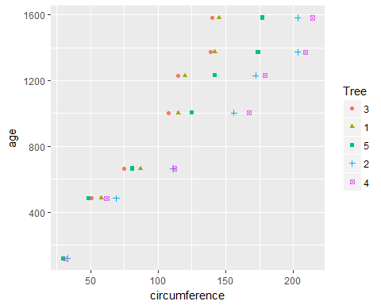

## Step 3: Display a Box Plot

Lastly, we will display the trunk circumferences on a comparative boxplot against Tree. We will order the boxplots in the increasing order of maximum diameter. In order to do this, we must create a new column for maximum diameter. To calculate maximum diameter, we divide the tree's circumference by pi.

#adding diameter to the dataset  
Orange$diameter<-Orange$circumference/pi  
maxTree1<-max(subset(Orange,Tree==1)$diameter,na.rm=TRUE)  
maxTree2<-max(subset(Orange,Tree==2)$diameter,na.rm=TRUE)  
maxTree3<-max(subset(Orange,Tree==3)$diameter,na.rm=TRUE)  
maxTree4<-max(subset(Orange,Tree==4)$diameter,na.rm=TRUE)  
maxTree5<-max(subset(Orange,Tree==5)$diameter,na.rm=TRUE)  
  
TreeDiam<-c(maxTree1,maxTree2,maxTree3,maxTree4,maxTree5)  
DiamRank<-rank(TreeDiam)  
TreeSize<-c(1,2,3,4,5)  
Treediam_df<-data.frame(TreeDiam,DiamRank,TreeSize)  
Orange_rank<-merge(Orange,Treediam_df,by.x="Tree",by.y="TreeSize")  
Orange_rank<-Orange_rank[order(Orange_rank$DiamRank),]  
#Circumference boxplots by Tree  
ggplot(Orange_rank,aes(x=factor(Tree),y=circumference))+geom_boxplot()

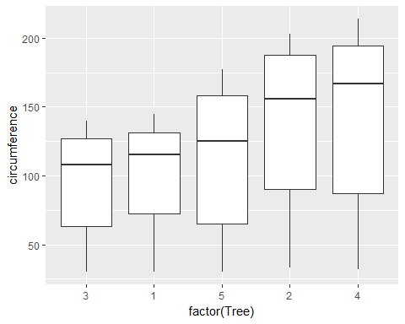

# Question 3 - Temp

## Step 1: Clean up the Temp Data (part i)

Before we perform our analysis, we will clean up the TEMP.csv data. We do this by defining YYYY-MM-DD as YMD and MM/DD/YY as MDY because there are 2 sets of dates in the sheet and we can only apply date formatting to 1 format. Next, we extract the years from each set and substitute NA with 0. Then, we combine the two sets based on the year variable and create a subset of that data where years greater than 1900*. Finally, we rename the columns appropriately and remove all NA records.

*Note: Combining year1 and year2 will give us a single column of the year of the date. However, we see that dates with years greater than 1900 are all formatted the same way. Therefore, this step could have potentially been removed

# Raw Data  
raw <- read.csv('C:/Users/ThomasWang/Desktop/Doing Data Science/caseStudy2/TEMP.csv')  
  
# There are 2 sets of dates in the sheet YYYY-MM-DD and MM/DD/YYYY. Applying any date   
#formating can be applied to only 1 format  
  
# Defining YMD for YYYY-MM-DD format  
raw$date1 <-ymd(raw$Date)

## Warning: 328503 failed to parse.

#Defining MDY for MM/DD/YY  
raw$date2<-mdy(raw$Date)

## Warning: 245720 failed to parse.

#Extracting the year from the first set  
raw$year1 <-year(raw$date1)  
  
#Extracting the year from the second set  
raw$year2<- year(raw$date2)  
  
#Substituting the NA with 0 for year1 dataset  
raw$year2[is.na(raw$year2)]<-0  
  
#Substituting NA with 0 for year2  
raw$year1[is.na(raw$year1)]<-0  
  
#Combining the years for filtering the dataset  
raw$year.combined <- raw$year1+raw$year2  
  
#Filtered out the dataset  
degree <- subset(raw,year.combined>1900)  
  
#Renaming the columns  
names(degree)<-c("Date","MoAvgTemp","MoAvgTemp_Unc","Country","date1","date2","year1","year2","year_comb")  
  
#Remove "NA"records  
degreeexNA<-subset(degree,MoAvgTemp!="NA")

## Step 2: Analyze and Visualize Temp Data (part i)

We begin our analysis by creating a dataset with the max and min temperatures for each country. We then combine the max and min temperatures to calculate the differences, and we rank the countries by decreasing order of max temperature difference. Lastly, we create a subset of only the top twenty countries based on maximum difference and plot the data using ggplot2.

#Create a dataset with the max and min temps for each country  
maxTemp<-ddply(degreeexNA,"Country", summarise,maxMoTemp=max(MoAvgTemp))  
minTemp<-ddply(degreeexNA,"Country", summarise,minMoTemp=min(MoAvgTemp))  
  
#Combine the max and min temps to calculate a difference  
degree2<-merge(maxTemp,minTemp,by.x="Country",by.y="Country")  
degree2$tempDiff<-degree2$maxMoTemp-degree2$minMoTemp  
  
#Order and rank the countries in decreasing order of max temp diff  
degree2_rank<-degree2[order(degree2$tempDiff,decreasing=TRUE),]  
  
degree2_rank$tempRank<-seq(1,241,1)  
  
#limit the data to only the top twenty  
degree_topTwenty<-subset(degree2_rank,tempRank<21)  
  
#Reorder the data on tempRank to make the graph prettier  
Countryorder<-degree_topTwenty$Country[order(degree_topTwenty$tempRank,decreasing=TRUE)]  
degree_topTwenty$Country<-factor(degree_topTwenty$Country,level=Countryorder)  
  
#Graph the results  
graphi <- ggplot(degree_topTwenty,aes(x=tempDiff,y=Country))+geom_segment(aes(yend=Country),xend=0)+geom_point()+theme_bw()+theme(panel.grid.major.y=element_blank())  
graphi

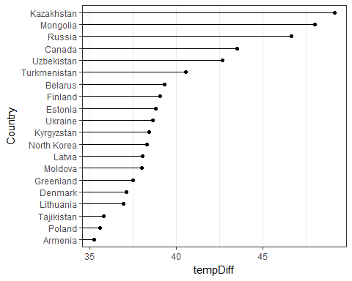

The top 20 countries with the maximum temperature differences for the period since 1900 are (in order) Kazakhstan, Mongolia, Russia, Canada, Uzbekistan, Turkmenistan, Belarus, Finland, Estonia, Ukraine, Kyrgezstan, North Korea, Latvia, Moldova, Greenland, Denmark, Lithuania, Tajikistan, Poland, and Armenia.

## Step 3: Analyze and Visualize subset UStemp (part ii)

UStemp is a subset of Temp data set that includes temperatures in the US since 1990. With UStemp, we will first create a new column to display the monthly average land temperature in Fahrenheit. Next, we will calculate and plot the average temperature by year. Finally, we will use a for loop to calculate the one year difference of average land temperature by year and provide the maximum difference of the corresponding two years.

#create US subset for only years >=1990  
UStemp<-subset(degree,degree$Country=="United States" & degree$year_comb>=1990)  
  
#add a Fahrenheit column  
UStemp$fahr<-UStemp$MoAvgTemp*1.8+32  
#avg temp by year with plot  
UStemp_year<-ddply(UStemp,"year_comb", summarise,AvgFarhTempYr=mean(fahr))  
ggplot(UStemp_year,aes(x=year_comb,y=AvgFarhTempYr))+geom_line()

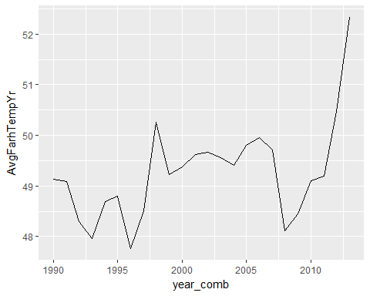

#Number of records  
  
t <-length(UStemp_year$AvgFarhTempYr)  
  
  
#Question 3 c  
  
#Defining the data frame to store the records  
mat <- data.frame(24,24)  
  
#Loop to do the difference of years  
for ( i in 1:t){  
 landtemp_diff <- round(UStemp_year[i+1,2]- UStemp_year[i,2],digits = 3)  
   
 year_diff <- paste(cbind(as.character(UStemp_year[i+1,1]),as.character(UStemp_year[i,1])),collapse='-')  
   
 mat[i,] <- c(year_diff,landtemp_diff)  
}  
  
#Renaming the coloumns  
names(mat) <- c('year_diff','temp_diff')  
  
#Printing the results  
mat

## year_diff temp_diff  
## 1 1991-1990 -0.05  
## 2 1992-1991 -0.787  
## 3 1993-1992 -0.34  
## 4 1994-1993 0.726  
## 5 1995-1994 0.109  
## 6 1996-1995 -1.038  
## 7 1997-1996 0.753  
## 8 1998-1997 1.743  
## 9 1999-1998 -1.034  
## 10 2000-1999 0.149  
## 11 2001-2000 0.244  
## 12 2002-2001 0.055  
## 13 2003-2002 -0.11  
## 14 2004-2003 -0.158  
## 15 2005-2004 0.405  
## 16 2006-2005 0.147  
## 17 2007-2006 -0.247  
## 18 2008-2007 -1.595  
## 19 2009-2008 0.334  
## 20 2010-2009 0.663  
## 21 2011-2010 0.08  
## 22 2012-2011 1.28  
## 23 2013-2012 1.865  
## 24 NA-2013 <NA>

#Substituting NA with 0 for last record  
mat$temp_diff[is.na(mat$temp_diff)] <-0  
  
#Finding the max diff  
  
max_diff <- subset(mat,mat$temp_diff ==max(mat$temp_diff))  
  
max_diff

## year_diff temp_diff  
## 23 2013-2012 1.865

Here we see that the maximum temperature difference between 2 years since 1990 is 2012-2013 where the temperature difference is 1.86 degree Fahrenheit.

## Step 4: Clean up the CityTemp Data (part iii)

Before we perform our analysis, we will clean up the CITYTEMP.csv data. We do this by defining YYYY-MM-DD as YMD and MM/DD/YY as MDY because there are 2 sets of dates in the sheet and we can only apply date formatting to 1 format. Next, we extract the years from each set and substitute NA with 0. Then, we combine the two sets based on the year variable and create a subset of that data where years greater than 1900*. Finally, we rename the columns appropriately and remove all NA records.

*Note: Combining year1 and year2 will give us a single column of the year of the date. However, we see that dates with years greater than 1900 are all formatted the same way. Therefore, this step could have potentially been removed

# CityTemp Data  
CityTemp <- read.csv('C:/Users/ThomasWang/Desktop/Doing Data Science/caseStudy2/CityTemp.csv')  
  
# There are 2 sets of dates in the sheet YYYY-MM-DD and MM/DD/YYYY. Applying any date   
# formating can be applied to only 1 format  
  
# Defining YMD for YYYY-MM-DD format  
CityTemp$date1 <-ymd(CityTemp$Date)

## Warning: 135135 failed to parse.

# Defining MDY for MM/DD/YY  
CityTemp$date2<-mdy(CityTemp$Date)

## Warning: 102065 failed to parse.

#Extracting the year from the first set  
CityTemp$year1 <-year(CityTemp$date1)  
  
#Extracting the year from the second set  
CityTemp$year2<- year(CityTemp$date2)  
  
#Substituting the NA with 0 for year1 dataset  
CityTemp$year2[is.na(CityTemp$year2)]<-0  
  
#Substituting NA with 0 for year2  
CityTemp$year1[is.na(CityTemp$year1)]<-0  
  
#Combining the years for filtering the dataset  
CityTemp$year.combined <- CityTemp$year1+CityTemp$year2  
  
#Filtered out the dataset  
CityTemp1900 <- subset(CityTemp,year.combined>1900)  
  
#Renaming the columns  
names(CityTemp1900)<-c("Date","MoAvgTemp","MoAvgTemp_Unc","City","Country","Latitude","Longitude","date1","date2","year1","year2","year_comb")  
  
#Remove "NA"records  
CityTemp1900exNA<-subset(CityTemp1900,MoAvgTemp!="NA")

## Step 5: Analyze and Visualize CityTemp Data (part iii)

We begin our analysis by creating a dataset with the max and min temperatures for each major city. We then combine the max and min temperatures to calculate the differences, and we rank the cities by decreasing order of max temperature difference. Lastly, we create a subset of only the top twenty cities based on maximum difference and plot the data using ggplot2.

#Create a dataset with the max and min temps for each City  
maxTemp<-ddply(CityTemp1900exNA,"City", summarise,maxMoTemp=max(MoAvgTemp))  
minTemp<-ddply(CityTemp1900exNA,"City", summarise,minMoTemp=min(MoAvgTemp))  
  
#Combine the max and min temps to calculate a difference  
CityTemp1900_2<-merge(maxTemp,minTemp,by.x="City",by.y="City")  
CityTemp1900_2$tempDiff<-CityTemp1900_2$maxMoTemp-CityTemp1900_2$minMoTemp  
  
#Order and rank the cities in decreasing order of max temp diff  
CityTemp1900_rank<-CityTemp1900_2[order(CityTemp1900_2$tempDiff,decreasing=TRUE),]  
  
CityTemp1900_rank$tempRank<-seq(1,99,1)  
  
#limit the data to only the top twenty  
CityTemp1900_top20<-subset(CityTemp1900_rank,tempRank<21)  
  
#Reorder the data on tempRank to make the graph prettier  
Cityorder<-CityTemp1900_top20$City[order(CityTemp1900_top20$tempRank,decreasing=TRUE)]  
CityTemp1900_top20$City<-factor(CityTemp1900_top20$City,level=Cityorder)  
  
#Graph the results  
graphii <- ggplot(CityTemp1900_top20,aes(x=tempDiff,y=City))+geom_segment(aes(yend=City),xend=0)+geom_point()+theme_bw()+theme(panel.grid.major.y=element_blank())  
graphii

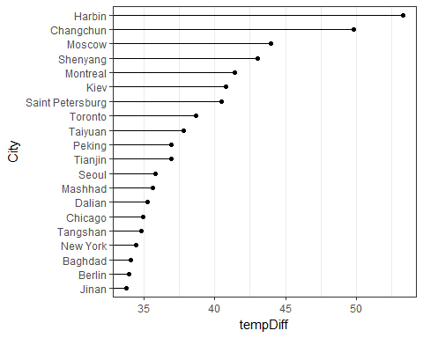

The top 20 major cities with the maximum temperature differences for the period since 1900 are (in order) Harbin, Changchun, Moscow, Shenyang, Montreal, Kiev, St Petersburg, Toronto, Taiyuan, Peking, Tianjin, Seoul, Mashhad, Dalian, Chicago, Tangshan, New York, Baghdad, Berlin, and Jinan.

## Step 6: Compare Temp plot and CityTemp plot

Comment here about below plots

#Plot the graph of the top 20 countries with the maximum temperature difference since 1900  
graphi



#Plot the graph of the top 20 major cities with the maximum temperature difference since 1900  
graphii



# Conclusion

Since this Case Study was based on 2 different projects (Orange and Temp), we will break down the conclusions seperately

## Orange

In this project, we calculated the circumference mean and median, and generated two plots to show our analysis on R's built-in data set Orange. Our mean/median calculations show that Tree 3 has the smallest circumference mean and median while Tree 4 has the largest. From our scatterplot, we can conclude that trees 2 and 4 are consistently at the larger end of the circumference measurements throughout the tree's lifecycle. Conversely, trees 3 and 1 are on the smaller end. Tree 5 starts out as the smallest tree, but eventually outgrows trees 3 and 1. Lastly, our boxplot(which is ordered by increasing diameter) shows that trees 3 and 1 are generally smaller that trees 2 and 4, no matter which quantile we compare them at. There are also no outliers in any of the 5 trees.

## Temp

In this project, we analyzed and visualized three data sets: Temp, TempUS, and CityTemp. Before we were able to conduct our analysis, we made sure to clean up our data accordingly so that we can extract the year correctly from the formatted dates.

From our Temp data analysis, we saw that the top 20 countries with the maximum differences for the period since 1900 are (in order) Kazakhstan, Mongolia, Russia, Canada, Uzbekistan, Turkmenistan, Belarus, Finland, Estonia, Ukraine, Kyrgezstan, North Korea, Latvia, Moldova, Greenland, Denmark, Lithuania, Tajikistan, Poland, and Armenia.

Analyzing USTemp, a subset of Temp with only temperatures in the United States, we can see that the average yearly temperature in Fahrenheit has been increasing at a quicker rate since 2008. In fact, we concluded that the maximum temperature difference between 2 years since 1990 was in 2012-2013 where the temperature difference was 1.865 degree Fahrenheit.

The CityTemp data set was similar to the Temp dataset. The difference was that it included major cities and their latitude and longitude. Our analysis showed that the top 20 major cities with the maximum temperature differences for the period since 1900 are (in order) Harbin, Changchun, Moscow, Shenyang, Montreal, Kiev, St Petersburg, Toronto, Taiyuan, Peking, Tianjin, Seoul, Mashhad, Dalian, Chicago, Tangshan, New York, Baghdad, Berlin, and Jinan.