**HOMEWORK #2**

**DUE: April 24, 2020, 17:00 pm**

**1)** Write a raw C code under Visual Studio (with OpenCV added to it) to calculate the histogram of a

given grayscale image. Display your histogram if possible.

Code:

#include <opencv2/imgproc/imgproc.hpp>

#include <opencv2/opencv.hpp>

#include <opencv2/highgui/highgui_c.h>

using namespace cv;

Mat img;

Mat img2;

Mat img3;

int dizi[255];

int dizi2[255];

int main()

{

img = imread("lena.png");

cvtColor(img, img2, CV_BGR2GRAY);

equalizeHist(img2, img3);

Mat graph2(512, 512, CV_8UC3, Scalar(255, 255, 255));

for (int i = 0; i < img3.cols; i++) {

for (int j = 0; j < img3.rows; j++) {

dizi2[img3.at<uchar>(j, i)]++;

}

}

int max2 = dizi2[0];

for (int i = 1; i < 256; i++) {

if (dizi2[i] > max2)max2 = dizi2[i];

}

for (int i = 1; i < 256; i++) {

dizi2[i] = dizi2[i] * 512 / max2;

}

for (int i = 0; i < 256; i++) {

line(graph2, Point(i * 2, 512), Point(i * 2, 512 - dizi2[i]),Scalar(i,0,255-i) ,2);

}

///////////////////7

Mat graph(512, 512, CV_8UC3, Scalar(255, 255, 255));

for (int i = 0; i < img2.cols; i++) {

for (int j = 0; j < img2.rows; j++) {

dizi[img2.at<uchar>(j, i)]++;

}

}

int max = dizi[0];

for (int i = 1; i < 256; i++) {

if (dizi[i] > max)max = dizi[i];

}

for (int i = 1; i < 256; i++) {

dizi[i] = dizi[i] * 512 / max;

}

for (int i = 0; i < 256; i++) {

line(graph, Point(i*2 , 512), Point(i*2 , 512 - dizi[i]), Scalar(i, 0, 255 - i), 2);

}

imshow("gray", img2);

imshow("equalized", img3);

imshow("grafik", graph);

imshow("equgrafik", graph2);

waitKey(0);

return 0;

}

Result:

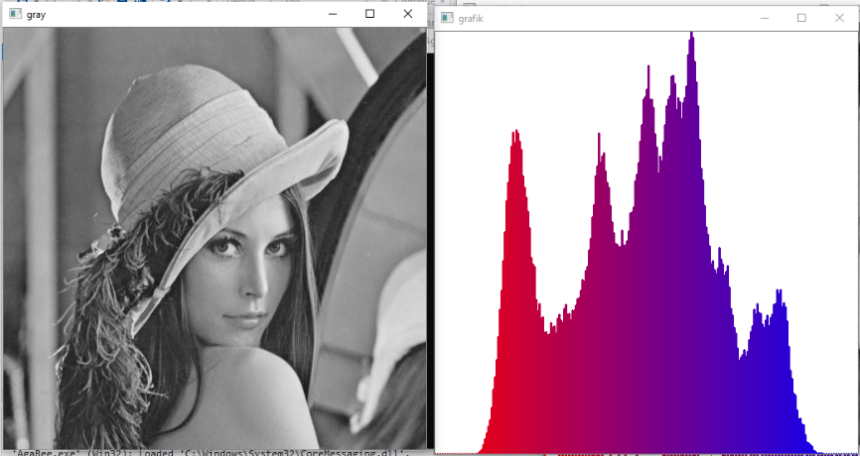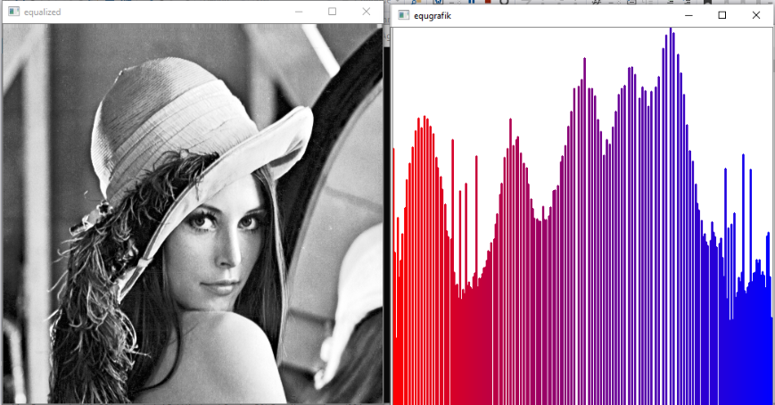

**2)**Write a raw C code under Visual Studio (with OpenCV added to it) to quantize a given 8-bit grayscae image to 5 bits. Display your result.

Code:

#include <opencv2/imgproc/imgproc.hpp>

#include <opencv2/opencv.hpp>

#include <opencv2/highgui/highgui_c.h>

using namespace cv;

Mat img;

Mat img2;

int a;

int main()

{

img = imread("eyes.jpg");

cvtColor(img, img2, CV_BGR2GRAY);

resize(img2, img2, Size(512, 512));

Mat Grayresim(img2.rows, img2.cols, CV_8UC1, Scalar(0));

imshow("ilk", img2);

for (int i = 0; i < img2.cols; i++) {

for (int j = 0; j < img2.rows; j++) {

a = 0;

if (img2.at<uchar>(j, i) % 8 > 4) {

a = (img2.at<uchar>(j, i) / 8 + 1);

a = a * 8;

Grayresim.at<uchar>(j, i) = a;

}

else {

a = img2.at<uchar>(j, i) / 8;

a = a * 8;

Grayresim.at<uchar>(j, i) = a;

}

}

}

imshow("5 bit 0-255", Grayresim);

waitKey(0);

return 0;

}

Result:

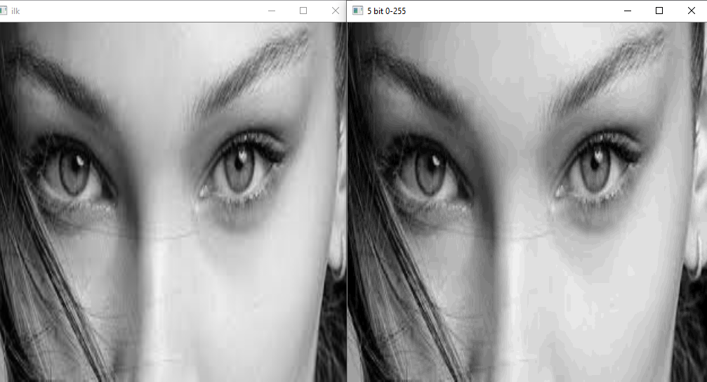

**3)**Form a 128x128 grayscale image composed of all 0 pixels.

**a)**Pick a random pixel location within the image.

**b)**Label all neighboring locations 5 pixels apart the selected pixel as logic level 1. Use the L1

distance for this purpose.

**c)**Provide the obtained result as an image.

#include <opencv2/imgproc/imgproc.hpp>

#include <opencv2/opencv.hpp>

#include <opencv2/highgui/highgui_c.h>

#include <stdio.h>

#include <stdlib.h>

#include <time.h>

using namespace cv;

using namespace std;

int L = 5;

Point pt1,pt2;

int main()

{

srand(time(NULL));

Mat Grayresim(128, 128, CV_8UC1, Scalar(0));

Mat Grayresim2(128, 128, CV_8UC1, Scalar(0));

namedWindow("empty image", WINDOW_AUTOSIZE);

imshow("empty image", Grayresim);

///////part a

pt1.x = rand() % 127 ;

pt1.y = rand() % 127;

cout << "random location raw:" << pt1.y << endl;

cout << "random location coulumn:" << pt1.x << endl;

Grayresim.at<uchar>(pt1) = 255;

namedWindow("ConsideredLocation", WINDOW_AUTOSIZE);

imshow("ConsideredLocation", Grayresim);

/////////partb

for (int i = 0; i <= L; i++) {

for (int j = (pt1.x - L); j <= (pt1.x + L); j++) {

for (int k =( pt1.y - L); k <= (pt1.y + L); k++) {

if (pt1.x + L < Grayresim2.cols && pt1.x - L > 0 && pt1.y + L < Grayresim2.rows && pt1.y - L > 0) {

pt2.x = j;

pt2.y = k;

if ((abs(pt1.x - pt2.x)+ abs(pt1.y - pt2.y))==L) {

Grayresim2.at<uchar>(pt2) = 255;

cout << "Point:" << j << "."<< k <<endl;

}

}

}

}

}

namedWindow("detectLocation", WINDOW_AUTOSIZE);

imshow("detectLocation", Grayresim2);

waitKey(0);

return 0;

}

////////////part c

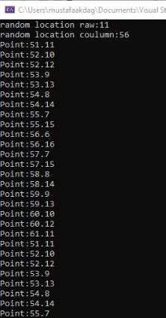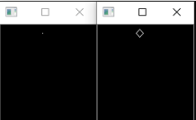

Selected location L1 distance

**4)**Repeat Question 3 by using the L2 distance.

#include <opencv2/imgproc/imgproc.hpp>

#include <opencv2/opencv.hpp>

#include <opencv2/highgui/highgui_c.h>

#include <stdio.h>

#include <stdlib.h>

#include <time.h>

using namespace cv;

using namespace std;

int L = 5;

Point pt1,pt2;

int main()

{

srand(time(NULL));

Mat Grayresim(128, 128, CV_8UC1, Scalar(0));

Mat Grayresim2(128, 128, CV_8UC1, Scalar(0));

namedWindow("empty image", WINDOW_AUTOSIZE);

imshow("empty image", Grayresim);

pt1.x = rand() % 127 ;

pt1.y = rand() % 127;

cout << "random location raw:" << pt1.y << endl;

cout << "random location coulumn:" << pt1.x << endl;

Grayresim.at<uchar>(pt1) = 255;

namedWindow("ConsideredLocation", WINDOW_AUTOSIZE);

imshow("ConsideredLocation", Grayresim);

for (int i = 0; i <= L; i++) {

for (int j = (pt1.x - L); j <= (pt1.x + L); j++) {

for (int k =( pt1.y - L); k <= (pt1.y + L); k++) {

if (pt1.x + L < Grayresim2.cols && pt1.x - L > 0 && pt1.y + L < Grayresim2.rows && pt1.y - L > 0) {

pt2.x = j;

pt2.y = k;

if (sqrt((pt1.x - pt2.x)* (pt1.x - pt2.x) + (pt1.y - pt2.y)* (pt1.y - pt2.y))==L) {

Grayresim2.at<uchar>(pt2) = 255;

cout << "Point:" << j << "."<< k <<endl;

}

}

}

}

}

namedWindow("detectLocation", WINDOW_AUTOSIZE);

imshow("detectLocation", Grayresim2);

waitKey(0);

return 0;

}

