**RGB Image Denoising**

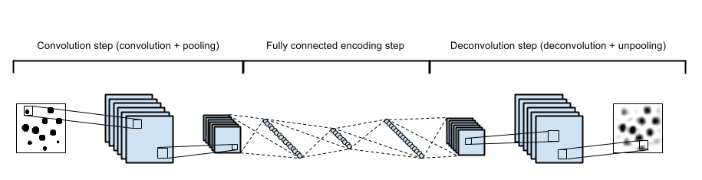

* Convolutional auto-encoder/decoder were used for restoration.
* Input image was distorted by a gaussian noise (-3 dB Gaussian Noise for rgb channels).
* Network structure contains 3 convolutional layers, and 3 deconvolutional layers (No pooling layers used).
* Convolutional layer 1: Filter size of 4*4 with initial weight W1, stride= 2, padding=(1,1), no bias, 48 filters, activation function= Relu
* Convolutional layer 2: Filter size of 4*4 with initial weight W2, stride= 2, padding=(1,1), no bias, 96 filters, activation function= Relu
* Convolutional layer 3: Filter size of 4*4 with initial weight W3, stride= 2, padding=(1,1), no bias, 192 filters, activation function= Relu
* No fully-connected layers used.
* Deconvolutional layer1: Filter size of 4*4 with initial weight W3, stride= 2, padding=(1,1), no bias, 192 filters 🡪 96 filters, activation function= Relu
* Deconvolutional layer2: Filter size of 4*4 with initial weight W2, stride= 2, padding=(1,1), no bias, 96 filters 🡪 48 filters, activation function= Relu
* Deconvolutional layer3: Filter size of 4*4 with initial weight W1, stride= 2, padding=(1,1), no bias, 48 filters 🡪 3 channels
* Cifar-32 dataset used for image restoration.
* Same initial weigths used for training in both PyTorch and Tensorflow.
* Same gaussian noise pattern used in both frameworks.
* Same training and test sets used in both frameworks.
* Same number of iterations, optimization algorithm (Adam Optimization), algorithm hyperparameters (beta1,beta2), mini-batch size, and learning rate used in both designs.
* Training performed on GPU.

**Case 1: initial weights 1, datasets 1, batch size 128, learning rate 0.001**

**Tensorflow**

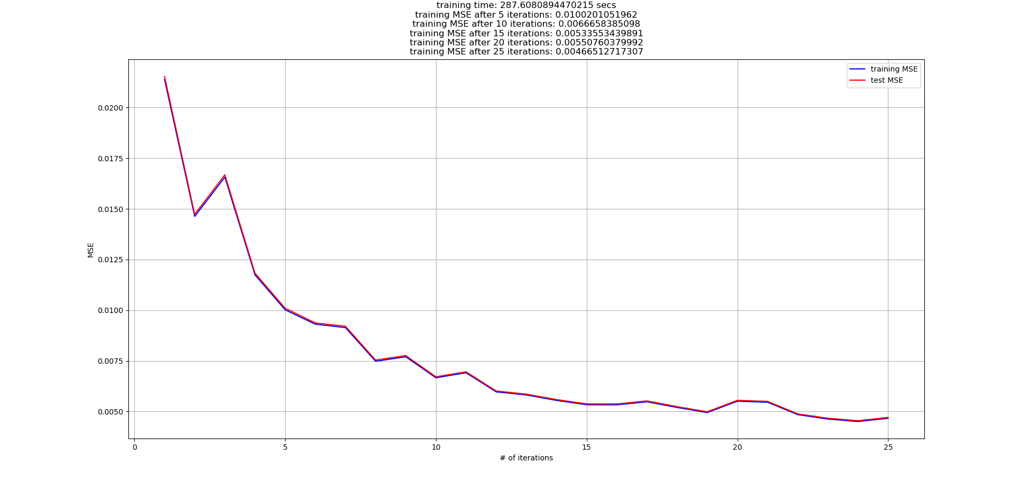

**Tensorflow**

Original

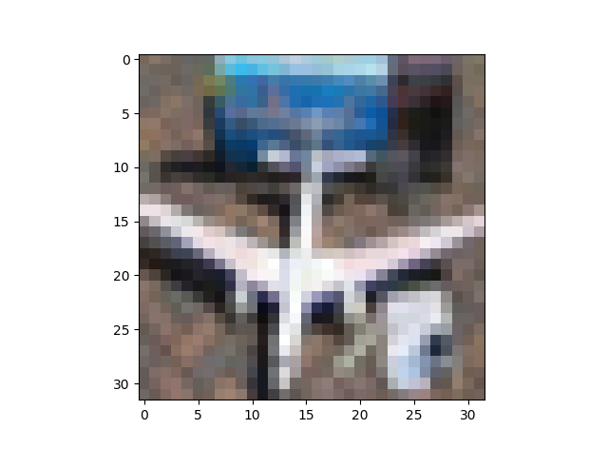 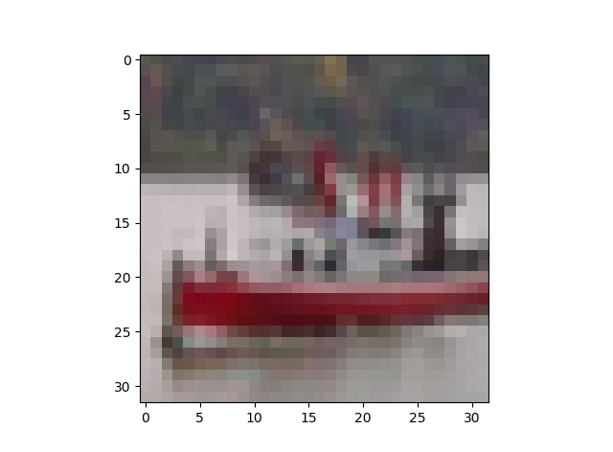

Noisy

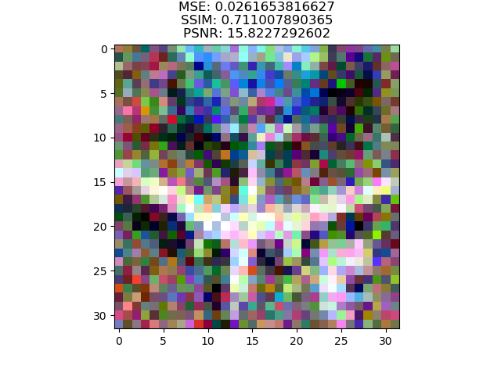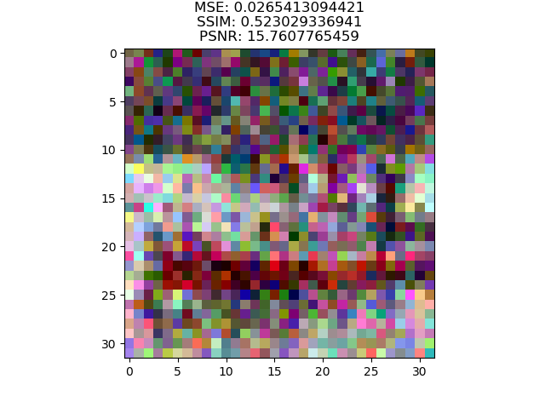

Restored

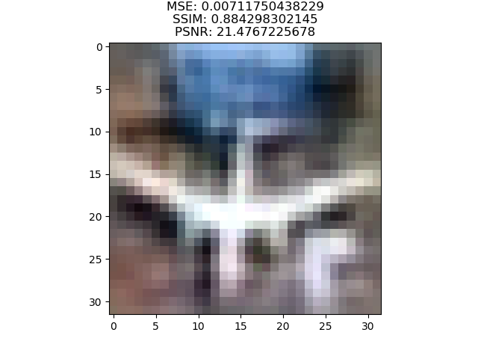

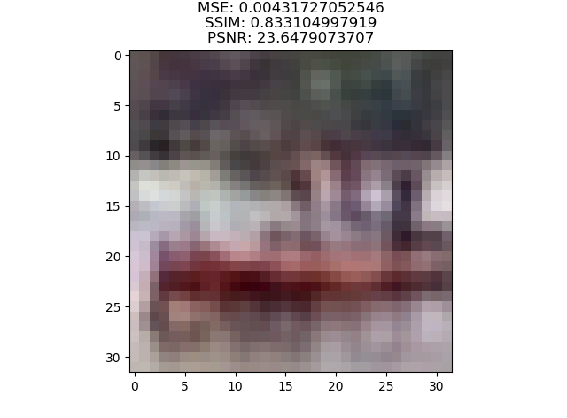

**Pytorch**

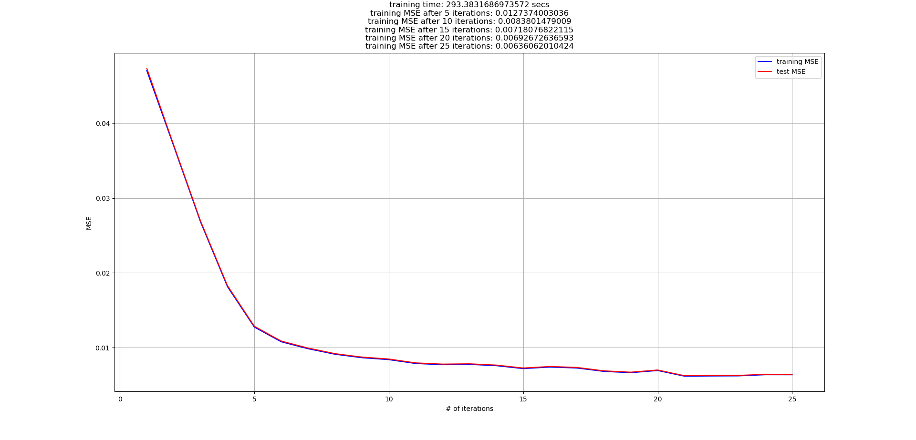

**Pytorch**

Original

 

Noisy



Restored

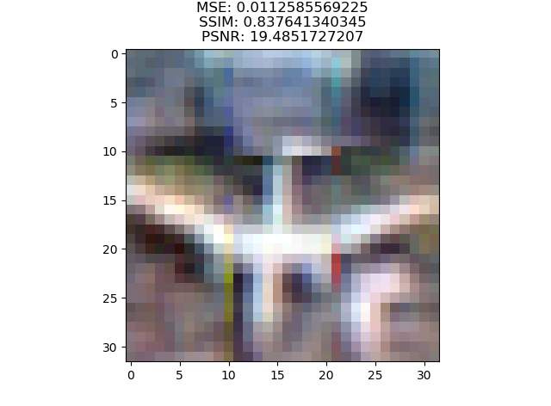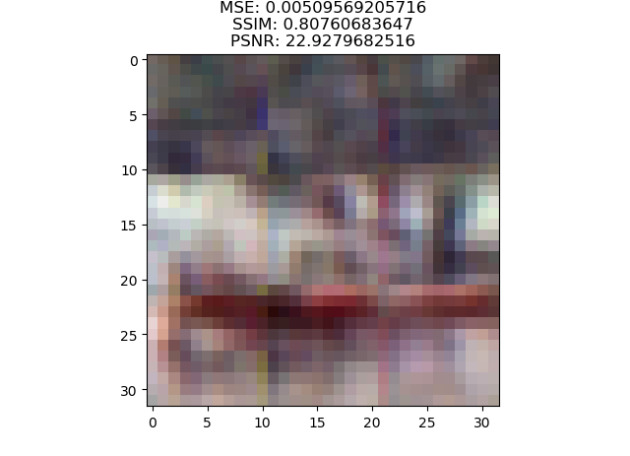

**Case 2: initial weights 2, datasets 2, batch size 256, learning rate 0.003**

**Tensorflow**

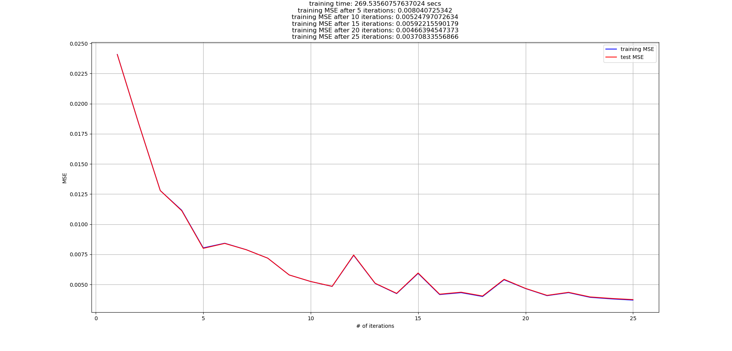

**Tensorflow**

Original

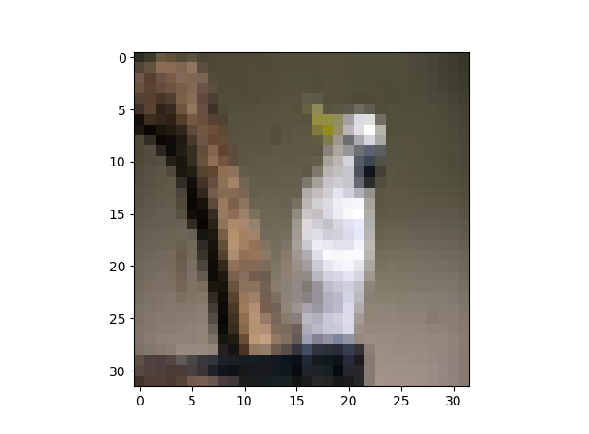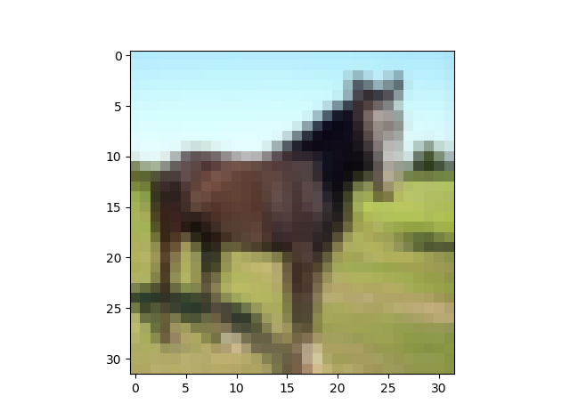

Noisy

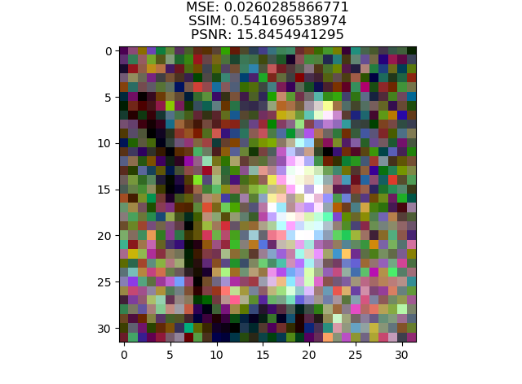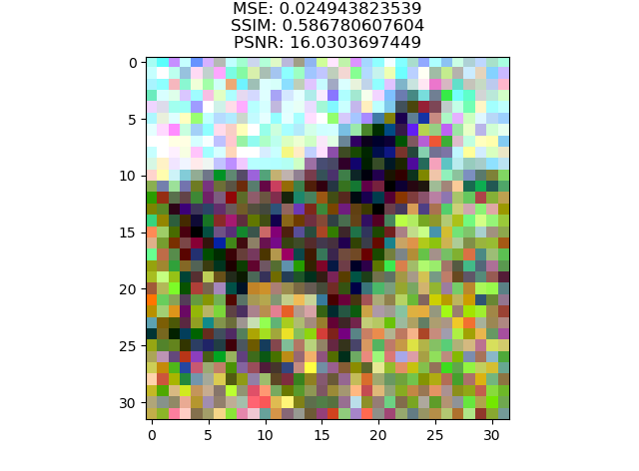

Restored

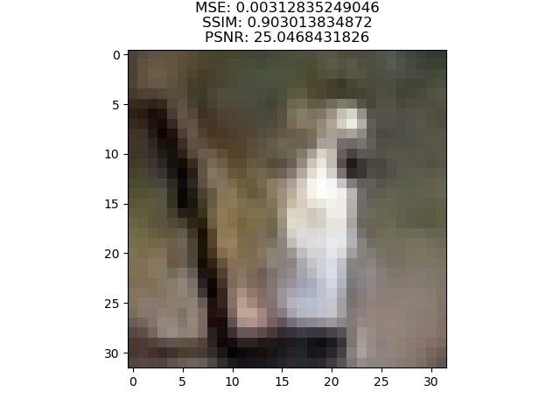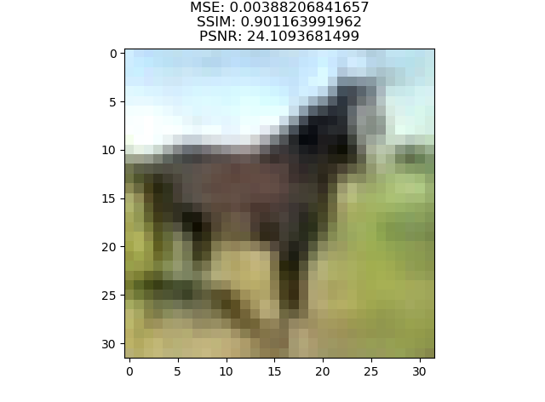

**Pytorch**

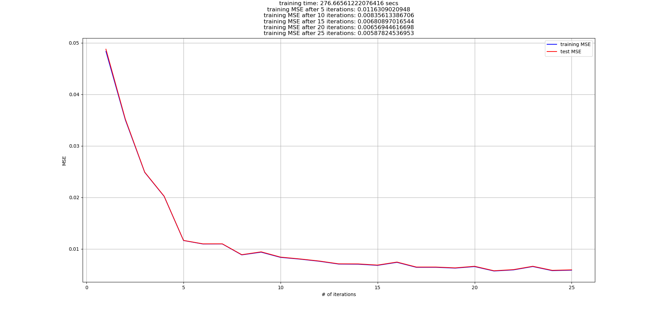

**Pytorch**

Original



Noisy



Restored

