Using Power BI to visualize data insights from Microsoft Dynamics CRM Online

When it comes to business intelligence (BI), one of our missions in Microsoft IT is to create an infrastructure that empowers data consumers by putting information at their fingertips. Easy, seamless access to the right intelligence can yield timely, strategic, data-driven decisions—with increased cost savings and productivity. To support our mission, we helped the Microsoft Operations Global Business Process Outsourcing (BPO) team capture and make customer data available to executives, managers of regional operating centers, service delivery managers in operations, and other decision makers in the organization.

The BPO team can now share customer information from Microsoft Dynamics CRM Online with stakeholders in their organization by just sending a link to a dashboard in Microsoft Power BI. Even though these stakeholders don’t have a license for CRM Online, accessing the data was no problem. They could still view, interact with, and analyze the same data through the dashboard.

# Data dividends from CRM Online and Power BI

Today, data is the new currency. As Microsoft CEO Satya Nadella said, “Every aspect of the company’s business is being fundamentally transformed because of data.”

The BPO team had information in CRM Online about operational incidents, related transactions, inquiries, trends, end-to-end cycle time, and adherence to service level agreements (SLAs). This information is critical to monitor, especially at the end of each quarter. The BPO team wanted an easy way to track and share this treasure trove. They also wanted to support the organization by allowing people to view trends, analyze the health of the transactional pipeline, and take any needed corrective actions.

But it was hard for the BPO team to share data with employees who didn’t have access to CRM Online. That’s where Power BI played a vital role. Among other benefits, Power BI gives data-visualization capabilities to CRM Online. Any employee with the right authorization and an Office 365 subscription (which includes access to Power BI) can view key customer information at a glance, without sifting through terabytes of data in CRM Online. With Power BI, it’s simple, safe, and cost effective to share data views within Microsoft.

Architecturally, what made this scenario possible was an out-of-the-box connector between CRM Online and Power BI. Because of this integration, employees can take advantage of CRM Online data, gain customer insights, and reap dividends in Power BI by:

* Sharing a Power BI dashboard or report.
* Exporting CRM Online data by using Power BI.
* Viewing CRM Online data with the Power BI app.

# Sharing a Power BI dashboard

The BPO team conducts business reviews and keeps executives and stakeholders up to date about the status of the business. They have a lot of data in CRM Online. But instead of giving everyone access to CRM Online, now they can just share the Power BI dashboard with those who need the information.

Because some employees only need occasional access to the data, the cost of a CRM Online license isn’t justified. Others, like senior managers and executives, may only want high-level views or access to certain aspects of the data, like opportunities or leads. Sharing data with Power BI is easy—both for those who share and those who receive it.

By using Power BI, beginners and occasional users can generate basic views. Advanced users and those with programming skills can perform sophisticated queries to slice and dice the data, and to create more detailed visualizations. An employee who shares a dashboard can limit sharing to designated recipients or can allow the recipient to share the dashboard with others.

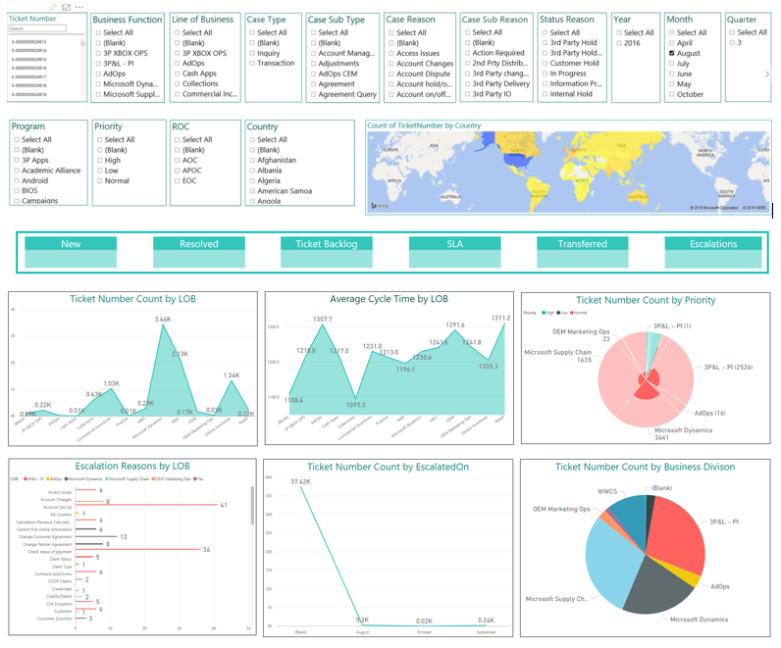

Figure 1. A sample dashboard in Power BI

# Exporting CRM Online data by using Power BI

Although stakeholders can quickly see CRM Online data through the Power BI dashboard, that isn’t the only way to view it. We wanted stakeholders, like executives, to be able to view the data and to also be able to perform their own data analysis. They can export the CRM Online data from the Power BI dashboard into a Microsoft Excel file by selecting **Export data**. From there, they can do their own customer reporting and can manipulate the data—for example, with pivot tables in Excel. Again, it’s about empowering our employees.

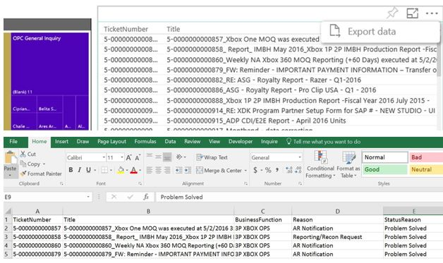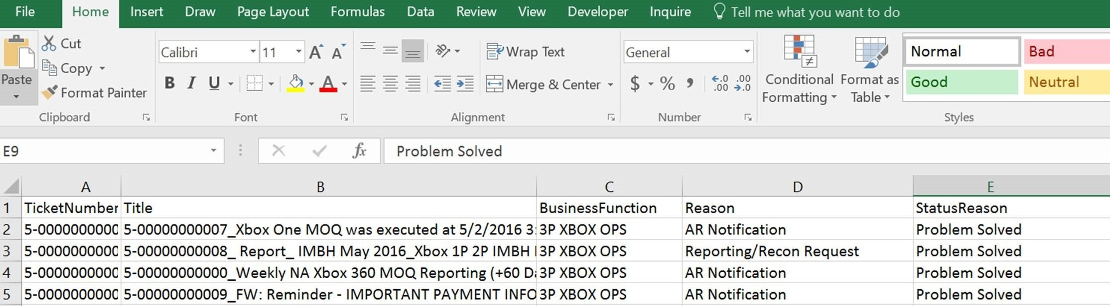

Figure 2. Dynamics CRM Online data exported from Power BI into Microsoft Excel

# Viewing CRM Online data with the Power BI app

To support the needs of Microsoft executives and managers who are often on the go from one meeting and conference call to another, there’s yet another way to view CRM Online data. The Power BI team built an app that provides a Power BI view for an Android, iPhone, or Windows Phone. This Power BI app is available as a free download for all of these devices. Addressing the mobility needs of our employees was one of the main contributors to a successful solution. With the app, executives can easily view data on their phones and devices while on the move.

# Business benefits

We’ve seen clear advantages from using Power BI to share CRM Online data:

* **Cost savings**. The organization saves money because they don’t need to provision licenses to CRM Online. Instead, they can use the capabilities in Power BI at no additional cost. Also, Power BI—as a cloud-based service—saves money because it doesn’t require on-premises hardware.
* **Increased productivity**. By being able to create reports quickly and independently, employees can spend more time on strategic activities rather than manually crunching data. And executives get a condensed view without having to spend time sorting through vast amounts of information that they don’t need.
* **Increased ability to make real-time, data-driven business decisions**. Employees have access to regularly refreshed information with the ability to filter, manipulate, and analyze data.

# The power of data

Microsoft IT and BPO have helped carry out the vision of transforming business as we know it—through data. Stakeholders can interact with and analyze data in Power BI, without a license to CRM Online. The result? Better insight into operational health and trends, and more informed decision making.

# For more information

[Microsoft Dynamics CRM Online](https://partner.microsoft.com/en-US/Solutions/microsoft-dynamics-crm-online)

[Microsoft Power BI](https://powerbi.microsoft.com/)

[Microsoft Power BI for Mobile](https://powerbi.microsoft.com/en-us/mobile/)

## Microsoft IT

[microsoft.com/itshowcase](http://www.Microsoft.com/ITShowcase)

© 2016 Microsoft Corporation. All rights reserved. Microsoft and Windows are either registered trademarks or trademarks of Microsoft Corporation in the United States and/or other countries. The names of actual companies and products mentioned herein may be the trademarks of their respective owners. This document is for informational purposes only. MICROSOFT MAKES NO WARRANTIES, EXPRESS OR IMPLIED, IN THIS SUMMARY.