Software Build Automation Tools — Module 1 Project
Git as a “Time Machine” • Project: Monthly Budget Planner
Author: Mustafa Cankatar | Repository: https://github.com/mustafacankatarr/Monthly-Budget-Planner

1. Purpose of the Script
Monthly Budget Planner is a small command-line Python application that reads a list of monthly expenses from an external file (expenses.txt) and writes a formatted spending report to an output file (report.txt). On each run it calculates the total spending, a per-category breakdown showing each category’s share of the total, the average daily spending, a recommended emergency fund (a configurable percentage of total spending), and the single biggest expense. The input parser is deliberately robust: blank lines, comment lines (starting with #) and malformed entries are skipped with a warning, so a single typo cannot crash the whole report. The script demonstrates the core build-automation idea of a reproducible process that turns a tracked input file into a generated, non-tracked output file.
2. Git Evolution (11 commits, a branch merge and a resolved conflict)
The project was built incrementally through 11 commits (the minimum required is 5), each with a clear “what and why” message: read the input and compute the total; add a per-category breakdown; calculate the emergency fund and write report.txt; add a .gitignore; add a README; make the parser robust; sort the breakdown and show percentage shares; and add average-daily-spending and biggest-expense statistics.
A feature branch, feature-emergency-fund, was then created to raise the emergency-fund buffer from 10% to 15%, while the main branch independently raised the same value to 20%. Merging the branch into main therefore produced a deliberate merge conflict on the BUFFER_RATE line. The conflict was resolved manually by keeping the 20% value, which created the final merge commit, and the release was tagged v1.0. The generated file report.txt is excluded by .gitignore, so it never appears as a tracked change.
3. Evidence
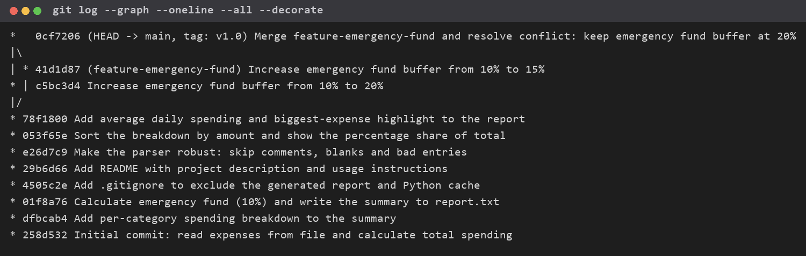
Figure 1 — Full commit history and branch/merge structure (git log --graph --oneline --all --decorate).
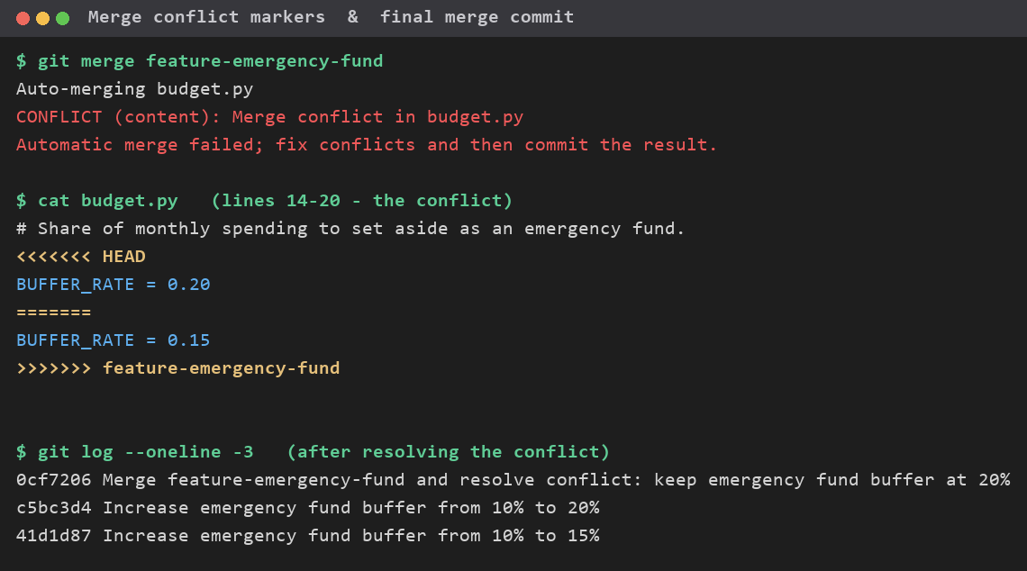
Figure 2 — The conflict markers (<<<<<<<, =======, >>>>>>>) and the final merge commit after resolution.
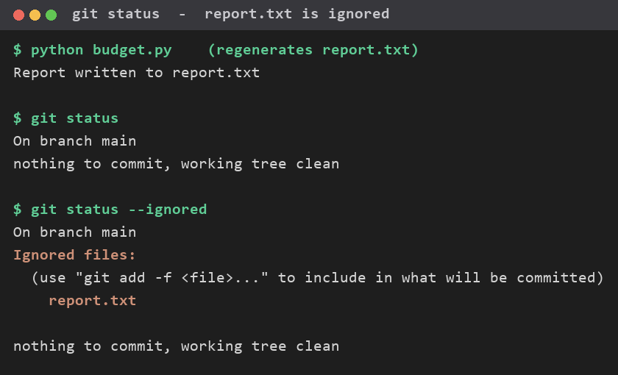
Figure 3 — git status confirming the output file report.txt is ignored by Git.

