ANKARA UNIVERSITY
ENGINEERING FACULTY
DEPARTMENT OF COMPUTER ENGINEERING

RESEARCHING REPORT

Digital Image and Video
Mustafa Ahmet DENİZ 14290087
Mustafa GÖKSEVER 14290099

TABLE OF CONTENTS
1. DIGITAL IMAGE 3
1.1. Digital Image Types 4
1.1.1. Binary Digital Image 4
1.1.2. Grayscale Digital Image 4
1.1.3. RGB Image 5
1.2. Converting the color image to Gray-Tone 6
1.3. Digital Image Formats 7
1.3.1. TIFF (.tif, .tiff) 7
1.3.2. JPEG (.jpg, .jpeg) 7
1.3.3. GIF (.gif) 8
1.3.4. PNG (.png) 8
1.3.5. RAW Image Files (.raw, .cr2, .nef, .orf, .sr2, and more) 8
1.4. Digital Image Size 8
2. DIGITAL VIDEO 9
2.1. Digital Video Formats 9
2.1.1. AVI (Audio Video Interleave) 9
2.1.2. FLV (Flash Video Format) 9
2.1.3. WMV (Windows Media Video) 10
2.1.4. MOV (Apple QuickTime Movie) 10
2.1.5. MP4 (Moving Pictures Expert Group 4) 10
2.2. Digital Video size 10
3. REFERENCE 12

1. DIGITAL IMAGE
A digital image is an array, or a matrix, of square pixels (picture elements) arranged in columns and rows. The basic component of a digital image is the pixel-picture element. Therefore, an image should be m x n dimensional matrix of pixels. To refer to a specific pixel within the image matrix, we define its coordinate at x and y. The coordinate system of image matrices defines x as increasing from left to right and y as increasing from top to bottom. Compared to the normal mathematic convention, the origin is in the top left corner and the y coordinate is flipped.
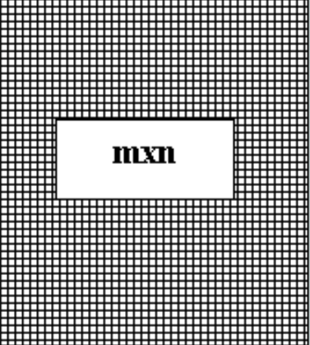
Figure 1.1. m x n dimensional matrix of pixels.
A pixel is the smallest unit of a digital image or graphic that can be displayed and represented on a digital display device. A pixel is the basic logical unit in digital graphics. Pixels are combined to form a complete image, video, text or any visible thing on a computer display. A pixel is also known as a picture element. Image size specifically describes the number of pixels within a digital image.


Figure1.2. Example pixel of an image A blue pixel

Digital Image Types

Binary Digital Image
A binary image is a digital image that has only two possible values for each pixel. Typically, the two colors used for a binary image are black and white. The color used for the object(s) in the image is the foreground color while the rest of the image is the background color. In the document-scanning industry, this is often referred to as "bi-tonal".
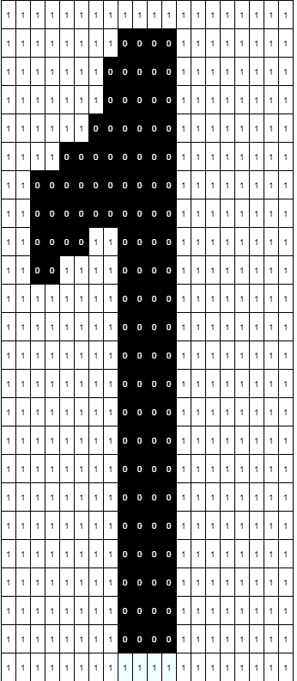
Figure 1.3. Binary Image

Grayscale Digital Image
The brightness value of each pixel of the digital image is called grey levels. The grey level range is determined by the number of bits that the brightness value at each pixel is encoded.
There are two colours in grey level borders, black and white. Images encoded between these two are called grayscale (monochromatic) images.
Each pixel commonly used in the application is encoded with 8 bits. In this type of image, each pixel consists of 2⁸ = 256 different grayscale (brightness level) values and the gray range of values is expressed as G = {0, 1, 2,…, 255}. As a rule; 0 gray level corresponds to black, 255 gray level corresponds to White and the gray levels between these values correspond to gray tones.

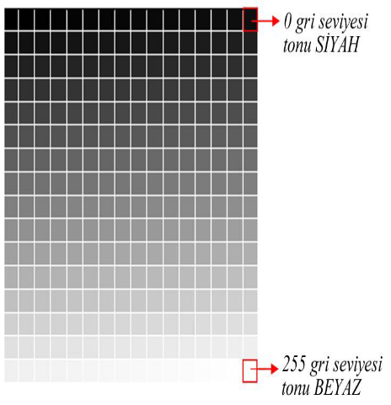
0 Black

255 White

Figure 1.4. Grayscale image

RGB Image
Color images, on the other hand, have intensity from the darkest and lightest of three different colors, Red, Green, and Blue.
Intensity values in digital images are defined by bits. A bit is binary and only has two possible values, 0 or 1. An 8-bit intensity range has 256 possible values, 0 to 255. This can be seen mathematically by 2^{(# of bits)}. For a 1-bit or binary, image, 2¹ = 2 possible values and for an 8-bit image, 2⁸ = 256 possible values. The various mixtures of these color intensities produce a color image. The standard digital photo uses an 8-bit range of values; RGB images contain 3 x 8-bit intensities they are also referred to as 24-bit color images.
Colors Name | R | G | B | Colors
Red | 255 | 0 | 0
Green | 0 | 255 | 0
Blue | 0 | 0 | 255
White | 255 | 255 | 255
Black | 0 | 0 | 0
Light Grey | 200 | 200 | 200
Dark Grey | 100 | 100 | 100
Yellow | 255 | 255 | 0
Cyan | 0 | 255 | 255
Magenta | 255 | 0 | 255

Figure 1.5. Table of RGB Colors

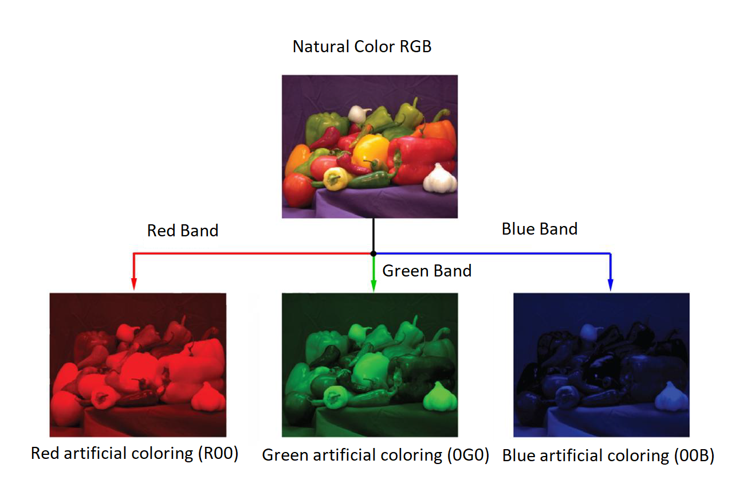
Figure 1.6. The artificial coloration of the natural-color RGB image with primary colors
(Red – Green - Blue)

Converting the color image to Gray-Tone
The process of converting a color digital image to a gray-toned image is, in fact, the scaling of the gray-tone images that correspond to each color band specified in the RGB color model. The formula is
gray = 0.299 x R + 0.587 x G + 0.114 x B
The grayscale of the color image is obtained using this equation.
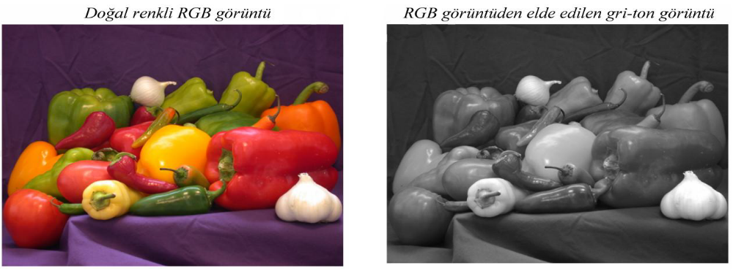
Figure 1.7. Grayscale image from RGB image.

Digital Image Formats
Some of the most common digital image formats are:

TIFF (.tif, .tiff)
TIFF or Tagged Image File Format are lossless images files meaning that they do not need to compress or lose any image quality or information, allowing for very high-quality images but also larger file sizes.
Compression: Lossless - no compression. Very high-quality images.
Best For: High quality prints, professional publications, archival copies

JPEG (.jpg, .jpeg)
JPEG, which stands for Joint Photographic Experts Groups is a “lossy” format meaning that the image is compressed to make a smaller file. The compression does create a loss in quality but this loss is generally not noticeable. JPEG files are very common on the Internet and JPEG is a popular format for digital cameras - making it ideal for web use and non-professional prints.
Compression: Lossy - some file information is compressed or lost
Best For: Web Images, Non-Professional Printing, E-Mail, PowerPoint
Special Attributes: Can choose the amount of compression when saving in image editing programs like Adobe Photoshop or GIMP.

GIF (.gif)
GIF or Graphics Interchange Format files are widely used for web graphics, because they are limited to only 256 colors, can allow for transparency, and can be animated. GIF files are typically small is the size and are very portable.
Compression: Lossless - compression without loss of quality
Best For: Web Images
Special Attributes: Can be Animated, Can Save Transparency

PNG (.png)
PNG or Portable Network Graphics files are a lossless image format originally designed to improve upon and replace the gif format. PNG files are able to handle up to 16 million colors, unlike the 256 colors supported by GIF.
Compression: Lossless - compression without loss of quality
Best For: Web Images

RAW Image Files (.raw, .cr2, .nef, .orf, .sr2, and more)
RAW images are images that are unprocessed that have been created by a camera or scanner. They hold a lot of image information, but still, need to be processed in an editor such as Adobe Photoshop or Lightroom.
Compression: None
Best For: Photography
Special Attributes: Saves metadata, unprocessed, lots of information

Digital Image Size
The number of bits for storing a numerical image (N × M) of each pixel, represented by n bits and M columns, is calculated as follows:
b = N x M x m (bit)
8 bits = 1byte, 1024 bytes = 1Kbyte, 1024 Kbytes = 1Mbyte
For example, if each pixel has a grey image represented by 8 bits, N x M = 1000x600 pixels
b = 1000x600x8 = 4,800,000 bits / 8 = 600,000 bytes = 600 Kbytes = 0.6 Mbytes.
If we store the same image with a 24-bit encoding (color image) (each pixel is shown with RGB = 28 + 28 + 28 = 224 = 16.777.216 million colors)
b = 1000x600x24 = 14.400.000 bits / 8 = 1.800.000 bytes = 1.800 Kbytes = 1.8 Mbytes.

2. DIGITAL VIDEO
Digital video is composed of a series of orthogonal bitmap (BMP) images displayed in constant rapid succession with common frequencies of 15, 24, 30 and 60 frames per second (FPS); the more frames the DV has, the more movement details are captured or displayed.

Digital Video Formats
A normal video file in a digital format is made up of two parts, a “codec” and a “container”. A “codec” is used to compress and decompress a video file, as there are times where video files are too large and may cause difficulty when trying to download or play the file. Some examples of “codecs” are FFMpeg, DivX, XviD, and x264. A “container” is a collection of files that stores information about the digital file. It simply means there is a combination of both audio and video data in a single file to allow for simultaneous audio-with-video playback. Some popular types of “containers” are AVI, FLV, WMV, MP4, and MOV.

AVI (Audio Video Interleave)
Developed by Microsoft and introduced to the public in November 1992 as part of its Video for Windows technology, the AVI format is one of the oldest video formats. It is so universally accepted that many people consider it the de facto standard for storing video and audio information on the computer. Due to it’s simple architecture, AVI files are able to run on a number of different systems like Windows, Macintosh, Linux; is also supported by popular web browsers. AVI files stores data that can be encoded in a number of different codec’s, although most commonly with M-JPEG or DivX codecs. This means that all AVI files, while they may look similar on the outside, differ substantially from one another on the inside.

FLV (Flash Video Format)
FLV files are videos that are encoded by Adobe Flash software, usually with codecs following the Sorenson Spark or VP6 video compression formats. They can be played via the Adobe Flash Player, web browser plugins or one of several third-party programs. Since virtually everyone has the player installed on their browsers, it has become the most common online video viewing platform used on the Web today. As almost all video sharing sites such as YouTube stream videos in Flash, practically all browsers support and are compatible with the Flash Video format and can play the video with ease. In addition to being an online video viewing format, the Flash Video format is also what many video-sharing sites convert videos to, from formats that were uploaded by their users in something other than Flash. This is because videos in the FLV format remain in high quality even after compression to a smaller file size, which means that the videos on the Web load quickly and won’t spend a lot of time using up bandwidth. Some notable users of the Flash Video are YouTube, Yahoo! Video, VEVO, Hulu and Myspace among many others.

WMV (Windows Media Video)
Developed by Microsoft, WMV was originally designed for web streaming applications, as a competitor to Real Video, but it can now cater to more specialized content. WMV files are the tiniest video files over the Web, as their file size decreases significantly after compression, which results in poor video quality. However, one advantage of this small file size is that it is probably the only video file format that allows users to upload and share their videos through the e-mail system. Being a Microsoft software, the Windows Media Player is the main application that is used to play WMV files on all Microsoft’s Windows operating systems, but there are also WMV players available for free for the Macintosh operating system.

MOV (Apple QuickTime Movie)
Developed by Apple. Inc, the QuickTime file format is a popular type of video sharing and viewing format amongst Macintosh users, and is often used on the Web, and for saving movie and video files. In recent years, Apple came up with a newer version called QuickTime X, currently available on Mac OS X Snow Leopard, Lion and Mountain Lion. MOV files are most commonly opened via the Apple QuickTime Player for the Macintosh Operating System. However, MOV files are not just limited to being played on Apple computers, as there is a free version of the QuickTime Player available for the Windows Operating System among many other players. Considered one of the best-looking file formats, MOV files are of high quality and are usually big in file size.

MP4 (Moving Pictures Expert Group 4)
MP4 is an abbreviated term for MPEG-4 Part 14, a standard developed by the Motion Pictures Expert Group who was responsible for setting industry standards regarding digital audio and video, and is commonly used for sharing video files on the Web. First introduced in 1998, the MPEG-4 video format uses separate compression for audio and video tracks; video is compressed with MPEG-4 or H.264 video encoding; and audio is compressed using AAC compression. The MP4 file format is also another great file sharing format for the Web, MP4 file sizes are relatively small but the quality remains high even after compression. MP4 standard is also becoming more popular than FLV for online video sharing, as it compatible with both online and mobile browsers and also supported by the new HTML5.
At MotionElements, when selling with us, we accept your stock footage in both AVI and MOV file formats, although the MOV file format is more highly recommended because of its preservation of high quality even after compression.

Digital Video size
Digital video comprises a series of orthogonal bitmap digital images displayed in rapid succession at a constant rate. In the context of video these images are called frames. The rate at which frames are displayed in is measured in frames per second (FPS). Since every frame is an orthogonal bitmap digital image it comprises a raster of pixels. If it has a width of W pixels and a height of H pixels it is said that the frame size is W x H. Pixels have only one property, their color. The color of a pixel is represented by a fixed number of bits. The more bits the subtler variations of colors can be reproduced. This is called the color depth (CD) of the video.
An example video can have a duration (T) of 1 hour (3600sec), a frame size of 640x480 (W x H) at a color depth of 24 bits and a frame rate of 25fps. This example video has the following properties:
- pixels per frame = 640 * 480 = 307,200
- bits per frame = 307,200 * 24 = 7,372,800 = 7.37 Mbits
- bit rate (BR) = 7.37 * 25 = 184.25 Mbits/sec
- video size (VS)^{[3]} = 184 Mbits/sec * 3600 sec = 662,400 Mbits = 82,800 Mbytes = 82.8 Gbytes
The most important properties are bit rate and video size. The formulas relating those two with all other properties are:
BR = W * H * CD * FPS
VS = BR * T = W * H * CD * FPS * T
(units are: BR in bit/s, W and H in pixels, CD in bits, VS in bits, T in seconds)
while some secondary formulas are:
pixels_per_frame = W * H
pixels_per_second = W * H * FPS
bits_per_frame = W * H * CD

The above are accurate for uncompressed video. Because of the relatively high bit rate of uncompressed video, video compression is extensively used. In the case of compressed video each frame requires a small percentage of the original bits. Assuming a compression algorithm that shrinks the input data by a factor of CF, the bit rate and video size would equal to:
BR = W * H * CD * FPS / CF
VS = BR * T / CF
Note that it is not necessary that all frames are equally compressed by a factor of CF. In practice they are not, so CF is the average factor of compression for all the frames taken together.
The above equation for the bit rate can be rewritten by combining the compression factor and the color depth like this:
BR = W * H * ( CD / CF ) * FPS
The value (CD / CF) represents the average bits per pixel (BPP). As an example, if there is a color depth of 12 bits/pixel and an algorithm that compresses at 40x, then BPP equals 0.3 (12/40). So in the case of compressed video the formula for bit rate is:
BR = W * H * BPP * FPS
The same formula is valid for uncompressed video because in that case one can assume that the "compression" factor is 1 and that the average bits per pixel equal the color depth.

Cozunurluk\

3. REFERENCE

- Lecture Notes, Ibrahim Cayiroglu, Karabük Üniversitesi, Mühendislik Fakültesi
- Lecture Notes, Introduction to Image Processing, Doç. Dr. Aybars UĞUR, 2013
- Gonzalez, R.C., Woods, R., “Digital Image Processing”, 3rd Edition, Prentice-Hall, 2008.
- http://www.yildiz.edu.tr/~bayram/sgi/saygi.htm
- “Image Processing”, https://en.wikipedia.org/wiki/Image_processing
- https://www.motionelements.com/blog/articles/what-you-need-to-know-about-the-5-most-common-video-file-formats
- https://en.wikipedia.org/wiki/Digital_video

