

FACULTY OF ENGINEERING AND NATURAL SCIENCES CAPSTONE PROJECT PROPOSAL
AUTOMATED STRUCTURAL SEGMENTATION OF MUSICAL PIECES

Software Engineering Kaan Akgül 2004221
Abdalla Hamuda 2105020 Mustafa Göktuğ İbolar 2101483

Advisors: Assist. Prof. Duygu Çakır Yenidoğan Department of Software Engineering

Jan, 2026

STUDENT DECLARATION

By submitting this report, as partial fulfilment of the requirements of the Capstone course, the students promise on penalty of failure of the course that

- they have given credit to and declared (by citation), any work that is not their own (e.g. parts of the report that is copied/pasted from the Internet, design or construction performed by another person, etc.);
- they have not received unpermitted aid for the project design, construction, report or presentation.
- they have not falsely assigned credit for work to another student in the group and not take credit for work done by another student in the group.

2

ECLARATION OF AI USAGE
Tools Used During the preparation of this Capstone Project Proposal, I utilized the following tools: ChatGPT-5.2
Gemini 3 Pro
Claude 4.5 Opus
Purpose and Methodology AI was used exclusively for [choose: ideation / proofreading / outlining / technical troubleshooting].
AI tools were used exclusively for technical troubleshooting, code-level clarification, and language refinement during the preparation of this project. The tools were not used to generate core ideas, design the methodology, or produce experimental results.
Specifically, AI assistance was utilized to:
- Clarify implementation details related to audio feature extraction and similarity matrix construction.
- Provide syntax-level guidance for Python code used in signal processing and data handling.
The conceptual framework, system architecture, experimental design, and evaluation methodology were entirely developed by the author.

The following types of prompts were entered during the development process:
- “Explain how chroma features are computed from an audio signal using a short-time Fourier transform.”
- “What is the purpose of a self-similarity matrix in music structure analysis?”
- “Provide an example of peak detection logic for a novelty curve in Python.”
- “How can a checkerboard kernel be applied for boundary detection in audio segmentation?”
- “Improve the academic tone of this paragraph without changing its technical meaning.”
These prompts were used solely for clarification, validation, and refinement purposes and did not contribute to the generation of original research content.

Validation and Authorship I certify that:
I have personally verified all facts, citations, and data points provided by the AI.
I have not simply copied and pasted AI outputs; all final text is my own writing or a significant rewrite of AI suggestions.
I accept full responsibility for the integrity and accuracy of this proposal.

3

Project Team

Department :Software Engineering
Member 1 :Kaan Akgül
Member 2 :Abdalla Hamuda
Member 3 :Mustafa Göktuğ İbolar
Advisor :Dr. Duygu Çakır

4

ABSTRACT

This project proposes the design and implementation of an automated system for music structure segmentation, focusing on the identification of meaningful structural boundaries such as verses, choruses, and other repeating sections in music recordings. Automatic music segmentation is a fundamental challenge in Music Information Retrieval (MIR) due to the complexity and variability of musical structure across genres. The scientific contribution of this project lies in applying and integrating established signal-processing and structural analysis techniques into a modular, evaluable system, enabling systematic comparison and validation against annotated ground truth data.
Methodologically, the system analyzes audio recordings by extracting mid-level musical features and modeling structural similarity within a song. Self-similarity matrices are used to capture relationships between different temporal segments of a track, while novelty detection techniques highlight points of significant musical change. Peak detection methods are then applied to identify candidate structural boundaries. The system is designed to be modular, allowing multiple segmentation strategies and feature configurations to be tested and combined. Performance is evaluated using publicly available annotated datasets and standard MIR evaluation metrics, including precision, recall, and F1-score, ensuring objective and reproducible assessment of segmentation accuracy.
Project management follows a structured, two-semester development plan. The first phase focuses on literature review, system architecture design, and implementation of core feature extraction and segmentation modules. The second phase emphasizes system integration, optimization, evaluation against ground truth datasets, and refinement of visualization and usability features. Development is supported by version control, clear task distribution, and incremental testing to ensure maintainability and steady progress within academic time constraints.
The primary outputs of the project include a fully functional music segmentation system capable of processing common audio formats, a visualization interface for displaying waveforms and detected boundaries, and an evaluation framework for quantitative performance analysis. Additional deliverables include comprehensive technical documentation, a user guide, and experimental results demonstrating system performance. Overall, the project delivers a practical and extensible software tool that supports music analysis, education, and research, while providing valuable hands-on experience in signal processing, algorithmic analysis, and software engineering.

Keywords: Music Information Retrieval, Music Structure Segmentation, Audio Signal Processing, Self-Similarity Analysis

5

TABLE OF CONTENTS

ABSTRACT | 5
TABLE OF CONTENTS | 6
LIST OF TABLES | 8
LIST OF FIGURES | 8
LIST OF ABBREVIATIONS | 9
1. Background and Motivation | 1
1.1 Background: | 1
1.2 Scope and Problem Statement: | 1
1.3 Project Objectives: | 1
1.4 Motivation and Significance: | 1
1.5 Limitations: | 1
1.5.1 Technical Constraints | 1
1.5.2 Realistic Constraints | 1
2. Literature Review / State of the Art | 2
3. Methodology and Technical Approach | 3
3.1 Overall Approach and Tasks: | 3
3.2 System Design / Architecture: | 3
3.3 Tools, Technologies, and Standards: | 3
3.4 Data Collection and Analysis (if applicable): | 3
3.5 Implementation Plan: | 3
4. Work Plan and Schedule | 4
4.1 Work Breakdown Structure | 4
4.2 Gantt chart | 4
5. Required Resources | 6
5.1 Hardware (if applicable): | 6
5.2 Software : | 6
5.3 Facilities and Services: | 6
5.4 Estimated Budget (if applicable): | 6
6. Risk Assessment and Mitigation | 7
6

- Expected Outcomes and Evaluation 8
  - Expected Outcomes: 8
  - Success Criteria: 8
  - Evaluation Methods: 8
- Ethical, Safety, and Sustainability Considerations 9
- References 10

7

LIST OF TABLES
Table 1. Gantt chart for the materialisation phase of the project. 23

LIST OF FIGURES

LIST OF ABBREVIATIONS

AI Artificial Intelligence
FFT Fast Fourier Transform
MIR Music Information Retrieval
SSM Self-Similarity Matrix
STFT Short-Time Fourier Transform

8

- Background and Motivation

  - Background:
Music structure analysis is a fundamental research area within the field of Music Information Retrieval (MIR). One of the core problems in this domain is music segmentation, which aims to automatically identify structural boundaries in an audio signal, such as transitions between musical sections (e.g., intro, verse, chorus, or bridge). Accurate segmentation plays a critical role in various applications, including music summarization, recommendation systems, content-based retrieval, audio editing, and musicological analysis.
Traditionally, music segmentation has been performed manually by domain experts, which is a time-consuming, subjective, and non-scalable process. With the increasing availability of large-scale digital music collections, there is a growing need for automated and objective segmentation techniques. Recent advances in signal processing and computational analysis have enabled the development of algorithmic approaches based on audio features, similarity analysis, and novelty detection. However, achieving reliable segmentation without relying on extensive labeled data remains an ongoing challenge.
This project is situated within this context and focuses on designing an automated, data-driven music segmentation system using audio signal processing techniques.

  - Scope and Problem Statement:
The core problem addressed in this project is the automatic detection of structural boundaries in music recordings without manual annotation. Given a raw audio input, the system aims to determine meaningful segmentation points that correspond to changes in musical structure.
The scope of the project is limited to audio-based segmentation, relying solely on signal-level features extracted directly from the waveform. The problem excludes semantic labeling of segments (e.g., identifying verses or choruses by name) and instead focuses on accurately identifying boundary locations. The challenge lies in designing a segmentation approach that is robust, interpretable, and applicable to diverse musical content without requiring supervised training data.

  - Project Objectives:
The primary goal of this project is to develop an automated music segmentation system based on audio feature similarity and novelty detection techniques.
The specific objectives are as follows:

- To extract chroma-based audio features from music recordings using time-frequency analysis.
- To construct a self-similarity matrix that captures structural repetition and variation within a musical piece.
- To compute a novelty curve using a checkerboard-based kernel in order to highlight potential segmentation boundaries.
- To detect and evaluate segment boundaries through peak detection methods applied to the novelty curve.
Each objective is designed to be measurable and verifiable through intermediate outputs and experimental evaluation.

  - Motivation and Significance:
Automated music segmentation is a key enabling technology for many intelligent music processing systems. An effective segmentation method can significantly enhance downstream applications such as music recommendation, audio browsing, automatic playlist generation, and interactive music analysis tools.
The motivation for this project arises from the need for interpretable and lightweight segmentation approaches that do not rely on large annotated datasets or complex machine learning models. By focusing on signal-processing-based techniques, the project contributes a transparent and reproducible methodology that can be easily extended or integrated into other MIR systems. The outcomes of this work may benefit researchers, developers, and practitioners working on music analysis, digital libraries, and audio-based information systems.

  - Limitations:
This project intentionally defines clear boundaries regarding its capabilities and scope.

    - Technical Constraints
The system operates under several technical constraints. The implementation is limited to a predefined set of audio features, primarily chroma-based representations, and does not incorporate multi-modal data such as lyrics or symbolic music formats. The segmentation approach is evaluated using a restricted dataset size due to time and computational limitations. Additionally, the project does not employ deep learning models, as the focus is on algorithmic transparency rather than model complexity.

    - Realistic Constraints
From an economic and sustainability perspective, the project is designed to run on standard consumer-grade hardware without requiring specialized computational resources, making it cost-effective and accessible. From an ethical and social standpoint, the system processes publicly available or user-provided audio data and does not involve personal or sensitive information. As a result, the project avoids privacy-related concerns and adheres to responsible data usage principles. These constraints guide the design toward practical, reproducible, and ethically sound solutions.

- Literature Review / State of the Art

Automatic music structure segmentation is a well-studied problem in the field of Music Information Retrieval (MIR). Early approaches focused on low-level audio features such as energy, spectral content, and timbre to detect changes in musical structure. Foote introduced the use of self-similarity matrices (SSMs) combined with novelty detection, which became a foundational technique for identifying structural boundaries in music recordings [1]. This method models repetitions and contrasts within a song and remains influential in many later systems.
Subsequent studies extended this approach by incorporating mid-level musical features, including rhythm, harmony, and chroma representations. Serra et al. demonstrated that combining multiple features improves segmentation robustness across different musical genres [2]. Other research explored probabilistic and machine learning-based methods, such as Hidden Markov Models and clustering techniques, to model musical form more explicitly [3]. While these methods improved accuracy, they often required extensive parameter tuning or large labeled datasets.
Several toolkits and datasets have been developed to support music segmentation research. The SALAMI dataset provides large-scale, human-annotated structural boundaries and has become a benchmark for evaluation [4]. Frameworks such as MSAF (Music Structure Analysis Framework) integrate multiple algorithms and provide standardized evaluation metrics, enabling reproducible experimentation [5]. However, many existing tools function as black boxes, offering limited transparency into how segmentation decisions are made.
Despite significant progress, key gaps remain. Many existing systems prioritize algorithmic performance but lack modular, extensible designs that allow easy comparison of methods and features. Additionally, visualization and interpretability are often limited, making results harder to analyze and validate, especially in educational or exploratory contexts. There is also a need for lightweight systems that can run efficiently on standard hardware without reliance on large-scale machine learning models.
This project addresses these gaps by developing a modular, transparent music segmentation system that combines established signal-processing techniques with clear visualization and systematic evaluation. By focusing on interpretability, extensibility, and reproducibility, the project complements existing research while providing a practical platform for analysis, education, and experimentation in music structure segmentation.

- J. Foote, “Automatic audio segmentation using a measure of audio novelty,” in Proc. IEEE Int. Conf. Multimedia and Expo, 2000, pp. 452–455.
- J. Serra, M. G. Müller, P. Grosche, and J. L. Arcos, “Unsupervised music structure annotation by time series structure features and segment similarity,” IEEE Trans. Multimedia, vol. 16, no. 5, pp. 1229–1240, 2014.
- M. Levy and M. Sandler, “Structural segmentation of musical audio by constrained clustering,” IEEE Trans. Audio, Speech, and Language Processing, vol. 16, no. 2, pp. 318–326, 2008.
- J. Smith, C. Burgoyne, J. Devaney, D. Turnbull, and G. Tzanetakis, “Design and creation of a large-scale database of structural annotations,” in Proc. ISMIR, 2011.
- J. Serra, S. Oramas, E. Gómez, and M. Müller, “MSAF: Music structure analysis framework,” in Proc. ISMIR, 2016.

- Methodology and Technical Approach

  - Overall Approach and Tasks:
This project follows a structured and modular approach for automated music segmentation, combining audio preprocessing, feature extraction, independent segmentation analysis, and result aggregation. The methodology is designed to operate without manual annotation and to produce meaningful structural boundaries directly from audio signals.
The processing pipeline begins with silence removal in order to eliminate non-informative segments that may negatively affect subsequent analysis. After preprocessing, the audio signal is analyzed through multiple parallel feature extraction paths representing different musical characteristics. These features are filtered and normalized to enhance robustness and reduce the impact of noise or local fluctuations. Each processed feature stream is then independently segmented using algorithmic techniques appropriate for the corresponding musical representation. Finally, the segmentation outputs are combined to generate a unified and structured segmentation of the song.
The main tasks involved in the proposed approach are summarized as follows:

- Audio preprocessing and silence removal
- Parallel extraction of multiple musical features
- Feature-level filtering and normalization
- Independent segmentation based on each feature representation
- Aggregation and fusion of segmentation results

This task-oriented structure ensures clarity, modularity, and ease of validation throughout the implementation process.

  - System Design / Architecture:
The system is designed as a modular pipeline to ensure reproducibility, extensibility, and clear separation of responsibilities. At a high level, the architecture consists of the following components:
- Input Layer
  - Accepts audio files in standard formats (e.g., WAV/MP3 depending on dataset availability) and performs validation.
- Processing Core
  - Feature Extraction Module
    - Produces frame-level chroma vectors aligned with a defined hop length and windowing strategy.
  - Similarity Module
    - Generates an SSM using a defined similarity measure (e.g., cosine similarity) applied to feature vectors.
  - Novelty Module
    - Computes novelty scores by correlating local SSM blocks with a checkerboard kernel.
  - Boundary Detection Module
    - Performs peak picking and applies constraints to produce final boundary timestamps.
- Output Layer
  - Exports boundary timestamps, segment intervals, and optional visual artifacts (SSM heatmaps and novelty curve plots) for analysis.
This architecture supports iterative experimentation by allowing individual modules (e.g., feature configuration or peak-picking parameters) to be modified independently without altering the entire system.

  - Tools, Technologies, and Standards:
The project is implemented using the following tools and technologies:

Programming Language
Python (primary implementation language for rapid prototyping and scientific

computing)
Core Libraries and Frameworks
Audio processing: librosa (feature extraction, time-frequency analysis) Numerical computation: NumPy
Scientific utilities: SciPy (signal processing, peak detection) Visualization: matplotlib (plots for SSM and novelty curves)
Development and Reproducibility Tools
Git and GitHub for version control and project management
Conda Virtual environment for dependency isolation
Containerization (Docker) to ensure consistent execution environments
Standards and Conventions
Reproducible experiment configuration via fixed random seeds where applicable Consistent naming/versioning for datasets and outputs
Standard reporting of evaluation metrics (precision, recall, F1-score) for boundary detection performance

  - Data Collection and Analysis (if applicable):
The project utilizes the SALAMI (Structural Analysis of Large Amounts of Music Information) dataset, which is a publicly available dataset specifically designed for music structural segmentation research. The dataset provides professionally annotated structural boundaries, making it suitable for both qualitative and quantitative evaluation of segmentation algorithms.
Data handling follows a standardized and reproducible workflow consisting of the following stages:

Data Acquisition

Audio recordings are obtained from the SALAMI dataset through publicly accessible and course-approved sources. For each recording, a metadata index is maintained, including unique identifiers, track titles, and corresponding file paths or URLs. This metadata structure enables consistent data management and traceability throughout the experimentation process.

Pre-processing

All audio files are preprocessed to ensure uniform sampling characteristics. Audio signals are converted to a consistent sampling rate and channel format according to predefined configuration

parameters. The signals are segmented into overlapping analysis frames using a fixed window size and hop length, providing a stable temporal representation for subsequent feature extraction.

Feature Computation

Chroma-based audio features are extracted on a frame-by-frame basis to represent harmonic content and tonal progression over time. These features are selected due to their robustness to timbral variation and their suitability for capturing musical structure. Optional smoothing and normalization operations are applied to reduce local fluctuations and improve temporal stability.

Structural Analysis

Structural similarity is modeled by constructing a Self-Similarity Matrix (SSM) from the extracted feature representations. Novelty scores are computed using the SSM to highlight potential structural transitions within the music signal. Candidate segmentation boundaries are then derived from peaks in the novelty curve.

Evaluation and Reporting

When ground-truth annotations provided by the SALAMI dataset are available, predicted segmentation boundaries are compared against reference boundaries using a predefined temporal tolerance window. Quantitative evaluation is conducted using standard boundary detection metrics, including precision, recall, and F1-score. In addition, qualitative analysis is supported through visual inspection of self-similarity matrices and novelty curves to assess segmentation plausibility.
All data processing and analysis steps are implemented deterministically. Given identical inputs and configuration parameters, the system produces consistent outputs, ensuring reproducibility and experimental reliability.

  - Implementation Plan:
The implementation is organized into clearly defined phases to ensure incremental development, systematic validation, and controlled integration of all components. Each phase produces measurable deliverables and enables verification before proceeding to the next stage.

Phase 1 — Project Setup and Environment Configuration

- Establish the repository structure and define module boundaries (frontend, backend,

workers, data processing, evaluation).
- Configure dependency management and runtime environments for reproducibility.
- Set up the containerized infrastructure, including PostgreSQL, RabbitMQ, backend service, and worker services.
- Define persistent storage structure for audio inputs, intermediate artifacts, and segmentation outputs.
Deliverables: running container stack; validated service connectivity; base project skeleton.

Phase 2 — Dataset Integration and Data Management

- Integrate SALAMI dataset ingestion and maintain a structured metadata index (track identifiers, titles, and file paths/URLs).
- Implement dataset validation (format checks, missing files, duration anomalies).
- Standardize audio preprocessing (sampling rate and channel handling) according to predefined configuration settings.
Deliverables: reproducible dataset loader; validated preprocessing pipeline; metadata registry.

Phase 3 — Core Segmentation Pipeline Implementation

- Implement silence removal where applicable and define consistent framing parameters (window size and hop length).
- Implement chroma feature extraction and optional normalization/smoothing.
- Construct self-similarity matrices and compute novelty curves using a defined kernel-based approach.
- Implement boundary detection via peak selection and apply post-processing constraints (e.g., minimum segment duration).
Deliverables: end-to-end segmentation output for a single track; intermediate artifacts produced for verification (features, SSM, novelty curve, boundaries).

Phase 4 — Distributed Processing and Orchestration

- Implement backend job creation, request validation, and orchestration logic.
- Define message formats and message codes for segmentation requests and results.
- Implement worker services as isolated Docker containers, each executing a distinct segmentation strategy (e.g., baseline methods and the proposed method).
- Ensure results are published back to the backend and persisted in PostgreSQL with traceable job identifiers.
Deliverables: asynchronous request processing; successful job execution across workers; stored results with job-level traceability.

Phase 5 — Evaluation Pipeline and Experimental Protocol

- Implement boundary-based evaluation against SALAMI annotations using a predefined tolerance window.
- Compute precision, recall, and F1-score for each segmentation method and configuration.
- Define an experimental protocol for parameter selection and comparison across methods.
- Generate structured result logs to support repeatable experiments and reporting.

Deliverables: automated evaluation scripts; metric reports per track and aggregated results; reproducible experiment configuration.

Phase 6 — Validation, Refinement, and Finalization

- Perform functional and robustness testing across a representative subset of the dataset.
- Identify failure cases and refine preprocessing, smoothing, and peak selection parameters.
- Finalize documentation, ensure consistency of outputs, and prepare the report deliverables.
- Ensure that the final system can be executed end-to-end from a clean environment using the provided configuration.
Deliverables: stable end-to-end system; final experimental results; completed written report.

- Work Plan and Schedule

Semester 1 (Weeks 1–14)
Weeks 1–2: Project planning, requirements analysis, and scope definition
Weeks 3–4: Literature review and analysis of existing music segmentation methods Weeks 5–6: System architecture design and selection of tools and libraries
Weeks 7–9: Implementation of audio feature extraction modules
Weeks 10–12: Development of segmentation algorithms and boundary detection methods Week 13: Visualization and user interface development and system integration
Week 14: Semester report writing and progress presentation
Semester 2 (Weeks 15–28)
Weeks 15–17: Refinement of segmentation methods and implementation of the fusion mechanism Weeks 18–20: System evaluation using annotated datasets and metric computation
Weeks 21–23: Performance optimization, debugging, and system stabilization Weeks 24–25: Comprehensive testing and validation
Weeks 26–27: Final documentation and report writing
Week 28: Final report submission, presentation, and system demonstration

  - Work Breakdown Structure
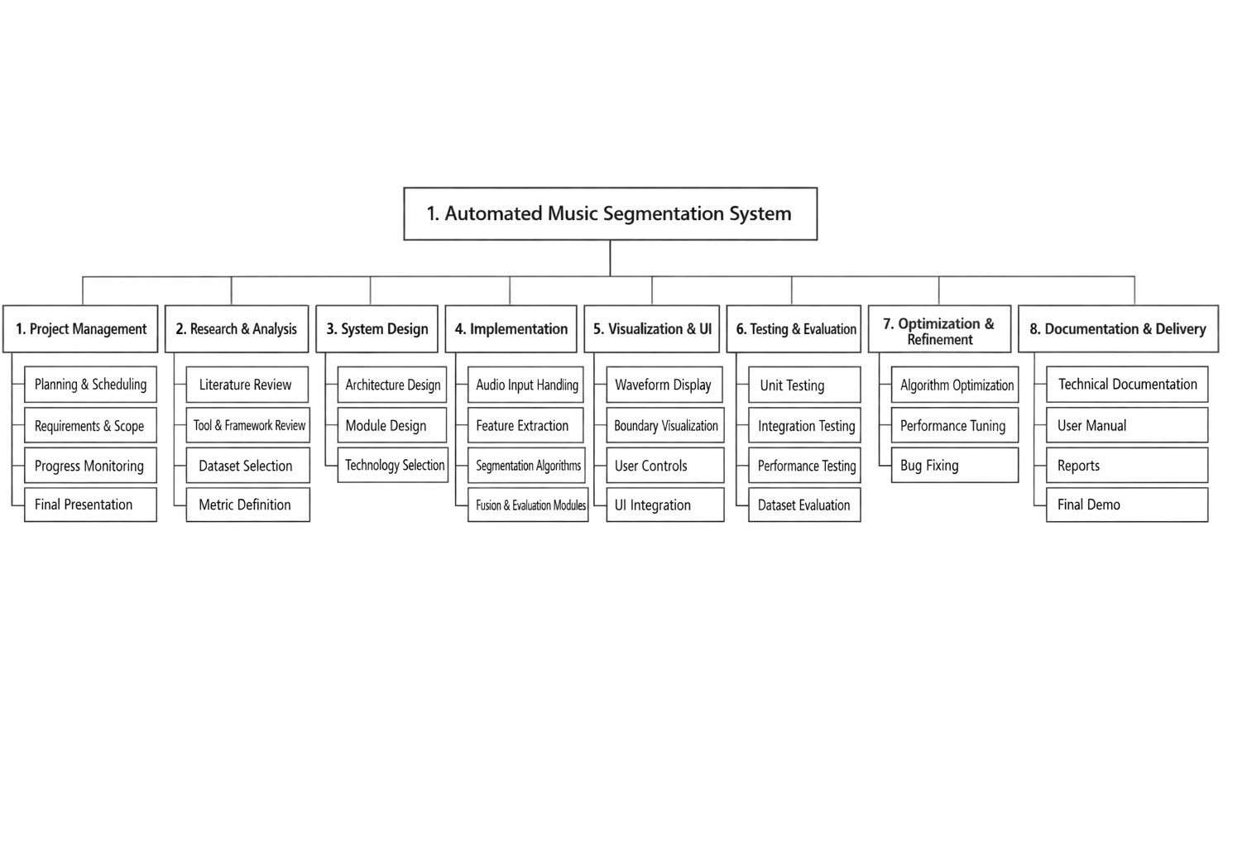
Responsibility Matrix for the team

R = Responsible
S = Support I = Informed

Work Package / Task | Kaan Akgül (KA) | Abdalla Hamuda (AH) | Mustafa Göktuğ İbolar (MG)
Project Planning & Coordination | R | S | S
Literature Review & Research | S | R | S
System Architecture Design | S | S | R
Feature Extraction | S | R | R
Segmentation Algorithms | R | R | R
Fusion Mechanism | S | R | R
Visualization & User Interface | R | S | I
System Integration | S | R | R
Testing & Evaluation | R | S | R
Optimization & Bug Fixing | S | R | R
Documentation & Reports | S | R | S
Final Presentation & Demo | R | S | S

  - Gantt chart

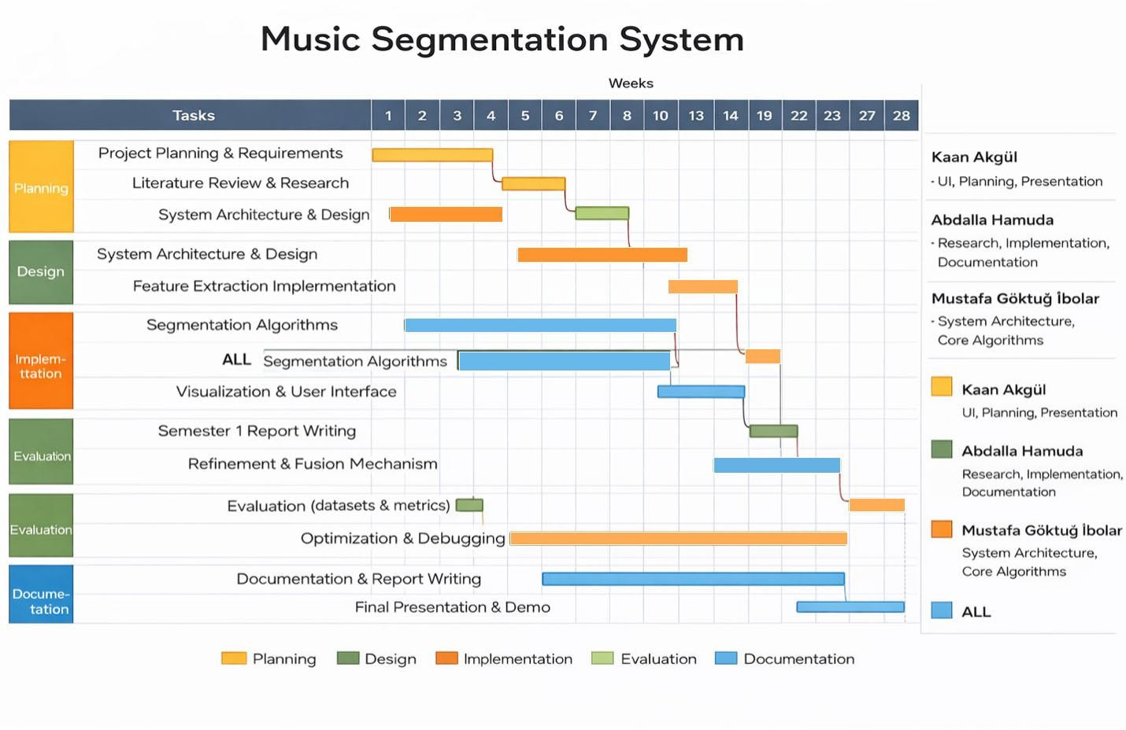

- Required Resources

  - Hardware (if applicable):
Standard consumer laptop or desktop computer
Minimum 8 GB RAM (16 GB recommended for batch processing) Standard CPU (no specialized hardware such as GPUs required)
  - Software :
Programming language: Python, Javascript
Audio processing libraries: Librosa, NumPy, SciPy
Music analysis frameworks: MSAF (Music Structure Analysis Framework) Frontend UI Framework and Tools: Svelte, Shadcn/UI
Development tools: Git for version control, Docker for containerized deployment
  - Facilities and Services:
Personal or university-provided computer labs Internet access for downloading datasets and libraries
Access to publicly available music datasets (e.g., SALAMI)
No specialized laboratories or external testing facilities required

  - Estimated Budget (if applicable):
Software and datasets: $0 (open-source and public resources) Hardware: $0 (uses existing personal or university-provided computers) Cloud services (Microsoft Azure):
-Used optionally for testing, scalability experiments, or deployment
-Estimated cost: Low to moderate, depending on usage (e.g., student credits or limited compute instances)
Estimated total cost: Low, assuming use of Azure student credits or limited cloud resources.

- Risk Assessment and Mitigation

This project may face technical, schedule, and resource-related risks. Technically, music structure segmentation is a complex task and results may vary across genres; this risk is mitigated by using established signal processing methods and validating results with publicly available annotated datasets and standard evaluation metrics. Schedule risks, such as delays in development or testing, are addressed through a structured Gantt chart with clear milestones and buffer time for optimization and debugging. Resource-related risks are minimal since the project relies on
open-source software and standard computing resources, with optional use of cloud services (e.g., Azure) if additional computing power is needed. Team-related risks are managed by clearly defined responsibilities and close collaboration, ensuring that team members can support each other throughout the project.
Table 5. Risk matrix
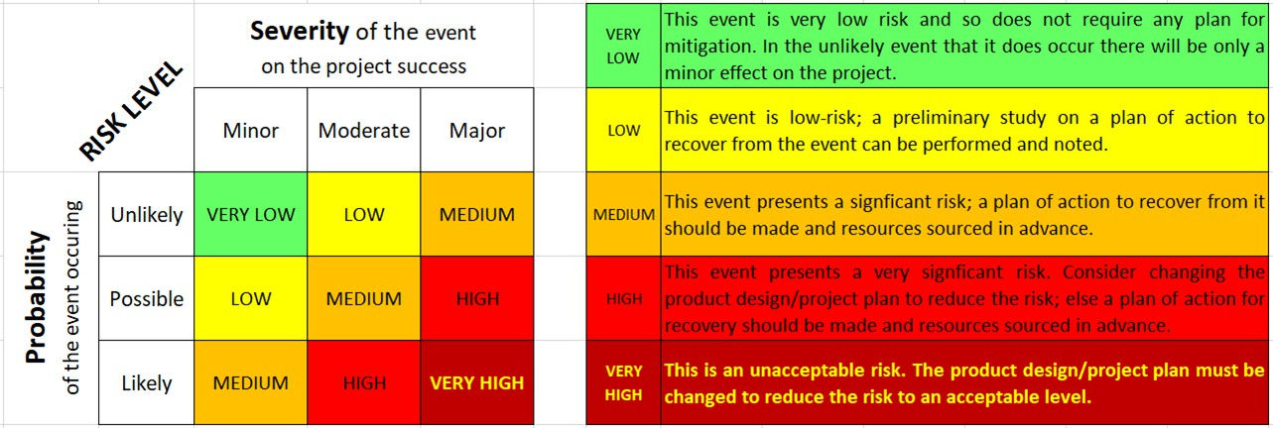
Table 6. Risk assessment

Risk Description | Probability | Severity | Risk Level | Mitigation Strategy
Segmentation algorithms may produce inaccurate results across music genres. | possible | Major | High | Use established signal processing methods and validate with multiple annotated datasets.
Integration issues between system modules. | possible | Moderate | Medium | Modular design and incremental integration testing.
Development or evaluation tasks may take longer than planned. | possible | Moderate | Medium | Follow Gantt chart and allocate buffer time.
Limited computing resources slow processing. | Unlikely | Moderate | Low | Optimize code and optionally use cloud resources (Azure).
Uneven workload or temporary unavailability of team members. | Unlikely | Minor | Very Low | Clear responsibilities and mutual team support.

- Expected Outcomes and Evaluation

Expected Outcomes:
The project is expected to deliver a fully functional automated music structure segmentation system capable of identifying structural boundaries (e.g., verses and choruses) in audio recordings. Key deliverables include:
-A working software prototype that processes common audio formats and produces segmentation results
-An evaluation framework for comparing results with annotated ground truth datasets
-Comprehensive project documentation, including system design, methodology, and user guidance
-A final technical report and project presentation demonstrating system performance

Success Criteria:
The project will be considered successful if:
-The system correctly identifies structural boundaries with measurable accuracy (acceptable precision, recall, and F1-score compared to ground truth annotations)
-A typical 3–5 minute song is processed within the defined runtime constraints
-The system operates reliably without errors on standard hardware
-All planned deliverables are completed within the project timeline

Evaluation Methods:
Evaluation will be conducted by testing the system on publicly available annotated music datasets. Detected boundaries will be compared to ground truth annotations using standard segmentation metrics such as precision, recall, and F1-score. Qualitative evaluation will include visual inspection of segmentation results and assessment of usability and clarity of outputs. Performance testing will also measure processing time and system stability under typical workloads.

Ethical, Safety, and Sustainability Considerations

Ethical Considerations

The project does not involve human subjects, personal data collection, or user profiling. All audio data used for development and evaluation will come from publicly available datasets or audio files that users have the right to process. The system analyzes music recordings for structural patterns only and does not extract personal or sensitive information. To avoid misuse, segmentation results are presented as analytical assistance rather than definitive ground truth, encouraging responsible interpretation.
Safety Considerations

The system is a software-only, non-safety-critical application and does not interact with physical hardware or real-time systems. As such, there are no direct physical safety risks. Basic software safety practices are followed, including proper error handling and validation of user inputs, to prevent crashes or data corruption during processing.
Sustainability Considerations

The project promotes sustainability by relying entirely on software-based solutions and existing computing resources, avoiding the need for additional hardware production. Efficient algorithms and offline processing help limit unnecessary computational overhead. When cloud services (e.g., Azure) are used, they are intended for limited testing or scalability experiments, helping reduce redundant local hardware usage. The use of open-source tools also supports long-term maintainability and reuse, contributing to sustainable software development practices.

References

- J. Foote, “Automatic audio segmentation using a measure of audio novelty,” in Proceedings of the IEEE International Conference on Multimedia and Expo (ICME), New York, NY, USA, 2000,
pp. 452–455.

- M. Levy and M. Sandler, “Structural segmentation of musical audio by constrained clustering,” IEEE Transactions on Audio, Speech, and Language Processing, vol. 16, no. 2, pp. 318–326, Feb. 2008.
- J. Serra, M. G. Müller, P. Grosche, and J. L. Arcos, “Unsupervised music structure annotation by time series structure features and segment similarity,” IEEE Transactions on Multimedia, vol. 16, no. 5, pp. 1229–1240, Aug. 2014.
- J. Paulus, M. Müller, and A. Klapuri, “Audio-based music structure analysis,” in Proceedings of the International Society for Music Information Retrieval Conference (ISMIR), Utrecht, The Netherlands, 2010, pp. 625–636.
- J. Smith, C. Burgoyne, J. Devaney, D. Turnbull, and G. Tzanetakis, “Design and creation of a large-scale database of structural annotations,” in Proceedings of ISMIR, Miami, FL, USA, 2011,
pp. 555–560.

- J. Serra, S. Oramas, E. Gómez, and M. Müller, “MSAF: Music structure analysis framework,” in Proceedings of ISMIR, New York, NY, USA, 2016, pp. 591–598.
- B. McFee and D. Ellis, “Analyzing song structure with spectral clustering,” in Proceedings of ISMIR, Porto, Portugal, 2014, pp. 405–410.
- A. Klapuri and M. Davy, Signal Processing Methods for Music Transcription. New York, NY, USA: Springer, 2006.
- B. McFee, C. Raffel, D. Liang, et al., “librosa: Audio and music signal analysis in Python,” in Proceedings of the Python in Science Conference (SciPy), Austin, TX, USA, 2015, pp. 18–25.
- M. Müller, Fundamentals of Music Processing: Audio, Analysis, Algorithms, Applications. Cham, Switzerland: Springer, 2015.
- D. Turnbull, G. Lanckriet, E. Pampalk, and M. Goto, “A supervised approach for detecting

boundaries in music using difference features and boosting,” in Proceedings of ISMIR, London, UK, 2005, pp. 51–54.

