Mustafa A. Hakkoz - 150117509 01.12.2019

Muhammed Adem E. Demirkuş - 150115003

**DATABASE SYSTEMS PROJECT STEP-3**

* **Subject**

This project is a business applicable database which is designed to represent **an** **online TV/movie streaming** **service** like Amazon Prime Video, Netflix, Hulu etc.

 ***CANNAL | Premium Streaming Service***

“Cannal” is an online streaming service offering live and on-demand TV and movies, with affordable prices for home sets and mobile devices. Along with his licensed library and on-growing originals, Cannal offers extensive streaming experience by virtue of highly customizable add-ons and features.

* **Summary**

For the first step we decided on subject and scope of the project firstly. Then we determined problem statements, system constraints and use cases, to have an overall design on tables and attributes. We stated all of thought process in our Report-1 with details.

And for second steps, we designed tables, attributes and relationships of database and drew an entity-relationship diagram. We changed some attributes and tables in step-2 to get a more improved structure. Final design for step-2 can be found on both .png and .drawio formats.

* **Objective**

For step-3, we will first convert our ERD tables to relations, determine primary and foreign keys to build relationships. Then we will search for possible anomalies to get valid relations in 1NF. After that we will detect multivalued attributes, partial and transitive dependencies. And finally, by removing them step by step, we will normalize all of relations to their 3th normal forms.

* **Updates on Previous Step**
  + **Associative entities on User Interface section:** We changed shapes of associative entities from pointed to rounded corners and removed relationships between “List” and “Title” tables. We also remove attribute “User Id” from “List” since it has already ternary relationship with “User” and “Title”. Last version is below:

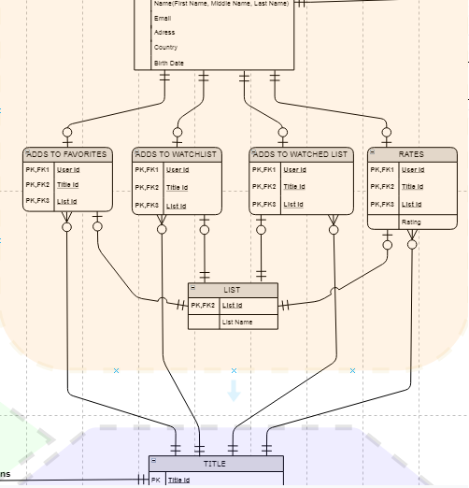

* + **Advertisement Type on Advertisement section:** We removed the attribute “Integrated Title” from the table “Advertisement Type” since it has a relationship with the table “Advertisement” which has already “Title” info in it. We saw it when we add foreign key “Title Id” to “Advertisement” relation. Last version is below:

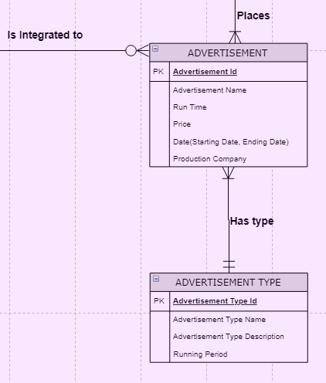

* + **Associative entities on Catalog section:** We changed shapes of associative entities (“Has Genre”, “Plays In”, “Writes Movie”, “Directs Movie”, ”Writes Episode”, “Directs Episode”, “Creates Series”) from pointed corners to rounded corners. Also we corrected relationship constraints of them (optional to mandatory). Last version is below:

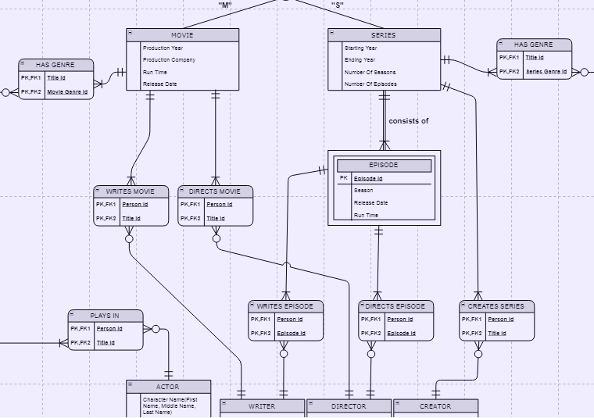

* **Removing Multivalued Attributes (Invalid Relations to 1NF)**

We didn’t use any multivalued attribute in our tables.

* **Removing Partial Dependencies (1NF to 2NF)**

We didn’t find any partial dependency in our tables.

* **Removing Transitive Dependencies (2NF to 3NF)**

We didn’t find any partial dependency in our tables.

* **Improvements (3NF to 3NF+)**
* **Payment Record relation in Membership section:** There was a derived attribute “Amount” in this relation. Since there was nothing about derived attributes on our text book, we searched this case on internet and found that we can improve our 3NF relations to 3NF+ by removing derived attributes so we did the same thing. Removing an attribute can be seen like a simplification but we will implement functionality of attribute “Amount” for later steps when we creating views. For example we can derive “Amount” if we export invoice by using view.

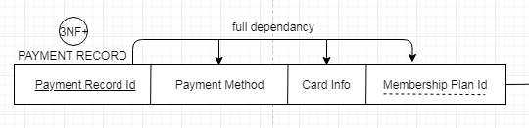 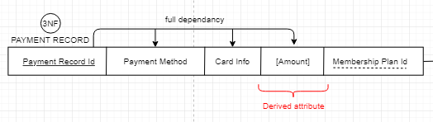

* **Conclusion**

Since we implement a digital world problem as our project, instead of a real world problem, all of our tables were already in 3NF. As we shown in the file “RelationModel.png”, all of their dependency were full dependency so we did mostly updates and improvements for this step.