MARMARA UNIVERSITY

FACULTY OF ENGINEERING

COMPUTER SCIENCE DEPARTMENT



CSE1142

COMPUTER PROGRAMMING II

SPRING 2018 PROJECT

PUZZLE GAME

NAME STUDENT NUMBER

Mustafa A. Hakkoz 150117509

Submitted to: Sanem Arslan Yılmaz

Due Date

20.05.2018

**I.PROBLEM DEFINITION**

My purpose for this project is to create a simple puzzle game which has 5 levels. The game consists 3 different shapes and 4 different lines, at total 7 different nodes. To finish the game, you have to shorten lines by clicking filled circles without any intersection with other nodes.

**II.IMPLEMENTATION DETAILS**

The project consists 5 different classes for each level pane and 1 application class to display game.

* UML diagrams:
* public class Lvl1Pane extends Pane

- BooleanProperty piece1Completed

- BooleanProperty piece2Completed

- BooleanProperty collision

+ public Lvl1Pane()

+ public void paintLvl1()

* public class Lvl2Pane extends Pane

- BooleanProperty piece1Completed

- BooleanProperty piece2Completed

- BooleanProperty piece3Completed

- BooleanProperty piece4Completed

- BooleanProperty collision

+ public Lvl2Pane()

+ public void paintLvl2()

* public class Lvl3Pane extends Pane

- BooleanProperty piece1Completed

- BooleanProperty piece2Completed

- BooleanProperty piece3Completed

- BooleanProperty collision

+ public Lvl3Pane()

+ public void paintLvl3()

* public class Lvl4Pane extends Pane

- BooleanProperty piece1Completed

- BooleanProperty piece2Completed

- BooleanProperty collision

-BooleanProperty horizontalDisconnector

+ public Lvl4Pane()

+ public void paintLvl4()

* public class Lvl5Pane extends Pane

- BooleanProperty piece1Completed

- BooleanProperty piece2Completed

- BooleanProperty piece3Completed

- BooleanProperty piece4Completed

- BooleanProperty collision

-BooleanProperty horizontalDisconnector

-BooleanProperty horizontalDisconnector2

+ public Lvl5Pane()

+ public void paintLvl5()

* public class DisplayGame extends Application

-public static BooleanProperty completedLevels[5]

-public int currentLevel=1

-private String[] lvlTitles

-private Pane[] lvlPanes

+public void Start()

+public static void main

* Incomplete Parts:
* Button functionality
* Highlight current level on list view

**III.TEST CASES**

* 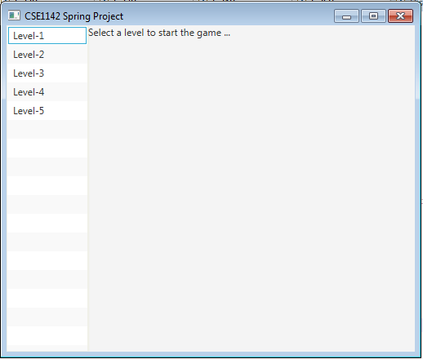**Main scene:**
* 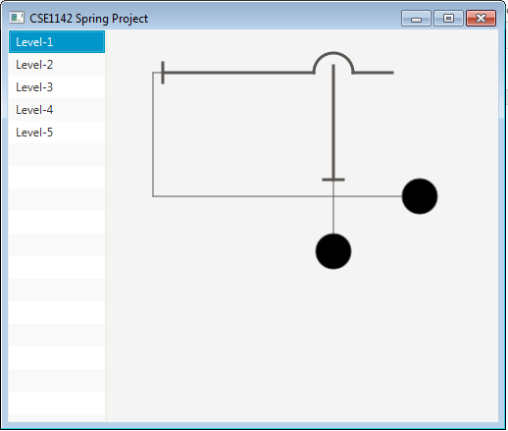**Level-1 initial scene:**
* 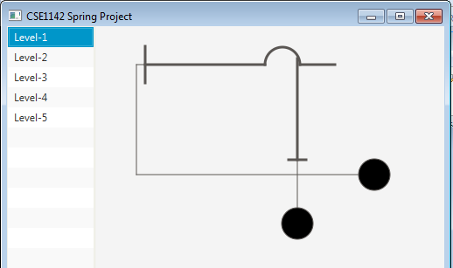**Level-1 collision-1:**
* 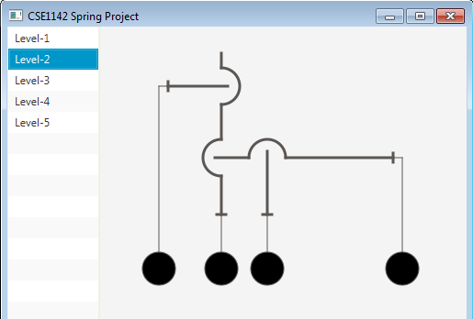**Level-2 initial scene:**
* **Level-2 collision-1:**

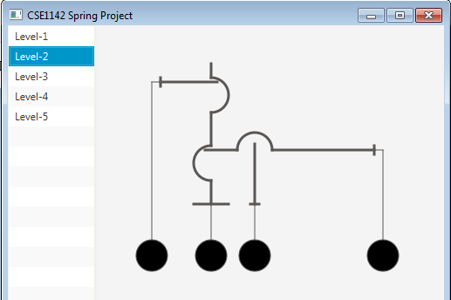

* 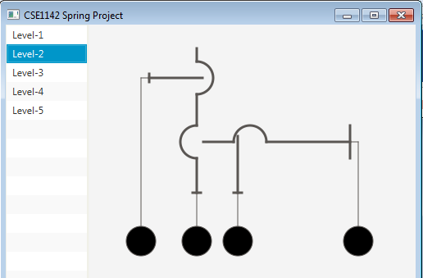**Level-2 collision-2:**
* **Level-3 initial scene:**

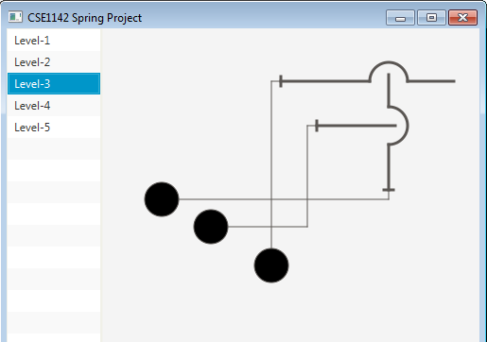

* **Level-3 collision-1:**

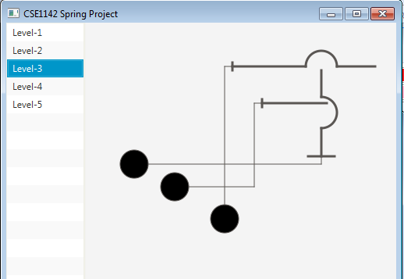

* **Level-3 collision-2:**

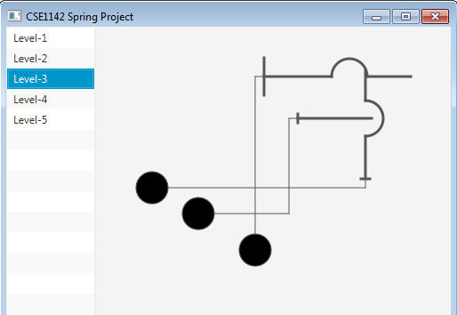

* **Level-4 initial scene:**

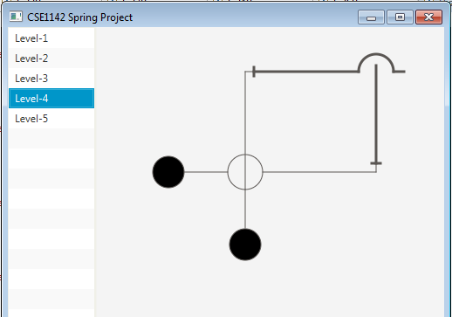

* **Level-4 collision-1:**

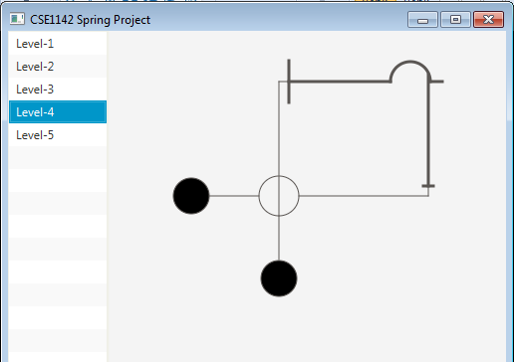

* 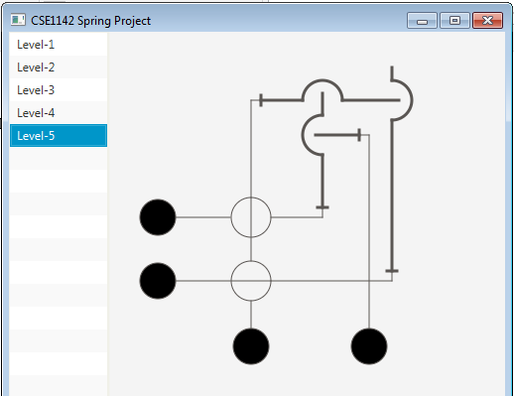**Level-5 initial scene:**
* 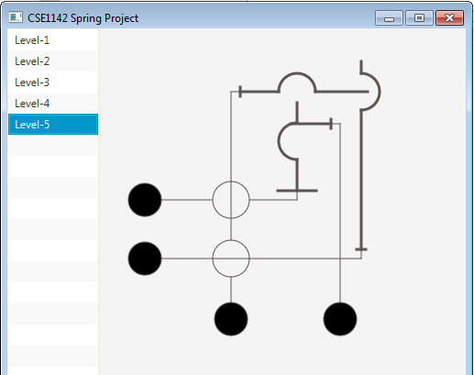**Level-5 collision-1:**
* **Level-5 collision-2:**

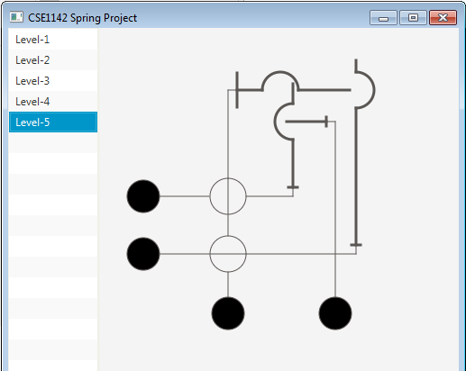

* 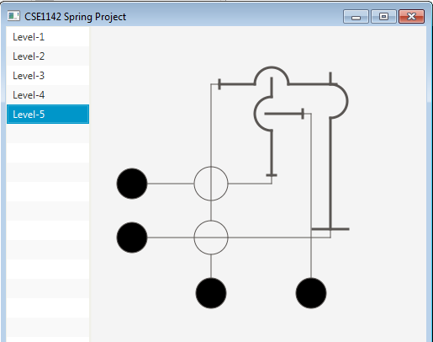**Level-5 collision-3:**
* **Ending scene:**

