|  |
| --- |
| **PROJECT PLANNING & MANAGEMENT FORM**  **CMSE 201**  **GROUP NO : 05**  **PROJECT NAME : Online Döner Ordering System**  **PROJECT START DATE : 18.10.21**  **PROJECT END DATE : 3.01.22**  **SUPERVISOR : -**  **SEMESTER TERM : Fall**  Project Type: Software Design & Development Project  Template updated: 20.08.2019 |

A.1. Preliminary Project Information

# A.1.1

|  |  |
| --- | --- |
| **Project No** | 1 |
| **Project Name** | Online Döner Ordering System |
| **Start Date** | 18.10.21 |
| **End Date** | 3.01.22 |
| **Time** | 12 Weeks |

# A.1.2

|  |  |  |  |
| --- | --- | --- | --- |
| **Project Manager** | | | |
| **Name Surname** | Emircan Karakoç | **ID No** | 19000090 |
| **Title/Role** | Project Manager, User Interface Designer, Data Base Developer | | |
| **Address** | Famagusta /TRCN | | |
| **Phone** | 0545 ***** | | |
| **Email** | 19000090@emu.edu.tr | | |

A.2 Group Information

# A.2.1

|  |  |  |  |
| --- | --- | --- | --- |
| **Student 1** | | | |
| **Name Surname** | Mihriban Özdemir | **ID No** | 18000048 |
| **Title/Role** | Analysis and Testing Team Manager, User Interface Designer | | |
| **Address** | Famagusta /TRCN | | |
| **Phone** | 0548 ******* | | |
| **Email** | 18000048@emu.edu.tr | | |

|  |  |  |  |
| --- | --- | --- | --- |
| **Student 2** | | | |
| **Name Surname** | Mustafa Mengütay | **ID No** | 20331143 |
| **Title/Role** | Software Team Leader, Programmer, Database Developer, Database Team Leader | | |
| **Address** | Famagusta /TRCN | | |
| **Phone** | 0554 ****** | | |
| **Email** | 20331143@emu.edu.tr | | |

# A.2.2

|  |
| --- |
| **List of Completed / Ongoing Projects of Team** |
| - |

B.1 Introduction to Project

# B.1.1

|  |
| --- |
| **Summary of Project** |
| Online Döner Ordering system is a android and web application that allows users to order döner from local restaurants. |

# B.1.2

|  |
| --- |
| **Key Words** |
| Döner, online ordering, online restaurant, multiple choice, online menu, food service. |

# B.1.3

|  |
| --- |
| **Aim of Project** |
| The main aim of this project is designing a mobile application for ordering döner that user friendly. Costumer can see all local restaurants from this application. |

# B.1.4

|  |
| --- |
| **Innovative Aspects/Contributions of Project** |
| This project is an innovative mobile-based application. From this application the costumer can choose ingredients of food. |

# B.1.5

|  |
| --- |
| **Methods to be Applied** |
| This project will be created using a lot of case tools such as Visual Paradigm, Lucidchart, draw.io, and Modelio. This design will be implemented using the Java programming language on the backend side using the IntelliJ IDE. The Project will be planned and managed using Microsoft Project which is a software management tool. |

# B.1.6

|  |
| --- |
| **Economic and National Outcomes** |
| The application help users save money from call credit as they no longer need to use a phone to call to order food.  It will reinvigorate the economy of local restaurants. |

B.2 Reason of Starting the Project, Methods and R&D Stages

# B.2.1

|  |
| --- |
| **1- Explain the reason of starting this project. (Max 500 charachter)** |
| The reason why are we starting this project is to bring customers and restaurants together. Customers get food without calling and customer can choose the ingredients in the food. Because we also notice that the when you call the restaurant for order a food sometimes there’s a tendency for misinterpretation and your food will be wrong gets delivered. Our application is a way of deal to these issues. That’s why we enter this job. |

|  |
| --- |
| **2- Explain the purpose of this project.** |
| Online Döner Ordering System is a site established to bring together restaurants with takeaway service and internet users who want to order food in the same location. Users can order food without any extra charge by accessing the latest updated menus of all contracted restaurants via the dönerye.com site and mobile applications. The order is delivered to the relevant restaurant within one minute at the latest, using the latest innovations in technology. |

|  |
| --- |
| **3- Explain**   * **output of project** * **national / international standards if exist** * **the specific objectives of the project** * **success criterias** * **realistic constraints** |
| Users can order food without any charge from the local restaurants and customers will deliver their food at maximum 30 minutes. In this way, the orders reach the customer in a shorter time.  **success criterias**  Working application that allows users order and the restaurant receives their order.  **realistic constraints**  Problems with the internet connection. |
| **4- Explain**   * **the methods to be applied during R&D activities** * **applications** * **technics and tools to be used** * **standards to be followed under the workflow** |
| *Due to our project we shall go with the incremental development techniques. More flexible – less costly to change scope and requirements. Easier to test and debug during a smaller iteration. Easier to manage risk because risky pieces are identified and handled during its iteration.*  **Explain, Project Workflow:**  Incremental development technics will be used because the customer's requests may change frequently.   1. **Feasibility and Pre-research:**   This is the first stage of the project. To increase the success of this project, research should be done from many resources. This research will give this system the competitive  edge amongst similar projects.   1. **System Design:**   This part contains all the decisions about parts of the system, including all modules, which techniques are suitable.     1. **Software development:**   In this phase, we will use Java programming language to develop our mobile application project. As an IDE, we chose IntelliJ IDE because it is very powerful IDE for developing Java based applications. Also, we will benefit from other tools such as Visual Paradigm to see class structures.   1. **Prototype implementation and testing work:**   In prototype and code implementation step, we are going to do application for Android. We will use IntelliJIDE platform of Android write code of application and to design  interface we will use AdobeXD. In testing step, we will use some tools for  check our codes (Selenium, TestComplete,  Appium e.g).   1. **Maintenance:**   Thanks to the feedback received from users of this system if there are bugs or if there will be any problem or any missing parts, recorded and continuously fixed. |
| **5- Explain**   * **the contribution of national/international technological development if exist** * **starting a new research and development projects within or outside the team** * **launch new applications or research studies in different technology areas**   **With whom we can cooperate?**  **Expectations:**  **Published work:**  **Can your output be an input for other similar national/international projects?** |
| For the spread of this project, it is possible to communicate with more restaurants and establish a business association. And the also project can be developed within IOS which is an  another mobile technology. Also, this project can be developed as a web-based application. |

B.3 Innovative and Unique Aspects

# B.3.1

|  |
| --- |
| **1- Describe**   * **differences** * **advantages** * **superiority**   **compared to other similar projects.** |
| Most significant difference between our project and similar projects is that our project is based on one food type. It is easier to find best döner for your tase from our project also you can track your food from gps tab, and the biggest disadvantage of the project is you can not find anything else than döner. |

# B.4.1

|  |
| --- |
| **2- Who can contribute to this project in your team?** |
| Project Manager  User Interface Designer  Tester  Project Interface Designer  Programmer  System Designer  Database Developer |

C.1 Gantt Chart and Work Packages

# C.1.1 Gantt Chart

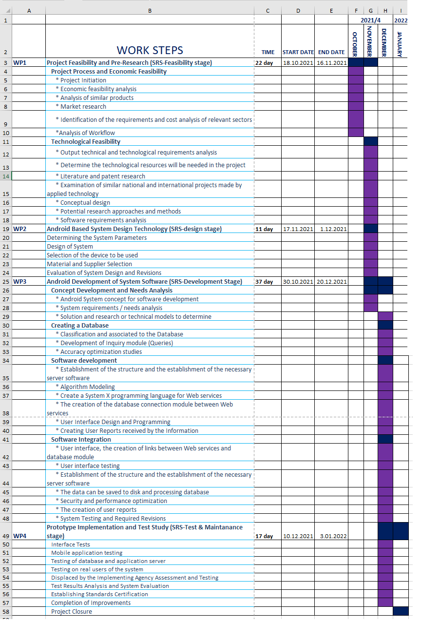

# C.1.2 List of Work Packages

|  |  |
| --- | --- |
| **Work Package No** | 1 |
| **Work Package Name** | **Project Feasibility and Pre-Research (Feasibility Analysis)** |
| **Start-End Date and Time** | 18.10.21 - 29.10.21 |
| **Related Organizations** |  |

|  |
| --- |
| **1- List the activities of work packages.** |
| **1.1 Project Process and Economic Feasibility:**  * Project Initiation  * Economic feasibility analysis  * Analysis of similar products  * Market research  * Identification of the requirements and cost analysis of relevant sectors  *Analysis of Workflow  **1.2 Technological Feasibility:**  * Output technical and technological requirements analysis  * Determine the technological resources will be needed in the project  * Literature and patent research  * Examination of similar national and international projects made by applied technology  * Conceptual design  * Potential research approaches and methods  * Software requirements analysis |
| **2- Describe the methods and parameters that will be used for work package.** |
| Research on the internet for similar applications.  -Research of the recent trends for mobile application.  -Determination of processes and methodology. |
| **3- List the experiments, tests and analysis in the work package.** |
| Budget feasibility analysis  Technological requirements |
| **4- List the output of work package and its success criterias.** |
| **Outputs:**  Complication of economic and technological feasibility.  Determination the outline of the project.  **Success Criterias:**  Obtaining the needed budget |
| **5- Explain the relation of output with other work packages** |
| It is not possible to pass to other packages without success this package because it is the first package. |

|  |  |
| --- | --- |
| **Work Package No** | 2 |
| **Work Package Name** | **Based System Design Technology (Analysis & Design stage)** |
| **Start-End Date and Time** | 17.11.21 -1.12.21 |
| **Related Organizations** |  |

|  |
| --- |
| **1- List the activities of work packages.** |
| **Determining the System Parameters**  **Design of System**  **Selection of the device to be used**  **Material and Supplier Selection**  **Evaluation of System Design and Revisions** |
| **2- Describe the methods and parameters that will be used for work package.** |
| Customer feedback  Managements tools (Mockflow, MS Word, eg) |
| **3- List the experiments, tests and analysis in the work package.** |
| Time Analysis  Budget Analysis  Risk Management |
| **4- List the output of work package and its success criterias.** |
| **Outputs:**  ● System requirement document  ● Project structure  ● Dataflow diagrams  ● Sequence diagrams  ● Use case diagrams  ● E-R diagrams  **Success Criteria:**  With this document’s estimates are more accurate like use case estimates using use case point as a unit of measurement |
| **5- Explain the relation of output with other work packages** |
| Development and unit testing stages can comment. |

|  |  |
| --- | --- |
| **Work Package No** | 3 |
| **Work Package Name** | **Development of System Software (Development Stage)** |
| **Start-End Date and Time** | 2.12.21 - 26.11.21 |
| **Related Organizations** |  |

|  |
| --- |
| **1- List the activities of work packages.** |
| **Concept Development and Needs Analysis**  **Creating a Database**  **Software development**  **Software Integration** |
| **2- Describe the methods and parameters that will be used for work package.** |
| UI design  Android studio for coding  Database Implementation  Functional Testing  Unit Testing |
| **3- List the experiments, tests and analysis in the work package.** |
| UI testing  Functional Testing  Risk Analysis and Monitoring  Broken link test and fixing  Algorithmic analysis |
| **4- List the output of work package and its success criterias.** |
| **Outputs:**  -A working database  -A Forgiving User Interface  -An improved program  -AN integrated system  **Success Criteria:**  -constant successful connection to server and database  -user interface components correctly carry out its functionality  -dataflow correctness  -robustness acquired  -database can hold large |
| **5- Explain the relation of output with other work packages** |
| When all pieces of the system have been completed, it will lead to the implementation and thus the creation of a prototype |

|  |  |
| --- | --- |
| **Work Package No** | 4 |
| **Work Package Name** | **Prototype Implementation and Test Study and Maintenance (Test & Maintenance stage)** |
| **Start-End Date and Time** | 10.12.21 - 3.01.22 |
| **Related Organizations** |  |

|  |
| --- |
| **1- List the activities of work packages.** |
| **Interface Tests**  **Mobile application testing**  **Testing of database and application server**  **Testing on real users of the system**  **Displaced by the Implementing Agency Assessment and Testing**  **Test Results Analysis and System Evaluation**  **Establishing Standards Certification**  **Completion of Improvements**  **Project Closure** |
| **2- Describe the methods and parameters that will be used for work package.** |
| ● Black-box testing  ● White-box testing  ● User experience measurement  ● Analysis of algorithms |
| **3- List the experiments, tests and analysis in the work package.** |
| -Interface Test  -Mobile Application Test  -Link tests and fixing |
| **4- List the output of work package and its success criterias.** |
| **Outputs:**  - Ready to release project  -Improved program  **Success Criterias:**  Successful connection to server, website, and application. |
| **5- Explain the relation of output with other work packages** |
| This work package is last step that means if the project has no error project will be ready to release market. |

# C.1.3 List of Milestones (should be matched in the Gantt chart)

|  |  |  |
| --- | --- | --- |
|  | **Description of Output** | **Expected Time Interval** |
| ***Example:*** | ***Feasibility Studies*** | ***01.07.2014 – 30.09.2014*** |
| 1 | Project Feasibility and Pre-Research (SRS-Feasibility stage) | 18.10.21 - 16.11.21 |
| 2 | X Based System Design Technology (SRS-design stage) | 17.11.21 - 1.12.21 |
| 3 | X Development of System Software (SRS-Development Stage) | 24.11.21 - 20.12.21 |
| 4 | Prototype Implementation and Test Study (SRS-Test & Maintanance stage) | 10.12.21 - 3.01.22 |

# C.1.4 List of Risks *(see following example, write possible risks for your project!)*

|  |  |  |  |
| --- | --- | --- | --- |
| Risk | Probability | Effects | Your Strategy |
| The time required to develop the software is underestimated. | High | Serious | Get additional software developers |
| Employees lose their motivation. | Moderate | Serious | Organizing weekly events for the employees |
| Customers fail to understand the impact of requirements changes. | Moderate | Tolerable | Meet with customers more often and get their opinions |
| The rate of defect repair is underestimated. | Moderate | Tolerable | Replace potentially defective components with more reliable bought-in components. |
| The size of the software is underestimated. | High | Serious | Software engineers will try to minimize the size of the software. |
| Key staff are ill at critical times in the project. | Low | Serious | Providing a work-from-home devices |

C.2 Project Management and Organization

# C.2.1 Project Team

|  |  |  |  |  |  |  |
| --- | --- | --- | --- | --- | --- | --- |
| **Personnel Name** | **Title** | **ID** | **Education Status** | **Graduation Date** | **Date of Starting Work** | **Idea Owner** |
| Emircan Karakoç | Project Manager | 19000090 | Undergraduate | 2023 | 18.10.21 |  |
| Mihriban Özdemir | User Interface Desinger | 18000048 | Undergraduate | 2023 | 18.10.21 |  |
| Mustafa Mengütay | Programmer | 20331143 | Undergraduate | 2023 | 18.10.21 |  |

# C.2.2 Organization Scheme (an example is given below!)

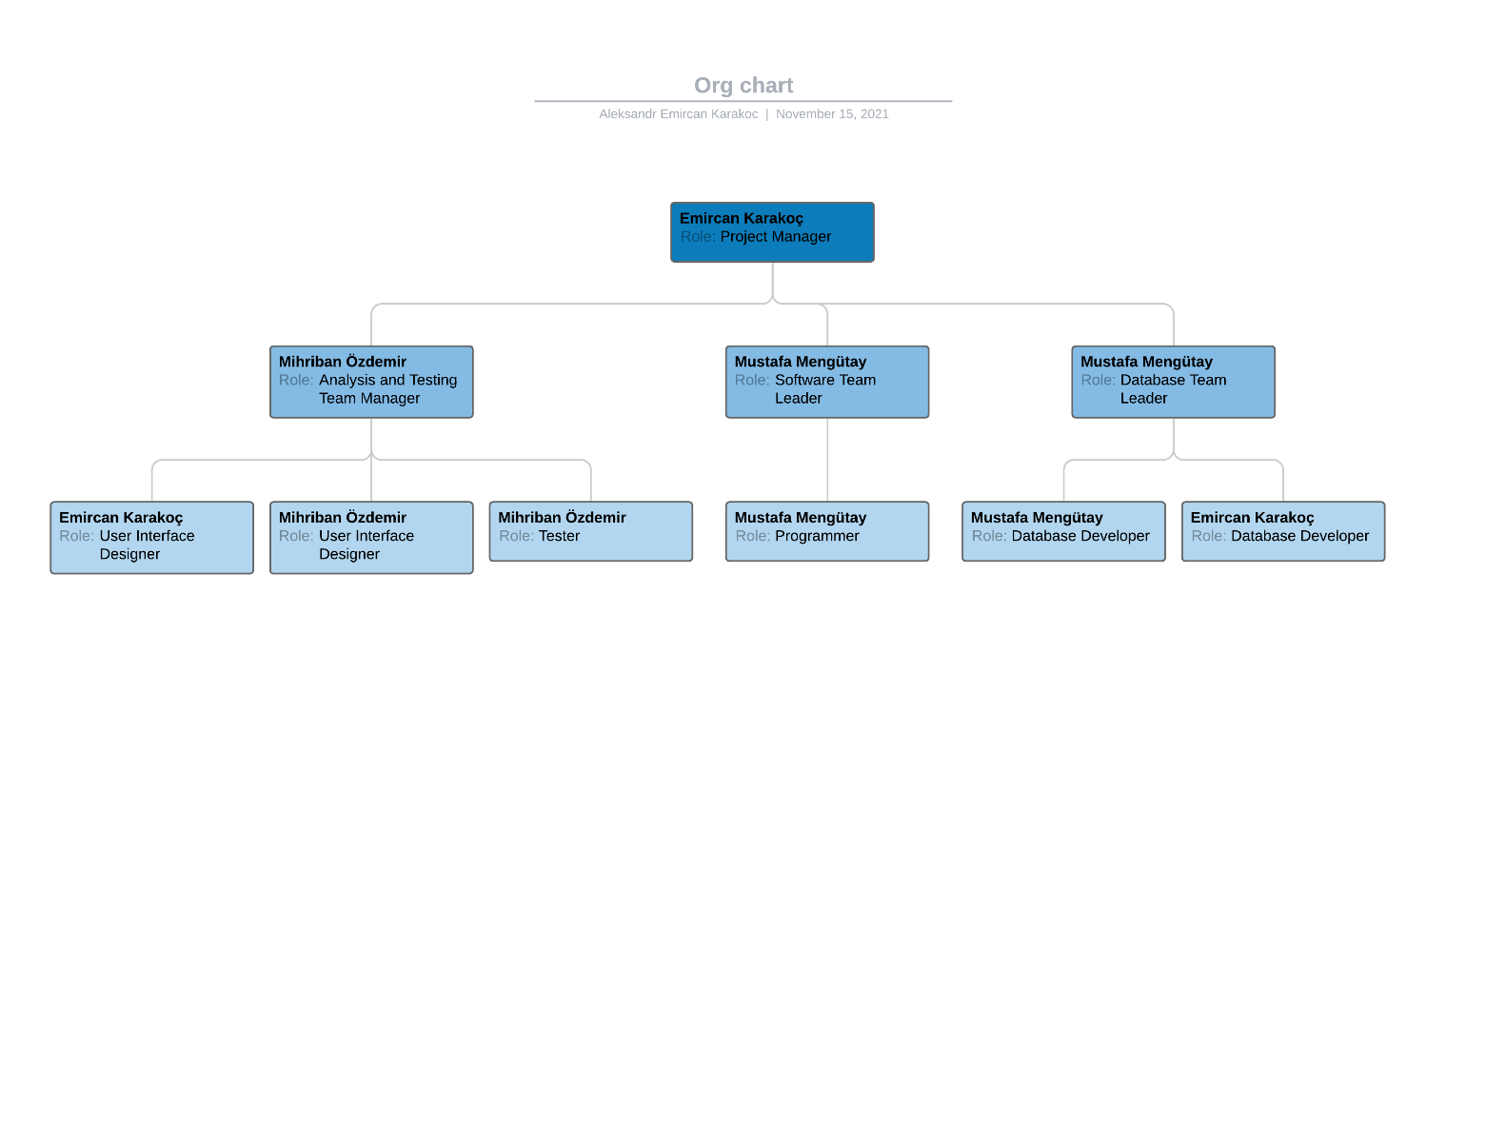

D.1 Economic Forecasts

|  |
| --- |
| **1- Evaluate the commercialization potential of project outcomes. List possible risks here?** |
| As a result of the failure of the marketing team, the application may not be recognized in the market and fail.  The application may not be of interest to the customer.  High salary demand of employees.  High level of competition in market. |

|  |  |
| --- | --- |
| **2- List your expectations to your team which are come by your project** | |
| Time-to-market (month): | 7.12.21 |
| The expected increase in sales revenue (%): | 30% |
| The expected increase in market share (%): | 50% |
| Time to start to gain: | March |

D.2 National Outcomes

|  |
| --- |
| **1- Specify the output that may be subject to patent, utility model and industrial design registration in the project.** |
| The approval of the TRNC Ministry of Health is needed. |
| **2- Explain the potential of project and its outputs that may have an effect on social life, education, health and etc.** |
| Instead of wasting time to buy food, people can easily order and continue their daily work. |
| **3- Explain the positive and negative effects of project outputs for environment and human being.** |
| It can make people lazy in the long term. On the other hand the restaurants are scored by users on the basis of speed, service and taste, and that they can also comment on the service received, guides other users in choosing restaurants and meals. |

(M013) Instrument / Equipment / Software / RELEASE PURCHASES

|  |  |  |  |  |  |  |  |  |  |  |  |
| --- | --- | --- | --- | --- | --- | --- | --- | --- | --- | --- | --- |
| **Project Name** | |  | | | | | | | | | |
| **Line no** | **Instrument / Equipment / Software / Publication Name** | | **No. of Item** | **Capacity** | **Technical specification** | **Purpose of Project Activities** | **Post-Project Place of Use / Purpose** | | **Unit Price (USD)** | **Unit Price (TL)** | **Total Amount (TL)** |
| **R & D** | **Production** |
| **1** | **Laptop device** | | **6** | **8GB Ram** | **Windows 10** | **Organization** | **X** | **X** | **1000$** | **10000** | **60000** |
| **2** | **Computer server** | | **1** | **500b GB** |  | **connectivity testing and storage** | **X** | **X** | **5000$** | **50000** | **50000** |
| **3** | **Android Studio** | | **2** | **1,2 GB** | **SDK 24.4.1** | **Coding** | **X** |  |  | **FREE** | **-** |
| **4** | **MS Office 2021** | | **6** | **1 GB** |  | **Documentation** | **X** | **X** | **250$** | **2500** | **15000** |
| **5** | **Adobe XD** | | **2** | **x** |  | **UI design** | **X** |  | **50$** | **500** | **1000** |
| **6** | **Virtual Machine** | | **2** | **x** |  | **Testing and Implementation** | **X** |  |  | **FREE** | **-** |
| **7** | **Android Device** | | **3** |  |  | **Testing User Experience** | **X** |  | **300$** | **3000** | **9000** |
| **8** | **Visual Paradigm** | | **3** |  |  | **Management** | **X** |  |  | **FREE** | **-** |
| **9** | **MS Project Tool** | | **3** |  |  | **Management** | **X** |  |  | **FREE** | **-** |
| **10** | **Intellij Idea** | | **3** |  |  | **Coding** | **X** |  |  | **FREE** | **-** |
| **11** | **MySQL (Development Tool)** | | **3** | **Undefined** |  | **Database** |  |  | $5,000 | 50000 | **150000** |
|  |  | |  |  |  |  |  |  |  | **TOTAL** | **285000TL** |

(M030) Quarterly Estimated Cost Form (TL)

|  |  |  |  |  |
| --- | --- | --- | --- | --- |
| **Project Name :** | | | | |
| **Cost Item** | **2018-2019** | | **TOTAL**  **(TL)** | **TOTAL COST RATE OF CONTENTS (%)** |
| **I** | **II** |
| **Personnel** | 5000 | 5000 | 10000 | 39.87% |
| **Travel** | 1000 | 1500 | 2500 | 9.97% |
| **Instrument / Equipment / Software / Publications** | 5100 | 1200 | 6300 | 25.12% |
| **Domestic Works Made By R & D and Testing Institutions** | 400 | 800 | 1200 | 4.79% |
| **International Works Made By R & D and Testing Institutions** | 1300 | 900 | 2200 | 8.77% |
| **Domestic Services Procurement** | 100 | 500 | 600 | 2.39% |
| **Overseas Service Procurement** | - | - | - | - |
| **Material** | 1500 | 780 | 2280 | 9.09% |
| **TOTAL COST** | 14400 | 10680 | 25080 | 100 |
| **CUMULATIVE COST** |  |  |  | 100 |
| **IN THE PROJECT TOTAL MAN-MONTH** | | | 1,2 | |

APPENDIX

1. Perform estimation of effort (Man/month), required total time duration and required number of team members by using COCOMO approach (or other methods are possible).
2. CPM (Critical Path Management) analysis by using PERT (defining paths)
3. Creating network diagram of the main tasks in WBS
4. Calculating probability of successful completion rate for each path
5. Crashing approach, etc. techniques and the results can be written here.

