PROJECT REPORT ON

A WEB MODULE FOR CLEARING SYSTEM TO MANAGE PLEDGE PROCESS

Submitted in partial fulfilment of the requirements for
The award of the degree of

BACHELOR OF TECHNOLOGY
IN
COMPUTER SCIENCE AND ENGINEERING

OF
SASTRA UNIVERSITY

Submitted by

MOHAMEED MUSTHAFA - 117003121

PATEL VAMSHI KRISHNA - 117003137



Under the Guidance of

VIJAYPRAKASH SODISETTI

INAUTIX TECHNOLOGIES Pvt. Ltd, CHENNAI

SCHOOL OF COMPUTING

SHANMUGHA

ARTS, SCIENCE, TECHNOLOGY & RESEARCH ACADEMY

(SASTRA UNIVERSITY)
(A University Established under section 3 of the UGC Act, 1956)

TIRUMALAISAMUDRAM

THANJAVUR – 613 401
April 2017
SCHOOL OF COMPUTING

SHANMUGHA

ARTS, SCIENCE, TECHNOLOGY & RESEARCH ACADEMY
(SASTRA UNIVERSITY)
(A University Established under section 3 of the UGC Act, 1956)

TIRUMALAISAMUDRAM, THANJAVUR – 613401

BONAFIDE CERTIFICATE

Certified that this project work entitled “A WEB MODULE FOR CLEARING SYSTEM TO MANAGE PLEDGE AND RELEASE PROCESS” submitted to the Shanmugha Arts, Science, Technology & Research Academy (SASTRA University), Tirumalaisamudram-613401 by MOHAMEED MUSTHAFA with Reg no.117003121, PATEL VAMSHI KRISHNA with Reg no.117003137 in partial fulfilment of the requirements for the award of the degree of BACHELOR OF TECHNOLOGY IN COMPUTER SCIENCE AND ENGINEERING is the original and independent work carried out under my guidance, during the period December 2016 - April 2017.

EXTERNAL GUIDE | ASSOCIATE DEAN
VIJAYPRAKASH SODISETTI | Dr. A. UMAMAKESWARI
INAUTIX TECHNOLOGIES Pvt Ltd, CHENNAI | SCHOOL OF COMPUTING

Submitted for University Examination held on___________________

EXAMINER - I EXAMINER - II
SCHOOL OF COMPUTING

SHANMUGHA

ARTS, SCIENCE, TECHNOLOGY & RESEARCH ACADEMY
(SASTRA UNIVERSITY)
(A University Established under section 3 of the UGC Act, 1956)

TIRUMALAISAMUDRAM, THANJAVUR – 613401


DECLARATION

We submit this project work entitled “A WEB MODULE FOR CLEARING SYSTEM TO MANAGE PLEDGE PROCESS” to the Shanmugha Arts, Science, Technology & Research Academy (SASTRA) University, Tirumalaisamudram–613 401, in partial fulfilment of the requirements for the award of the degree of BACHELOR OF TECHNOLOGY IN COMPUTER SCIENCE AND ENGINEERING and declare that it is our original and independent work carried out under the guidance of VIJAYPRAKASH SODISETTI, iNautix Technologies, Chennai.

Date : | Name | :MOHAMEED MUSTHAFA | Signature:
Place : | Reg. No:117003121
 | Name | : PATEL VAMSHI KRISHNA | Signature:
 | Reg. No:117003137

ACKNOWLEDGEMENT

First and Foremost, we take pride in thanking the almighty to gave us strength for the successful completion of this project.

We have immense pleasure in expressing my heartfelt thanks to our Vice-Chancellor prof.R.Sethuraman for the benevolent advice and guidance during my tenure in the college.

We would like to express our gratitude to Dr.Balachandran, Registrar, SASTRA UNIVERSITY, for his benevolent guidance through-out my college life.

We wish to express our thanks to Dr.S.Vaidhyasubramanian, Dean of Planning and Development for his encouragement and providing us with all the needed amenities.

We would like to express our gratitude to Dr.P.Swaminathan, Dean , School of Computing, SASTRA UNIVERSITY, for his benevolent guidance through-out my college life.
We would like to express our gratitude to Dr.A.Umamakeshwari, Associate Dean , Computer Science and Engineering, School of Computing, SASTRA UNIVERSITY, for her benevolent guidance through-out my college life.
We wish to express our thanks to Prof. Kamakshi . S, Associate Professor Computer Science and Engineering, School of Computing, SASTRA UNIVERSITY for her encouragement and providing us with all the needed amenities.

we deeply thank our family and friends for supporting me in all the tasks that I have carried for the successful completion of this project.

LIST OF TABLES USED IN THIS PROJECT

S.NO | TABLE.NO | NAME OF THE TABLE | PAGE NUMBER
1 | 4.1 | Hardware Specification | 11
2 | 4.2 | Mainframe Specification | 13

TABLE OF FIGURES USED IN THIS PROJECT

S.NO | FIG.NO | NAME OF THE FIGURE | PAGE NUMBER
1 | FIG 4.1 | Spring Framework | 18
2 | FIG 4.2 | Dependency injection | 24
3 | FIG 5.1 | Flowchart of Pledging Screen | 26
4 | FIG 5.2 | Block diagram showing flow of control from front end to back end mainframe | 27
5 | FIG 6.1 | Use case Diagram for Pledging and Releasing | 28
6 | FIG 6.2(1) | Activity Diagram for overall pledging and releasing process. | 30
7 | FIG 6.2(2) | Activity Diagram for Pledging Process | 32
8 | FIG 6.2(3) | Activity Diagram for Releasing Process | 34
9 | FIG 6.3 | Sequence Diagram for Pledging and Release Process | 36
10 | FIG 6.4 | Class Diagram for Pledging and Releasing Process | 38
11 | FIG 6.5 | Collaboration Diagram for Pledging and Releasing Process | 40
12 | FIG 8.1 | Output Screen of Pledging Process | 43
13 | FIG 8.2 | Output Screen of Releasing Process | 44

TABLE OF CONTENTS

S. No. | Title | Page No.
1 | Introduction | 9
2 | Problem Statement
 |  | 10
3 | Literature Review / Literature | 10
4 | Software, Hardware Requirement Specification | 11
5 | Conceptual Model / Proposed Architecture | 26
6 | Interaction Scenario
 |  | 29
7 | Methodology and Approach
 |  | 42
8 | Output/Results
 |  | 43
9 | Conclusion
 |  | 45
10 | References | 45

ABSTRACT

The purpose of this project is to build a web based system that will allow end clients to initiate their pledge and release process. Currently Clients are handling their own collateral funding and pledging process using various tools and platform, and they are using multiple tools to view securities that are available for pledging and release.
As per this web based project, the client will be able to view / perform the securities in a consolidated portal by which they can perform their pledging process for the Clearing house. Client will be using the Front end screens to view the securities for pledging and releasing. Appropriate levels of access are regulated via entitlements. No clients will be having direct control over pledge and release process. There will be an advisor / broker / relationship manager who takes care of all the client related process (pledge & release). This clearing house system mainly focuses on complete settlement policies between the two parties in a transaction. Some transaction may get cleared in two days, some may take more than two days which depends on their pledging policies, usually it is termed as T+2, T+3 days transaction. The complete clearance and settlement of the securities and the proof of transaction will be provided to both the parties. The transacted information can be viewed via this portal.
The archival data for pledging and releasing will be maintained for 10 years. The Pledging and Releasing Screen will be available 24/7. Action can only be taken on US business days from 6AM – 6 PM EST. During bank holidays, client can view their account holdings but no further action can be taken from the screens.

1) INTRODUCTION

EXISTING SYSTEM:
DonorSnap is a tool which manages pledge and release process completely. It is a third party application which can be used by any organization for managing their securities. Here also, multiple tools are needed to manage pledge and release process. And the system is globally available and are not specific to the requirements of our client.

PROPOSED SYSTEM:
In the proposed system, we create a standalone pledger management for our clients. Using this system, any client can easily pledge their securities and manage it with the help of their brokers (i.e.) intermediators. The status of every transaction is updated to the clients and the complete settlement is done at the end.

The main purpose is to create a Pledge Management page which is used by administrators and staff members to manage pledge records. From this page, you can view clients who have pledged to a specific fund, add and delete pledge records, view pledge details, and make adjustments to existing pledges. The organization administrator can see all funds and their associated pledges while staff members can see only those pledges associated with the funds they granted permission to access. Every clients will be having their own broker dealer and every dealer will have their own unique IBD(Broker Dealer ID). Using that IBD, clients can either pledge or release shares and securities.

2) PROBLEM STATEMENT

An equity which is also called as shares or stocks, are sold by any organization to the client. The buyer who bought the stocks becomes the owner of the shares. The buyer can sell the stocks at any time. The buyer has share in company’s profit or loss. The buyer can also have the option to pledge under any bank.

In Early, it was very difficult to manage this pledge process for the individual clients. Many components are needed to check the status of the individual user’s pledge process. To view the pledge details, the client has to navigate to different modules which are tedious process. Since, many components are needed to check the status of the individual user’s pledge process, the convenience of the user and the response time is affected.

In order to overcome all the burden of the user, a single page is developed to fetch all the details from various components and displayed in the required format. User can specify their own requirements and can change the columns to be displayed. Every shares and securities associated with each banks for the particular broker id can be viewed with great ease. The pledging process can be scalable for existing and new client.

3) Literature Review

The system has option of buy today and sells tomorrow. This means the stocks which are bought today will be automatically sold tomorrow.
The organization administrator can see all funds and their associated pledges while staff members can see only those pledges associated with the funds they granted permission to access. Every clients will be having their own broker dealer and every dealer will have their own unique IBD(Broker Dealer ID). Using that IBD, clients can either pledge or release shares and securities.

4) SOFTWARE/HARWARE REQUIREMENT SPECIFICATION

ESTABLISHING CONNECTION WITH BACKEND MAINFRAME SERVER FROM FRONT END USING P-LINK AS MIDDLEWARE

4.1. HARDWARE REQUIREMENT SPECIFICATION:
4.1.1. Client Side:
The basic system requirement for the client to use the web based module are given in the below table:

Processor | Intel core 2 duo and advance
Speed | 2.0 GHz
Hard Disk Drive | 250 GB and above.
Operating System | Windows, linux
Memory | 2 GB RAM and above
System Type | 32,64 bit Operating System
Table: 4.1.Hardware Specification

4.1.2. Server Side:
Mainframe:
A Mainframe Computer, though it may be the legacy system, the performance of the mainframe computer is massive.

Characteristics:
1) Highly Secured and maintenance.
2) High bandwidth.
3) Maximum input/output connectivity.
4) Reliable Services.
5) Highly Scalable.

Z13 Mainframe:
The most advanced and upto date IBM’s mainframe is Z13 mainframe. Some of the features of Z13 mainframes are,
1. 5GHZ clock speed.
2. 8 cores system.
3. up to 10 TB of external memory.
4. Simultaneous multithreading.

The z13 supports up to 8000 Linux images simultaneously for cloud computing. For the mobile economy, the z13 does real-time encryption and decryption and it can execute billions of transactions in a day. For the Z13, IBM spent over 1 billion dollars and five years of development and with more than 500 new patents.

The following table shows the specifications of IBM z13 Mainframe

Available | March 9,2015
Memory | Up to 10TB
Number Of Models | 5-NE1,NC9,N96,N63,N30
Channels | -16GBps buses  -4 Sub channels  -Flash Express
Table:4.2. Mainframe Specification

The above mentioned configuration of mainframe is of high level standards. Apart from that, the system can run under the following mainframes:
-Z/800
-Z/890
-Z9

4.2. SOFTWARE REQUIREMENTS SPECIFICATION

4.2.1 npm and node js Installation

Node.js and npm are essential to modern web development with Angular2 and other platforms. Node powers client development and build tools. The npmpackage manager, itself a node application, installs JavaScript libraries.
Version:
Node js version 4 or higher
npm version 3 or higher

The versions of node and npm can be checked using following commands :
node -v
npm –v
Older versions produce errors.

After installing node and npm, the following steps are performed
- Create a project folder named quickstart.
- Clone the Quick Start seed into project folder.
- Install npm packages.
- Run npm start to launch the sample application.

git clone https://github.com/angular/quickstart.git quickstart
The above command is given in GIT bash console to clone the quickstart folder from the GitHub link. We can also download it separately and save it in a folder.
cd quickstart
Switch to the quickstart folder
npm install
Install all the packages necessary to run Angular JS 2 application
npm start
Once the command is executed, the npm server is started and https://localhost:3000 path is set by default.

4.2.2 Visual studio code editor

Visual studio is a Microsoft code editor which has inbuilt typescript functions. So it eases the developer work by suggesting the code especially in case of angular2. Since angular2 itself developed over a typescript.

The general code structure looks like:
-src
-app
-app.component.ts
-app.module.ts
-main.ts

app.component.ts :
It is the root component of what will become a tree of nested components as the application evolves.
app.module.ts:
Defines AppModule, the root module that tells Angular how to assemble the application. Right now it declares only the AppComponent.
main.ts:
Compiles the application with the JIT compiler and bootstraps the application's main module (AppModule) to run in the browser.
The JIT compiler is a reasonable choice during the development of most projects and it's the only viable choice for a sample running in a live-coding environment.

The following is the small snippet of code which is used to display the table in front end using Angular JS 2 technology:
app.component.js
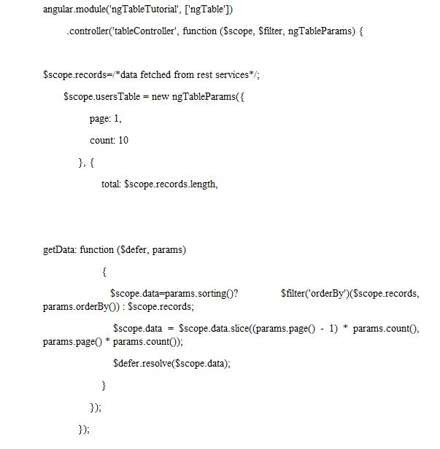

ngtable.html
<div ng-controller="tableController">
<table ng-table="releaseTable" showfilter=”true” class="table table-striped">
<tr ng-repeat="row in data">
<td data-title="'CUSIP'" >
{{row.cusip}}
</td>
<td data-title="'SYMBOL'" >
{{row.symbol}}
</td>
<td data-title="'DESCRIPTION'" >
{{row.description}}
</td>
<td data-title="'RELEASE QUANTITY" >
{{row.release_quantity}}
</td>
<td data-title="'PLEDGE QUANTITY'">
{{row.pledge_quantity}}
</td>
<td data-title="'PLEDGE VALUE'" >
{{row.pledge_value}}
</td>
</td>
<td data-title="'PLEDGE BANK'" >
{{row.pledge_bank}}
</td>
</tr>
</table></div>
4.2.3 Bootstrap framework
Bootstrap is a technology which is highly used for user convenience. The size of the website is always adjusted based on the screen in which the site is opened. And it provides more responsive pages and increases user comfort.
ADVANTAGES OF BOOTSTRAP
- Ease of Use
- Highly Flexible
- Responsive Grid
- Comprehensive List of Components
- Leveraging JavaScript Libraries
- Frequent Updates
- Detailed Documentation and Vast Community
- Consistency
4.2.4 Interfacing Client FrontEnd and RESTful Services Using Spring MVC framework:
SPRING MVC
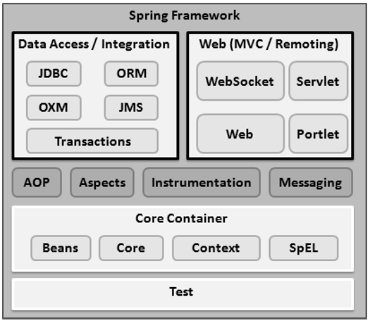
Fig: 4.1. Spring Framework

The below code is responsible for invoking rest services from Angular 2:
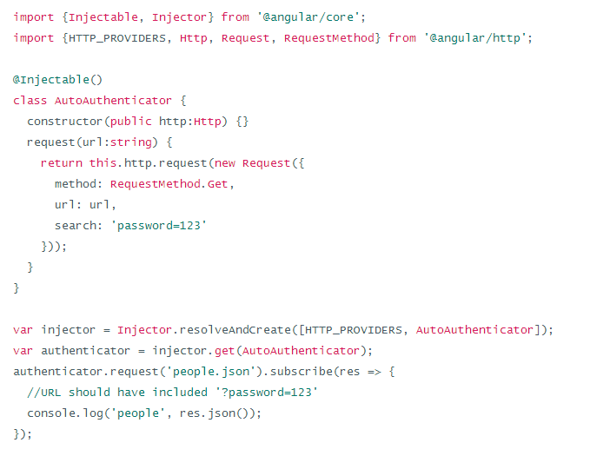

As shown in the code, the AutoAuthenticator class which calls the rest service using the url and gets the list of records in JSON format and return it to the called method. This result is printed using console.log () method.

4.2.5 Interfacing RESTful Services and Backend Mainframe Server Using Message Queuing:

The following are the configuration files used :
Pom.xml
Spring-Servlet.xml
Web.xml

Pom.xml:
This file contains all the dependencies that are required to get the application work. The code dependencies and the properties tag are given below.
<project xmlns="http://maven.apache.org/POM/4.0.0" xmlns:xsi="http://www.w3.org/2001/XMLSchema-instance"
xsi:schemaLocation="http://maven.apache.org/POM/4.0.0 http://maven.apache.org/maven-v4_0_0.xsd">
<modelVersion>4.0.0</modelVersion>
<groupId>pledge</groupId>
<artifactId>pledge.test</artifactId>
<packaging>war</packaging>
<version>0.0.1-SNAPSHOT</version>
<name>Test Pledge Maven Webapp</name>
<url>http://maven.apache.org</url>
<properties>
<jdk.version>1.7</jdk.version>
<spring.version>4.1.1.RELEASE</spring.version>
<jstl.version>1.2</jstl.version>
<junit.version>4.11</junit.version>
<logback.version>1.0.13</logback.version>
<jcl-over-slf4j.version>1.7.5</jcl-over-slf4j.version>
</properties>
<dependencies>
<!-- Unit Test -->
<dependency>
<groupId>junit</groupId>
<artifactId>junit</artifactId>
<version>${junit.version}</version>
</dependency>
<!-- Spring Core -->
<dependency>
<groupId>org.springframework</groupId>
<artifactId>spring-core</artifactId>
<version>${spring.version}</version>
<exclusions>
<exclusion>
<groupId>commons-logging</groupId>
<artifactId>commons-logging</artifactId>
</exclusion>
</exclusions>
</dependency>

<dependency>
<groupId>org.slf4j</groupId>
<artifactId>jcl-over-slf4j</artifactId>
<version>${jcl-over-slf4j.version}</version>
</dependency>

<dependency>
<groupId>ch.qos.logback</groupId>
<artifactId>logback-classic</artifactId>
<version>${logback.version}</version>
</dependency>
<dependency>
<groupId>org.springframework</groupId>
<artifactId>spring-web</artifactId>
<version>${spring.version}</version>
</dependency>
<dependency>
<groupId>org.springframework</groupId>
<artifactId>spring-webmvc</artifactId>
<version>${spring.version}</version>
</dependency>

<!-- jstl -->
<dependency>
<groupId>jstl</groupId>
<artifactId>jstl</artifactId>
<version>${jstl.version}</version>
</dependency>
<dependency>
<groupId>org.springframework</groupId>
<artifactId>spring-jdbc</artifactId>
<version>${spring.version}</version>
</dependency>
<!-- Jackson JSON Processor -->
<dependency>
<groupId>com.fasterxml.jackson.core</groupId>
<artifactId>jackson-databind</artifactId>
<version>2.4.1</version>
</dependency>
</dependencies>
<build>
<finalName>Test</finalName>
</build>
</project>

Maven Dependency :
Maven is very powerful framework that makes the users to use and download dependencies that are required for the application to run. To use maven, dependencies must be added to the pom.xml file which in turn downloads the version specified once the project is maven updated. This reduces the burden of the programmer, for each time to download all the required dependencies. The war file can be generated and can be put up in the server. This is the major feature of maven.

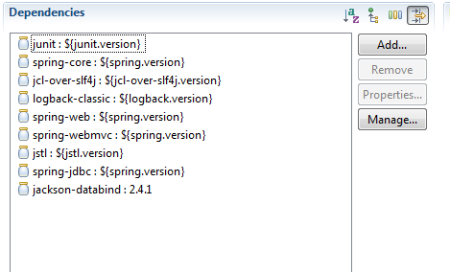
Fig: 4.2. Dependency injection

The above screenshot contains some of the core dependency injected and each one is responsible for importing some specific packages. For example, Jackson-databind will import the packages at run time which will convert list into JSON objects and vice versa.

Spring-servlet.xml:

<beans>
xmlns="http://www.springframework.org/schema/beans"
xmlns:xsi="http://www.w3.org/2001/XMLSchema-instance"
xmlns:context="http://www.springframework.org/schema/context"
xmlns:mvc="http://www.springframework.org/schema/mvc"
xmlns:tx="http://www.springframework.org/schema/tx"
xsi:schemaLocation="http://www.springframework.org/schema/mvc http://www.springframework.org/schema/mvc/spring-mvc.xsd
http://www.springframework.org/schema/beans http://www.springframework.org/schema/beans/spring-beans.xsd
http://www.springframework.org/schema/tx http://www.springframework.org/schema/tx/spring-tx-4.1.xsd
http://www.springframework.org/schema/context http://www.springframework.org/schema/context/spring-context.xsd”
</beans>

The above shown configuration file contains a beans tag which is used to download the required packages from the url provided.

5) CONCEPTUAL MODEL/ PROPSED ARCHITECTURE

FLOW DIAGRAM:

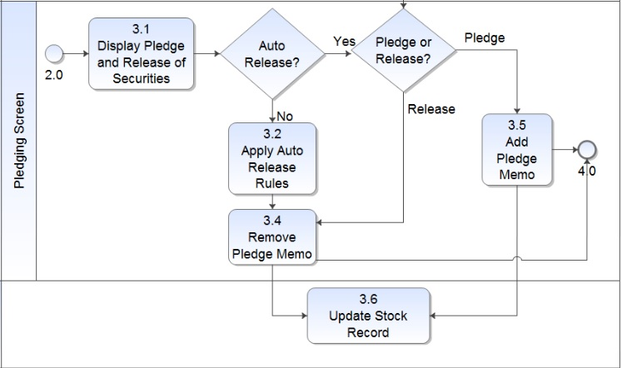

Fig 5.1: Flowchart of Pledging Screen

The flowchart shown above depicts how the pledging and releasing process works. In the first place, the broker selected by the client sees the pledge and release security records under each bank. There is an option of Auto Release. In Auto Release, After 24 hours of time, the pledged amount will be automatically released and the amount is deducted from the client account. If Auto release is not applied, then the broker can release the pledged stock manually. After the above mentioned process is completed, the record is updated to view the changes made.

BLOCK DIAGRAM:

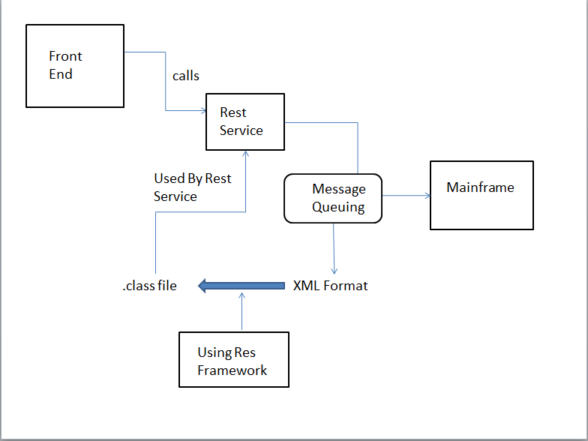
Fig:5.2 Block diagram showing flow of control from front end to back end mainframe

The above block diagram shows the flow in which the client interacts with the user interface. Initially, upon client request, the front end calls the rest service. The REST service also called as web service is used because of its low response rate when compared to SOAP API. To fetch data, REST API calls the Mainframe. Here message queuing is used to retrieve data from the mainframe, and the format is XML. A framework called Res Framework is used which generates equivalent java class file for the XML file. This class objects can be used by the initially invoked REST Service. The REST service returns the object in the JSON format. Angular JS 2 technology is implemented in viewing the retrieved data in single page application.

6) INTERACTION SCENARIO:

USECASE DIAGRAM

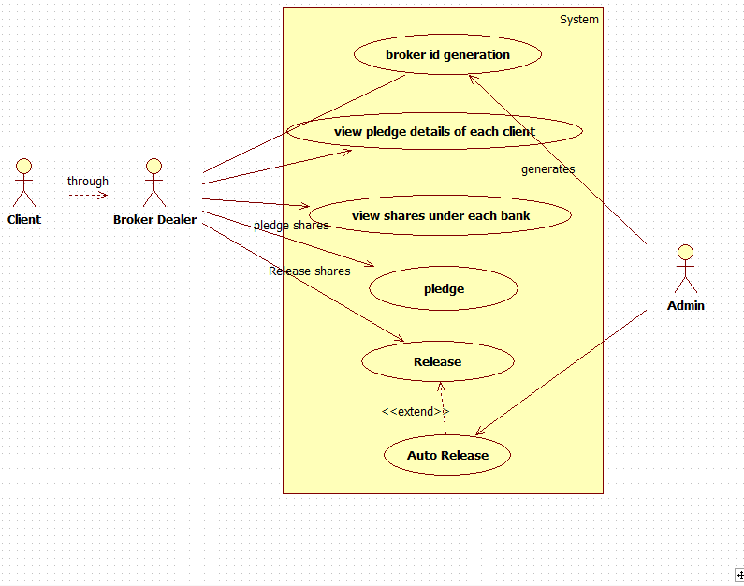
Fig: 6.1 : Use case Diagram for Pledging and Releasing

In this Use case diagram, client, broker and admin are the actors who are interacting with the application software. The client interacts with the application through a broker who acts as a mediator to pledging and releasing process.

For each broker a unique broker id will be generated which is used for authentication purpose. The broker not only views the pledge details of each client but also the shares which are under each bank. The broker has all the privileges to pledge the shares and release the pledged shares. Release of stocks can also happen automatically which is termed as Auto Release.
The admin’s job is to generate the broker id and has all the rights to perform the Auto Release. The Auto Release will happen 24 hours after the stock is being pledged.
Auto Release process deducts the amount from the client account and release the shares correspondingly. If the required amount is not available in the client’s account, penalty is given to the client.
Since, same transaction can be performed concurrently in two or more systems, some transaction may fail. For every unsuccessful process, an error popup message is thrown with corresponding error statements. The log of every unsuccessful transactions are saved and can be viewed later.

Use case Diagram Process flow:
1. Client to Broker Interaction.
2. Unique Broker id will be generated.
3. Broker views all the pledge details of each client.
4. Broker places the shares in the pledge.
5. Broker can also have the option to release the shares from the bank.
6. Finally there is an Auto release option to make the release of equities with 24 hours from the stocks pledged.
ACTIVITY DIAGRAM

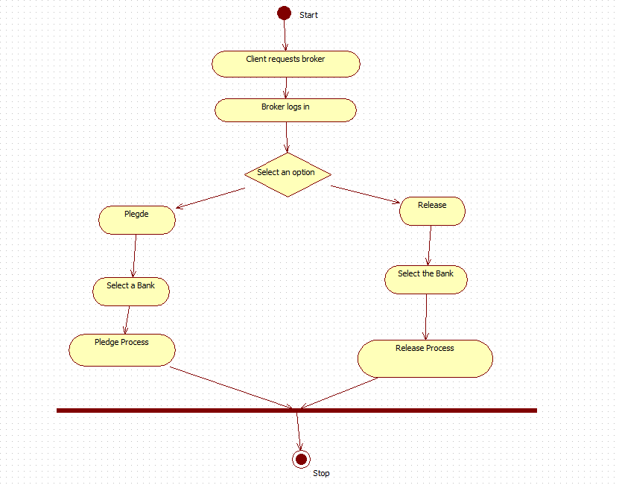
Fig 6.2(1) Activity Diagram for overall pledging and releasing process.

In this Activity diagram, basic flow of process starts from client requesting the broker to pledge or release the shares which the client is holding. Many clients can request one or more brokers for pledging and releasing process. The client will also give additional information to the broker like As soon as broker gets the information from the clients; he starts logging in to the application. The broker has an option to select pledge or do release. When pledge is selected, the broker then selects a bank from the list of banks available. All the banks will not encourage pledging process. Only few banks which are allowed are displayed. After selecting the bank, the quantity of shares to be pledged is given and pledge process is done.
When Release option is selected, the broker selects the banks for releasing the stocks from bank. Now all the stocks which belong to the client; that are held by the bank are given to Client.

Activity Diagram Process flow:
1. Client requests Broker and gives required information.
2. Broker logs in to the application.
3. If the Pledge option is selected, the available bank is listed down along with the details of all the client’s shares under the specific bank.
4. In pledge process, the clients’ shares are given to the bank and in return bank gives the money to the client based on share value.
5. If release option is selected, then broker selects the user share’s CUSIP ID to be released and proceeds with Release process.
6. In release process the client pays the money back to the bank and takes back his shares. When failed to lend the money to the bank, then the bank puts penalty on the client which is to be paid.

ACTIVITY DIAGRAM FOR PLEDGING

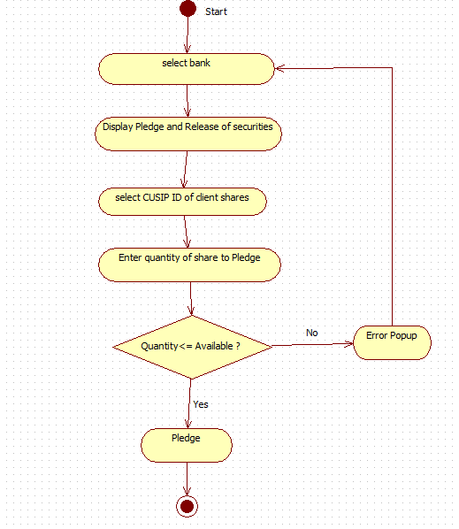

Fig 6.2(2) Activity Diagram for Pledging Process

Initially the broker selects the bank to perform the pledging process and the user interface displays the pledge and release security policies.
The Broker then selects the CUSIP id of the client shares and enters the quantity of each share to pledge. If the quantity of the shares to be pledged under the selected bank is less than or equal to the available quantity, then the stocks are successfully pledged and given to the bank.
Here, bank becomes the owner of the stocks and client borrows money from the bank. If the quantity is not available, then the application prompts the popup message stating insufficient quantity and it is not accepted.
Since, same transaction can be performed concurrently in two or more systems, some transaction may fail. For every unsuccessful process, an error popup message is thrown with corresponding error statements. The log of every unsuccessful transactions are saved and can be viewed later.

Activity Diagram process flow:
1. Broker selects the bank to perform pledging
2. Pledging and release securities are displayed.
3. CUSIP id of client shares is selected.
4. The quantity of the stock is entered.
5. If quantity of stock is available, then the stocks are pledged to bank.
6. Otherwise error popup is thrown and process is restarted.

ACTIVITY DIAGRAM FOR RELEASE:

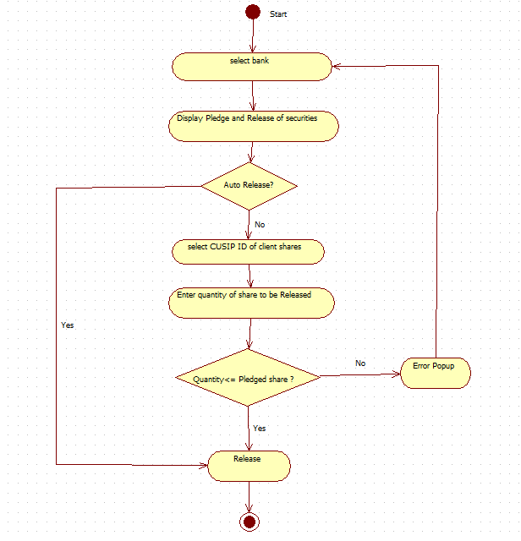
Fig 6.2(3) Activity Diagram for Releasing Process

Initially the broker selects the bank to perform the release process and the user interface displays the pledge and release security policies.

The Broker then selects the CUSIP id of the client shares and enters the quantity of each share to release. If the quantity of the shares to be released under the selected bank is less than or equal to the pledged quantity, then the stocks are successfully released and given back to the client.
Here, bank returns the stocks back to the owner upon receiving the money. Once the release process is done, the amount is deducted from the client’s account depends on the number of share they released.
Since, same transaction can be performed concurrently in two or more systems, some transaction may fail. For every unsuccessful process, an error popup message is thrown with corresponding error statements. The log of every unsuccessful transactions are saved and can be viewed later.

Activity Diagram process flow:
1. Broker selects the bank under which the client has pledged their stocks.
2. Pledging and release securities are displayed.
3. CUSIP id of client share is selected.
4. The quantity of the stock to be released is entered.
5. If quantity of stock is valid, then the stocks are released and given back to the client.
6. The equivalent amount is deducted from the client’s account.
SEQUENCE DIAGRAM:
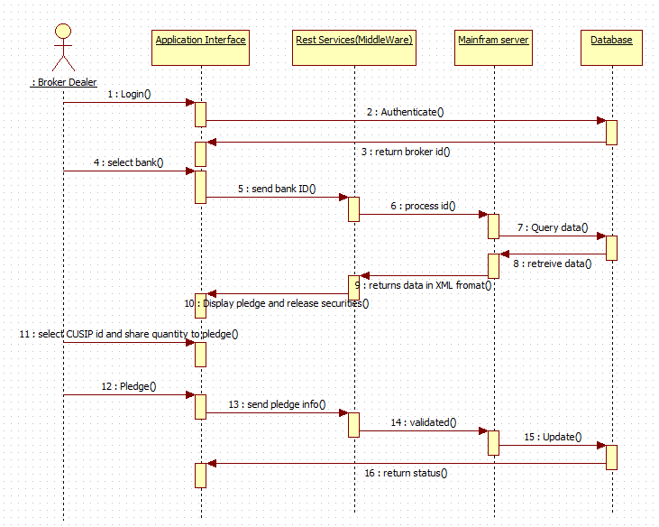
Fig 6.3 Sequence Diagram for Pledging and Release Process

This sequence diagram explains process flow and interaction of processes in a sequence. It explains how input is taken at each stage and processed to next stage.
It explains sequence of events through which entire process flow occurs. In the given diagram, process flow starts with broker dealer interacting with API and feeding input and this input is authenticated from database which returns the broker id. After the broker id is returned, the broker can select the bank out of all lists of banks available.
Based on the bank id and the process id queried to mainframe, the database returns the pledge and release share records under that bank. The data that is returned from Mainframe server to middleware is in XML format. The pledge and release security records under the given bank id is displayed in the application interface.
For the pledge process, the CUSIP ID and quantity of shares to be pledged is given as input in UI. That info is sent to rest service and processed and updated in database using Mainframe Server. The status of the current transaction is returned back to the application interface and displayed. The same process is carried out for release process also except it deals with releasing pledged shares.

Sequence Diagram process flow:
1. End user(broker dealer) to Application Interface.
2. End user provides inputs.
3. The inputs are sent to REST services in JSON format.
4. Mainframe server processes this inputs from REST Services.
5. Database gets updated based on the inputs provided.
6. Finally, the status of the transaction is returned back to the end user.

CLASS DIAGRAM:
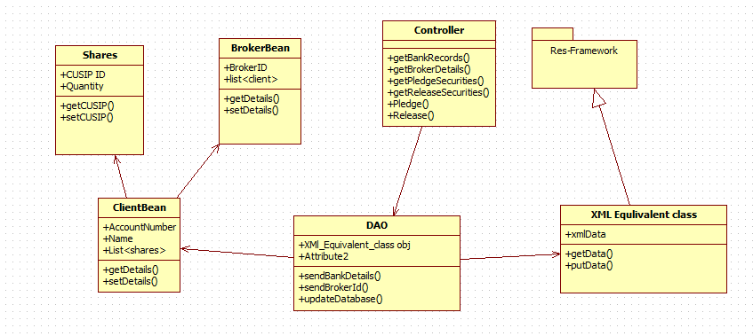
Fig 6.4: Class Diagram for Pledging and Releasing Process
In the above class diagram, six classes are available namely, Shares, BrokerBean, Controller, ClientBean, DAO, XMLEquivalentClass. These six classes form main contents of project and help in achieving goals.

Each class has several attributes which determines properties of class respectively. These classes interact with each other for successful functioning of the application.

Class Diagram Process Flow:
1. Controller to DAO.
2. Class Diagrams contains Attributes and Functions.
EXAMPLE:
*DAO contains attributes and functions as follows:
*Attributes:
* XMl_Equivalent_class obj
*Functions:
* sendBankDetails()
* sendBrokerId()
* updateDatabase()
3. In this way all the class Diagrams are linked :
Controller to DAO.
DAO uses ClientBean, Shares , BrokerBean, XMLEquivalentClass.
ClientBean will have Shares and BrokerBean Object.
XMLEquivalentClass uses classes present is Res Framework package.

COLLABORATION DIAGRAM:

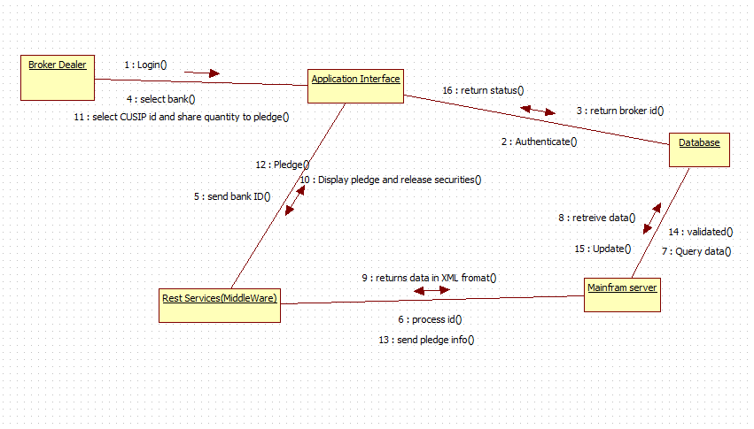
Fig 6.5: Collaboration Diagram for Pledging and Releasing Process

This collaboration diagram describes how various objects are organized in the project. It also depicts communication between objects which send and receive messages. It describes dynamic behaviour of the system.

In the above diagram, various objects like Broker Dealer, Application Interface , Database, Res Framework and Mainframe Server interact with each other transferring system messages which help in successful functioning of the system.
The collaboration Diagram of this project explains about the way of process flow with Arrow marks having inputs to next object.

Process Flow:
1. Broker Dealer logs on to application interface and authentication is done with the database.
2. A Broker id is returned to the application interface from the database.
3. Broker Dealer selects the bank and sends to middle ware which sends the process id to mainframe.
4. With the given requirements a query is made to the database which returns the data as output.
5. The data is returned from mainframe to middle ware in XML format
6. The Interface displays the pledge and release securities.
7. Now the broker dealer selects the cusip id and the quantity of shares to perform pledge.
8. The pledge request is sent to REST Service.
9. The information of the pledge is sent to mainframe.
10. The requested details that are sent to the database are validated.
11. Finally if the validation is true then the database gets updated and the status report is sent back to the application interface.

7) METHODLOGY AND APPROACH
Module No. 1: Setting up the Initial Software and configuring all the configuration files
In the Eclipse IDE, all the API files like servlet.api are added into the build path. The configuration files like pom.xml, spring-servlet.xml, and web.xml are edited. All the required files are included. The created project is converted into Maven which helps in downloading the required dependencies from the internet. The versions of the required dependency are mentioned in pom.xml file.

Module No. 2: Performing the Pledging Process
Initially the broker selects the bank to perform the pledging process and the user interface displays the pledge and release security policies.
The Broker then selects the CUSIP id of the client shares and enters the quantity of each share to pledge. If the quantity of the shares to be pledged under the selected bank is less than or equal to the available quantity, then the stocks are successfully pledged and given to the bank.
Here, bank becomes the owner of the stocks and client borrows money from the bank. If the quantity is not available, then the application prompts the popup message stating insufficient quantity and it is not accepted.

Module No. 3: Performing the Release Process
Initially the broker selects the bank to perform the release process and the user interface displays the pledge and release security policies.
The Broker then selects the CUSIP id of the client shares and enters the quantity of each share to release. If the quantity of the shares to be released under the selected bank is less than or equal to the pledged quantity, then the stocks are successfully released and given back to the client.
Here, bank returns the stocks back to the owner upon receiving the money. Once the release process is done, the amount is deducted from the client’s account depends on the number of share they released.
Since, same transaction can be performed concurrently in two or more systems, some transaction may fail. For every unsuccessful process, an error popup message is thrown with corresponding error statements. The log of every unsuccessful transactions are saved and can be viewed later.

8) OUTPUT/RESULTS:
Pledge Screen:

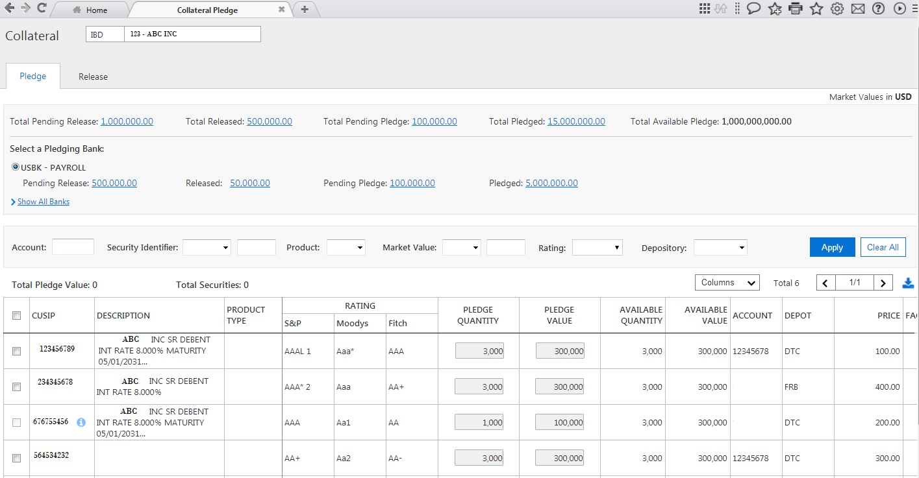Fig 8.1: Output Screen of Pledging Process

In the Fig 9.1: output screen of Pledge Process is shown. The broker id is displayed on the top. The details like total pending release, total release and total pending pledge and total available pledge are available. Filtering facilities are provided and the table is shown.
Release Screen:
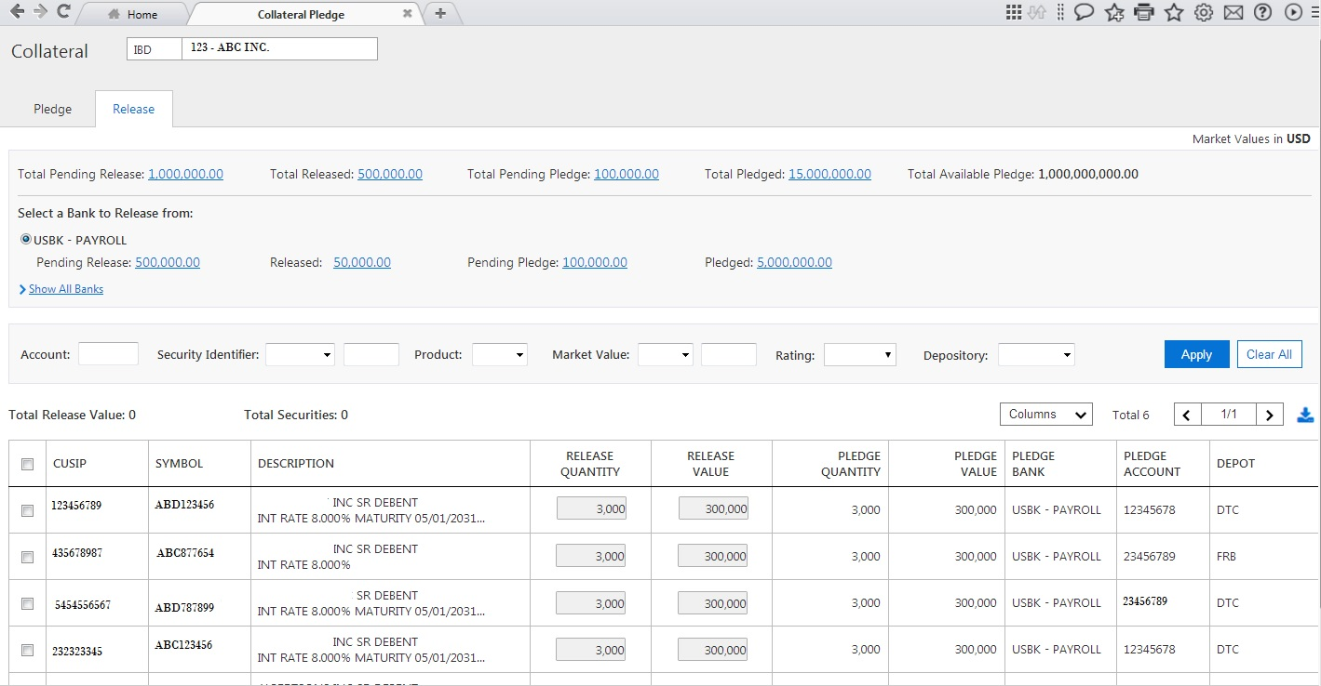
Fig 8.2: Output Screen of Releasing Process

In the Fig 9.1: output screen of Release Process is shown. It is similar to the pledge screen except that few columns in the table differ. Here, the pledged quantity and release quantity is displayed.

9)CONCLUSION:

Thus, the main aim of designing this application software is to ease out the user experience in dealing with the pledging and release process. This application also displays all the security policies of the software and makes the user interface self-explanatory, thereby increasing the comfort level of the user. The application is very secure since end to end encryption and decryption algorithms are used. This developed module responds to user queries in a fraction of time because of highly sophisticated technologies like Angular JS 2, Node JS . The best part of the application software is that there is no external agent is required to perform clearing process, instead a single module will take care of all the settlement process completely. The development and maintenance job of the application is also very easy. Between buyers and sellers, this application software acts as a bridge. Such systems are called as Clearing House System.

10) REFERENCES:
REFERENCE:

https://inautixonline.inautix.com/ – iNautix Company.

