Name: Mustafa Nafia

Date: 8/16/18

Class: CIT-149

Professor: Cindy Tucker

Picture1:

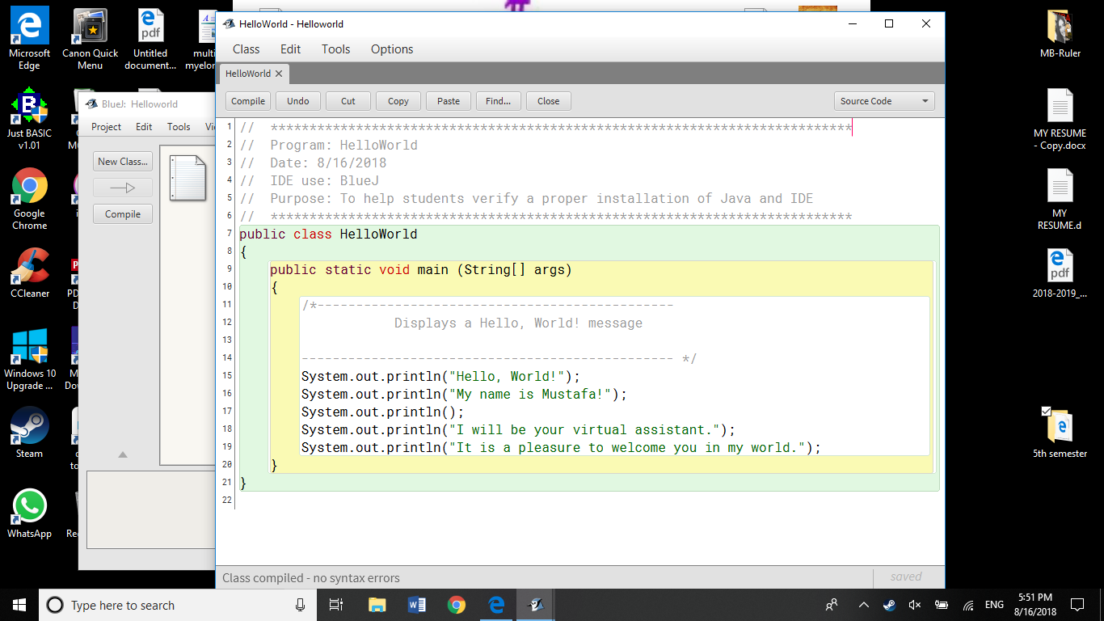

Picture2:

