

**DOKUZ EYLUL UNIVERSITY**

**ENGINEERING DEPARTMENT**

**DEPARTMENT OF COMPUTER ENGINEERING**

**CME3202 CONCEPTS OF PROGRAMMING LANGUAGES**

**FINAL ASSIGNMENT**

**CENGOnline**

**By**

Türkü Su KAPLAN - 2016510036

Berkay Sert - 2017510068

Mustafa Çağatay Önal – 2016510082

July, 2020

Izmir

**TABLE OF CONTENTS**

1. List of Figures………………………………………………………………….3
2. List of Tables…………………………………………………………………..3
3. **Introduction……………………………………………………………………….….4**
   1. Purpose and Scope…………………………………………………………….…..4
   2. Project Description………………………………………………………………...4
   3. Terms, Acronyms, and Abbreviations……………………………………………4
   4. References…………………………………………………………………………5
4. **Project Requirements……………………………………………………………..….6**

2.1. Functional Requirements………………………………………………………….6

2.2. Data Requirements………………………………………………………………..7

2.3. Non-functional Requirements……………………………………………………..7

1. **Project Management Plan………………………………………………………..…..8**
2. **Project Design………………………………………………………………………...9**

4.1. Graphical User Interface Design……………………………………………….….9

4.2. Data Repository Design………………………………………………………….11

4.3. Class Interface Design………………………………………………………...…13

1. **Additional Improvements…………………………………………………………..13**
2. **Conclusion…………………………………………………………………………….**
3. List of Figures

Figure 1: Task Timeline**…………………………………………………………………………….…...**8

Figure2.1: Login Page**…………………………………………………………………………………...**9

Figure2.2: Course Student Page**………………………………………………………………………...**9

Figure2.3: Course Page Details**…………………………………………………………………………**9

Figure2.4: Stream Page**…………………………………………………………………………………**9

Figure 3.1:Mailbox 10

Figure 2.1:Teacher Course Page 10

Figure 3: MySQL Database Design 12

Figure 4:Class Table 13

Figure 5:Abstract Class 13

Figure 6:Inheritance 14

Figure 7: Database connection 14

1. List of Tables

Table 1: Teacher CRUD Operations:………………………………………………………….6

Table 2: Student CRUD Operations:…………………………………………………………..7

1. **INTRODUCTION**
   1. Purpose and Scope:

This report explains and details functionalities, requirements, design, and task sharing of ‘CENGOnline’. It includes explanation about the project and some screenshots from application.

* 1. Project Description:

This project is a Course Management System built as a software development project in Java programming language using the Eclipse IDE. Its main purpose is

making efficient interaction between students and teachers. Application is built for managing college activities such as showing students’ course information, assigning homework and communication between the users.

* 1. Terms, Acronyms and Abbreviations:

**Object Oriented Programming (OOP):** is a programming model which focused on objects and its operations instead of logical operations.

**Inheritance:** Transferring properties (functions, attributes etc.) from super class to base class in OOP.

**Associative Array:** An associative array is an abstract data type which keeps a collection of pair such as key and value.

**Named Constants:** An identifier that represents a permanent value. Java has two types of named constants: final and static final.

**Integrated Development Environment (IDE):** A software application that provides comprehensive facilities to computer programmers for software development.

**Method Overloading:** A feature that allows a class to have more than one method having the same name if their argument lists are different.

**Structured Query Language (SQL):** A standard language for accessing and manipulating databases.

**Graphical User Interface (GUI):** A system of interactive visual components for computer software.

* 1. **References:**

[1] <https://stackoverflow.com/questions/8849063/adding-a-scrollable-jtextarea-java/41238607>

[2] <https://coderanch.com/t/346552/java/Disable-Selection-JTable>

[3]<https://stackoverflow.com/questions/18337580/jtable-clearselection-vs-jtable-getselectionmodel-clearselection-when-to-u>

[4] <https://stackoverflow.com/questions/21871561/how-to-convert-mysql-database-to-class-diagram>

[5]<https://www.geeksforgeeks.org/java-swing-jtable/#:~:text=The%20JTable%20class%20is%20a,data%20in%20a%20tabular%20form.&text=JTable()%3A%20A%20table%20is%20created%20with%20empty%20cells>

[6] <https://docs.oracle.com/javase/7/docs/api/javax/swing/JTextArea.html>

[7] <https://www.javatpoint.com/example-to-connect-to-the-mysql-database>

[8] <https://web.mit.edu/6.005/www/sp14/psets/ps4/java-6-tutorial/components.html>

1. **PROJECT REQUIREMENTS**

2.1 Functional Requirements:

* System Requirements:
* Java SE 8 or higher
* Eclipse IDE
* MySQL
* JDBC Driver for MySQL
* Windows Builder for Eclipse (Eclipse Kepler)
* Login: CENGOnline has two types of users: students and teachers. Each user has unique e-mail and password combination that is stored in the database. Each type of user has different features in the application.

Table 1: Teacher CRUD Table

|  |  |  |  |  |
| --- | --- | --- | --- | --- |
|  | Add | Delete | Edit | View |
| Course | X | X | X | X |
| Assignment | X | X | X | X |
| Announcement | X | X | X | X |
| Attachment |  |  |  | X |
| Message | X |  |  | X |
| Post | X | X | X | X |
| Comment | X |  |  | X |

Table 2: Student CRUD Table

|  |  |  |  |  |
| --- | --- | --- | --- | --- |
|  | Add | Delete | Edit | View |
| Course |  |  |  | X |
| Assignment |  |  |  | X |
| Announcement |  |  |  | X |
| Attachment | X | X |  | X |
| Message | X |  |  | X |
| Post |  |  |  | X |
| Comment | X |  |  | X |

The following programming concepts have been implemented in this project:

* Inheritance
* Abstract data type
* Foreach loop
* Switch-case condition
* Named constant
* Associative arrays
* Method overloading

2.2 Data Requirements:

Data is stored at the MySQL data repository. The project is created with Object-Oriented Principles, so each object is determined and stored with respect to this principle.

Main objects/entities are;

* Announcement
* Assignment
* Attachment
* Comment
* Course
* Message
* Post
* Student
* Teacher

2.3 Non-functional Requirements:

* Data integrity is ensured by using the Java’s Exception Handling feature. Each object/entity is stored within itself and data type errors are avoided. Unintentional changes caused by user error is prevented.
* Students cannot change their assignment’s grade, only the course teacher can see and change the student’s grades.
* Students can only see their profile; they cannot change or view other student’s profile.
* Teachers can only add/edit/delete courses they are lecturing.
* Usability and understandability are achieved by using user-friendly GUI.

1. **PROJECT MANAGEMENT PLAN**

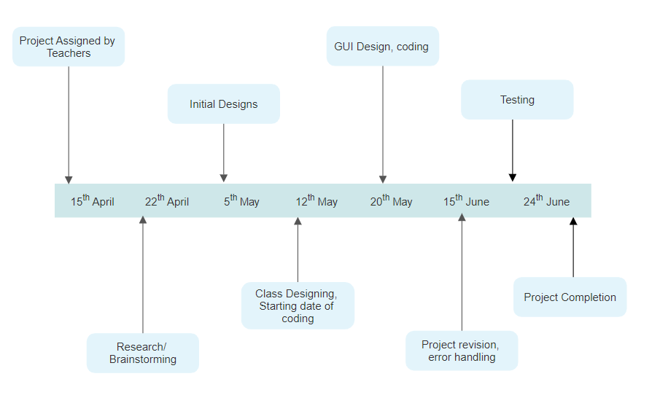

Figure 1: Task Timeline

Türkü Su KAPLAN: Login page and menu designing. Developing the GUI. Creating announcement and mailbox class designs and coding. Contribution to the OOP classes and database design.

Berkay SERT: Student and attachment classes. Designing the GUI of student page. Stream page, post and comment design and coding. Contribution to the OOP classes and database design.

Mustafa Çağatay ÖNAL: Teacher class and teacher related page design and coding. CRUD operation design of the assignment and announcement data. Contribution to the OOP classes and database design.

1. **PROJECT DESIGN**
   1. Graphical User Interface Design:

In order to design the GUI of the project, Java Swing application is used. Java Swing is a part of the Java Foundation Classes that is build on the top of AWT (Abstract Windowing Toolkit) API.

Swing provides interface components such as buttons, text-fields, tables and makes the design phase easier for coding.

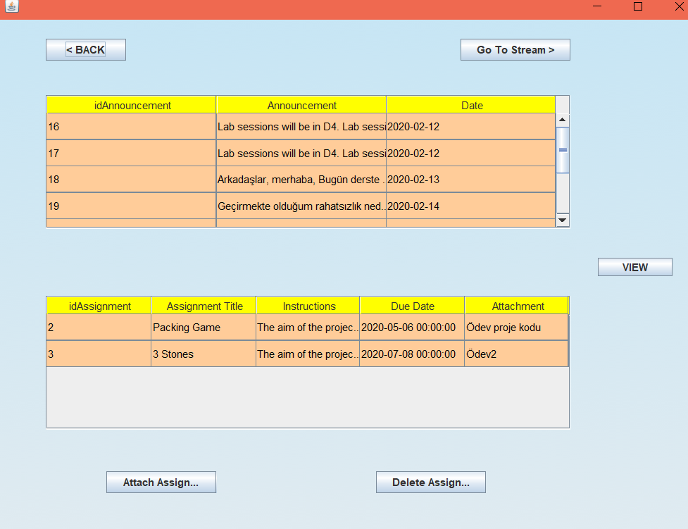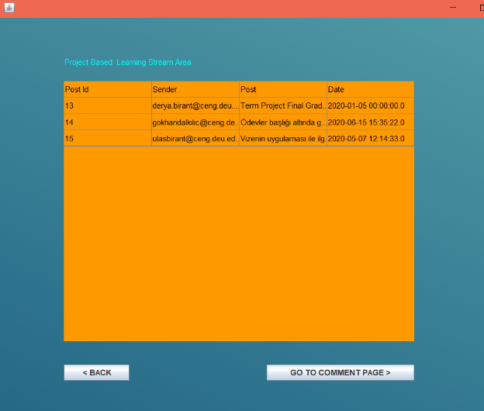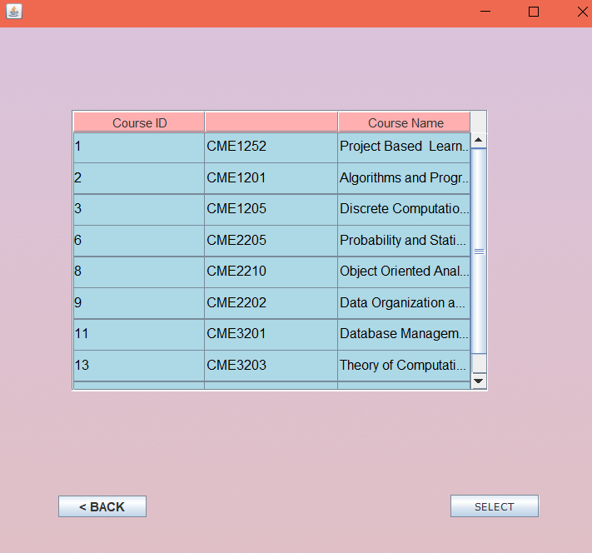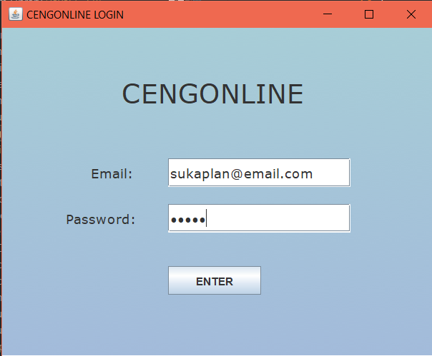 Student GUI Screenshots:

Figure2.3: Course Page Details

Figure2.4:Stream Page

Figure2.2: Course Page Student

Figure 2.1: Login Page

Teacher GUI Screenshots:

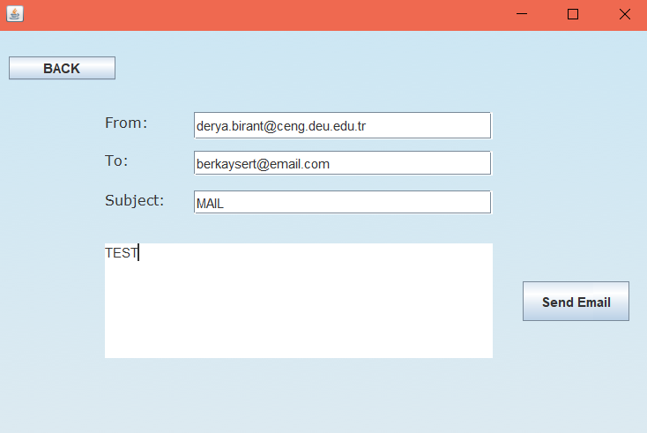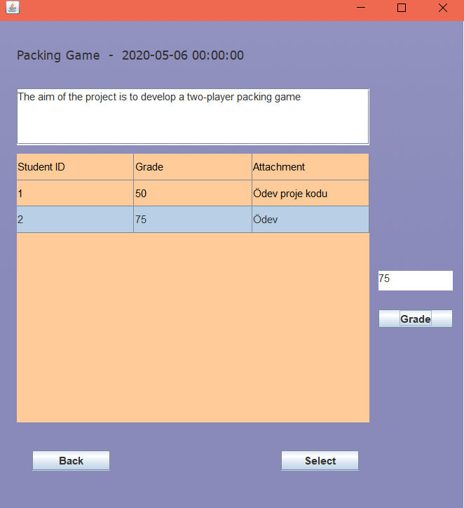

Figure 3.3: Send Mail Page

Figure 3.4: View Assignment / Grade Page

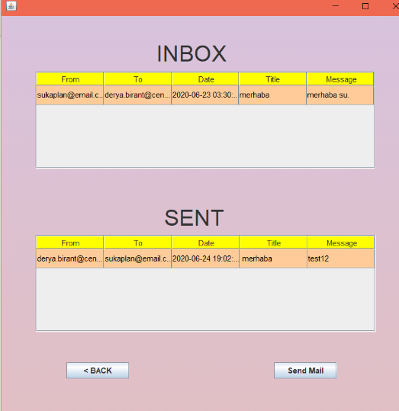 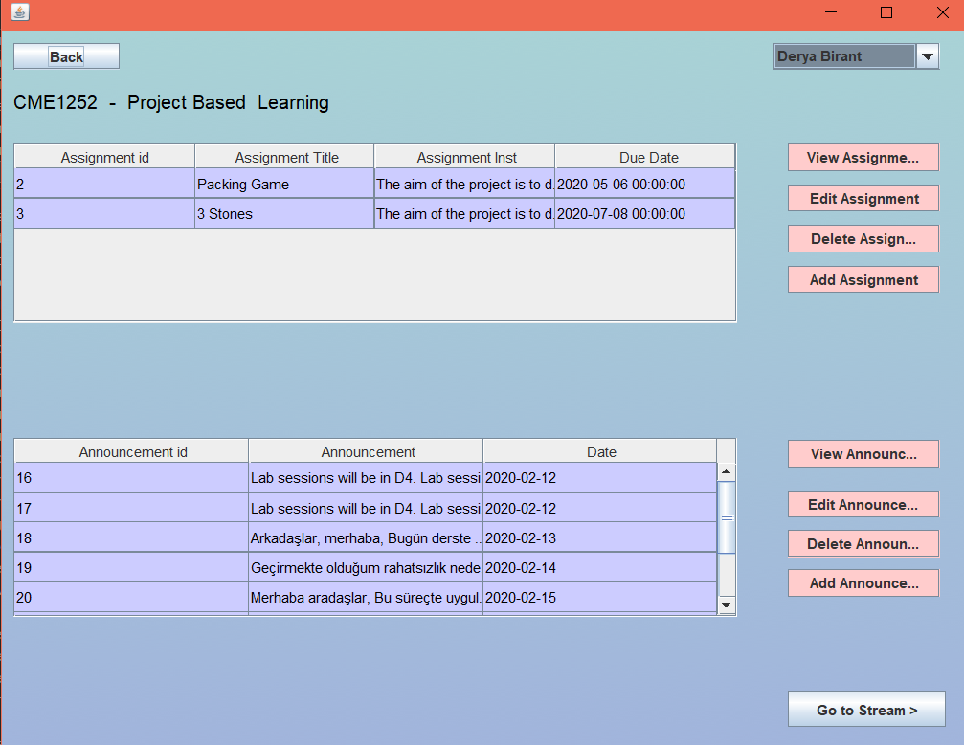

Figure 3.1:Mailbox

Figure 3.1:Teacher Course Page

* 1. Data Repository Design

Data are stored at MySQL Database. Classes in the project is created in the database as entities and its attributes and properties are same except enrollment and course_teacher.These two entities are not main entities of the database and they are used to connect two other databases each other and prevent data redundancy. For example, 'enrollment entity' is to connect 'course and student entities' and show enrolled students to courses; course_teacher is to connect 'course and teacher entities' and show lectures which related teacher gives.

There are foreign key connections between entities which are related each other.

Course - Enrollment ---------> idCourse

Student - Enrollment ---------> idStudent

Assignment - Attachment -------> idAssignment

Student - Attachment ------------> idStudent

Course - Announcement ----------> idCourse

Course - Assignment ---------------> idCourse

Post - Course -----------------------> idCourse

Comment - Post --------------------> idPost

In order to make connection between database and Java, a 'jar' file is added to referenced libraries. In the code part, this connection is provided by using 'DriverManager.getConnection(database, user, password)' function. When user takes action on the application to change data, the changing is provided by 'PreparedStatement' class. This class is connected with 'Connection' class by using a Sql string in function as parameter.

Figure 3: MySQL Database Design

* 1. Class Interface Design:

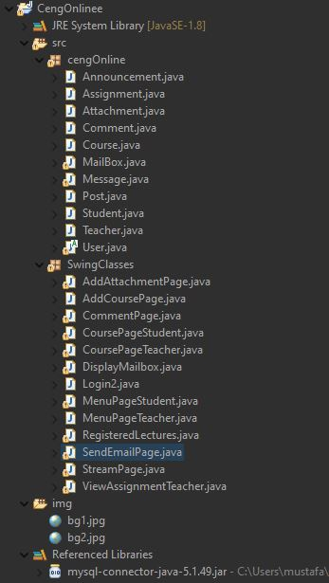

Java classes divided into two packets under project, cengOnline package desing for java class structure, base of the project classes like Course, Teacher, Student etc. SwingClasses package desing for build user interface in swing java, connection with database, in order to handle students and teachers CRUD operations. SwingClasses package connect to the cengOnline package for using these classes to build up system and control data.

Figure 4:Class Table

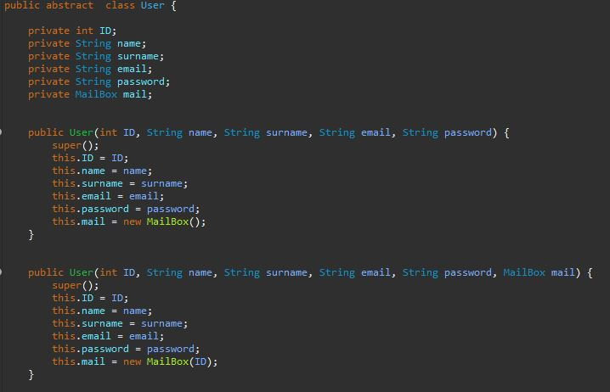

Figure 5:Abstract Class

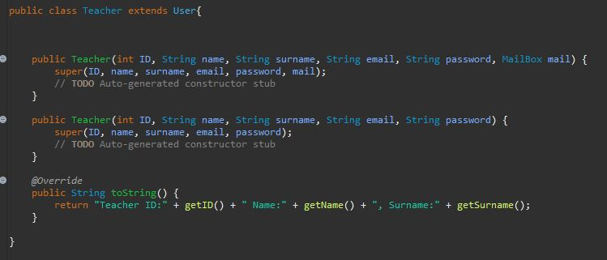

Figure 6:Inheritance

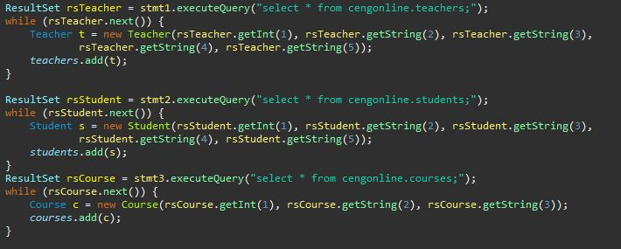

Figure 7: Database connection

Connection between java and database provided and hold into result sets and derived.

Additionally, grade can assign from teacher and students can view grade to their attachment. Grade can be assigned only between zero to one hundred from teacher and grade hold into HashMap.

1. **ADDITIONAL IMPROVEMENTS**

There are two additional improvements we have made in the project. One of them is the teacher giving grades to the student’s assignment. In order to keep this data, HashMap structure is used. HashMap is an associative array type used in Java, so one of the requirements in our project is achieved.

Another improvement we have made is adding a background to the GUI. JLabel’s icon feature is used when adding the images to the interface.

1. **CONCLUSION**

In conclusion, the aim of this project was to design and implement a course management system that can be used both by teachers and students. The requirements of the project have been accomplished successfully. At the last week of the project, we have tried to improve the project as best as we can.