

**KASTAMONU ÜNİVERSİTESİ**

**BİLGİSAYAR MÜHENDİSLİĞİ BÖLÜMÜ GÖRÜNTÜ İŞLEME DERSİ ÖDEV RAPORU**

**ÖDEV**

**Görüntü İşleme 3. Grup**

**Dataset C (flowers-recognition)**

**İş Akışı-3 Uygulamaları**

**ÖDEV TARİHİ**

**22.01.2021**

**DERSİN SORUMLUSU**

**Kemal AKYOL**

**RAPORU YAZAN ÖĞRENCİ**

**174410037**

**Mustafa Said ÇELİK**

**İş Tanımı**

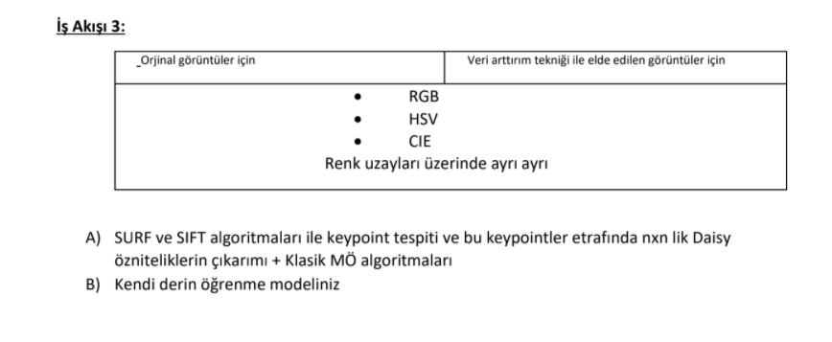



**A)Ekran Görüntüleri**

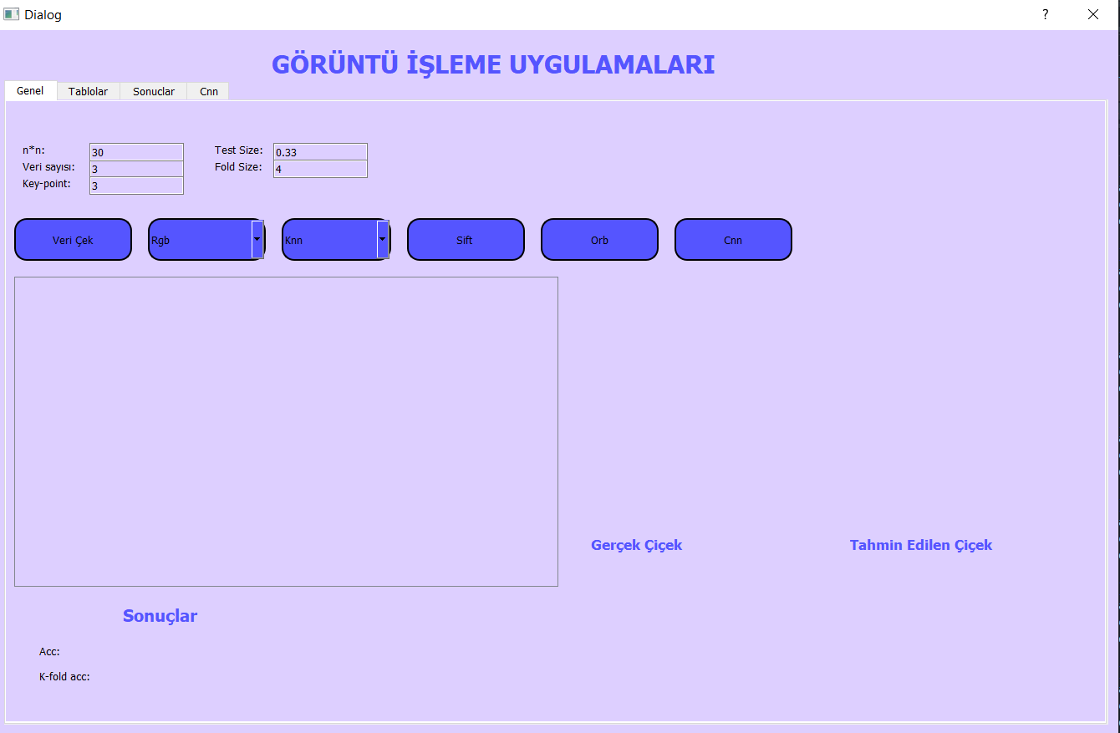

**Arayüz Açıklaması**

-Veri Çek butonuna basıldığında ilgili klasör seçilir ve veriler yazdırılır.

-İlk comboBox renk uzayı seçimi içindir.

-İkinci comboBox algoritma seçimi içindir.

-Sift butonu yukarıda bulunan veri sayısı, n*n daisy değeri, key point sayısı, test size ve fold size’a göre işlem yapar.

-Orb butonu yukarıda bulunan veri sayısı, n*n daisy değeri, key point sayısı, test size ve fold size’a göre işlem yapar.

-Cnn butonu cnn işlemini gerçekleştirir.

**1)Sift Butonuna Basıldığında Yürtülen İşlem**

**RGB İçin**

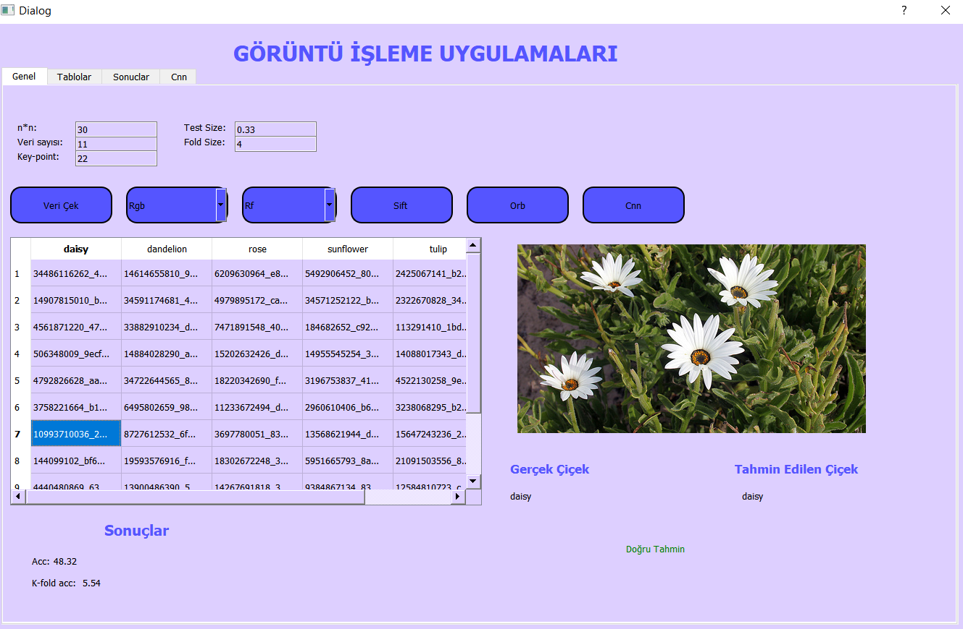

**HSV İçin**

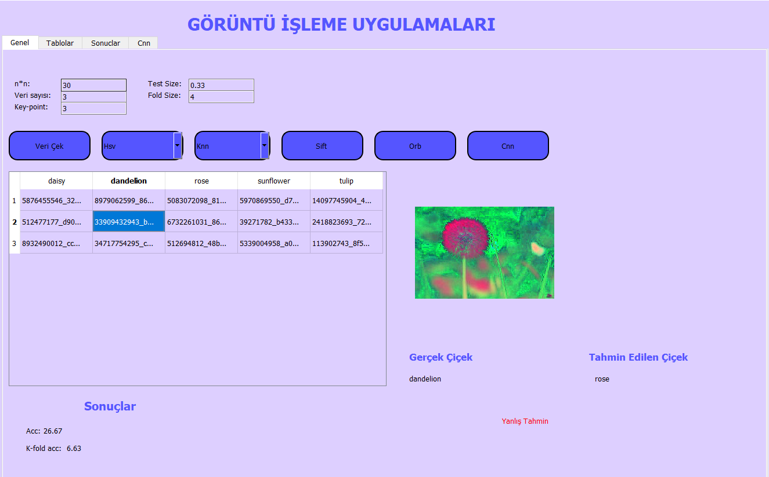

**CİE İçin**

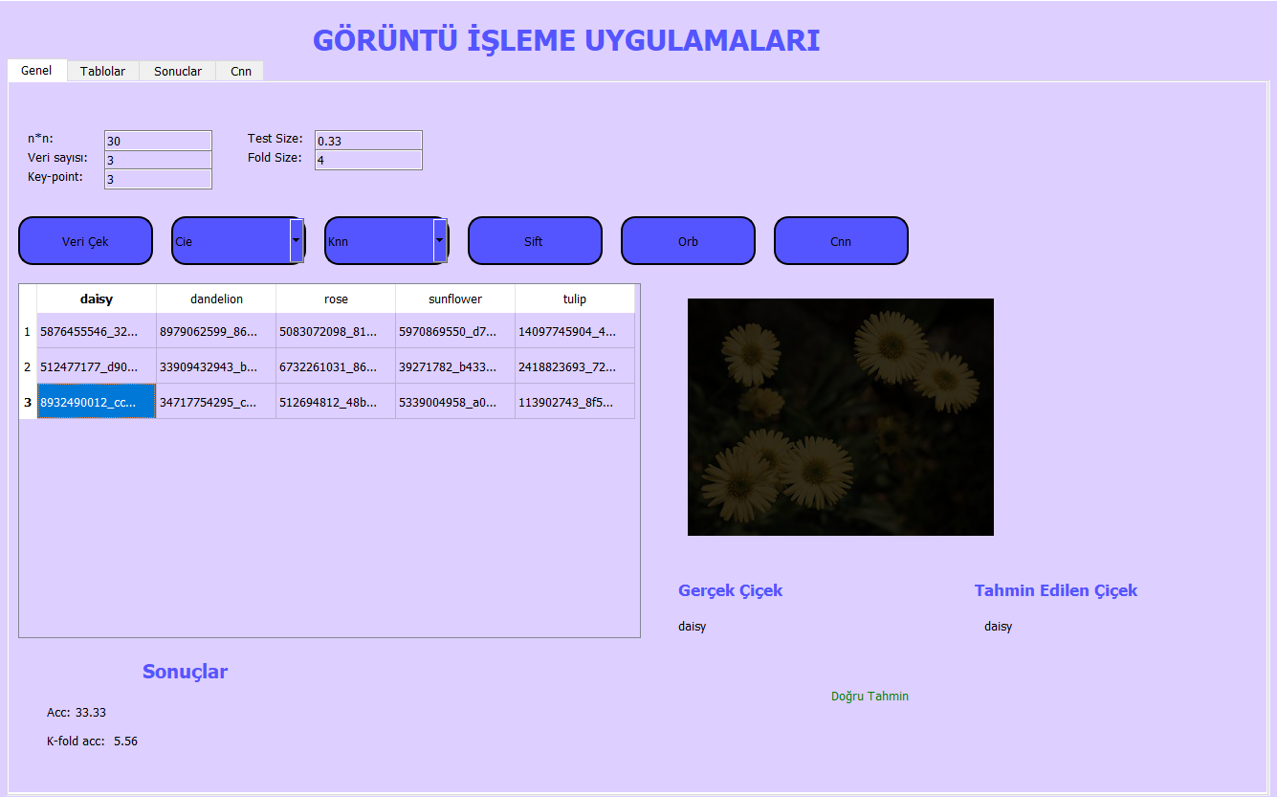

-Sift algoritması çalışır ve sonucu labellara yazılır. Tablodan seçim yapılarak model doğruluğu görüntüde olduğu gibi sınanır.

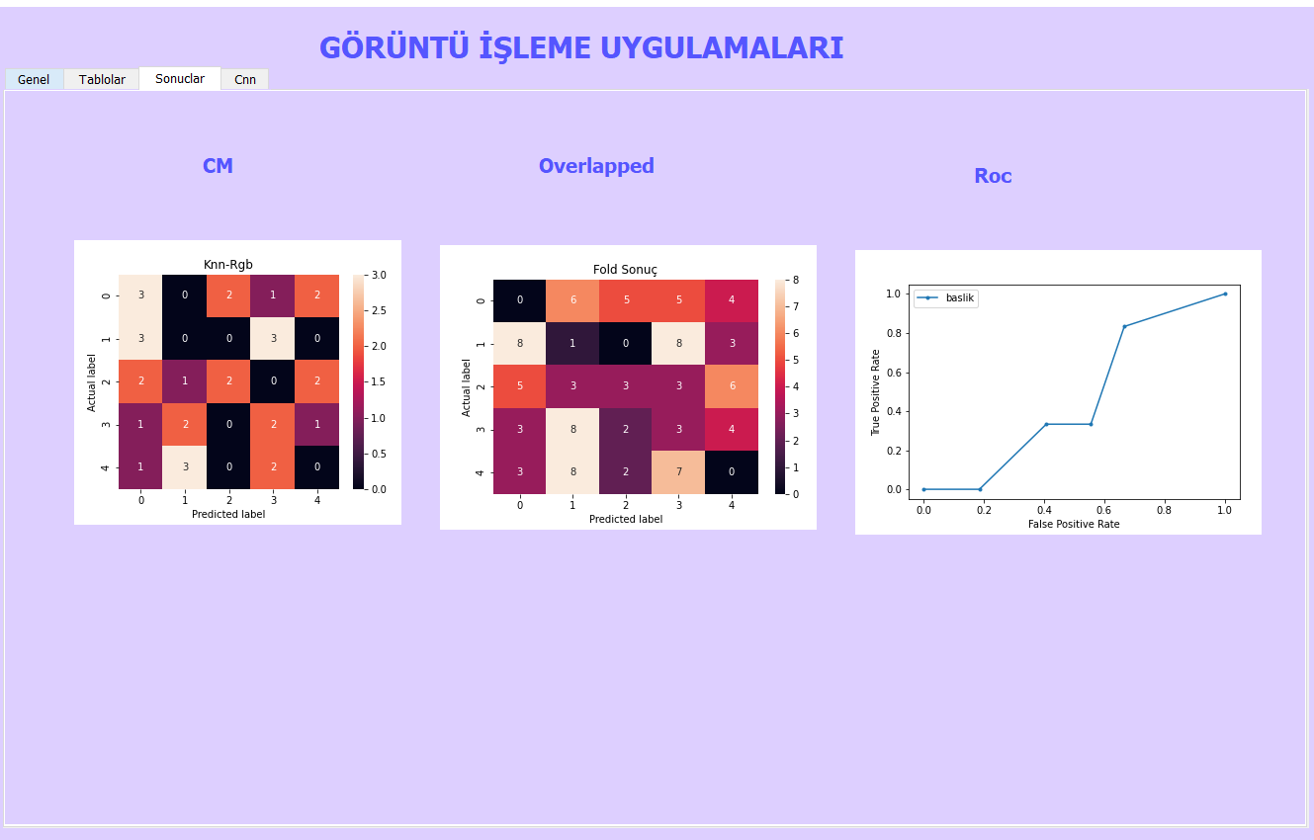

-Hold-out ile yapılan Confusion matrix ve Roc eğrisi, k-fold ile yapılan Overlapped matrix ekranda gösterilir.

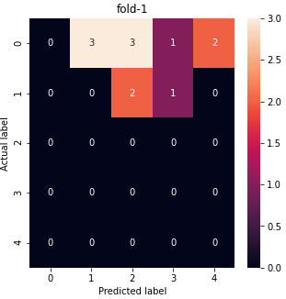 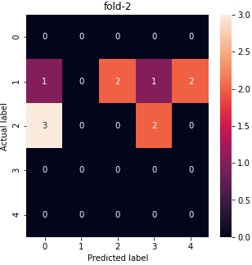

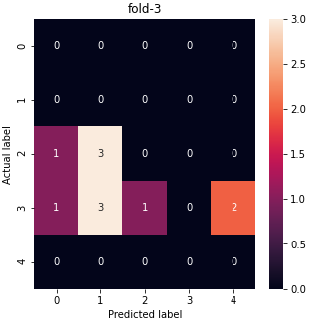 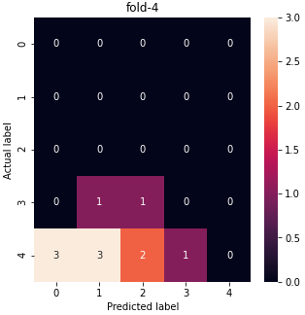

-Her Fold değeri gösterilmiştir.

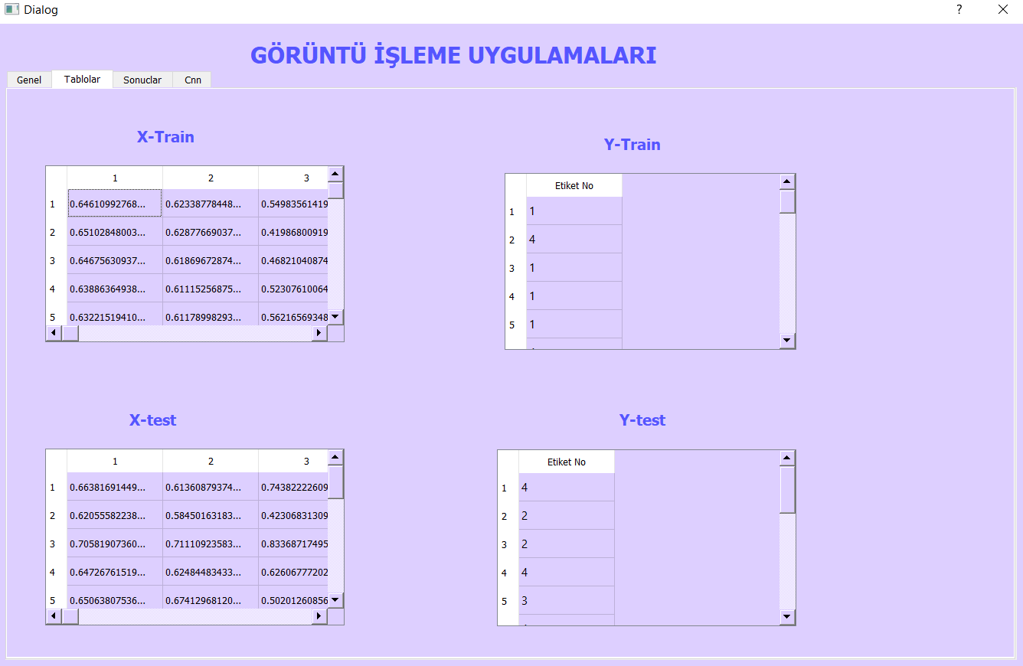

-Daisyden dönen verilerin test ve train olarak ayrımı gösterilmiştir.

-Orb butonu sonucuda ayni işlemler yapılır ve sonuçları gösterir.

**2)Cnn Butonuna Basıldığında Yürtülen İşlem**

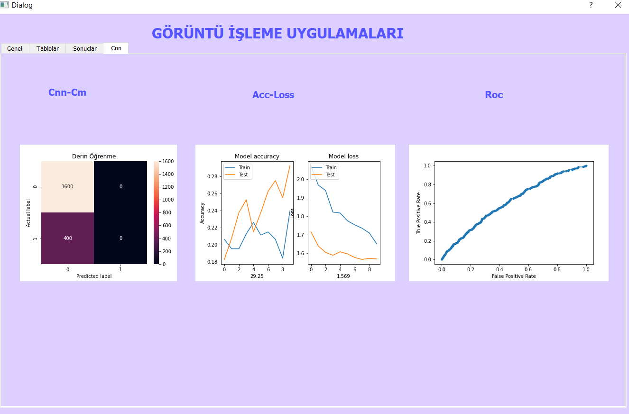

-Cnn sonucunda Confusion matrix, acc-loss grafikleri ve Roc eğrisi gösterilir.

**B)KODLAR VE AÇIKLAMALARI**

**1)Veri Yükleme İşlemi**

**def** Yukle**(**self**,**veridoldur**):**

**from** pandas **import** DataFrame

c**=**len**(**veridoldur**.**columns**)**

r**=**len**(**veridoldur**.**values**)**

self**.**tableWidget**.**setColumnCount**(**r**)**

self**.**tableWidget**.**setRowCount**(**c**)**

self**.**tableWidget**.**setHorizontalHeaderLabels**(**self**.**labels**)**

# print(genelList)

**for** i**,**row **in** enumerate**(**veridoldur**):**

**for** j**,**cell **in** enumerate**(**veridoldur**.**values**):**

self**.**tableWidget**.**setItem**(**i**,**j**,** QtWidgets**.**QTableWidgetItem**(**str**(**cell**[**i**])))**

**def** ekleme**(**self**):**

**import** os

**from** pandas **import** DataFrame

file **=** str**(**QFileDialog**.**getExistingDirectory**(**self**,** "Select Directory"**))**

path**=**file**+**"/"

self**.**liste**=[]**

self**.**labels**=[]**

directories**=**os**.**listdir**(**path**)**

gecici **=** **[]**

sayi **=**int**(**self**.**lineEdit**.**text**())**

directories **=** os**.**listdir**(**path**)**

**for** label_no**,** directory **in** enumerate**(**directories**):**

gecici**=[]**

self**.**labels**.**append**(**directory**)**

files **=** os**.**listdir**(**path **+** directory**)**

random**.**shuffle**(**files**)**

**for** i**,**j **in** enumerate**(**files**):**

**if** i **==** sayi**:**

**break**

gecici**.**append**(**j**)**

self**.**liste**.**append**(**gecici**)**

self**.**df **=** DataFrame**(**self**.**liste**)**

self**.**Yukle**(**self**.**df**)**

-Veri Seç butonuna basıldığında ilk olarak ekleme fonksiyonu çalışır. Seçilen klasör alınır ve bu klasör içindeki veriler random karıştırılır. Arayüzde istenilen veri sayısı kadar veri çekilir, tabloya yazdırlır.

**2)Tablodan Veri Seçme İşlemi**

**def** cekk**(**self**):**

column **=** self**.**tableWidget**.**currentItem**().**column**()**

row **=** self**.**tableWidget**.**currentItem**().**row**()**

yol **=** **(**self**.**tableWidget**.**item**(**row**,** column**).**text**())**

photo_path2 **=** "./flowers/"**+**self**.**labels**[**column**]+**"/"**+**yol

self**.**label_2**.**setPixmap**(**QPixmap**(**photo_path2**))**

# photo = cv2.imread(photo_path2)

# print(photo_path2)

# photo = cv2.resize(photo,(20,30),interpolation = cv2.INTER_AREA)

sec**=**self**.**comboBox**.**currentText**()**

**if** sec**==**'Rgb'**:**

self**.**label_2**.**setPixmap**(**QPixmap**(**photo_path2**))**

**if** sec**==**'Hsv'**:**

hsv **=**cv2**.**imread**(**photo_path2**)**

hsv**=**color**.**rgb2hsv**(**hsv**)**

hsv **=** img_as_ubyte**(**hsv**)**

cv2**.**imwrite**(**"hsv.jpg"**,**hsv**)**

photo_path2 **=** "./hsv.jpg"

self**.**label_2**.**setPixmap**(**QPixmap**(**photo_path2**))**

**if** sec**==**'Cie'**:**

cie **=**cv2**.**imread**(**photo_path2**)**

cie**=**color**.**rgb2rgbcie**(**cie**)**

cie **=** img_as_ubyte**(**cie**)**

cv2**.**imwrite**(**"cie.jpg"**,**cie**)**

photo_path2 **=** "./cie.jpg"

self**.**label_2**.**setPixmap**(**QPixmap**(**photo_path2**))**

image **=** cv2**.**imread**(**photo_path2**)**

image **=** cv2**.**cvtColor**(**image**,** cv2**.**COLOR_RGB2GRAY**)**

image **=** cv2**.**resize**(**image**,** **(**28**,**28**))**

image **=** image**.**flatten**()**

#image = cv2.cvtColor(image, cv2.COLOR_BGR2RGB)

test **=** **[]**

test**.**append**(**image**)**

test **=** np**.**array**(**test**)/**255.0

tahmin **=** self**.**Algdeger**.**predict**(**test**)**

# if self.Algdegercnn!= None:

# tahmin1 = self.Algdegercnn.predict(test).round()

# print(tahmin[0])

self**.**label_28**.**setText**(**self**.**labels**[**tahmin**[**0**]])**

self**.**label_26**.**setText**(**self**.**labels**[**column**])**

**if** **(**self**.**labels**[**column**]==**self**.**labels**[**tahmin**[**0**]]):**

self**.**label_31**.**setText**(**"Doğru Tahmin"**)**

self**.**label_31**.**setStyleSheet**(**"color: Green"**)**

**else:**

self**.**label_31**.**setText**(**"Yanlış Tahmin"**)**

self**.**label_31**.**setStyleSheet**(**"color: Red"**)**

-İlgili renk uzayına göre görüntü arayüzde gösterilir. Her algoritma sonrasında model, self.Algdeger değişkenine aktarılır. Sonrasında cekk fonksiyonunda bulunan self.Algdeger ile predict işlemi yapılır. Tablodan seçilen değere göre sonuç olarak doğru veya yanlış yazdırılır.

**3)Orb Butonuna Basıldığında Yürütülen Kodlar**

**def** OrbAlg**(**self**):**

self**.**Algsayi**=**1

self**.**Sift**()**

-self.Algsayi değeri 1 olur. Bu işlemin amacı sift algoritmasıyla aynı işlevleri olduğu için kodda self.Algsayi’sina bakılarak yapılan değişiklik ile kod tekrarını önlemektir.

**4)Sift Butonuna Basıldığında Yürütülen Kodlar**

**def** Sift**(**self**):**

# crop_image = cv2.cvtColor(crop_image, cv2.COLOR_BGR2GRAY)

# crop_image=crop_image.reshape(crop_image.shape[0],crop_image.shape[1]*crop_image.shape[2])

# print(crop_image.shape)

**from** pandas **import** DataFrame

**from** skimage**.**transform **import** resize

**from** skimage**.**feature **import** daisy

**from** skimage **import** io**,**color

sec**=**self**.**comboBox**.**currentText**()**

**if** sec**==**'Rgb'**:**

**print(**"---------RGB----------------------"**)**

Xlist**=[]**

Ylist**=[]**

deslist**=[]**

**for** label_no**,** directory **in** enumerate**(**self**.**labels**):**

**for** i **in** self**.**liste**[**label_no**]:**

sayac2 **=**int**(**self**.**lineEdit_2**.**text**())**

img **=**cv2**.**imread**(**'./flowers/'**+**directory**+**'/'**+**i**)**

# try:

img_width **=** img**.**shape**[**1**]**

img_height **=** img**.**shape**[**0**]**

# except:

# print("hata")

# break

# img=img.reshape(img.shape[0],img.shape[1]*img.shape[2])

**if** self**.**Algsayi**==**1**:**

sift **=** cv2**.**ORB_create**()**

self**.**Algsayi**=**0

**else:**

sift **=** cv2**.**SIFT_create**()**

kp**,**descss **=** sift**.**detectAndCompute**(**img**,None)**

# img1=cv2.drawKeypoints(gray,kp,img1)

img**=** cv2**.**cvtColor**(**img**,**cv2**.**COLOR_BGR2GRAY**)**

random**.**shuffle**(**kp**)**

**for** s1**,**i **in** enumerate**(**kp**):**

**if** s1**==**sayac2**:**

**break**

x**,**y **=** int**(**i**.**pt**[**0**]),** int**(**i**.**pt**[**1**])**

n**=**int**(**self**.**lineEdit_3**.**text**())**

# print(x,y)

**if** **(**x**-**n**)>**0 **and** **(**y**-**n**)>**0 **and** **(**x**+**n**)<**img_width **and** **(**y**+**n**)<**img_height**:**

a**=**x**-**n

b**=**x**+**n

c**=**y**-**n

d**=**y**+**n

crop_image **=** img**[**c**:**d**,** a**:**b**]**

# crop_image = cv2.rectangle(crop_image, start_point, end_point, color, thickness)

descs**,** descs_img **=** daisy**(**crop_image**,** step**=**90**,** radius**=**3**,** rings**=**2**,** histograms**=**5**,**

orientations**=**5**,** visualize**=True)**

# fig, ax = plt.subplots()

# ax.axis('off')

# ax.imshow(descs_img)

# ax.set_title('DAISY')

# plt.show()

descs**=**descs**.**reshape**(**descs**.**shape**[**0**],**descs**.**shape**[**1**]\***descs**.**shape**[**2**])**

descs**=**resize**(**descs**,** **(**28**,** 28**))**

descs**=**descs**.**flatten**()**

deslist**.**append**(**descs**)**

Ylist**.**append**(**label_no**)**

**else:**

sayac2**+=**1

Xlist**=**np**.**array**(**deslist**)**

Ylist**=**np**.**array**(**Ylist**)**

self**.**Xdegerler**=**Xlist

self**.**Ydegerler**=**Ylist

sec1**=**self**.**comboBox_2**.**currentText**()**

**if** sec1**==**'Knn'**:**

**from** sklearn**.**model_selection **import** train_test_split

tast_size1**=**float**(**self**.**lineEdit_4**.**text**())**

fold_size**=**int**(**self**.**lineEdit_5**.**text**())**

self**.**foldsizee**=**fold_size

x_train**,** x_test**,** y_train**,** y_test **=** train_test_split**(**Xlist**,** Ylist**,** test_size **=** tast_size1**,** random_state **=** 42**)**

self**.**csvYukle**(**x_train**,**y_train**,**x_test**,**y_test**)**

# from sklearn.preprocessing import StandardScaler

# sc_X=StandardScaler()

# x_train=sc_X.fit_transform(x_train)

# x_test=sc_X.fit_transform(x_test)

**from** sklearn**.**neighbors **import** KNeighborsClassifier

knn **=** KNeighborsClassifier**(**n_neighbors**=**5**)**

knn**.**fit**(**x_train**,** np**.**ravel**(**y_train**))**

y_pred**=** knn**.**predict**(**x_test**)**

self**.**Algdeger**=**knn

acc**=**accuracy_score**(**y_test**,** y_pred**)\***100

self**.**label_16**.**setText**(**str**(**round**(**acc**,**2**)))**

**print(**"knn"**,**acc**)**

self**.**Cmatrix**(**y_test**,**y_pred**,**"Knn-Rgb"**)**

self**.**pltRoc**(**y_test**,**y_pred**,**"Knn"**)**

# y_test = y_test.reshape(-1, 1)

# y_pred=y_pred.reshape(-1, 1)

**from** tensorflow**.**keras**.**utils **import** to_categorical

# y_test = to_categorical(y_test)

# y_pred = to_categorical(y_pred)

# y_pred=np.argmax(y_pred, axis=1)

# y_test=np.argmax(y_test, axis=1)

# print(y_test)

# print(y_pred)

# self.pltRoc2(y_test,y_pred,"KnnRoc")

**from** sklearn**.**model_selection **import** KFold

**from** numpy **import** mean

**from** sklearn**.**model_selection **import** cross_val_score

x_deger**=** DataFrame**(**Xlist**)**

y_deger**=** DataFrame**(**Ylist**)**

X **=** x_deger**.**values

y **=** y_deger**.**values

# X = Xlist

# y = Ylist

kf **=** KFold**(**n_splits**=**fold_size**)**

kf**.**get_n_splits**(**X**)**

sayma**=**0

**for** train_index**,** test_index **in** kf**.**split**(**X**):**

sayma**+=**1

# print("TRAIN:", train_index, "TEST:", test_index)

x_train**,** x_test **=** X**[**train_index**],** X**[**test_index**]**

y_train**,** y_test **=** y**[**train_index**],** y**[**test_index**]**

NBG **=** KNeighborsClassifier**(**n_neighbors**=**5**)**

NBG**.**fit**(**x_train**,**np**.**ravel**(**y_train**))**

y_pred **=** NBG**.**predict**(**x_test**)**

acc**=**accuracy_score**(**y_test**,** y_pred**)\***100

**print(**y_test**.**shape**)**

**print(**y_pred**.**shape**)**

self**.**CmatrixFold**(**y_test**,**y_pred**,**"fold-"**+**str**(**sayma**))**

self**.**kfoldCmatrix**(**y_test**,** y_pred**,**"Fold Sonuç"**)**

**print(**acc**)**

model **=** KNeighborsClassifier**(**n_neighbors**=**5**)**

scores **=** cross_val_score**(**model**,** X**,** y**,** scoring**=**'accuracy'**,** cv**=**kf**,** n_jobs**=-**1**)**

self**.**label_17**.**setText**(**str**(**round**(**mean**(**scores**\***100**),**2**)))**

**print(**'Accuracy: %.3f (%.3f)' **%** **(**mean**(**scores**),** scores**.**max**()))**

**print(**"--------------------"**)**

**if** sec1**==**'Rf'**:**

**from** sklearn**.**model_selection **import** train_test_split

tast_size1**=**float**(**self**.**lineEdit_4**.**text**())**

fold_size**=**int**(**self**.**lineEdit_5**.**text**())**

self**.**foldsizee**=**fold_size

x_train**,** x_test**,** y_train**,** y_test **=** train_test_split**(**Xlist**,** Ylist**,** test_size **=** tast_size1**,** random_state **=** 42**)**

self**.**csvYukle**(**x_train**,**y_train**,**x_test**,**y_test**)**

**from** sklearn**.**ensemble **import** RandomForestClassifier

rnd **=** RandomForestClassifier**(**random_state**=**26**,** n_jobs **=** **-**1**,**n_estimators**=**100**)**

rnd**.**fit**(**x_train**,**np**.**ravel**(**y_train**))**

y_pred **=** rnd**.**predict**(**x_test**)**

self**.**Algdeger**=**rnd

acc**=**accuracy_score**(**y_test**,** y_pred**)\***100

self**.**label_16**.**setText**(**str**(**round**(**acc**,**2**)))**

self**.**Cmatrix**(**y_test**,**y_pred**,**"Rf-Rgb"**)**

self**.**pltRoc**(**y_test**,**y_pred**,**"Rf"**)**

**from** sklearn**.**model_selection **import** KFold

**from** numpy **import** mean

**from** sklearn**.**model_selection **import** cross_val_score

x_deger**=** DataFrame**(**Xlist**)**

y_deger**=** DataFrame**(**Ylist**)**

X **=** x_deger**.**values

y **=** y_deger**.**values

kf **=** KFold**(**n_splits**=**fold_size**)**

kf**.**get_n_splits**(**X**)**

sayma**=**0

**for** train_index**,** test_index **in** kf**.**split**(**X**):**

sayma**+=**1

# print("TRAIN:", train_index, "TEST:", test_index)

x_train**,** x_test **=** X**[**train_index**],** X**[**test_index**]**

y_train**,** y_test **=** y**[**train_index**],** y**[**test_index**]**

NBG **=** RandomForestClassifier**(**random_state**=**26**,** n_jobs **=** **-**1**,**n_estimators**=**100**)**

NBG**.**fit**(**x_train**,**np**.**ravel**(**y_train**))**

y_pred **=** NBG**.**predict**(**x_test**)**

acc**=**accuracy_score**(**y_test**,** y_pred**)\***100

self**.**CmatrixFold**(**y_test**,**y_pred**,**"fold-"**+**str**(**sayma**))**

self**.**kfoldCmatrix**(**y_test**,** y_pred**,**"Fold Sonuç"**)**

**print(**acc**)**

model **=**RandomForestClassifier**(**random_state**=**26**,** n_jobs **=** **-**1**,**n_estimators**=**100**)**

scores **=** cross_val_score**(**model**,** X**,** y**,** scoring**=**'accuracy'**,** cv**=**kf**,** n_jobs**=-**1**)**

self**.**label_17**.**setText**(**str**(**round**(**mean**(**scores**\***100**),**2**)))**

**print(**'Accuracy: %.3f (%.3f)' **%** **(**mean**(**scores**),** scores**.**max**()))**

**print(**"--------------------"**)**

**if** sec1**==**"Dt"**:**

**from** sklearn**.**model_selection **import** train_test_split

tast_size1**=**float**(**self**.**lineEdit_4**.**text**())**

fold_size**=**int**(**self**.**lineEdit_5**.**text**())**

self**.**foldsizee**=**fold_size

x_train**,** x_test**,** y_train**,** y_test **=** train_test_split**(**Xlist**,** Ylist**,** test_size **=** tast_size1**,** random_state **=** 42**)**

self**.**csvYukle**(**x_train**,**y_train**,**x_test**,**y_test**)**

**from** sklearn**.**tree **import** DecisionTreeClassifier

c **=** DecisionTreeClassifier**()**

c**.**fit**(**x_train**,**np**.**ravel**(**y_train**))**

self**.**Algdeger**=**c

y_pred**=**c**.**predict**(**x_test**)**

acc**=**accuracy_score**(**y_test**,** y_pred**)\***100

self**.**label_16**.**setText**(**str**(**round**(**acc**,**2**)))**

self**.**Cmatrix**(**y_test**,**y_pred**,**"Dt-Rgb"**)**

self**.**pltRoc**(**y_test**,**y_pred**,**"Dt"**)**

**print(**"DT"**,**acc**)**

**from** sklearn**.**model_selection **import** KFold

**from** numpy **import** mean

**from** sklearn**.**model_selection **import** cross_val_score

x_deger**=** DataFrame**(**Xlist**)**

y_deger**=** DataFrame**(**Ylist**)**

X **=** x_deger**.**values

y **=** y_deger**.**values

kf **=** KFold**(**n_splits**=**fold_size**)**

kf**.**get_n_splits**(**X**)**

sayma**=**0

**for** train_index**,** test_index **in** kf**.**split**(**X**):**

sayma**+=**1

# print("TRAIN:", train_index, "TEST:", test_index)

x_train**,** x_test **=** X**[**train_index**],** X**[**test_index**]**

y_train**,** y_test **=** y**[**train_index**],** y**[**test_index**]**

NBG **=** DecisionTreeClassifier**()**

NBG**.**fit**(**x_train**,**np**.**ravel**(**y_train**))**

y_pred **=** NBG**.**predict**(**x_test**)**

acc**=**accuracy_score**(**y_test**,** y_pred**)\***100

self**.**CmatrixFold**(**y_test**,**y_pred**,**"fold-"**+**str**(**sayma**))**

self**.**kfoldCmatrix**(**y_test**,** y_pred**,**"Fold Sonuç"**)**

**print(**acc**)**

model **=** DecisionTreeClassifier**()**

scores **=** cross_val_score**(**model**,** X**,** y**,** scoring**=**'accuracy'**,** cv**=**kf**,** n_jobs**=-**1**)**

self**.**label_17**.**setText**(**str**(**round**(**mean**(**scores**\***100**),**2**)))**

**print(**'Accuracy: %.3f (%.3f)' **%** **(**mean**(**scores**),** scores**.**max**()))**

**print(**"--------------------"**)**

**if** sec**==**'Hsv'**:**

Xlist**=[]**

Ylist**=[]**

deslist**=[]**

**print(**"-----------HSV--------------------"**)**

**for** label_no**,** directory **in** enumerate**(**self**.**labels**):**

**for** i **in** self**.**liste**[**label_no**]:**

sayac2 **=**int**(**self**.**lineEdit_2**.**text**())**

img **=**cv2**.**imread**(**'./flowers/'**+**directory**+**'/'**+**i**)**

img**=**color**.**rgb2hsv**(**img**)**

img**=** img_as_ubyte**(**img**)**

img_width **=** img**.**shape**[**1**]**

img_height **=** img**.**shape**[**0**]**

# img=img.reshape(img.shape[0],img.shape[1]*img.shape[2])

**if** self**.**Algsayi**==**1**:**

sift **=** cv2**.**ORB_create**()**

self**.**Algsayi**=**0

**else:**

sift **=** cv2**.**SIFT_create**()**

kp**,**descss **=** sift**.**detectAndCompute**(**img**,None)**

# img1=cv2.drawKeypoints(gray,kp,img1)

img**=** cv2**.**cvtColor**(**img**,**cv2**.**COLOR_BGR2GRAY**)**

random**.**shuffle**(**kp**)**

**for** s1**,**i **in** enumerate**(**kp**):**

**if** s1**==**sayac2**:**

**break**

# print(s1)

# print(len(kp))

# for i in kp:

x**,**y **=** int**(**i**.**pt**[**0**]),** int**(**i**.**pt**[**1**])**

n**=**int**(**self**.**lineEdit_3**.**text**())**

# print(x,y)

**if** **(**x**-**n**)>**0 **and** **(**y**-**n**)>**0 **and** **(**x**+**n**)<**img_width **and** **(**y**+**n**)<**img_height**:**

a**=**x**-**n

b**=**x**+**n

c**=**y**-**n

d**=**y**+**n

crop_image **=** img**[**c**:**d**,** a**:**b**]**

# crop_image = cv2.rectangle(crop_image, start_point, end_point, color, thickness)

# print("asd" ,crop_image.shape[0])

descs**,** descs_img **=** daisy**(**crop_image**,** step**=**90**,** radius**=**3**,** rings**=**2**,** histograms**=**5**,**

orientations**=**5**,** visualize**=True)**

# print("ddd",descs.shape)

# print("resm",descs_img)

# fig, ax = plt.subplots()

# ax.axis('off')

# ax.imshow(descs_img)

# ax.set_title('DAISY')

# plt.show()

descs**=**descs**.**reshape**(**descs**.**shape**[**0**],**descs**.**shape**[**1**]\***descs**.**shape**[**2**])**

descs**=**resize**(**descs**,** **(**28**,** 28**))**

descs**=**descs**.**flatten**()**

deslist**.**append**(**descs**)**

Ylist**.**append**(**label_no**)**

**else:**

sayac2**+=**1

Xlist**=**np**.**array**(**deslist**)**

Ylist**=**np**.**array**(**Ylist**)**

self**.**Xdegerler**=**Xlist

self**.**Ydegerler**=**Ylist

sec1**=**self**.**comboBox_2**.**currentText**()**

**if** sec1**==**'Knn'**:**

**from** pandas **import** DataFrame

**from** sklearn**.**model_selection **import** train_test_split

tast_size1**=**float**(**self**.**lineEdit_4**.**text**())**

fold_size**=**int**(**self**.**lineEdit_5**.**text**())**

self**.**foldsizee**=**fold_size

x_train**,** x_test**,** y_train**,** y_test **=** train_test_split**(**Xlist**,** Ylist**,** test_size **=** tast_size1**,** random_state **=** 42**)**

self**.**csvYukle**(**x_train**,**y_train**,**x_test**,**y_test**)**

# from sklearn.preprocessing import StandardScaler

# sc_X=StandardScaler()

# x_train=sc_X.fit_transform(x_train)

# x_test=sc_X.fit_transform(x_test)

**from** sklearn**.**neighbors **import** KNeighborsClassifier

knn **=** KNeighborsClassifier**(**n_neighbors**=**5**)**

knn**.**fit**(**x_train**,** np**.**ravel**(**y_train**))**

self**.**Algdeger**=**knn

y_pred**=** knn**.**predict**(**x_test**)**

acc**=**accuracy_score**(**y_test**,** y_pred**)\***100

self**.**label_16**.**setText**(**str**(**round**(**acc**,**2**)))**

**print(**"knn"**,**acc**)**

# from sklearn.preprocessing import StandardScaler

# sc_1=StandardScaler()

# y_test=sc_1.fit_transform(y_test)

# y_pred=sc_1.fit_transform(y_pred)

self**.**Cmatrix**(**y_test**,**y_pred**,**"Knn-HSV"**)**

self**.**pltRoc**(**y_test**,**y_pred**,**"Knn"**)**

# y_test = y_test.reshape(-1, 1)

# y_pred=y_pred.reshape(-1, 1)

# print(y_test)

# print(y_pred)

# self.pltRoc2(y_test,y_pred,"KnnRoc")

**from** sklearn**.**model_selection **import** KFold

**from** numpy **import** mean

**from** sklearn**.**model_selection **import** cross_val_score

x_deger**=** DataFrame**(**Xlist**)**

y_deger**=** DataFrame**(**Ylist**)**

X **=** x_deger**.**values

y **=** y_deger**.**values

kf **=** KFold**(**n_splits**=**fold_size**)**

kf**.**get_n_splits**(**X**)**

sayma**=**0

**for** train_index**,** test_index **in** kf**.**split**(**X**):**

sayma**+=**1

# print("TRAIN:", train_index, "TEST:", test_index)

x_train**,** x_test **=** X**[**train_index**],** X**[**test_index**]**

y_train**,** y_test **=** y**[**train_index**],** y**[**test_index**]**

NBG **=** KNeighborsClassifier**(**n_neighbors**=**5**)**

NBG**.**fit**(**x_train**,**np**.**ravel**(**y_train**))**

y_pred **=** NBG**.**predict**(**x_test**)**

acc**=**accuracy_score**(**y_test**,** y_pred**)\***100

self**.**CmatrixFold**(**y_test**,**y_pred**,**"fold-"**+**str**(**sayma**))**

self**.**kfoldCmatrix**(**y_test**,** y_pred**,**"Fold Sonuç"**)**

**print(**acc**)**

model **=** KNeighborsClassifier**(**n_neighbors**=**5**)**

scores **=** cross_val_score**(**model**,** X**,** y**,** scoring**=**'accuracy'**,** cv**=**kf**,** n_jobs**=-**1**)**

self**.**label_17**.**setText**(**str**(**round**(**mean**(**scores**\***100**),**2**)))**

**print(**'Accuracy: %.3f (%.3f)' **%** **(**mean**(**scores**),** scores**.**max**()))**

**print(**"--------------------"**)**

**if** sec1**==**'Rf'**:**

**from** sklearn**.**model_selection **import** train_test_split

tast_size1**=**float**(**self**.**lineEdit_4**.**text**())**

fold_size**=**int**(**self**.**lineEdit_5**.**text**())**

self**.**foldsizee**=**fold_size

x_train**,** x_test**,** y_train**,** y_test **=** train_test_split**(**Xlist**,** Ylist**,** test_size **=** tast_size1**,** random_state **=** 42**)**

self**.**csvYukle**(**x_train**,**y_train**,**x_test**,**y_test**)**

**from** sklearn**.**ensemble **import** RandomForestClassifier

rnd **=** RandomForestClassifier**(**random_state**=**26**,** n_jobs **=** **-**1**,**n_estimators**=**100**)**

# rnd.fit(x_train, np.ravel(y_train))

rnd**.**fit**(**x_train**,**np**.**ravel**(**y_train**))**

self**.**Algdeger**=**rnd

y_pred **=** rnd**.**predict**(**x_test**)**

acc**=**accuracy_score**(**y_test**,** y_pred**)\***100

self**.**label_16**.**setText**(**str**(**round**(**acc**,**2**)))**

self**.**Cmatrix**(**y_test**,**y_pred**,**"Rf-Hsv"**)**

self**.**pltRoc**(**y_test**,**y_pred**,**"Rf"**)**

**from** sklearn**.**model_selection **import** KFold

**from** numpy **import** mean

**from** sklearn**.**model_selection **import** cross_val_score

x_deger**=** DataFrame**(**Xlist**)**

y_deger**=** DataFrame**(**Ylist**)**

X **=** x_deger**.**values

y **=** y_deger**.**values

kf **=** KFold**(**n_splits**=**fold_size**)**

kf**.**get_n_splits**(**X**)**

sayma**=**0

**for** train_index**,** test_index **in** kf**.**split**(**X**):**

sayma**+=**1

# print("TRAIN:", train_index, "TEST:", test_index)

x_train**,** x_test **=** X**[**train_index**],** X**[**test_index**]**

y_train**,** y_test **=** y**[**train_index**],** y**[**test_index**]**

NBG **=** RandomForestClassifier**(**random_state**=**26**,** n_jobs **=** **-**1**,**n_estimators**=**100**)**

NBG**.**fit**(**x_train**,**np**.**ravel**(**y_train**))**

y_pred **=** NBG**.**predict**(**x_test**)**

acc**=**accuracy_score**(**y_test**,** y_pred**)\***100

self**.**CmatrixFold**(**y_test**,**y_pred**,**"fold-"**+**str**(**sayma**))**

self**.**kfoldCmatrix**(**y_test**,** y_pred**,**"Fold Sonuç"**)**

**print(**acc**)**

model **=**RandomForestClassifier**(**random_state**=**26**,** n_jobs **=** **-**1**,**n_estimators**=**100**)**

scores **=** cross_val_score**(**model**,** X**,** y**,** scoring**=**'accuracy'**,** cv**=**kf**,** n_jobs**=-**1**)**

self**.**label_17**.**setText**(**str**(**round**(**mean**(**scores**\***100**),**2**)))**

**print(**'Accuracy: %.3f (%.3f)' **%** **(**mean**(**scores**),** scores**.**max**()))**

**print(**"--------------------"**)**

**if** sec1**==**"Dt"**:**

**from** sklearn**.**model_selection **import** train_test_split

tast_size1**=**float**(**self**.**lineEdit_4**.**text**())**

fold_size**=**int**(**self**.**lineEdit_5**.**text**())**

self**.**foldsizee**=**fold_size

x_train**,** x_test**,** y_train**,** y_test **=** train_test_split**(**Xlist**,** Ylist**,** test_size **=** tast_size1**,** random_state **=** 42**)**

self**.**csvYukle**(**x_train**,**y_train**,**x_test**,**y_test**)**

**from** sklearn**.**tree **import** DecisionTreeClassifier

c **=** DecisionTreeClassifier**()**

c**.**fit**(**x_train**,**np**.**ravel**(**y_train**))**

self**.**Algdeger**=**c

y_pred**=**c**.**predict**(**x_test**)**

acc**=**accuracy_score**(**y_test**,** y_pred**)\***100

self**.**Cmatrix**(**y_test**,**y_pred**,**"Dt-Hsv"**)**

self**.**pltRoc**(**y_test**,**y_pred**,**"Dt"**)**

self**.**label_16**.**setText**(**str**(**round**(**acc**,**2**)))**

**print(**"DT"**,**acc**)**

**from** sklearn**.**model_selection **import** KFold

**from** numpy **import** mean

**from** sklearn**.**model_selection **import** cross_val_score

x_deger**=** DataFrame**(**Xlist**)**

y_deger**=** DataFrame**(**Ylist**)**

X **=** x_deger**.**values

y **=** y_deger**.**values

kf **=** KFold**(**n_splits**=**fold_size**)**

kf**.**get_n_splits**(**X**)**

sayma**=**0

**for** train_index**,** test_index **in** kf**.**split**(**X**):**

sayma**+=**1

# print("TRAIN:", train_index, "TEST:", test_index)

x_train**,** x_test **=** X**[**train_index**],** X**[**test_index**]**

y_train**,** y_test **=** y**[**train_index**],** y**[**test_index**]**

NBG **=** DecisionTreeClassifier**()**

NBG**.**fit**(**x_train**,**np**.**ravel**(**y_train**))**

y_pred **=** NBG**.**predict**(**x_test**)**

acc**=**accuracy_score**(**y_test**,** y_pred**)\***100

self**.**CmatrixFold**(**y_test**,**y_pred**,**"fold-"**+**str**(**sayma**))**

self**.**kfoldCmatrix**(**y_test**,** y_pred**,**"Fold Sonuç"**)**

**print(**acc**)**

model **=** DecisionTreeClassifier**()**

scores **=** cross_val_score**(**model**,** X**,** y**,** scoring**=**'accuracy'**,** cv**=**kf**,** n_jobs**=-**1**)**

self**.**label_17**.**setText**(**str**(**round**(**mean**(**scores**\***100**),**2**)))**

**print(**'Accuracy: %.3f (%.3f)' **%** **(**mean**(**scores**),** scores**.**max**()))**

**print(**"--------------------"**)**

**if** sec**==**'Cie'**:**

**print(**"---------CIE----------------------"**)**

Xlist**=[]**

Ylist**=[]**

deslist**=[]**

**for** label_no**,** directory **in** enumerate**(**self**.**labels**):**

**for** i **in** self**.**liste**[**label_no**]:**

sayac2 **=**int**(**self**.**lineEdit_2**.**text**())**

img **=**cv2**.**imread**(**'./flowers/'**+**directory**+**'/'**+**i**)**

img **=** color**.**rgb2rgbcie**(**img**)**

img **=** img_as_ubyte**(**img**)**

img_width **=** img**.**shape**[**1**]**

img_height **=** img**.**shape**[**0**]**

# img=img.reshape(img.shape[0],img.shape[1]*img.shape[2])

**if** self**.**Algsayi**==**1**:**

sift **=** cv2**.**ORB_create**()**

self**.**Algsayi**=**0

**else:**

sift **=** cv2**.**SIFT_create**()**

kp**,**descss **=** sift**.**detectAndCompute**(**img**,None)**

# img=cv2.drawKeypoints(img,kp,img)

img**=** cv2**.**cvtColor**(**img**,**cv2**.**COLOR_BGR2GRAY**)**

random**.**shuffle**(**kp**)**

# print("img",img.shape)

# print("kp",len(kp))

# print(img)

**for** s1**,**i **in** enumerate**(**kp**):**

**if** s1**==**sayac2**:**

**break**

x**,**y **=** int**(**i**.**pt**[**0**]),** int**(**i**.**pt**[**1**])**

n**=**int**(**self**.**lineEdit_3**.**text**())**

**if** **(**x**-**n**)>**0 **and** **(**y**-**n**)>**0 **and** **(**x**+**n**)<**img_width **and** **(**y**+**n**)<**img_height**:**

a**=**x**-**n

b**=**x**+**n

c**=**y**-**n

d**=**y**+**n

crop_image **=** img**[**c**:**d**,** a**:**b**]**

# crop_image = cv2.rectangle(crop_image, start_point, end_point, color, thickness)

# print("asd" ,crop_image.shape[0])

descs**,** descs_img **=** daisy**(**crop_image**,** step**=**90**,** radius**=**3**,** rings**=**2**,** histograms**=**5**,**

orientations**=**5**,** visualize**=True)**

# print("ddd",descs.shape)

# print("resm",descs_img)

# fig, ax = plt.subplots()

# ax.axis('off')

# ax.imshow(descs_img)

# ax.set_title('DAISY')

# plt.show()

descs**=**descs**.**reshape**(**descs**.**shape**[**0**],**descs**.**shape**[**1**]\***descs**.**shape**[**2**])**

descs**=**resize**(**descs**,** **(**28**,** 28**))**

descs**=**descs**.**flatten**()**

deslist**.**append**(**descs**)**

Ylist**.**append**(**label_no**)**

**else:**

sayac2**+=**1

Xlist**=**np**.**array**(**deslist**)**

Ylist**=**np**.**array**(**Ylist**)**

self**.**Xdegerler**=**Xlist

self**.**Ydegerler**=**Ylist

sec1**=**self**.**comboBox_2**.**currentText**()**

**if** sec1**==**'Knn'**:**

**from** pandas **import** DataFrame

**from** sklearn**.**model_selection **import** train_test_split

tast_size1**=**float**(**self**.**lineEdit_4**.**text**())**

fold_size**=**int**(**self**.**lineEdit_5**.**text**())**

self**.**foldsizee**=**fold_size

x_train**,** x_test**,** y_train**,** y_test **=** train_test_split**(**Xlist**,** Ylist**,** test_size **=** tast_size1**,** random_state **=** 42**)**

self**.**csvYukle**(**x_train**,**y_train**,**x_test**,**y_test**)**

# from sklearn.preprocessing import StandardScaler

# sc_X=StandardScaler()

# x_train=sc_X.fit_transform(x_train)

# x_test=sc_X.fit_transform(x_test)

**from** sklearn**.**neighbors **import** KNeighborsClassifier

knn **=** KNeighborsClassifier**(**n_neighbors**=**5**)**

knn**.**fit**(**x_train**,** np**.**ravel**(**y_train**))**

self**.**Algdeger**=**knn

y_pred**=** knn**.**predict**(**x_test**)**

acc**=**accuracy_score**(**y_test**,** y_pred**)\***100

self**.**label_16**.**setText**(**str**(**round**(**acc**,**2**)))**

**print(**"knn"**,**acc**)**

# from sklearn.preprocessing import StandardScaler

# sc_1=StandardScaler()

# y_test=sc_1.fit_transform(y_test)

# y_pred=sc_1.fit_transform(y_pred)

self**.**Cmatrix**(**y_test**,**y_pred**,**"Knn-Cie"**)**

self**.**pltRoc**(**y_test**,**y_pred**,**"Knn"**)**

# y_test = y_test.reshape(-1, 1)

# y_pred=y_pred.reshape(-1, 1)

# print(y_test)

# print(y_pred)

# self.pltRoc2(y_test,y_pred,"KnnRoc")

**from** sklearn**.**model_selection **import** KFold

**from** numpy **import** mean

**from** sklearn**.**model_selection **import** cross_val_score

x_deger**=** DataFrame**(**Xlist**)**

y_deger**=** DataFrame**(**Ylist**)**

X **=** x_deger**.**values

y **=** y_deger**.**values

kf **=** KFold**(**n_splits**=**fold_size**)**

kf**.**get_n_splits**(**X**)**

sayma**=**0

**for** train_index**,** test_index **in** kf**.**split**(**X**):**

sayma**+=**1

# print("TRAIN:", train_index, "TEST:", test_index)

x_train**,** x_test **=** X**[**train_index**],** X**[**test_index**]**

y_train**,** y_test **=** y**[**train_index**],** y**[**test_index**]**

NBG **=** KNeighborsClassifier**(**n_neighbors**=**5**)**

NBG**.**fit**(**x_train**,**np**.**ravel**(**y_train**))**

y_pred **=** NBG**.**predict**(**x_test**)**

acc**=**accuracy_score**(**y_test**,** y_pred**)\***100

self**.**CmatrixFold**(**y_test**,**y_pred**,**"fold-"**+**str**(**sayma**))**

self**.**kfoldCmatrix**(**y_test**,** y_pred**,**"Fold Sonuç"**)**

**print(**acc**)**

model **=** KNeighborsClassifier**(**n_neighbors**=**5**)**

scores **=** cross_val_score**(**model**,** X**,** y**,** scoring**=**'accuracy'**,** cv**=**kf**,** n_jobs**=-**1**)**

self**.**label_17**.**setText**(**str**(**round**(**mean**(**scores**\***100**),**2**)))**

**print(**'Accuracy: %.3f (%.3f)' **%** **(**mean**(**scores**),** scores**.**max**()))**

**print(**"--------------------"**)**

**if** sec1**==**'Rf'**:**

**from** sklearn**.**model_selection **import** train_test_split

tast_size1**=**float**(**self**.**lineEdit_4**.**text**())**

fold_size**=**int**(**self**.**lineEdit_5**.**text**())**

self**.**foldsizee**=**fold_size

x_train**,** x_test**,** y_train**,** y_test **=** train_test_split**(**Xlist**,** Ylist**,** test_size **=** tast_size1**,** random_state **=** 42**)**

self**.**csvYukle**(**x_train**,**y_train**,**x_test**,**y_test**)**

**from** sklearn**.**ensemble **import** RandomForestClassifier

rnd **=** RandomForestClassifier**(**random_state**=**26**,** n_jobs **=** **-**1**,**n_estimators**=**100**)**

rnd**.**fit**(**x_train**,**np**.**ravel**(**y_train**))**

self**.**Algdeger**=**rnd

y_pred **=** rnd**.**predict**(**x_test**)**

acc**=**accuracy_score**(**y_test**,** y_pred**)\***100

self**.**Cmatrix**(**y_test**,**y_pred**,**"Rf-Cie"**)**

self**.**label_16**.**setText**(**str**(**round**(**acc**,**2**)))**

self**.**pltRoc**(**y_test**,**y_pred**,**"Rf"**)**

**from** sklearn**.**model_selection **import** KFold

**from** numpy **import** mean

**from** sklearn**.**model_selection **import** cross_val_score

x_deger**=** DataFrame**(**Xlist**)**

y_deger**=** DataFrame**(**Ylist**)**

X **=** x_deger**.**values

y **=** y_deger**.**values

kf **=** KFold**(**n_splits**=**fold_size**)**

kf**.**get_n_splits**(**X**)**

sayma**=**0

**for** train_index**,** test_index **in** kf**.**split**(**X**):**

sayma**+=**1

# print("TRAIN:", train_index, "TEST:", test_index)

x_train**,** x_test **=** X**[**train_index**],** X**[**test_index**]**

y_train**,** y_test **=** y**[**train_index**],** y**[**test_index**]**

NBG **=** RandomForestClassifier**(**random_state**=**26**,** n_jobs **=** **-**1**,**n_estimators**=**100**)**

NBG**.**fit**(**x_train**,**np**.**ravel**(**y_train**))**

y_pred **=** NBG**.**predict**(**x_test**)**

acc**=**accuracy_score**(**y_test**,** y_pred**)\***100

self**.**CmatrixFold**(**y_test**,**y_pred**,**"fold-"**+**str**(**sayma**))**

self**.**kfoldCmatrix**(**y_test**,** y_pred**,**"Fold Sonuç"**)**

**print(**acc**)**

model **=**RandomForestClassifier**(**random_state**=**26**,** n_jobs **=** **-**1**,**n_estimators**=**100**)**

scores **=** cross_val_score**(**model**,** X**,** y**,** scoring**=**'accuracy'**,** cv**=**kf**,** n_jobs**=-**1**)**

self**.**label_17**.**setText**(**str**(**round**(**mean**(**scores**\***100**),**2**)))**

**print(**'Accuracy: %.3f (%.3f)' **%** **(**mean**(**scores**),** scores**.**max**()))**

**print(**"--------------------"**)**

**print(**"rn"**,**acc**)**

**if** sec1**==**"Dt"**:**

**from** sklearn**.**model_selection **import** train_test_split

tast_size1**=**float**(**self**.**lineEdit_4**.**text**())**

fold_size**=**int**(**self**.**lineEdit_5**.**text**())**

self**.**foldsizee**=**fold_size

x_train**,** x_test**,** y_train**,** y_test **=** train_test_split**(**Xlist**,** Ylist**,** test_size **=** tast_size1**,** random_state **=** 42**)**

self**.**csvYukle**(**x_train**,**y_train**,**x_test**,**y_test**)**

**from** sklearn**.**tree **import** DecisionTreeClassifier

c **=** DecisionTreeClassifier**()**

c**.**fit**(**x_train**,**np**.**ravel**(**y_train**))**

self**.**Algdeger**=**c

y_pred**=**c**.**predict**(**x_test**)**

acc**=**accuracy_score**(**y_test**,** y_pred**)\***100

self**.**Cmatrix**(**y_test**,**y_pred**,**"Dt-Cie"**)**

self**.**pltRoc**(**y_test**,**y_pred**,**"Dt"**)**

self**.**label_16**.**setText**(**str**(**round**(**acc**,**2**)))**

**print(**"DT"**,**acc**)**

**from** sklearn**.**model_selection **import** KFold

**from** numpy **import** mean

**from** sklearn**.**model_selection **import** cross_val_score

x_deger**=** DataFrame**(**Xlist**)**

y_deger**=** DataFrame**(**Ylist**)**

X **=** x_deger**.**values

y **=** y_deger**.**values

kf **=** KFold**(**n_splits**=**fold_size**)**

kf**.**get_n_splits**(**X**)**

sayma**=**0

**for** train_index**,** test_index **in** kf**.**split**(**X**):**

sayma**+=**1

# print("TRAIN:", train_index, "TEST:", test_index)

x_train**,** x_test **=** X**[**train_index**],** X**[**test_index**]**

y_train**,** y_test **=** y**[**train_index**],** y**[**test_index**]**

NBG **=** DecisionTreeClassifier**()**

NBG**.**fit**(**x_train**,**np**.**ravel**(**y_train**))**

y_pred **=** NBG**.**predict**(**x_test**)**

acc**=**accuracy_score**(**y_test**,** y_pred**)\***100

self**.**CmatrixFold**(**y_test**,**y_pred**,**"fold-"**+**str**(**sayma**))**

self**.**kfoldCmatrix**(**y_test**,** y_pred**,**"Fold Sonuç"**)**

**print(**acc**)**

model **=** DecisionTreeClassifier**()**

scores **=** cross_val_score**(**model**,** X**,** y**,** scoring**=**'accuracy'**,** cv**=**kf**,** n_jobs**=-**1**)**

self**.**label_17**.**setText**(**str**(**round**(**mean**(**scores**\***100**),**2**)))**

**print(**'Accuracy: %.3f (%.3f)' **%** **(**mean**(**scores**),** scores**.**max**()))**

**print(**"--------------------"**)**

**def** Cmatrix**(**self**,**y_test**,**y_pred**,**isim**):**

cm **=** confusion_matrix**(**y_test**,** y_pred**)**

# classNames = ['0','1',"2","3","4"]

cm_data **=** pd**.**DataFrame**(**cm**)**

plt**.**figure**(**figsize **=** **(**5**,**4**))**

sns**.**heatmap**(**cm_data**,** annot**=True,**fmt**=**"d"**)**

plt**.**title**(**isim**)**

plt**.**ylabel**(**'Actual label'**)**

plt**.**xlabel**(**'Predicted label'**)**

plt**.**savefig**(**'cm1.png'**)**

plt**.**show**()**

photo_path2 **=** "./cm1.png"

self**.**label_11**.**setPixmap**(**QPixmap**(**photo_path2**))**

**def** pltRoc2**(**self**,**y_test**,**y_pred**,**baslik**):**

**from** sklearn**.**metrics **import** roc_curve

**from** sklearn**.**metrics **import** roc_auc_score

**from** matplotlib **import** pyplot

lr_auc **=** roc_auc_score**(**y_test**,** y_pred**)**

# summarize scores

**print(**'ALGRTM: ROC AUC=%.3f' **%** **(**lr_auc**))**

# calculate roc curves

lr_fpr**,** lr_tpr**,** _ **=** roc_curve**(**y_test**,** y_pred**)**

# plot the roc curve for the model

pyplot**.**plot**(**lr_fpr**,** lr_tpr**,** marker**=**'.'**,** label**=**baslik**)**

# axis labels

pyplot**.**xlabel**(**'False Positive Rate'**)**

pyplot**.**ylabel**(**'True Positive Rate'**)**

# show the legend

pyplot**.**legend**()**

pyplot**.**show**()**

**def** CmatrixFold**(**self**,**y_test**,**y_pred**,**isim**):**

cm **=** confusion_matrix**(**y_test**,** y_pred**)**

# classNames = ['0','1',"2","3","4"]

cm_data **=** pd**.**DataFrame**(**cm**)**

plt**.**figure**(**figsize **=** **(**5**,**5**))**

sns**.**heatmap**(**cm_data**,** annot**=True,**fmt**=**"d"**)**

plt**.**title**(**isim**)**

plt**.**ylabel**(**'Actual label'**)**

plt**.**xlabel**(**'Predicted label'**)**

plt**.**show**()**

**def** pltRoc**(**self**,**y_test**,**y_pred**,**baslik**):**

**from** sklearn**.**metrics **import** roc_curve

**from** sklearn**.**metrics **import** roc_auc_score

**from** sklearn**.**linear_model **import** LogisticRegression

**from** sklearn **import** metrics

y_test**=**np**.**array**(**y_test**)**

y_pred**=**np**.**array**(**y_pred**)**

postotal**=**0

**for** i **in** range**(**4**):**

**if** np**.**count_nonzero**(**y_pred **==** i**)!=**0**:**

postotal**+=**1

lr_fpr**,** lr_tpr**,** thresholds **=**metrics**.**roc_curve**(**y_test**,** y_pred**,** pos_label**=**postotal**)**

plt**.**plot**(**lr_fpr**,** lr_tpr**,** marker**=**'.'**,** label**=**'baslik'**)**

#axis labels

plt**.**xlabel**(**'False Positive Rate'**)**

plt**.**ylabel**(**'True Positive Rate'**)**

#show the legend

plt**.**legend**()**

plt**.**savefig**(**'roc_klasik.png'**)**

plt**.**show**()**

photo_path2 **=** "./roc_klasik.png"

self**.**label_33**.**setPixmap**(**QPixmap**(**photo_path2**))**

-Arayüzde belitilen veri sayısı kadar değer alınır. Self. Algsayi değeri varsayılan 0 olarak belirlenmiştir. Orb butonuna basıldığında bu değer 1 olur ve ilgili kod çalışır.

-Arayüzde belirtilen miktarda key point alınma işlemi için ilk olarak key pointler random sıralanır ve belirtilen sayı kadar alınır.

-Her keypoint için crop noktaları belirlenir ve croplu resimler daisy için işleme alınır.

-Bu işlem sonucunda çıkan öznitelikler X listesine, Labller ise y listesine alınır.

-Arayüzden seçilen renk uzayına ve algoritmaya göre ilgili kod kısmı

işlettirilir. Bu değerler hold-out ile Confusion matrix, Roc eğrisi ve Overlapped matrix olarak ekranda gösterilir.

**5)Cnn Butonuna Basıldığında Yürütülen Kodlar**

**def** CnnAlgrt**(**self**):**

x**=** self**.**Xdegerler

y**=** self**.**Ydegerler

**from** sklearn**.**preprocessing **import** StandardScaler

sc_X**=**StandardScaler**()**

x**=**sc_X**.**fit_transform**(**x**)**

# x_test=sc_X.fit_transform(x_test)

tast_size1**=**float**(**self**.**lineEdit_4**.**text**())**

x_train**,** x_test**,** y_train**,** y_test **=** train_test_split**(**x**,** y**,** test_size **=**tast_size1 **,** random_state **=** 42**)**

**from** keras**.**utils **import** to_categorical

y_train **=** to_categorical**(**y_train**,** 5**)**

y_test**=** to_categorical**(**y_test**,** 5**)**

**from** keras**.**models **import** Sequential

**from** keras**.**layers **import** Dense**,**Dropout**,**BatchNormalization**,**Activation

#modeli oluşturalım

model **=** Sequential**()**

#eğitim verisinde kaç tane stun yani model için girdi sayısı var onu alalım

n_cols **=** x_train**.**shape**[**1**]**

#model katmanlarını ekleyelim

model**.**add**(**Dense**(**16**,** input_shape**=(**n_cols**,)))**

model**.**add**(**Activation**(**"relu"**))**

model**.**add**(**BatchNormalization**())**

model**.**add**(**Dropout**(**0.5**))**

model**.**add**(**Dense**(**9**))**

model**.**add**(**Activation**(**"relu"**))**

model**.**add**(**BatchNormalization**())**

model**.**add**(**Dropout**(**0.5**))**

model**.**add**(**Dense**(**6**))**

model**.**add**(**Activation**(**"relu"**))**

model**.**add**(**BatchNormalization**())**

model**.**add**(**Dropout**(**0.5**))**

model**.**add**(**Dense**(**5**,** activation**=**'softmax'**))**

model**.**summary**()**

model**.**compile**(**optimizer**=**'adam'**,** loss**=**'categorical_crossentropy'**,** metrics**=[**'accuracy'**])**

history **=**model**.**fit**(**x_train**,**

y_train**,**

validation_data**=(**x_test**,** y_test**),**

batch_size**=**16**,**

shuffle**=True,**

verbose**=**1**,**

epochs**=**10**)**

score **=** model**.**evaluate**(**x_test**,** y_test**,** verbose**=**0**)**

**print(**'Test loss:'**,** score**[**0**])**

**print(**'Test accuracy:'**,** score**[**1**])**

**from** matplotlib **import** pyplot **as** plt

# Plot training & validation accuracy values

# plt.figure(figsize=(14,3))

plt**.**subplot**(**1**,** 2**,** 1**)**

plt**.**plot**(**history**.**history**[**'accuracy'**])**

plt**.**plot**(**history**.**history**[**'val_accuracy'**])**

plt**.**title**(**'Model accuracy'**)**

plt**.**ylabel**(**'Accuracy'**)**

plt**.**xlabel**(**str**(**round**(**score**[**1**]\***100**,**3**)))**

plt**.**legend**([**'Train'**,** 'Test'**],** loc**=**'upper left'**)**

# Plot training & validation loss values

plt**.**subplot**(**1**,** 2**,** 2**)**

plt**.**plot**(**history**.**history**[**'loss'**])**

plt**.**plot**(**history**.**history**[**'val_loss'**])**

plt**.**title**(**'Model loss'**)**

plt**.**ylabel**(**'Loss'**)**

plt**.**xlabel**(**str**(**round**(**score**[**0**],**3**)))**

plt**.**legend**([**'Train'**,** 'Test'**],** loc**=**'upper left'**)**

plt**.**savefig**(**'acc_loss.png'**)**

photo_path3 **=** "./acc_loss.png"

self**.**label_23**.**setPixmap**(**QPixmap**(**photo_path3**))**

plt**.**show**()**

self**.**Algdegercnn**=**model

**print(**'----Sonuç-----'**)**

score **=** model**.**evaluate**(**x_test**,** y_test**,** verbose**=**0**)**

**print(**'Test loss:'**,** score**[**0**])**

**print(**'Test accuracy:'**,** score**[**1**])**

y_pred **=** model**.**predict**(**x_test**)**

y_test **=** y_test**.**reshape**(-**1**,** 1**)**

y_pred**=**y_pred**.**reshape**(-**1**,** 1**)**

# print(confusion_matrix(y_test, y_pred.round()))

y_pred2**=**y_pred**.**round**()**

self**.**Cmatrixcnn**(**y_test**,**y_pred2**,**"Derin Öğrenme"**)**

self**.**pltRocCnn**(**y_test**,**y_pred**,**"Derin Öğrenme"**)**

-Cnn ile model oluşturulur epoch sayısı 10, batch size 16 olan bir eğitim gerçekleştirilir. Sonuç olarak acc-loss grafikleri, Confusion matrixi ve Roc eğrisi gösterilir.