

Solv


Get access to a readymade pool
of qualified Software Professionals
Leveraging our tremendous resourcing infrastructure,
we provide flexible Project Staffing solutions for your IT projects,
helping you convert some of the fixed project costs into variable costs




Your Full-Service Engineering
Recruitment Support
We deliver flexible Project Staffing solutions for your IT projects.
Our professionals are highly skilled in their technology fields.
These top-notch professionals have excellent academic backgrounds,
extensive industry experience, proven expertise and ability to work in a team.





Access to Pool of Networking Professionals

We specialize in providing resources in Networking domain,
and have strong capabilities in speedy recruitment of professionals
for both Engineering & IT positions in Networking.

Engineering Positions

- Software Engineers

- Embedded engineers

- Layer 2 & 3 Software Testing

- SQA and Test Automation

- ASIC Designer

- ASIC Verification (Vera and System C)

- Security software development. (L2TP/PPTP/VPN/Firewall)

- Routing Protocol Development. (OSPF/BGP implementation)

- Build/Release engineering SCM, Clearcase, Configuration Management and Product support





Flexi Staffing Solutions

We offer flexible staffing solutions depending on your requirement. Our Staffing models give you the convenience to hire professionals on contract basis, as well as for permanent hire.

Contract Position:

We work on the basic principles of wanting to save time, effort and money for you by providing you with the best professionals quickly to match your requirement. We understand the urgency of your requirement and provide you with the best resources on contract basis who can immediately join your team and start the work.

With QSolv you gain access to our highly qualified and experienced pool of professionals specializing in the networking domain, to cater to your spikes in seasonal work loads. We can provide qualified contract staffing employees with an agreed upon start and end date, alleviating the need to lay off employees after the completion of a project.

We offer you the commercial flexibility to spread out the cost of an employee over the contract
period in addition to the ability to focus on winning new business instead of concentrating on hiring full-time talent.

Besides Contract/Temporary staffing we also provide Permanent staffing and other related services that a business could need eventually.

Permanent Position:

QSolv will provide you with employees to join your company on permanent/employee basis. We make sure that the cream of professionals is what we employ for you depending on the need and requirement. For ensuring the quality of the candidate we implement a stringent recruitment process for evaluation of the candidate.

The candidate chosen by us is highly qualified, experienced and has the subject matter expertise & in-depth knowledge to suit your requirement. We bring to you professionals having experience working in positions for a Networking organization.

Our evaluation process guarantees that we carefully scrutinize the candidate’s background, qualification, experience and eligibility to work for any employer in the U.S. on a permanent basis.


Recruitment Outsourcing

We have rich experience in managing complete recruitment process - spanning from recruitment planning to searching the right professionals, screening, interviews, assessments, candidate delivery, verification, offer and on boarding. We can competently manage your recruitment process and ensure that you meet your staffing requirements efficiently and on time. We provide flexible models of engagement - monthly, quarterly, semi-annual for mutual benefits.

Recruitment Outsourcing Process
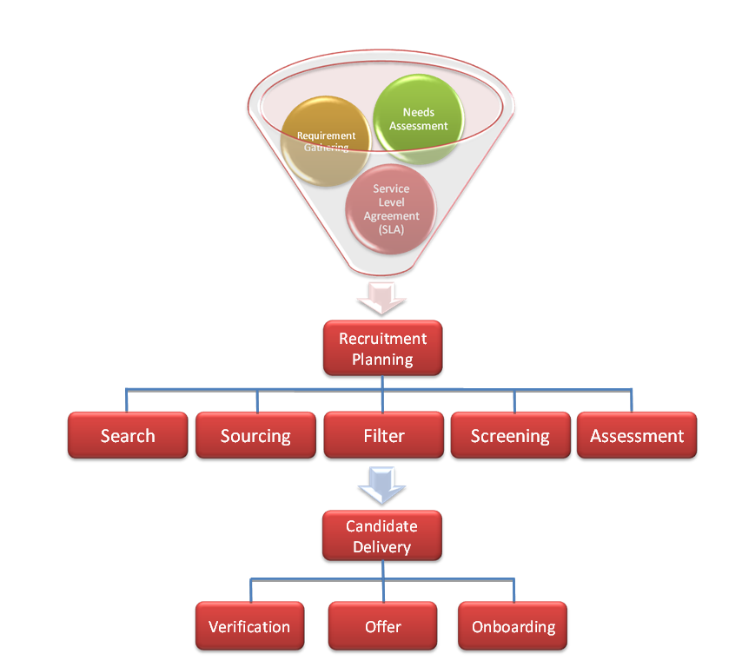

Contact Information
QSolv Inc
1286 Kifer Road, Suite 103
Sunnyvale, CA 94086
Phone: (408)-392-9291
Fax: (408)-904-4505
Email: info@qsolv-inc.com

