DECODELABS
INDUSTRIAL TRAINING
DASHBOARD
Project 1 - Full Stack Development Internship
Professional Project Report
Developer | Mustafa Tahir
Internship Track | Full Stack Development
Organisation | DecodeLabs
Year | 2026
HTML5 | CSS3 | JavaScript | Responsive Design | GitHub Pages

1. Project Introduction
The Industrial Training Dashboard is a responsive frontend web application developed for the DecodeLabs Full Stack Development Internship. It brings internship progress, weekly assignments, project milestones and learning development into one structured interface. The final version is presented as a completed Project 1 submission rather than an in-progress prototype.

1.1 Problem and Purpose
Internship activities can easily become scattered across messages, notes and separate task lists. The project addresses this by presenting important training information in a single visual dashboard. It also serves as a practical exercise in semantic HTML, responsive CSS, JavaScript interaction and frontend usability.

1.2 Objectives
- Design a clear and professional internship progress interface.
- Use semantic HTML5 to create meaningful and accessible page structure.
- Use CSS Grid, Flexbox and media queries for responsive layouts.
- Add JavaScript for task filtering, mobile navigation, theme switching and form validation.
- Demonstrate accessibility-aware frontend implementation.
- Prepare clean source code, testing evidence, screenshots and documentation for GitHub submission.

1.3 Final Outcome
The final application shows 100% project completion, six completed development tasks and four completed milestones. It is fully static, requires no backend server and is ready for hosting through GitHub Pages.
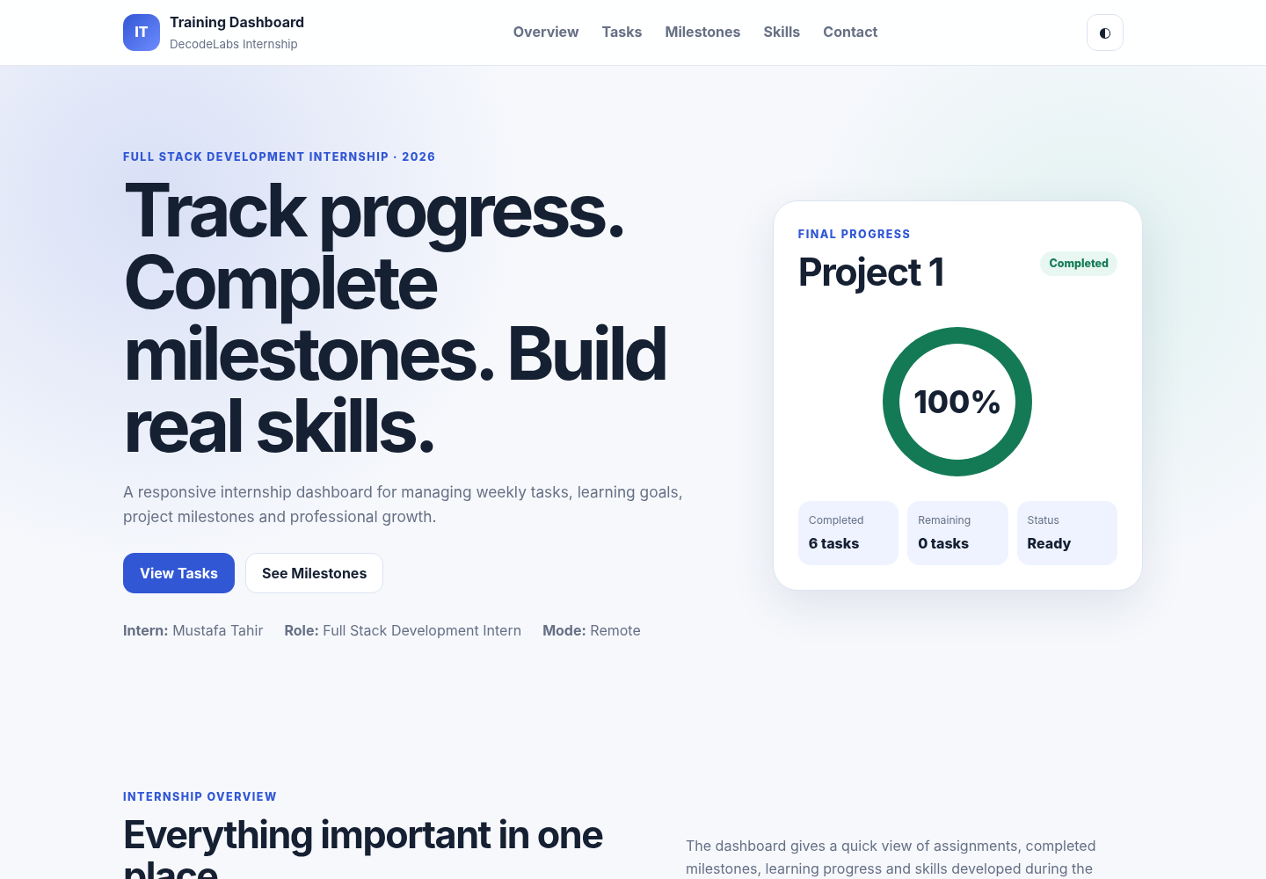
Figure 1. Final dashboard homepage showing Project 1 completion status.

2. Technology Stack and Architecture
Technology | Use in Project | Evidence
HTML5 | Semantic structure and page content | Header, navigation, main sections, form and footer
CSS3 | Visual design and responsiveness | Grid, Flexbox, media queries, progress components
JavaScript | Client-side interaction | Filters, theme, mobile menu and form validation
Git/GitHub | Version control and repository hosting | Submission-ready folder structure
GitHub Pages | Static deployment target | No server-side runtime required

2.1 Frontend Architecture
Browser
|
+-- index.html Semantic structure and content
+-- css/style.css Responsive visual presentation
+-- js/script.js Interaction and validation

2.2 Development Approach
The implementation followed a progressive frontend workflow. Planning and content hierarchy were completed first, followed by semantic HTML structure, responsive styling, JavaScript interactions, accessibility review, testing and final documentation. This sequence is reflected directly in the task board and milestone timeline.
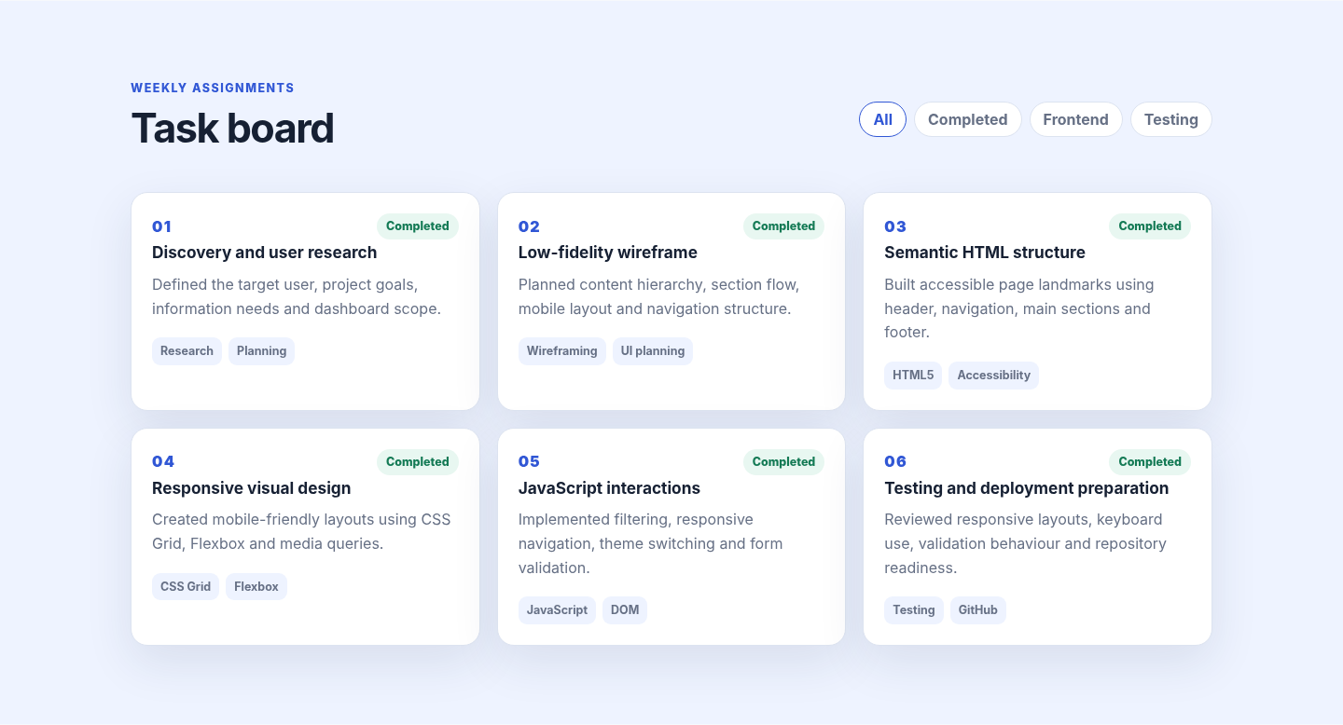
Figure 2. Completed task board documenting the frontend development workflow.

3. Core Features

Completed Progress Summary
The hero section gives an immediate final status with a 100% progress ring, six completed tasks and zero remaining tasks.

Interactive Task Board
Six completed task cards document research, wireframing, semantic HTML, responsive CSS, JavaScript interactions and testing. Filter buttons allow category-based viewing.

Milestone Timeline
A four-stage timeline communicates the project journey from planning through final submission preparation.

Skill Development
Progress indicators communicate development in HTML5, CSS3, JavaScript and accessibility.

Responsive Navigation
Desktop navigation changes into a mobile menu on smaller screens to preserve usability.

Theme Switching
A JavaScript theme control provides light and dark viewing modes and stores the user's preference when browser storage is available.
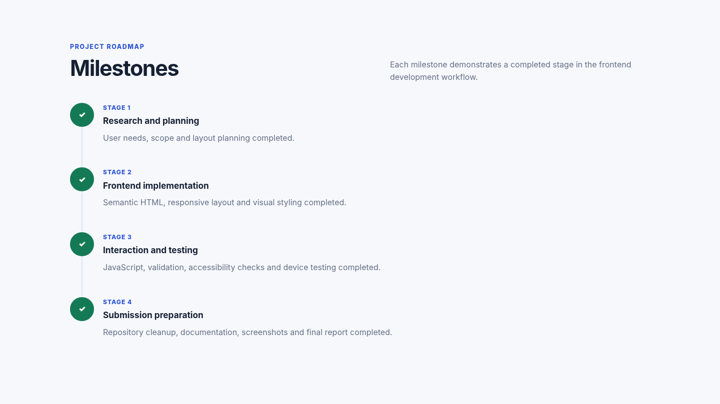
Figure 3. Milestone timeline showing all major development stages as completed.

4. JavaScript, Responsive Design and Accessibility

4.1 JavaScript Functionality
- Task filtering through DOM class changes and data attributes.
- Responsive mobile menu using a button-controlled open state and aria-expanded value.
- Light/dark theme switching.
- Client-side form validation for name, email and project-update length.
- Live error and success feedback.

4.2 Responsive Design
The CSS uses flexible containers, Grid and Flexbox for desktop presentation. At tablet and mobile breakpoints, multi-column layouts collapse and the navigation changes into a compact menu. This allows the same HTML structure to remain usable at different viewport sizes.
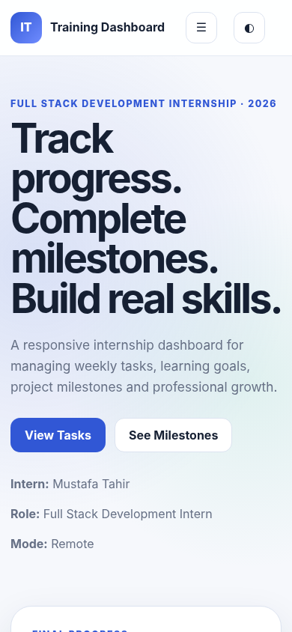
Figure 4. Mobile viewport demonstrating responsive layout behaviour.

4.3 Accessibility Considerations
- Semantic structural elements including header, nav, main, section and footer.
- Skip-to-content link for keyboard users.
- Explicit form labels.
- ARIA labels and aria-expanded state for responsive controls.
- aria-live regions for validation feedback.
- Visible focus styling for form controls and interactive elements.

5. Form Validation and Testing
The project-update form is intentionally frontend-only. It demonstrates input validation but does not transmit or permanently store user data. This limitation is stated within the interface and documentation so the project does not imply backend functionality that is not implemented.
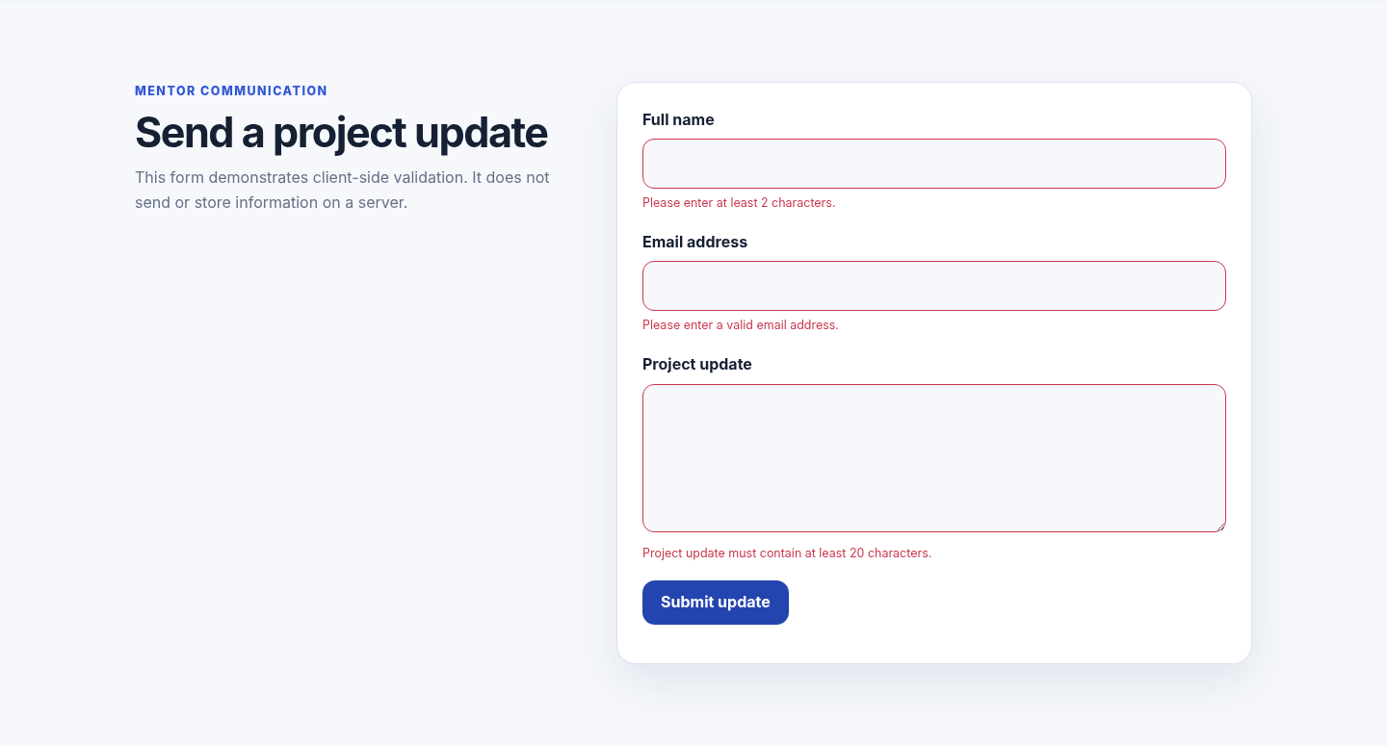
Figure 5. Client-side validation feedback when required inputs are missing.

5.1 Testing Summary
Test | Expected Result | Status
Homepage assets | Dashboard opens with styling and JavaScript loaded | PASS
Responsive desktop | Layout remains aligned and readable | PASS
Responsive mobile | Sections collapse correctly | PASS
Task filters | Non-matching task cards are hidden | PASS
Theme switch | Theme state toggles | PASS
Form validation | Invalid inputs show field-level errors | PASS
Valid form | Success feedback appears | PASS
Navigation | Section links and mobile navigation work | PASS

6. Challenges, Solutions and Learning Outcomes
Challenge | Issue | Solution
Responsive layout consistency | Different sections needed to remain balanced on both wide and narrow screens. | Grid and Flexbox layouts were combined with breakpoint-specific rules to create predictable responsive behaviour.
Communicating project status | Earlier versions showed an in-progress state even after implementation was complete. | The final submission version was normalised to show 100% completion, completed tasks and completed milestones.
Form feedback | Browser-only forms can appear functional without clearly communicating validation. | Field-level messages, invalid states and a success status were added while clearly stating that data is not sent to a server.
Accessibility | Interactive controls require more than visual styling. | Labels, ARIA attributes, keyboard-friendly buttons, focus styling and a skip link were incorporated.

6.1 Learning Outcomes
- Improved understanding of semantic HTML and page structure.
- Stronger responsive design skills using Grid, Flexbox and media queries.
- Practical experience with JavaScript DOM manipulation and validation.
- Greater awareness of accessibility requirements in frontend interfaces.
- Experience preparing a project for GitHub, documentation and formal submission.

7. Conclusion and Submission Readiness
Project 1 successfully demonstrates a complete frontend development workflow. The final Industrial Training Dashboard combines responsive layout, semantic structure, JavaScript interaction, validation, accessibility considerations and professional documentation in a single static application.
The packaged submission contains the working source code, screenshots, detailed documentation, testing records, README, editable report and final PDF report. The project can be placed directly inside the DecodeLabs master repository under `Task_1_Industrial_Training_Dashboard`.

7.1 Submission Package
- Working `index.html`, `css/style.css` and `js/script.js` files.
- Seven evidence screenshots generated from the final project.
- README and detailed project documentation.
- Feature and testing records.
- Submission notes for the DecodeLabs master repository.
- Professional Project 1 report in Word and PDF format.

7.2 Future Improvements
- Connect the update form to a backend API.
- Store tasks and progress dynamically in a database.
- Add authentication and user-specific dashboards.
- Add real internship analytics and chart visualisations.
- Run automated accessibility and cross-browser test suites.
FINAL STATUS: PROJECT 1 COMPLETED AND SUBMISSION-READY

Developer
Mustafa Tahir
Full Stack Development Intern - DecodeLabs
2026

