Unsharp based Pansharpening of Göktürk-2 Satellite Imagery

Mustafa Teke
TÜBİTAK UZAY (The Scientific and Technological Research Council of Turkey, Space Technologies Research Institute)
Group of Image Processing
Ankara, Turkey
mustafa.teke@tubitak.gov.tr

Ezgi San, Ezgi Koç
TOBB University of Economics and Technology
Department of Electrical and Electronics Engineering
Ankara, Turkey
{ezgisan.93, ezgikoc92}@gmail.com

Abstract— Pan sharpening is a pixel-level fusion technique for increasing the spatial resolution of low-resolution multi-spectral satellite imagery using high resolution panchromatic imagery. In this work, the performance of various pan sharpening algorithms in improving the 2.5 meter resolution of GÖKTÜRK-2 satellite imagery is compared. Eight different pan sharpening algorithms are tested on seven different Göktürk-2 images and evaluated using eight different metrics. Our results show that the High Pass Filter (HPF) yields the sharpest pan sharpened image, while the hyper spherical Color Space (HCS) method provides the truest colors while preserving sharpness to a certain.
Keywords— GÖKTÜRK-2 ; pan sharpening ; HPF ; HCS.

Introduction
Göktürk-2 is the second mini satellite of Turkey, which was built by TÜBİTAK UZAY and Turkish Aerospace Industries Inc. consortium. The Göktürk-2 spacecraft was launched on 18th December 2012. Göktürk-2 has a 2.5 m resolution pan and 5 m resolution multispectral imager.Göktürk-2 includes NIR band in addition to red(R), green (G), blue (B) bands. According to the specifications, Göktürk-2 has significantly better spatial and spectral resolution than RASAT. While Göktürk-2 satellite is operated by Turkish Air Force (TUAF) it caters to national civilian and military imaging needs. [1]

Pan sharpening is a pixel-level fusion technique for increasing the spatial resolution of low-resolution multi-spectral satellite imagery using high resolution panchromatic imagery.[2] The goal of Pan Sharpening is assembling pan and multi-spectral imagery using Pan Sharpening algorithms. During the fusion, multi-spectral imagery is resampled via interpolation techniques which are nearest, bilinear, bicubic, lanzcos, triangle, and box. In accordance with the results obtained, the most accurate consequence is obtained with bicubic technique. In this study, eight different pan sharpening algorithms are tested on seven different GÖKTÜRK-2 images and evaluated using eight different metrics. Accordingly data, for GÖKTÜRK-2 images,
The most accurate and applicable methods are proposed.

The second part of paper consists of Pan Sharpening algorithms and general features. The third part of paper includes Unsharpening Method .In fourth part, metrics used for evaluating results are clarified. Visual results and multiple comparisons between algorithms are demonstrated in the last part of paper.

PAN SHARPENING ALGORİTHMS

Brovey
In this method, each spectral band is multiplicated with pan imagery. Result obtained is divided sum of all spectral bands. Brovey method gives sharpness prominence.

Gramm-Schmitt
In this method, multi-spectral imagery is not resampled using interpolation techniques differently from other methods. As a first step, multi-spectral imagery is calculated weighted mean, thereby low-resolution pan imagery is obtained, then pan imagery is chosen as a first spectral band. Whole bands are equated vertically using Gramm-Schmitt orthogonalization algorithm.

Hyperspherical Color Space(HCS)
Multi-spectral imagery is transformed into hyperspherical color space. Intensity image matching algorithm is applied to pan and multi-spectral imagery. After Pan Sharpening, Pan sharpened imagery is obtained via inverse transformation. [3]

High Pass Filter(HPF)
In this method, 5x5, 7x7, 9x9 filters are used in accordance with ratio of pan and multi-spectral imagery. Filter’s elements except central element must be minus one, central element must be selected according to total of entire elements must be zero. This filter is implemented upon Pan Imagery. High passed imagery which is obtained this process is fused with multi-spectral imagery. By this means resolution of pan sharpened imagery increases. [4]

Intensity Hue Saturation (IHS)
The principal idea is to first transform the multi-spectral image into intensity (I), hue (H) and saturation (S) components (IHS color space). The next step is to scale the Pan image so that it has the same mean and variance as the intensity component of the MS image. The intensity component is then replaced with the appropriately scaled Pan image and finally the inverse IHS transformation is taken to get the fused image. The IHS method produces images that typically have high spatial fidelity but suffer from spectral distortion.

Hue-Saturation Value (HSV)
The logic of HSV is similar to intensity hue saturation method.
Diversely, in this method, HSV color space is used instead of HIS color space.

Optimized HPF
This algorithm resembles high pass filter method in many aspects. Similar to HPF, filters are chosen according to ratio of pan and multi-spectral imagery. Only difference is that in Optimized HPF method, 5x5x, 7x7x, 9x9x filters are used twice, thus resolution of pan sharpened image reduplicates according to HPF.

Principle Component Analysis: PCA
The PCA is applied to the multispectral image bands and the principal components are computed. The first principal component is replaced by the panchromatic image. The inverse PCA transform is computed to go back to the image domain. The PCA sharpening is sensitive to the area to be sharpened.[5]

Wavelet
The multi-resolution analysis approach to pan sharpening is widely used and there are numerous techniques today based on it. The basic idea is to take the discrete wavelet transform of both the MS and Pan images. The next step is to retain the approximation coefficients for the MS image but replace the detail coefficients with those from the Pan image.

unsharp method
The methods which are mentioned before are used to add details an image. Unsharp mask increase the sharpness in an image. Firstly unsharp mask is applied to pan image, using this unsharpened pan image other mentioned methods are applied, so the sharpened images are acquired. This method has 3 parameters such as sigma, weight, and threshold. Sigma determines the size of distance from a given pixel at the center of the convolution matrix. Weight affects the strength of sharpness. Threshold prevents from noise in an image.

Quantitative Quality Metrics
For the evaluation of the quality of the pan sharpened image, many different metrics have been proposed.

Root Mean Square Error (RMSE)
The RMSE is defined as;
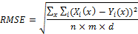
Where X is the MS image, Y is the pan sharpened image, x is the pixel and is the band number. Finally, n is the number of rows, m is the number of column and d is the number of bands.

SAM (Spectral Angle Mapper)
The Spectral Angle Mapper (SAM) is a metric that calculates the spectral similarity between two spectral vectors as a spectral angle,
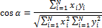
Where N is the number of bands and x = (x1, x2, · · ·, xN) and y = (y1, y2, · · ·, yN) are two spectral vectors at some pixel location in the original MS image and the fused image, respectively. The value of SAM for the entire image is the average of all the values for every pixel.

Qave
Qave is a metric that attempts to model the spectral distortion as a combination of three factors. These factors are loss of correlation, luminance distortion and contrast distortion. The metric is given by,
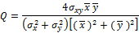

,
,

Where x = {xi|i = 1, 2, · · ·, N} and y = {yi|i = 1, 2, · · ·, N} are the original MS and fused image vectors,

Relative average spectral error (RASE)
RASE computes the average performance in terms of the RMSE of the bands in the pan sharpened image.
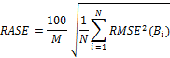

ERGAS
This metric calculates the amount of spectral distortion in the fused image and is given by,
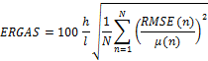
Where N is the number of bands, RMSE is the root mean square error, h/l is the ratio of pixels in the Pan image to the MS image and μ (n) is the mean of then band.

Spatial
The spatial metric used computing the correlation coefficient
Between the high-frequency data of each MS band and the high frequency data of the Pan image. To extract the high-frequency data of a band, it is convoluted with the following
mask. To extract the high-frequency data of a band, it is convoluted with the following mask

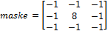

Correlation coefficient (CC)
The correlation coefficient (CC) between the original MS image (X) and the pan sharpened image (Y) is defined as,
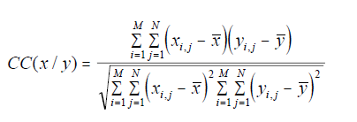
Where X and Y are the mean values of the corresponding images.

Spectral Information Divergence (SID)
Each pixel spectrum is viewed as a random variable and SID measures the difference or discrepancy of the probabilistic behaviors between two spectral vectors, taken from the MS image and final fused image, respectively.

THE RESULTS OF OPTIMAL PAN SHARPENING
The results figure out that HPF method is the sharpest method among all algorithms. On the other hand, in HPF method, value of color cannot be conserved.HCS, Wavelet and Optimized HPF method bring to a successful conclusion in terms of both metric results and visual results.
In IHS method, the point of sharpness is crucible, but Pan sharpened image have spectral determination.
In this examination, also Commercial software methods are tested in visual and metric criterion. Erdas which is one of the commercial software methods lead to success in HCS method.

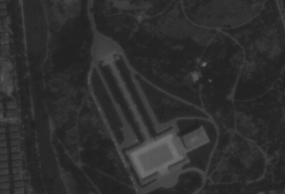 | 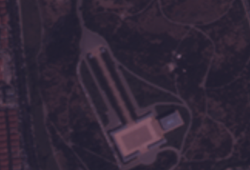 | 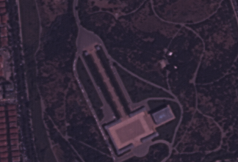 | 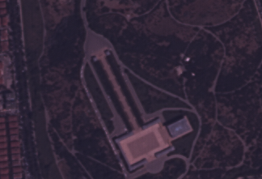
Pan | MS Image | HCS | ENVI-HCS

Figure 1 the visual results Anıtkabir image of HCS method

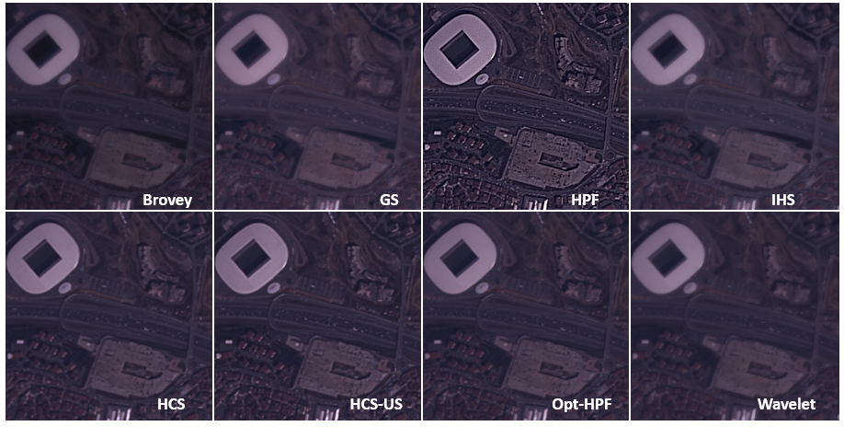
Figure 2 the visual results of İstanbul image of all pan sharpening methods

Table 1 Average metric results of all method

Table 2 Metric results of commercial software and pan sharpening methods of Ankara image

 | HPF | PCA | Brovey | GS | Wavelet | IHS | Opt_HPF | HCS | HCS-US | SFIM
RMSE|0 | 87,24 | 75,20 | 70,77 | 53,87 | 15,66 | 49,60 | 32,26 | 33,39 | 46,87 | 25,32
SAM|0 | 2,71 | 4,69 | 0,00 | 3,06 | 0,92 | 2,12 | 1,57 | 0,19 | 0,19 | 0,00
CC|1 | 0,91 | 0,90 | 0,95 | 0,95 | 1,00 | 0,96 | 0,98 | 0,99 | 0,98 | 0,99
RASE|0 | 29,94 | 25,81 | 24,29 | 18,49 | 5,37 | 17,02 | 11,07 | 9,15 | 12,89 | 5,88
QAVE|1 | 0,98 | 0,94 | 0,97 | 0,97 | 0,99 | 0,99 | 0,99 | 1,00 | 0,99 | 1,00
SID|0 | 0,01 | 0,02 | 0,00 | 0,01 | 0,00 | 0,01 | 0,00 | 0,00 | 0,00 | 0,00
ERGAS|0 | 7,94 | 7,36 | 7,82 | 5,25 | 1,51 | 4,53 | 3,13 | 2,40 | 3,38 | 1,49
SPATIAL|1 | 0,98 | 0,95 | 0,95 | 0,96 | 0,85 | 0,97 | 0,97 | 0,70 | 0,71 | 0,37
 | IHS | Arcmap  IHS | Opt_HPF | Erdas  Opt_HPF | GS | Envi  GS | HCS | Erdas  HCS | NN Diffuse
RMSE|0 | 34,03 | 60,63 | 22,97 | 25,87 | 34,46 | 16,95 | 47,14 | 37,69 | 32,02
SAM|0 | 0,73 | 0,05 | 0,26 | 0,48 | 0,69 | 0,43 | 0,17 | 0,03 | 0,43
CC|1 | 0,98 | 0,98 | 0,99 | 0,99 | 0,98 | 1,00 | 0,98 | 0,98 | 0,99
RASE|0 | 6,48 | 13,22 | 4,37 | 4,90 | 6,56 | 3,21 | 10,53 | 7,14 | 8,64
QAVE|1 | 1,00 | 0,98 | 1,00 | 1,00 | 1,00 | 1,00 | 0,99 | 1,00 | 0,99
SID|0 | 0,00 | 0,00 | 0,00 | 0,00 | 0,00 | 0,00 | 0,00 | 0,00 | 0,00
ERGAS|0 | 1,77 | 3,72 | 1,10 | 1,22 | 1,72 | 0,88 | 2,60 | 1,77 | 2,05
SPATIAL|1 | 0,91 | 0,95 | 0,90 | 0,92 | 0,91 | 0,88 | 0,87 | 0,90 | 0,87

REFERENCES
[1] Mustafa Teke, Satetellite image process workflow for RASAT and Göktürk-2, journal of aeronautics and space technologies.
[2] Amro, I., Mateos, J., Vega, M., Molina, R., and Katsaggelos, A.K., “A survey of classical methods and new trends in pansharpening of multispectral images,” EURASIP Journal on Advances in Signal Processing, Vol. 79, 2011.
[3] Padwick, Chris, et al. "WorldView-2 pan-sharpening." American Society for Photogrammetry and Remote Sensing. 2010.
[4] Schowengerdt, Robert A. "Reconstruction of multispatial, multispectral image data using spatial frequency content." Photogrammetric Engineering and Remote Sensing 46 (1980): 1325-1334.

Selected Topics in Applied Earth Observations and Remote Sensing, IEEE Journal of, vol.5, no.1, pp.281, 297, Feb. 2012
[5] Palsson, F.; Sveinsson, J.R.; Benediktsson, J.A.; Aanaes, H., "Classification of Pansharpened Urban Satellite Images,"
[6]. Strait, Melissa, Sheida Rahmani, and D. Merkurev. "Evaluation of pan-sharpening methods." UCLA Department of Mathematics (2008).

