

Mustafa Yasin Emir

Hazelcast & Oracle Homework-2

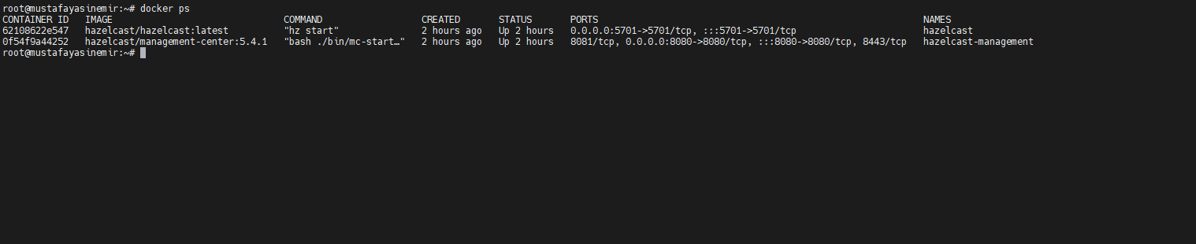

DigitalOcean🡪 Docker🡪 Hazelcast&Hazelcast Management Center

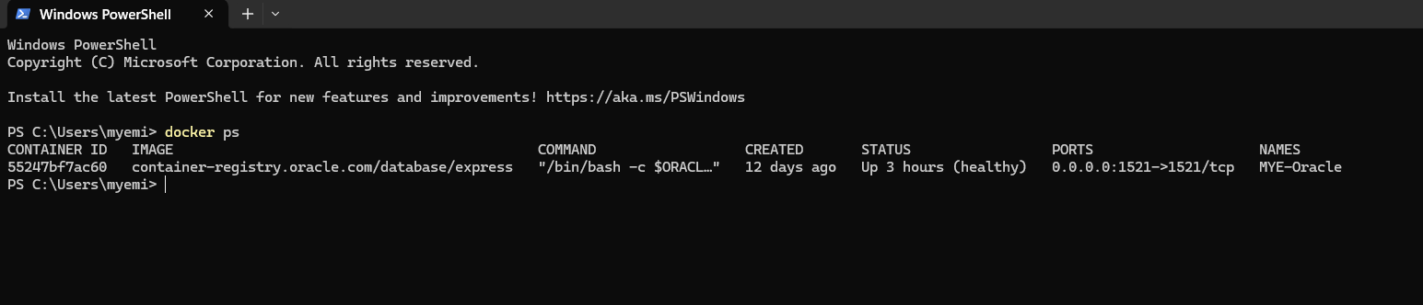

Localhost🡪Docker🡪 Oracle DB

PERFORMANCE METRİCS ORACLE AND HAZELCAST

1-Oracle Performance Metrics



20000 Data



100000 Data

2-Hazelcast Performance Metrics

//TODO