Since the topology is Push-Pull D should be between 0 and 0.5 because D is used twice during a period. We would like to have charging and discharging durations to be close to each other in order to stay away from discontinuous conduction mode. We calculated the turns ratio considering the 0.25 duty is aligned with average input voltage.

metin içeren bir resim

Açıklama otomatik olarak oluşturuldu

Duty cycle will be the controlled parameter in order to keep the output voltage constant with changing input voltage. We calculated the interval of duty cycle.

metin içeren bir resim

Açıklama otomatik olarak oluşturuldu

Since the output side of the push-pull topology is identical to buck converter, output voltage ripple has the same characteristics with half of the period.

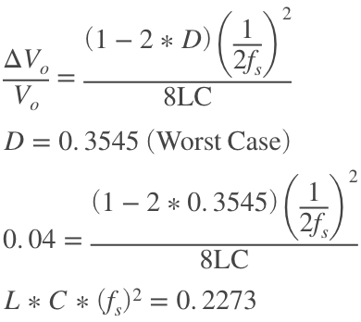

As we increase the frequency, we can use smaller components for L and C and reduce the cost.