**Transformer Magnetic Design**

We set 10 as transformer turns ratio. Maximum input voltage is 400V, input frequency is 100kHz, maximum input current is 0.25A and maximum output current is 8.33A. A core should be selected due to stated specifications. We decided to use 2 EER ferrite cores. We checked several cores and calculated required and present window areas and chose 0R42814EC. Primary and secondary winding turn numbers are calculated as:

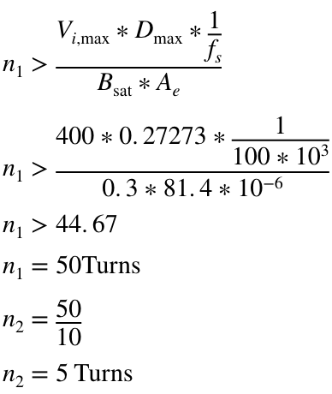

Required and present window areas are:

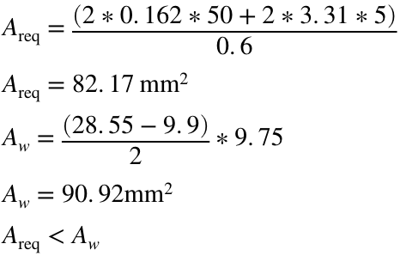

Magnetizing inductance of the transformer is calculated as:

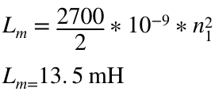

**Inductor Magnetic Design**

An output inductor is needed with capability of handling 8.33A and being larger than 160μH. We checked the cores from the smallest one in order to reduce costs and achieved our criterion at 0W41305TC. Calculations are as follows:

