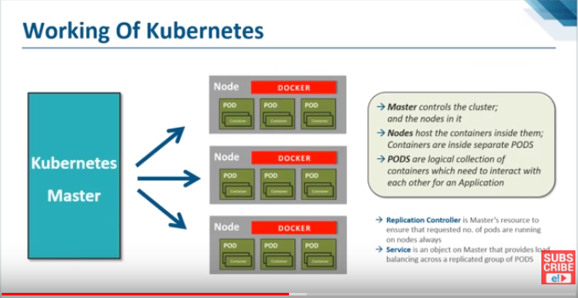
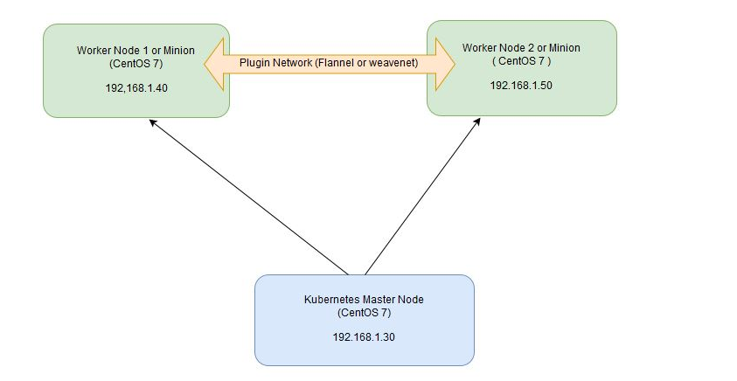
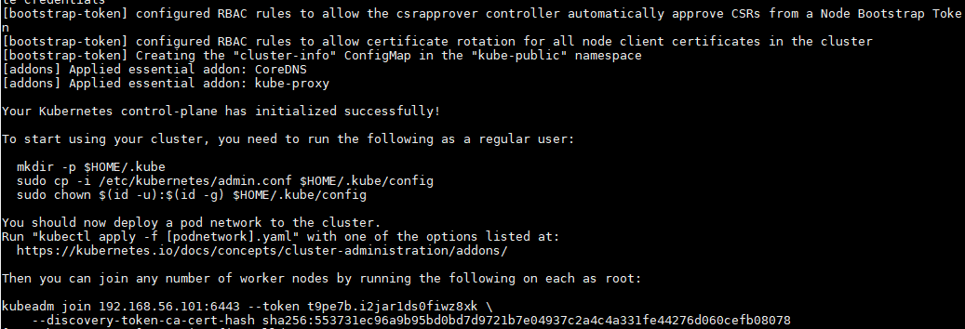
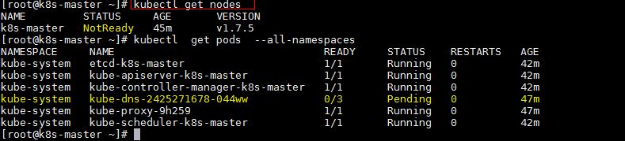
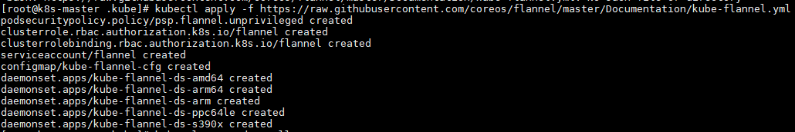
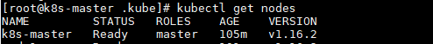
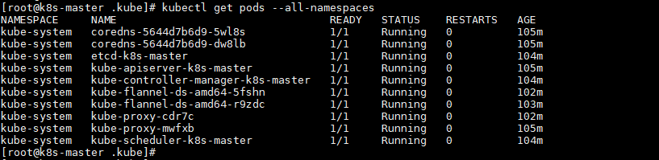
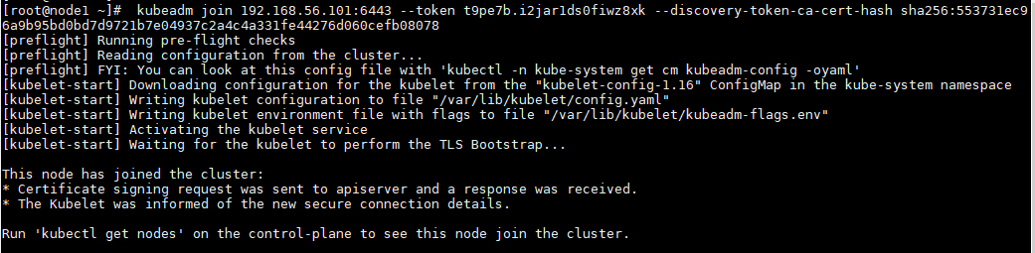
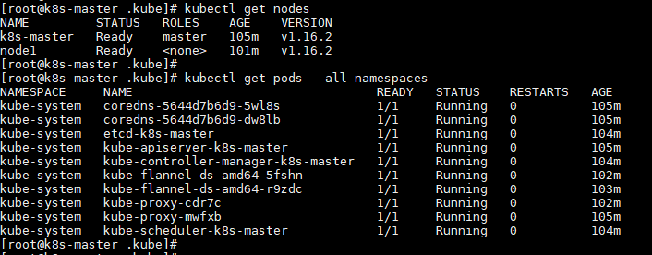
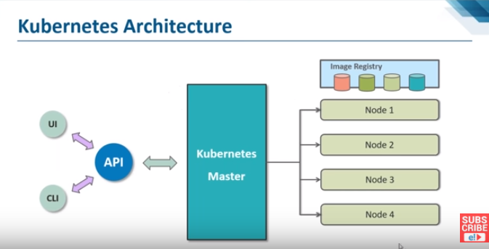
Installation procedure of kubernetes on Centos7

Basic Understanding about kubernetes

One server will acts master node and rest two servers will be minion or worker nodes.

On the Master Node following components will be installed
- API Server – It provides kubernetes API using Jason / Yaml over http, states of API objects are stored in etcd
- Scheduler – It is a program on master node which performs the scheduling tasks like launching containers in worker nodes based on resource availability
- Controller Manager – Main Job of Controller manager is to monitor replication controllers and create pods to maintain desired state.
- etcd – It is a Key value pair data base. It stores configuration data of cluster and cluster state.
- Kubectl utility – It is a command line utility which connects to API Server on port 6443. It is used by administrators to create pods, services etc.

On Worker Nodes following components will be installed
- Kubelet – It is an agent which runs on every worker node, it connects to docker and takes care of creating, starting, deleting containers.
- Kube-Proxy – It routes the traffic to appropriate containers based on ip address and port number of the incoming request. In other words we can say it is used for port translation.
- Pod – Pod can be defined as a multi-tier or group of containers that are deployed on a single worker node or docker host.

Installations Steps of Kubernetes
Perform the following steps on Master Node

Step 1: Disable SELinux & setup firewall rules
Login to your kubernetes master node and set the hostname and disable selinux using following commands

~]# hostnamectl set-hostname 'k8s-master'
~]# exec bash
~]# setenforce 0
~]# sed -i --follow-symlinks 's/SELINUX=enforcing/SELINUX=disabled/g' /etc/sysconfig/selinux
Set the following firewall rules.

[root@k8s-master ~]# firewall-cmd --permanent --add-port=6443/tcp
[root@k8s-master ~]# firewall-cmd --permanent --add-port=2379-2380/tcp
[root@k8s-master ~]# firewall-cmd --permanent --add-port=10250/tcp
[root@k8s-master ~]# firewall-cmd --permanent --add-port=10251/tcp
[root@k8s-master ~]# firewall-cmd --permanent --add-port=10252/tcp
[root@k8s-master ~]# firewall-cmd --permanent --add-port=10255/tcp
[root@k8s-master ~]# firewall-cmd --reload
[root@k8s-master ~]# modprobe br_netfilter
[root@k8s-master ~]# echo '1' > /proc/sys/net/bridge/bridge-nf-call-iptables
Note: In case you don’t have your own dns server then update /etc/hosts file on master and worker nodes
# vi /etc/hosts

192.168.56.101 k8s-master
192.168.56.102 node1

# vi /etc/fstab
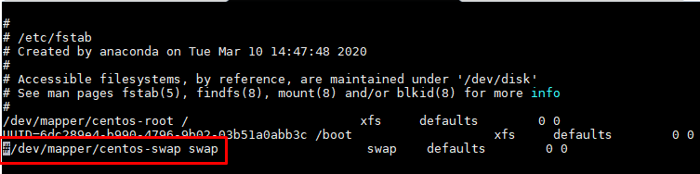

Step 2: Configure Kubernetes Repository
Kubernetes packages are not available in the default CentOS 7 & RHEL 7 repositories, Use below command to configure its package repositories.
[root@k8s-master ~]# cat <<EOF > /etc/yum.repos.d/kubernetes.repo
> [kubernetes]
> name=Kubernetes
> baseurl=https://packages.cloud.google.com/yum/repos/kubernetes-el7-x86_64
> enabled=1
> gpgcheck=1
> repo_gpgcheck=1
> gpgkey=https://packages.cloud.google.com/yum/doc/yum-key.gpg
> https://packages.cloud.google.com/yum/doc/rpm-package-key.gpg
> EOF [root@k8s-master ~]#

Step 3: Install Kubeadm and Docker
Once the package repositories are configured, run the beneath command to install kubeadm and docker packages.
[root@k8s-master ~]# yum install kubeadm docker -y
Start and enable kubectl and docker service
[root@k8s-master ~]# systemctl restart docker && systemctl enable docker
[root@k8s-master ~]# systemctl restart kubelet && systemctl enable kubelet

Step 4: Initialize Kubernetes Master with ‘kubeadm init’
Run the beneath command to initialize and setup kubernetes master. Here API server ip is your master server IP=192.168.56.101
[root@k8s-master ~]# kubeadm init --apiserver-advertise-address=192.168.56.101 --pod-network-cidr=192.168.0.0/16
Output of above command would be something like below

As we can see in the output that kubernetes master has been initialized successfully. Execute the beneath commands to use the cluster as root user.

[root@k8s-master ~]# mkdir -p $HOME/.kube
[root@k8s-master ~]# cp -i /etc/kubernetes/admin.conf $HOME/.kube/config
[root@k8s-master ~]# chown $(id -u):$(id -g) $HOME/.kube/config

Step 5: Deploy pod network to the cluster
Try to run below commands to get status of cluster and pods.

To make the cluster status ready and kube-dns status running, deploy the pod network so that containers of different host communicated each other. POD network is the overlay network between the worker nodes.
Run the beneath command to deploy network.
# kubectl apply -f https://raw.githubusercontent.com/coreos/flannel/master/Documentation/kube-flannel.yml

Now run the following commands to verify the status

Now let’s add worker nodes to the Kubernetes master nodes.

Perform the following steps on each worker node

Step 1: Disable SELinux & configure firewall rules on the nodes
Before disabling SELinux set the hostname on the nodes as node1

~]# setenforce 0
~]# sed -i --follow-symlinks 's/SELINUX=enforcing/SELINUX=disabled/g' /etc/sysconfig/selinux
~]# firewall-cmd --permanent --add-port=10250/tcp
~]# firewall-cmd --permanent --add-port=10255/tcp
~]# firewall-cmd --permanent --add-port=30000-32767/tcp
~]# firewall-cmd --permanent --add-port=6783/tcp
~]# firewall-cmd --reload
~]# echo '1' > /proc/sys/net/bridge/bridge-nf-call-iptables

Step 2: Configure Kubernetes Repositories on both worker nodes
]# cat <<EOF > /etc/yum.repos.d/kubernetes.repo
> [kubernetes]
> name=Kubernetes
> baseurl=https://packages.cloud.google.com/yum/repos/kubernetes-el7-x86_64
> enabled=1
> gpgcheck=1
> repo_gpgcheck=1
> gpgkey=https://packages.cloud.google.com/yum/doc/yum-key.gpg
> https://packages.cloud.google.com/yum/doc/rpm-package-key.gpg
> EOF

Step 3: Install Kubeadm and Docker
Once the package repositories are configured, run the beneath command to install kubeadm and docker packages.
[root@k8s-master ~]# yum install kubeadm docker -y
Start and enable kubectl and docker service
[root@k8s-master ~]# systemctl restart docker && systemctl enable docker
[root@k8s-master ~]# systemctl restart kubelet && systemctl enable kubelet

Step 4: Now Join worker nodes to master node
To join worker nodes to Master node, a token is required. Whenever kubernetes master initialized , then in the output we get command and token. Copy that command and run on both nodes.

Run this command in kubernetes master to get the token
# kubeadm token create --print-join-command

[root@worker-node1 ~]# kubeadm join 192.168.56.101:6443 --token t9pe7b.i2jar1ds0fiwz8xk --discovery-token-ca-cert-hash sha256:553731ec96a9b95bd0bd7d9721b7e04937c2a4c4a331fe44276d060cefb08078

Now verify Nodes status from master node using kubectl command

As we can see master and worker nodes are in ready status. This concludes that kubernetes 1.7 has been installed successfully and also we have successfully joined two worker nodes. Now we can create pods and services.

References:
Docker install: https://phoenixnap.com/kb/how-to-install-docker-centos-7
Kubernetes install: https://phoenixnap.com/kb/how-to-install-kubernetes-on-centos
https://medium.com/@nmlaxaman/kubernetes-quick-installation-on-centos-7-6-65ffe863a87c

https://docs.oracle.com/en/operating-systems/olcne/1.1/start/netfilter.html
https://kubernetes.io/docs/setup/production-environment/tools/kubeadm/install-kubeadm/
https://kubernetes.io/docs/setup/production-environment/tools/kubeadm/install-kubeadm/
https://kubernetes.io/docs/setup/production-environment/tools/kubeadm/install-kubeadm/

