Objectives
Chapter 1 | Introduction
Chapter 2 | Installation Prerequisite
Chapter 3 | Installation on Centos 7
Chapter 4 | Creating the Cluster
Chapter 5 | Creating Docker Image
Chapter 6 | Test Deployment
Chapter 7 | Creating the Service
Chapter 8 | Final Output
Chapter 9 | References

1.Introduction: Kubernetes is a portable, extensible, open-source platform for managing containerized workloads and services, that facilitates both declarative configuration and automation. It has a large, rapidly growing ecosystem. Kubernetes services, support, and tools are widely available.

Kubernetes Cluster: A Kubernetes cluster consists of a set of worker machines, called nodes, that run containerized applications. Every cluster has at least one worker node.
Basic architecture of a cluster with different components.
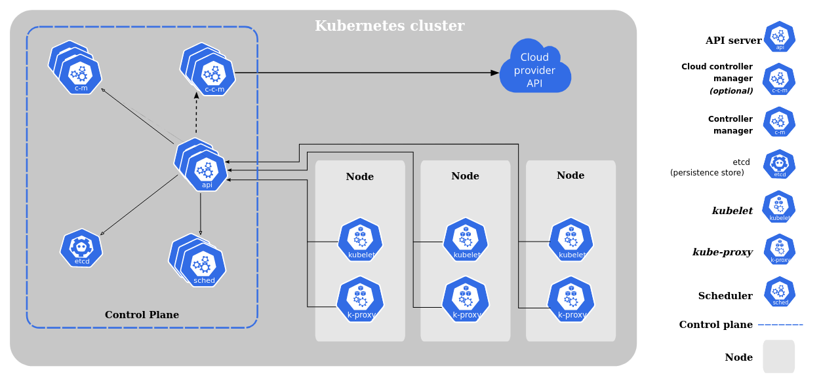

2.Installation Prerequisites:
- A compatible Linux host with 2 GB or more of RAM & 2 CPUs or more.
- Full network connectivity between all machines in the cluster (public or private network)
- Docker in the machine.

Different Installation Toolbox:
- Kubeadm → Bare Metal Installation.
- MiniKube → Virtualized Environment for Kubernetes
- Kops → Kubernetes on AWS
- Kubernetes on GCP → Kubernetes running on Google Cloud Platform
- AKS → Azure Kubernetes Services on Azure platform.

Installation Packages: Below packages need to install on the all machines.
- Kudeadm → the command to bootstrap the cluster.
- Kubelet → the component that runs on all of the machines in the cluster and does things like starting pods and containers.
- Kubectl → the command line utility to talk to the cluster.
Note: kubeadm will not install or manage kubelet or kubectl.
3.Installation on Centos 7: In this setup one virtual machine will prepare as master and another machine will paly the role of slave. First install docker and Kubernetes on both machines.
#turn of the swap
$swapoff -a
# Comment out swap line in fstab so that it remains disabled after reboot
$vi /etc/fstab

#common utilities install
$yum install -y yum-utils device-mapper-persistent-data lvm2

#it is preferred to disable the firewall
$sudo systemctl disable --now firewalld
#if needs to active the firewall than add the following ports in the firewall on Master
$sudo firewall-cmd --add-port={6443,2379-2380,10250,10251,10252,5473,179,5473}/tcp --permanent
$sudo firewall-cmd --add-port={4789,8285,8472}/udp --permanent
$sudo firewall-cmd –reload
#for worker nodes
sudo firewall-cmd --add-port={10250,30000-32767,5473,179,5473}/tcp --permanent
sudo firewall-cmd --add-port={4789,8285,8472}/udp --permanent
sudo firewall-cmd –reload

#Set the net.bridge.bridge-nf-call-iptables to ‘1’ in sysctl config file. This ensures that
packets are properly processed by IP tables during filtering and port forwarding
$cat <<EOF > /etc/sysctl.d/k8s.conf
net.bridge.bridge-nf-call-ip6tables = 1
net.bridge.bridge-nf-call-iptables = 1
EOF

$sysctl --system

#Enable br_netfilter Kernel Module
$sudo modprobe overlay
$sudo modprobe br_netfilter

$sudo tee /etc/sysctl.d/kubernetes.conf<<EOF
net.bridge.bridge-nf-call-ip6tables = 1
net.bridge.bridge-nf-call-iptables = 1
net.ipv4.ip_forward = 1
EOF

$sudo sysctl --system
# Install packages
$sudo yum-config-manager --add-repo https://download.docker.com/linux/centos/docker-ce.repo
$sudo yum install docker-ce docker-ce-cli containerd.io

# Create required directories
$sudo mkdir /etc/docker
$sudo mkdir -p /etc/systemd/system/docker.service.d

# Create daemon json config file
$sudo tee /etc/docker/daemon.json <<EOF
{
"exec-opts": ["native.cgroupdriver=systemd"],
"log-driver": "json-file",
"log-opts": {
"max-size": "100m"
},
"storage-driver": "overlay2",
"storage-opts": [
"overlay2.override_kernel_check=true"
]
}
EOF

# Start and enable Services
$sudo systemctl daemon-reload
$sudo systemctl restart docker
$sudo systemctl enable docker

#Set hostname in master
$sudo hostnamectl set-hostname ‘k8s-master’
$exec bash

# Provide entry in the host’s file in the master
$sudo vi /etc/hosts
192.168.0.131 k8s-master

#add the repository for the Kubernetes.
cat <<EOF | sudo tee /etc/yum.repos.d/kubernetes.repo
[kubernetes]
name=Kubernetes
baseurl=https://packages.cloud.google.com/yum/repos/kubernetes-el7-\$basearch
enabled=1
gpgcheck=1
repo_gpgcheck=1
gpgkey=https://packages.cloud.google.com/yum/doc/yum-key.gpg https://packages.cloud.google.com/yum/doc/rpm-package-key.gpg
exclude=kubelet kubeadm kubectl
EOF

# Set SELinux in permissive mode (effectively disabling it)
$sudo setenforce 0
$sudo sed -i 's/^SELINUX=enforcing$/SELINUX=permissive/' /etc/selinux/config
#install kubelet kubeadm kubectl
$sudo yum install -y kubelet kubeadm kubectl --disableexcludes=kubernetes
#check the version
$sudo kubeadm version

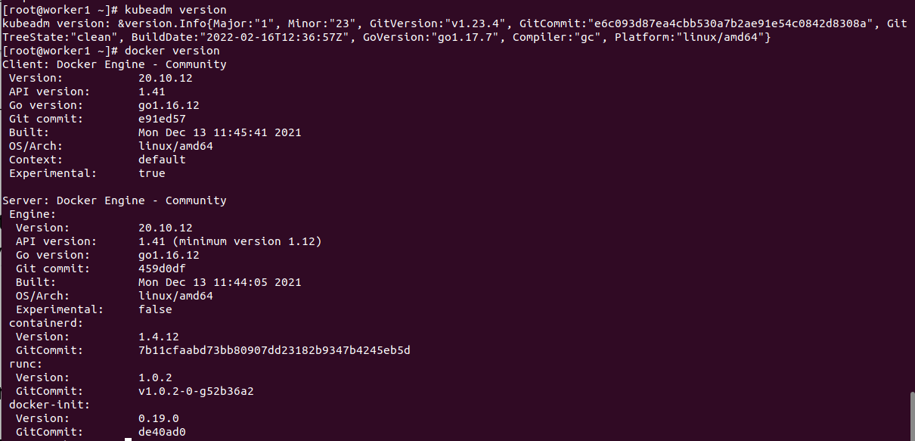
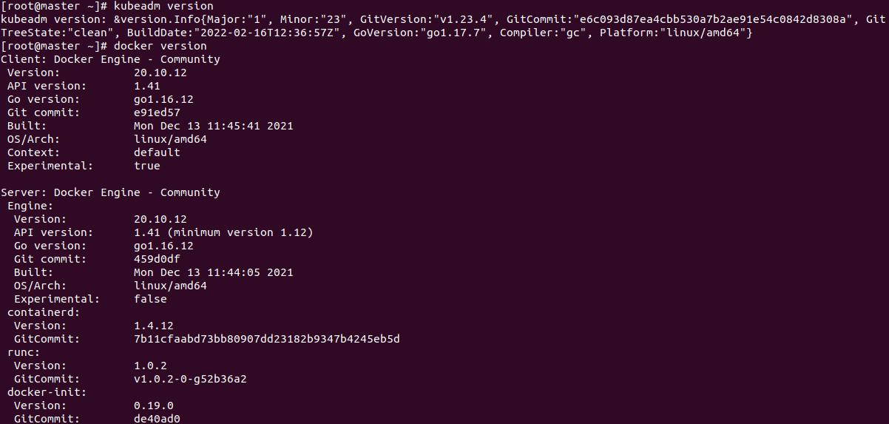
Note: After installation reboot the both machines

#start and enable the kubelet service
$sudo systemctl start kubelet && sudo systemctl enable kubelet

#Change the cgroup-driver
$sudo docker info | grep -i cgroup

4.Creating the cluster:
#pull the container images so that it could easy crate the cluster during offline.
$sudo kubeadm config images pull

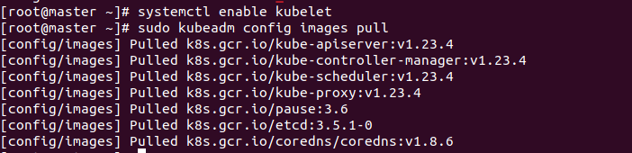
#initialize the master
$sudo kubeadm init --pod-network-cidr=10.10.0.0/16 --upload-certs --control-plane-endpoint=192.168.0.131

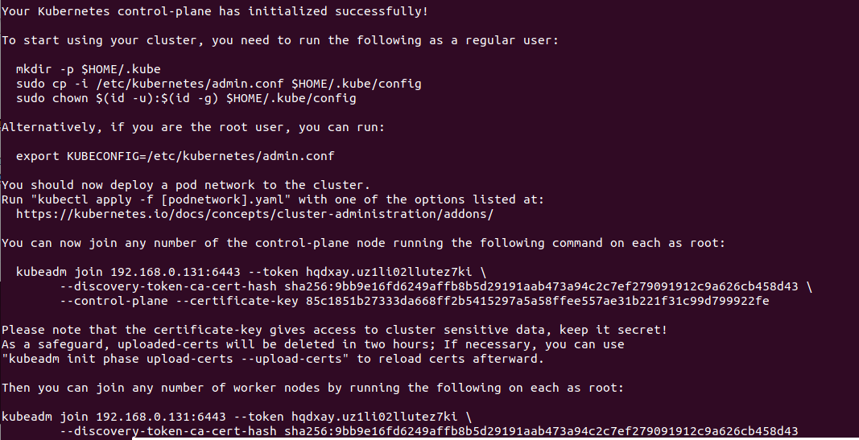
#Configure kubectl using commands in the output for non-root users
$mkdir -p $HOME/.kube
$sudo cp -i /etc/kubernetes/admin.conf $HOME/.kube/config
$sudo chown $(id -u):$(id -g) $HOME/.kube/config

# Configure kubectl using commands in the output for root users
export KUBECONFIG=/etc/kubernetes/admin.conf

# For printing the join command
kubeadm token create --print-join-command

#check the cluster status
$kubectl cluster-info
#deploy the flannel network to the kubernetes cluster using the kubectl command in master
$kubectl apply -f https://raw.githubusercontent.com/coreos/flannel/master/Documentation/kube-flannel.yml

Note: Follow above all the steps to prepare the worker node

#Set host name in node
$sudo hostnamectl set-hostname ‘k8s-workernode-1’
$exec bash

# Provide entry in the hosts file in worker node
$sudo vi /etc/hosts
192.168.0.132 k8s-workernode-1

#joining the worker node with master
$kubeadm join 192.168.0.131:6443 --token 4kwlkq.0qko5na74eb7y5r1 --discovery-token-ca-cert-hash sha256:225c197a3a592689aa4d4cbb2abfc9e1974c64194249137b16f3ef8e2417a737

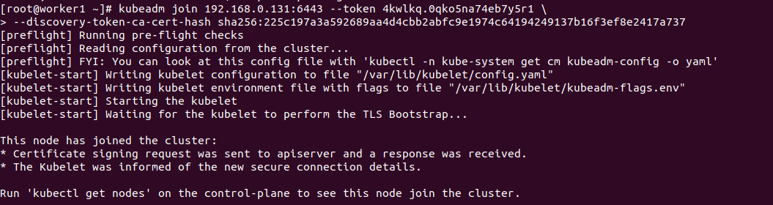
#to check all nodes status
$kubectl get nodes
#to check all podes
$kubectl get pods --all-namespaces
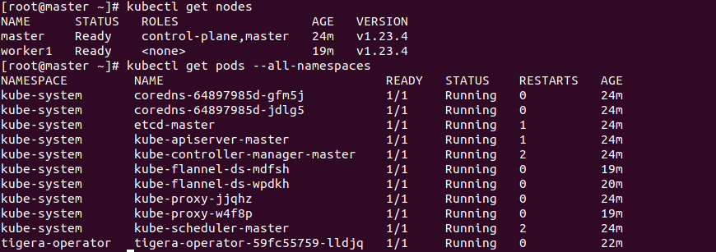

5. Creating Docker image:
#Dockerfile configuration file
FROM httpd:2.4
WORKDIR /usr/local/
EXPOSE 80
RUN sed -i "s/DirectoryIndex index.html/DirectoryIndex index.php/g" apache2/conf/httpd.conf
RUN apt-get update -y \
&& apt-get install git -y \
&& rm -rf apache2/htdocs/index.html \
&& git clone https://github.com/shindesharad71/Club-Manager.git apache2/htdocs/
#docker image build
$sudo docker build -t azizur013/club-manager .
#push the image into docker-hub
$sudo docker push azizur013/club-manager
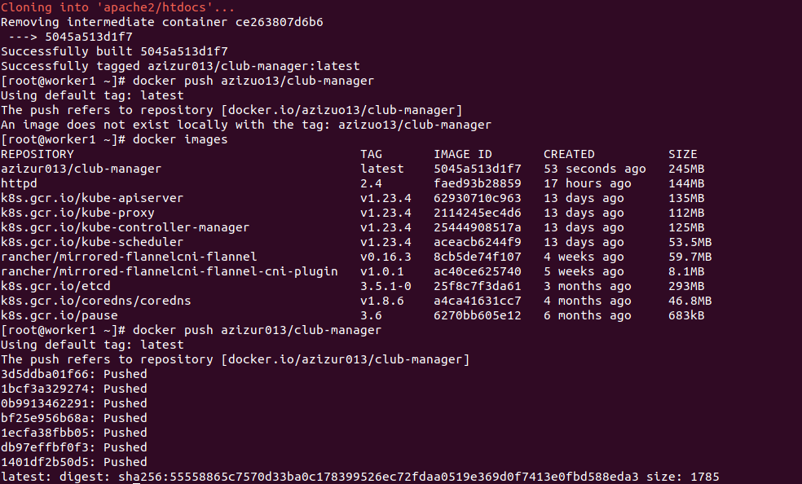

6.Test Deployment:
#manifest for the deployment
apiVersion: apps/v1
kind: Deployment
metadata:
name: test-deploy
labels:
environment: test
spec:
replicas: 3
selector:
matchLabels:
environment: test
minReadySeconds: 10

strategy:
rollingUpdate:
maxSurge: 1
maxUnavailable: 0
type: RollingUpdate

template:
metadata:
labels:
environment: test
spec:
containers:
- name: club-manager-application
image: azizur013/club-manager:latest
ports:
- containerPort: 80
#deployment command
$kubectl apply -f club-manager-deployment.yml
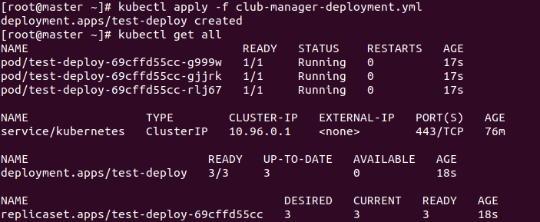
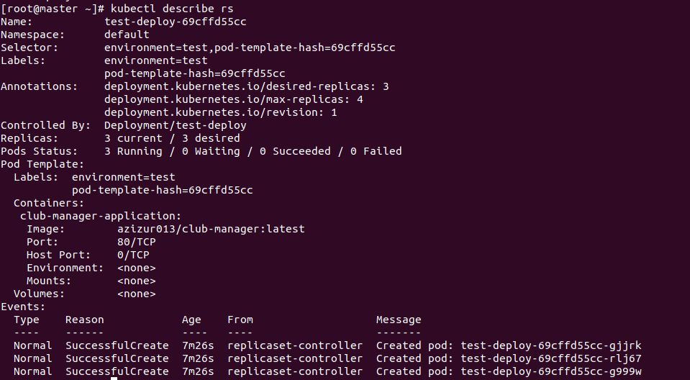
7. Creating the Service:
#yml to create the services
apiVersion: v1
kind: Service
metadata:
name: test-deploy-service
spec:
selector:
environment: test
type: LoadBalancer
ports:
- protocol: TCP
port: 8000
targetPort: 80
nodePort: 31110

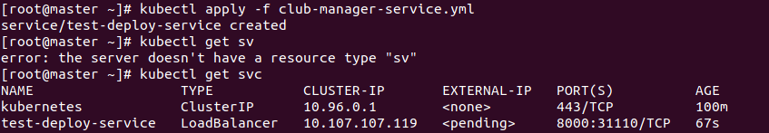
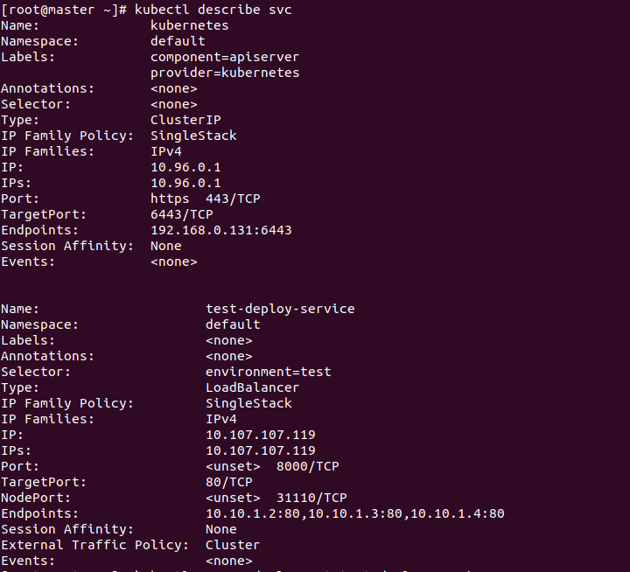
8.Final output :

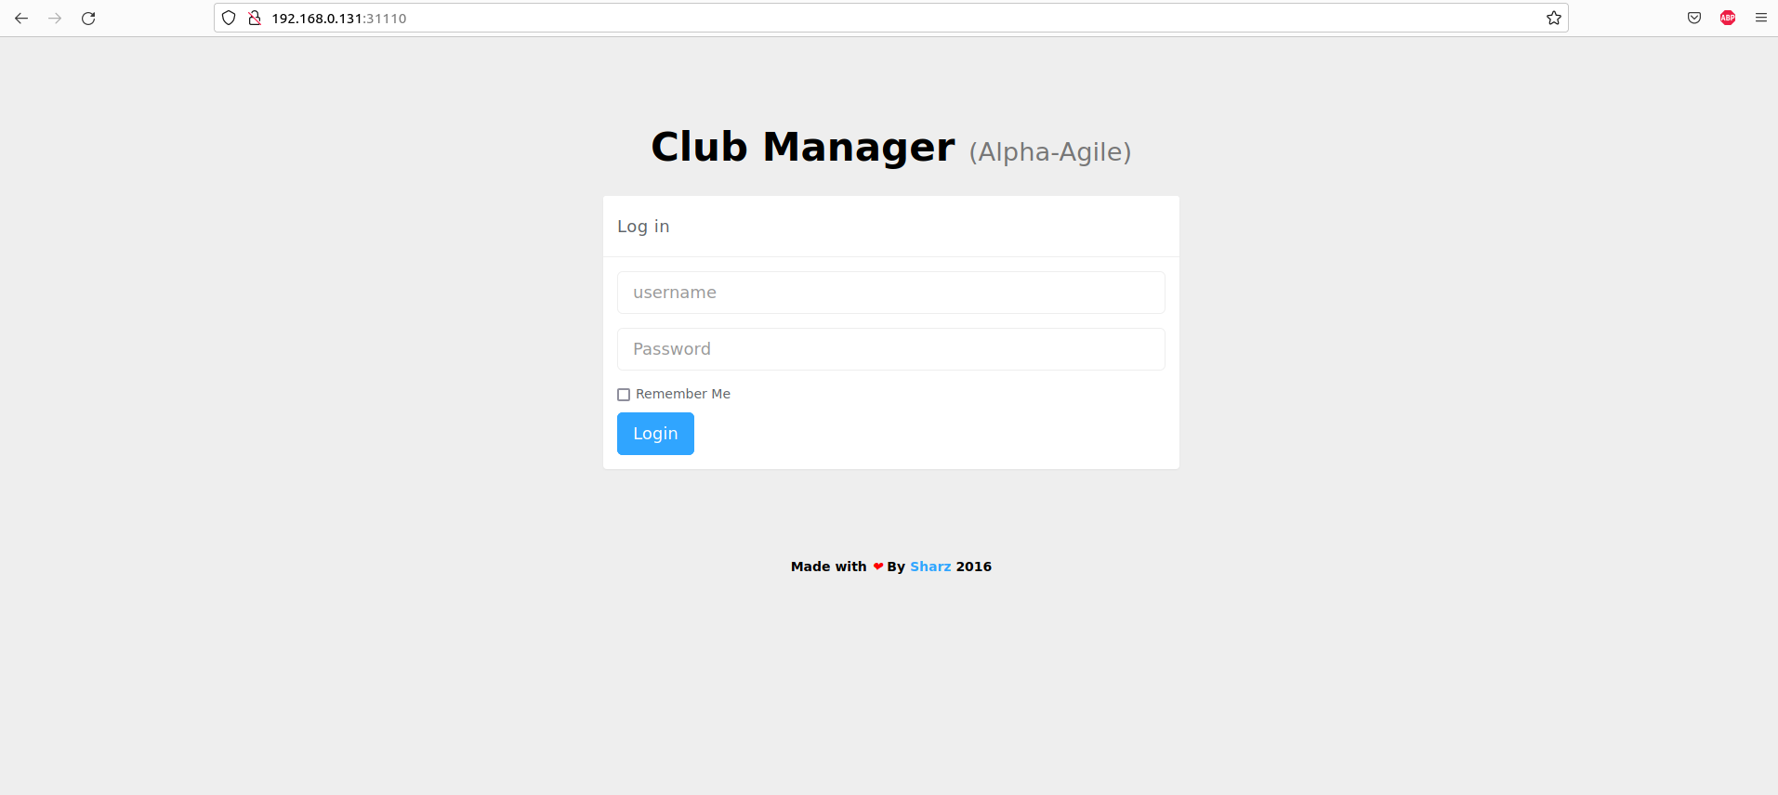

9. References:
- Github Code Repo → https://github.com/shindesharad71/Club-Manager.git
- Docker image → https://hub.docker.com/repository/docker/azizur013/club-manager
- Kubeadm install documentation by Kubernetes→ https://kubernetes.io/docs/setup/production-environment/tools/kubeadm/install-kubeadm/
- Kubectl commands → https://kubernetes.io/docs/reference/generated/kubectl/kubectl-commands
- External code for centos 7 → https://computingforgeeks.com/install-kubernetes-cluster-on-centos-with-kubeadm/
- Kubernetes Dashboard configure → https://computingforgeeks.com/how-to-install-kubernetes-dashboard-with-nodeport/
- Youtube video reference → https://www.youtube.com/watch?v=CfPRbdT-wXo

https://stackoverflow.com/questions/46276796/kubernetes-cannot-cleanup-flannel

