Docker container backup:
Process-1: Save in .tar format

Step-1: First of all we need to create image from running container which we want to store. For that we need to run the below command:
$ docker commit containter_id image_name
it will create an image of the running container.
Step-2: After that we need to save the image in .tar format. For that we need to run the below command.
$ sudo docker save -o /location/name.tar image_name
it will store the image on the given location in .tar format.

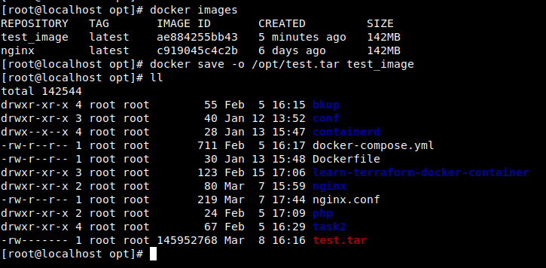

Now, for restore this .tar file in another docker machine - you need to copy the .tar file in that machine and need to provide the below command:

$ docker load < test.tar

it will create an image and if you run container from that image you can find the same output.

Process-2: Save in docker hub

Step-1: For that we need to first log in to docker hub. For log in write the below command-

$ docker login

it will ask for user name (not email) and password. After provided authentic username and password you can login to docker hub through CLI.

Step-2: From docker hub portal create a repository

Step-3: Now, need to create image with docker repository name and need to provide tags. For this need to run the below command-

$ docker tag image_name:tag repository_name:tag

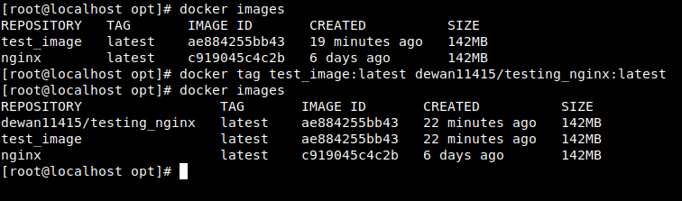
it will create an image with repository_name and tag

Step-4: Now push the code by below command-

$ docker push repository_name:tag

it will upload the image in your docker hub account.

Now, for restore in another docker machine you need to run the below command:

$ docker pull repository_name:tag

it will create an image and if you run container from that image you can find the same output.

