For understanding the kubernetes cluster and it's management we need to understand what are services in kubernetes and it's types and how services connects the micro services such as frontend, applications, databases etc.

Service: A Service in Kubernetes is an abstraction which defines a logical set of Pods and a policy by which to access them. Services enable a loose coupling between dependent Pods. A Service is defined using YAML(preferred) or JSON, like all Kubernetes objects.The set of Pods targeted by a Service is usually determined by a LabelSelector.

Here is an example screen shot how services are coupling between different Pods.
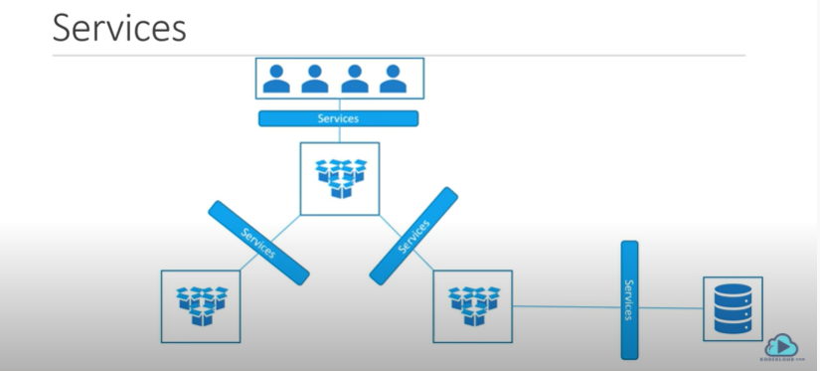

Although each Pod has a unique IP address, those IPs are not exposed outside the cluster without a Service. Services allow your applications to receive traffic. Here is an example screen shot how services exposing application to the outside world.
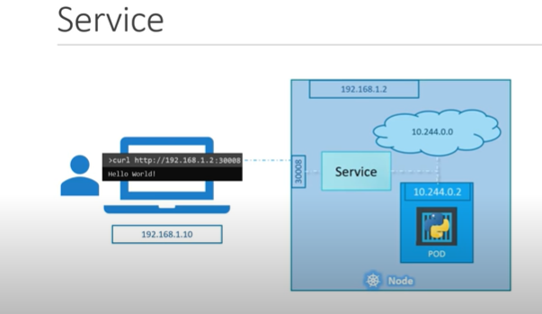

Services Types:

NodePort service
ClusterIP Service
LoadBalancer Service

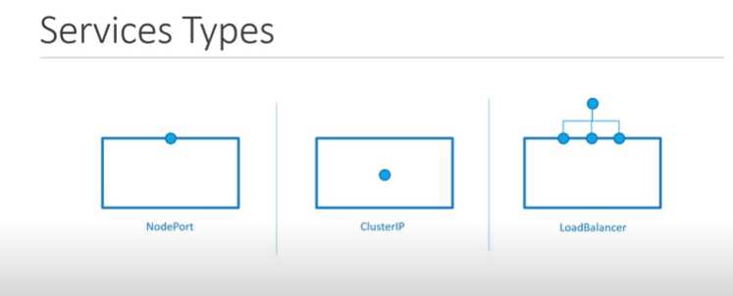

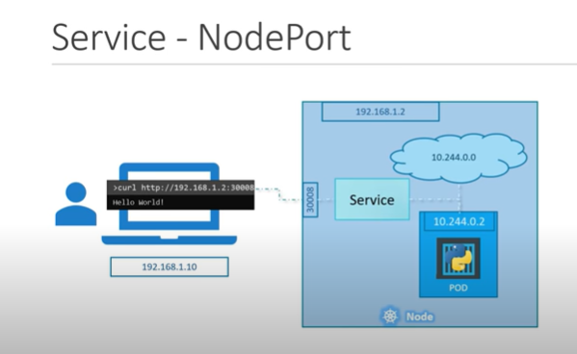

Single Node-Single pod
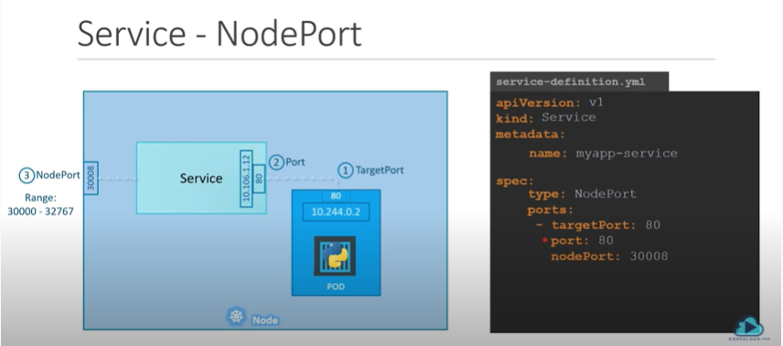

Here is an example of service-definition.yml and pod-definition.yml

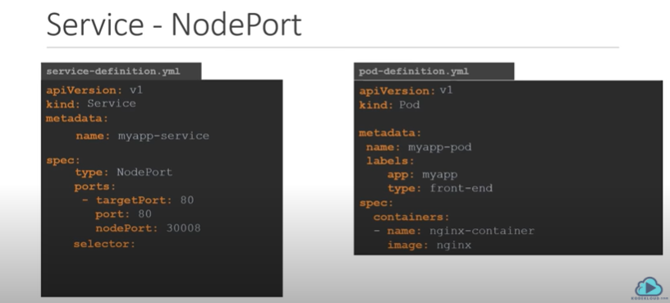
In the selector tag of service definition file write the label of pod-definition file.
Selector:
app: myapp
type: front-end
Now run the pod-definiton.yml and service-definiton.yml like this.
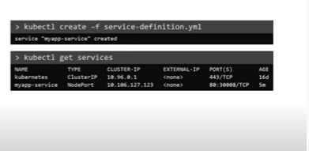
-> kubectl create -f service-definition.yml
-> kubectl get services

This is an example of
Signle node-Single pod

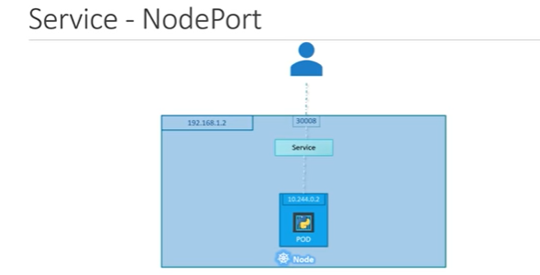

Signle Node -Multiple pod
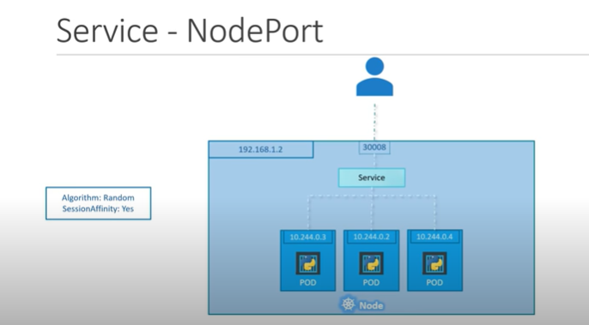
Multiple Node-Multiple Pod

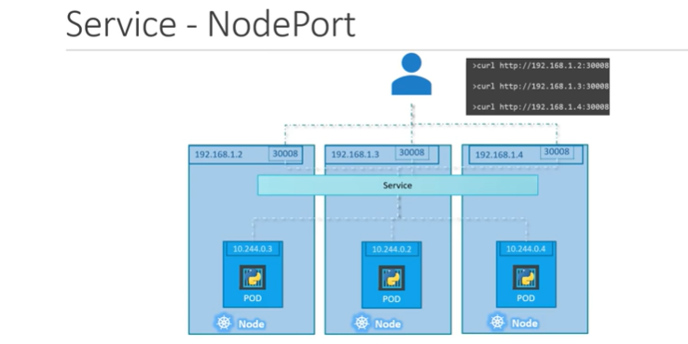

Cluster IP : Cluster IP exposes the service within the kubernetes cluster. This is the default service type in kubernetes.

For example, you are going to deploy one application which consits of frontend application and backend database.Since data is sensitive we dont provide a direct access of database to outside world.For this we can restrict access of backend database to only within the kubernetes cluster.
For this purpose we have to use Cluster IP service.

Here is an example screen shot of high level Cluster IP service.
For example we have a frontend pod which is exposed to the outside world and providing access to the application. And there is another set of pod which are not exposed to the outside world and they are strictly internal to the company which includes the database like oracle,mysql,postgresql etc.
Now to connect the frontend pod with the backend pod we will use a service called Cluster Ip.

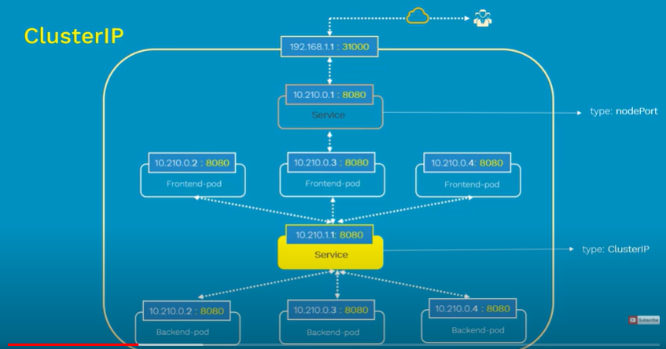

A Demo using Cluster IP service:
In this demo we will deploy a guest book application which has a frontend and backend database.
In this gurest book application we will enter a guest name and hit submit and this guest name will be stored in Redis as a backend database.

For this demo we will deploy
Redis DB Master
Redis DB slave
Frontend
and two cluster IP service for connecting forntend wtih the database. One Cluster Ip for connecting the Redis master database and another Cluster Ip for connecting Redis slave database.

And we will deploy a Load balancer service for exposing the service to the outside world.

So total six, three for deployments and three for creating services.
Here is an example screen shot of total deployments.

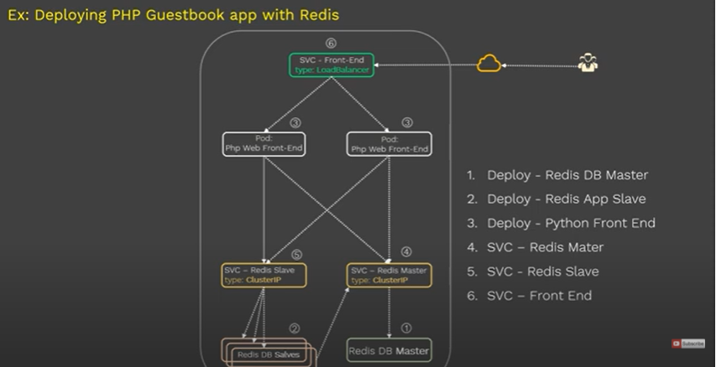

Here is the yml file description of Redis DB Master. Deploy all yml file using command
# kubectl create -f [yml file name]

# redis master deployment
apiVersion: apps/v1
kind: Deployment
metadata:
name: redis-master
labels:
app: redis
spec:
replicas: 1
selector:
matchLabels:
app: redis
role: master
tier: backend
template:
metadata:
labels:
app: redis
role: master
tier: backend
spec:
container:
- name: master
image: k8s.gcr.io/redis:e2e
resources:
requests:
cpu: 100m
memory: 100Mi
ports:
- containerPort: 6379

Here is the yml description of Redis DB slave descriptiong

# redis slave deployment
apiVersion: apps/v1 # for version before 1.9.0 use apps/v1beta2
kind: Deployment
metadata:
name: redis-slave
labels:
app: redis
spec:
replicas: 3
selector:
matchLabels:
app: redis
role: slave
tier: backend
template:
metadata:
labels:
app: redis
role: slave
tier: backend
spec:
container:
- name: slave
image: gcr.io/google_samples/gb-redisslave:v1
resources:
requests:
cpu: 100m
memory: 100Mi
ports:
- containerPort: 6379

Here is the description of frontend

# Frontend deployment
apiVersion: apps/v1 # for version before 1.9.0 use apps/v1beta2
kind: Deployment
metadata:
name: frontend
labels:
app: guestbook
spec:
replicas: 2
selector:
matchLabels:
app: guestbook
tier: frontend
template:
metadata:
labels:
app: guestbook
tier: frontend
spec:
container:
- name: php-redis
image: gcr.io/google_samples/gb-frontend:v4
resources:
requests:
cpu: 100m
memory: 100Mi
ports:
- containerPort: 80

And now will deploy the services.
Here is the yml description of Redis master service

# redis master service deployment
apiVersion: v1 # for version before 1.9.0 use apps/v1beta2
kind: Service
metadata:
name: redis-master-svc
labels:
app: guestbook
role: master
tier: backend
spec:
ports:
- port: 6379
targetPort: 6379
type: ClusterIp
selector:
app: redis
role: master
tier: backend

Here is the yml descriptin of redis slave service

# redis slave service deployment
apiVersion: v1 # for version before 1.9.0 use apps/v1beta2
kind: Service
metadata:
name: redis-slave-svc
labels:
app: redis
role: slave
tier: backend
spec:
ports:
- port: 6379
type: ClusterIp
selector:
app: redis
role: slave
tier: backend

Here is the yml description of LoadBalancer

# redis loadBalancer service deployment
apiVersion: v1 # for version before 1.9.0 use apps/v1beta2
kind: Service
metadata:
name: frontend-svc
labels:
app: guestbook
tier: frontend
spec:
type: LoadBalancer
ports:
- port: 80
selector:
app: guestbook
tier: frontend

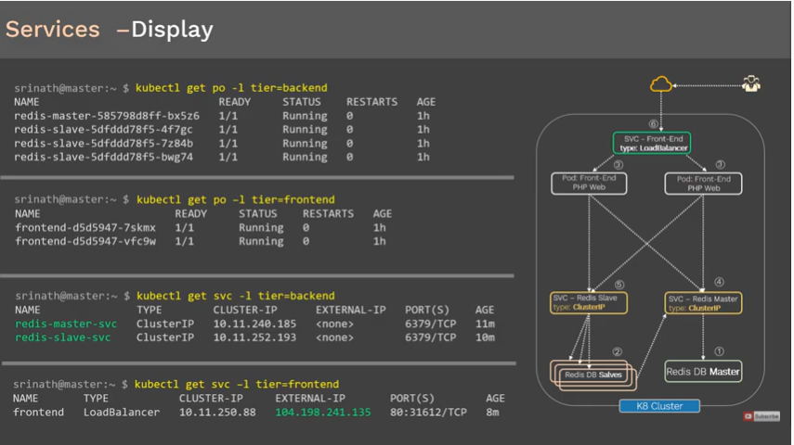

-> kubectl get po -l tier=backend
-> kubectl get po -l tier=frontend
-> kubectl get svc -l tier=backend
-> kubectl get svc -l tier=frontend
-> kubectl get no -o w
-> kubectl get svc -l tier=frontend

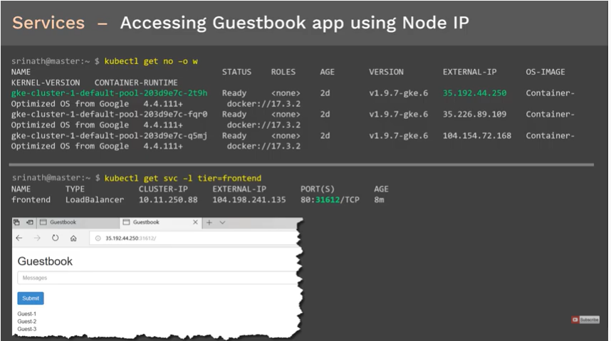
Referecences:

https://www.youtube.com/watch?v=5lzUpDtmWgM
https://www.youtube.com/watch?v=dVDElh_Kd48
https://www.youtube.com/watch?v=SdhCbs7g6ZY

