**Format of Database on Farm Machinery**

**Farm Machineries in Bangladesh**

ACI Ltd.

Alim Industires Ltd.

Metal Private Ltd.

**SICMA Rotavator**

RDA

I**nstitute**

BMWRI

HSTU

BAU

BRRI

BSRI

BARI

Mahabub Engineering

Janata Engineering

Krishi Engineering

Uttaran

**Workshop**

Abedin Equipment Ltd.

**Company**

Irrigation

Threshing

Harvesting

Inter-culture

Planting

Tillage

**Indigeneous**

**Intermediate**

**Modern**

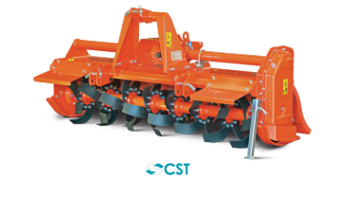

* Model no-CST155
* Blades-42
* Effective width-156cm or 57inch
* Effective depth-20cm or 8inch
* Weight-300Kg
* Price-270000