**Group – 03**

|  |  |
| --- | --- |
| **NUR HOSSAIN** | **21-45833-3** |
| **MARISHAT TASMIM** | **22-46483-1** |
| **MD. SIKHUL ISLAM SHIHAB** | **22-46484-1** |
| **MD.HASAN AL MAHMUD NAFIS** | **22-46498-1** |

**Group Members:**

***Wasty***  [lab-1]

Background Description :

Food waste is an increasing issue right in the middle of Bangladesh, where vibrant cultures and communities are at home. Despite the friendly and giving nature of its people, leftover food frequently goes to waste, causing hunger and raising environmental issues. We suggest creating the "The Foods” App, an innovative mobile application, to solve this critical issue. Like many other countries, Bangladesh struggles with the twin issues of lack of food and food waste. Due to logistical issues, restaurants, homes, and individuals frequently have extra food that is thrown away rather than helping those in need. This issue is made worse by the absence of effective channels for food donation. Hunger and malnutrition are simultaneously experienced by poor communities, highlighting the need for filling this gap.

The Food Waste Management App is designed to provide a comprehensive solution to these issues. It connects restaurants, individuals, and dedicated riders through a digital ecosystem. Donors can easily specify the type, quantity, and duration of use of their surplus food. Real-time location tracking connects them with nearby riders who collect and deliver food to underserved communities. Importantly, the app uses smart algorithms to prioritize foods that are perishable, ensuring that the food that is about to expire is delivered quickly.

This project sees a future in Bangladesh where no edible food goes to waste. We hope to create an efficient and inclusive platform that not only reduces food waste but also reduces hunger and promotes a sustainable food system by utilizing the power of technology and community spirit.

Problem Domain :

* **Food Waste Epidemic:** Inefficiencies in food distribution, inadequate food preservation practices, and a lack of proper channels for food donation.

Food waste increases hunger, drains resources, and harms the environment. This issue must be discussed for food safety and sustainability.

* **Unequal Access to Nutritious Meals:** Because of economic disparities and logistical challenges, underprivileged groups often do not have access to nutritious food.

Hunger and malnutrition have a disproportionate impact on people with special needs. It is a matter of social equity and the public's well-being to ensure proper access to healthy food.

* **Limited Food Donation Infrastructure:** There is a lack of efficient platforms that connect food donors, volunteers, and recipients, resulting in missed opportunities for food rescue.

Efficient food donation facilities can significantly reduce food waste, help the needy, and encourage community participation in solving hunger and food safety issues.

Objectives :

* **Reduce Food Wastage:** The primary objective of the project is to significantly decrease food wastage in Bangladesh.
* **Combat Hunger and Food Insecurity:** The project aims to solve hunger by ensuring that surplus food reaches marginalized and underprivileged communities promptly.
* **Promote Sustainability and Community Engagement**: The project seeks to foster a sense of social responsibility and community engagement by encouraging individuals, restaurants, and businesses to actively participate in reducing food wastage and supporting the less fortunate.

Technical choice :

* **Framework :** React Native
* **Programming Language :** JavaScript
* **Devices for Testing :** Android and iOS devices
* **Database :** MySQL

Target User :

Our target users include restaurants, individuals with surplus food, volunteers (riders), and underprivileged communities.

Benefits :

* **Restaurants & Individuals:** Reduce food wastage, demonstrate social responsibility, and ensure excess food reaches those in need.
* **Volunteers (Riders):** Engage in meaningful community service, combat hunger, and promote food sustainability.
* **Underprivileged Communities:** Access nutritious meals, reduce economic burden, and improve overall well-being through free or low-cost food.

Functionality :

1. **User Registration, login, and Profile Management** - Allow users (restaurants, individuals, and riders) to create accounts, login, manage their profiles, and provide necessary information.
2. **Food Listing and Donation** - Enable restaurants and individuals to list surplus food items with details such as type, quantity, and expiration date.
3. **Real-Time Location Tracking** - Implement GPS-based location tracking to show the real-time location of food donors, riders, and recipients on a map.
4. **Matching and Notification System** - Develop a system that matches food donors with nearby riders and sends notifications for food pickups and deliveries.
5. **Food Priority System** - Create an algorithm to prioritize perishable food items nearing their expiration date, ensuring quick delivery to recipients.
6. **Donation Feature** - Allow users to contribute financially to support those in need directly through the application.
7. **Scheduling and Alerts** - Enable users to schedule food donations and pickups for specific times and send notifications and alerts for upcoming activities.
8. **Food Donation Records** - Maintain a comprehensive record of all food donations, including donor and recipient information, food types, and quantities, for transparency and accountability.

**Diagram :**

**Sequence diagram:** [lab-2]

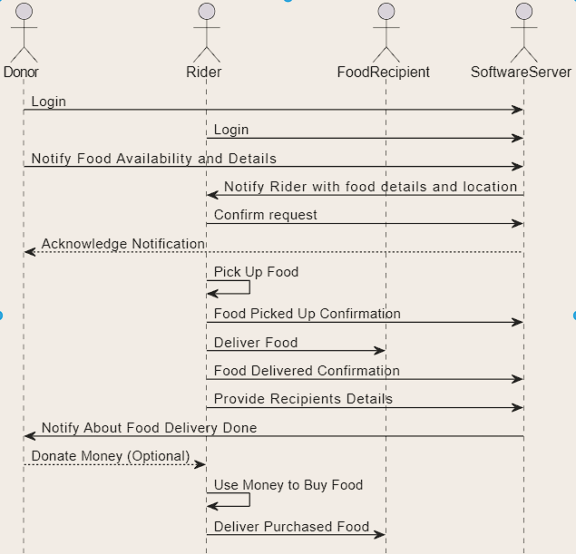

**Class diagram:**

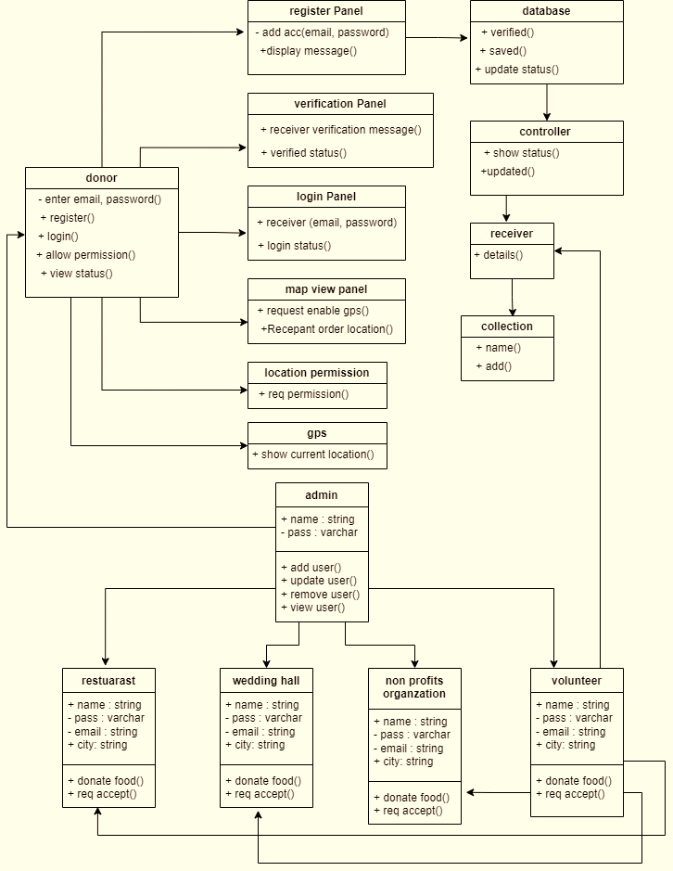

**Activity diagram :**

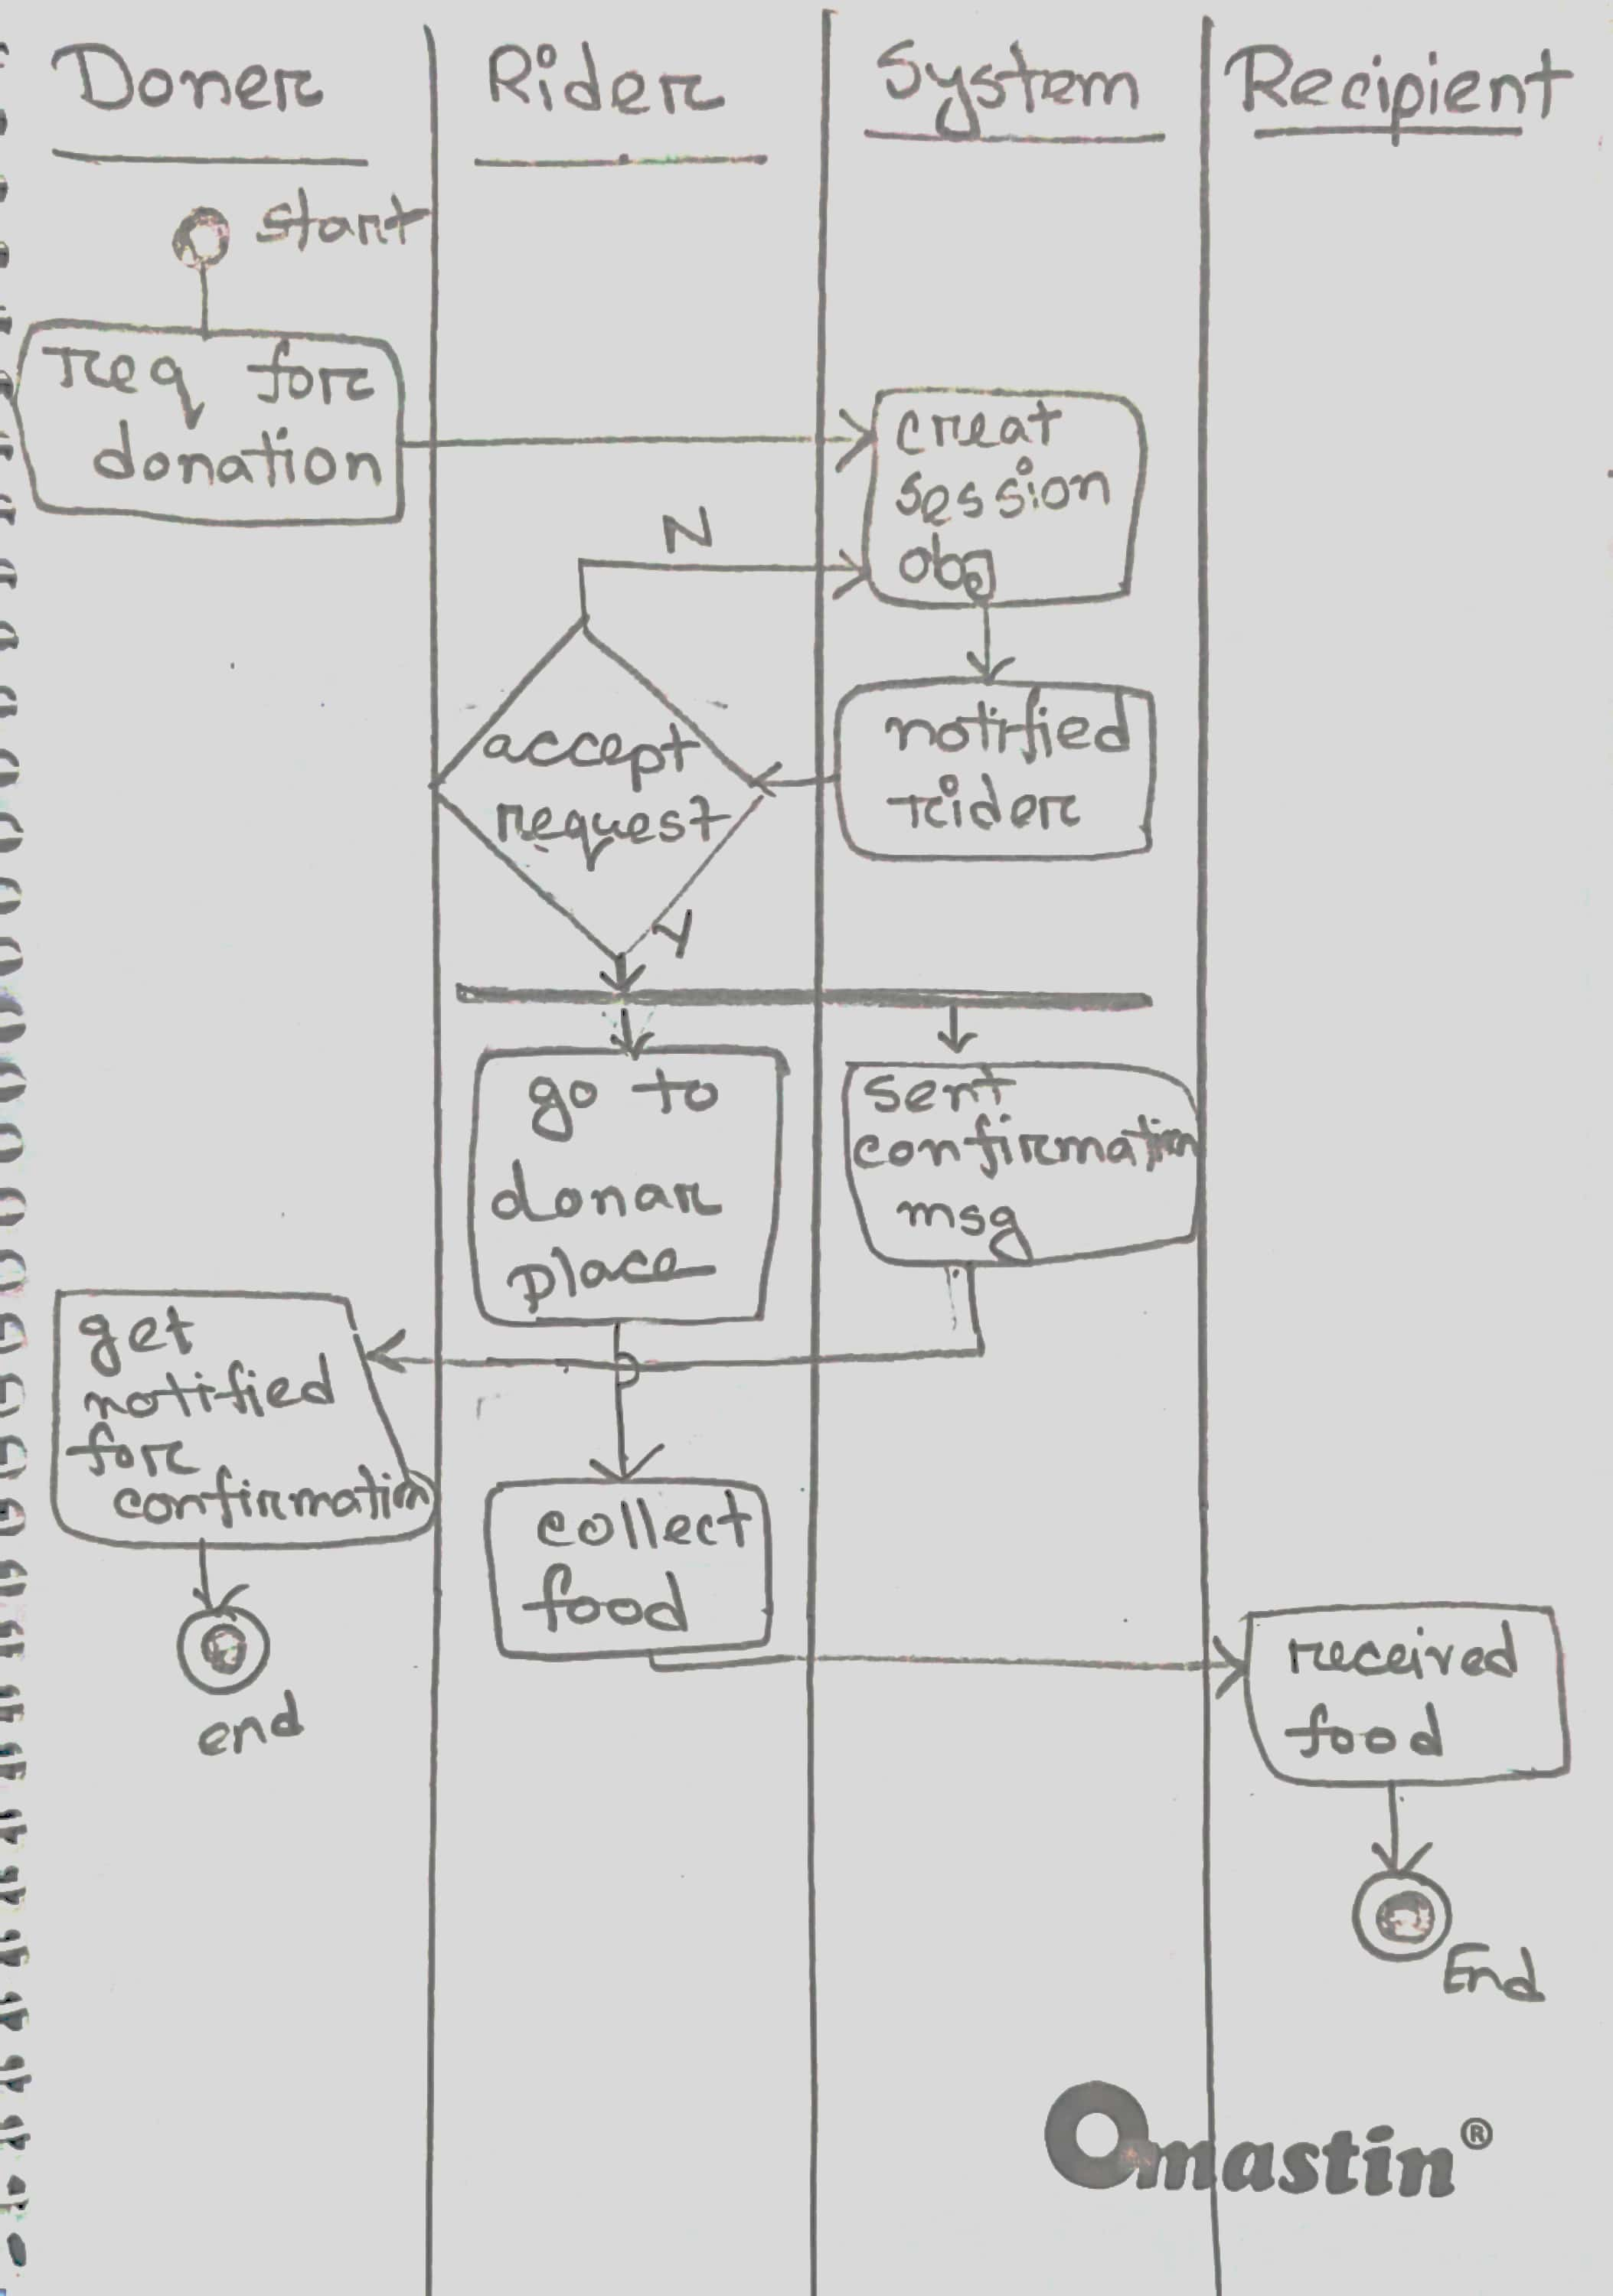

**Use case diagram:**

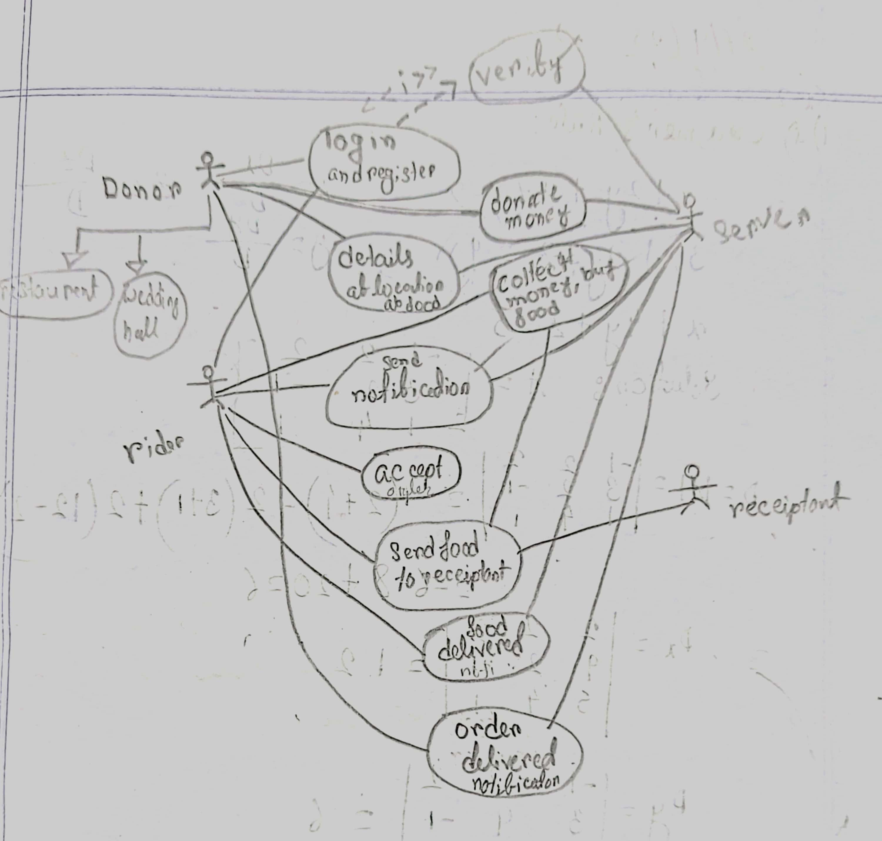

**Model:** Incremental Development [lab-3]

Arguments:

we can break down the project into small parts and develop them. Like we can create the main core features like connecting donors with rider for pickup and delivery.

It’s easier to add features later in incremental development. Like if the user wants a feature, we can provide it next incremental release. If the software doesn’t show the riders location in gps tracking system to the donor, and user want this feature in later, we can update the system in the next incremental release.

Because incremental development provides a basic core system to the user to test in limited geographical area. and by analyzing the performance we can minimize the risk of a large-scale rollout.

Because we test each feature so many times before incremental release, we can ensure that each feature works properly. Like in our software we test the gps tracking and sever database many times so that it doesn’t fail.

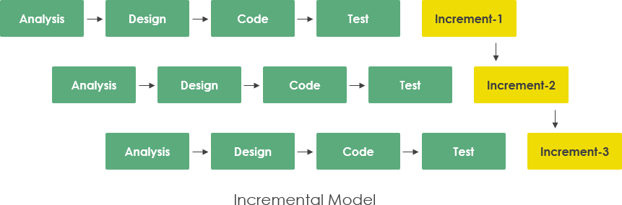

Requirements:

1. **Android Developer:**

* Develop the android application and the features.
* Ensure a seamless and user-friendly experience.
* Optimize the app performance for mobile devices.

1. **Front-end Developer:**

* Implement the UI design.
* Develop the structure, optimizing page and loading time.
* Using variety of markup language to create the page.

1. **Back-end Developer:**

* Design the back-end server and API.
* Implement database integration.
* Ensure data handling.

1. **UI/UX Designer:**

* Create the user interface.
* Design user friendly interface
* Testing UI elements such as CTAs, banners, page layouts etc.

1. **Database Administrator:**

* Design and maintain database server.
* Optimize database performance for faster response.
* Monitor and provide security to the database server.

1. **Tester:**

* Test the application to find the bugs and problems.
* Test all the features and prepare test scenario.
* Document the test case and report the defects.

1. **Project Manager:**

* Define project goals and manage the team.
* Create project schedule and allocate task to the team member.
* Monitor and analyze project progress and deal with the users.

**Requirements Analysis:** [lab-4]

**1. Food Listing and Donation**

Functional Requirements:

1.1 The software shall allow restaurants and individuals to list surplus food items.

1.2 Users must provide details such as type, quantity, expiration date, and location when

listing food items.

1.3 The listed food items will be stored in the application's database for matching and

distribution.

1.4 Donors should have the option to specify pickup times for their donations.

1.5 User can provide picture of the foods to provide additional information.

Priority Level: High

Precondition: Donor and riders must register and login.

**2: Real-Time Location Tracking**

Functional Requirements:

2.1 The software shall implement GPS-based location tracking.

2.2 Users shall be able to view the real-time locations of food donors, riders, and

recipients on a map.

2.3 Location data shall be continuously updated to provide accurate tracking

information.

2.4 The application shall offer route optimization for riders to reach donors and

recipients efficiently.

2.5 Every delivery location information will be stored in the database.

Priority Level: High

Precondition: Donors and riders must grant location access permission to the app.

**3: Matching and Notification System**

Functional Requirements:

3.1 The software shall employ an algorithm to match food donors with nearby riders.

3.2 Notifications shall be sent to donors and riders for food pickup and delivery requests.

3.3 Matching and notifications shall be based on proximity, availability, and pickup

times.

3.4 Users should have the option to accept or decline matching requests based on their

availability.

3.5 Riders and donors can communicate through and in-app chat feature for

coordination.

Priority Level: High

Precondition: Donor must fill all the information of foods to request food delivery.

**4: Food Priority System**

Functional Requirements

4.1 The software shall feature a priority system for food items nearing their expiration

dates.

4.2 Perishable food items shall be identified and prioritized for quick collection and

delivery.

4.3 The system shall optimize the distribution of food to minimize wastage and prioritize

needy recipients.

4.4 Users shall receive notifications for high-priority food donations to ensure timely

delivery.

4.5 Donor can designate certain food item as “urgent” to highlight their importance.

Priority Level: High

Precondition: Expiration date and food item type must be specified when listing donations.

**UI Design of Homepage**: [lab -5]

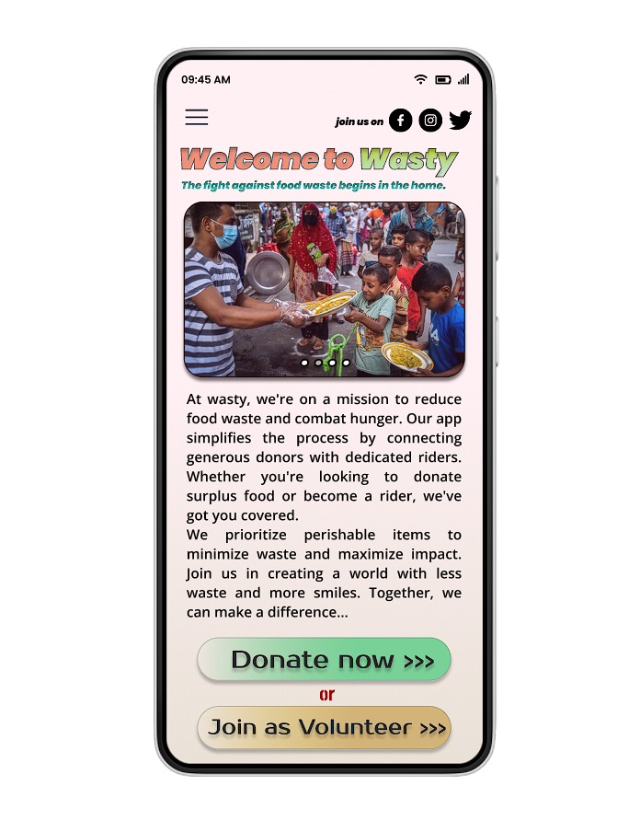

|  |  |
| --- | --- |
| Project Name: The Wasty | Test Designed by: MD. Hasan Al Mahmud Nafis |
| Test Case ID: FD-01  Test Priority: High  Module Name: Food Listing | Test Designed date: 31-10-23  Test Executed by: MD. Hasan Al Mahmud Nafis  Text Execution date: 31-10-23 |
| Test Title: Verify successful food listing with all details provided | |
| Description: Test the process of listing surplus food items on the app  Precondition (If any): User must be logged into the app | |
| |  |  |  |  |  | | --- | --- | --- | --- | --- | | Test Steps | Test data | Expected Results | Actual Results | Status (Pass/Fail) | | **1.** Go to the "List Food" section in the app.  **2.** Provide details of a food item, including type (e.g., vegetables), quantity (e.g., 5 kg), expiration date (e.g., 31-10-23), and location (e.g., Banasree, A block, road no-6, house -34).  **3.** Attach an image of the food item (e.g., a picture of the vegetables).  **4.** Click the "List Food" button to submit the listing. | Type: Vegetables  Quantity: 5 kg  Expiration Date: 31-10-23  Location: Banasree, A block, road no-6, house -34 | The food item should be successfully listed on the app. | The food items are not included to the list properly. | Fail | | Post Condition: | | | | | | |

|  |  |
| --- | --- |
| Project Name: Wasty | Test Designed by: MD. Sikhul Islam Shihab |
| Test Case ID: QX-1  Test Priority (Low, Medium, High): High  Module Name: Real-Time Location Tracking | Test Designed date: 31.10.23  Test Executed by:  Text Execution date: |
| Test Title: Real-Time Location Accuracy Test for a rider from pickup location to destination | |
| Description: Test Rider real-time location  Precondition (If any): Rider must need to on his or her location always. | |
| |  |  |  |  |  | | --- | --- | --- | --- | --- | | Test Steps | Test data | Executed Results | Actual Results | Status (Pass/Fail) | | 1. Go to our app 2. Click show location button 3. Show rider location |  | User always show the rider’s real-time location for the time being | User don’t show the rider’s real-time location | Fail | | Post Condition: The app accurately displays the user's current location within a specified margin of error. | | | | | | |

|  |  |
| --- | --- |
| **Project Name**: Wasty | **Test Designed by:** Marishat Tasmim |
| **Test Case ID:** M2T  **Test Priority (Low, Medium, High):** High  **Module Name**: Notification System - Food Matching | **Test Designed date:**31/10/23  **Test Executed by:**  **Text Execution date**: |
| **Test Title:** Verify notification of food donation request to a rider | |
| **Description:** Test the system's ability to notify a rider of a food donation request.  Precondition (If any): Rider must be logged into the app and available for food delivery. | |
| |  |  |  |  |  | | --- | --- | --- | --- | --- | | **Test Steps** | **Test data** | **Executed Results** | **Actual Results** | **Status (Pass/Fail)** | | 1. Log in as a rider into the app.  2. Ensure that you are available for food delivery.  3. Go to the "Matching Requests" section in the app.  4. Wait for a food donation request from a donor. |  | The rider should receive a notification when a food donation request is made by a donor. | Rider didn’t get notification. | Fail | | **Post Condition**: If the test passes, the rider should see the notification and be able to accept or reject the donation request. The app should log the notification event. | | | | | | |

|  |  |
| --- | --- |
| **Project Name**: Wasty | **Test Designed by:** Nur Hossain |
| **Test Case ID:** NK50  **Test Priority (Low, Medium, High):** High  **Module Name**: Priority System for Perishable Food | **Test Designed date:**31/10/23  **Test Executed by:**  **Text Execution date**: |
| **Test Title:** Verify correct prioritization of perishable food | |
| **Description:** Test the app's ability to prioritize perishable food items that are nearing their expiration date. | |
| |  |  |  |  |  | | --- | --- | --- | --- | --- | | **Test Steps** | **Test data** | **Executed Results** | **Actual Results** | **Status (Pass/Fail)** | | 1. One user list a perishable food item with an expiration date within the next three days.  2. Another user list a non-perishable food item.  3. Verify that the app correctly prioritizes the perishable item donation over the non-perishable item. | Perishable Food: Ripe mango  Non-Perishable Food: Canned soup | The app should correctly prioritize the perishable food delivery to the rider, indicating that it's near its expiration date. | Rider gets both donation priority same. | Fail | | **Post Condition**: If the test passes, the app should prioritize perishable food item delivery that are nearing their expiration date. | | | | | | |