**LAB 2**

1. **Is your browser running HTTP version 1.0 or 1.1? What version of HTTP is the server running?**

Answer: My browser is running HTTP version 1.1 and the server is running HTTP 1.1.

1. **What languages (if any) does your browser indicate that it can accept to the server?**

Answer: en-us

1. **What is the IP address of your computer? Of the gaia.cs.umass.edu server?**

Answer: My IP = 192.168.1.11; Server IP = 128.119.245.12

1. **What is the status code returned from the server to your browser?**

Answer: 200 OK

1. **When was the HTML file that you are retrieving last modified at the server?**

Answer: Wed, 19 Oct 2016 05:59:01 GMT

1. **How many bytes of content are being returned to your browser?**

Answer: 128 bytes

1. **By inspecting the raw data in the packet content window, do you see any headers within the data that are not displayed in the packet-listing window? If so, name one.**

Answer: No I do not

Screenshots for section 1:

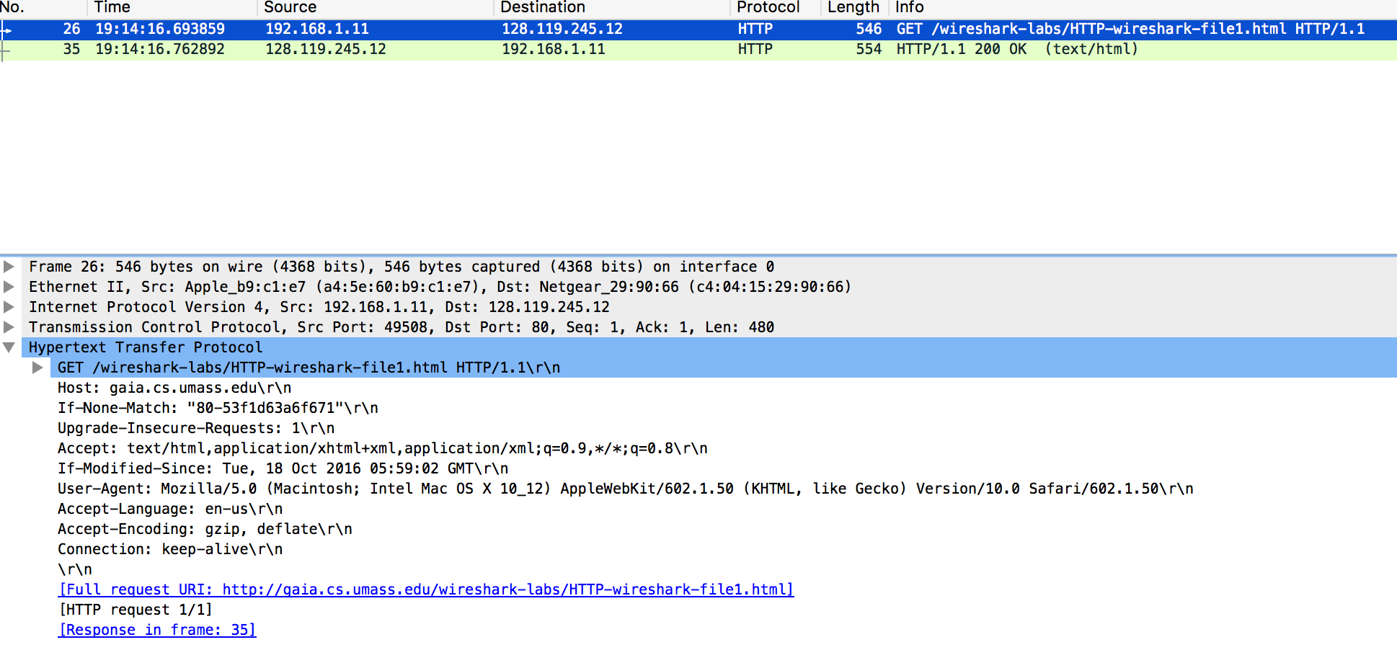

31

21

1

1

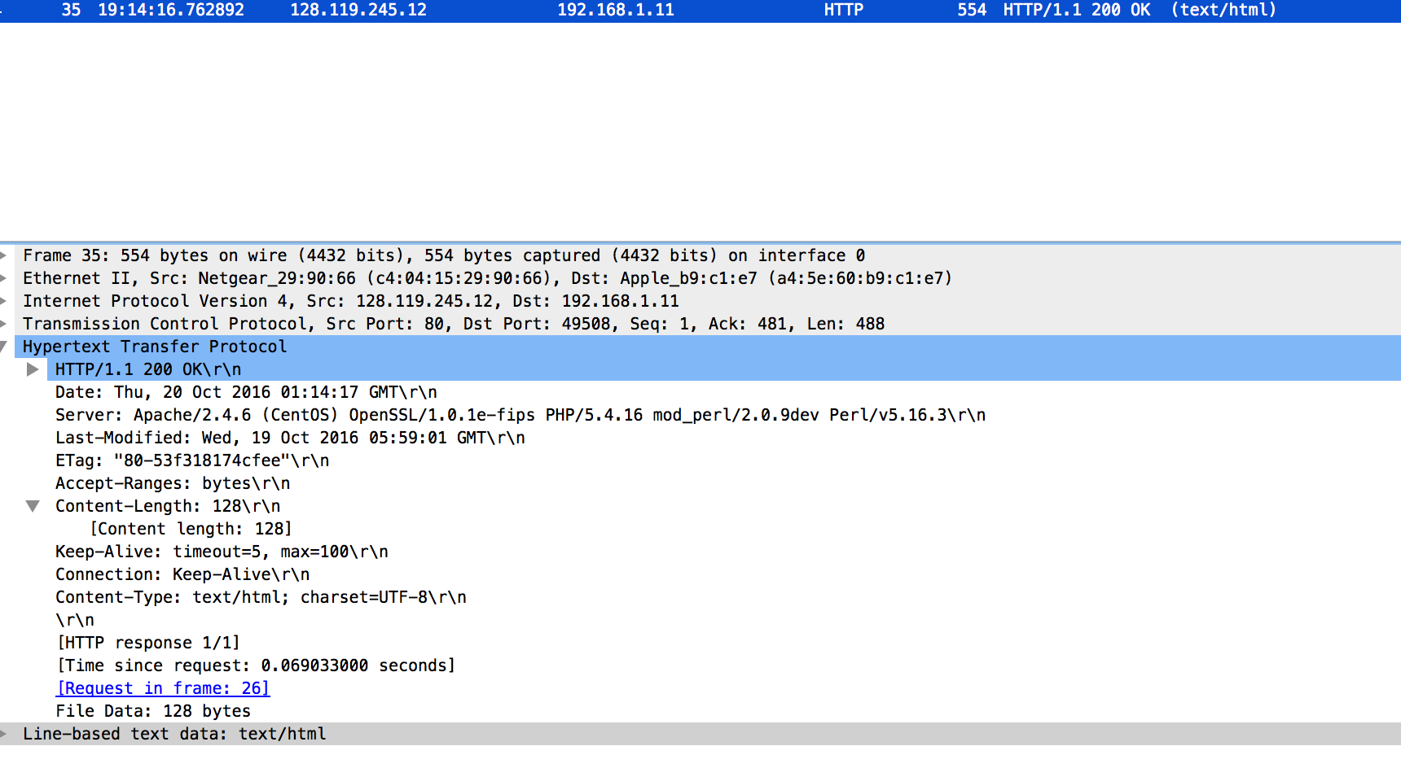

61

51

41

1

1. **Inspect the contents of the first HTTP GET request from your browser to the server. Do you see an “IF-MODIFIED-SINCE” line in the HTTP GET?**

Answer: No I do not.

1. **Inspect the contents of the server response. Did the server explicitly return the**

**contents of the file? How can you tell?**

Answer: Yes, you can see the contents of the file below the packet. It is titled as Line-based text data.

1. **Now inspect the contents of the second HTTP GET request from your browser to the server. Do you see an “IF-MODIFIED-SINCE:” line in the HTTP GET? If so, what information follows the “IF-MODIFIED-SINCE:” header?**

Answer: Yes, I do see that line. It contains: Wed, 19 Oct 2016 05:59:01 GMT\r\n

1. **What is the HTTP status code and phrase returned from the server in response to this second HTTP GET? Did the server explicitly return the contents of the file?**

**Explain.**

Answer: The code returned is 304 Not Modified. Since the file had not changed since last accessed, no data was sent from the server with this request.

Section 2 Screenshots:

1st Get Request

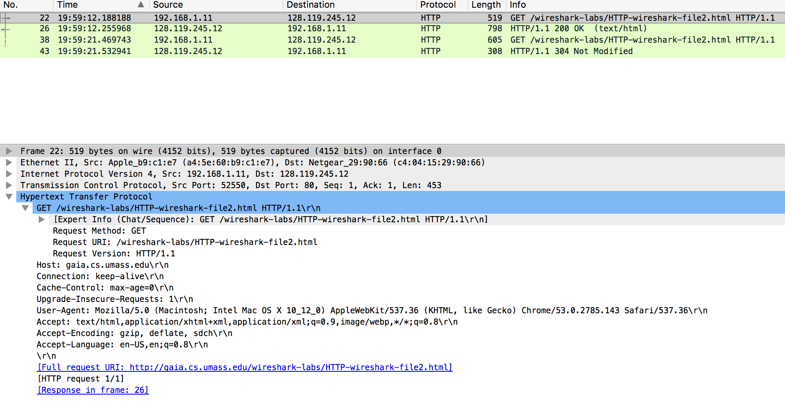

1st Response

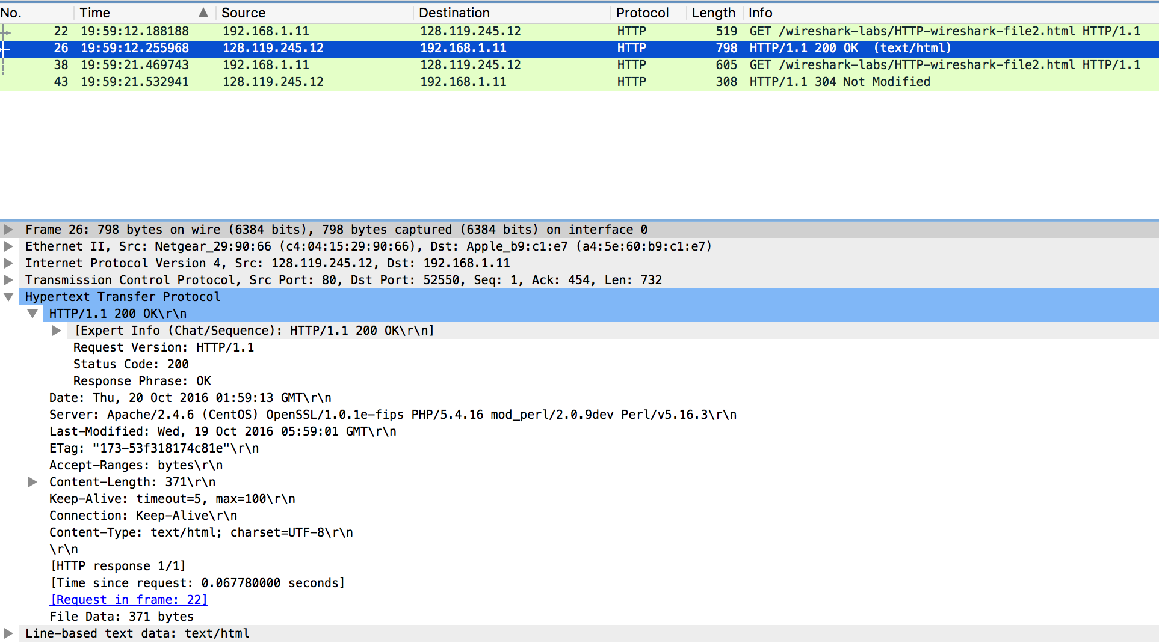

961

2nd Get request

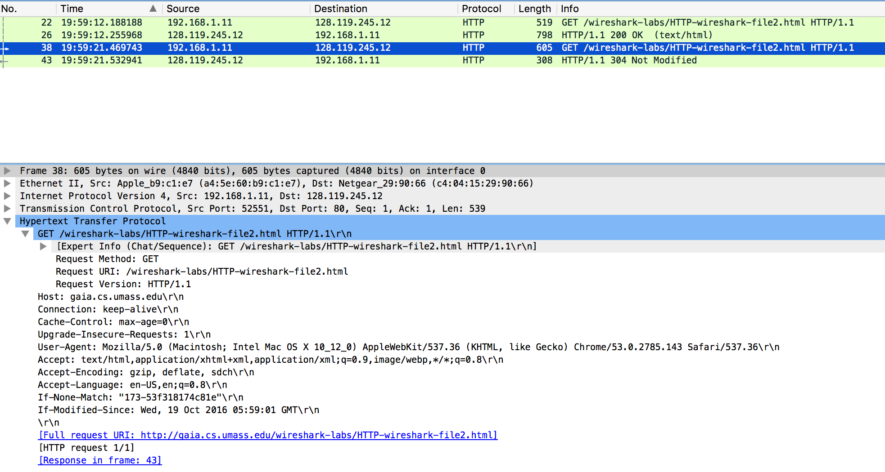

10

2nd Response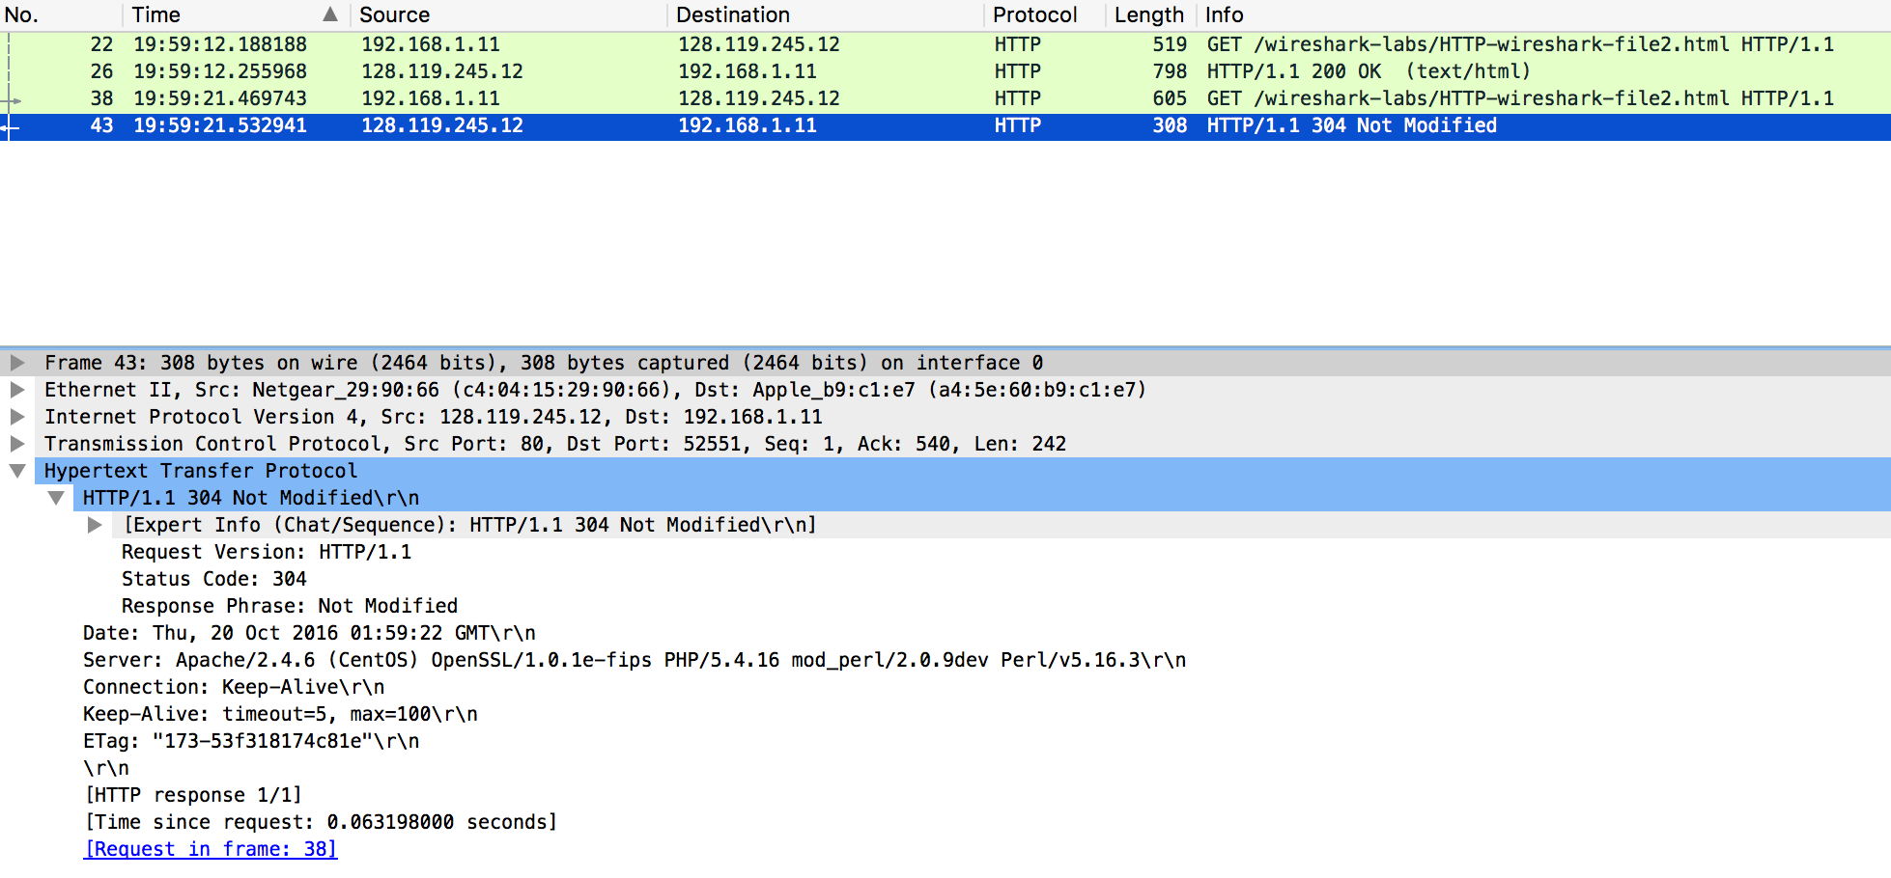

11

1. **How many HTTP GET request messages did your browser send? Which packet number in the trace contains the GET message for the Bill or Rights?**

Answer: There was one GET request sent. It was contained in packet 215.

1. **Which packet number in the trace contains the status code and phrase associated**

**with the response to the HTTP GET request?**

Answer: Packet 219

1. **What is the status code and phrase in the response?**

Answer: 200 OK

1. **How many data-containing TCP segments were needed to carry the single HTTP**

**response and the text of the Bill of Rights?**

Answer: 4 packets

GET Request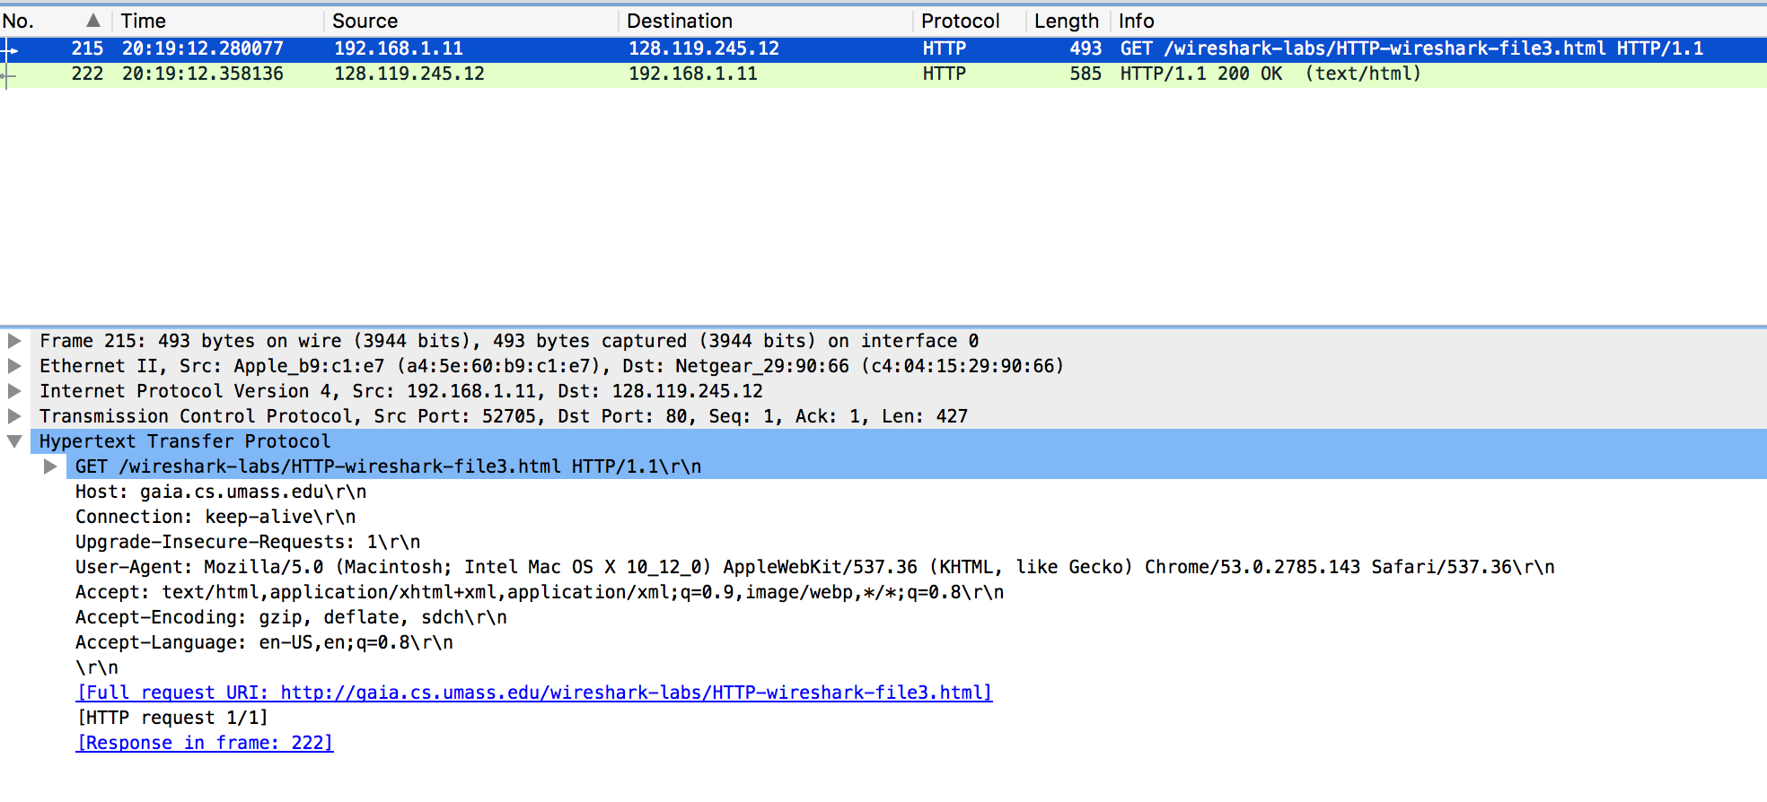

12

Response

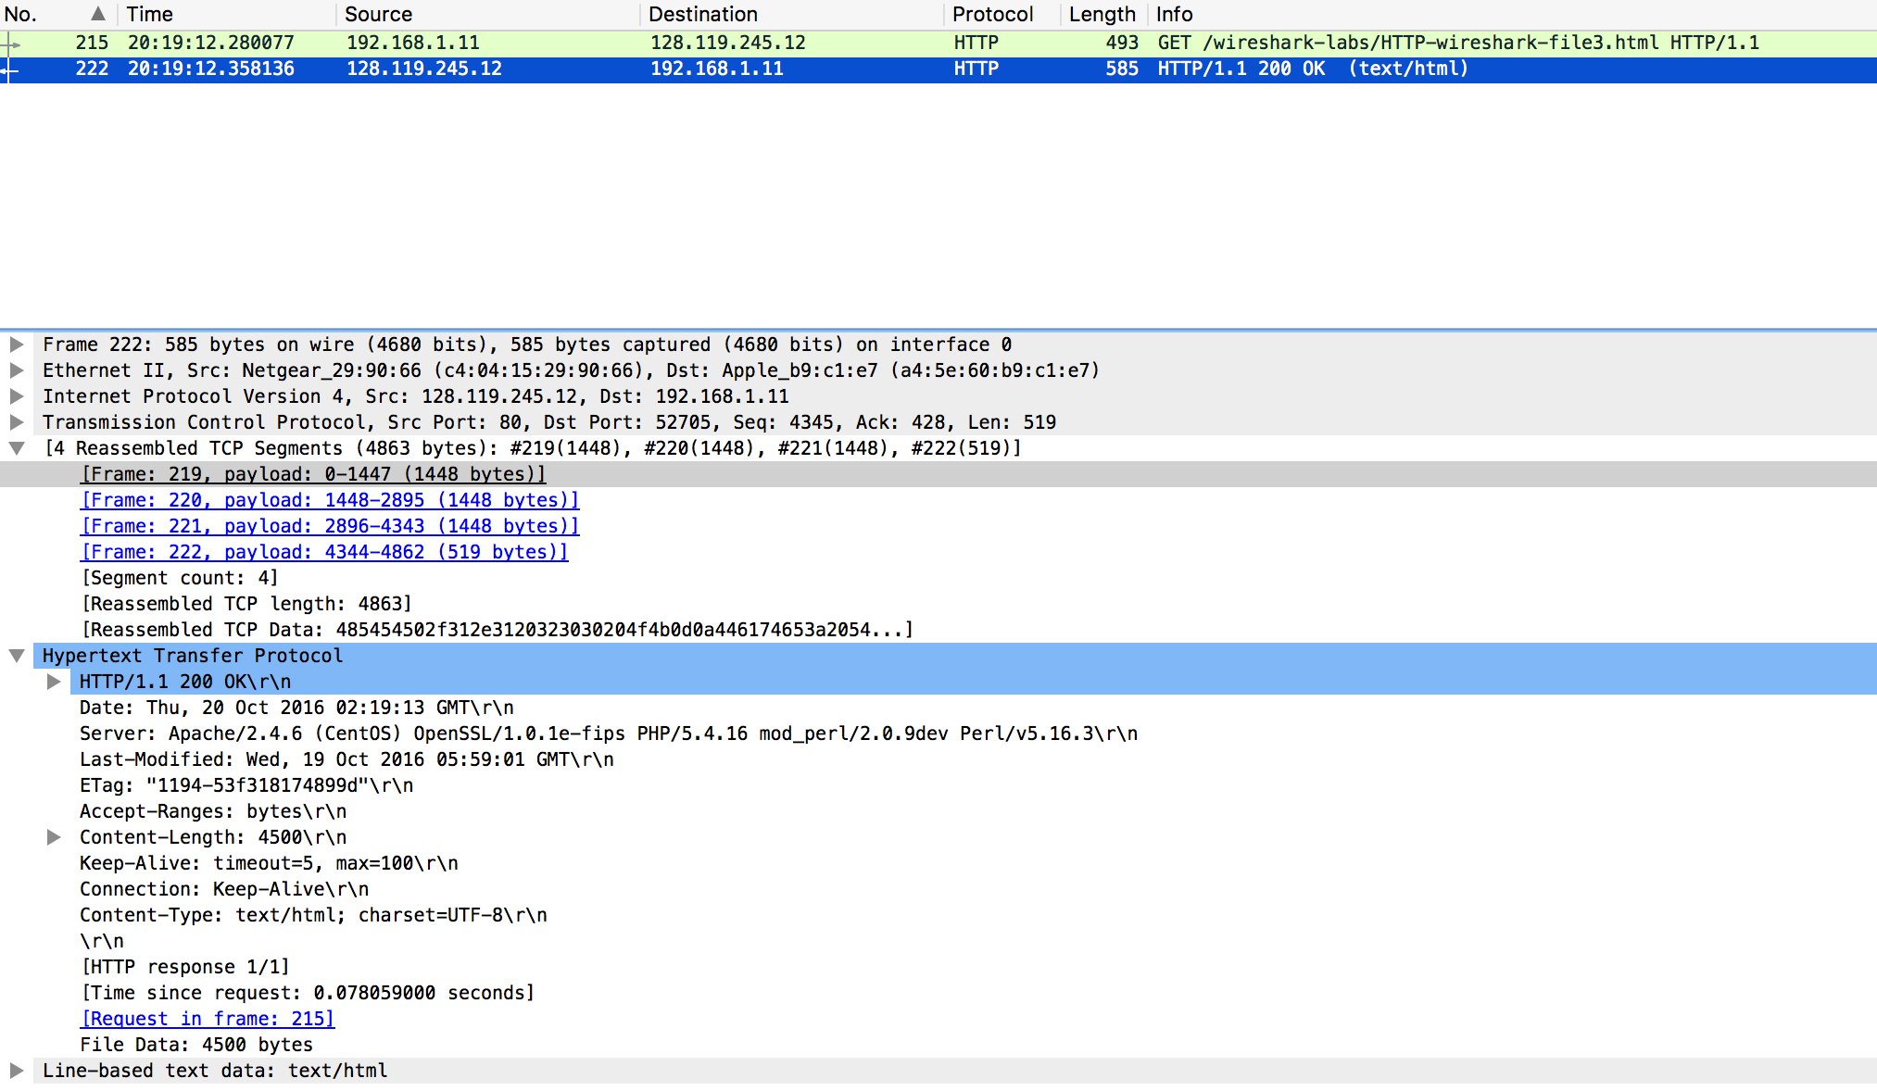

13, 15

1410

1. **How many HTTP GET request messages did your browser send? To which Internet addresses were these GET requests sent?**

Answer: My browser sent a total of 4 GET requests. They are as follows:

GET /wireshark-labs/HTTP-wireshark-file4.html HTTP/1.1

Destination: 128.119.245.12

GET /pearson.png HTTP/1.1

Destination: 128.119.245.12

GET /~kurose/cover_5th_ed.jpg HTTP/1.1

Destination: 128.119.240.90

GET /~kurose/cover_5th_ed.jpg HTTP/1.1

Destination: 128.119.240.90

1. **Can you tell whether your browser downloaded the two images serially, or whether they were downloaded from the two web sites in parallel? Explain.**

Answer: They were sent serially; you can tell this since the GET requests occur one after another. This is also confirmed since the images were sent over TCP and came from the same port.

Section 4 Screenshots

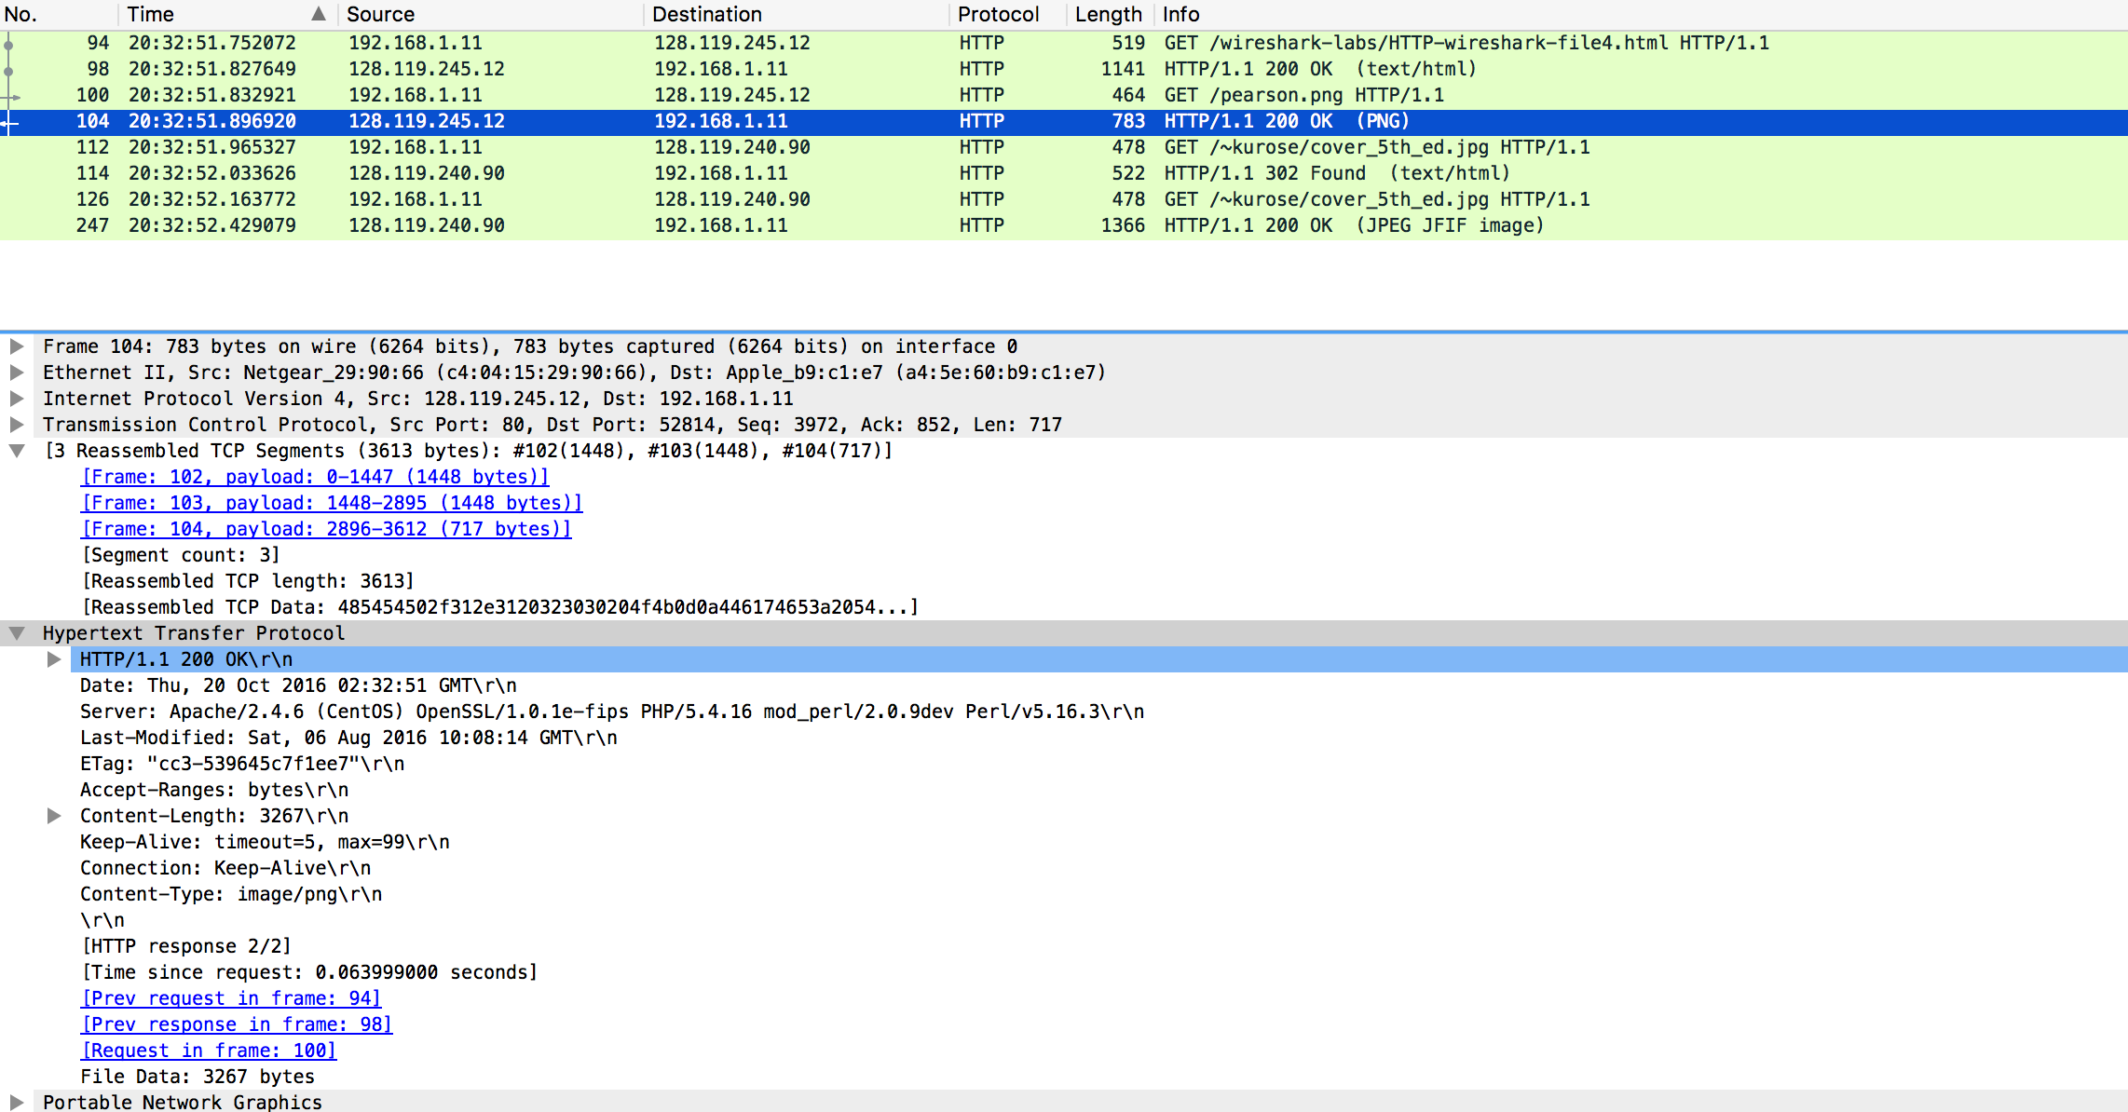

17

16

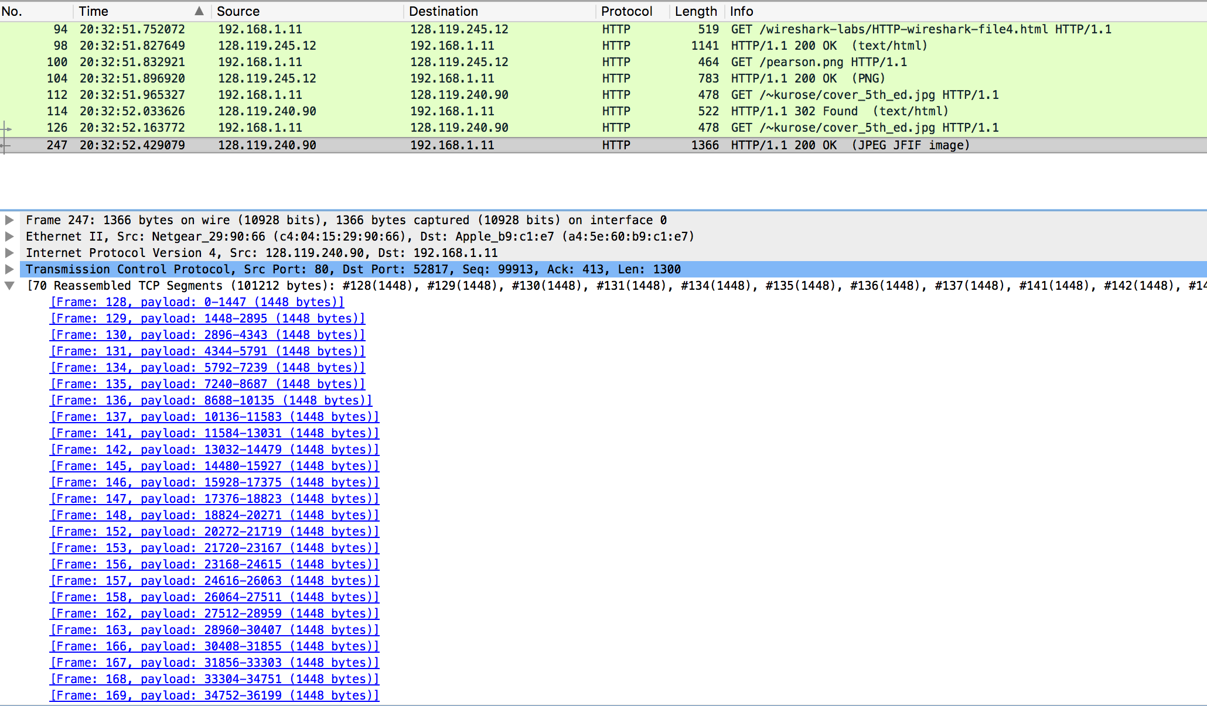

17

1. **What is the server’s response (status code and phrase) in response to the initial HTTP GET message from your browser?**

Answer: 401 Unauthorized

1. **When your browser’s sends the HTTP GET message for the second time, what**

**new field is included in the HTTP GET message?**

Answer: The authorization field was added and has the value Basic d2lyZXNoYXJrLXN0dWRlbnRzOm5ldHdvcms=\r\n

Section 5 Screenshots:

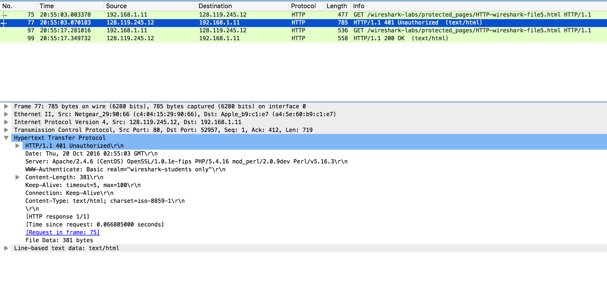

18

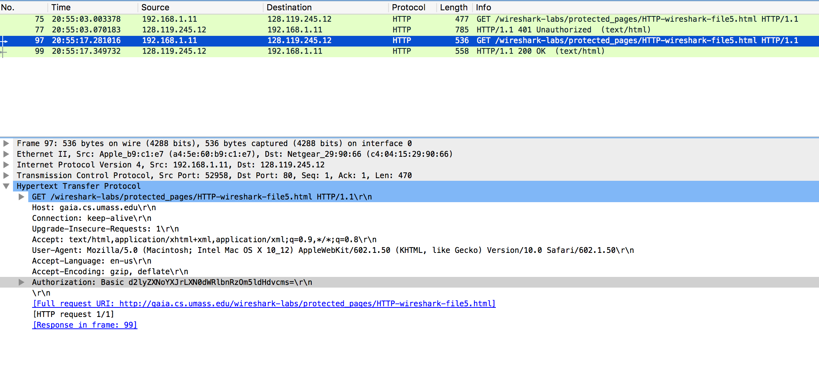

19