1.

db.collection.find({},

{

user_id: 1,

firstName: 1,

lastname: 1,

_id: 0

})

2.

db.collection.find({

firstName: "Grace"

},

{

_id: 0,

email: 1,

password: 1

})

3.

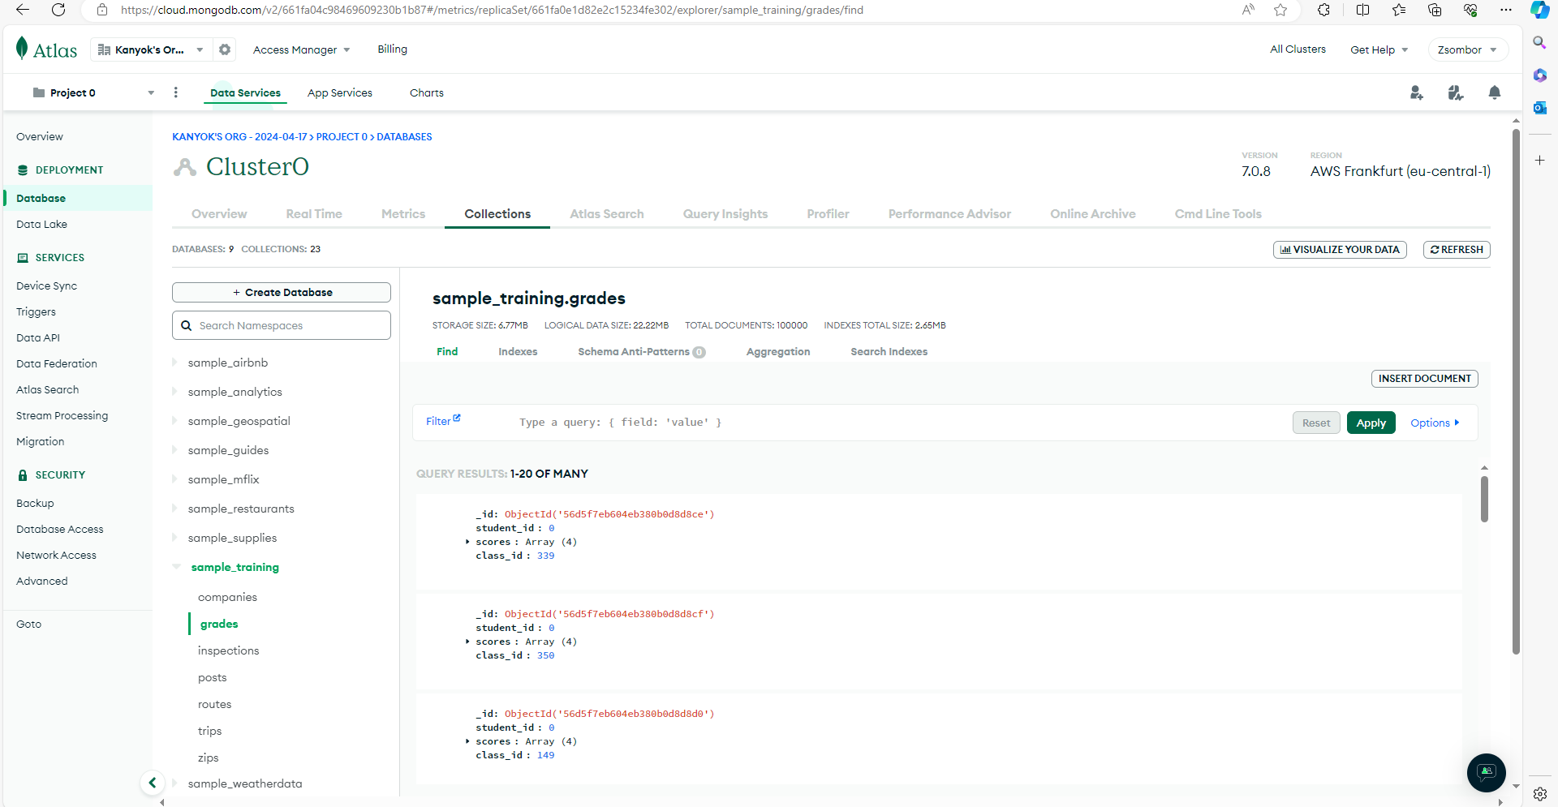

4.

{class_id: 339, student_id: {$lt: 100}}

5.

