1.

db.collection.find({},

{

user_id: 1,

firstName: 1,

lastname: 1,

_id: 0

})

2.

db.collection.find({

firstName: "Grace"

},

{

_id: 0,

email: 1,

password: 1

})

3.

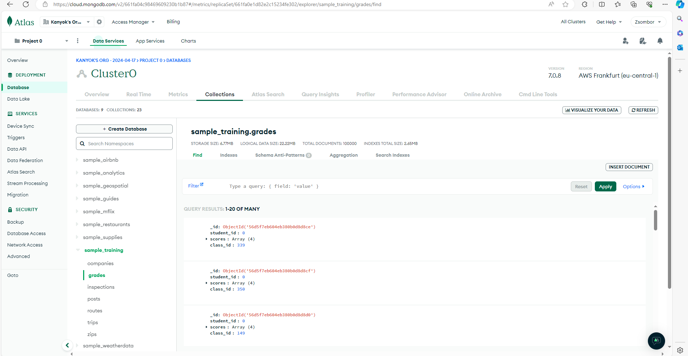

4.

{class_id: 339, student_id: {$lt: 100}}

5.

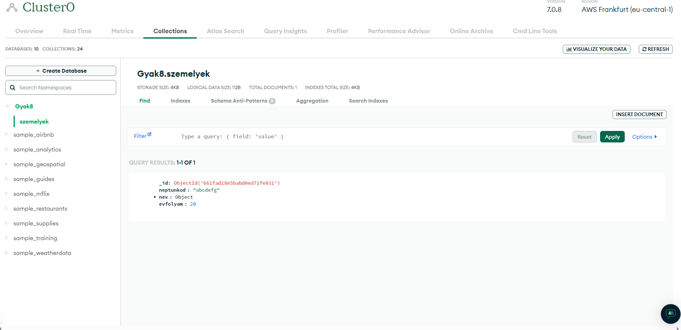

6. 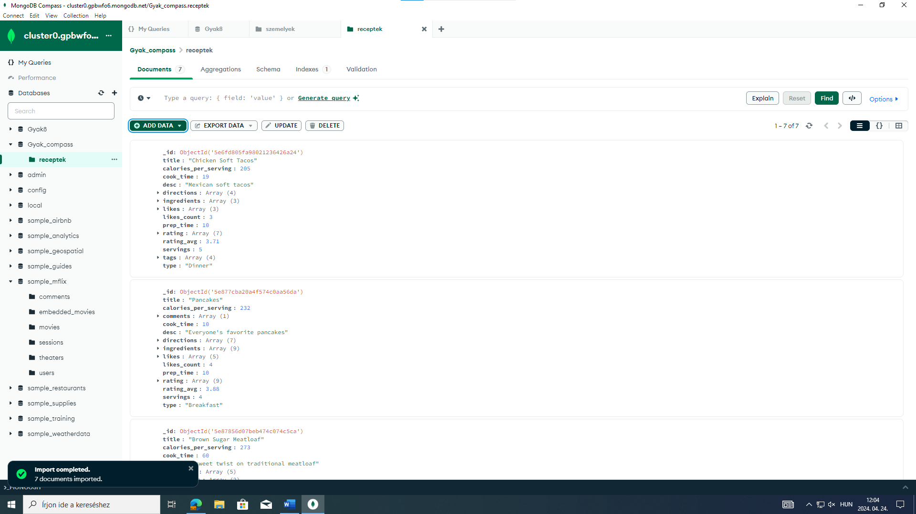

7.

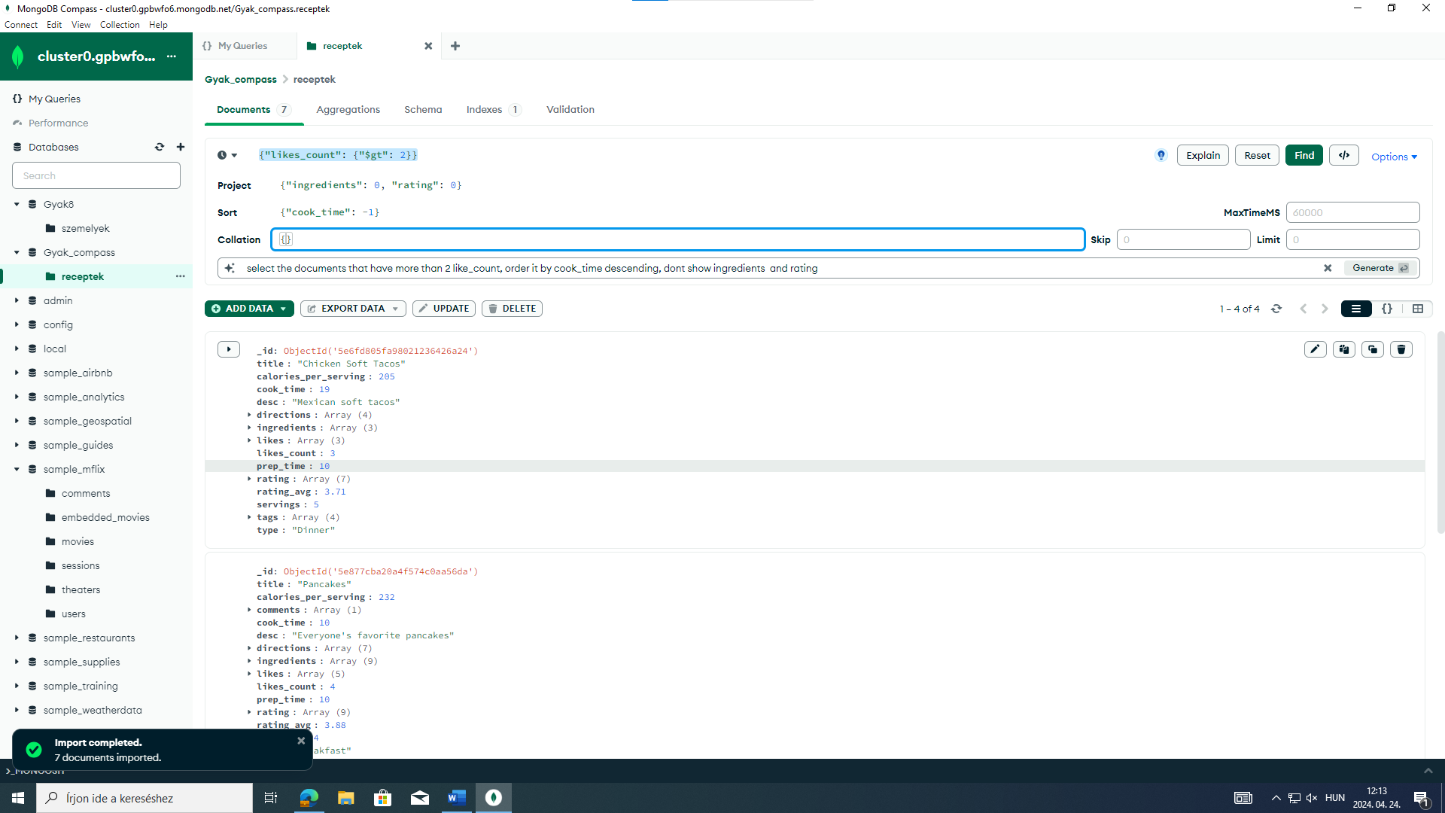

8.

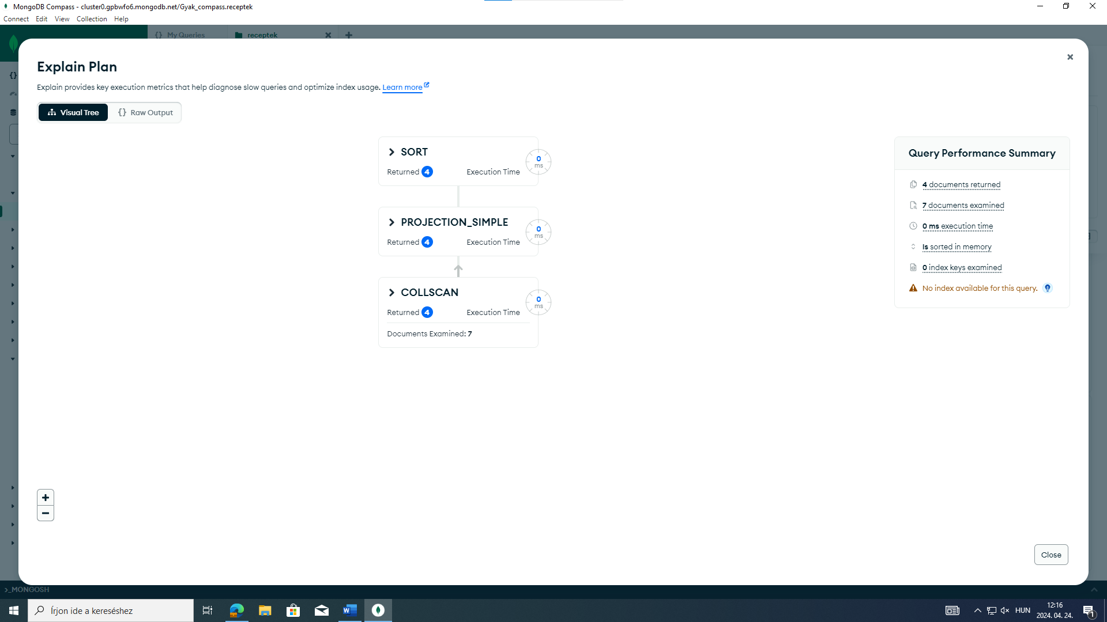

9.

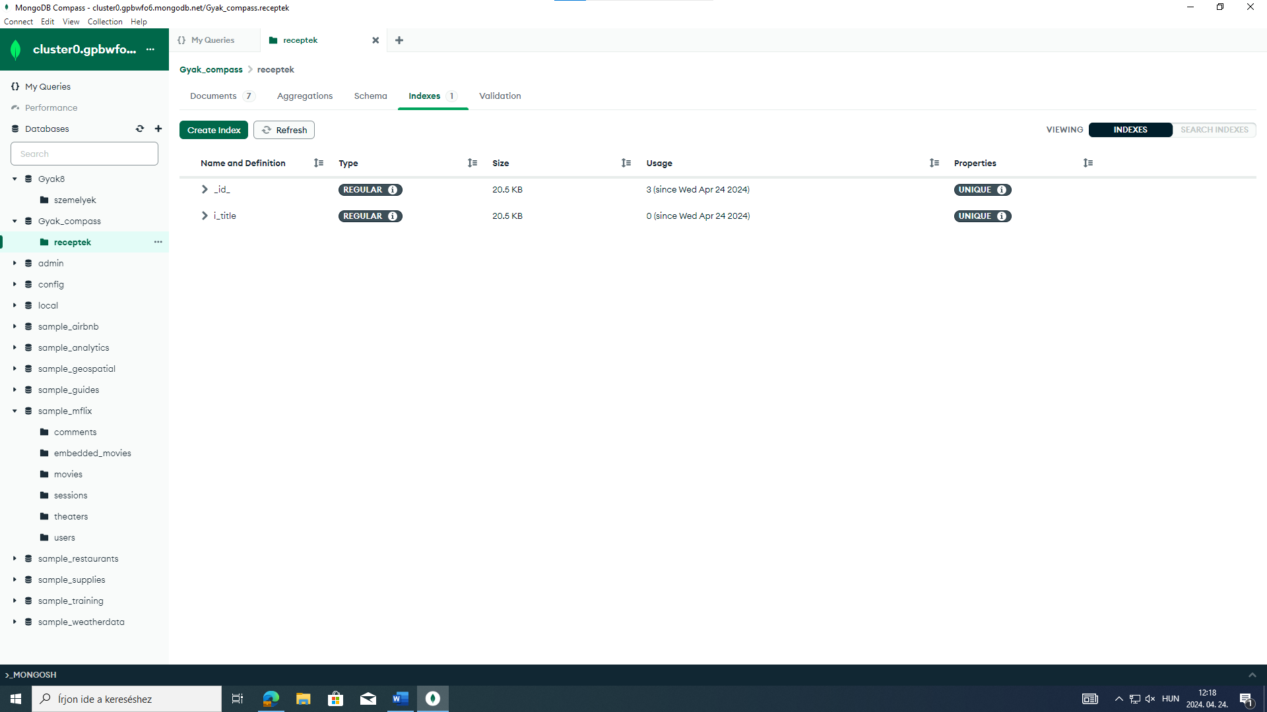

10.

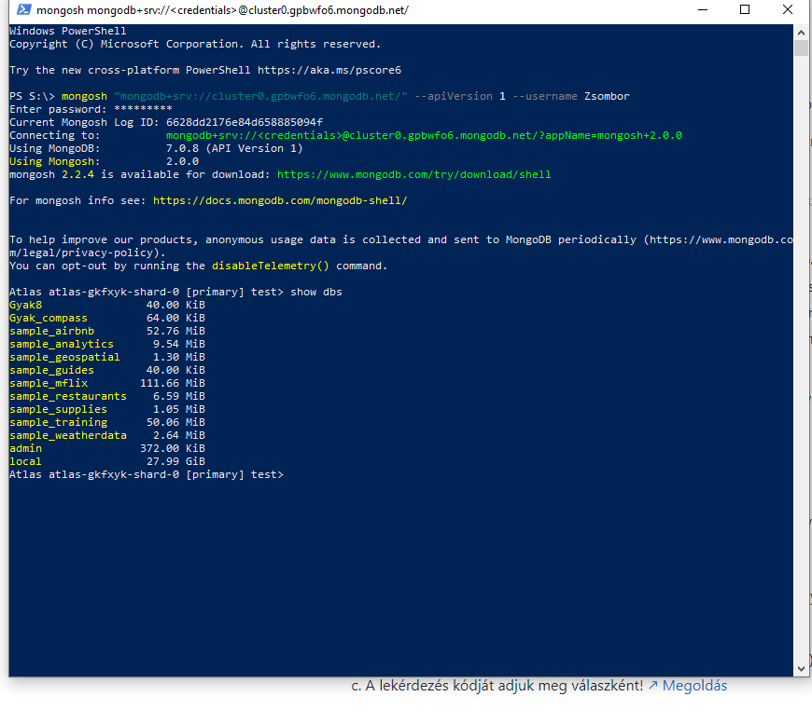

11.

use Gyak_compass

db.receptek.find({title: {$regex: /tacos/}})

db.receptek.find({title: {$regex: /tacos/}}).count()

12.

db.receptek.aggregate([{$group: {_id: „$type”, osszeg: {$sum: „$cook_time”}}}])

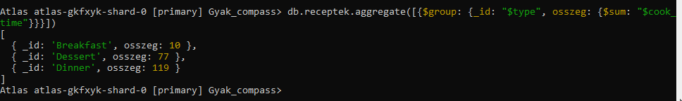

13.

