**Redis**

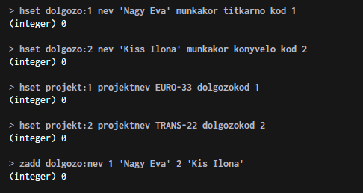

**Cassandra**

desc keyspaces;

desc tables;

use Movies;



