1. feladat

Sort: {"genres.0": "Short", "year" : {"$gte": 1945, "$lte": 1970}}  
Project: {"title": 1, "year": 1, "_id": 0}  
Sort: {"year": 1, "title": 1}

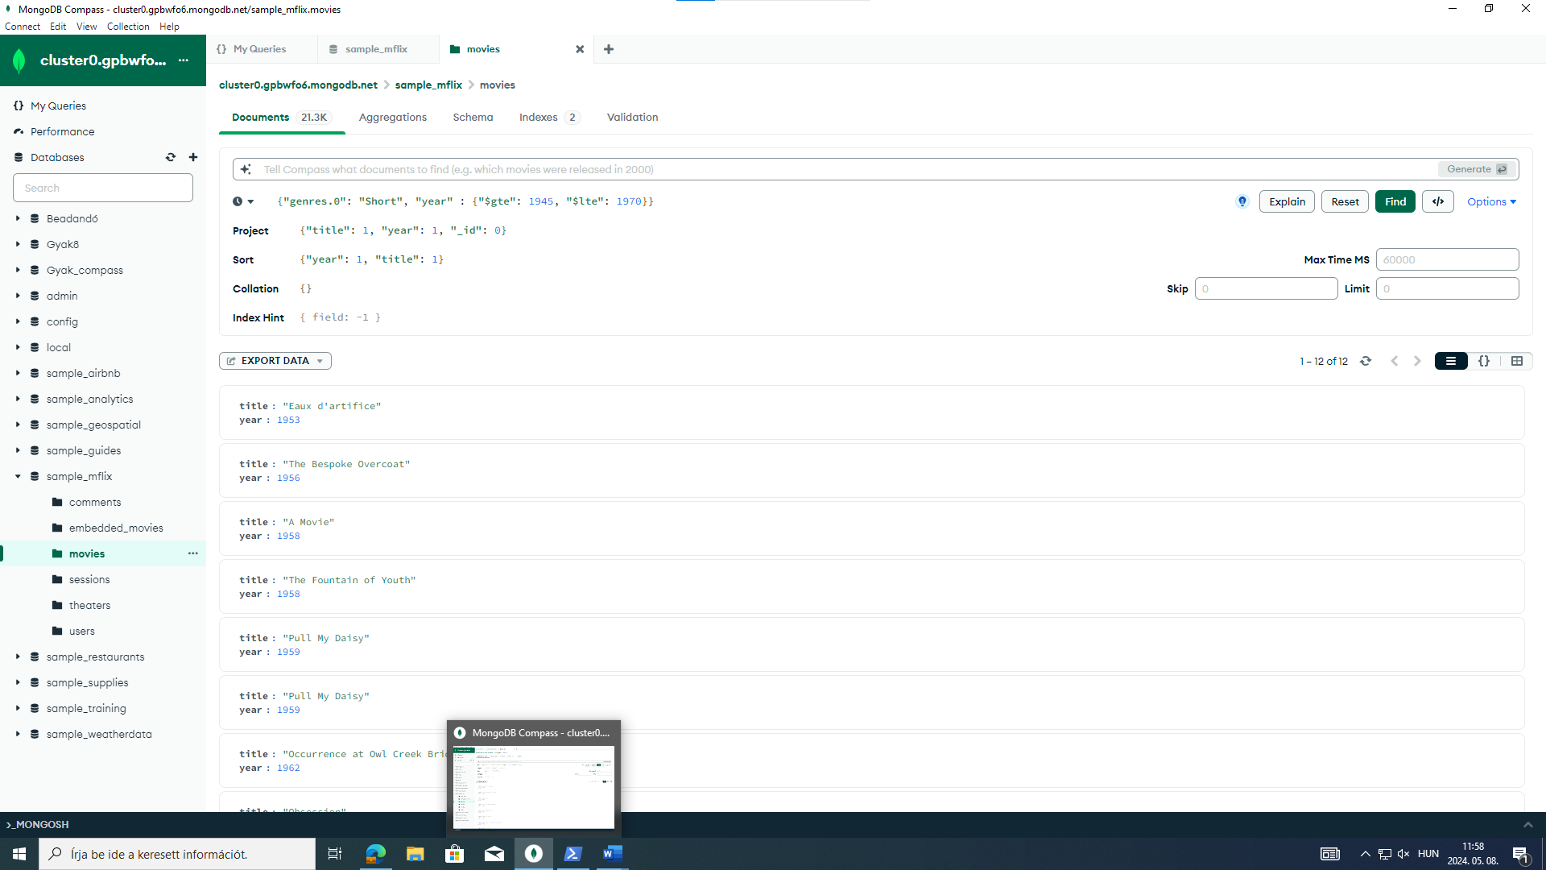

2. feladat

db.users.find({email: {$regex: /.com/}},{name: 1, _id: 0, email: 1})

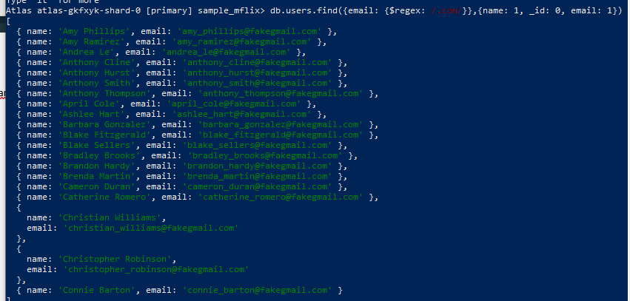

3.feladat

db.movies.aggregate([{"$match":{"year": {$gt: 1950}}},{"$group":{_id: "rated", Átlag: {$avg: "$runtime"}}}])

4.feladat

match(p:Person)-[:ACTED_IN]->(m:Movie)

with count(*) as db, m.title as cim

return cim, db

order by db desc

limit 1

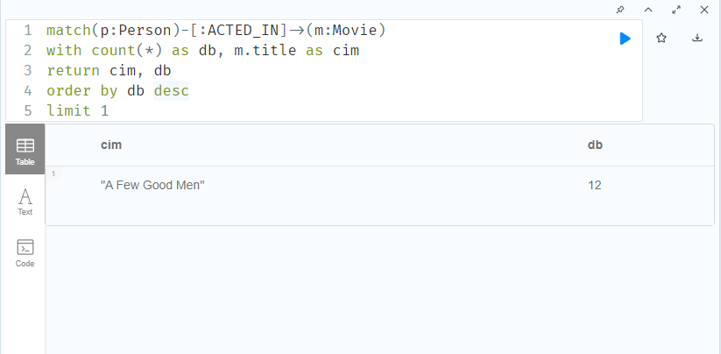

5.feladat

match(p:Person)-[:ACTED_IN]->(m:Movie)

with p.name as Actor, p.born as BirthYear, count(m.title) as NumMoviesActedIn

where p.born>1980

return Actor, BirthYear, NumMoviesActedIn

