Software Design Document
An AI-Assisted Code Exchange and
Developer Mentorship Platform



Submitted by
Mustansar Hussain (S23BINFT1M01071)

Submitted to
Mr. Mustafa Hameed

Department of Information Technology
Faculty of Computing
The Islamia University of Bahawalpur

Summary
This Software Design Document (SDD) defines the technical design of the AI-Assisted Code Exchange and Developer Mentorship Platform. The document translates the requirements identified in the Software Requirement Specification into an implementable architecture, database schema, API structure, and user interface design.
The platform is designed as a web-based, role-driven mentorship ecosystem for junior developers, senior mentors, and system administrators. Junior developers submit code snippets for review, the system performs AI preprocessing to generate a logic summary and preliminary checks, and verified senior mentors provide structured human feedback through an asynchronous review workflow.
The design follows a modular client-server architecture. React is used for the user interface, NestJS is used for backend APIs and business logic, Prisma is used as the type-safe database access layer, and PostgreSQL stores the persistent relational data. An external Artificial Intelligence API is integrated as a supporting service for automated code summarization and preliminary review before mentor involvement.
Major design considerations include role-based access control, password hashing, HTTPS-based communication, maintainable backend modules, atomic mentor claiming to avoid concurrency conflicts, and a responsive developer-friendly interface with syntax highlighting and dark mode support. The architecture intentionally remains asynchronous and focused on mentorship instead of real-time pair programming, video calls, payment handling, or full cloud IDE execution.

Table of Content
1. Application Architecture 4
1.1 Architectural Overview 4
1.2 Design Pattern and Layered Structure 4
1.3 Backend Controllers, Services and Functions 5
1.4 API Design 5
1.5 External APIs and Libraries 7
1.6 Sequence Diagrams 8
1.7 Coding Conventions 10
2. Data Model Schema 11
2.1 Conceptual Data Model 11
2.2 Entity Relationship Diagram 11
2.3 Entity Details 12
2.4 Relationships and Constraints 12
3. User Interface 14
3.1 Design Philosophy 14
3.2 Screen and Page Design 14
3.3 Controls and Input Constraints 15
3.4 Responsiveness and Accessibility 16

1. Application Architecture
1.1 Architectural Overview
The system uses a modular client-server architecture. The React frontend is responsible for presentation, form validation, code editor interaction, dashboard rendering, and communication with the backend through HTTPS REST APIs. The NestJS backend is responsible for authentication, authorization, snippet management, AI preprocessing orchestration, mentor routing, feedback management, notifications, and administration.
The database layer is implemented using PostgreSQL and accessed through Prisma ORM. Prisma provides a typed data access layer that maps backend models to relational tables and supports migrations, validation-friendly queries, and transactions. The AI module is treated as an external service. It receives sanitized code-related input from the backend and returns a plain-text logic summary, syntax observations, and preliminary security notes.
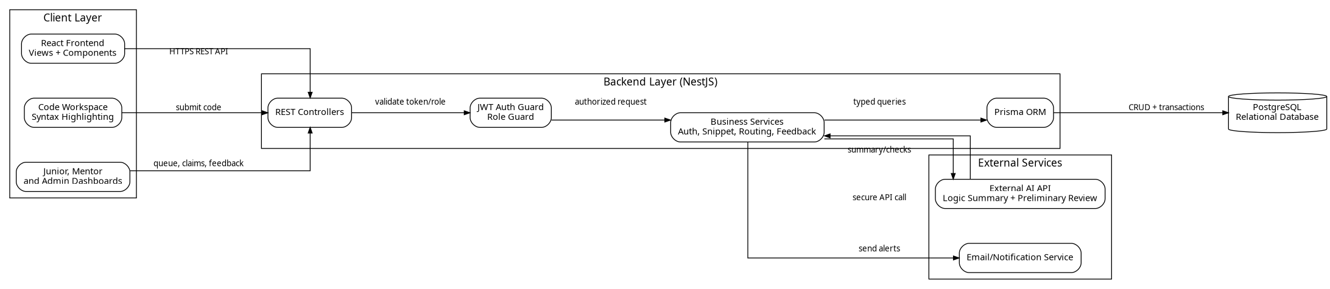
Figure 1: Proposed Application Architecture
1.2 Design Pattern and Layered Structure
The backend follows a modular layered design inspired by MVC and service-oriented architecture. In this design, controllers receive HTTP requests, guards validate authentication and role permissions, services implement business rules, and Prisma repositories perform database operations. This separation keeps the codebase maintainable and allows each module to be tested independently.
• Presentation Layer: React views and reusable components for forms, dashboards, code workspace, feedback thread, and admin screens.
• API Layer: NestJS controllers expose REST endpoints and define request/response boundaries.
• Security Layer: JWT authentication guards and role guards restrict access according to Junior Developer, Senior Mentor, and Admin privileges.
• Business Logic Layer: Services implement snippet submission, AI preprocessing, mentor claiming, feedback submission, notifications, and mentor verification workflows.
• Data Access Layer: Prisma manages typed database operations, relations, migrations, and transaction handling for concurrency-sensitive actions.
• External Service Layer: The AI service communicates with an external AI provider and normalizes its response before saving it to the database.
1.3 Backend Controllers, Services and Functions
The following table lists the proposed backend modules, their main functions, and their design responsibility. These controllers act as entry points, while the corresponding services contain the main business logic.
Module | Main Functions | Responsibility
AuthController / AuthService | signUp(), login(), logout(), refreshSession(), forgotPassword() | Registers users, authenticates credentials, issues secure tokens, and starts role-based sessions.
UsersController / UsersService | getProfile(), updateProfile(), getUserById() | Manages user profile data and returns role-specific account information.
AdminController / AdminService | listUsers(), verifyMentor(), rejectMentor(), banUser() | Allows administrators to verify senior mentor applications and manage platform users.
SnippetController / SnippetService | createSnippet(), saveDraft(), getSnippet(), listMySnippets(), updateSnippetStatus() | Handles code snippet submission, draft saving, status updates, and retrieval of submitted snippets.
AiReviewService | preprocessSnippet(), generatePrompt(), parseAiResponse(), handleAiFailure() | Sends code to the external AI API, receives summaries and checks, and attaches the result to the snippet.
MentorRoutingController / RoutingService | listQueue(), filterQueue(), claimSnippet(), releaseSnippet() | Displays AI-preprocessed snippets to mentors and performs atomic claim operations.
FeedbackController / FeedbackService | createFeedback(), listThread(), markCompleted() | Stores structured feedback, optional annotated code, and completes the review cycle.
NotificationController / NotificationService | listNotifications(), markAsRead(), createNotification() | Notifies users about AI results, mentor feedback, account approval, and workflow status changes.

1.4 API Design
The system exposes RESTful APIs. Every protected route requires a valid JWT token, and role-sensitive endpoints also require role authorization. API input is validated before business logic is executed.
Method | Endpoint | Authorized Role | Purpose
POST | /auth/signup | Public | Registers a Junior Developer or Senior Mentor applicant.
POST | /auth/login | Public | Authenticates user credentials and returns a secure session token.
GET | /users/me | All logged-in users | Returns the authenticated user profile and role information.
POST | /snippets | Junior Developer | Creates a new snippet and queues it for AI preprocessing.
POST | /snippets/drafts | Junior Developer | Saves a snippet draft without sending it for review.
GET | /snippets/my | Junior Developer | Lists snippets submitted by the current junior developer.
GET | /mentor/queue | Senior Mentor | Lists AI-preprocessed snippets awaiting mentor review; supports language filters.
POST | /mentor/snippets/{id}/claim | Senior Mentor | Atomically assigns the snippet to the mentor and marks it under review.
POST | /snippets/{id}/feedback | Assigned Senior Mentor | Stores mentor feedback and can mark the review as completed.
GET | /notifications | All logged-in users | Returns user-specific notifications.
PATCH | /admin/mentors/{id}/verify | Admin | Approves or rejects a senior mentor application.

1.5 External APIs and Libraries
API / Library | Working in the System
External AI API | Receives sanitized code block and programming language, then returns logic summary, syntax observations, and preliminary vulnerability notes.
React | Builds reusable frontend components and dynamic user interface screens.
NestJS | Provides structured backend modules, dependency injection, controllers, guards, and services.
Prisma ORM | Maps TypeScript models to PostgreSQL tables, manages migrations, and provides type-safe queries.
PostgreSQL | Stores users, snippets, AI evaluations, mentor feedback, notifications, tags, and audit logs.
bcrypt | Hashes passwords before storage to protect user credentials.
JWT | Maintains secure stateless authentication and role-based route protection.
Syntax Highlighting Library | Improves readability of submitted code blocks in the workspace and review screens.

1.6 Sequence Diagrams
The main workflow begins when a junior developer submits a code snippet. The system validates the input, saves the record, sends the code to the AI module, stores the AI-generated result, and finally makes the snippet visible to mentors.
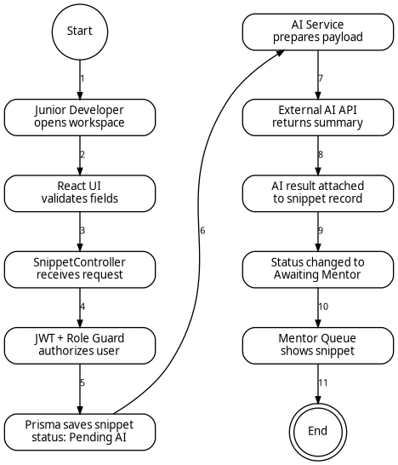
Figure 2: Sequence Diagram for Code Submission and AI Preprocessing
The second major workflow starts when a senior mentor opens the queue and claims a snippet. A transaction is used during the claim operation so that two mentors cannot claim the same snippet at the same time. After reviewing the AI-preprocessed submission, the mentor submits structured feedback and the junior developer receives a notification.
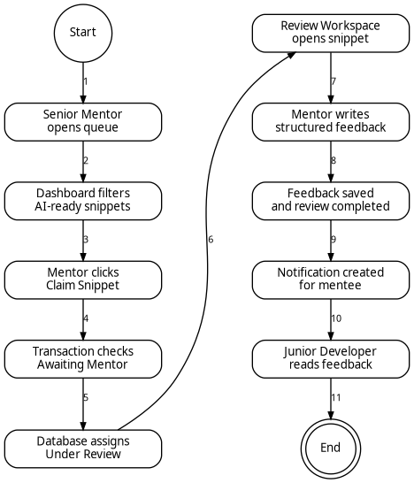
Figure 3: Sequence Diagram for Mentor Claim and Feedback Flow
1.7 Coding Conventions
The project will follow consistent coding conventions to improve readability, maintainability, and collaboration among contributors.
• Use TypeScript for both React and NestJS source code to enforce static typing and reduce runtime errors.
• Use PascalCase for React components and NestJS classes, camelCase for variables and functions, and UPPER_SNAKE_CASE for fixed constants.
• Separate backend modules by domain, such as auth, users, snippets, ai-review, mentor-routing, feedback, notifications, and admin.
• Validate all incoming request bodies using DTOs and validation pipes before passing data to services.
• Keep controllers thin; business rules should be written inside services, and database logic should be performed through Prisma.
• Use environment variables for secrets, database URLs, JWT configuration, and external AI API keys.
• Never store raw passwords, API keys, or sensitive tokens in the database or source repository.
• Write clear commit messages and keep functions short, descriptive, and focused on one responsibility.

2. Data Model Schema
2.1 Conceptual Data Model
The database schema is designed around users, code snippets, AI evaluations, mentor feedback, notifications, and administrative audit trails. Since the system contains different roles, the User entity acts as the central identity record. Role-specific behavior is handled through role fields and supporting entities such as MentorProfile.
Each code snippet belongs to a junior developer. After submission, it may receive one AI evaluation and may later be assigned to one senior mentor. A snippet can have multiple feedback entries because the mentor and mentee may continue an asynchronous discussion thread. Notifications are created whenever a meaningful event occurs, such as mentor approval, AI preprocessing completion, feedback submission, or review completion.
2.2 Entity Relationship Diagram
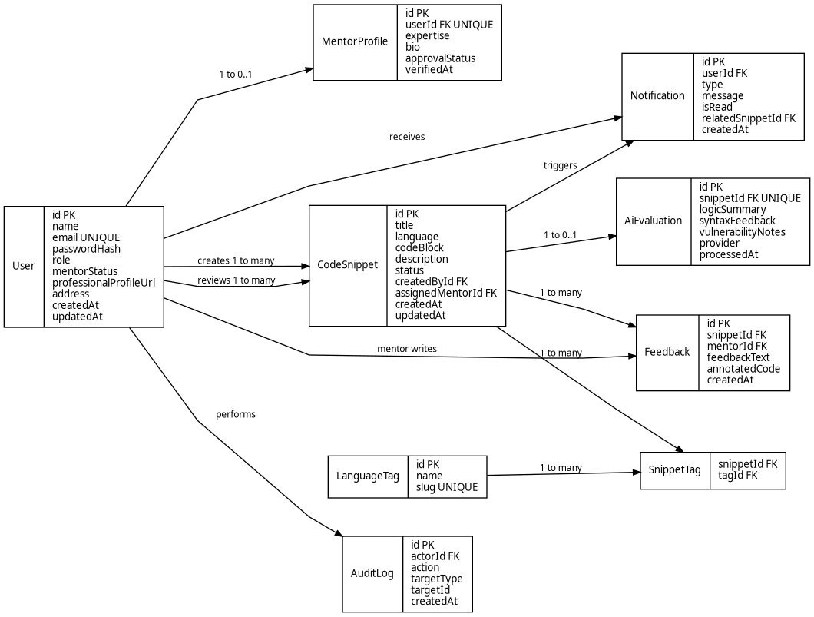
Figure 4: Conceptual Entity Relationship Diagram
2.3 Entity Details
Entity | Important Attributes | Purpose | Relationships
User | id, name, email, passwordHash, role, mentorStatus, professionalProfileUrl, address, createdAt, updatedAt | Stores account identity, authentication data, and role information for Junior Developers, Senior Mentors, and Admins. | Creates many snippets, may receive many notifications, may write feedback if role is Senior Mentor.
MentorProfile | id, userId, expertise, bio, approvalStatus, verifiedAt | Stores additional professional information for users applying as Senior Mentors. | One-to-one relationship with User.
CodeSnippet | id, title, language, codeBlock, description, status, createdById, assignedMentorId, createdAt, updatedAt | Stores the actual code submission, context, programming language, review status, and assignment details. | Many snippets belong to one junior user; one snippet may be assigned to one senior mentor.
AiEvaluation | id, snippetId, logicSummary, syntaxFeedback, vulnerabilityNotes, provider, processedAt | Stores the AI-generated summary and preliminary review generated before human mentor review. | One-to-one relationship with CodeSnippet.
Feedback | id, snippetId, mentorId, feedbackText, annotatedCode, createdAt | Stores structured mentor guidance, optional refactored code, and threaded review comments. | Many feedback records can belong to one CodeSnippet and one Senior Mentor.
Notification | id, userId, type, message, isRead, relatedSnippetId, createdAt | Stores user-specific alerts for system events and review workflow updates. | Many notifications belong to one User and may reference one CodeSnippet.
LanguageTag | id, name, slug | Stores programming languages or expertise tags used for filtering snippets and mentor queues. | Many-to-many relationship with CodeSnippet through SnippetTag.
SnippetTag | snippetId, tagId | Junction table used to attach one or more technology tags to a code snippet. | Connects CodeSnippet and LanguageTag.
AuditLog | id, actorId, action, targetType, targetId, createdAt | Stores important administrative and security-relevant actions for traceability. | Many audit logs can be created by one User.

2.4 Relationships and Constraints
• User.email must be unique because it is used as the primary login identifier.
• User.passwordHash stores only the hashed password. The raw password is never stored.
• User.role is restricted to Junior Developer, Senior Mentor, or Admin. Role guards use this field to protect APIs.
• Senior Mentor accounts must have mentorStatus set to approved before accessing the mentor queue.
• CodeSnippet.status is controlled through a defined workflow: Draft, Pending AI Evaluation, Awaiting Mentor, Under Review, Completed, or Rejected.
• A CodeSnippet can have only one AiEvaluation record, but it can have many Feedback records to support threaded mentorship.
• The claim operation for a CodeSnippet must be atomic. If a mentor claims a snippet, the system checks that the status is still Awaiting Mentor before assigning it.
• Deleting a user should not automatically remove historical review records unless the administrator intentionally performs a data cleanup action.
• AuditLog records should be append-only so that administrative actions remain traceable.

3. User Interface
3.1 Design Philosophy
The user interface is designed for developers, so readability, focus, and workflow clarity are more important than decorative complexity. The design uses a clean layout, sufficient spacing, clear headings, consistent button placement, and a code-friendly workspace. The primary interface should support both light and dark themes, with dark mode preferred for extended code review sessions.
The visual style follows a modern web application approach: neutral backgrounds, high-contrast text, clear form fields, status badges for snippet state, and consistent accent colors for important actions such as Submit, Claim, Review, Approve, and Mark Completed. The code workspace uses syntax highlighting and monospaced code rendering to improve comprehension.
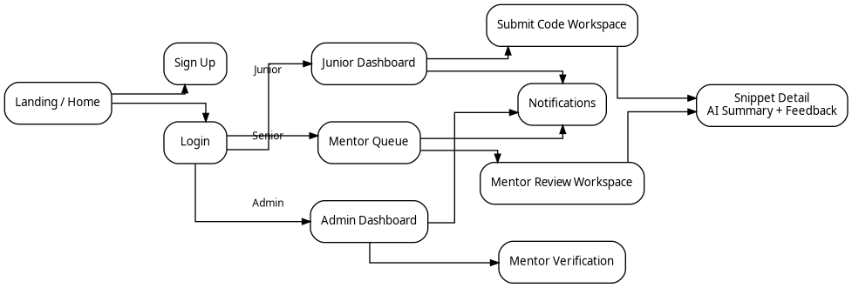
Figure 5: Proposed User Interface Navigation Flow
3.2 Screen and Page Design
Screen / Page | Users | Data Displayed | Controls
Landing / Home | Public users | Project introduction, platform purpose, role-based call-to-action buttons. | Sign Up button, Login button, navigation links.
Sign Up | Junior Developer, Senior Mentor | Registration form with name, email, password, role selection, address, and professional profile link. | Textboxes, password field, role dropdown/radio buttons, submit button.
Login | All registered users | Authentication form for email and password. | Email textbox, password field, login button, forgot password link.
Junior Dashboard | Junior Developer | Submitted snippets, review status, AI processing state, recent feedback notifications. | Create snippet button, status filters, view details buttons.
Code Submission Workspace | Junior Developer | Title, programming language, code editor, description field, and submission status. | Title textbox, language dropdown, code editor, description textarea, save draft button, submit button.
Snippet Detail | Junior Developer, Senior Mentor | Original code, AI logic summary, syntax feedback, vulnerability notes, mentor feedback thread. | Feedback thread, copy code button, status badge, comment display area.
Mentor Queue Dashboard | Senior Mentor | List of AI-preprocessed snippets awaiting review with language and status filters. | Search field, language filter dropdown, claim snippet button.
Mentor Review Workspace | Senior Mentor | Claimed snippet, AI summary, code block, feedback editor, optional annotated code area. | Feedback textarea, annotated code editor, submit feedback button, mark completed checkbox/button.
Admin Dashboard | Admin | User list, mentor applications, flagged content, platform activity overview. | Search, approve/reject buttons, ban/unban buttons, moderation actions.
Notifications / Profile | All logged-in users | User alerts, profile data, theme preference, and account settings. | Mark as read button, edit profile form, theme toggle.

3.3 Controls and Input Constraints
Input / Control | UI Control Type | Validation / Constraint
Name | Textbox | Required. Should contain real user name and must not be empty.
Email Address | Textbox | Required. Must follow valid email format and must be unique during sign up.
Password | Password Field | Required. Minimum 8 characters and must include at least one number and one special character.
Role Selection | Dropdown / Radio Buttons | Required. Values are Junior Developer or Senior Mentor during registration.
Professional Profile Link | URL Textbox | Required for Senior Mentor applicants. Must be a valid GitHub or LinkedIn URL.
Programming Language | Dropdown | Required. Must be selected from supported languages such as JavaScript, TypeScript, Python, Java, or C++.
Code Block | Code Editor | Required for submission. Must not be empty and should support syntax highlighting.
Description | Textarea | Required. Must provide context, problem statement, or the area where guidance is required.
Feedback Text | Textarea | Required for mentor feedback. Empty feedback cannot be submitted.
Annotated Code | Code Editor | Optional. Used for suggested corrections or refactored code blocks.

3.4 Responsiveness and Accessibility
The frontend should be fully responsive and should adapt to desktop, tablet, and mobile screen sizes. Desktop layouts may use multi-column dashboards, while smaller screens should switch to a single-column layout with collapsible navigation. The code editor area should remain horizontally scrollable where necessary so that long code lines do not break the surrounding layout.
• Use semantic HTML elements for headings, forms, buttons, and navigation.
• Maintain sufficient text contrast in both light and dark themes.
• Provide visible focus states for keyboard users.
• Use labels and helper text for every input field.
• Show clear validation messages near the relevant field rather than using generic errors only.
• Use status badges and notification messages to communicate snippet workflow states.
• Avoid overlapping elements on small screens by using responsive breakpoints and flexible grid layouts.
This design provides a maintainable foundation for implementing the final year project as a secure, modular, and developer-focused mentorship platform. The design keeps the first version focused on asynchronous AI-assisted code review and human mentor feedback, while leaving room for future improvements such as richer analytics, mentor matching, and additional code quality checks.

End

